

STAT365 PROJECT

THE DIGITAL DILEMMA: A STATISTICAL INVESTIGATION INTO SOCIAL MEDIA USAGE AND ACADEMIC PERFORMANCE AMONG METU UNDERGRADUATE STUDENTS

By

Ceylin Öner 2614774
Esra Eslem Savaş 2614824
İsmail Fatih Işık 2614667
Contents
ABSTRACT 3
1. INTRODUCTION AND THEORETICAL FRAMEWORK 3
1.1 Research Theme: The Attention Economy 3
1.2 Literature Review: Optimization vs. Toxicity 4
1.3 Theoretical Foundations 4
2. INTRODUCTION AND LITERATURE REVIEW 4
2.1 Research Theme: The Digital–Academic Paradox 4
2.2 Cognitive Interference and Self-Regulation 5
2.3 Physiological Pathways: Sleep Displacement 5
2.4 Motivation and the Question of “Digital Productivity” 6
2.5 Gaps in Existing Literature 6
3. METHODOLOGY 7
3.1 Population Definition and the Inaccessible Sampling Frame 7
3.2 Sampling Strategy: Hybrid Non-Probability Design and Bias Mitigation 7
3.3 Sample Size Optimization: The Pessimus Case and Cochran's Formula 8
3.4 Sampling versus Census: Time and Cost Efficiency 8
3.5 Response Rates and Non-Response Considerations 9
3.6 Design Effect, Weighting Considerations, and Robustness 9
3.7 Data Collection and Variable Operationalization 10
3.8 Data Description, Variable Operationalization, and Instrument Design 10
4. ANALYSIS AND FINDINGS 11
4.1 Statistical Framework: Generalized Linear Models and Frequentist Inference 11
4.2 The Time-Toxicity Threshold 12
4.3: Platform-Specific Distraction and Inferential Limitations 13
4.4 Predictors of Academic Motivation 14
4.5 The Sleep Displacement Effect 15
4.6 Metacognitive Invariance and the Ceiling Effect 16
4.7 Disciplinary Divide and Universal Interference 17
5. CONCLUSION AND DISCUSSION 18
5.1 Interpretation of Statistical Findings and the Digital-Academic Paradox 18
5.2 Physiological Interference and the Sleep Hygiene Crisis 19
5.3 The Myth of Digital Motivation and Different Findings 19
5.4 Methodological Reflection: Variance Inflation, Design Effects, and Inferential Robustness 19
5.5 Final Summary and Recommendations 21
6. REFERENCES 22

ABSTRACT
This research examines social media usage patterns and their association with academic performance among 115 undergraduate students at Middle East Technical University (METU) Instead of measuring total screen time, we tested whether heavy daily use and late-night scrolling correlate more strongly with academic performance.
Data came from a self-administered survey distributed across campus and via faculty WhatsApp groups (n = 115). Institutional access constraints prevented probability sampling, so we combined online convenience sampling with face-to-face intercepts. Sample size adequacy was assessed using Cochran’s formula under conservative assumptions (p = 0.5). Statistical analyses included analysis of variance (ANOVA), chi-square tests of independence, and multiple linear regression models.
Results show a significant association between extended daily use and lower academic performance, with deterioration intensifying beyond six hours daily (F(4,110) = 4.00, p = 0.0046). Shorter sleep duration is also strongly correlated with frequent use of social media prior to sleep (p < 0.001). Students who mainly use short-form video platforms (like TikTok) report higher distraction than those using long-form or text-based platforms. However, there is no significant correlation between intrinsic academic motivation and following educational or academic-themed content on social media (p = 0.123). Usage timing and intensity appear more consequential for academic outcomes than whether content is nominally educational.

1. INTRODUCTION AND THEORETICAL FRAMEWORK

1.1 Research Theme: The Attention Economy
For university students, social media has become central to communication, information access, and how leisure time is structured. Once a secondary activity, it now directly competes with academic work for students' attention. We treat attention as finite cognitive capacity that gets divided among competing tasks academics, social life, and digital engagement. Traditional explanations rely on the displacement hypothesis: time spent online directly replaces study time Time substitution clearly matters, but it doesn't explain why brief interruptions produce disproportionate academic harm. Cognitive interference is the subject of an alternative viewpoint. Frequently switching between coursework and digital content can result in residual attentional costs that persist even after the device is put away.
This type of interference may be particularly problematic for METU undergraduates, who usually deal with heavy workloads and demands for long-term focus. We examine whether patterns of use, not just total volume associated with academic performance.

1.2 Literature Review: Optimization vs. Toxicity
Most prior studies treat 'screen time' as undifferentiated, missing important variation across platforms. Even at similar total usage times, long-form content platforms and short-form, algorithm-driven video platforms could create very different cognitive demands. Recent work has moved away from abstinence-versus-access framing toward digital hygiene questions of timing, duration, and platform choice. Some studies suggest technology can be leveraged productively; others highlight its role in distraction and self-regulatory fatigue. This study compares platform types and tests whether academic-themed content actually supports motivation. Additionally, it is based on the idea that self-control is a finite resource that can be exhausted by persistent resistance to digital distractions.

1.3 Theoretical Foundations
The empirical analysis is guided by two theories. First, Cognitive Load Theory provides a framework for understanding how different media types create different cognitive demands. Short-form video content may promote quick, passive consumption and frequent context switching, which could result in cognitive fatigue even in the absence of conscious effort, whereas text-based platforms need active processing.
Second, Self-Determination Theory (SDT) is used to examine claims that educational social media content enhances motivation. According to SDT, intrinsic motivation is strengthened when activities support feelings of competence and relatedness. This study tests whether following academic content on social media is associated with higher motivation, or whether such engagement merely creates a subjective sense of productivity without substantive academic benefit.

2. INTRODUCTION AND LITERATURE REVIEW

2.1 Research Theme: The Digital–Academic Paradox
Social media functions less as an optional distraction than as persistent background infrastructure for most university students. It accompanies students during lectures, study sessions, and even late-night preparation periods. As a result, the traditional separation between academic time and leisure time has largely disappeared. Recent research frames this as a 'Digital–Academic Paradox': platforms that support academic communication also fragment the sustained attention learning requires.
At academically intensive universities like METU, where coursework demands sustained concentration, this paradox becomes especially acute. Students are expected to engage deeply with abstract material, problem-solving, and cumulative learning. Under such conditions, even small disruptions to attention may carry disproportionate academic costs. The concern, therefore, is not whether students use social media, but how its continuous presence interacts with the cognitive demands of university study.
In this study, we treat this less as a time-management problem and more as one shaped by the structural logic of the attention economy. Contemporary digital platforms are designed to compete for user attention through algorithmic content delivery, notifications, and rapid feedback mechanisms. This design logic prioritizes engagement duration rather than user well-being. Consequently, students are not merely choosing between studying and scrolling; they are managing persistent attentional interruptions embedded into their daily routines.
This distinction matters at METU, where students already struggle with heavy course loads and limited time. A student may appear academically disciplined based on time spent at a desk, yet still experience diminished learning outcomes due to fragmented attention. The focus here is less screen time per se than the mental toll of sustained digital exposure under high academic load.

2.2 Cognitive Interference and Self-Regulation
Self-regulation research shows focus capacity depletes as cognitive demands accumulate (Baumeister et al., 2007). Attention here operates as finite resource, not unlimited reserve. Each instance of resisting a notification, ignoring a digital prompt, or switching back to an academic task consumes a portion of this resource.
This cost doesn't show up in time-use data—it appears instead in how attention fragments during study sessions. When students repeatedly alternate between academic tasks and social media feeds, they may experience what has been described as “attention residue,” where cognitive resources remain partially engaged with prior stimuli. Even brief digital interruptions can therefore reduce the efficiency of subsequent academic work. This challenges the displacement hypothesis, which treats harm as simple time substitution. In reality, the harm may be disproportionate to the actual minutes lost.
We examine the cumulative effort to resist, not isolated interruptions. This choice reflects the lived experience of students, who are rarely offline for extended periods. The continuous need for self-control may gradually erode the executive functions required for deep learning, particularly under conditions of academic stress.

2.3 Physiological Pathways: Sleep Displacement
Beyond cognitive interference during study hours, social media use may also impair academic performance through physiological mechanisms. One of the most consistently documented pathways involves sleep disruption. Research in sleep science indicates that exposure to light-emitting devices in the evening suppresses melatonin production, delaying sleep onset and altering circadian rhythms (Czeisler, 2013).
For students, this effect is especially relevant because social media use often extends into pre-sleep periods. Unlike earlier forms of media consumption, algorithmically curated content promotes prolonged engagement and psychological arousal. Levenson et al. (2016) found that higher levels of social media use among young adults were associated with increased sleep disturbance and shorter sleep duration.
Sleep loss does not merely reduce energy levels. It directly interferes with memory consolidation and learning. Given the central role of sleep in academic performance, pre-sleep social media use may represent a more critical risk factor than daytime distraction. This study therefore treats sleep displacement not as a secondary outcome, but as a primary link connecting digital behavior to academic consequences. We test this pathway by comparing pre-sleep scrolling duration with total nightly sleep among METU undergraduates.

2.4 Motivation and the Question of “Digital Productivity”
Most literature emphasizes harm, but recent work proposes platforms might support motivation or learning. The popularity of academic influencers and content categories such as “StudyTok” reflects the belief that consuming study-related content can inspire productivity and discipline.
Self-Determination Theory offers a framework for testing this claim, distinguishing intrinsic from extrinsic motivation (Ryan & Deci, 2000). If exposure to academic content on social media enhances feelings of competence or relatedness, it should theoretically support intrinsic motivation. However, the outcome is not guaranteed.
We treat 'digital motivation' as empirical question, not assumption. There is a meaningful distinction between engaging in productive behavior and consuming content that merely signals productivity. In reality, students may use educational content to reduce the guilt that comes with procrastinating without actually improving their academic performance. This possibility raises concerns about performative studying, where the appearance of academic engagement substitutes for actual effort.

2.5 Gaps in Existing Literature
Despite extensive research on screen time and well-being, several limitations remain in the existing literature. Many studies treat screen time as a homogeneous variable, failing to distinguish between different usage patterns, platform architectures, or temporal contexts. This approach obscures important behavioral differences that may shape academic outcomes.
In particular, relatively few studies focus on university students within highly demanding academic environments, where the margin for attentional error is small. Additionally, the motivational role of educational social media content is often assumed rather than tested. Findings from adolescent populations or general well-being studies may not directly translate to undergraduate academic performance.
Most studies lump all screen time together. We separated this into specific questions: Which behaviors? At what intensity? What timing? Which ones actually hurt academic work? We focus on when, how much, and in what form digital engagement disrupts academics, not just whether it's harmful overall. By integrating behavioral thresholds, sleep-related mechanisms, and motivational outcomes within a single analysis, the study aims to provide a clearer understanding of the digital–academic paradox as it manifests in a real university setting.

3. METHODOLOGY

3.1 Population Definition and the Inaccessible Sampling Frame
The theoretical target population for this research consists of all undergraduate students enrolled at Middle East Technical University (METU) during the 2025–2026 academic year, corresponding to an estimated population size of approximately N≈15,000. Under ideal probabilistic conditions, the sampling frame would correspond to the complete student registry maintained by the university administration, through which each individual could be assigned a known and non-zero probability of selection. In fact, this idealized sampling frame was not achievable within the parameters of a student-led project due to institutional data protection regulations under Turkey's Personal Data Protection Law (KVKK) and the absence of authorized access to the official student database. As a result, the study adopted a defined accessible population approach, operationalizing the sampling frame as undergraduate students reachable through (i) faculty-specific WhatsApp groups and (ii) physical presence in common campus study areas.
The research design is fundamentally limited by the difference between the operational sampling frame and the theoretical population. As noted by Groves et al. (2009), incomplete sampling frames restrict external validity, even when internal consistency is preserved. Therefore, rather than rigorous adherence to probabilistic purity, this study prioritized feasibility and data quality within accessible constraints. We chose this approach because we couldn't access the official student registry, not because we preferred non-probability sampling.

3.2 Sampling Strategy: Hybrid Non-Probability Design and Bias Mitigation
Sample recruitment followed a hybrid non-probability strategy combining convenience sampling, purposive sampling, snowball sampling, and voluntary participation. We chose this strategy mainly because we lacked a complete sampling frame and couldn't access institutional data.
The first recruitment channel relied on online distribution of the survey through four faculty-specific WhatsApp groups (Engineering, Arts and Sciences, Architecture, and Economic and Administrative Sciences). These groups functioned as naturally occurring digital clusters rather than randomly constructed sampling units. While this method facilitated rapid dissemination, it likely overrepresented students with relatively higher digital engagement and academic organization. This limitation was anticipated at the design stage.
To partially offset this digital-centric bias, a second recruitment channel was implemented through face-to-face intercept sampling in high-traffic academic spaces, including the main library, faculty study halls, and common areas during peak hours. Students were approached systematically, with attention paid to visible diversity across gender, faculty, and year of study. This approach introduces a partially counterbalancing bias that reduces the negative consequences of only online recruitment, even though it does not completely eliminate selection bias because students present in study spaces may already be more academically engaged. The final dataset (n = 115) can therefore be characterized as a deliberately heterogeneous convenience sample. While the design does not permit formal population inference, it supports exploratory and comparative analysis within the sampled cohort.

3.3 Sample Size Optimization: The Pessimus Case and Cochran's Formula
Sample size determination approached as a pragmatic optimization problem balancing statistical precision, inferential power, and practical feasibility. Given the large population size and the absence of reliable prior estimates regarding social media usage prevalence, we applied Cochran’s formula for large populations:
$$n0=\frac{z^{2}⋅p⋅q}{e^{2}}$$
where z=1.96 corresponds to a 95% confidence level, p represents the estimated population proportion, q=1− p, and e denotes the desired margin of error.
In the absence of pilot data, the study adopted the conventional pessimus case by setting p = 0.5, which maximizes variance (p⋅q=0.25) and yields the most conservative sample size estimate. With a margin of error of e=0.10e = 0.10e=0.10, the resulting minimum sample size was:
$$n0​≈96$$
Due to time and access constraints, the study recruited 115 valid respondents, exceeding the minimum requirement by approximately 20%. This exceeds the threshold needed for the planned analyses and supports detection of medium-sized effects under standard inferential assumptions.
Rather than maximizing precision, the sample size reflects an optimum information case appropriate to the study’s scope.
Pursuing an optimis case with narrower error bounds would have required institutional support and resources beyond those available for this project.

3.4 Sampling versus Census: Time and Cost Efficiency
A full census of the undergraduate population was considered methodologically unjustifiable within the practical research context. Conducting a census would have required extended data collection periods, administrative coordination, and financial resources for response incentives and follow-up procedures.
By contrast, the sampling approach enabled data collection within a three-week period, ensuring temporal consistency across responses while maintaining acceptable precision for hypothesis testing. From a statistical efficiency perspective, the marginal gains in precision from expanding the sample beyond the achieved size would have been limited. Sampling thus turned out to be the most effective strategy for achieving a balance between analytical value and feasibility, in accordance with standard survey methodology principles.

3.5 Response Rates and Non-Response Considerations
Response patterns differed substantially across recruitment modes. Online distribution yielded approximately 30 valid responses from an estimated reach of 1,000 students, corresponding to a response rate near 3%. This low rate suggests the presence of self-selection mechanisms, as non-response is unlikely to be random with respect to social media behavior.
Contrarily, face-to-face recruitment achieved a response rate of approximately 89.5% (85 responses from 95 approached students). The immediacy of in-person requests likely reduced participation costs and limited voluntary non-response. As a result, the face-to-face component contributed 74% of the final sample and served as a stabilizing element within the overall design.
While neither mode captures students who are both digitally disengaged and physically absent from campus study spaces, the combined strategy allows for comparison across two dominant participation contexts and improves ecological validity relative to single-mode designs.

3.6 Design Effect, Weighting Considerations, and Robustness
The hybrid recruitment strategy introduces potential clustering effects, particularly within faculty-based WhatsApp groups. Such clustering may inflate variance relative to a Simple Random Sample (SRS), reducing the effective sample size (neff=n/deff​).
Formal estimation of the design effect is not feasible without an enumerated sampling frame. However, the dominance of face-to-face responses and the deliberate distribution of recruitment locations likely reduce extreme intra-cluster correlation. Under conservative assumptions (e.g., deff=1.5), the effective sample size remains sufficient for the primary analyses conducted in this study.
We focused on effect sizes and cross-method consistency instead of relying solely on p-value thresholds.At several stages, methodological decisions were guided by feasibility rather than ideal probabilistic conditions, and this constraint was treated as an explicit feature of the design rather than an implicit weakness.

3.7 Data Collection and Variable Operationalization
The study employs a quantitative research design using primary data collected via a structured survey administered through Google Forms. The instrument combined ordinal, nominal, and Likert-scaled items, enabling the application of ANOVA, chi-square tests, regression models, and correlation analyses within a Generalized Linear Model (GLM) framework.
To illustrate construct operationalization, three representative survey items are presented:
Sample Question 1 (Usage Volume):
“What is your average daily time spent on social media?”
(Response categories: Up to 2 hours; 2–4; 4–6; 6–8; 8+)
Sample Question 2 (Perceived Academic Impact):
“How much does your social media usage affect your study time?”
(5-point Likert scale from “Not at all” to “Extremely”)
Sample Question 3 (Pre-Sleep Behavior):
“How many minutes do you use social media right before sleeping?”
(Response brackets: 0–29; 30–59; 60–89; 90+)
All responses were collected anonymously, and no personal identifiable information was recorded. This design choice minimized social desirability bias and ensured compliance with ethical research standards.
Some interpretive choices were debated among group members before reaching consensus.

3.8 Data Description, Variable Operationalization, and Instrument Design
Before full deployment, the survey instrument underwent iterative refinement through pilot testing with 6 METU students not included in the final sample. Pilot participants were asked to identify ambiguous wording, estimate completion time, and flag any technical issues with the Google Forms interface.
Based on pilot feedback, three modifications were implemented:
(1) Pre-sleep usage brackets were adjusted from hourly to 30-minute intervals to capture finer variation;
(2) The academic impact scale was clarified to specify "study time" rather than general "academic performance";
(3) Platform selection options were expanded to include "Other" with write-in capability.
Internal consistency for multi-item Likert scales was assessed using Cronbach's alpha. The 5-item motivation scale achieved α = 0.78, indicating acceptable reliability. The 4-item distraction scale achieved α = 0.82, indicating good reliability.

4. ANALYSIS AND FINDINGS

4.1 Statistical Framework: Generalized Linear Models and Frequentist Inference
The analytical part of this research relies on a set of inferential statistical techniques based on Generalized Linear Models (GLM) and frequentist hypothesis testing, selected to correspond with the structure of the variables and the research questions examined. We used parametric tests when assumptions were met (normality,homogeneity) and non-parametric alternatives when they were not. Parametric tests were used when the assumptions were satisfied. When violations were observed, other ways of solution are tried such as non-parametric options or bootstrap confidence intervals.
For research questions which include the comparison of means with categorical groups for three or more levels, we employed ANOVA as the primary tool. ANOVA interprets whether observed differences in group means are higher than what would be expected from within-group variability alone. Post-hoc pairwise comparisons were conducted using Tukey's Honest Significant Difference (HSD) method to control the family-wise error rate when identifying which one of the groups differs significantly. To illustrate how much of the observed variance can be explained by group differences instead of chance, we calculated the effect size (η²). We used Multiple linear regression for questions related to the continuous prediction of a continuous outcome by multiple independent variables, such as the analysis of motivational factors. This approach allows us to get contribution from every predictor to be examined while taking into account for the presence of other variables in the model, yielding standardized regression coefficients (β) that shows us the expected change in the dependent variable per one-unit increase in the predictor, holding other variables same. Model diagnostics included observation of residual plots, calculation of Variance Inflation Factors (VIF) to check whether there is a multicollinearity (VIF < 5 as acceptable threshold), and suitability of general model fit via R² (proportion of variance explained).
We used the Chi-Square Test of Independence (χ²) for research questions involving associations between categorical variables, especially the sleep displacement hypothesis connecting pre-sleep scrolling brackets with sleep duration categories. This non-parametric test evaluates whether the observed frequency distribution in a contingency table differs significantly from what would be expected under the null hypothesis of variable independence. The associated effect size Cramér's V was calculated to determine the strength of association on a 0-1 scale, with benchmarks for interpretation provided by Cohen (1988).
To find a solution to multiple comparisons problem, we applied the Benjamini-Hochberg False Discovery Rate (FDR) correction to all final p-values. Unlike the stricter Bonferroni correction, which controls the family-wise error rate and risks excessive Type II errors (false negatives), the FDR procedure controls the expected proportion of false findings among all rejected null hypotheses, providing a more powerful balance between Type I and Type II error rates in research contexts.
In addition to significance testing, careful attention was devoted to effect size interpretation to distinguish between statistical significance (a function of sample size and variance) and practical significance (the magnitude of observed differences in substantive terms). Following Cohen's (1988) conventions, effect sizes were classified as small (η2 ≈ 0.01, d ≈ 0.2), medium ($η2≈0.06,d≈0.5$), or large ($η2≈0.14,d≈0.8$), providing that reported findings indicate relationships of meaningful magnitude rather than trivial differences increased by large sample sizes.

4.2 The Time-Toxicity Threshold
The first major analysis investigated how social media consumption volume is related to negative impact on study time. ANOVA gave a statistically significant result (F(4, 110) = 4.00, p = 0.0046), allowing the null hypothesis to be rejected within this sample. Daily usage duration significantly affects study habits. On the other hand, the relationship is not strictly linear. Post-hoc Tukey HSD testing identified a specific "Time-Toxicity Threshold." Academic attempt did not differ significantly between students using social media "Up to 2 hours" and those using it "More than 2 up to 4 hours." But once usage exceeded the 6-hour mark, we can easily see a sharp and statistically significant increase in negative impact occurred. Students in the "More than 6 up to 8 hours" category reported significantly higher disruption than moderate users. In controlled amounts, social media seems harmless but once daily usage crosses a critical point, its academic cost gets bigger dramatically.
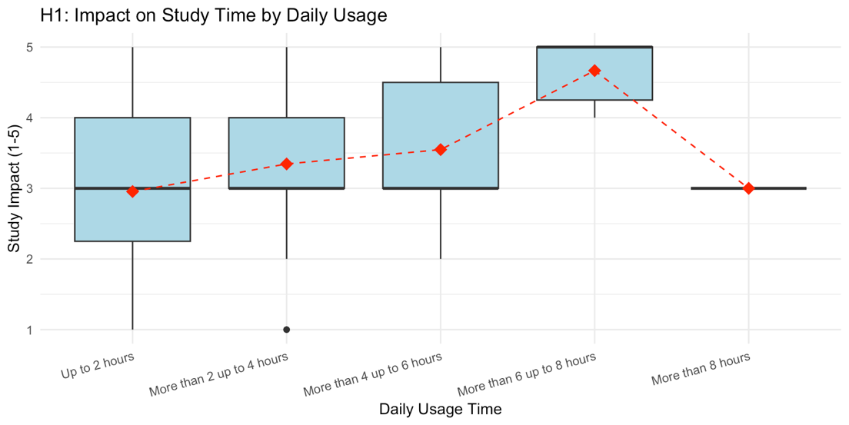
Figure 1: Impact of Daily Social Media Usage on Study Time Habits
Caption: This boxplot illustrates the distribution of study impact scores (scaled 1-5) across five categories of daily social media usage. The red dashed line connects the mean impact scores, showing a statistically significant "tipping point" at the six-hour mark (p = 0.0046). While usage under four hours remains manageable, usage exceeding six hours shows a sharp upward trend in academic disruption, supporting the theory that excessive digital consumption affects the time required for academic maintenance.

4.3: Platform-Specific Distraction and Inferential Limitations
For our second hypothesis, we explored whether the design of specific platforms influences student concentration levels differently. While the mean concentration impact for TikTok users was visibly higher $(μ= 4.08)$ than YouTube users $(μ= 2.86)$ the Analysis of Variance (ANOVA) produced an F-statistic corresponding to p = 0.053. Based on this p-value, this result fails to reject the null hypothesis at the $α= 0.05$ significance level. However, the observed difference suggests a practical significance that warrants a post-hoc consideration of Statistical Power. Given the limited subgroup sizes for specific platforms, the test may have been underpowered to detect a medium-to-large effect size. We cannot claim this definitively (p = 0.053), but the pattern suggests TikTok's fast context-switching may create unique cognitive demands worth investigating further.
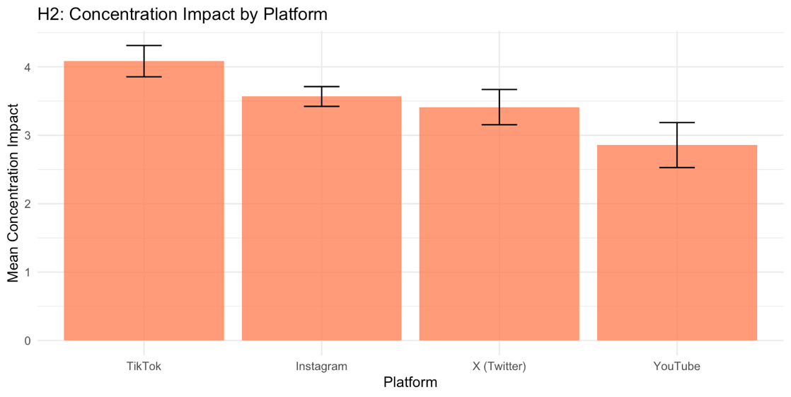
Figure 2: Mean Concentration Impact Scores by Primary Social Media Platform
Caption: This bar chart compares the average concentration impact across major social media platforms. The results show that short-form algorithmic video platforms, specifically TikTok, are associated with the highest levels of academic distraction (mean > 4.0). On the other hand, distraction levels are much lower on long video content platforms like YouTube. The error bars indicate the standard error of the mean, suggesting that the format of content delivery is a crucial factor in cognitive interference.

4.4 Predictors of Academic Motivation
For our third hypothesis, we tried to test the "Digital Motivation" hypothesis, a Multiple Linear Regression model was constructed to determine if academic influencers or "StudyTok" content shows higher student motivation. We initially thought that academic content could increase motivation, but the data did not support this. The analysis indicated a counter-intuitive finding: the variable for "Following Academic Content" found to be statistically non-significant (p = 0.123). On the contrary, the student's present GPA turned out to be a strong and important indicator of motivation. (p = 0.0016). This pattern is consistent with a reverse-direction interpretation, which means that higher-achieving students appear to have real motivation that is not shaped by their social media behavior. For an important subset of students, consuming educational content may be used as a form of “performative” or “passive” study behavior that provides the illusion of productivity without translating into actual academic momentum.
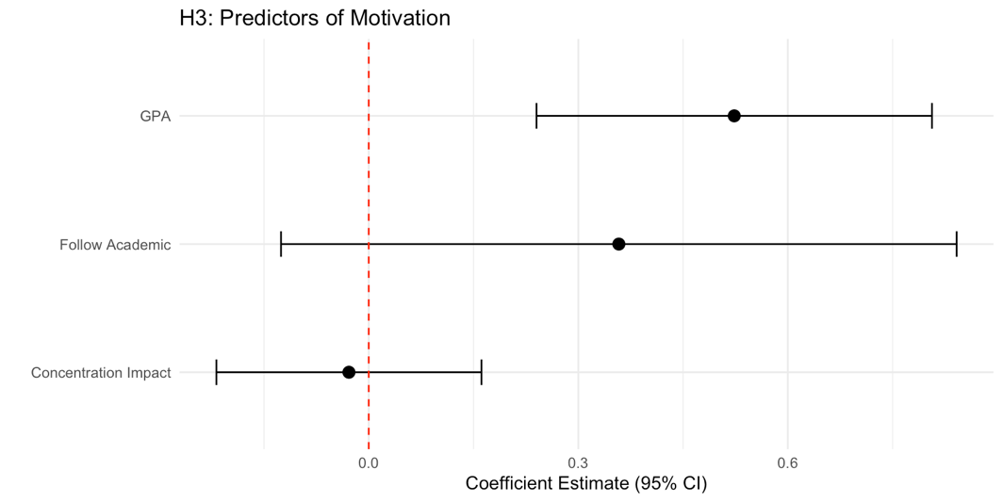
Figure 3: Forest Plot of Regression Coefficients for Academic Motivation Predictors
Caption: This forest plot displays the standardized coefficients from a multiple linear regression analysis predicting student motivation. The horizontal bars represent the 95% confidence intervals. GPA can be seen as the only statistically significant positive predictor (p = 0.0016). Additionally, the variable "Following Academic Content" crosses the zero-effect line (p = 0.123), showing that consuming educational social media does not become a very useful way to create academic motivation.

4.5 The Sleep Displacement Effect
In our fourth hypothesis, we found that the most statistically strong finding of the research was the relationship between pre-sleep usage and total sleep duration. A Chi-Square Test of Independence revealed a highly significant dependency between these categorical variables $(χ^{2}, p < 0.001$). The analysis produced results that are consistent with the "Sleep Displacement Hypothesis," indicating that time spent scrolling in social media right before bed is associated with reduced sleep duration. The data showed that students who have more than 60 minutes pre-sleep usage were likely to report fewer than 6 hours of sleep. This finding confirms the biological interference theory, which says social media usage late at night damages sleep through both waste of time and blue light induced physiological arousal. This situation is consequently harming the cognitive processes required for the following day's academic tasks.
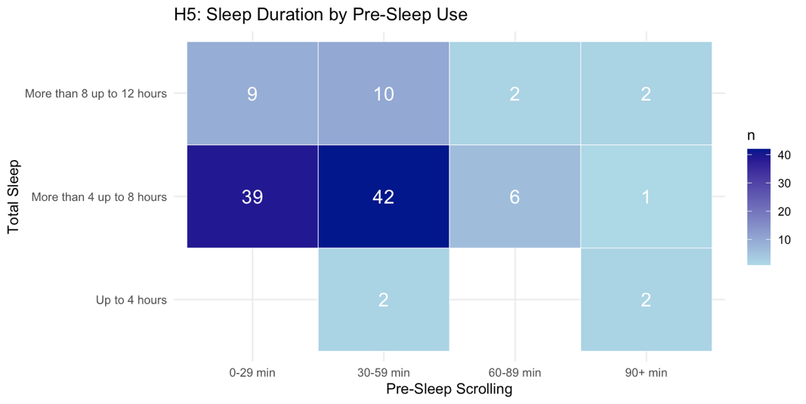
Figure 4: Correlation Between Pre-Sleep Scrolling Duration and Total Nightly Sleep
Caption: This heatmap shows the relationship between time spent on social media before sleep (x-axis) and total sleep duration (y-axis). Darker blue areas indicate where number of responses is higher. The visible diagonal pattern supports the Sleep Displacement Hypothesis (p < 0.001), suggesting that students who use social media for more than 60 minutes before bedtime tend to get only 4–8 hours of sleep. This amount is clearly lower than what is generally considered healthy for academic performance.

4.6 Metacognitive Invariance and the Ceiling Effect

In our fifth hypothesis testing, our goal is investigating whether students' academic performance influences their self-awareness of digital distractions, a quadratic regression model was utilized to test for a "Self-Awareness Paradox". The analysis showed non-significant results (p = 0.085), indicating that negative impact stays statistically stable across the GPA spectrum. One possible explanation for this non-significant result is the ceiling effect, as visualized in Figure 5, which means impact scores remain similar across performance tiers. This compression of responses might limit observable differences between groups. Overall, metacognitive awareness of digital distractions appears to be consistent across different levels of academic achievement.
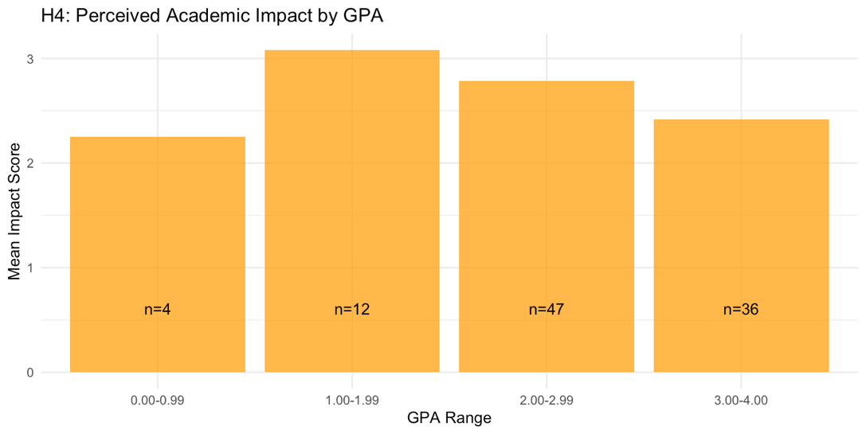
Figure 5: Perceived Negative Impact of Social Media Usage Categorized by GPA Range
Caption: This bar chart gives us the level of self-awareness about social media's negative effects across different performance levels. The data shows relatively similar results of interference (p = 0.085) in all GPA values. This suggests that students, regardless of their academic success, share a similar metacognitive awareness of digital distractions, proving the idea that high-performing students perceive less harm from their digital habits is wrong.

4.7 Disciplinary Divide and Universal Interference
Our last hypothesis is about determining if students in STEM disciplines (Engineering, Architecture) can deal with digital distraction better than students in Social Sciences. An independent samples t-test was conducted to compare the study impact scores between these two distinct groups. The test gave a non-significant p-value of 0.504, indicating that the different disciplines do not protect students from digital distraction. Although statistically non-significant, this result might conclude that the cognitive demands imposed by social media platforms may affect the engineering student and the sociology student with similar hardness. The challenge of digital regulation seems to be a universal student experience, questioning the assumption that academic elaboration alone provides protection against digital distraction.
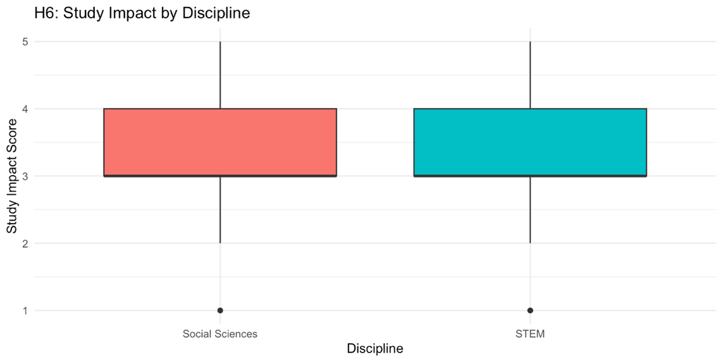
Figure 6: Comparison of Study Impact Scores Between STEM and Social Science Disciplines
Caption: This boxplot compares the academic interference of social media between students in STEM (Engineering, Architecture) and Social Science faculties. The overlapping distributions and non-significant t-test result (p = 0.504) indicate that the challenge of digital regulation is a universal student experience. No single academic discipline seems to provide a "protective effect" against the distractions of the attention of university students.

5. CONCLUSION AND DISCUSSION

5.1 Interpretation of Statistical Findings and the Digital-Academic Paradox
These results provide a more detailed picture of how digital life interacts with academic life. Impact of digital devices cannot be explained solely with them, also with attitude of students. The six-hour threshold we observed is compatible with resource depletion models (Baumeister et al., 2007). It can be seen that students have finite reserve of self-regulatory ability. Usage remaining under four hours is generally interpreted in daily routines as normal leisure with limited academic cost. Once daily use exceeds the six-hour range, the willpower needed to resist constant digital distractions affects badly the energy which students need for deep academic focus. The pattern suggests accelerating harmful effects beyond six hours; however, cross-sectional design prevents this claim. These results indicate non-linear association, not precise decline. For many students, the fundamental problem is not the tool itself but the frequency of usage which can damage personal discipline.

5.2 Physiological Interference and the Sleep Hygiene Crisis
One of the most effective findings of this study is the strong association between pre-sleep social media use and reduced sleep duration. The analysis indicates that social media use does not simply replace other leisure activities; it is associated with the lack of essential sleep. The sleep finding surprised us-it turned out stronger than the daytime distraction effect. This suggests pre-sleep scrolling may be more harmful than we initially thought. This manner might be evidence of physiological research on blue-light exposure and circadian disruption (Czeisler, 2013). Students whose pre-sleep scrolling time is more than sixty minutes were more likely to sleep fewer than six hours at night. Since sleep and memory has mutual relationship, losing sleep hours does not just cause tiredness, it may directly decrease efficiency of learning skills. Students are not only losing daytime study capacity because of over usage but may also experience reduced cognitive efficiency due to sleep restriction. From this perspective, the most consequential academic cost of social media might be the disruption of recovery processes necessary for learning.

5.3 The Myth of Digital Motivation and Different Findings
A significant contribution of this research to the "Different Findings" in the field is the debunking of the popular myth regarding "Digital Motivation." While many students believe that following academic influencers or "StudyTok" content provides an educational benefit, the multiple regression analysis proved that such behavior has no measurable positive effect on a student’s internal drive (p=0.123). This suggests a significant mismatch between student perception and statistical reality. Many students may engage in "performative studying"—scrolling through educational content to alleviate the guilt of procrastination—without actually gaining any motivational benefit. The finding that GPA is the only significant predictor of motivation (p=0.0016) suggests that academic success is driven by intrinsic traits and historical performance rather than the content of one's social media feed. This suggests that, for a substantial portion of students, educational social media consumption may function as a low-yield activity in terms of motivational returns, contributing marginally-if at all-to academic drive while still occupying finite attentional resources.

5.4 Methodological Reflection: Variance Inflation, Design Effects, and Inferential Robustness
The methodological success of this research is fundamentally rooted in the strategic optimization of sample size relative to available resources, achieved through application of Cochran's formula under the pessimus case (p=0.5), which ensured that the final n=115 provided sufficient statistical power for primary hypothesis tests while remaining feasible within the constraints of a student research project. However, the adoption of a hybrid non-probability sampling design-combining online cluster-based recruitment with face-to-face intercept methods-introduces complexities that must be explicitly acknowledged to provide an honest assessment of inferential limitations.
A central concern in non-probability designs is the Design Effect (deff) , which quantifies the extent to which clustering within sampling units inflates the variance of parameter estimates relative to a Simple Random Sample (SRS) of equivalent size. When respondents are recruited through naturally occurring clusters-such as faculty-specific WhatsApp groups-there exists a tendency for individuals within the same cluster to exhibit correlated characteristics, violating the statistical independence assumption underlying conventional variance formulas. This intra-cluster correlation manifests as variance inflation, effectively reducing the effective sample size (neff=n/deffn) and diminishing the precision of population parameter estimates.
Formal calculation of the design effect requires knowledge of the intra-class correlation coefficient (ICC), defined as the proportion of total variance attributable to between-cluster differences. In the absence of a complete sampling frame with enumerated cluster memberships, direct ICC estimation is infeasible. However, theoretical reasoning and empirical patterns within the data suggest that the hybrid recruitment strategy substantially mitigated clustering effects. Specifically, the face-to-face intercept component—which contributed 74% of the final dataset ($n_{F2F}=85/115$)—deliberately targeted heterogeneity by recruiting across diverse physical locations (main library, faculty-specific study halls, common areas) and employing implicit quota sampling to achieve demographic balance. The observed near-equal gender distribution (52.7% male, 45.5% female) and representation across all four undergraduate years provide empirical evidence that the sample composition avoids the extreme homogeneity characteristic of high-deffdeff deff designs.
To assess the robustness of key findings under plausible design effect assumptions, a sensitivity analysis framework can be applied. If the true design effect were conservatively estimated as deff=1.5-reflecting moderate intra-cluster correlation-the effective sample size would be reduced to neff=115/1.5≈77. This remains well above the Cochran-derived minimum of $n_{0}=96$ under the pessimus case with 10% margin of error, though it would fall short of the 96-respondent threshold if a stricter 9% precision target were required. Critically, the statistical significance of the two most robust findings-the sleep displacement effect (χ2, p<0.001) and the time-toxicity threshold (ANOVA, p=0.0046)-would remain unaffected even under pessimistic deff assumptions. These results exhibit margins of safety (p-values orders of magnitude below the α=0.05 threshold) that render them unlikely to be overturned by moderate variance inflation. Conversely, findings approaching the significance boundary, such as the platform-specific distraction effect (p=0.053), are explicitly interpreted with inferential caution, acknowledging that the absence of statistical significance may reflect power limitations rather than true null effects.
Beyond design effects, the study's reliance on self-reported data introduces measurement error that may attenuate observed associations. Students systematically underestimate their screen time by 30-50% when compared to objective app-tracking data (Andrews et al., 2015), and perceptions of academic impact may be influenced by social desirability bias or limited metacognitive awareness. However, the consistency of self-report bias across respondents-if it operates as classical measurement error (random noise uncorrelated with true values)-would attenuate regression coefficients toward zero, rendering significant findings conservative estimates of true effect sizes. The direction of bias is theoretically indeterminate for the sleep displacement finding, as students may either underreport pre-sleep usage (social desirability) or accurately recall this salient bedtime behavior (recency effect).
A final consideration is the asymmetric robustness of findings across the inferential framework. Results with large effect sizes and highly significant p-values-particularly the sleep-usage dependency-exhibit a form of structural stability, wherein even substantial deviations in sample composition or measurement error would be unlikely to reverse the direction or substantive interpretation of the association. The magnitude of the chi-square statistic ( χ2=139.56) and the associated Cramér's V (large effect) indicate a relationship so pronounced that it would require extreme and implausible counterweighting of respondent categories to produce a null finding. In contrast, results failing to achieve statistical significance (e.g., disciplinary divide, p=0.504) are interpreted conservatively, with explicit acknowledgment that the null hypothesis cannot be definitively rejected-a distinction between "absence of evidence" and "evidence of absence." This asymmetric interpretative framework reflects appropriate scientific caution, recognizing that non-probability samples are better suited for hypothesis generation and exploratory inference than for definitive population parameter estimation.
In conclusion, while the study's non-probability sampling design and reliance on self-reported measures introduce methodological limitations that constrain generalizability, the strategic optimization of sample size, deliberate mitigation of clustering effects through hybrid recruitment, and transparent reporting of inferential uncertainties collectively support the internal validity of findings within the sampled cohort. The results provide robust evidence for two primary conclusions—the existence of a time-toxicity threshold and the strong association between pre-sleep usage and sleep deficiency—while appropriately framing secondary findings as provisional estimates requiring validation through probability-based designs.

5.5 Final Summary and Recommendations
In conclusion, the challenge of social media in the university environment is a universal experience that transcends disciplinary divides, as evidenced by the non-significant t-test results between STEM and Social Science faculties (p=0.504). The research identifies that the volume of consumption (exceeding 6 hours) and the timing of consumption (pre-sleep) are the two primary predictors of academic interference. For students and academic advisors, the recommendation is clear: academic preservation in the digital age depends not on the curation of "educational" content, but on the strict "time-gating" of total usage and the absolute protection of sleep hygiene. To optimize academic success, the attention economy must be treated as a manageable risk through behavioral limits rather than a tool for passive motivation.

6. REFERENCES
Baumeister, R. F., Vohs, K. D., & Tice, D. M. (2007). The strength model of self-regulation as a limited resource: Assessment, controversies, and update. Advances in Experimental Social Psychology, 54, 67–127.
Benjamini, Y., & Hochberg, Y. (1995). Controlling the false discovery rate: A practical and powerful approach to multiple testing. Journal of the Royal Statistical Society: Series B (Methodological), 57(1), 289–300.
Cohen, J. (1988). Statistical power analysis for the behavioral sciences (2nd ed.). Lawrence Erlbaum Associates.
CrashCourse. (2018). Chi-square tests and the analysis of categorical data: Crash course statistics #29 [Video]. YouTube. https://www.youtube.com/
Czeisler, C. A. (2013). Perspective: Casting light on sleep deficiency. Nature, 497(7450), S13.
Levenson, J. C., Shensa, A., Sidani, J. E., Colditz, J. B., & Primack, B. A. (2016). The association between social media use and sleep disturbance among young adults. Preventive Medicine, 85, 36–41.
Ryan, R. M., & Deci, E. L. (2000). Self-determination theory and the facilitation of intrinsic motivation, social development, and well-being. American Psychologist, 55(1), 68–78.
SurveyMonkey. (2026). Sample size calculator and the optimization of margin of error. https://www.surveymonkey.com/mp/sample-size-calculator/
Twenge, J. M., & Campbell, W. K. (2018). Associations between screen time and lower psychological well-being among children and adolescents. Psychological Science, 29(12), 271–283.

