Example taken: Github.com



Source code:

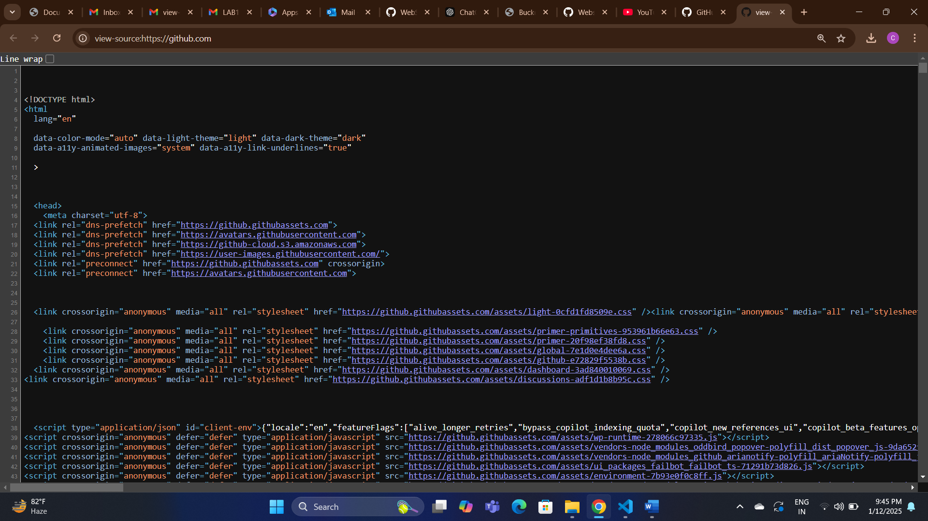

Meta Tag: The <meta> tag in HTML provides metadata about the HTML document. Metadata is information about the data on the page, but it is not displayed on the webpage itself. Instead, it is used to give instructions to the browser, search engines, and other services that interact with the page.

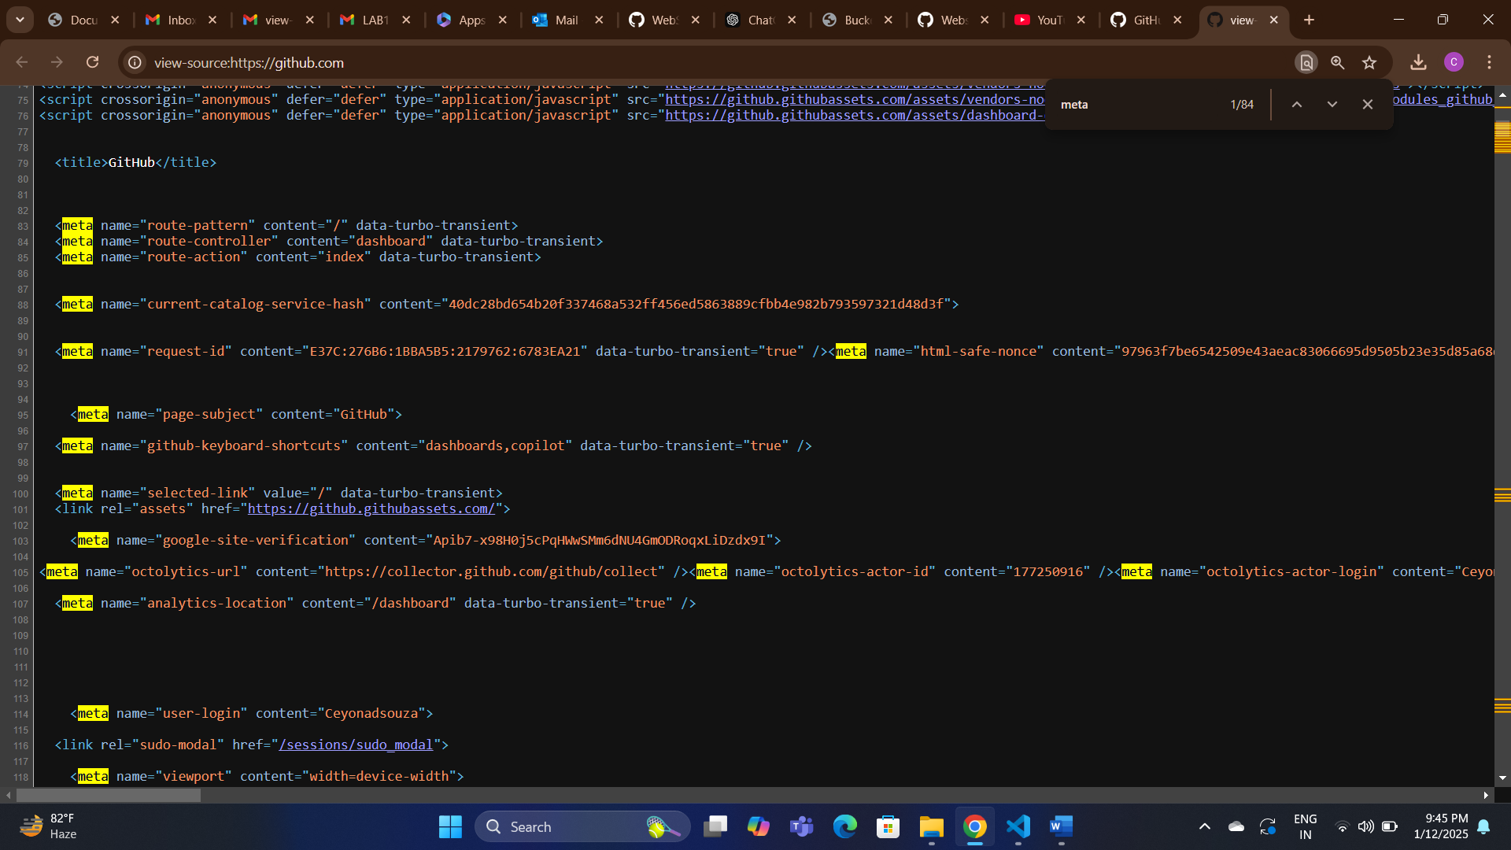

Heading tag:

Heading tags in HTML, ranging from <h1> to <h6>, are used to define the structure and hierarchy of content on a webpage. These tags help organize content, making it more readable and accessible both to users and search engines.

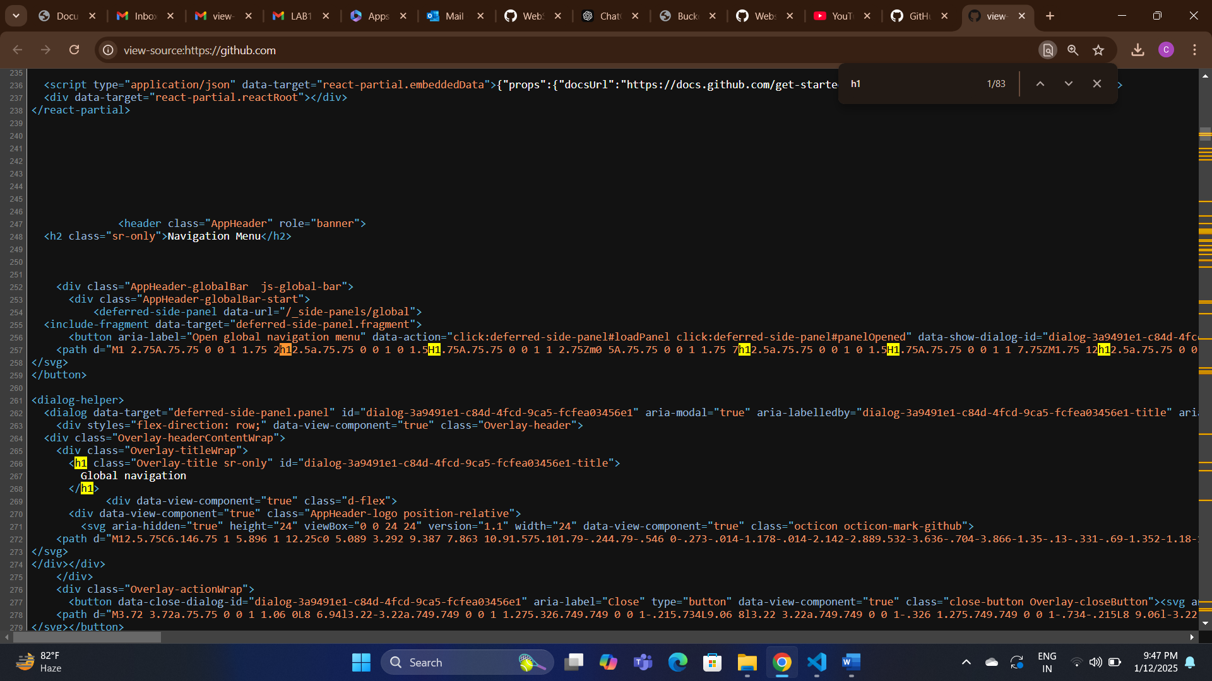

Security related tags:

The crossorigin="anonymous" attribute ensures that no credentials (like cookies or HTTP authentication) are sent with the request to the external resources. This is important for preventing cross-site request forgery (CSRF) attacks.

