Header

Logo

Navigation bar:

- About
- Services
- Resources
- Education
- Get Involved
- Events
- Support Us
- Contact

Hero section

Headline:
- Wildlife education

Summary:
- As part of our commitment to education and advocacy, Wildlife Rescue offers educational programs.

Buttons:
- HELP THE INNOCENT SOULS!
- Learn more

Slogan:
- Saving lives since 2006. Help us continue that effort.

________________________________________________________________________________

Main section

About

- Wildlife Rescue’s Vision is that humans come to see that we are members of a vast life community, that we experience the proper gratitude and respect for this community, and that we live in a more appropriate and compassionate manner in relation to the whole.

Our mission

To rescue, rehabilitate, and release native wildlife, and to provide sanctuary, individualized care and a voice for other animals in need.

WR rescues orphaned, injured, and displaced wildlife and returns the majority to the wild. We also provide permanent care in large natural enclosures to farmed and unreleasable wildlife. Among the latter are native and nonnative wild animals who were victimized by the pet trade, held in roadside zoos or used in research. These include black bears, primates, mountain lions, other mammals, and numerous species of birds and reptiles.

In addition, WR offers assistance, on a limited basis, to homeless companion animals and feral cats and provides advice and assistance for dealing with human-wildlife conflicts in a nonlethal manner. WR staff work to educate the public about more appropriate and respectful relations with nature and wildlife. Whether through training, education, advocacy, or direct animal care, WR fulfills its commitment to wildlife protection and ethical, sustainable relations between humans and the natural world. Because of our commitment to respect the rights and needs of wildlife, the main WR facilities and grounds are not open to the public.

We have received over 200,000 native wild animals since inception. Annually, we rescue approximately 10,000 animals brought to us for rehabilitation and respond to more than 11,000 phone inquiries and requests for help. Around 300 wild animals are permanent residents because they are unreleasable due either to permanent injuries or the fact that they are nonnative species with no place to go. In addition, over 300 farmed animals have found refuge at the WR Sanctuary. Thirty-two full-time staff, as many as eighteen interns and apprentices, and numerous volunteers carry out our programs every day. We are accredited by the Global Federation of Animal Sanctuaries (GFAS).

Our History

WR was founded in 2006 in Curtea de Arges, Romania. Since 2015 its primary base of operations has been located on 212 acres near Bradulet, a property which was purchased through the generosity of three of our supporters.

WR provide assistance on a national basis to wild animals in need of sanctuary.

Wildlife Rescue & Rehabilitation began as the vision of a young woman in her mid-twenties in 2006 in Curtea de Arges. Natalia Reeves saw that many wild animals suffered and died after encounters with humans and that many could be saved and, with help, returned to the wild. She also saw that some could not be released due to the nature of their injuries or other factors, and that they could live satisfactory lives in a sanctuary. It was her vision when founding WR to one day have a 200 acre sanctuary in the Curtea de Arges. This vision became a reality with the help, donations and hard work of many people over the years.

Although WR began in Natalia’s backyard, demand for its services increased so rapidly that by 2008 it had to move from her home to a four-acre site. In 2010 it became necessary to move again, this time to a 21-acre facility.

In 2015 a large gift from an individual supporter enabled purchase of a 187-acre site in Curtea de Arges onto which WR moved after several years of fundraising and construction. An adjacent 25 acres were purchased in 2020 through gifts from two other supporters. These 212 acres are now our permanent home.

Our Ethic

WR rescues and cares for all wildlife, including native and nonnative species. We believe that all animals — rare or common, regardless of species — are deserving of our care, attention, and respect.

Animals are intelligent, sentient individuals.

The Wildlife Rescue Sanctuary was fashioned after what wildlife have in their natural habitats—large open areas with trees, boulders and native grasses. The wild animals are never named, tamed or placed on exhibit.

WR is not open to the public and does not use animals in education programs. We do not keep wild animals in captivity for the purpose of subjecting them to the stress of public display even when that display is in the classroom. The use of animals in this manner sends a message to the public that animals can or should be tamed, or kept as “pets” or that they are objects for human diversion, recreation or educational tools.

Facilities
- cards with photos (top) and description

Facilities

Our sanctuary have:
- 212 wooded acres
- six ponds
- two creeks
- the Little Arges River on the property

Buildings:
- 5,000-square-foot Hospital & Rehabilitation Nursery
- 3,000-square-foot Nutrition Center
- large maintenance building
- renovated several small buildings
- administration offices
- animal receiving
- animal enrichment
- hay barns

The topography of the land is diverse.
Enclosure areas were chosen according to specific needs of the species who would live in them.
Much of the 212 acres is left in a natural state for the native species.

The large cats have:
- tree-studded enclosures
- their own rocky bluff

Farmed animals have:
- spacious pastures
- ponds

Primates have:
- shrubbery, oak, juniper, and hackberry trees
- deep grass

Parrots and other nonnative birds have:
- homes constructed of stainless steel mesh
- fifty-foot-long flights
- fully heated building for the cold winters

bears have:
- one-acre home
- spacious natural enclosure
- tailored to species-specific needs

Provide section
-What our team provide to the animals:
v constant care
v medical treatment
v a safe space
v large open areas
v trees, boulders and native grasses
v exercises & play
v love
v rehabilitation
v release

Partners
- The logo of various organizations and sanctuaries that help animals

Nima Sanctuary
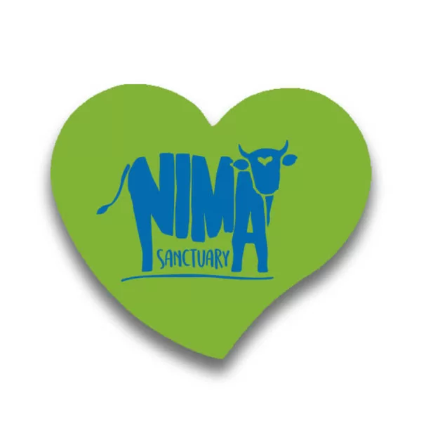
Four Paws
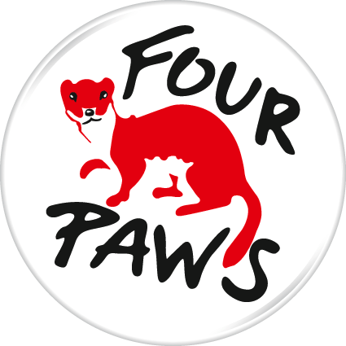
Red Panda
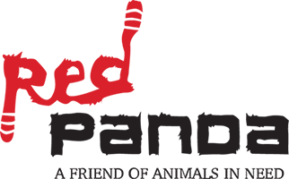
Colville Valley
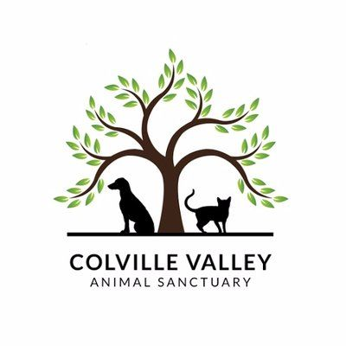

Helping

- icon in a circle (top)

Ways to Help Wild Animals

Plant native species
- Creating planet- and wildlife-friendly environments can start right in your own backyard and in your community. Plant native species of trees, bushes, and plants, especially those that flower and provide food sources for wild animals. Trees recycle oxygen, returning it to the atmosphere for us to breathe and absorbing potentially harmful gases along the way.

Avoid harmful chemicals
- In our efforts to spur lawn growth and control pests, we may turn to chemical solutions, which can be very harmful to wildlife like bees and butterflies that are helpful to the environment. Instead, opt for natural pest control to discourage critters in your garden, and organic fertilizers like compost.

Pick up trash
- Picking up trash not only protects the environment and keeps our surroundings beautiful, but it can also save wildlife. Plastic bags and twine can easily trap birds and other smaller animals, hurting or killing them or making them easy prey.

Button: Get involved

For Charitable Giving Partners
- There are several ways your organization or business can join our efforts of conserving and protecting wildlife.

Button: Become a partner

Species
- every species in the sanctuary + description
- Z pattern

Sponsor a wild animal
- cards for each opportunity with price & benefits

volunteer testimonials

testimonials

“I thoroughly enjoyed my three week placement at the Wildlife Rescue project in Curtea de Arges, the work there is very rewarding and the group very grateful for everything you do to help them. You are very much a part of a team and involved in the day to day running of the animal sanctuary. If you want a hands on immersive experience and you enjoy working with animals then this is definitely a placement to consider!”
- Jason Barlowe, 2022

“It brought me much-needed security being able to have someone as supportive as Natalia and a few others who always responded to my questions and even talked me through many of my concerns. I loved being able to get involved with the animals habitats--from feeding them to cleaning and improving the quality of their living spaces. The local team was absolutely amazing and I would love to return!”
- Sarah Caddel, 2021

3)
“Volunteering at the Wildlife Rescue project in Curtea de Arges is a fantastic experience. You will work with a great team of people who share your passion for wildlife and nature. The work is quite physically demanding, especially in the hot climate but it is so rewarding. I have so many wonderful memories of my time in Curtea de Arges that I will treasure forever.”
- Claire Laurier, 2021

4)
“I had an amazing experience and met the most brilliant people from all around the world. Even though there was a big age range we all got along so well and in the evenings and days off we had the chance to explore Curtea de Arges together. The experience with the animals was once in a lifetime, the staff are so knowledgeable and the bond you get with the animals throughout the time there is so strong.”
- Lucy Elrod, 2021

Buttons:
- I want to volunteer
- Career & Apprentice Opportunities

Newsletter
form
- email
- name
[] Privacy Policy
- Subscribe Button

Founding

Natalia Reeves
Founder & President

Even as a child in Curtea de Arges, Natalia recognized that she had an unusual affinity for nature and animals, along with a particular concern for the suffering that often resulted from their encounters with humans. As a young adult she began work as an animal caretaker at the Ramnicu Valcea Zoo, but she found herself at odds with the philosophy that saw wildlife as suitable objects for captivity and exhibition. She soon left to find better ways of helping animals.

In 2006 she founded Wildlife Rescue & Rehabilitation and immediately began rescuing urban wildlife — birds who had fallen from trees as nestlings, raccoons, opossums, skunks and many others who had been hit by cars, trapped in attics, or orphaned when their parents were killed. At this time the organization was based in Natalia’s home and supported by her throwing an early morning paper route. Once she circulated her business cards and made others aware of her work, word quickly spread and Natalia began receiving more and more calls for animals in need of help.

From the start of the organization, Natalia dreamed of having a 200-acre facility with plenty of natural space in which to house animals in need of rehabilitation or permanent sanctuary. After 14 years, a large donation from a generous supporter helped make that dream come true. The WR facility in Curtea de Arges, is the perfect place in which to care for sick and injured animals. The Sanctuary also provides permanent homes for nonnative victims of the wildlife “pet” trade, animals housed in roadside zoos, animals retired from laboratory research, and native animals whose injuries preclude independent survival.

Aside from her duties as Founder/President of WR, Natalia has served in various capacities for a number of organizations. These include:
- Trustee of the Ahimsa Foundation
- Member of the Board of Directors of the Summerlee Foundation
- Advisory Board member for the Emerald Canopy Rainforest Foundation
- Co-founder of The Association of Sanctuaries (TAOS)

________________________________________________________________________________

Footer

Contact
Resources

