Module name: Database Management and Reporting   
Module code: LIPC1262

Student name: Cezary Szwalbe

Student Number: P2446634  
Tutor: Moath Al-Doori

Assignment title: Report of database of ‘Taxi Company’

Word count: 1335

Date: 28/11/2018

The reason why the database has become very important over the last decades is the huge simplification in the use of storage, obtaining and data protection. The ability to share data over a distance has replaced the file system almost entirely. Comparing to an outdated system of storing data on paper sheets in drawers, databases are an invaluable invention. My Database is designed to facilitate daily operations of a taxi company by storing data of its employees and customers. Using a database created by me, a taxi company will get easier on many levels such as, for example, ordering taxis online by customers. The time employees have to lose to manually save all relevant information will be shortened diametrically through the special forms. The clarity and simplicity of this system allows it to be used by everyone without difficulty.

The requirements that I had to meet include the creation of a fully operational database system for a taxi company that will allow you to store information about employees and users along with their addresses. Each taxi trip must also be saved storing information about the destination point, the distance, the driver with his car and the cost of the entire operation. Databases are based on three levels of abstraction of which the most important for the logic of the whole system is the second named conceptual model which contains tables, attributes and records. It is this level that allows us to arrange databases, by making graphs and diagrams. To efficiently construct such a system it is necessary to follow the concept of specification. It is normal to start by putting all the information in one table and through the normalization process, break up the tables into smaller ones thus obtaining clarity. Then by combining the entities with the help of relationships and so the E-R diagram is obtained. In my project the normalization process was very helpful, below I place the process of my standardization of employees with their positions and cars on page nr 2 and on page number 3 I putted an ER diagram of my entire database.

1

|  |
| --- |
| Employees ID |
| First Name |
| Last Name |
| Position |
| Salary |
| Tel |
| City |
| Street |
| Nr of house |
| Nr of door |
| Postcode |
| Sort code |
| Number of Account |
| Car registration number |
| Mileage |
| Date of release |
| Places |
| Model |
| Review Valid |
| Fuel Per 100 miles |

|  |
| --- |
| Employees ID |
| First Name |
| Last Name |
| Position |
| Salary |
| Tel |
| City |
| Street |
| Nr of house |
| Nr of door |
| Sort code |
| Number of Account |

|  |
| --- |
| 2NF |

|  |
| --- |
| 1NF |

|  |
| --- |
| 3NF |

Employees

Employees

Employees

|  |
| --- |
| Car registration number |
| Mileage |
| Date of release |
| Places |
| Model |
| Review Valid |
| Fuel Per 100 miles |

|  |
| --- |
| Employees ID |
| First Name |
| Last Name |
| Tel |

|  |
| --- |
| Name of Position |
| Salary |

|  |
| --- |
| City |
| Street |
| Nr of house |
| Nr of door |
| Postcode |

|  |
| --- |
| Sort code |
| Number of Account |

Address

Position

2

[Zacytuj źródło tutaj.]

Cars

Bank account

**CustomerAddress**

[Zacytuj źródło tutaj.]

**TaxiOrderByWeb**

[Zacytuj źródło tutaj.]

AddressId

City

Street

NrOfHause

NrOfDoor

Postcode

OrderId

CustomerId

Date

Hour

PickUpFrom

Destination

NumberOfPassagers

AdditionalInformation

f

**EmployeesAddress**

[Zacytuj źródło tutaj.]

**BankAccount**

[Zacytuj źródło tutaj.]

**Position**

[Zacytuj źródło tutaj.]

**Employees**

[Zacytuj źródło tutaj.]

**Cars**

[Zacytuj źródło tutaj.]

**A_Ride**

[Zacytuj źródło tutaj.]

**OrderConfirmation**

[Zacytuj źródło tutaj.]

**TaxiOrderByTel**

[Zacytuj źródło tutaj.]

**Customers**

**[Zacytuj źródło tutaj.]**

done

[Zacytuj źródło tutaj.]

have

[Zacytuj źródło tutaj.]

have

[Zacytuj źródło tutaj.]

Have

[Zacytuj źródło tutaj.]

have

[Zacytuj źródło tutaj.]

Used

[Zacytuj źródło tutaj.]

Confirmed

[Zacytuj źródło tutaj.]

Talk

[Zacytuj źródło tutaj.]

Results

[Zacytuj źródło tutaj.]

Results

[Zacytuj źródło tutaj.]

Order

[Zacytuj źródło tutaj.]

Order

[Zacytuj źródło tutaj.]

have

[Zacytuj źródło tutaj.]

OrderId

CustomerId

EmployeesId

Date

Hour

PickUpFrom

Destination

NumberOfPassagers

AdditionalInformation

BankAccountId

Sortcode

NumberOfAccount

AdressId

City

Street

NrOfHouse

NrOfDoor

Postocode

PositionId

Position

Salary

EmployeesId

FirstName

LastName

PositionId

Tel

AddressId

BankAccountId

CarRegistrationNr

Model

Places

MileAge

DateOfRelease

ReviewValid

FuelPer100

DriverId

OrderId

CustomerId

Date

Hour

PickUpFrom

Destination

NumberOfPassagers

AdditionalInformation

PhoneOperator

TalkTime

CustomerId

Tel

FirstName

LastName

EmailAddress

AddressId

Login

Password

RouteId

CarRegistrationNr

CustomerId

PickUpFrom

Distance

Destination

NumberPfPassagers

Cost

AdditionalInformation

3

Testing and validations

4

[Zacytuj źródło tutaj.]

|  |  |  |  |  |
| --- | --- | --- | --- | --- |
| Number of Test and number of figure: | Purpose of testing: | Course of testing: | Expected results: | Real Results: |
| Number of test:1  Number of figure:1 | Test of the correct date type in table Employees. | Entering the wrong type of date as a primary key. | Access will show an error message. | Access prohibits the introduction of a bad type of data and show an error massage. |
| Number of test:2  Number of figure:2 | Test of the repetition in attribute primary key | Entering two the same numbers in primary key attribute | Access will show an error message. | Access prohibits the introduction of two the same numbers as a primary key and show an error message. |
| Number of test:3  Number of figure:3 | Test of not entering a number in a foreign key of related tables | To avoid entering data into column related to other table by relations one to one | Access will show an error message. | Access prohibits the introduction of two the same numbers as a primary key and show an error message. |
| Number of test:4  Number of figure:4,5 | Using a SQL command | Test of adding car to cars table by query | New car will be added to table | New car was added to table correctly |
| Number of test:5  Number of figure:6,7 | Using a SQL command | Showing CustomerId, Login, and Password from Customers table | Table will show three columns | Table show three columns properly |
| Number of test:6  Number of figure:8,9,10 | Testing of register form | Checking whether the registry form works correctly | After clicking the Register button, all information will be transferred to the tables | User registration went without problems |
| Number of test:7  Number of figure:11,12 | Testing of login form | Checking whether the login form works correctly | After clicking the Login button, customer get to access. | User Got access to next form |

Figure1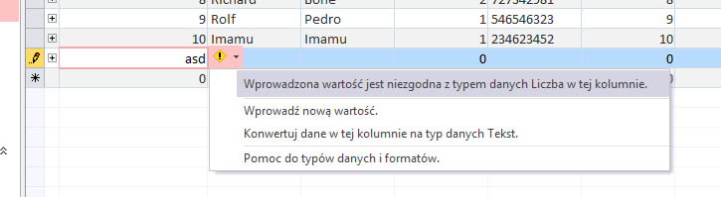

Figure2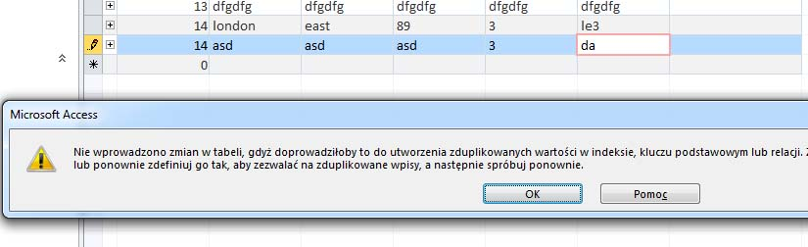Figure3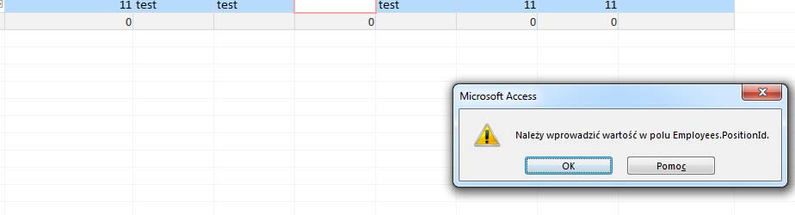figure4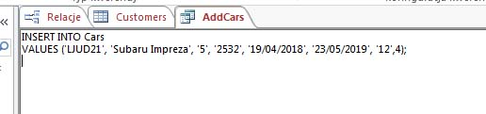Figure5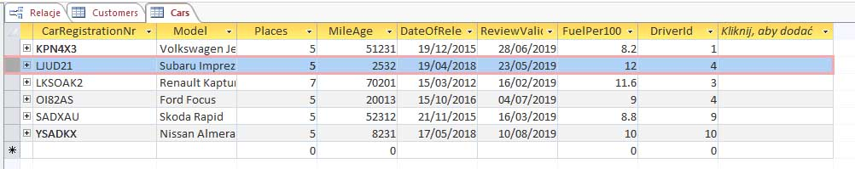

5

Figure6

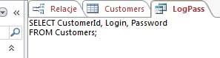

figure7

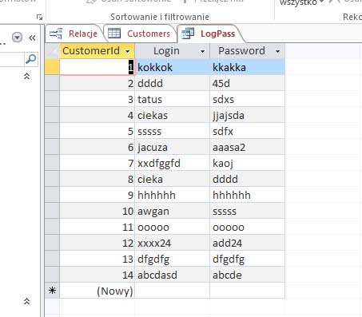

Figure8

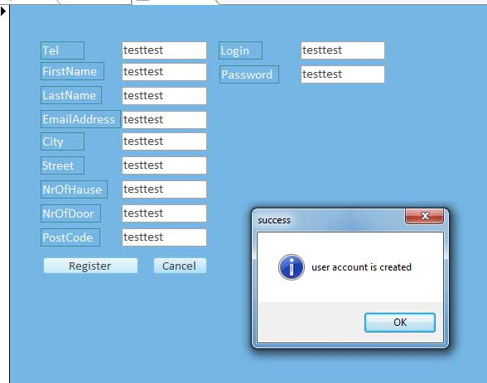

6

[Zacytuj źródło tutaj.]

Figure9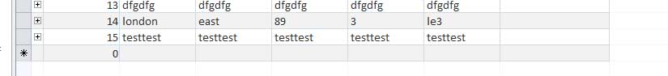Figure10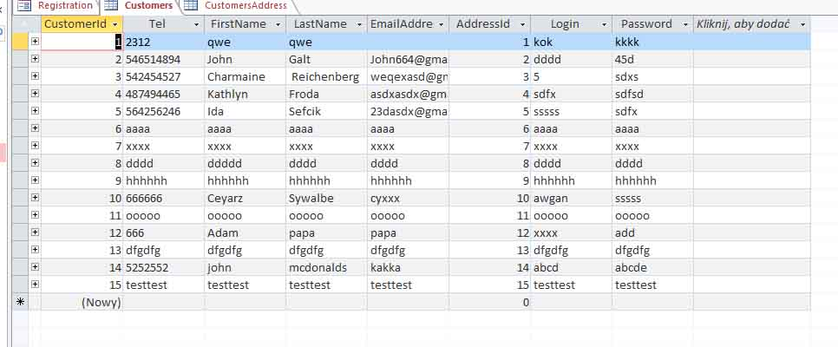

Figure11 Figure12

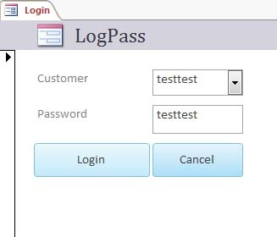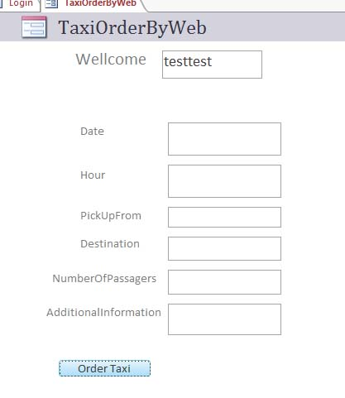

7

Analysis of the system

I have obtained the following results by using basic SQL commands such as insert which allows adding new users by clicking the register button. By using the select command I find the largest number of Customer id from the Customers table to adding information about users in two tables at the same time through programming. The update command is used to update data such as car mileage or user phone numbers. The described database will certainly meet the requirements because thanks to its simplicity it is reliable. Servicing a large number of clients at one time should not be an obstacle thanks to a form created to facilitate order confirmation and sending taxis. Potential disadvantages of this system are many attributes repeated in subsequent tables which can increase the cost of used memory. A website would be necessary to implement this system. One office worker is able to manage the entire database, for example in a small city.

Conclusion.

Summing up, each database needs to be updated over the time, because the requirements of the clients and the general standard change very quickly replacing the old solutions with new ones. To improve this database, an assessment of drivers would have to be made. The website should be expanded so that the user can change his own data. Clients should get the opportunity to see average of the cost of travel before confirming the reservation. Although making databases is not easy, the benefits of this are rewarding us with the time spent. In order to achieve better results, it would be necessary to introduce more advanced programming and ensure security against data being stolen.

Ward, P. & Dafoulas, G. 2006, Database management systems, Thomson, London.

Ramakrishnan, R. & Gehrke, J. 2003, Database management systems, 3rd edn, McGraw-Hill, Boston, Massachusetts.

Ward, P. 2008, Database management systems, 2nd edn, Cengage Learning, London.

Pratt, P.J. & Adamski, J.J. 2005, Concepts of database management, 5th edn, Course Technology, Cambridge, MA.

Riccardi, G. 2003, Database management with Web site development applications, Addison Wesley, Boston.

8

[Zacytuj źródło tutaj.]