

**MODULE NAME:** Advanced Programming

**MODULE CODE:** CTEC2902_1920_520

**TUTOR:** Dr Eseosa Oshodin

**NAME:** Cezary Stanislaw Szwalbe

**P NUMBER:** P2446634

**Assignment title:** Assignment 1 – Windows Form Program

**Word count:** 400+

**Date:** 08/01/2020

1. **Abstract:**

The system I created is designed to serve the client in browsing used laptops and based on information and price, choosing the right one for them. Admin panel also contains additional options. The whole project is based on the object-oriented language c sharp and was created in visual studio programming environment.

1. **Introduction**

Window applications are undoubtedly very close to everyone because most of the programs we use for everyday use are just windows. The program I created is not complicated, but it can be very helpful when it comes to recalculating product prices, it can be easily extended with new functions and adapted to the requirements. Administrator functions such as adding deleting and editing objects, i.e. in this case laptops can also be used very effectively e.g. in an online store. It shows how necessary and needed things are contained in the advanced programming program.

1. **Design considerations:**

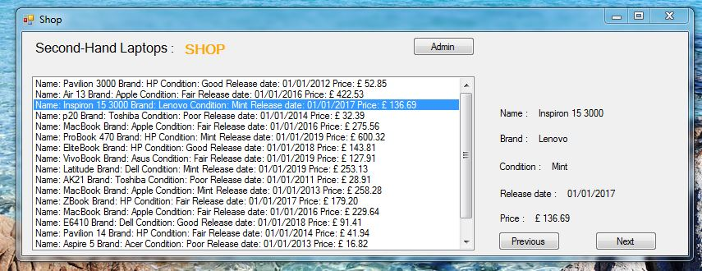

Figure.1

Designing the appearance of my program I took care of the greatest transparency and easy access to functions, e.g. by pressing an item from the list, the data is displayed on the right so that it can be read freely.

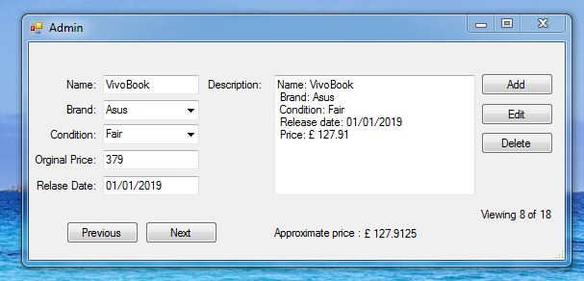

Figure.2

The validations used prevent the input of inappropriate data and thus the system is stable. Closing the window will update the first form data in the main list.

1. **Software solutions:**

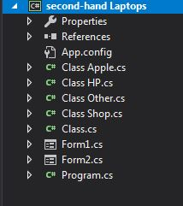

Figure.3

The program consists of simple classes of which Class.cs is the main class and 3 classes Apple, HP and Other are inheriting classes. The Shop class is responsible for creating a list of laptops.

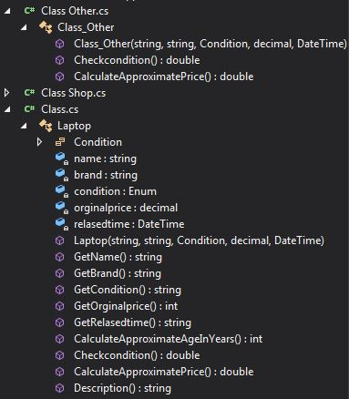

Figure.4

The main class contains most methods

Inheritance classes calculate the price of laptops depending on the brand.

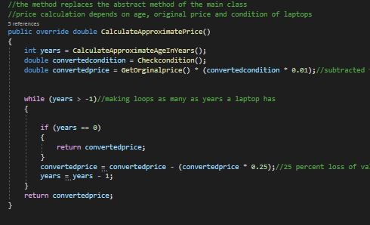

Figure.5

This is an example of a solution that uses While loops

I could use loop For, but I am more convinced of this solution because its syntax is very simple.

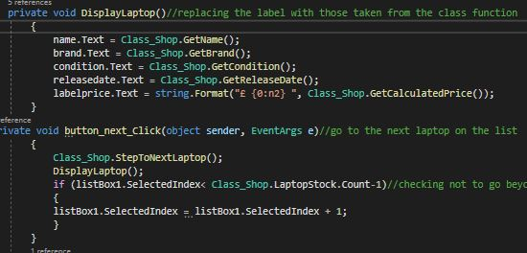

Figure.6

Jumping to the next laptop caused me a lot of problems because every now and then the program showed an error, adequate solution was to protect from not go beyond of the list of items in the form of the If function.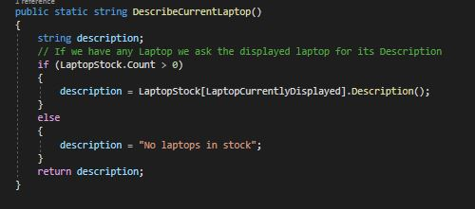

Figure.7

In this way we protect the program from going outside the set while obtaining a description of the laptop that is currently displayed.

1. **Conclusion:**

In general, I am satisfied with the project that I was able to create by using Encapsulation, Inheritance and Polymorphism, these concepts have become familiar to me. I look forward with a desire to take on new programming challenges.