Analysis of electric vehicle usage patterns in New Zealand

Statistical Report

Rafferty Parker and Ben Anderson (University of Otago)

Last run at: 2019-02-05 16:11:00

Table of Contents

# Introduction

The New Zealand government has set a target of increasing the number of EVs in New Zealand to 64,000 by 2021. High penetration of EVs would cause EV recharging to contribute a substantial portion of total electricity load. A report prepared for lines companies Orion, Powerco and Unison by Concept Consulting Group entitled “Driving change - Issues and options to maximise the opportunities from large-scale electric vehicle uptake in New Zealand” predicts that if all current light private vehicles were electric, annual residential electricity consumption would increase by approximately 30%, whereas if all vehicles including trucks were electric, this would increase the total electricity consumption of New Zealand by approximately 41%[concept_2018].

New Zealand’s total electricity demand varies throughout the day, with weekdays in particular having two distinct “peaks”; one in the morning, and one in the evening. Providing the electicity to meet these demand peaks is a costly and inefficient process. Concurrent electric vehicle (EV) charging, especially in the early evening when many motorists return home, would have the potential to negatively impact the operation of the grid through drastically increasing peak loads [Azadfar2015], leading to an increased cost of electricity due to the requirement of expensive upgrades to the electricity grid(**???**).

This report hopes to provide further insight into the potential effects on the New Zealand electricity grid that may occur with a dramatic increase in EVs, so that these may be planned for and mitigated. It is based on and inspired by the [UK DoT statistical report 2018](https://assets.publishing.service.gov.uk/government/uploads/system/uploads/attachment_data/file/764270/electric-chargepoint-analysis-2017-domestics.pdf).

# Data information

## Background

The data used has been provided by “Flip the Fleet”, a community organisation that hopes to increase uptake of electric vehicles in New Zealand. Flip the Fleet have been collecting data on electric vehicle usage patterns, collected using Exact IOT Limited’s [blackbox recorder](https://flipthefleet.org/ev-black-box/), a small electronic device that connects to the vehicle’s internal computer and sends detailed data about the battery health, consumption, speed, etc.

The data used consisted of 1291881 data points from 44 vehicles over 8 months (April 2018 - January 2019). The recorder provided measurements at 1 minute frequency of charging behaviour and battery charge state.

Due to privacy considerations, the data is not publically available.

## Initial cleaning

There were 6 vehicles in the data provided that had no recorded charging occur. These were immediately discarded.

Some instances of charging power greater than 120kW were recorded. These were considered anomolies and discarded, as these exceed the capacity of the highest charging stations available in New Zealand(Concept Consulting 2018).

Instances of battery state of charge being greater than 100% or less than 0% were also discarded.

## Definitions and preparation

Charging data has been broadly seperated into two seperate catagories, “standard” and “fast”. Standard charging is when the charger is reading less than 7kW - this is considered the upper limit of what can be obtained from a standard home charging scenario without an expensive wiring upgrade(Concept Consulting 2018). Fast charging is all charging above 7kW, and would likely occur at designated and purpose-built fast charging stations.

The data was also catagorised according to whether it was a weekday or not. This allows analysis to occur of differing charging patterns between weekdays and weekends, allowing for further accuracy in determining the effects of electric vehicles on grid peaks.

In order to determine charging durations, rows were initially flagged as “charging begins” if the charging power was greater than zero and the previous and following row’s charging power were (respectively) equal to zero and greater than zero. Similarly, rows were flagged as “charge ends” if the charging power was greater than zero and the previous and following row’s charging power were (respectively) greater than zero and equal to zero.

Using this method we obtained 7376 instances of charge beginning, and 7385 instances of charge ending. The additional 9 instances of the charge ending than there are of the charge beginning may be due to the first instance of data collection occurring during mid-charge for some vehicles.

The charge duration was then calculated as being the time duration between each pair of “charge begins” and “charge ends” flags.

Figure 1 shows the overall distribution of all charging sequences. Clearly there are very small and a few very large values for Standard Charges, but this is not the case for Fast charges.

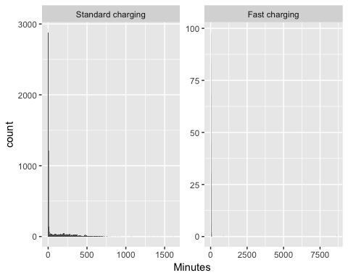

Figure 1 Duration of charging sequences

Table 1 shows the overall distributions and indicates the extent to which the means are skewed by the very small and a few very large values shown in Figure 1.

Table 1 Duration of all charge sequences by charge type (minutes)

chargeType

N

mean

median

min

max

Standard charging

6983

101.24

3.72

0.27

1616.72

Fast charging

392

38.00

12.48

0.32

8621.00

Figure 2 shows the distribution of very short charging sequences. As we can see these appear to be generally less than 8 minutes in length for Standard Charges.

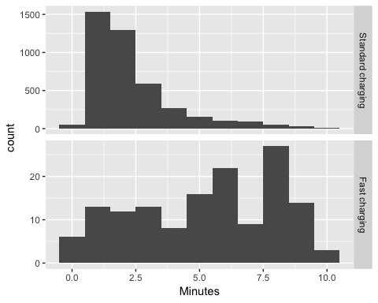

Figure 2 Duration of charging sequences < 10 minutes

Table 2 shows the same descriptive statistics but for all sequences of greater than 8 minute duration. Now we can see that the mean and median durations for Standard Charge sequences are closer to one another.

Table 2 Duration of charge sequences > 8 minutes by charge type (minutes, )

chargeType

N

mean

median

min

max

Standard charging

2860

244.01

208.65

8.02

1616.72

Fast charging

279

51.61

15.73

8.05

8621.00

Manual inspection of the data showed that these short-duration charging “events” generally occurred near the end of a longer-duration charging event. It appeared that once the vehicle had reached its highest state of charge, charging would intermittantly stop and start again. This is likely due to the behaviour of the charger once the battery was almost full. As these can not be considered truly independent charging events, they have been removed from the data for the rest of the analysis.

In addition to the myriad “small” charging duration values, a small amount of unreasonably long charging durations (longer than 100 hours for standard charging or longer than 14 hours for fast charging) were calculated. As these exceeded the expected charge durations of the most high capacity vehicles currently available, they were assumed to be anomalies and are not included in the following analyses.

Figure 3 shows the distribution of charging sequences with the excessively long or short events removed. As we can see these appear to be generally less than 3 hours in length for Standard Charges.

All further duration-related analysis is conducted with these unreasonably long or short events removed from the data.

## `stat_bin()` using `bins = 30`. Pick better value with `binwidth`.

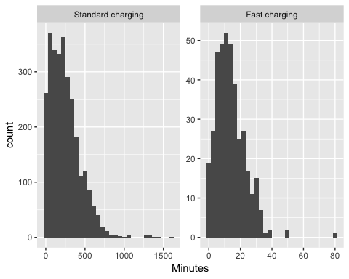

Figure 3 Duration of charging sequences with unreasonably long or short values removed

# Key Findings:

* *Power supplied*: The median power supplied during a standard charging was 1.78 kW. The mean was slightly higher at 2.12 kW. Fast charging observations had a median of 30.84 kW (mean = 30.68);
* *Charging duration*: Charging durations tended to fall into one of two groups - longer ‘standard’ charges with a median of 3.48 hours and shorter “fast” charge events with a median duration of 12.47 minutes.
* *Time of Day*: charging events were more frequent at specific times of the day and day of the week with more evening and over-night charging during weekdays and more day-time charging at weekends. The power demand also varied according to time of day and day of the week.

# Observed demand

Figure 4 shows the distribution of observed charging kW demand by inferred charge type. This plot shows that fast charges are relatively rare in the dataset whilst standard charges are much more common, and are concentrated around 1.8kW, 3kW and 6kW.

## `stat_bin()` using `bins = 30`. Pick better value with `binwidth`.

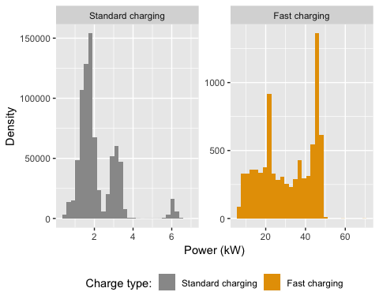

Figure 4 Observed power demand distribution by charge type where charging observed

75% of standard charging observations were 1.47 kW or more but the figure was 20.28 kW or more for fast charging

# Daily demand

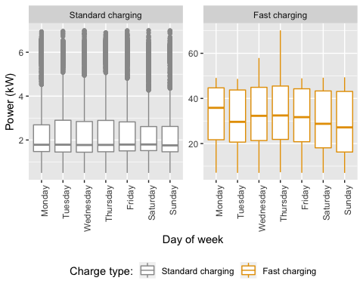

Figure 5 Observed power demand distribution by day of the week and charge type

Figure 5 shows the distribution of observed charging kW demand by day of the week. We can see that fast charging varies in demand more than standard charging does across days.

# Charging duration

# Duration by time of day

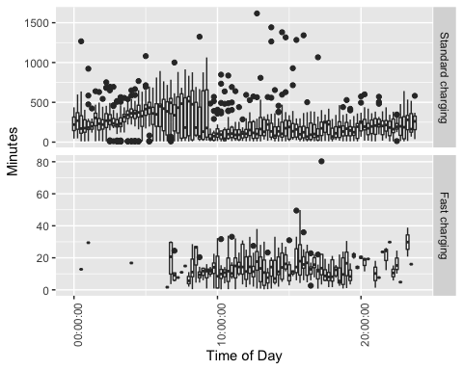

Figure 6 Duration by time of charging start

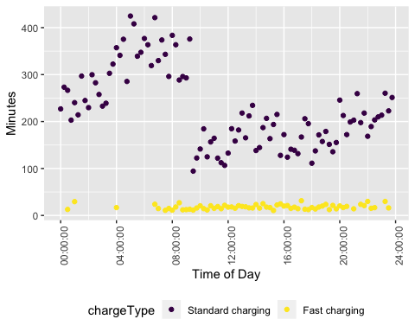

Figure 7 Mean duration (within quarter hours) by time of charging start for sequences > 8 minutes

Table 3 Mean duration of charge events by charge type

chargeType

N

mean

median

min

max

Standard charging

2860

244.00682

208.65000

8.016667

1616.717

Fast charging

279

51.61231

15.73333

8.050000

8621.000

# State of charge

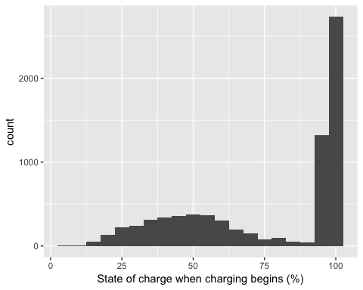

Figure 8 Value of state of charge at beginning of charge

## Saving 5 x 4 in image

As can be seen in Figure 8, using the originally defined “charge begins” data we have the majority of charges beginning while the state of charge is above 90%. This is likely due to the manner in which the charger regularly turns off and on again near the end of the charging cycle.

Figure 9 shows the state of charge values when charge begins but with state of charge greater than 90% removed from the data. The figure shows that many vehicles arrive home with greater than 50% charge remaining. This indicates that charging may be delayed until early the following morning (during low aggregate electricity demand) while providing enough “back up” state of charge to allow for small evening trips if necessary. Alternatively, the battery may be able to transfer energy to the home during the evening grid peak as a form of demand response.

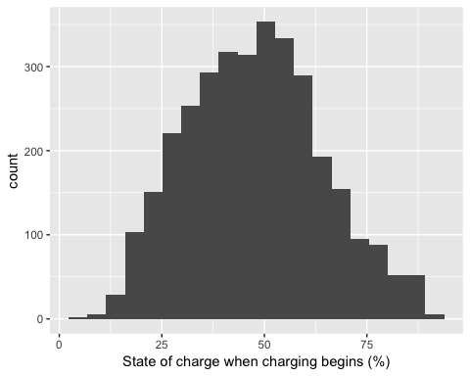

Figure 9 Value of state of charge at beginning of charge (>90% values removed)

## Saving 5 x 4 in image

# Time charging begins

After filtering out any data whereby charging begins while the state of charge is greater than 90% to account for battery ‘top-ups’ (refer to 8) we obtain the following figues.

## Picking joint bandwidth of 6060

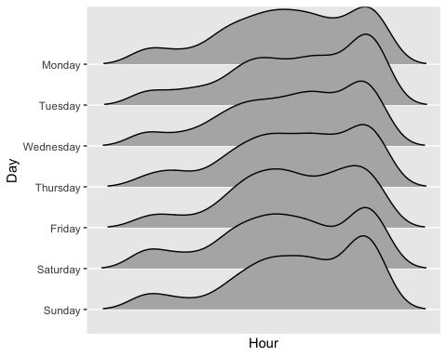

Figure 10 Time charging begins

## <ggproto object: Class FacetGrid, Facet, gg>  
## compute_layout: function  
## draw_back: function  
## draw_front: function  
## draw_labels: function  
## draw_panels: function  
## finish_data: function  
## init_scales: function  
## map_data: function  
## params: list  
## setup_data: function  
## setup_params: function  
## shrink: TRUE  
## train_scales: function  
## vars: function  
## super: <ggproto object: Class FacetGrid, Facet, gg>

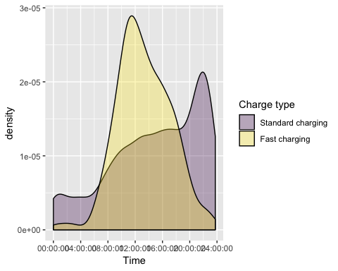

Figure 11 Density plot of charging start times during weekdays

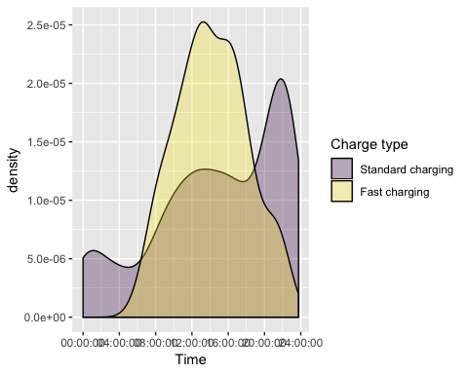

Figure 12 Density plot of charging start times during weekends

Standard charging has a noticeably different profile to charging patterns for fast charges. It suggests that it is common for plug-in vehicle owners to charge overnight at home, and perhaps use the more powerful public chargepoints to top up during the day.

Slow charging events most commonly began around 10pm during both weekdays and weekends. As it seems unlikely that this is due to vehicle drivers returning home at this hour, this effect may be due to drivers setting the charger on a timer to take advantage of cheaper “off-peak” electricity times, which freqently begin around 10pm.

Fast charging events tended to begin at 11:30am on weekdays and 1pm during weekends.

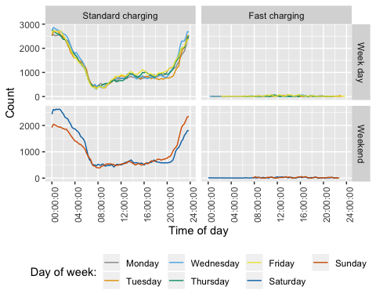

Figure 13 Count of observed charging events by type, day of week and time

Figure 13 shows the distribution of observed charging by time of day and day of the week. Aggregating counts in this way emphasises the times at which charging most commonly occurs and we can see…

Fig: profile of median charging demand by time of day and day of the week faceted by at home vs not at home

Charging demand varies somewhat by time of day and day of the week. Weekdays show … whilst weekends show. Saturdays and Sundays vary with…

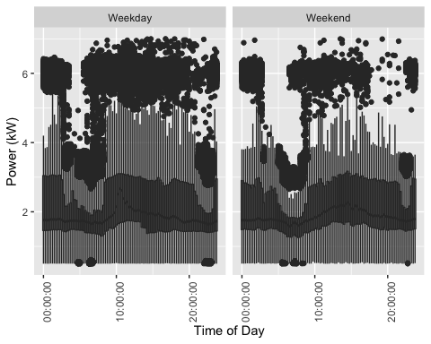

Figure 14 Boxplot of daily standard charging demand

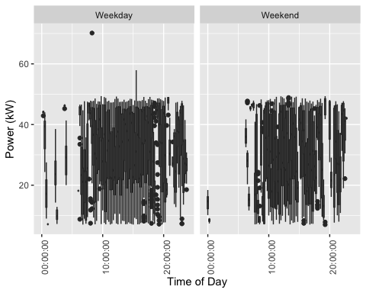

Figure 15 Boxplot of daily fast charging demand

Discuss any other patterns

Fig: Mean state of battery charge at the first ‘at home’ charging observation by hour and day of the week *No “at home” data with SOC*

should show the timing of ‘coming home’ battery state?

Fig: Distribution of duration of charge events starting ‘at home’ in the evening (by day of the week) *Duration difficult to accurately determine without date due to charging occurring through the night*

The figure shows that vehicles may then be available for further demand response and/or re-charging for up to XX hours from this point.

Discuss any other patterns

# References

Concept Consulting. 2018. “‘ Driving change ’ – Issues and options to maximise the opportunities from large-scale electric vehicle uptake in New Zealand,” no. March.