Analysis of electric vehicle usage patterns in New Zealand

Statistical Report

Rafferty Parker and Ben Anderson ([ben.anderson@otago.ac.nz](mailto:ben.anderson@otago.ac.nz)), [Centre for Sustainability](https://www.otago.ac.nz/centre-sustainability/), University of Otago

Last run at: 2019-04-12 14:52:01

Table of Contents

# Introduction

The New Zealand government has set a target of increasing the number of electric vehicles (EVs) in New Zealand to 64,000 by 2021 (Transpower New Zealand 2017). High penetration of EVs would cause EV recharging to contribute a substantial portion of total electricity load. A report prepared for lines companies Orion, Powerco and Unison by Concept Consulting Group entitled “Driving change - Issues and options to maximise the opportunities from large-scale electric vehicle uptake in New Zealand” predicts that if all current light private vehicles were electric, annual residential electricity consumption would increase by approximately 30%, whereas if all vehicles including trucks were electric, this would increase the total electricity consumption of New Zealand by approximately 41% (Concept Consulting 2018).

New Zealand’s total electricity demand varies throughout the day, with weekdays in particular having two distinct “peaks”; one in the morning, and one in the evening (Transpower New Zealand 2015). Providing the electricity to meet these demand peaks is a costly and inefficient process (Khan, Jack, and Stephenson 2018). Concurrent electric vehicle charging, especially in the early evening when many motorists return home (Speidel and Bräunl 2014,Langbroek, Franklin, and Susilo (2017)), would have the potential to negatively impact the operation of the grid through drastically increasing peak loads (Azadfar, Sreeram, and Harries 2015,Langbroek, Franklin, and Susilo (2017)), leading to an increased cost of electricity due to the requirement of expensive upgrades to the electricity grid (Stephenson et al. 2017).

The Concept Consulting report considers different methods of EV charging in its models. The assumption that most drivers would begin charging immediately after returning home is referred to as “passive” charging, while charging that is programmed (either by the driver or by an external entity) to occur during off-peak periods is referred to as “smart”. The modelling undertaken in the Concept Consulting report suggests that under a scenario whereby 57% of the current private vehicle fleet were EVs (corresponding to one EV per household), passive charging would cause an increase of peak electricity demand of approximately 3,000MW, whereas if all were charged in a “smart” fashion, there would be no increase in peak demand.

This report extends the work done by Concept Consulting, but utilises actual data collected from electric vehicles, as opposed to using models based on the current New Zealand transport sector. The intention of the report is to provide further insight into the potential effects on the New Zealand electricity grid that may occur with a dramatic increase in EVs, so that these may be planned for and mitigated. It is also inspired by the [UK Department of Transport 2018 statistical report](https://assets.publishing.service.gov.uk/government/uploads/system/uploads/attachment_data/file/764270/electric-chargepoint-analysis-2017-domestics.pdf) (Eyers 2018).

# Data

## Background

The data used has been provided by “Flip the Fleet”, a community organisation that hopes to increase uptake of electric vehicles in New Zealand. Flip the Fleet have been collecting data on electric vehicle usage patterns, via Exact IOT Limited’s [blackbox recorder](https://flipthefleet.org/ev-black-box/), a small electronic device that connects to the vehicle’s internal computer and sends detailed data about the battery health, power demand, charging rate, speed and other performance information to a secure database.

The subset of this data provided to the University of Otago was collected from 50 domestic electric vehicles monitored from April 2018 to January 2019. The data consisted of 1,515,812 1 minute interval observations of timestamped odometer readings (in km) together with measurements of charging power (kW) and battery charge state (% charged) linked to a unique anonymised vehicle identifier.

There are a number of important limitations to this data:

* measurement of observations only occurs when the car is switched on and/or plugged in and charging. As a result no data will be collected when the EV is switched off. This means that there are large non-erroneous ‘gaps’ in the data which represent ‘no charging’ (and also ‘no driving’) but which are not included as ‘0 power demand’ in the analyses since to do so would require imputation of a very large number of missing time stamps for each vehicle. This means we are only really able to analyse power demand profiles for vehicles that were charging, *not for all vehicles in all time periods*;
* data upload relied on mobile 3G data signal and the extent to which gaps in the data are due to data upload errors rather than vehicle non-use (as above) is currently unclear;
* these vehicles are driven by “early adopters” who have opted to install the measuring devices in order to collect their vehicle usage data. As a result the data may not be representative of the usage patterns of current or future EV drivers (Rezvani, Jansson, and Bodin 2015,Li et al. (2017)).

Even though the use of an anonymised vehicle identifier should prevent the identification of the vehicles in the sample, the fine-grained temporal nature of the data and the relatively small population of EV owners from whom the sample is drawn (Flip The Fleet members) means that the data cannot be publicly released.

## Initial cleaning

Figure 1 shows the number of unique EVs observed by time of day and date. As we can see the early part of the sample is sparse and indeed the maximum number of EVs observed in any 15 minute time period was only 22 out of a possible total of 50. While this will not affect some analyses, it is likely to introduce error and small sample effects to summary analyses (e.g. means) or month by month analyses. In some sections the analysis will therefore be restricted to the data from September to January.

In addition Table 1 shows that a small number of EVs have very few observations, in some cases not extending beyond 1 day (shown as 0 days observed).

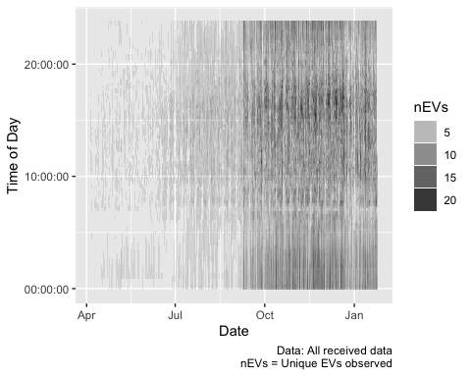

Table 1 Number of observations and start/end dates for vehicles (6 most scarce)

id

nObs

startTime

endTime

meanWhCharging

maxWhCharging

nDaysObserved

0cc746a3f5ae75ee94068a8354b6be08

3

2018-09-09 10:46:30

2018-09-09 10:48:42

0.0000000

0.000000

0 days

01583b8a5f0344cc4aa3b3939a27af2a

4

2018-09-09 10:34:12

2018-09-09 10:36:25

0.0000000

0.000000

0 days

4a6bb6e7ffc28d9d8eda7b4c6377a027

19

2018-09-08 08:48:38

2018-09-09 10:27:50

4.2251742

27.557201

1 days

126c8759ec95ba40070b16a11fe0e587

258

2018-09-30 11:54:18

2018-09-30 19:24:05

1.5869526

1.960213

0 days

4e48f4155c29c763ffe6d9e17a495200

530

2019-01-17 14:12:57

2019-01-25 10:31:16

0.0000000

0.000000

8 days

6e3293c77f562262ed6608db1b596d36

4315

2018-05-15 14:48:15

2018-12-06 13:25:56

0.2872577

47.245786

205 days

Further, as Table 1 also indicates, there were several (6) vehicles that had no recorded charging observations. These were discarded (which also discarded those with very few observations).

We then discarded:

* 0 instances of charging power greater than 120kW. These were considered anomalies and as these exceed the capacity of the highest charging stations currently available in New Zealand (Concept Consulting 2018);
* 0 instances of battery state of charge observations of greater than 100%.

This left 44 remaining vehicles, and 1,291,881 observations as shown in Table 2.

Table 2 Number of observations by charge flag (final cleaned data)

Weekdays

Weekends

NA

Sum

Fast charging

5830

2537

0

8367

Not charging

402519

98971

0

501490

Standard charging

584821

197203

0

782024

NA

0

0

0

0

Sum

993170

298711

0

1291881

## Definitions and preparation

### Charge type

Charging data has been broadly separated into two separate categories, “standard” and “fast”. Standard charging is defined to be when the charger is reading less than 7kW - this is considered the upper limit of ordinary home charging without an expensive wiring upgrade (Concept Consulting 2018). Fast charging is all charging equal to or greater than 7kW, and would likely occur at designated and purpose-built public charging stations.

It should be noted that this method is not always accurate since we can identify apparent sequences of charging which start at > 7kW and decline to < 7kW over a relatively short period. In this circumstance the first observation will be correctly classified as ‘Fast’ but the lower observations, which we assume are lower power trickle ‘top-up’ at the end of a fast charge will be incorrectly classified as ‘Standard’ (see 9.1.2). This is clarified in Section 5 where we use the first observation in a sequence to denote fast/standard but has yet to be resolved in other sections. As a result we may currently be *under-estimating* the number of fast charge observations and *over-estimating* the mean power demand of standard charges. Future work will resolve this potential misclassification error.

As an example, we know that there are 105 sequences of charging events (out of a total of 15186) where the first and last charge types do not match. Of these 478 were pairs where the first charging observation was ‘Fast’ and the last classified at ‘Standard’.

Figure 2 shows the distribution of observed charging kW demand by inferred charge type without correcting for potential mis-classifications. Setting aside the small number of potential misclassifications noted above, the plot confirms the validity of our definition and shows that fast charges were relatively rare in the dataset. Fast charges have two distinct power demand ‘peaks’ at ~22kW and ~45kW while the far more common standard charging was mostly concentrated around 1.8kW and 3kW, with a smaller concentration around 6kW.

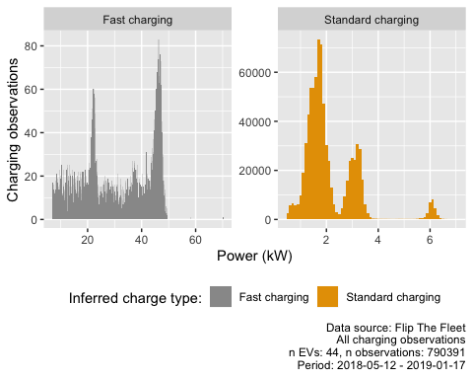

Figure 2 Observed power demand distribution by charge type where charging observed

### Charge sequences

In order to determine charging durations, we need to identify observations which are the start and end of charging sequences. We use the following logic to do this:

* rows were coded as “charging begins” if the charging power was greater than zero and the previous and following row’s charging power were (respectively) equal to zero and greater than zero;
* rows were coded as “charge ends” if the charging power was greater than zero and the previous and following row’s charging power were (respectively) greater than zero and equal to zero;
* rows were coded as “charge in a sequence” if charging power > 0 and the observations either side were also > 0
* rows were coded as “single charge events” if charging power > 0 but the observations either side were 0.

Table 3 Charge sequence coding results

Fast charging

Not charging

Standard charging

NA

Sum

Charging in a seq

7272

0

762195

0

769467

First charge obs in a seq

478

0

7110

0

7588

Last charge in a seq

402

0

7196

0

7598

Not charging (0 kW)

0

501490

0

0

501490

Single charge observation

213

0

5513

0

5726

NA

2

0

10

0

12

Sum

8367

501490

782024

0

1291881

Table 3 shows the results of this coding for all clean observations. As we can see very few observations were not coded using this scheme. As shown in Section 9.1.2.1 an alternative method which added a 120 second maximim threshold to sequences of observations was also tested but not used as it failed to identify sparse sequences of charging events.

Using this method we obtained 7,588 instances of charging starting, and 7,598 instances of charge ending. The additional 10 instances of the charge ending than there are of the charge beginning may be due to the first instance of data collection occurring during mid-charge for some vehicles.

The charge duration was then calculated as being the time duration between each pair of “first charge” and “last charge” observations

Figure 3 shows the overall distribution of all charging sequences. Clearly there are very small and a few very large values for both charging types.

## Don't know how to automatically pick scale for object of type difftime. Defaulting to continuous.

## Warning: Removed 1 rows containing non-finite values (stat_bin).

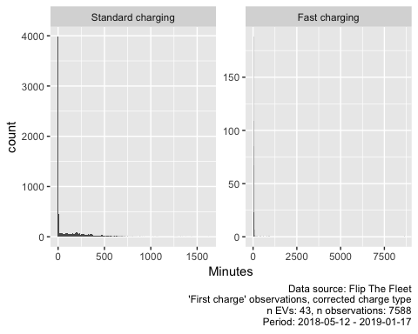

Figure 3 Duration of charging sequences

Table 4 shows the overall distributions and indicates the extent to which the means are skewed by the very small and a few very large values shown in Figure 3.

Table 4 Duration of all charge sequences by charge type

chargeTypeFixed

N

mean

median

min

max

Standard charging

7095

98.49 mins

3.43

0.27 mins

1616.72 mins

Fast charging

492

41.89 mins

13.53

0.02 mins

8621.00 mins

Figure 4 shows the distribution of very short charging sequences. As we can see these appear to be generally less than 8 minutes in length for Standard Charges.

## Don't know how to automatically pick scale for object of type difftime. Defaulting to continuous.

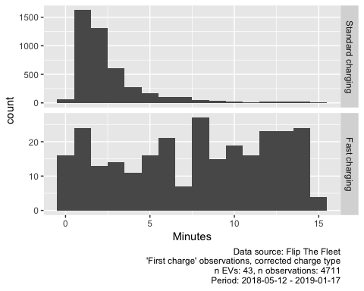

Figure 4 Duration of charging sequences < 15 minutes

Table 5 shows the same descriptive statistics but for all sequences of greater than 8 minute duration. Now we can see that the mean and median durations for both Standard and Fast Charge sequences are closer.

Table 5 Duration of charge sequences > 8 minutes by charge type (minutes)

chargeTypeFixed

N

mean

median

min

max

Standard charging

2809

245.40 mins

209.80

8.02 mins

1616.72 mins

Fast charging

356

56.48 mins

17.86

8.05 mins

8621.00 mins

Manual inspection of the data showed that these short-duration charging “events” generally occurred near the end of a longer-duration charging sequence It appeared that once the vehicle had reached its highest state of charge, charging would intermittently stop and start again. This is probably due to the behaviour of the charger once the battery was almost full. In addition to the myriad “short” charging duration values, a small number of unreasonably long charging durations (longer than 100 hours for standard charging or longer than 14 hours for fast charging) were calculated. As these exceeded the expected charge durations of the most high capacity vehicles currently available, they were also assumed to be anomalies. The analyses in Section 5 below was therefore made with the following charge events excluded from the data:

* duration > 6000 minutes (1 observations)
* duration < 8 minutes for standard charging (4285 observations - noting that some of these may be short low power ‘fast charge’ events as discussed in Section @ref(#chargeType))
* duration > 840 minutes for fast charging (3 observations)

Figure 5 and 6 shows the distribution of charging sequences with the excessively long or short events removed. These charging durations appear more reasonable when considering standard battery capacities and charging powers.

## Don't know how to automatically pick scale for object of type difftime. Defaulting to continuous.

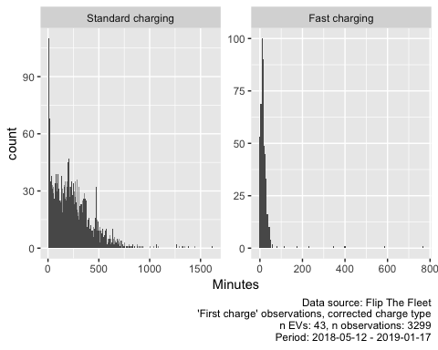

Figure 5 Duration of charging sequences with unreasonably long or short values removed

## Saving 5 x 4 in image  
## Don't know how to automatically pick scale for object of type difftime. Defaulting to continuous.

Table 6 Duration of charge sequences, final duration data (minutes)

chargeTypeFixed

N

mean

median

min

max

Standard charging

2810

245.32 mins

209.73

8.00 mins

1616.72 mins

Fast charging

489

20.86 mins

13.50

0.02 mins

767.20 mins

# Time of charging

It has been suggested that EV charging is more likely to occur in the early evening (Langbroek, Franklin, and Susilo 2017). Figure 8 uses a density plot to represent the proportion of charging and non-charging observations at different times of day be weekday vs weekends. The plot clearly shows non-charging during day-time use and also shows a bi-model distribution for fast charging (non-corrected categorisation). Standard charging also shows a bi-modal distribution with a peak around 22:00 on weekdays and another at 01:00 presumably indicating the use of timed or ‘smart’ charging or trickle events.

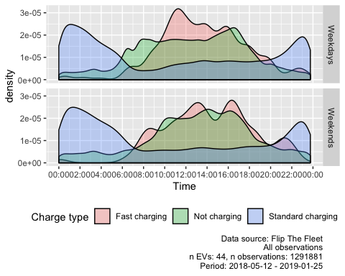

Figure 6 Density plot of charging start times during weekdays

## Saving 5 x 4 in image

These patterns are also visible in Figure 6 which shows the distribution of observed charging events by time of day and day of the week.

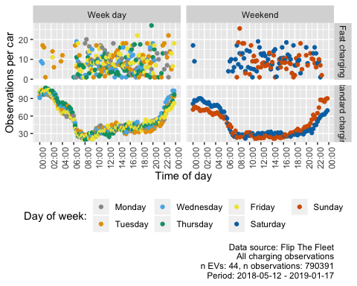

Figure 7 Count of observed charging events by type, day of week and time

This figure indicates that the greatest frequency of standard charging events occur between the hours of 8pm and 8am, with very low occurrences of charging during morning and evening grid peaks. Fast charging on the other hand is a day-time activity on both weekdays and weekends.

To make the patterns of ‘initial charging’ clearer, we use just the ‘first’ charge observation in a pair (see above) and exclude automatic battery ‘top-ups’ (refer to Section 6) by also filtering out any data where a charging observation begins while the state of charge is greater than 90%. Having done so, Figure 8 uses a density plot to represent the proportion of charging events that begin at different times of the day on weekdays vs weekends for standard and fast charging (corrected classification).

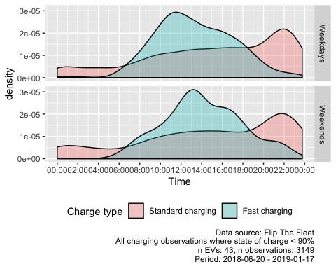

Figure 8 Density plot of charging start times during weekdays where state of charge < 90%

## Saving 5 x 4 in image

As we can see, standard charging sequences (as opposed to single observations) have a noticeably different profile to charging patterns for fast charges. It suggests that the majority of standard charging events start at 22:00 and run overnight at home, and perhaps use the more powerful public charge points to top up during the day. However the plot also shows that this is not universal with a reasonable proportion of charging events starting earlier in the day, including during the NZ [peak demand periods](https://www.electrickiwi.co.nz/hour-of-power) of 07:00 - 09:00 and 17:00 - 21:00.

Standard charging events were most likely to begin around 10pm during both weekdays and weekends. As it seems unlikely that this is due to vehicle drivers returning home at this hour, this effect may be due to drivers setting the charger on a timer to take advantage of cheaper “off-peak” electricity times, which frequently begin around 10pm.

Fast charging events were most likely to begin at 11:30am on weekdays and 1pm during weekends.

# Patterns of power demand

Given this distribution of charging events, it is important to understand their magnitude to understand the potential effect on the electricity network. Although we are hampered by the lack of ‘no charge’ data when the EV is not connected to the charger and switched off, this section analyses the patterns of power demand where charging is observed. Clearly this does not provide overall sample mean power demand which would include charging, non-charging *and* non-use observations.

Overall 75% of standard charging observations were 1.47 kW or more but the figure was 20.28 kW or more for fast charging.

Figure 9 shows the mean power demand for standard charging observations by time of day and weekdays vs weekends for the charging data collected after September 2018 to ensure maximum sample size (see Section 2.2). The plot uses transparency to indicate the number of EVs contributing to each of the mean calculations to give a guide to their reliability. Dots with stronger colours indicate means calculated from a larger number of EVs and, given the data gaps noted in Section 2.1, this indicates patterns which are generally shared across more EVs.

This plot appears to show that there are three peaks in standard charging, one at 10:00, one at 18:00 (possibly based on fewer EVs) and one after midnight on weekdays. There are also noticeable 07:00 and 16:00 charging blips. On the other hand at weekends the daytime peak shifts to 14:00. Thus, while our previous analysis suggested that charging events were more likely to startlaterin the evening, the power demand of earlier charging events may actually be relatively high and co-incide with exisitng peak demand periods.

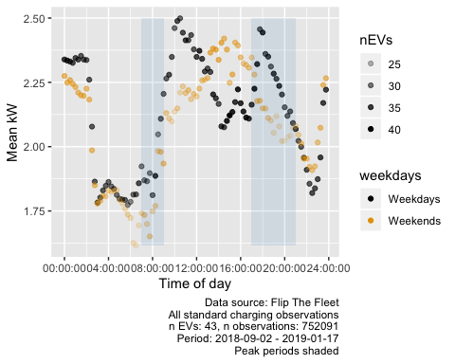

Figure 9 Mean charging power demand (kW) by time of day

Fast charging however has no detectable pattern other than a clear increase in density during weekday daytimes (Figure 10).

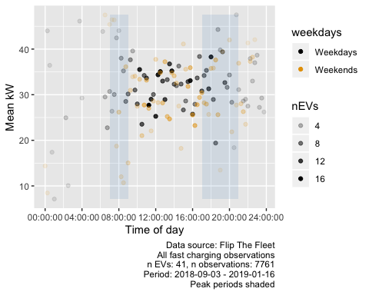

Figure 10 Mean charging power demand (kW) by time of day

It seems likely that the ‘standard charge’ day-time peak is skewed by mis-classified short low power ‘fast charge’ observations (see Section @ref(#chargeType)). Figure 11 attempts to allow for this misclassification by plotting the median rather than the mean. The plot more clearly shows the 10:00 weekday spike which, if we assume that the mis-classified ‘fast charges’ will be skewing the standard charge mean value upwards, is likely to be due to mis-classified ‘fast charging’. However the 18:00 peak persists as does the 14:00 weekend peak while overnight charging levels are relatively stable as we would expect from 9.

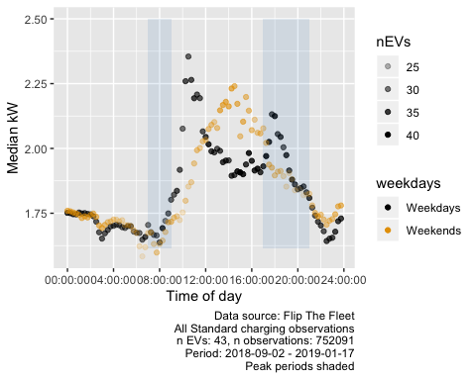

Figure 11 Median charging power demand (kW) by time of day

Figure 12 repeats the median power-based analysis for ‘Standard charging’ but shows the results by month. While the sample size is probably too small to draw robust conclusions there appear to be differences between months with December showing few discernable peaks and September and January showing much lower daytime weekday charging. In addition, weekdays and weekends are much more similar in November and December.

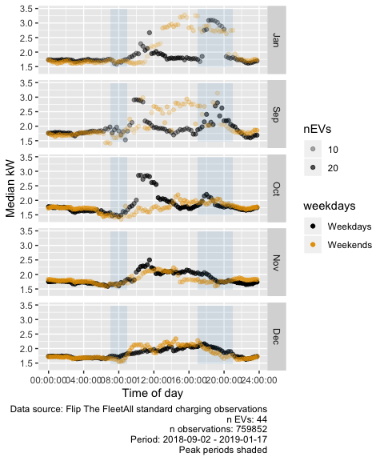

Figure 12 Median charging power demand (kW) by time of day

On face value the results suggest that EVs could be placing additional power demand on local and national networks during well-known periods of peak demand although this appears to vary by month for this small sample of EV owners.

Clearly this analysis should be revisited once the potential misclassification of ‘fast’ as ‘standard’ charging observations has been resolved and the ‘missing’ non-use (zero charging) observations have been imputed.

# Charging duration

This section analyses the duration of observed charging events to understand when longer charging sequences are likely to occur. Table 7 shows the mean durations for all all charging events by event start time for standard charging durations greater than 8 minutes (see Section 2.3.2) and all fast charging events for observations collected after 01 September 2018.

Table 7 Mean duration of charge events by charge type (filtered data, corrected charge type)

chargeTypeFixed

mean

median

min

max

sd

Standard charging

251.15 mins

217.78 mins

8.00 mins

1616.72 mins

189.62

Fast charging

21.66 mins

13.70 mins

0.02 mins

767.20 mins

53.25

Table 8 Mean duration of charge sequences (values > 480 minutes)

qHour

chargeTypeFixed

weekdays

meanDuration

nEVs

10:30:00

Standard charging

Weekends

684.57 mins

2

04:45:00

Standard charging

Weekdays

596.40 mins

1

21:00:00

Fast charging

Weekdays

582.53 mins

1

21:00:00

Standard charging

Weekends

500.20 mins

11

Figure 13 plots the mean duration by time of day and weekday vs weekend and charge type. As before we use transparency to indicate the number of unique EVs contributing to the mean values and we have removed a small number of very large duration outliers (mean duration > 540 minutes or 9 hours) which appears to be based on just 1 or 2 EVs (see Table @ref:(tab:makeDurationTimeMean)).

As we would expect, the plot shows that for standard charging mean ‘forward’ duration generally decreases from midnight, presumably as batteries are becoming fully charged through to 06:00 and then increases as the time of starting to charge increases through the day before trending downwards before midnight. Again, this confirms that charge events starting in or just after the evening peak demand period on both weekdays and weekends are likely to be longer, possibly reflecting the lower state of charge at this time of day (following use).

Duration of fast charge events by start time appear to be more randomly distributed, although very few events were recorded between midnight and 7am. This, along with the comparatively low number of recorded fast charge events indicated in Fig. 2 suggests that drivers utilize fast charging only “as necessary” to ensure they have enough battery capacity to complete their journey or when ‘at work’ or conducting some other mobility related task such as shopping.

## Don't know how to automatically pick scale for object of type difftime. Defaulting to continuous.

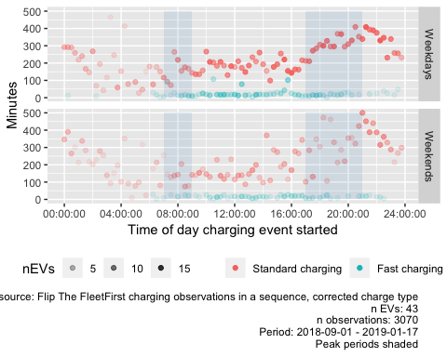

Figure 13 Mean duration (within quarter hours) by time of charging start

# State of charge

The state of charge is the percentage of energy still available to be used in the battery. In future, electric vehicles may be able to discharge any remaining battery charge as electricity into the grid, a process known as vehicle to grid (V2G) energy transfer. This may allow electric vehicles to have a net beneficial effect on the grid, reducing the evening peaks by providing electricity to the home during this period, and then recharging later in the evening or early the next morning when peak demand has diminished.

This section provides an indication of the state of charge of electric vehicles upon charging, so that the potential of V2G technology can be assessed.

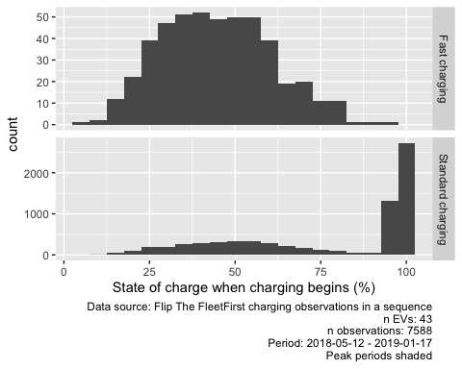

Figure 14 Value of state of charge at beginning of charge

## Saving 5 x 4 in image

As can be seen in Figure 14, using the cleaned complete observations data, the majority of standard charges begin while the state of charge is above 90%. This is most likely due to the manner in which the charger regularly turns off and on again near the end of the charging cycle as described in Section 2.2.

Figure 15 shows the state of charge values when charge begins but with state of charge greater than 90% removed from the data for clarity. The figure indicates that many vehicles begin charging despite having greater than 50% charge remaining. This has clear implications for battery life management since continually top-up charging is known to substantially shorten the lifetime of EV batteries (XX ref needed XX). However it also indicates the potential to use the charge in the battery to feed into the grid, especially in the residential context.

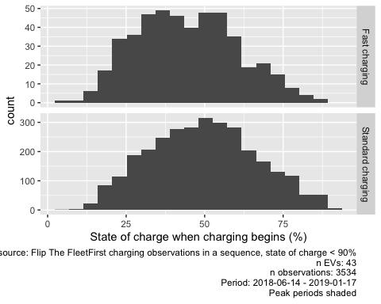

Figure 15 Value of state of charge at beginning of charge (values > 90% removed)

## Saving 5 x 4 in image

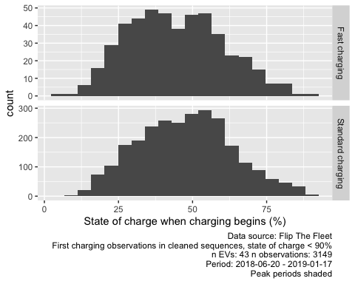

Figure 16 Value of state of charge at beginning of charge (values > 90% removed)

## Saving 5 x 4 in image

Figure 16 repeats this but using the cleaned and corrected inferred start/end of charging sequence data. These show very similar disatirbutions to the previous plot (Figure 15) which used all observations and conforms that sequences of stabdnard chargin in particualr most frequently start with battery state of charge over 50%.

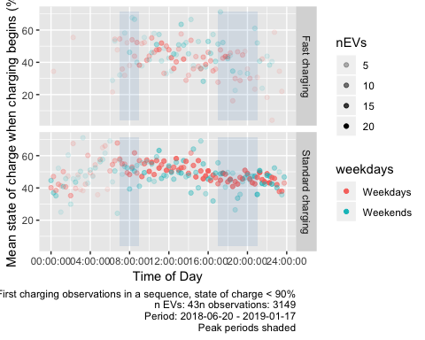

Figure 17 Mean state of charge at beginning of charge (values > 90% removed)

## Saving 5 x 4 in image

Finally, Figure 17 shows the mean % charge by time of first charging observation in a sequence using the cleaned and corrected inferred start/end of charging sequence data. The plot suggests that this capacity may be relatively stable throughout the day albiet with slightly higher mean capacity around the morning peak as we would expect given over-night charging. It is unlikely that this early morning capacity would be willingly made available for V2G since the EV may be used in the near future although this may not always be the case. However it is interesting to note that mean capacity at start of charge in the evening peak period is still roughly 50% indicating relatively substantial power availability.

# Summary

# Key Findings

Based on a relatively small and probably non-representative sample of 44 domestic electric vehicles provided by our research partner [FlipTheFleet](https://flipthefleet.org/) and which were monitored from April 2018 to January 2019 we have found that:

* *Power supplied*: The median power supplied during a charging event coded as ‘standard’ was 1.78 kW. The mean was slightly higher at 2.12 kW. Charging observations coded as ‘Fast’ had a median of 1.78 kW (mean = 2.12 kW). Mean power when charging showed a complex temporal profile for weekday standard charging (Figure 9) with a peak of ~ 2.5kw at 10:00 and a second of the same value at around 18:00 with further peaks just after midnight. The inverse is seen on weekends with a charge peak during the middle of the day;
* *Charging duration*: Charging durations tended to fall into one of two groups. Longer ‘standard’ charges had a median duration of 209.7333333 minutes and a mean duration of 245.3190629 minutes High power “fast” charge events had a median duration of 13.5 minutes and a mean duration of 13.5 minutes;
* *Time of day*: Standard charging events tended to be the most frequent around 22:00 on both weekdays and weekends, suggesting the drivers in our dataset utilise timers to take advantage of off-peak electricity although this is not universal with a substantial proportion of charging events starting earlier in the day and potentially at higher power levels (see above). Fast charging events tended to begin at 11:30am on weekdays and 1pm during weekends;
* *State of charge*: As has been previously shown (Speidel and Bräunl 2014), any drivers begin recharging with greater than 50% charge still remaining in the battery for both standard and fast charge events. This has clear implications both for the management of battery life and also for the potential for vehicle-to-grid power flows during peak demand periods where vehciles may be at or arriving home with substantial available charge.

In the data provided for this study, most charging occurs at home using either a 1.8kw or 3kW charger, and commonly occurs both in the evening peak period and through the night. In addition, many vehicles begin charging with significant battery capacity remaining, providing them with the ability to provide vehicle to grid energy transfer should that technology become widely available.

These preliminary findings support recent modelling work (Concept Consulting 2018) that suggests that any negative effects electric vehicles may have on the evening national electricity grid peaks should be mitigable through “smart” charging methods. In addition, our analysis indicates that this may already be occurring to some extent in this sample of EV owners. If later adopters of electric vehicles can be induced to follow the same “smart” charging patterns as those displayed in some of our data sample, it is likely that the effects that electric vehicles are otherwise likely to have on the electricity grid may be mitigated.

# Statistical Annex

## Flip The Fleet data description

### Raw data

Data description for original data supplied (before processing or filtering).

## Skim summary statistics  
## n obs: 1515812   
## n variables: 8   
##   
## ── Variable type:character ─────────────────────────────────────────────────────────────────────────────────────────────────────────────────  
## variable missing complete n min max empty n_unique  
## day_of_week 0 1515812 1515812 6 9 0 7  
## id 0 1515812 1515812 32 32 0 50  
## month 0 1515812 1515812 3 3 0 10  
##   
## ── Variable type:Date ──────────────────────────────────────────────────────────────────────────────────────────────────────────────────────  
## variable missing complete n min max median  
## date 0 1515812 1515812 2018-04-05 2019-01-25 2018-11-09  
## n_unique  
## 293  
##   
## ── Variable type:difftime ──────────────────────────────────────────────────────────────────────────────────────────────────────────────────  
## variable missing complete n min max median n_unique  
## time 0 1515812 1515812 0 secs 86399 secs 44827 secs 86400  
##   
## ── Variable type:numeric ───────────────────────────────────────────────────────────────────────────────────────────────────────────────────  
## variable missing complete n mean sd p0  
## charge_power_kw 0 1515812 1515812 1.73 71 0  
## odometer_km 1000156 515656 1515812 7290.5 7954.38 -62920  
## state_of_charge_percent 0 1515812 1515812 69.11 20.85 0  
## p25 p50 p75 p100 hist  
## 0 1.37 1.9 74940.42 ▇▁▁▁▁▁▁▁  
## 1889 4749 10529 69394 ▁▁▁▆▇▂▁▁  
## 56.43 70.57 83.2 1677.72 ▇▁▁▁▁▁▁▁

### Processed and cleaned data

Data description for cleaned data (all observations).

## Skim summary statistics  
## n obs: 1291881   
## n variables: 15   
##   
## ── Variable type:character ─────────────────────────────────────────────────────────────────────────────────────────────────────────────────  
## variable missing complete n min max empty n_unique  
## chargeFlag 12 1291869 1291881 17 25 0 5  
## chargeType 0 1291881 1291881 12 17 0 3  
## dvID 0 1291881 1291881 9 10 0 44  
## id 0 1291881 1291881 32 32 0 44  
## weekdays 0 1291881 1291881 8 8 0 2  
##   
## ── Variable type:Date ──────────────────────────────────────────────────────────────────────────────────────────────────────────────────────  
## variable missing complete n min max median  
## date 0 1291881 1291881 2018-05-12 2019-01-25 2018-11-13  
## n_unique  
## 249  
##   
## ── Variable type:difftime ──────────────────────────────────────────────────────────────────────────────────────────────────────────────────  
## variable missing complete n min max median  
## dateTimeDiff 44 1291837 1291881 0 secs 4912664 secs 50 secs  
## qHour 0 1291881 1291881 0 secs 85500 secs 11:45:00  
## time 0 1291881 1291881 0 secs 86399 secs 11:50:53  
## n_unique  
## 13443  
## 96  
## 86400  
##   
## ── Variable type:factor ────────────────────────────────────────────────────────────────────────────────────────────────────────────────────  
## variable missing complete n n_unique  
## day_of_week 0 1291881 1291881 7  
## month 0 1291881 1291881 9  
## top_counts ordered  
## Fri: 206422, Wed: 206292, Thu: 205166, Mon: 190389 TRUE  
## Nov: 298332, Oct: 280869, Dec: 272272, Jan: 188498 FALSE  
##   
## ── Variable type:numeric ───────────────────────────────────────────────────────────────────────────────────────────────────────────────────  
## variable missing complete n mean sd p0 p25  
## charge_power_kw 0 1291881 1291881 1.48 2.89 0 0   
## odometer_km 857152 434729 1291881 6801.77 7943.05 -62920 1698   
## SoC_percent 46 1291835 1291881 68.42 18.58 0 55.68  
## p50 p75 p100 hist  
## 1.38 1.9 70.16 ▇▁▁▁▁▁▁▁  
## 4123 8816 69394 ▁▁▁▇▇▂▁▁  
## 69.73 82.26 98.1 ▁▁▂▃▆▇▇▇  
##   
## ── Variable type:POSIXct ───────────────────────────────────────────────────────────────────────────────────────────────────────────────────  
## variable missing complete n min max median  
## dateTime 0 1291881 1291881 2018-05-12 2019-01-25 2018-11-13  
## n_unique  
## 1230977

Data description for cleaned data (first observations in a charging sequence).

## Skim summary statistics  
## n obs: 3299   
## n variables: 19   
##   
## ── Variable type:character ─────────────────────────────────────────────────────────────────────────────────────────────────────────────────  
## variable missing complete n min max empty n_unique  
## chargeFlag 0 3299 3299 25 25 0 1  
## chargeType 0 3299 3299 13 17 0 2  
## chargeTypeError 0 3299 3299 29 37 0 4  
## dvID 0 3299 3299 9 10 0 43  
## endType 0 3299 3299 13 17 0 2  
## id 0 3299 3299 32 32 0 43  
## weekdays 0 3299 3299 8 8 0 2  
##   
## ── Variable type:Date ──────────────────────────────────────────────────────────────────────────────────────────────────────────────────────  
## variable missing complete n min max median n_unique  
## date 0 3299 3299 2018-05-12 2019-01-17 2018-11-09 201  
##   
## ── Variable type:difftime ──────────────────────────────────────────────────────────────────────────────────────────────────────────────────  
## variable missing complete n min  
## dateTimeDiff 0 3299 3299 0 secs   
## pairDuration 0 3299 3299 0.01666667 mins  
## qHour 0 3299 3299 0 secs   
## time 0 3299 3299 40 secs   
## max median n_unique  
## 230025 secs 305 secs 1804  
## 1616.717 mins 178.8167 mins 3024  
## 85500 secs 15:15:00 96  
## 86246 secs 15:22:14 3167  
##   
## ── Variable type:factor ────────────────────────────────────────────────────────────────────────────────────────────────────────────────────  
## variable missing complete n n_unique  
## chargeTypeFixed 0 3299 3299 2  
## day_of_week 0 3299 3299 7  
## month 0 3299 3299 9  
## top_counts ordered  
## Sta: 2810, Fas: 489, Not: 0, NA: 0 FALSE  
## Fri: 524, Wed: 502, Thu: 490, Mon: 489 TRUE  
## Nov: 791, Oct: 743, Dec: 702, Sep: 458 FALSE  
##   
## ── Variable type:numeric ───────────────────────────────────────────────────────────────────────────────────────────────────────────────────  
## variable missing complete n mean sd p0 p25  
## charge_power_kw 0 3299 3299 7.31 12.68 0.5 1.62  
## odometer_km 2555 744 3299 5649.15 7459.93 -52352 1289.25  
## SoC_percent 0 3299 3299 49.41 18.72 4.11 35.89  
## p50 p75 p100 hist  
## 2.62 3.35 70.16 ▇▁▁▁▁▁▁▁  
## 3435 7345.75 54443 ▁▁▁▂▇▁▁▁  
## 48.41 59.63 98.1 ▁▃▆▇▇▃▂▂  
##   
## ── Variable type:POSIXct ───────────────────────────────────────────────────────────────────────────────────────────────────────────────────  
## variable missing complete n min max median n_unique  
## dateTime 0 3299 3299 2018-05-12 2019-01-17 2018-11-09 3299

#### Charge flag

This is used to identify observations that form part of a sequence. The logic is given in Section 2.3.2. Here we show the results of applying an additional 120 second rule. In this case a sequence only exists where we have charging observations which have less than 120 seconds between them.

Table 9 Charge sequence flags (120 second rule)

Fast charging

Not charging

Standard charging

NA

Charging in a seq

6995

0

750485

0

First charge obs in a seq

311

0

5124

0

Last charge in a seq

380

0

7045

0

Not charging (0 kW)

0

501490

0

0

Not classified (what is this??)

464

0

13839

0

Single charge observation

213

0

5513

0

NA

4

0

18

0

Table 9 Charge sequence flags (no 120 second rule)

Fast charging

Not charging

Standard charging

NA

Charging in a seq

7272

0

762195

0

First charge obs in a seq

478

0

7110

0

Last charge in a seq

402

0

7196

0

Not charging (0 kW)

0

501490

0

0

Single charge observation

213

0

5513

0

NA

2

0

10

0

As we can see, applying the 120 second rule reduces the number of observations categorised as part of a sequence as it will not know what to do with:

* charge -> gap of > 120 secs -> charge 120 secs -> charge

For now we therefore do not use the 120 second rule.

#### Check charge type

chargeType is used to classify charging events into standard vs fast using the 7 kW threshold. But there may be misclassfications where a sequence starts on a fast charger but power demand declines below the threshold. We can check this.

## chargeType is used to classify charging events into standard vs fast using the 7 kW threshold. But there may be misclassfications:

##   
## Error: first = Fast, last = Standard  
## Fast charging 91  
## Standard charging 0  
## <NA> 0  
##   
## Error: first = Standard, last = Fast  
## Fast charging 0  
## Standard charging 14  
## <NA> 0  
##   
## OK: first = Fast, last = Fast  
## Fast charging 387  
## Standard charging 0  
## <NA> 0  
##   
## OK: first = Standard, last = Standard <NA>  
## Fast charging 0 402  
## Standard charging 7096 7196  
## <NA> 0 0

## There are 105 pairs (out of a total of 7593) from 26 EVs where charge type doesn't match.

## N observations where previous dateTime unknown (should match to n EVs)

## [1] 43

## N observations where next dateTime unknown (should match to n EVs)

## [1] 43

## N observations where chargeFlag is unknown

## [1] 9

## These seem to occur when charging is detected but the dateTime before/after is unkown due to data truncation

Check charge flags:

## chargeFlag is used to classify charging events - check against charge type:

##   
## Standard charging <NA>  
## Charging in a seq 734213 0  
## First charge obs in a seq 6598 0  
## Last charge in a seq 6678 0  
## Single charge observation 4593 0  
## <NA> 9 0

## There are a few observations that have chargeFlag = NA but are charging... why?

## N observations where previous dateTime unknown (should match to n EVs)

## [1] 43

## N observations where next dateTime unknown (should match to n EVs)

## [1] 43

## N observations where chargeFlag is unknown

## [1] 9

## These seem to occur when charging is detected but the dateTime before/after is unkown due to data truncation

# References

Azadfar, Elham, Victor Sreeram, and David Harries. 2015. “The investigation of the major factors influencing plug-in electric vehicle driving patterns and charging behaviour.” *Renewable and Sustainable Energy Reviews* 42. Elsevier: 1065–76. doi:[10.1016/j.rser.2014.10.058](https://doi.org/10.1016/j.rser.2014.10.058).

Concept Consulting. 2018. “‘ Driving change ’ – Issues and options to maximise the opportunities from large-scale electric vehicle uptake in New Zealand,” no. March.

Eyers, Lisa. 2018. “Electric Chargepoint Analysis 2017 : Domestics Key findings :” no. December.

Khan, Imran, Michael W. Jack, and Janet Stephenson. 2018. “Analysis of greenhouse gas emissions in electricity systems using time-varying carbon intensity.” *Journal of Cleaner Production* 184. Elsevier Ltd: 1091–1101. doi:[10.1016/j.jclepro.2018.02.309](https://doi.org/10.1016/j.jclepro.2018.02.309).

Langbroek, Joram H. M., Joel P. Franklin, and Yusak O. Susilo. 2017. “When Do You Charge Your Electric Vehicle? A Stated Adaptation Approach.” *Energy Policy* 108 (September): 565–73. doi:[10.1016/j.enpol.2017.06.023](https://doi.org/10.1016/j.enpol.2017.06.023).

Li, Wenbo, Ruyin Long, Hong Chen, and Jichao Geng. 2017. “A Review of Factors Influencing Consumer Intentions to Adopt Battery Electric Vehicles.” *Renewable and Sustainable Energy Reviews* 78 (October): 318–28. doi:[10.1016/j.rser.2017.04.076](https://doi.org/10.1016/j.rser.2017.04.076).

Rezvani, Zeinab, Johan Jansson, and Jan Bodin. 2015. “Advances in Consumer Electric Vehicle Adoption Research: A Review and Research Agenda.” *Transportation Research Part D: Transport and Environment* 34 (January): 122–36. doi:[10.1016/j.trd.2014.10.010](https://doi.org/10.1016/j.trd.2014.10.010).

Speidel, Stuart, and Thomas Bräunl. 2014. “Driving and Charging Patterns of Electric Vehicles for Energy Usage.” *Renewable and Sustainable Energy Reviews* 40 (December): 97–110. doi:[10.1016/j.rser.2014.07.177](https://doi.org/10.1016/j.rser.2014.07.177).

Stephenson, Janet, Rebecca Ford, Nirmal-Kumar Nair, Neville Watson, Alan Wood, and Allan Miller. 2017. “Smart grid research in New Zealand – A review from the GREEN Grid research programme.” doi:[10.1016/j.rser.2017.07.010](https://doi.org/10.1016/j.rser.2017.07.010).

Transpower New Zealand. 2015. “Transmission Planning Report,” no. July: 320.

———. 2017. “Battery Storage in New Zealand,” no. September: 41. <https://www.transpower.co.nz/sites/default/files/publications/resources/Battery Storage in New Zealand.pdf>.