Analysis of electric vehicle usage patterns in New Zealand

Statistical Report

Rafferty Parker and Ben Anderson (University of Otago)

Last run at: 2019-03-27 00:37:20

Table of Contents

# Key Findings:

Based on a relatively small sample of 44 domestic electric vehicles provided by our research partner and monitored over 8 months from April 2018 to January 2019. The recorder provided measurements at 1 minute frequency of charging power and battery charge state.

* *Power supplied*: The median power supplied during a standard charging event was 1.78 kW. The mean was slightly higher at 2.12 kW. Fast charging observations had a median of 30.84 kW (mean = 30.68kW);
* *Charging duration*:Charging durations tended to fall into one of two groups. Longer ‘standard’ charges had a median duration of 0.06 hours and a mean duration of 1.69 hours. High power “fast” charge events had a median duration of 12.47 minutes and a mean duration of 13.87 minutes.
* *Time of day*: Standard charging events tended to begin around 10pm, suggesting the drivers in our dataset utilise timers to take advantage of off-peak electricity. Fast charging events tended to begin at 11:30am on weekdays and 1pm during weekends.
* *State of charge*: Many drivers begin recharging with greater than 50% charge still remaining in the battery.

In concurrence with the 2018 Concept Consulting report (Concept Consulting 2018), these findings suggest that any negative effects electric vehicles may have on the evening national electricity grid peaks should be mitigable through “smart” charging methods. In addition, our analysis indicates that this is already occurring to some extent.

# Introduction

The New Zealand government has set a target of increasing the number of electric vehicles (EVs) in New Zealand to 64,000 by 2021 (Transpower New Zealand 2017). High penetration of EVs would cause EV recharging to contribute a substantial portion of total electricity load. A report prepared for lines companies Orion, Powerco and Unison by Concept Consulting Group entitled “Driving change - Issues and options to maximise the opportunities from large-scale electric vehicle uptake in New Zealand” predicts that if all current light private vehicles were electric, annual residential electricity consumption would increase by approximately 30%, whereas if all vehicles including trucks were electric, this would increase the total electricity consumption of New Zealand by approximately 41% (Concept Consulting 2018).

New Zealand’s total electricity demand varies throughout the day, with weekdays in particular having two distinct “peaks”; one in the morning, and one in the evening (Transpower New Zealand 2015). Providing the electricity to meet these demand peaks is a costly and inefficient process (Khan, Jack, and Stephenson 2018). Concurrent electric vehicle charging, especially in the early evening when many motorists return home, would have the potential to negatively impact the operation of the grid through drastically increasing peak loads (Azadfar, Sreeram, and Harries 2015), leading to an increased cost of electricity due to the requirement of expensive upgrades to the electricity grid (Stephenson et al. 2017).

The Concept Consulting report considers different methods of EV charging in its models. The assumption that most drivers would begin charging immediately after returning home is referred to as “passive” charging, while charging that is programmed (either by the driver or by an external entity) to occur during off-peak periods is referred to as “smart”. The modelling undertaken in the Concept Consulting report suggests that under a scenario whereby 57% of the current private vehicle fleet were EVs (corresponding to one EV per household), passive charging would cause an increase of peak electricity demand of approximately 3,000MW, whereas if all were charged in a “smart” fashion, there would be no increase in peak demand.

This report extends the work done by Concept Consulting, but utilises actual data collected from electric vehicles, as opposed to using models based on the current New Zealand transport sector. The intention of the report is to provide further insight into the potential effects on the New Zealand electricity grid that may occur with a dramatic increase in EVs, so that these may be planned for and mitigated. It is also inspired by the [UK Department of Transport 2018 statistical report](https://assets.publishing.service.gov.uk/government/uploads/system/uploads/attachment_data/file/764270/electric-chargepoint-analysis-2017-domestics.pdf)(Eyers 2018).

# Data information

## Background

The data used has been provided by “Flip the Fleet”, a community organisation that hopes to increase uptake of electric vehicles in New Zealand. Flip the Fleet have been collecting data on electric vehicle usage patterns, collected using Exact IOT Limited’s [blackbox recorder](https://flipthefleet.org/ev-black-box/), a small electronic device that connects to the vehicle’s internal computer and sends detailed data about the battery health, consumption, speed, etc.

The data provided was collected from 50 individual vehicles over 8 months (April 2018 - January 2019). The recorder provided measurements at 1 minute frequency of charging power and battery charge state. It is important to note that these vehicles are driven by “early adopters” who have opted to collect their vehicle usage data, and therefore the data may not be a precise representation of the usage patterns of current or future EV drivers.

Due to privacy considerations, the data is not publicly available.

## Initial cleaning

There were 6 vehicles in the data provided that had no recorded charging occur. These were immediately discarded leaving 44 remaining vehicles, in total consisting of 1291881 data points.

Some instances of charging power greater than 120kW were recorded. These were considered anomalies and discarded, as these exceed the capacity of the highest charging stations available in New Zealand (Concept Consulting 2018).

Instances of battery state of charge being greater than 100% or less than 0% were also discarded.

## Definitions and preparation

Charging data has been broadly separated into two separate categories, “standard” and “fast”. Standard charging is defined to be when the charger is reading less than 7kW - this is considered the upper limit of what can be obtained from an ordinary home charging scenario without an expensive wiring upgrade (Concept Consulting 2018). Fast charging is all charging above 7kW, and would likely occur at designated and purpose-built public charging stations.

The data was also categorised according to whether it was a weekday or not. This allows analysis to occur of differing charging patterns between weekdays and weekends, allowing for further accuracy in determining the effects of electric vehicles on grid peaks.

In order to determine charging durations, rows were initially flagged as “charging begins” if the charging power was greater than zero and the previous and following row’s charging power were (respectively) equal to zero and greater than zero. Similarly, rows were flagged as “charge ends” if the charging power was greater than zero and the previous and following row’s charging power were (respectively) greater than zero and equal to zero.

Using this method we obtained 7376 instances of charging starting, and 7385 instances of charge ending. The additional 9 instances of the charge ending than there are of the charge beginning may be due to the first instance of data collection occurring during mid-charge for some vehicles.

The charge duration was then calculated as being the time duration between each pair of “charge begins” and “charge ends” flags.

Figure 1 shows the overall distribution of all charging sequences. Clearly there are very small and a few very large values for both charging types.

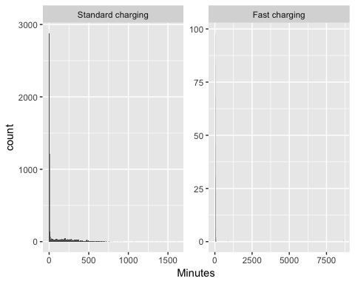

Figure 1 Duration of charging sequences

Table 1 shows the overall distributions and indicates the extent to which the means are skewed by the very small and a few very large values shown in Figure 1.

Table 1 Duration of all charge sequences by charge type (minutes)

chargeType

N

mean

median

min

max

Standard charging

6983

101.24

3.72

0.27

1616.72

Fast charging

392

38.00

12.48

0.32

8621.00

Figure 2 shows the distribution of very short charging sequences. As we can see these appear to be generally less than 8 minutes in length for Standard Charges.

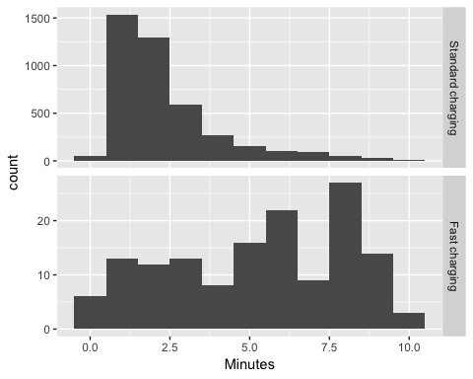

Figure 2 Duration of charging sequences < 10 minutes

Table 2 shows the same descriptive statistics but for all sequences of greater than 8 minute duration. Now we can see that the mean and median durations for Standard Charge sequences are closer to one another.

Table 2 Duration of charge sequences > 8 minutes by charge type (minutes, )

chargeType

N

mean

median

min

max

Standard charging

2860

244.01

208.65

8.02

1616.72

Fast charging

279

51.61

15.73

8.05

8621.00

Manual inspection of the data showed that these short-duration charging “events” generally occurred near the end of a longer-duration charging event. It appeared that once the vehicle had reached its highest state of charge, charging would intermittently stop and start again. This is likely due to the behaviour of the charger once the battery was almost full. In addition to the myriad “short” charging duration values, a small amount of unreasonably long charging durations (longer than 100 hours for standard charging or longer than 14 hours for fast charging) were calculated. As these exceeded the expected charge durations of the most high capacity vehicles currently available, they were also assumed to be anomalies. The analyses in Sections 1 and 5 were therefore made with these unreasonably long or short duration charge events excluded from the data.

Figure 3 shows the distribution of charging sequences with the excessively long or short events removed. These charging durations appear more reasonable when considering standard battery capacities and charging powers.

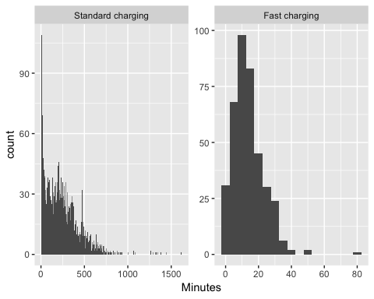

Figure 3 Duration of charging sequences with unreasonably long or short values removed

## Saving 5 x 4 in image

# Observed demand

Figure 4 shows the distribution of observed charging kW demand by inferred charge type. This plot shows that fast charges are relatively rare in the dataset whilst standard charges are much more common, and are mostly concentrated around 1.8kW and 3kW, with a smaller concentration around 6kW.

## `stat_bin()` using `bins = 30`. Pick better value with `binwidth`.

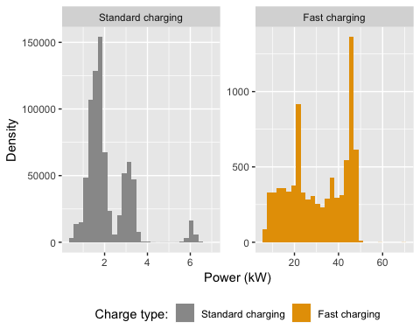

Figure 4 Observed power demand distribution by charge type where charging observed

75% of standard charging observations were 1.47 kW or more but the figure was 20.28 kW or more for fast charging

# Charging duration

Figure 5 show that the duration of standard charging events by event end time drops significantly for events ending around 9:45am. This may indicate that people are plugging in after returning home from a school run or other morning activity, even though the battery is still close to full capacity. It may also suggest that those who plug in shortly after 9:45am but do not have a high battery state of charge are only “topping up”, and take the vehicle out again before charging is fully complete. Duration of fast charge events by event end time appear to be more randomly distributed, although very few events were recorded between midnight and 7am. This, along with the comparatively low number of recorded fast charge events indicated in Fig. 4 suggests that drivers utilize fast charging only “as necessary” to ensure they have enough battery capacity to complete their journey.

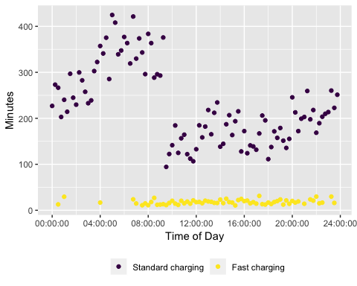

Figure 5 Mean duration (within quarter hours) by time of charging end

Table 3 Mean duration of charge events by charge type

chargeType

N

mean

median

min

max

Standard charging

2860

244.00682

208.65000

8.016667

1616.717

Fast charging

279

51.61231

15.73333

8.050000

8621.000

# State of charge

The state of charge is the percentage of energy still available to be used in the battery. In future, electric vehicles may be able to discharge any remaining battery charge as electricity into the grid, a process known as vehicle to grid (V2G) energy transfer. This may allow electric vehicles to have a net beneficial effect on the grid, reducing the evening peaks by providing electricity to the home during this period, and then recharging later in the evening or early the next morning when peak demand has diminished.

This section provides an indication of the state of charge of electric vehicles upon charging, so that the potential of V2G technology can be assessed.

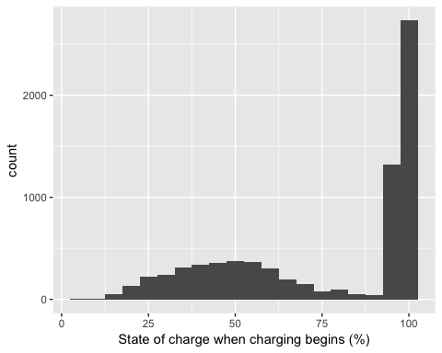

Figure 6 Value of state of charge at beginning of charge

## Saving 5 x 4 in image

As can be seen in Figure 6, using the originally defined “charge begins” data we have the majority of charges beginning while the state of charge is above 90%. This is likely due to the manner in which the charger regularly turns off and on again near the end of the charging cycle as described in Section 3.3.

Figure 7 shows the state of charge values when charge begins but with state of charge greater than 90% removed from the data for clarity. The figure indicates that many vehicles begin charging despite having greater than 50% charge remaining.

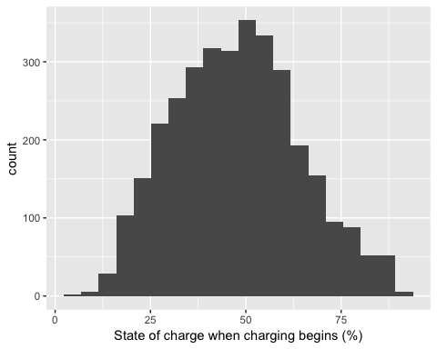

Figure 7 Value of state of charge at beginning of charge (>90% values removed)

## Saving 5 x 4 in image

# Time charging begins

If EV users were starting to charge their vehicles as they arrived home then we would expect a surge in charging observations betweem 16:00 and 18:00 on weekdays. To exclude battery ‘top-ups’ (refer to Section 6) we filter out any data where a charging observation begins while the state of charge is greater than 90%. Having done so, Figure 8 represents the number of charging events that begin at different times of the day on weekdays for standard and fast charging.

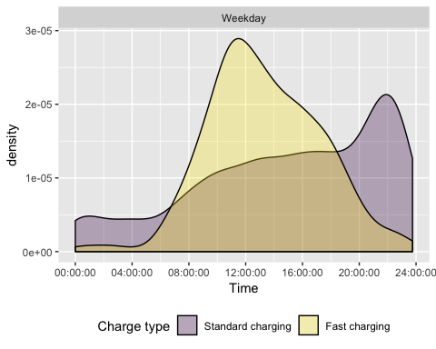

Figure 8 Density plot of charging start times during weekdays

## Saving 5 x 4 in image

Figure 9 repeats this analysis but for charging events that start at weekends.

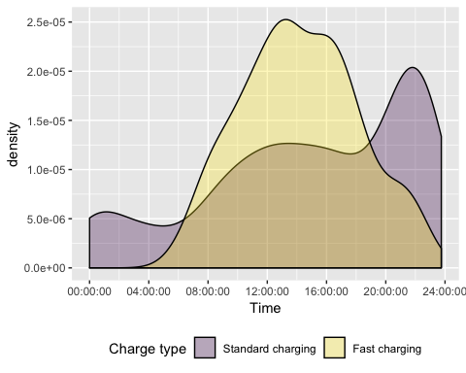

Figure 9 Density plot of charging start times during weekends

## Saving 5 x 4 in image

As we can see, standard charging has a noticeably different profile to charging patterns for fast charges. It suggests that it is common for plug-in vehicle owners to charge overnight at home, and perhaps use the more powerful public charge points to top up during the day.

Standard charging events were most likely to begin around 10pm during both weekdays and weekends. As it seems unlikely that this is due to vehicle drivers returning home at this hour, this effect may be due to drivers setting the charger on a timer to take advantage of cheaper “off-peak” electricity times, which frequently begin around 10pm.

Fast charging events were most likely to begin at 11:30am on weekdays and 1pm during weekends.

These patterns are to some extent repeated in Figure 10 which shows the distribution of observed charging events by time of day and day of the week.

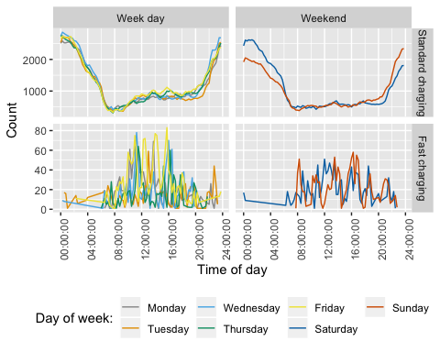

Figure 10 Count of observed charging events by type, day of week and time

This figure indicates the greatest standard charging occurance between the hours of 8pm and 8am, with very low occurrences of charging during morning and evening grid peaks. Fast charging on the other hand is a day-time activityon both weekdays and weekends.

# Summary

In the data provided for this study, most charging occurs at home using either a 1.8kw or 3kW charger, and commonly occurs through the night as opposed to during current grid peaks. In addition, many vehicles begin charging with significant battery capacity remaining, providing them with the ability to provide vehicle to grid energy transfer should that technology become widely available.

If later adopters of electric vehicles can be induced to follow the same “smart” charging patterns as those displayed in our data sample, we propose the effects that electric vehicles have on the electricity grid may not be particularly negative.

# Statistical Annex

## Flip The Fleet data description

Data description for original data supplied (before processing or filtering).

## Skim summary statistics  
## n obs: 1515812   
## n variables: 11   
##   
## ── Variable type:character ─────────────────────────────────────────────────────────────────  
## variable missing complete n min max empty n_unique  
## day_of_week 0 1515812 1515812 6 9 0 7  
## dayid 0 1515812 1515812 32 32 0 5787  
## id 0 1515812 1515812 32 32 0 50  
## month 0 1515812 1515812 3 3 0 10  
##   
## ── Variable type:Date ──────────────────────────────────────────────────────────────────────  
## variable missing complete n min max median  
## date 0 1515812 1515812 2018-04-05 2019-01-25 2018-11-09  
## n_unique  
## 293  
##   
## ── Variable type:difftime ──────────────────────────────────────────────────────────────────  
## variable missing complete n min max median n_unique  
## time 0 1515812 1515812 0 secs 86399 secs 44827 secs 86400  
##   
## ── Variable type:logical ───────────────────────────────────────────────────────────────────  
## variable missing complete n mean count  
## location 1515812 0 1515812 NaN 1515812  
##   
## ── Variable type:numeric ───────────────────────────────────────────────────────────────────  
## variable missing complete n mean sd p0  
## charge_power_kw 0 1515812 1515812 1.73 71 0  
## fractime 0 1515812 1515812 11.9 7.21 0  
## odometer_km 1000156 515656 1515812 7290.5 7954.38 -62920  
## state_of_charge_percent 0 1515812 1515812 69.11 20.85 0  
## p25 p50 p75 p100 hist  
## 0 1.37 1.9 74940.42 ▇▁▁▁▁▁▁▁  
## 5.04 12.45 17.8 24 ▇▆▅▆▆▇▅▆  
## 1889 4749 10529 69394 ▁▁▁▆▇▂▁▁  
## 56.43 70.57 83.2 1677.72 ▇▁▁▁▁▁▁▁

# References

Azadfar, Elham, Victor Sreeram, and David Harries. 2015. “The investigation of the major factors influencing plug-in electric vehicle driving patterns and charging behaviour.” *Renewable and Sustainable Energy Reviews* 42. Elsevier: 1065–76. doi:[10.1016/j.rser.2014.10.058](https://doi.org/10.1016/j.rser.2014.10.058).

Concept Consulting. 2018. “‘ Driving change ’ – Issues and options to maximise the opportunities from large-scale electric vehicle uptake in New Zealand,” no. March.

Eyers, Lisa. 2018. “Electric Chargepoint Analysis 2017 : Domestics Key findings :” no. December.

Khan, Imran, Michael W. Jack, and Janet Stephenson. 2018. “Analysis of greenhouse gas emissions in electricity systems using time-varying carbon intensity.” *Journal of Cleaner Production* 184. Elsevier Ltd: 1091–1101. doi:[10.1016/j.jclepro.2018.02.309](https://doi.org/10.1016/j.jclepro.2018.02.309).

Stephenson, Janet, Rebecca Ford, Nirmal-Kumar Nair, Neville Watson, Alan Wood, and Allan Miller. 2017. “Smart grid research in New Zealand – A review from the GREEN Grid research programme.” doi:[10.1016/j.rser.2017.07.010](https://doi.org/10.1016/j.rser.2017.07.010).

Transpower New Zealand. 2015. “Transmission Planning Report,” no. July: 320.

———. 2017. “Battery Storage in New Zealand,” no. September: 41. <https://www.transpower.co.nz/sites/default/files/publications/resources/Battery Storage in New Zealand.pdf>.