Analysis of electric vehicle usage patterns in New Zealand

Summary Statistical Report

Rafferty Parker and Ben Anderson (University of Otago)

Last run at: 2019-02-05 15:52:29

Table of Contents

# Note

Based on and inspired by the [UK DoT statistical report 2018](https://assets.publishing.service.gov.uk/government/uploads/system/uploads/attachment_data/file/764270/electric-chargepoint-analysis-2017-domestics.pdf).

This is a summary report. A discussion into the background around the effects of EV charging in New Zealand, as well as detailed information on data limitations and data cleaning procedure is given in the full report.

# Data information

## Background

The data consisted of 1291881 data points (of which 790391 were charging (power demand > 0)) from 50 vehicles over 8 months (April 2018 - January 2019) derived from FlipTheFleet’s [blackbox recorder](https://flipthefleet.org/ev-black-box/). The recorder provided measurements at 1 minute frequency of charging behaviour and battery charge state.

Due to privacy considerations, the data is not publically available.

## Definitions:

The capacity of most domestic charging is between 1.8kW to 7kW, whereas charging power above 7kW is available at purpose-built charging stations(Concept Consulting 2018). Each charging event was therefore seperated into “Fast” (> = 7kW) and “Standard” (below 7kW).

A charging event was defined as a continuous sequence of 1 minute observations per vehicle when > 0 kW of demand was observed.

## Cleaning and Preparation

*Perhaps for the summary report this entire subsection could be removed?* There were 6 vehicles within the provided data that had no recorded charging occur. These were immediately discarded.

Some instances of charging power greater than 120kW were recorded. These were considered anomolies and discarded, as these exceed the capacity of the highest charging stations available in New Zealand (Concept Consulting 2018).

Instances of battery state of charge being greater than 100% or less than 0% were also discarded.

Standard charge durations of less than 8 minutes were frequently encountered near the end of a longer charging cycle, where the state of charge had reached it’s maximum. These were assumed to be minor ‘top-ups’, and were discarded. In addition, slow charging events greater than 100 hours were discarded, as were fast charge durations greater than 14 hours. These were presumed anomolies as they exceed the battery capacity of electric vehicles commonly encountered in New Zealand.

For more detailed information on the data cleaning process refer to the main report.

# Key Findings:

* *Power supplied*: The median power supplied during a standard charging was 1.78 kW. The mean was slightly higher at 2.12 kW. Fast charging observations had a higher median of 30.84 kW (mean = 30.68);
* *Charging duration*: Charging durations tended to fall into one of two groups - longer ‘overnight’ charges with a median of XX hours and shorter events during the day both at standard and fast charge rates with a median duration of XX hours.
* *Time of Day*: charging events were more frequent at specific times of the day and day of the week with more evening and over-night charging during weekdays and more day-time charging at weekends. The power demand also varied according to time of day and day of the week.

# Observed demand

Figure 1 shows the distribution of observed charging kW demand by inferred charge type. This plot shows that fast charges are relatively rare in the dataset whilst standard charges are much more common, and are concentrated around 1.8kW, 3kW and 6kW.

## `stat_bin()` using `bins = 30`. Pick better value with `binwidth`.

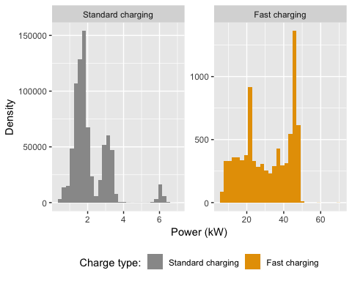

Figure 1 Observed power demand distribution by charge type

75% of standard charging observations were 1.47 kW or more but the figure was 20.28 kW or more for fast charging

# Daily demand

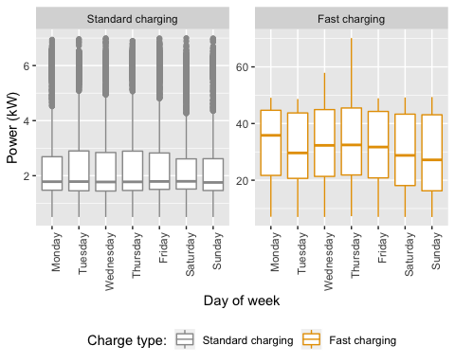

Figure 2 Observed power demand distribution by day of the week and charge type

Figure 2 shows the distribution of observed charging kW demand by day of the week. We can see that fast charging varies in demand but standard charging is relatively constant across days.

# Charging duration

Figure 3 shows the overall distribution of charging sequences. As would be expected, fast charging events tend to have a much shorted duration than standard charging.

Table 1 Duration (minutes) of charge sequences by charge type

chargeType

N

mean

median

min

max

Standard charging

2860

244.01

208.65

8.02

1616.72

Fast charging

277

17.74

15.50

8.05

80.27

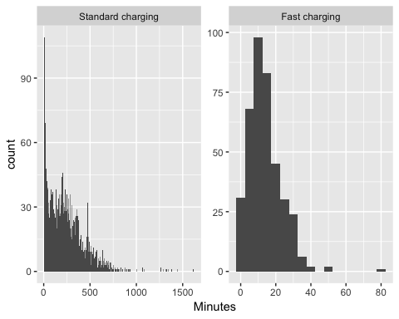

Figure 3 Duration of charging sequences

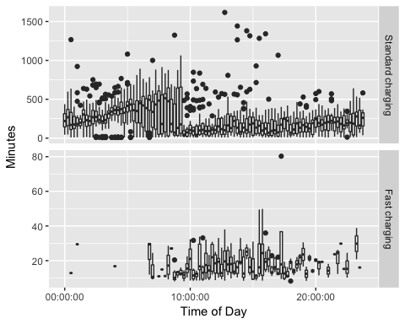

Figure 4 Duration by time of charging start for sequences > 8 minutes

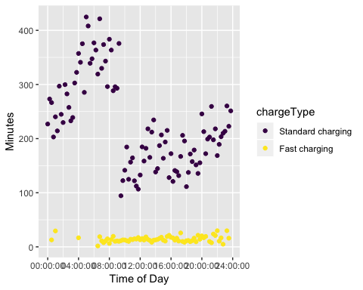

Figure 5 Mean duration (within quarter hours) by time of charging start for sequences > 8 minutes

Table 2 Mean duration of charge events by charge type

chargeType

N

mean

median

min

max

Standard charging

2860

244.00682

208.65

8.016667

1616.71667

Fast charging

277

17.73694

15.50

8.050000

80.26667

# Time of charging

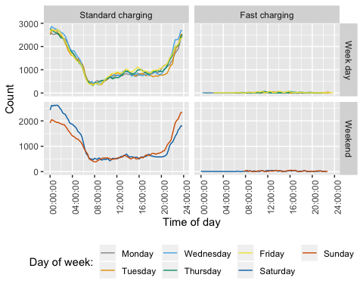

Figure 6 Count of observed charging events by type, day of week and time

Figure 6 shows the distribution of observed charging by time of day and day of the week. Aggregating counts in this way emphasises the times at which charging most commonly occurs and we can see…

Fig: profile of median charging demand by time of day and day of the week faceted by at home vs not at home

Charging demand varies somewhat by time of day and day of the week. Weekdays show … whilst weekends show. Saturdays and Sundays vary with…

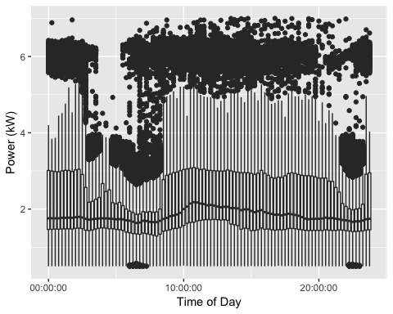

Figure 7 Boxplot of daily standard charging demand

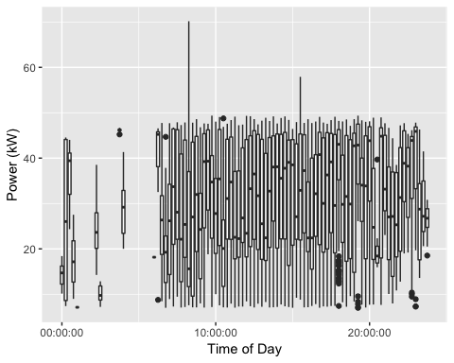

Figure 8 Boxplot of daily fast charging demand

## <ggproto object: Class FacetGrid, Facet, gg>  
## compute_layout: function  
## draw_back: function  
## draw_front: function  
## draw_labels: function  
## draw_panels: function  
## finish_data: function  
## init_scales: function  
## map_data: function  
## params: list  
## setup_data: function  
## setup_params: function  
## shrink: TRUE  
## train_scales: function  
## vars: function  
## super: <ggproto object: Class FacetGrid, Facet, gg>

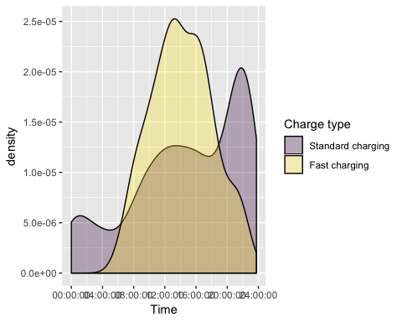

Figure 9 Density plot of charging start times during weekdays



Figure 10 Density plot of charging start times during weekends

Slow charging events most commonly began around 10pm during both weekdays and weekends. As it seems unlikely that this is due to vehicle drivers returning home at this hour, this effect may be due to drivers setting the charger on a timer to take advantage of cheaper “off-peak” electricity times, which freqently begin around 10pm.

Fast charging events tended to begin at 11:30am on weekdays and 1pm during weekends.  
> Discuss any other patterns

# State of charge

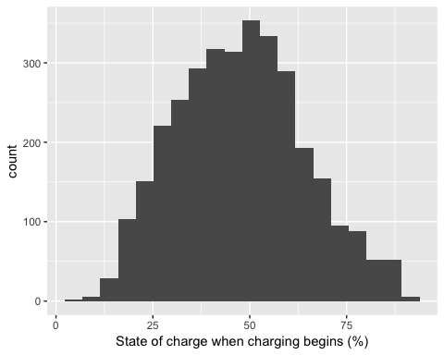

Figure 11 Value of state of charge at beginning of charge

## Saving 5 x 4 in image

Figure 11 shows that many vehicles arrive home with greater than 50% charge remaining and would therefore be able to transfer energy to the home during the evening grid peak as a form of demand response.

# References

Concept Consulting. 2018. “‘ Driving change ’ – Issues and options to maximise the opportunities from large-scale electric vehicle uptake in New Zealand,” no. March.