Code

* Show All Code
* Hide All Code

# NZ GREEN Grid Household Electricity Demand Data

### EECA Data Processing (Part A) Report v0.1

#### Ben Anderson

#### Last run at: 2019-09-03 20:43:15 (Pacific/Auckland)

# 1 About

## 1.1 Citation

If you wish to use any of the material from this report please cite as:

* Ben Anderson (2019) NZ GREEN Grid Household Electricity Demand Data: EECA Data Processing (Part A) Report v0.1 , [Centre for Sustainability](http://www.otago.ac.nz/centre-sustainability/), University of Otago: Dunedin.

This work is (c) 2019 the authors.

## 1.2 Report circulation:

* Public – this report is intended for publication following EECA approval.

## 1.3 License

This work is made available under the Creative Commons [Attribution-ShareAlike 4.0 International (CC BY-SA 4.0) License](https://creativecommons.org/licenses/by-sa/4.0/).

This means you are free to:

* Share — copy and redistribute the material in any medium or format
* Adapt — remix, transform, and build upon the material for any purpose, even commercially.

Under the following terms:

* Attribution — You must give appropriate credit, provide a link to the license, and indicate if changes were made. You may do so in any reasonable manner, but not in any way that suggests the licensor endorses you or your use.
* ShareAlike — If you remix, transform, or build upon the material, you must distribute your contributions under the same license as the original.
* No additional restrictions — You may not apply legal terms or technological measures that legally restrict others from doing anything the license permits.

**Notices:**

* You do not have to comply with the license for elements of the material in the public domain or where your use is permitted by an applicable exception or limitation.
* No warranties are given. The license may not give you all of the permissions necessary for your intended use. For example, other rights such as publicity, privacy, or moral rights may limit how you use the material. #YMMV

For the avoidance of doubt and explanation of terms please refer to the full [license notice](https://creativecommons.org/licenses/by-sa/4.0/) and [legal code](https://creativecommons.org/licenses/by-sa/4.0/legalcode).

## 1.4 History

You may not be reading the most recent version of this report. Please check:

* the github [repository](https://cfsotago.github.io/GREENGridEECA/) and specifically;
* this [report’s edit history](https://github.com/CfSOtago/GREENGridEECA/commits/master/reports/partA_dataProcessing)

## 1.5 Support

This work was supported by:

* The New Zealand Energy Efficiency and Conservation Authority ([EECA](https://www.eeca.govt.nz/))

# 2 Introduction

This report uses the GREEN Grid project (Stephenson et al. 2017) research data to…

XX tbc

# 3 Data

The [NZ GREEN Grid household electricity demand study](https://cfsotago.github.io/GREENGridData/) recruited a sample of c 40 households in each of two regions of New Zealand (Stephenson et al. 2017). The first sample was recruited in early 2014 and the second in early 2015. Research data includes:

* 1 minute electricity power (W) data was collected for each dwelling circuit using [GridSpy](https://gridspy.com/) monitors on each power circuit (and the incoming power). The power values represent mean(W) over the minute preceeding the observation timestamp;
* Dwelling & appliance surveys;
* Occupant time-use diaries (focused on energy use).

The data collection was supported by the New Zealand [Ministry of Business, Innovation and Employment (MBIE)](http://www.mbie.govt.nz/) through the [Renewable Energy and the Smart Grid (GREEN Grid)](https://www.otago.ac.nz/centre-sustainability/research/energy/otago050285.html) grant (Contract ID: UOCX1203).

# 4 Multi-year data availability

Whilst the GREEN Grid project collected data from 2014-01-06 to 2018-11-22, we do not have complete multi-year coverage of the 45 dwellings for whom data exists.

As Figure 4.1 shows data is available for most of the 24 dwellings in the Taranaki region from mid 2014 and for most of the 20 dwellings in Hawkes Bay from early 2015. In most cases the ‘right’ number of observations were received per half hour (30) when the dwellings were sending data. However not all dwellings sent data continuously with substantial attrition by 2017 (Figure 4.2.

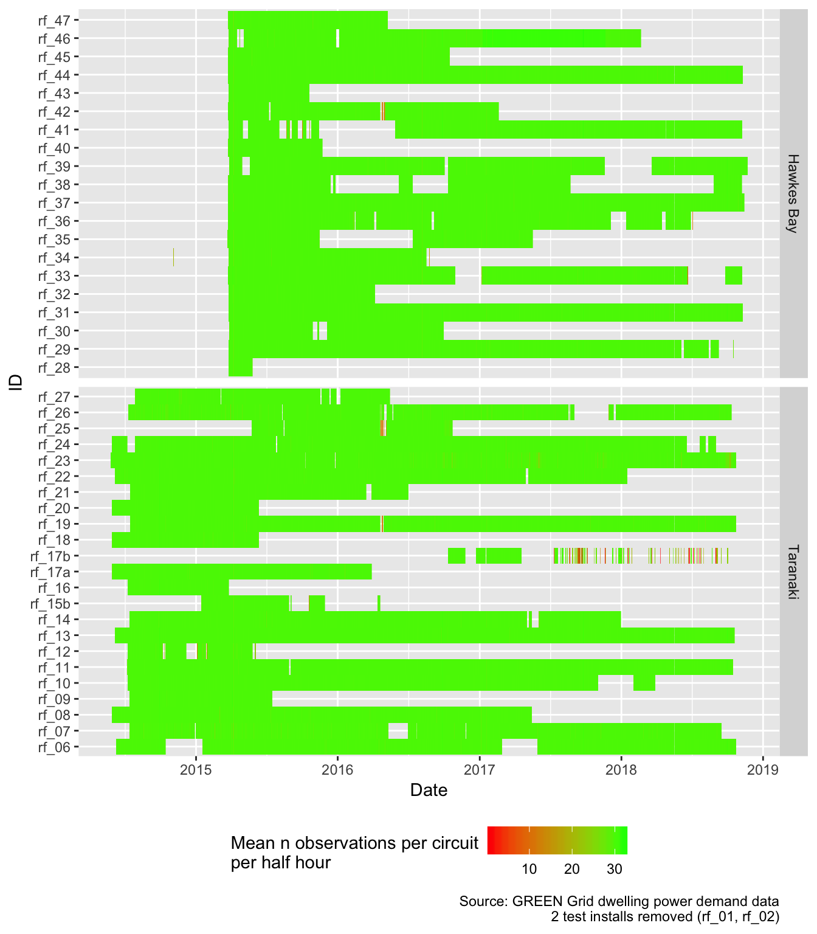

Figure 4.1: Mean number of observations per circuit per half hour

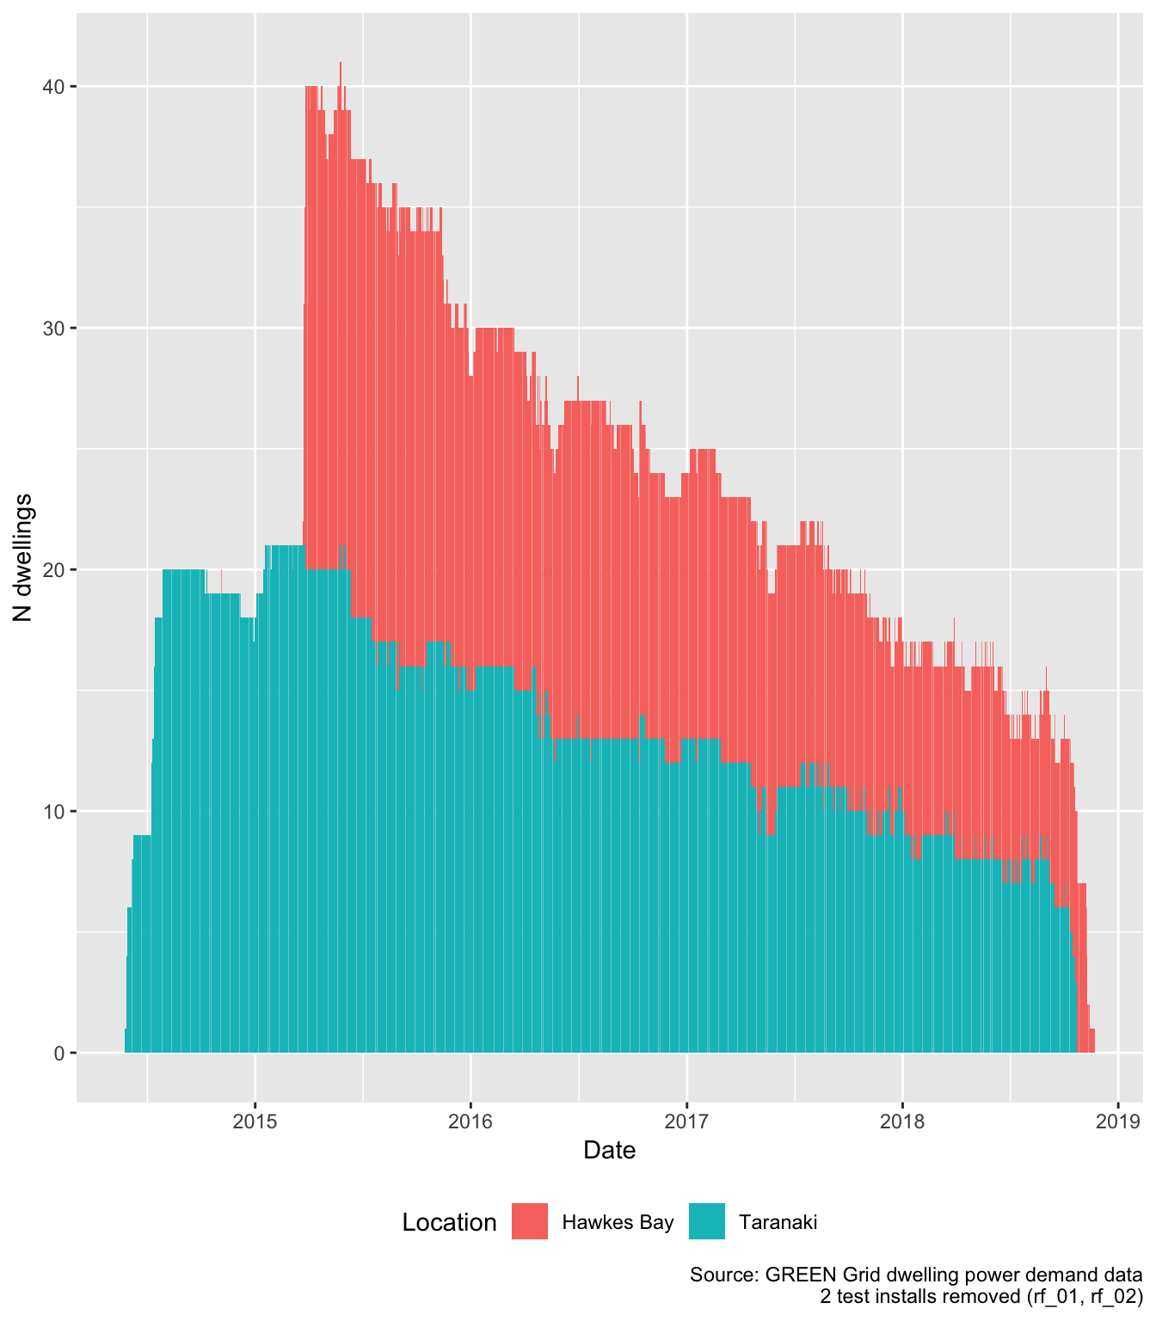

Figure 4.2: Number of dwellings sending data per day

For clarity, Figure 4.3 shows the mean daily number of dwellings present in the data in each year and season for each region. Whilst it is clear that 2015 provides the highest level of reporting dwellings, it also shows that it would be at least possible to calculate seasonal summaries for several years.

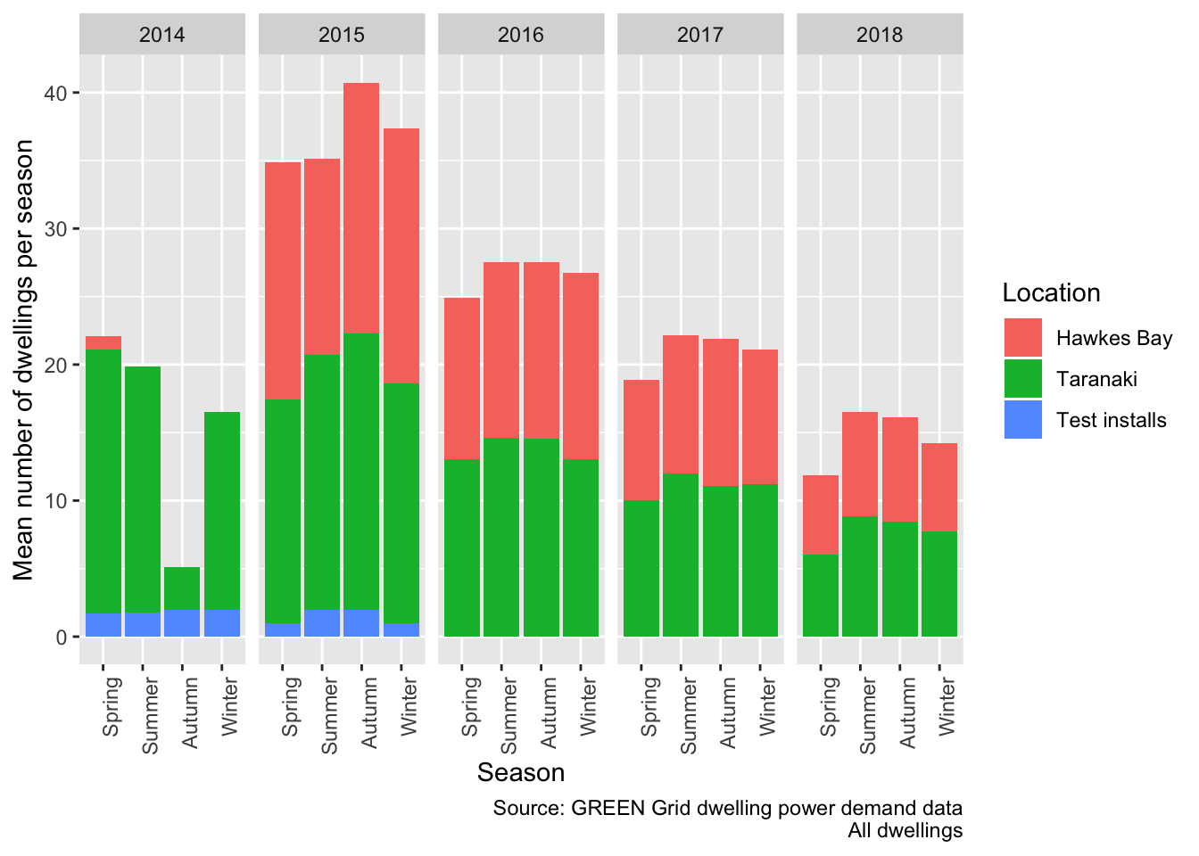

Figure 4.3: Active dwellings by season

However, it should be noted that:

* not all dwellings contained the appliance circuits of analyitic interest;
* one dwelling (rf_46) has ambiguous circuit labels and so [should be ignored](https://github.com/CfSOtago/GREENGridData/issues/1);
* a number of dwellings have a very high proportion of -ve power values for some circuits mostl likely due to PV installation (e.g. [rf_14,rf_25,rf_26,rf_43](https://cfsotago.github.io/GREENGridData/reportTotalPower_circuitsToSum_v1.1.html#6_implications)) and so should be ignored if total dwelling load is required;
* similarly some dwellings have a small number of -ve power values on non-PV circuits at some times, possibly due to brief incorrect fitting of the monitors.

As a result the effective number of dwellings available for any given analysis will always be lower than the numbers reported above and should be evaluated on a case by case basis.

# 5 Imputation of ‘total load’ per minute per dwelling

Whilst in theory the calculation of total load in any given minute should be a matter of merely summing all monitored circuits, in practice the task is not quite this simple. There are a number of reasons for this:

* for some dwellings the hot water circuit is seperately metered and thus monitored but for others it is part of the overall ‘incomer/mains’ demand;
* photovoltaic panels were installed in several dwellings which produce negative power values and so would reduce apparent demand if naively aggregated;
* several dwellings report either systematic or intemittent negative values yet do not have PV installations.

Our previously work has shown that [with appropriate care](https://cfsotago.github.io/GREENGridData/reportTotalPower_circuitsToSum_v1.1.html) it is possible to derive best effort estimates of total dwelling power load by summing a small number of particular circuits for each dwelling (Anderson 2019). However the issues described above mean that users should:

* exclude dwellings with (link) IDs: rf_14,rf_25,rf_26 and rf_43 due to substantial unexplained negative values;
* exclude other -ve values on a per-value basis. We recommend setting such values to NA (***not 0***);
* include dwellings known to have PV only if analysis of demand during non-daylight hours is being undertaken or if net demand is of interest.

Seperately, for reasons explained [elsewhere](https://cfsotago.github.io/GREENGridData/gridSpy1mOutliersReport_v1.0.html#45_the_mysterious_case_of_rf_46) we also recommend removing rf_46 from the data prior to analysis.

In all cases we recommend that users check the data carefully before analysis and document any filtering they apply.

We have therefore created a new dataset for each dwelling which comprises the estimated total load per minute for each dwelling for the entire time frame for which we have data (ref Figure 4.2). For ease of use this data is available as:

* an additional set of observations added to the end of each clean data file with circuit label set to imputedTotalDemand_circuitsToSum_v1.1 indicating that the [aggregation code](https://github.com/CfSOtago/GREENGridData/blob/master/dataProcessing/gridSpy/imputeTotalPower.R) used the [circuitsToSum definition v1.1](https://github.com/CfSOtago/GREENGridData/blob/master/data/circuitsToSum_v1.1.csv);
* a single file containing only the estimated total load per minute per dwelling.

Note that we have not applied the exclusion rules described above. In order to ensure all data is available if required, these rules should only be applied just prior to analysis. The files are listed in Table 5.1. Whilst we can make these data files available, potential users should note that they are larger than the original data files. The single file containing only the estimated total load per minute per dwelling is especially large.

| Table 5.1: Size of clean data files with estimated load | |
| --- | --- |
| **file** | **Mb (gzipped)** |
| all_1min_data_withImputedTotal_circuitsToSum_v1.1.csv.gz | 497.70 |
| rf_01_all_1min_data_withImputedTotal_circuitsToSum_v1.1.csv.gz | 35.43 |
| rf_02_all_1min_data_withImputedTotal_circuitsToSum_v1.1.csv.gz | 21.24 |
| rf_06_all_1min_data_withImputedTotal_circuitsToSum_v1.1.csv.gz | 78.65 |
| rf_07_all_1min_data_withImputedTotal_circuitsToSum_v1.1.csv.gz | 83.80 |
| rf_08_all_1min_data_withImputedTotal_circuitsToSum_v1.1.csv.gz | 63.28 |
| rf_09_all_1min_data_withImputedTotal_circuitsToSum_v1.1.csv.gz | 21.92 |
| rf_10_all_1min_data_withImputedTotal_circuitsToSum_v1.1.csv.gz | 69.41 |
| rf_11_all_1min_data_withImputedTotal_circuitsToSum_v1.1.csv.gz | 80.80 |
| rf_12_all_1min_data_withImputedTotal_circuitsToSum_v1.1.csv.gz | 15.83 |
| rf_13_all_1min_data_withImputedTotal_circuitsToSum_v1.1.csv.gz | 98.29 |
| rf_14_all_1min_data_withImputedTotal_circuitsToSum_v1.1.csv.gz | 68.16 |
| rf_15b_all_1min_data_withImputedTotal_circuitsToSum_v1.1.csv.gz | 16.53 |
| rf_16_all_1min_data_withImputedTotal_circuitsToSum_v1.1.csv.gz | 14.47 |
| rf_17a_all_1min_data_withImputedTotal_circuitsToSum_v1.1.csv.gz | 38.17 |
| rf_17b_all_1min_data_withImputedTotal_circuitsToSum_v1.1.csv.gz | 10.32 |
| rf_18_all_1min_data_withImputedTotal_circuitsToSum_v1.1.csv.gz | 23.23 |
| rf_19_all_1min_data_withImputedTotal_circuitsToSum_v1.1.csv.gz | 118.11 |
| rf_20_all_1min_data_withImputedTotal_circuitsToSum_v1.1.csv.gz | 22.37 |
| rf_21_all_1min_data_withImputedTotal_circuitsToSum_v1.1.csv.gz | 38.80 |
| rf_22_all_1min_data_withImputedTotal_circuitsToSum_v1.1.csv.gz | 78.65 |
| rf_23_all_1min_data_withImputedTotal_circuitsToSum_v1.1.csv.gz | 91.03 |
| rf_24_all_1min_data_withImputedTotal_circuitsToSum_v1.1.csv.gz | 86.61 |
| rf_25_all_1min_data_withImputedTotal_circuitsToSum_v1.1.csv.gz | 28.56 |
| rf_26_all_1min_data_withImputedTotal_circuitsToSum_v1.1.csv.gz | 76.03 |
| rf_27_all_1min_data_withImputedTotal_circuitsToSum_v1.1.csv.gz | 36.07 |
| rf_28_all_1min_data_withImputedTotal_circuitsToSum_v1.1.csv.gz | 3.49 |
| rf_29_all_1min_data_withImputedTotal_circuitsToSum_v1.1.csv.gz | 74.76 |
| rf_30_all_1min_data_withImputedTotal_circuitsToSum_v1.1.csv.gz | 29.38 |
| rf_31_all_1min_data_withImputedTotal_circuitsToSum_v1.1.csv.gz | 67.48 |
| rf_32_all_1min_data_withImputedTotal_circuitsToSum_v1.1.csv.gz | 20.82 |
| rf_33_all_1min_data_withImputedTotal_circuitsToSum_v1.1.csv.gz | 66.67 |
| rf_34_all_1min_data_withImputedTotal_circuitsToSum_v1.1.csv.gz | 30.87 |
| rf_35_all_1min_data_withImputedTotal_circuitsToSum_v1.1.csv.gz | 32.93 |
| rf_36_all_1min_data_withImputedTotal_circuitsToSum_v1.1.csv.gz | 57.78 |
| rf_37_all_1min_data_withImputedTotal_circuitsToSum_v1.1.csv.gz | 65.21 |
| rf_38_all_1min_data_withImputedTotal_circuitsToSum_v1.1.csv.gz | 35.26 |
| rf_39_all_1min_data_withImputedTotal_circuitsToSum_v1.1.csv.gz | 56.52 |
| rf_40_all_1min_data_withImputedTotal_circuitsToSum_v1.1.csv.gz | 14.53 |
| rf_41_all_1min_data_withImputedTotal_circuitsToSum_v1.1.csv.gz | 55.73 |
| rf_42_all_1min_data_withImputedTotal_circuitsToSum_v1.1.csv.gz | 38.96 |
| rf_43_all_1min_data_withImputedTotal_circuitsToSum_v1.1.csv.gz | 11.20 |
| rf_44_all_1min_data_withImputedTotal_circuitsToSum_v1.1.csv.gz | 67.23 |
| rf_45_all_1min_data_withImputedTotal_circuitsToSum_v1.1.csv.gz | 32.28 |
| rf_46_all_1min_data_withImputedTotal_circuitsToSum_v1.1.csv.gz | 160.69 |
| rf_47_all_1min_data_withImputedTotal_circuitsToSum_v1.1.csv.gz | 21.95 |

Table 5.2 shows basic statistics for the estimated 1 minute level load for each dwelling and illustrates some of the issues described above.

| Table 5.2: Basic statistics for the estimated 1 minute level load (W) for each dwelling | | | | | | | |
| --- | --- | --- | --- | --- | --- | --- | --- |
| **linkID** | **PV Inverter** | **Location** | **nObs** | **meanW** | **minW** | **maxW** | **sdW** |
| rf_01 | NA | Test installs | 851,716 | 1662.15 | 0.00 | 13560.50 | 1742.03 |
| rf_02 | NA | Test installs | 581,156 | 719.25 | -330.38 | 10204.00 | 998.49 |
| rf_06 |  | Taranaki | 1,883,074 | 941.95 | -1436.21 | 10804.38 | 1128.38 |
| rf_07 |  | Taranaki | 2,010,201 | 604.47 | -263.00 | 9508.46 | 656.20 |
| rf_08 |  | Taranaki | 1,548,193 | 1044.98 | 35.14 | 11973.94 | 1144.81 |
| rf_09 |  | Taranaki | 527,883 | 648.63 | -16.00 | 8586.00 | 757.80 |
| rf_10 |  | Taranaki | 1,822,053 | 596.12 | 27.68 | 9860.26 | 772.91 |
| rf_11 |  | Taranaki | 2,127,141 | 545.92 | 14.00 | 11855.49 | 885.84 |
| rf_12 |  | Taranaki | 398,134 | 779.81 | -406.00 | 10439.03 | 1217.16 |
| rf_13 |  | Taranaki | 2,179,995 | 1455.69 | 92.46 | 11580.60 | 1188.63 |
| rf_14 |  | Taranaki | 1,783,337 | 612.96 | -1758.08 | 9894.88 | 739.48 |
| rf_15b |  | Taranaki | 390,846 | 1255.16 | -1062.00 | 10536.10 | 1202.39 |
| rf_16 |  | Taranaki | 372,306 | 538.28 | -262.00 | 8691.89 | 821.54 |
| rf_17a |  | Taranaki | 959,929 | 526.92 | -1084.72 | 9041.53 | 788.89 |
| rf_17b |  | Taranaki | 272,150 | 351.03 | 32.17 | 6495.37 | 481.33 |
| rf_18 |  | Taranaki | 540,446 | 1444.19 | -1842.66 | 13079.07 | 1901.81 |
| rf_19 | yes | Taranaki | 2,109,122 | -589.54 | -12407.52 | 7363.92 | 2035.90 |
| rf_20 |  | Taranaki | 543,382 | 813.60 | -1273.19 | 9739.43 | 1083.75 |
| rf_21 |  | Taranaki | 1,010,258 | 483.36 | 31.00 | 7990.10 | 607.06 |
| rf_22 |  | Taranaki | 1,885,333 | 1291.44 | 47.92 | 11535.40 | 1342.73 |
| rf_23 | yes | Taranaki | 2,181,070 | 1078.65 | -1871.83 | 11015.80 | 1126.36 |
| rf_24 | yes | Taranaki | 2,107,577 | 76.59 | -7542.61 | 9929.11 | 1518.25 |
| rf_25 |  | Taranaki | 706,148 | 859.16 | 0.00 | 11814.74 | 1071.90 |
| rf_26 |  | Taranaki | 1,938,549 | 707.24 | -482.36 | 9366.50 | 997.70 |
| rf_27 |  | Taranaki | 908,658 | 1118.20 | 58.00 | 9569.40 | 1062.34 |
| rf_28 | yes | Hawkes Bay | 86,311 | -135.48 | -3366.52 | 7960.34 | 983.91 |
| rf_29 |  | Hawkes Bay | 1,749,695 | 1606.68 | 76.85 | 12011.87 | 1400.14 |
| rf_30 |  | Hawkes Bay | 743,770 | 743.41 | 30.00 | 8706.07 | 751.49 |
| rf_31 |  | Hawkes Bay | 1,760,227 | 642.32 | 24.00 | 10547.60 | 864.45 |
| rf_32 |  | Hawkes Bay | 541,109 | 677.75 | 0.00 | 8274.91 | 850.74 |
| rf_33 |  | Hawkes Bay | 1,601,314 | 814.45 | 63.47 | 9654.25 | 966.47 |
| rf_34 |  | Hawkes Bay | 730,613 | 1159.12 | 0.00 | 13043.50 | 1189.61 |
| rf_35 |  | Hawkes Bay | 781,977 | 1339.89 | -622.00 | 10373.54 | 1223.08 |
| rf_36 |  | Hawkes Bay | 1,605,647 | 829.98 | 0.00 | 14826.00 | 1301.66 |
| rf_37 |  | Hawkes Bay | 1,763,330 | 583.05 | 51.00 | 9365.54 | 1019.71 |
| rf_38 |  | Hawkes Bay | 886,482 | 1058.81 | -179.00 | 9455.19 | 1383.36 |
| rf_39 |  | Hawkes Bay | 1,537,301 | 1920.08 | -199.00 | 15593.20 | 1767.34 |
| rf_40 |  | Hawkes Bay | 348,217 | 1191.50 | 24.00 | 12527.77 | 1326.90 |
| rf_41 |  | Hawkes Bay | 1,372,961 | 1014.34 | 54.83 | 12857.00 | 1053.56 |
| rf_42 |  | Hawkes Bay | 975,198 | 1230.27 | 33.61 | 12383.70 | 1563.55 |
| rf_43 |  | Hawkes Bay | 296,190 | 626.90 | 0.00 | 6687.53 | 719.72 |
| rf_44 |  | Hawkes Bay | 1,762,049 | 1079.67 | 32.00 | 12165.12 | 1573.37 |
| rf_45 |  | Hawkes Bay | 819,601 | 771.95 | 23.90 | 10385.13 | 1237.62 |
| rf_46 |  | Hawkes Bay | 1,939,634 | 1622.95 | 92.00 | 12979.28 | 1399.64 |
| rf_47 |  | Hawkes Bay | 588,348 | 415.53 | 21.00 | 11171.30 | 673.20 |

# 6 Development of a half-hourly power demand dataset

In response to EECA’s request we have used the per-dwelling files listed in Table 5.1 to produce an aggregated half-hourly power demand dataset **for each dwelling**.

These files contain:

* r_dateTimeHalfHour (in UTC) in half hours;
* number of observations, mean, min, max and standard deviation of power (W) for each half hour;
* circuit label with total load labelled as imputedTotalDemand_circuitsToSum_v1.1;
* dwelling linkID (for linkage to survey data).

Table 6.1 shows the first few rows of one of these files.

| Table 6.1: Half hourly data format with example data | | | | | | | |
| --- | --- | --- | --- | --- | --- | --- | --- |
| **linkID** | **circuit** | **r_dateTimeHalfHour** | **meanPowerW** | **nObs** | **sdPowerW** | **minPowerW** | **maxPowerW** |
| rf_01 | Heating$1633 | 2014-01-06 16:00:00 | 28.39 | 2 | 0.00 | 28.39 | 28.39 |
| rf_01 | Heating$1633 | 2014-03-07 15:30:00 | 28.27 | 4 | 0.24 | 27.91 | 28.39 |
| rf_01 | Heating$1633 | 2014-03-07 16:00:00 | 393.55 | 19 | 423.92 | 27.91 | 925.09 |
| rf_01 | Heating$1633 | 2014-03-07 16:30:00 | 909.96 | 30 | 7.65 | 897.09 | 921.28 |
| rf_01 | Heating$1633 | 2014-03-07 17:00:00 | 896.36 | 30 | 2.77 | 891.39 | 903.27 |
| rf_01 | Heating$1633 | 2014-03-07 17:30:00 | 905.08 | 30 | 17.19 | 885.21 | 936.97 |

The resulting files are listed in Table 6.2.

| Table 6.2: Size of clean half hourly data files | |
| --- | --- |
| **file** | **Mb (gzipped)** |
| rf_01_allObs_halfHourly.csv.gz | 3.71 |
| rf_02_allObs_halfHourly.csv.gz | 2.25 |
| rf_06_allObs_halfHourly.csv.gz | 8.26 |
| rf_07_allObs_halfHourly.csv.gz | 8.92 |
| rf_08_allObs_halfHourly.csv.gz | 5.73 |
| rf_09_allObs_halfHourly.csv.gz | 2.54 |
| rf_10_allObs_halfHourly.csv.gz | 7.21 |
| rf_11_allObs_halfHourly.csv.gz | 7.97 |
| rf_12_allObs_halfHourly.csv.gz | 1.71 |
| rf_13_allObs_halfHourly.csv.gz | 10.48 |
| rf_14_allObs_halfHourly.csv.gz | 7.43 |
| rf_15b_allObs_halfHourly.csv.gz | 1.59 |
| rf_16_allObs_halfHourly.csv.gz | 1.75 |
| rf_17a_allObs_halfHourly.csv.gz | 3.73 |
| rf_17b_allObs_halfHourly.csv.gz | 1.03 |
| rf_18_allObs_halfHourly.csv.gz | 2.21 |
| rf_19_allObs_halfHourly.csv.gz | 10.40 |
| rf_20_allObs_halfHourly.csv.gz | 2.37 |
| rf_21_allObs_halfHourly.csv.gz | 3.88 |
| rf_22_allObs_halfHourly.csv.gz | 8.42 |
| rf_23_allObs_halfHourly.csv.gz | 9.19 |
| rf_24_allObs_halfHourly.csv.gz | 7.90 |
| rf_25_allObs_halfHourly.csv.gz | 3.09 |
| rf_26_allObs_halfHourly.csv.gz | 7.92 |
| rf_27_allObs_halfHourly.csv.gz | 3.10 |
| rf_28_allObs_halfHourly.csv.gz | 0.37 |
| rf_29_allObs_halfHourly.csv.gz | 6.54 |
| rf_30_allObs_halfHourly.csv.gz | 2.84 |
| rf_31_allObs_halfHourly.csv.gz | 6.60 |
| rf_32_allObs_halfHourly.csv.gz | 1.84 |
| rf_33_allObs_halfHourly.csv.gz | 6.29 |
| rf_34_allObs_halfHourly.csv.gz | 3.23 |
| rf_35_allObs_halfHourly.csv.gz | 3.21 |
| rf_36_allObs_halfHourly.csv.gz | 4.99 |
| rf_37_allObs_halfHourly.csv.gz | 7.10 |
| rf_38_allObs_halfHourly.csv.gz | 4.16 |
| rf_39_allObs_halfHourly.csv.gz | 6.28 |
| rf_40_allObs_halfHourly.csv.gz | 1.53 |
| rf_41_allObs_halfHourly.csv.gz | 6.39 |
| rf_42_allObs_halfHourly.csv.gz | 4.01 |
| rf_43_allObs_halfHourly.csv.gz | 1.06 |
| rf_44_allObs_halfHourly.csv.gz | 6.58 |
| rf_45_allObs_halfHourly.csv.gz | 3.09 |
| rf_46_allObs_halfHourly.csv.gz | 18.22 |
| rf_47_allObs_halfHourly.csv.gz | 2.03 |

Further, these per-dwelling files have been used to attempt to create single data files containing all observations for the circuits or (partial) circuit labels set out in the following sections. Table 8.2 in Section 8.3 of the Data Annex shows the unique circuit labels available as a guide to what can be meaningfully extracted.

## 6.1 Lighting

In this section we extract every record where:

* the string “Lighting” is found in circuit

Table 6.3 and Figure 6.1 show summary statistics of the half-hourly mean values for all observations extracted by circuit label. Note that the process may have matched a number of circuits and in some cases circuits may contain other appliances. Analysis should therefore proceed with caution.

| Table 6.3: Summary statistics for extract | | | | | | |
| --- | --- | --- | --- | --- | --- | --- |
| **circuitLabel** | **nObs** | **nDwellings** | **meanW** | **minW** | **maxW** | **sdW** |
| Lighting | 820108 | 20 | 105.181 | -127.277 | 3411.401 | 234.672 |
| Lighting & 2 Towel Rail | 56686 | 1 | 277.431 | 0.000 | 2101.948 | 183.183 |
| Lighting (inc heat lamps) | 32529 | 1 | 361.126 | 0.000 | 3528.905 | 538.110 |
| Lighting 1/2 | 9236 | 1 | -1.737 | -68.609 | 14.600 | 6.008 |
| Lighting 2/2 | 9236 | 1 | 7.948 | 0.000 | 166.436 | 19.380 |
| Lighting1 | 19407 | 1 | 440.832 | 41.400 | 2187.108 | 312.316 |
| Lighting2 | 19407 | 1 | 42.556 | -127.277 | 415.553 | 68.866 |
| Lighting_Imag | 7583 | 1 | 9.507 | -96.211 | 471.371 | 68.458 |

## Gziping /Users/ben/Data/NZ_GREENGrid/safe//gridSpy/halfHour/extracts/halfHourLighting.csv

## Gzipped /Users/ben/Data/NZ_GREENGrid/safe//gridSpy/halfHour/extracts/halfHourLighting.csv

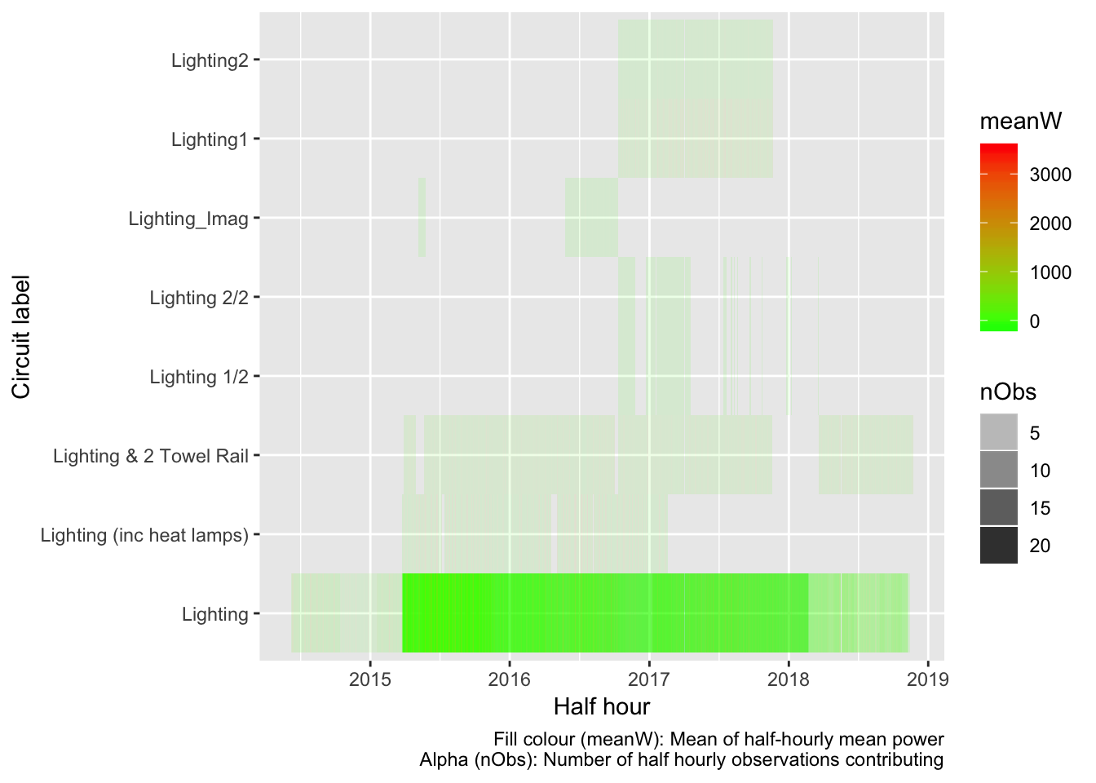

Figure 6.1: Lighting data summary

We therefore have Lighting data for 27 dwellings.

## 6.2 Hot water

In this section we extract every record where:

* the string “Hot water” is found in circuit
* the string “Hot Water” is found in circuit

Table 6.4 and Figure 6.2 show the mean power (mean of the half-hourly mean values) for all observations extracted by circuit label. Note that in some cases circuits may contain other appliances. Analysis should therefore proceed with caution.

| Table 6.4: Summary statistics for extract | | | | | | |
| --- | --- | --- | --- | --- | --- | --- |
| **circuitLabel** | **nObs** | **nDwellings** | **meanW** | **minW** | **maxW** | **sdW** |
| Hot Water | 32452 | 2 | 305.402 | 0.000 | 2215.737 | 495.432 |
| Hot Water (2 elements) | 56686 | 1 | 398.646 | 0.000 | 3317.472 | 800.113 |
| Hot Water - Controlled | 1026607 | 23 | 289.521 | -525.423 | 3317.720 | 642.417 |
| Hot Water - Controlled (HEMS) | 76868 | 1 | 264.077 | 0.000 | 1459.965 | 435.468 |
| Hot Water - Controlled1 | 19407 | 1 | 264.633 | -0.570 | 2137.988 | 613.222 |
| Hot Water - Controlled2 | 19407 | 1 | 2.893 | -26.632 | 56.671 | 6.783 |
| Hot Water - Controlled_Imag | 7583 | 1 | 1.385 | -32.408 | 89.840 | 4.947 |
| Hot Water - Uncontrolled | 136539 | 4 | 308.662 | -208.233 | 3901.050 | 624.055 |
| Hot Water Cpbd Heater- Cont | 74492 | 1 | 75.778 | 0.000 | 1955.707 | 152.815 |
| Hot water | 28401 | 1 | 216.747 | 0.000 | 1874.646 | 470.285 |
| Incomer 1 - Hot Water - Cont | 13310 | 1 | 431.691 | 0.000 | 3057.669 | 763.904 |

## Gziping /Users/ben/Data/NZ_GREENGrid/safe//gridSpy/halfHour/extracts/halfHourHotWater.csv

## Gzipped /Users/ben/Data/NZ_GREENGrid/safe//gridSpy/halfHour/extracts/halfHourHotWater.csv

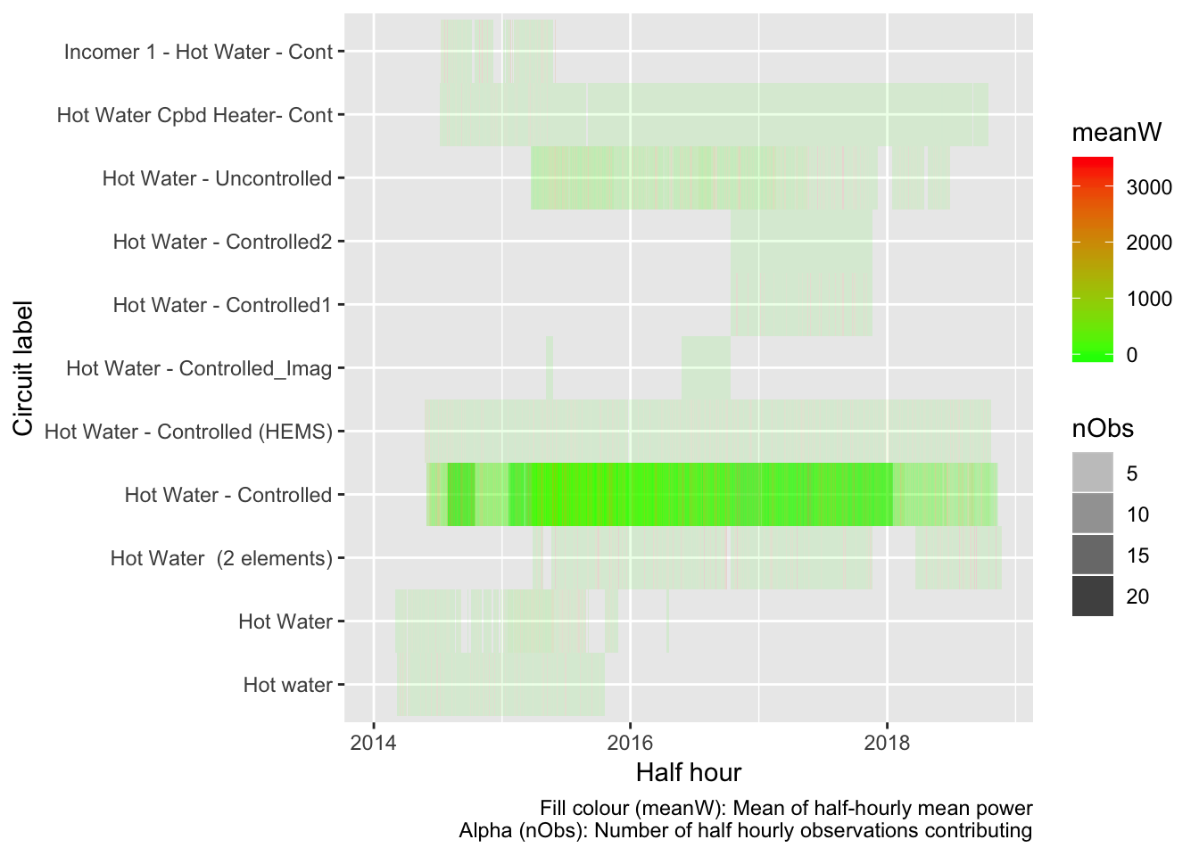

Figure 6.2: Hot water data summary

We therefore have Hot Water data for 37 dwellings.

## 6.3 Heat pumps

In this section we extract every record where:

* the string “Heat Pump” is found in circuit

Table 6.5 and Figure 6.3 show the mean power (mean of the half-hourly mean values) for all observations extracted by circuit label. Note that in some cases circuits may contain other appliances. Analysis should therefore proceed with caution.

| Table 6.5: Summary statistics for extract | | | | | | |
| --- | --- | --- | --- | --- | --- | --- |
| **circuitLabel** | **nObs** | **nDwellings** | **meanW** | **minW** | **maxW** | **sdW** |
| Bedroom & Lounge Heat Pumps | 74276 | 1 | 92.887 | 0.000 | 2555.719 | 196.406 |
| Downstairs (inc 1 Heat Pump) | 76421 | 1 | -8.075 | -2583.502 | 2967.435 | 458.986 |
| Heat Pump | 667260 | 18 | 92.005 | -64.270 | 4982.931 | 285.687 |
| Heat Pump & 2 x Bathroom Heat | 19625 | 1 | 119.058 | 0.000 | 3559.722 | 368.699 |
| Heat Pump & Bedroom 2 | 17605 | 1 | 153.405 | -26.877 | 3242.937 | 320.690 |
| Heat Pump & Kitchen Appliances | 59922 | 1 | 592.044 | 0.000 | 3760.920 | 479.634 |
| Heat Pump & Lounge | 74492 | 1 | 227.028 | 0.000 | 3314.134 | 374.529 |
| Heat Pump & Misc | 18124 | 1 | 176.614 | -173.072 | 1701.146 | 225.030 |
| Heat Pump & Washing Machine | 33684 | 1 | 113.523 | 0.000 | 3120.887 | 268.412 |
| Heat Pump (x2) & Lounge Power | 11618 | 1 | 330.668 | 0.000 | 5340.914 | 710.990 |
| Heat Pumps (2x) & Power | 81989 | 1 | 116.971 | -242.388 | 2959.364 | 291.750 |
| Heat Pumps (2x) & Power1 | 19407 | 1 | 235.390 | 5.915 | 2959.364 | 284.451 |
| Heat Pumps (2x) & Power2 | 19407 | 1 | -66.280 | -241.699 | 249.051 | 60.350 |
| Heat Pumps (2x) & Power_Imag | 7583 | 1 | -105.076 | -269.724 | 250.487 | 50.018 |
| Kitchen Appliances & Heat Pump | 55442 | 1 | 272.446 | 62.990 | 3180.312 | 264.583 |
| Theatre Heat Pump | 74276 | 1 | 2.908 | -3.267 | 999.087 | 28.316 |
| Upstairs Heat Pumps | 76421 | 1 | 151.876 | -46.290 | 2762.926 | 366.908 |

## Gziping /Users/ben/Data/NZ_GREENGrid/safe//gridSpy/halfHour/extracts/halfHourHeatPump.csv

## Gzipped /Users/ben/Data/NZ_GREENGrid/safe//gridSpy/halfHour/extracts/halfHourHeatPump.csv

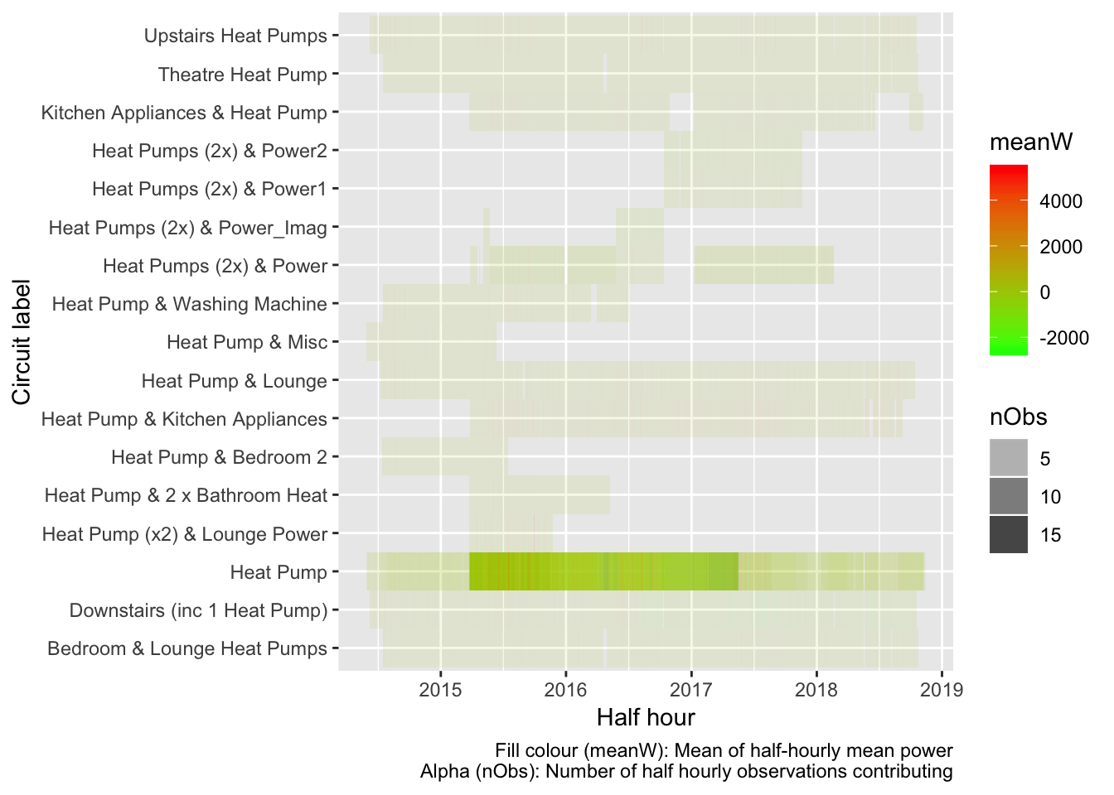

Figure 6.3: Heat Pump data summary

We therefore have Heat Pump data for 34 dwellings.

## 6.4 Kitchen

Noting that this may include other areas of the dwelling…

In this section we extract every record where:

* the string “Kitchen” is found in circuit

Table 6.6 and Figure 6.4 show the mean power (mean of the half-hourly mean values) for all observations extracted by circuit label. Note that in some cases circuits may contain other appliances. Analysis should therefore proceed with caution.

| Table 6.6: Summary statistics for extract | | | | | | |
| --- | --- | --- | --- | --- | --- | --- |
| **circuitLabel** | **nObs** | **nDwellings** | **meanW** | **minW** | **maxW** | **sdW** |
| Heat Pump & Kitchen Appliances | 59922 | 1 | 592.044 | 0.000 | 3760.920 | 479.634 |
| Hob & Kitchen Appliances | 23570 | 1 | 349.554 | 0.000 | 2379.292 | 319.873 |
| Kitchen | 190450 | 3 | 89.979 | 0.000 | 2273.916 | 159.578 |
| Kitchen & Bedrooms | 81989 | 1 | 111.272 | -45.302 | 2106.422 | 165.294 |
| Kitchen & Bedrooms1 | 19407 | 1 | 117.717 | 0.000 | 1436.520 | 170.837 |
| Kitchen & Bedrooms2 | 19407 | 1 | 39.627 | -37.738 | 205.681 | 69.900 |
| Kitchen & Bedrooms_Imag | 7583 | 1 | 98.201 | -41.499 | 204.522 | 79.882 |
| Kitchen & Laundry | 139301 | 2 | 327.456 | 0.000 | 4445.761 | 331.461 |
| Kitchen Appliances | 850539 | 22 | 119.651 | -586.962 | 3484.788 | 210.113 |
| Kitchen Appliances & Bedrooms | 12416 | 1 | 39.718 | 0.000 | 2247.657 | 73.991 |
| Kitchen Appliances & Garage | 33684 | 1 | 46.272 | -2.523 | 1952.114 | 178.958 |
| Kitchen Appliances & Heat Pump | 55442 | 1 | 272.446 | 62.990 | 3180.312 | 264.583 |
| Kitchen Appliances & Laundry | 143802 | 2 | 170.632 | -41.100 | 3144.275 | 202.388 |
| Kitchen Appliances & Lounge | 13310 | 1 | 147.102 | -1.686 | 2063.290 | 195.101 |
| Kitchen Appliances & Ventilati | 18032 | 1 | 438.888 | -500.265 | 3044.483 | 323.134 |
| Kitchen Power & Heat, Lounge | 19625 | 1 | 142.513 | 13.810 | 2670.404 | 180.314 |
| Kitchen power | 28401 | 1 | 203.905 | 0.000 | 3048.565 | 296.531 |
| Kitchen, Dining & Office | 33011 | 1 | 118.837 | 0.000 | 2221.450 | 181.845 |
| Kitchen, Laundry & Beds 1&3 | 30305 | 1 | 344.661 | 19.907 | 2555.615 | 316.372 |
| Kitchen, Laundry & Ventilation | 76868 | 1 | 240.002 | 41.791 | 3810.431 | 224.100 |
| Laundry & Kitchen | 24801 | 1 | 15.004 | 0.000 | 1073.849 | 34.050 |
| Laundry & Kitchen Appliances | 13040 | 1 | 259.593 | -564.167 | 4637.651 | 401.028 |
| Oven & Kitchen Appliances | 18124 | 1 | 262.494 | 39.133 | 3397.599 | 278.561 |

## Gziping /Users/ben/Data/NZ_GREENGrid/safe//gridSpy/halfHour/extracts/halfHourKitchen.csv

## Gzipped /Users/ben/Data/NZ_GREENGrid/safe//gridSpy/halfHour/extracts/halfHourKitchen.csv

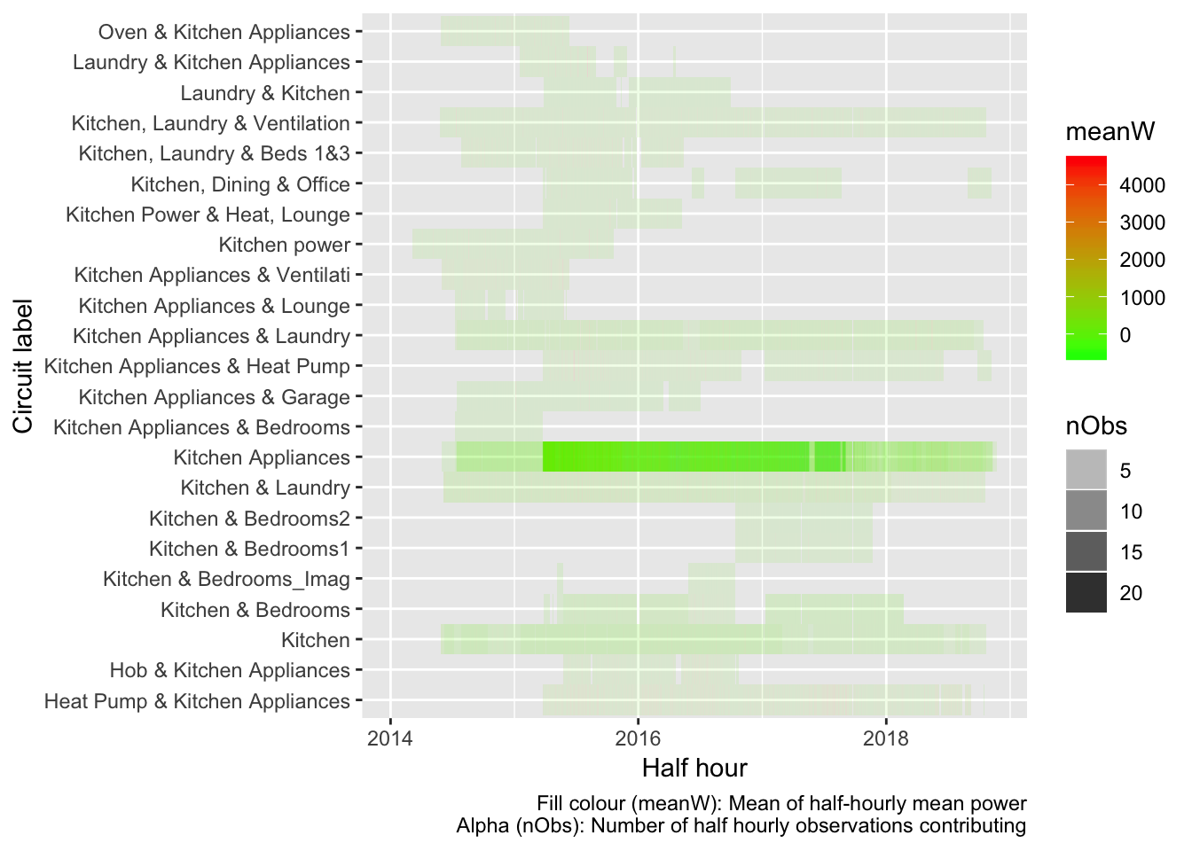

Figure 6.4: Kitchen data summary

We therefore have Kitchen data for 48 dwellings.

## 6.5 Non-heat pump ‘Heat’

Noting that this circuit label may include other appliances…

In this section we extract every record where:

* the string “Heat” is found in circuit but excluding ‘Heat Pump’

Table 6.7 and Figure 6.5 show the mean power (mean of the half-hourly mean values) for all observations extracted by circuit label. Note that in some cases circuits may contain other appliances. Analysis should therefore proceed with caution.

| Table 6.7: Summary statistics for extract | | | | | | |
| --- | --- | --- | --- | --- | --- | --- |
| **circuitLabel** | **nObs** | **nDwellings** | **meanW** | **minW** | **maxW** | **sdW** |
| Heating | 47813 | 2 | 635.647 | 0.00 | 7084.992 | 959.578 |
| Hot Water Cpbd Heater- Cont | 74492 | 1 | 75.778 | 0.00 | 1955.707 | 152.815 |
| Kitchen Power & Heat, Lounge | 19625 | 1 | 142.513 | 13.81 | 2670.404 | 180.314 |

## Gziping /Users/ben/Data/NZ_GREENGrid/safe//gridSpy/halfHour/extracts/halfHourNonHP_Heat.csv

## Gzipped /Users/ben/Data/NZ_GREENGrid/safe//gridSpy/halfHour/extracts/halfHourNonHP_Heat.csv

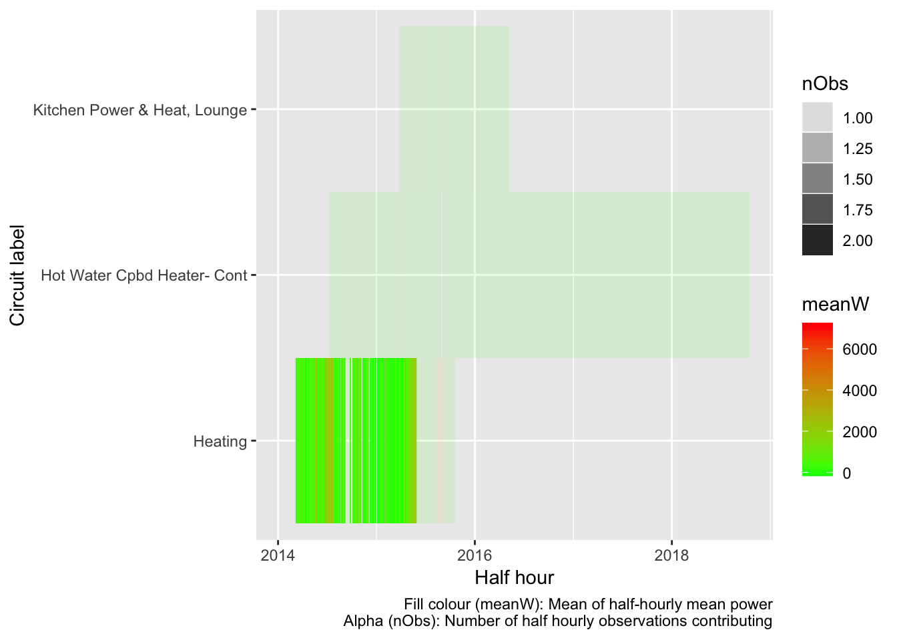

Figure 6.5: Heat data summary

We therefore have non Heat Pump Heat data for 4 dwellings.

## 6.6 Refrigerator/Fridge

Noting that this circuit label may include other appliances…

In this section we extract every record where:

* the string “Fridge” is found in circuit

Table 6.8 and Figure 6.6 show the mean power (mean of the half-hourly mean values) for all observations extracted by circuit label. Note that in some cases circuits may contain other appliances. Analysis should therefore proceed with caution.

| Table 6.8: Summary statistics for extract | | | | | | |
| --- | --- | --- | --- | --- | --- | --- |
| **circuitLabel** | **nObs** | **nDwellings** | **meanW** | **minW** | **maxW** | **sdW** |
| Bed 2, 2nd Fridge | 30311 | 1 | 80.180 | 0.000 | 926.520 | 159.651 |
| Fridge | 53096 | 2 | 81.083 | 0.000 | 1212.828 | 104.190 |
| Laundry & 2nd Fridge Freezer | 51639 | 1 | 146.050 | 0.000 | 3843.133 | 250.991 |
| Laundry & Fridge Freezer | 63760 | 1 | 55.401 | 0.000 | 1136.268 | 67.517 |
| Laundry & Garage Fridge | 27332 | 1 | 37.189 | 0.000 | 1716.550 | 82.971 |
| Laundry, Fridge & Freezer | 71418 | 1 | 97.933 | -25.632 | 1286.748 | 55.375 |
| Laundry, Fridge & Microwave | 13310 | 1 | 63.840 | -26.408 | 993.040 | 52.576 |
| Laundry, Garage Fridge Freezer | 26083 | 1 | 124.969 | 25.640 | 2389.454 | 92.344 |
| Laundry, Sauna & 2nd Fridge | 68111 | 1 | 63.532 | -7.444 | 2557.823 | 77.111 |

## Gziping /Users/ben/Data/NZ_GREENGrid/safe//gridSpy/halfHour/extracts/halfHourFridge.csv

## Gzipped /Users/ben/Data/NZ_GREENGrid/safe//gridSpy/halfHour/extracts/halfHourFridge.csv

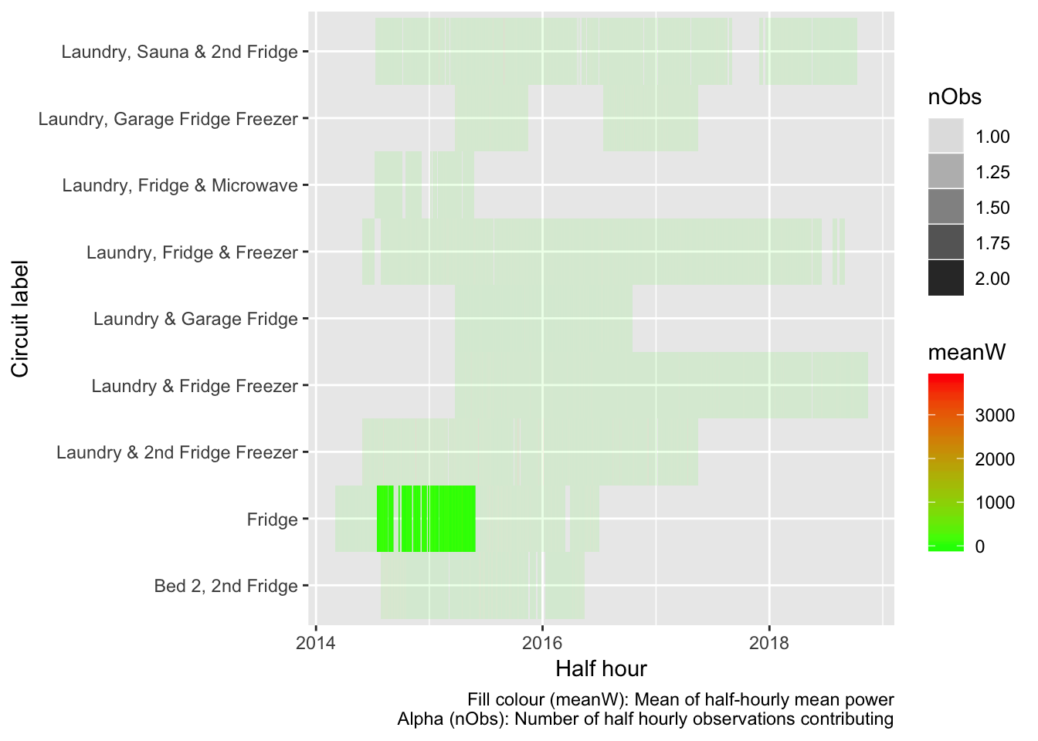

Figure 6.6: Fridge data summary

We therefore have Fridge data for 10 dwellings.

## 6.7 Freezer

Noting that this circuit label may include other appliances…

In this section we extract every record where:

* the string “Freezer” is found in circuit

Table 6.9 and Figure 6.7 show the mean power (mean of the half-hourly mean values) for all observations extracted by circuit label. Note that in some cases circuits may contain other appliances. Analysis should therefore proceed with caution.

| Table 6.9: Summary statistics for extract | | | | | | |
| --- | --- | --- | --- | --- | --- | --- |
| **circuitLabel** | **nObs** | **nDwellings** | **meanW** | **minW** | **maxW** | **sdW** |
| Laundry & 2nd Fridge Freezer | 51639 | 1 | 146.050 | 0.000 | 3843.133 | 250.991 |
| Laundry & Freezer | 32529 | 1 | 131.294 | 0.000 | 1633.096 | 49.098 |
| Laundry & Fridge Freezer | 63760 | 1 | 55.401 | 0.000 | 1136.268 | 67.517 |
| Laundry & Garage Freezer | 24373 | 1 | 104.939 | 0.000 | 2209.190 | 135.381 |
| Laundry, Fridge & Freezer | 71418 | 1 | 97.933 | -25.632 | 1286.748 | 55.375 |
| Laundry, Garage Fridge Freezer | 26083 | 1 | 124.969 | 25.640 | 2389.454 | 92.344 |

## Gziping /Users/ben/Data/NZ_GREENGrid/safe//gridSpy/halfHour/extracts/halfHourFreezer.csv

## Gzipped /Users/ben/Data/NZ_GREENGrid/safe//gridSpy/halfHour/extracts/halfHourFreezer.csv

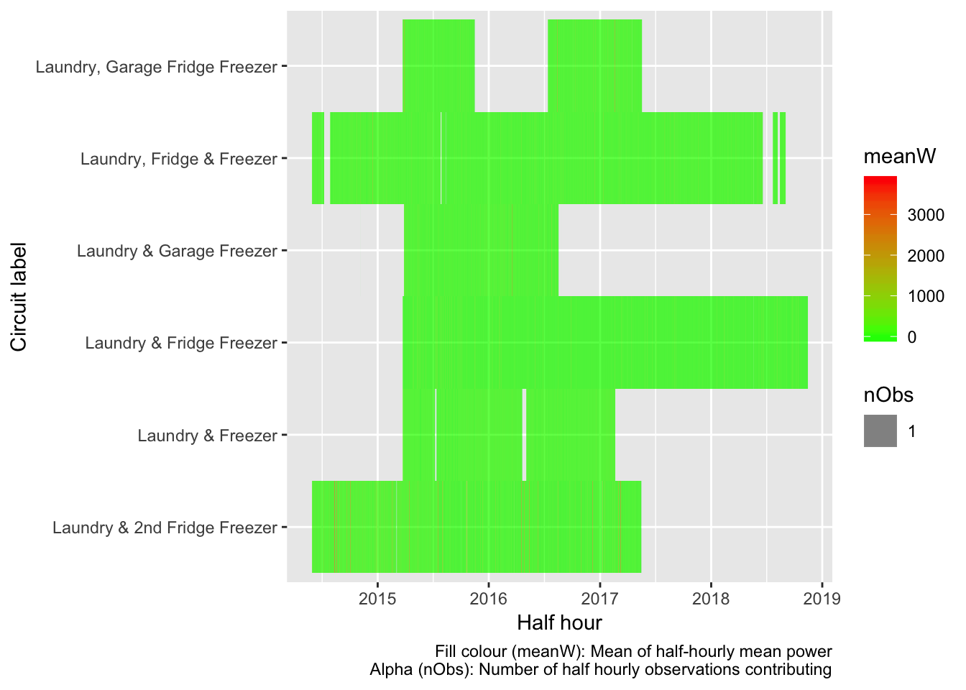

Figure 6.7: Freezer data summary

We therefore have Freezer data for 6 dwellings.

## 6.8 Oven

Noting that this circuit label may include other appliances…

In this section we extract every record where:

* the string “Oven” is found in circuit

Table 6.10 and Figure 6.8 show the mean power (mean of the half-hourly mean values) for all observations extracted by circuit label. Note that in some cases circuits may contain other appliances. Analysis should therefore proceed with caution.

| Table 6.10: Summary statistics for extract | | | | | | |
| --- | --- | --- | --- | --- | --- | --- |
| **circuitLabel** | **nObs** | **nDwellings** | **meanW** | **minW** | **maxW** | **sdW** |
| Incomer 1 - Uncont inc Oven | 12416 | 1 | 61.806 | 0.000 | 2251.039 | 163.328 |
| Incomer 1 - inc Top Oven | 9236 | 1 | 137.337 | 0.000 | 2831.723 | 241.952 |
| Incomer 2 - Uncont - Inc Oven | 17605 | 1 | 241.256 | -26.040 | 3920.391 | 409.398 |
| Incomer 2 - Uncont - inc Oven | 32019 | 1 | 237.832 | -376.067 | 4797.083 | 373.024 |
| Incomer 2 - Uncont inc Oven | 59477 | 1 | 102.715 | -1372.399 | 2974.610 | 179.291 |
| Incomer 2 - inc Bottom Oven | 9236 | 1 | 216.669 | 36.218 | 2333.497 | 205.168 |
| Oven | 690851 | 15 | 37.713 | -1067.563 | 3676.903 | 195.803 |
| Oven & Hob | 266871 | 4 | 57.893 | -24.645 | 3919.073 | 258.710 |
| Oven & Hobb | 24801 | 1 | 26.524 | 0.000 | 2908.371 | 163.390 |
| Oven & Kitchen Appliances | 18124 | 1 | 262.494 | 39.133 | 3397.599 | 278.561 |
| Oven & Oven Wall Appliances | 30311 | 1 | 38.181 | 0.000 | 2495.701 | 225.925 |
| Oven, Hob & Microwave | 55442 | 1 | 36.873 | 0.000 | 3614.151 | 212.934 |
| Wall Oven | 19625 | 1 | 26.402 | -2.423 | 2473.255 | 177.663 |

## Gziping /Users/ben/Data/NZ_GREENGrid/safe//gridSpy/halfHour/extracts/halfHourOven.csv

## Gzipped /Users/ben/Data/NZ_GREENGrid/safe//gridSpy/halfHour/extracts/halfHourOven.csv

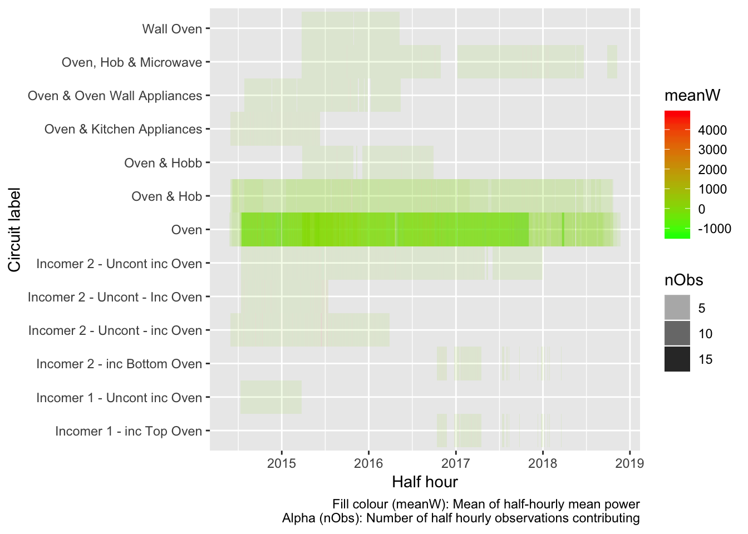

Figure 6.8: Oven data summary

We therefore have Oven data for 30 dwellings.

## 6.9 Photovoltaic panels

Noting that this circuit label may include other appliances…

In this section we extract every record where:

* the string “PV” is found in circuit

Table 6.11 and Figure 6.9 show the mean power (mean of the half-hourly mean values) for all observations extracted by circuit label. Note that in some cases circuits may contain other appliances. Analysis should therefore proceed with caution.

| Table 6.11: Summary statistics for extract | | | | | | |
| --- | --- | --- | --- | --- | --- | --- |
| **circuitLabel** | **nObs** | **nDwellings** | **meanW** | **minW** | **maxW** | **sdW** |
| PV | 71418 | 1 | -797.512 | -4549.259 | 5.767 | 1233.125 |
| PV & Garage | 2885 | 1 | -489.754 | -3071.270 | 93.182 | 837.672 |
| PV & Storage | 76868 | 1 | -99.093 | -2044.631 | 2049.756 | 406.343 |
| PV 1 | 74276 | 1 | -595.107 | -3966.106 | 38.187 | 939.615 |
| PV 2 | 74276 | 1 | -605.907 | -4037.073 | 27.978 | 955.533 |

## Gziping /Users/ben/Data/NZ_GREENGrid/safe//gridSpy/halfHour/extracts/halfHourPV.csv

## Gzipped /Users/ben/Data/NZ_GREENGrid/safe//gridSpy/halfHour/extracts/halfHourPV.csv

## Scale for 'fill' is already present. Adding another scale for 'fill',

## which will replace the existing scale.

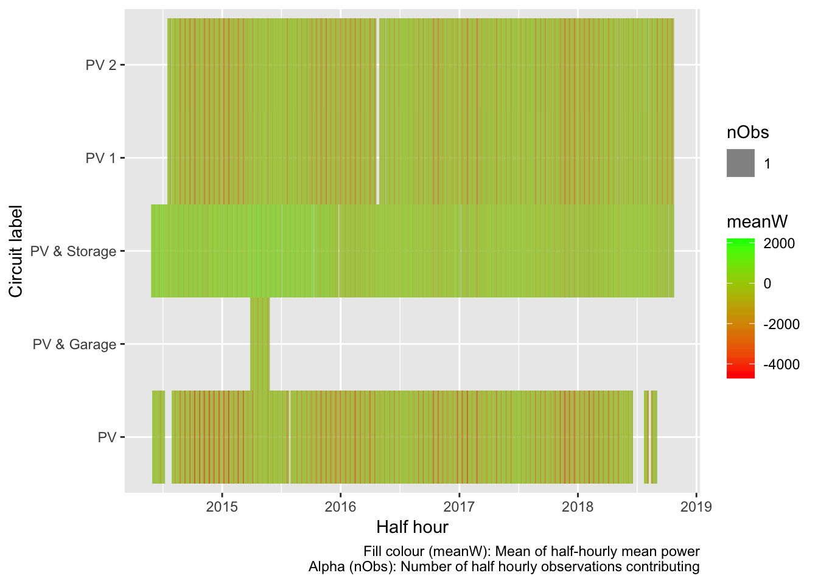

Figure 6.9: PV data summary

We therefore have Oven data for 5 dwellings.

## 6.10 Total load

In this section we extract every record where:

* the string “imputedTotalDemand” is found in circuit

Table 6.12 and Figure 6.10 show the mean power (mean of the half-hourly mean values) for all observations extracted by circuit label.

| Table 6.12: Summary statistics for extract | | | | | | |
| --- | --- | --- | --- | --- | --- | --- |
| **circuitLabel** | **nObs** | **nDwellings** | **meanW** | **minW** | **maxW** | **sdW** |
| imputedTotalDemand_circuitsToSum_v1.1 | 1828811 | 45 | 866.257 | -7627.66 | 10981.59 | 1161.741 |

## Gziping /Users/ben/Data/NZ_GREENGrid/safe//gridSpy/halfHour/extracts/halfHourImputedTotalDemand.csv

## Gzipped /Users/ben/Data/NZ_GREENGrid/safe//gridSpy/halfHour/extracts/halfHourImputedTotalDemand.csv

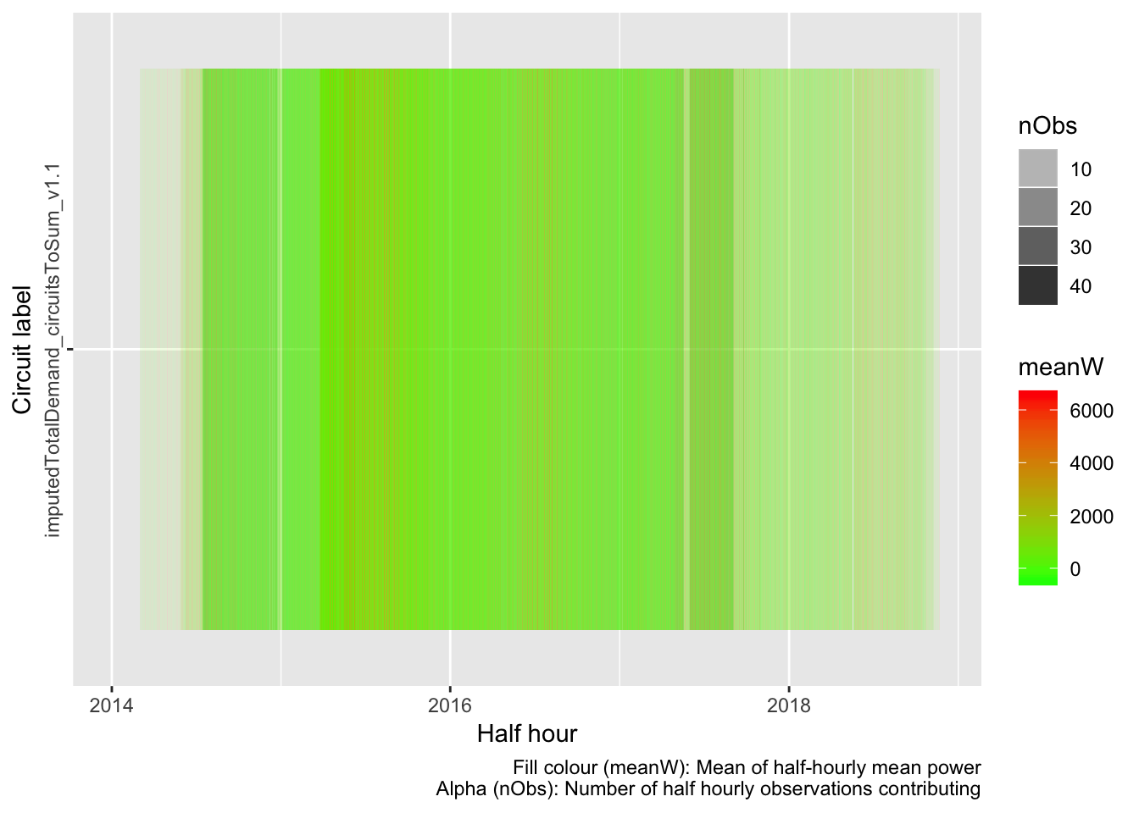

Figure 6.10: Total load data summary

We therefore have imputedTotalDemand data for 45 dwellings.

# 7 Summary

XX tbc

# 8 Data Annex

## 8.1 Half hourly total load summary

Descriptive statistics for aggregate half hourly power data for all dwellings and all circuits:

## Skim summary statistics

## n obs: 13489366

## n variables: 10

##

## ── Variable type:character ─────────────────────────────────────────────────────────────────────────────────────────

## variable missing complete n min max empty n_unique

## circuit 0 13489366 13489366 7 37 0 298

## circuitID 1828811 11660555 13489366 4 4 0 279

## circuitLabel 0 13489366 13489366 2 37 0 139

## linkID 0 13489366 13489366 5 6 0 45

##

## ── Variable type:integer ───────────────────────────────────────────────────────────────────────────────────────────

## variable missing complete n mean sd p0 p25 p50 p75 p100

## nObs 0 13489366 13489366 30.01 1.21 1 30 30 30 64

## hist

## ▁▁▁▇▁▁▁▁

##

## ── Variable type:numeric ───────────────────────────────────────────────────────────────────────────────────────────

## variable missing complete n mean sd p0 p25 p50

## maxPowerW 0 13489366 13489366 619.11 1165.25 -6970.85 0 140.67

## meanPowerW 0 13489366 13489366 298.9 713.74 -7627.66 0 76.81

## minPowerW 0 13489366 13489366 124.06 562.91 -12407.52 0 15.49

## sdPowerW 810 13488556 13489366 163.36 323.54 0 0 32.55

## p75 p100 hist

## 599.67 30822.4 ▁▇▁▁▁▁▁▁

## 329.77 10981.59 ▁▁▁▇▁▁▁▁

## 150.37 9600.58 ▁▁▁▁▇▁▁▁

## 102.76 5627.37 ▇▁▁▁▁▁▁▁

##

## ── Variable type:POSIXct ───────────────────────────────────────────────────────────────────────────────────────────

## variable missing complete n min max

## r_dateTimeHalfHour 0 13489366 13489366 2014-01-06 2018-11-22

## median n_unique

## 2016-04-19 82757

## 8.2 Per dwelling summaries of half-hourly power data

The following tables show descriptive statistics for the meanPowerW values for each circuit by dwelling.

## #-> Dwelling: rf_01

| Table 8.1: rf_01: Mean of half-hourly mean power (W) by circuit type | | | | |
| --- | --- | --- | --- | --- |
| **circuit** | **meanPowerW** | **minPowerW** | **maxPowerW** | **nObs** |
| Heating$1633 | 960.23691 | 0.000 | 7084.992 | 28401 |
| Hot water$1636 | 216.74744 | 0.000 | 1874.646 | 28401 |
| Kitchen power$1632 | 203.90506 | 0.000 | 3048.565 | 28401 |
| Lights$1635 | 118.29809 | 0.000 | 1102.658 | 28401 |
| Mains$1634 | 1661.72822 | 90.722 | 10981.588 | 28401 |
| Range$1637 | 39.21129 | 0.000 | 3550.979 | 28401 |
| imputedTotalDemand_circuitsToSum_v1.1 | 1662.01730 | 90.722 | 10981.588 | 28401 |
| All | 694.59204 | 0.000 | 10981.588 | 198807 |

## #-> Dwelling: rf_02

| Table 8.1: rf_02: Mean of half-hourly mean power (W) by circuit type | | | | |
| --- | --- | --- | --- | --- |
| **circuit** | **meanPowerW** | **minPowerW** | **maxPowerW** | **nObs** |
| Cooking Bath tile heat$1573 | 135.77070 | 0.000 | 798.9143 | 19412 |
| Fridge$1572 | 18.98057 | 0.000 | 126.3063 | 19412 |
| Heating$1576 | 160.75117 | 0.000 | 3360.7323 | 19412 |
| Hot Water$1574 | 234.30121 | 0.000 | 2215.7370 | 19412 |
| Lights$1577 | 23.67056 | 0.000 | 559.3363 | 19412 |
| Mains$1575 | 721.14730 | 25.467 | 7427.8692 | 19412 |
| imputedTotalDemand_circuitsToSum_v1.1 | 721.25805 | 25.467 | 7427.8692 | 19412 |
| All | 287.98280 | 0.000 | 7427.8692 | 135884 |

## #-> Dwelling: rf_06

| Table 8.1: rf_06: Mean of half-hourly mean power (W) by circuit type | | | | |
| --- | --- | --- | --- | --- |
| **circuit** | **meanPowerW** | **minPowerW** | **maxPowerW** | **nObs** |
| Hot Water - Controlled$2248 | 419.57092 | 0.00000 | 2057.424 | 67393 |
| Incomer - Uncontrolled$2249 | 525.93799 | -1293.19033 | 5881.824 | 67393 |
| Kitchen$2246 | 106.93703 | 0.00000 | 1723.618 | 67393 |
| Laundry, Downstairs & Lounge$2245 | 239.23594 | 0.00000 | 2799.643 | 67393 |
| Lighting$2244 | 116.61632 | 0.00000 | 2160.544 | 67393 |
| Oven & Hob$2247 | 19.60169 | -24.64467 | 3919.073 | 67393 |
| imputedTotalDemand_circuitsToSum_v1.1 | 945.58519 | -1284.93400 | 7143.127 | 67393 |
| All | 339.06930 | -1293.19033 | 7143.127 | 471751 |

## #-> Dwelling: rf_07

| Table 8.1: rf_07: Mean of half-hourly mean power (W) by circuit type | | | | |
| --- | --- | --- | --- | --- |
| **circuit** | **meanPowerW** | **minPowerW** | **maxPowerW** | **nObs** |
| Incomer 1 - Uncontrolled$2726 | 256.32565 | -41.633333 | 2999.776 | 69310 |
| Incomer 2 - Uncontrolled$2725 | 349.88123 | 0.000000 | 5118.139 | 69310 |
| Kitchen Appliances & Laundry$2722 | 202.35191 | -41.100000 | 2440.366 | 69310 |
| Microwave$2721 | 41.62986 | 0.000000 | 1788.205 | 69310 |
| Oven$2724 | 104.75711 | 0.000000 | 3399.987 | 69310 |
| Workshop$2723 | 18.99376 | -7.428571 | 1759.159 | 69310 |
| imputedTotalDemand_circuitsToSum_v1.1 | 606.24733 | 20.433333 | 5912.322 | 69310 |
| All | 225.74098 | -41.633333 | 5912.322 | 485170 |

## #-> Dwelling: rf_08

| Table 8.1: rf_08: Mean of half-hourly mean power (W) by circuit type | | | | |
| --- | --- | --- | --- | --- |
| **circuit** | **meanPowerW** | **minPowerW** | **maxPowerW** | **nObs** |
| Heat Pump$2092 | 67.12562 | 0.000 | 2036.822 | 51639 |
| Hot Water - Controlled$2094 | 272.31189 | 0.000 | 2366.140 | 51639 |
| Incomer - Uncontrolled$2093 | 772.53902 | 244.899 | 6425.929 | 51639 |
| Kitchen$2089 | 136.33455 | 0.000 | 2273.916 | 51639 |
| Laundry & 2nd Fridge Freezer$2090 | 146.05024 | 0.000 | 3843.133 | 51639 |
| Oven & Hob$2091 | 48.22041 | 0.000 | 3480.848 | 51639 |
| imputedTotalDemand_circuitsToSum_v1.1 | 1044.94407 | 244.899 | 7882.448 | 51639 |
| All | 355.36083 | 0.000 | 7882.448 | 361473 |

## #-> Dwelling: rf_09

| Table 8.1: rf_09: Mean of half-hourly mean power (W) by circuit type | | | | |
| --- | --- | --- | --- | --- |
| **circuit** | **meanPowerW** | **minPowerW** | **maxPowerW** | **nObs** |
| Heat Pump & Bedroom 2$2731 | 153.40526 | -26.87667 | 3242.937 | 17605 |
| Incomer 1 - Uncont - Inc Hob$2729 | 407.19026 | 38.83267 | 3396.080 | 17605 |
| Incomer 2 - Uncont - Inc Oven$2730 | 241.25607 | -26.04000 | 3920.391 | 17605 |
| Kitchen Appliances$2727 | 110.67502 | 24.50100 | 1271.055 | 17605 |
| Laundry$2732 | 16.05779 | 0.00000 | 1479.713 | 17605 |
| Lounge, Dining & Bedrooms$2728 | 169.89889 | 0.00000 | 3062.734 | 17605 |
| imputedTotalDemand_circuitsToSum_v1.1 | 648.58905 | 13.81733 | 5490.639 | 17605 |
| All | 249.58176 | -26.87667 | 5490.639 | 123235 |

## #-> Dwelling: rf_10

| Table 8.1: rf_10: Mean of half-hourly mean power (W) by circuit type | | | | |
| --- | --- | --- | --- | --- |
| **circuit** | **meanPowerW** | **minPowerW** | **maxPowerW** | **nObs** |
| Bedrooms & Lounge$2602 | 130.08729 | -358.24333 | 1319.592 | 60754 |
| Heat Pump$2598 | 48.31930 | 0.00000 | 2510.320 | 60754 |
| Incomer - All$2599 | 596.13591 | 89.53033 | 6202.287 | 60754 |
| Kitchen Appliances$2601 | 107.85218 | 0.00000 | 2090.831 | 60754 |
| Laundry & Garage$2597 | 223.85985 | 21.78100 | 3457.719 | 60754 |
| Oven$2600 | 28.88877 | 0.00000 | 2444.982 | 60754 |
| imputedTotalDemand_circuitsToSum_v1.1 | 596.16782 | 89.53033 | 6202.287 | 60754 |
| All | 247.33016 | -358.24333 | 6202.287 | 425278 |

## #-> Dwelling: rf_11

| Table 8.1: rf_11: Mean of half-hourly mean power (W) by circuit type | | | | |
| --- | --- | --- | --- | --- |
| **circuit** | **meanPowerW** | **minPowerW** | **maxPowerW** | **nObs** |
| Heat Pump & Lounge$2590 | 227.02831 | 0.0000000 | 3314.134 | 74492 |
| Hob$2589 | 20.38968 | -0.7333333 | 2354.543 | 74492 |
| Hot Water Cpbd Heater- Cont$2586 | 75.77815 | 0.0000000 | 1955.707 | 74492 |
| Incomer - Uncontrolled$2585 | 444.84877 | 22.5333333 | 5982.562 | 74492 |
| Kitchen Appliances & Laundry$2588 | 141.11844 | 0.0000000 | 3144.275 | 74492 |
| Spa - Uncontrolled$2587 | 27.71096 | 0.0000000 | 3044.716 | 74492 |
| imputedTotalDemand_circuitsToSum_v1.1 | 548.36357 | 22.5333333 | 8698.006 | 74492 |
| All | 212.17684 | -0.7333333 | 8698.006 | 521444 |

## #-> Dwelling: rf_12

| Table 8.1: rf_12: Mean of half-hourly mean power (W) by circuit type | | | | |
| --- | --- | --- | --- | --- |
| **circuit** | **meanPowerW** | **minPowerW** | **maxPowerW** | **nObs** |
| Incomer 1 - Hot Water - Cont$2626 | 431.69058 | 0.00000 | 3057.669 | 13310 |
| Incomer 2 - Uncontrolled$2625 | 255.26592 | 16.27286 | 4005.747 | 13310 |
| Incomer 3 - Uncontrolled$2627 | 93.38327 | -32.41120 | 1023.548 | 13310 |
| Kitchen Appliances & Lounge$2630 | 147.10153 | -1.68640 | 2063.290 | 13310 |
| Laundry, Fridge & Microwave$2628 | 63.83951 | -26.40826 | 993.040 | 13310 |
| Oven$2629 | 93.47560 | 0.00000 | 3676.903 | 13310 |
| imputedTotalDemand_circuitsToSum_v1.1 | 780.43025 | 48.00048 | 6001.540 | 13310 |
| All | 266.45524 | -32.41120 | 6001.540 | 93170 |

## #-> Dwelling: rf_13

| Table 8.1: rf_13: Mean of half-hourly mean power (W) by circuit type | | | | |
| --- | --- | --- | --- | --- |
| **circuit** | **meanPowerW** | **minPowerW** | **maxPowerW** | **nObs** |
| Downstairs (inc 1 Heat Pump)$2212 | -8.074854 | -2583.5016667 | 2967.435 | 76421 |
| Hot Water - Controlled$2208 | 201.659286 | 0.0000000 | 2311.007 | 76421 |
| Incomer - Uncontrolled$2209 | 1453.548584 | 141.7340000 | 9575.828 | 76421 |
| Kitchen & Laundry$2213 | 433.057052 | 76.6173333 | 4445.761 | 76421 |
| Oven & Hob$2210 | 108.064739 | -0.5226667 | 3689.630 | 76421 |
| Upstairs Heat Pumps$2211 | 151.876469 | -46.2900000 | 2762.926 | 76421 |
| imputedTotalDemand_circuitsToSum_v1.1 | 1453.681640 | 141.7340000 | 9575.828 | 76421 |
| All | 541.973274 | -2583.5016667 | 9575.828 | 534947 |

## #-> Dwelling: rf_14

| Table 8.1: rf_14: Mean of half-hourly mean power (W) by circuit type | | | | |
| --- | --- | --- | --- | --- |
| **circuit** | **meanPowerW** | **minPowerW** | **maxPowerW** | **nObs** |
| Hot Water - Controlled$2719 | 229.63362 | -525.4233 | 963.0263 | 59477 |
| Incomer 1 - Uncont inc Stove$2718 | 280.63840 | 0.0000 | 4072.8347 | 59477 |
| Incomer 2 - Uncont inc Oven$2717 | 102.71532 | -1372.3987 | 2974.6097 | 59477 |
| Kitchen Appliances$2715 | 75.55101 | -586.9623 | 2694.3280 | 59477 |
| Laundry & Microwave$2720 | 172.13112 | 0.0000 | 3690.1560 | 59477 |
| Power Outlets$2716 | 37.49355 | -944.9340 | 1939.8627 | 59477 |
| imputedTotalDemand_circuitsToSum_v1.1 | 613.05153 | -1120.3857 | 6565.6810 | 59477 |
| All | 215.88779 | -1372.3987 | 6565.6810 | 416339 |

## #-> Dwelling: rf_15b

| Table 8.1: rf_15b: Mean of half-hourly mean power (W) by circuit type | | | | |
| --- | --- | --- | --- | --- |
| **circuit** | **meanPowerW** | **minPowerW** | **maxPowerW** | **nObs** |
| Hob$3954 | 18.63477 | -134.600000 | 1831.218 | 13040 |
| Hot Water$3952 | 411.24684 | 0.000000 | 1998.152 | 13040 |
| Incomer 1$3956 | 693.70182 | 1.139333 | 5209.020 | 13040 |
| Incomer 2$3955 | 561.38914 | -660.500000 | 5345.709 | 13040 |
| Laundry & Kitchen Appliances$3951 | 259.59320 | -564.166667 | 4637.651 | 13040 |
| Oven$3953 | 31.02041 | 0.000000 | 1648.313 | 13040 |
| imputedTotalDemand_circuitsToSum_v1.1 | 1255.17370 | -586.433333 | 7318.499 | 13040 |
| All | 461.53712 | -660.500000 | 7318.499 | 91280 |

## #-> Dwelling: rf_16

| Table 8.1: rf_16: Mean of half-hourly mean power (W) by circuit type | | | | |
| --- | --- | --- | --- | --- |
| **circuit** | **meanPowerW** | **minPowerW** | **maxPowerW** | **nObs** |
| Hallway & Washing Machine$2683 | 108.15574 | -4.552 | 990.3657 | 12416 |
| Hot Water - Controlled$2679 | 299.68561 | 0.000 | 2327.8963 | 12416 |
| Incomer 1 - Uncont inc Oven$2681 | 61.80580 | 0.000 | 2251.0390 | 12416 |
| Incomer 2 - Uncont inc Stove$2680 | 176.84312 | 0.000 | 2164.4770 | 12416 |
| Kitchen Appliances & Bedrooms$2684 | 39.71844 | 0.000 | 2247.6567 | 12416 |
| Microwave & Breadmaker$2682 | 59.20784 | 0.000 | 756.9517 | 12416 |
| imputedTotalDemand_circuitsToSum_v1.1 | 538.38054 | 23.855 | 4486.0077 | 12416 |
| All | 183.39958 | -4.552 | 4486.0077 | 86912 |

## #-> Dwelling: rf_17a

| Table 8.1: rf_17a: Mean of half-hourly mean power (W) by circuit type | | | | |
| --- | --- | --- | --- | --- |
| **circuit** | **meanPowerW** | **minPowerW** | **maxPowerW** | **nObs** |
| Heat Pump$2148 | 25.98453 | 0.0000000 | 3489.125 | 32019 |
| Hot Water - Controlled$2150 | 88.39686 | -0.0333333 | 2056.734 | 32019 |
| Incomer 1 - Uncont - inc Hob$2152 | 200.58446 | 21.2280000 | 4712.595 | 32019 |
| Incomer 2 - Uncont - inc Oven$2151 | 237.83215 | -376.0673333 | 4797.083 | 32019 |
| Kitchen Appliances$2147 | 98.30310 | -379.2153333 | 1748.831 | 32019 |
| Laundry$2149 | 24.14114 | 0.0000000 | 2147.561 | 32019 |
| imputedTotalDemand_circuitsToSum_v1.1 | 526.84766 | -332.6076667 | 7611.202 | 32019 |
| All | 171.72713 | -379.2153333 | 7611.202 | 224133 |

## #-> Dwelling: rf_17b

| Table 8.1: rf_17b: Mean of half-hourly mean power (W) by circuit type | | | | |
| --- | --- | --- | --- | --- |
| **circuit** | **meanPowerW** | **minPowerW** | **maxPowerW** | **nObs** |
| Incomer 1 - inc Top Oven$5620 | 137.337266 | 0.00000 | 2831.7230 | 9236 |
| Incomer 2 - inc Bottom Oven$5621 | 216.669305 | 36.21833 | 2333.4967 | 9236 |
| Kitchen Appliances$5625 | 22.834176 | 0.00000 | 622.9377 | 9236 |
| Laundry & Garage$5624 | 85.773057 | 0.00000 | 2039.3000 | 9236 |
| Lighting 1/2$5623 | -1.736804 | -68.60867 | 14.6000 | 9236 |
| Lighting 2/2$5622 | 7.948279 | 0.00000 | 166.4357 | 9236 |
| imputedTotalDemand_circuitsToSum_v1.1 | 354.009028 | 42.60500 | 3819.8710 | 9236 |
| All | 117.547758 | -68.60867 | 3819.8710 | 64652 |

## #-> Dwelling: rf_18

| Table 8.1: rf_18: Mean of half-hourly mean power (W) by circuit type | | | | |
| --- | --- | --- | --- | --- |
| **circuit** | **meanPowerW** | **minPowerW** | **maxPowerW** | **nObs** |
| Hot Water - Controlled$2129 | 348.40618 | -74.2000 | 2107.445 | 18032 |
| Incomer 1 - Uncontrolled$2128 | 237.97939 | 0.0000 | 3485.951 | 18032 |
| Incomer 2 - Uncontrolled$2130 | 857.55685 | -890.5782 | 6400.352 | 18032 |
| Kitchen Appliances & Ventilati$2131 | 438.88811 | -500.2655 | 3044.483 | 18032 |
| Laundry & Hob$2133 | 92.18203 | 0.0000 | 3457.229 | 18032 |
| Oven$2132 | 35.22306 | -1067.5630 | 2143.595 | 18032 |
| imputedTotalDemand_circuitsToSum_v1.1 | 1444.10304 | -373.0617 | 10051.113 | 18032 |
| All | 493.47695 | -1067.5630 | 10051.113 | 126224 |

## #-> Dwelling: rf_19

| Table 8.1: rf_19: Mean of half-hourly mean power (W) by circuit type | | | | |
| --- | --- | --- | --- | --- |
| **circuit** | **meanPowerW** | **minPowerW** | **maxPowerW** | **nObs** |
| Bedroom & Lounge Heat Pumps$2741 | 92.8872070 | 0.0000000 | 2555.71900 | 74276 |
| Incomer 1 - All$2738 | -293.6615084 | -3698.6333333 | 2592.05167 | 74276 |
| Incomer 2 - All$2737 | -296.0497400 | -3929.0263333 | 4736.61867 | 74276 |
| Kitchen Appliances$2735 | 13.3428002 | -0.0333333 | 1504.76733 | 74276 |
| Laundry$2734 | 20.1366382 | 0.0000000 | 3288.41833 | 74276 |
| Oven$2736 | 0.3322254 | -107.1110000 | 1698.06167 | 74276 |
| PV 1$2739 | -595.1074554 | -3966.1063333 | 38.18667 | 74276 |
| PV 2$2733 | -605.9072110 | -4037.0730000 | 27.97800 | 74276 |
| Theatre Heat Pump$2740 | 2.9081021 | -3.2666667 | 999.08700 | 74276 |
| imputedTotalDemand_circuitsToSum_v1.1 | -589.6747333 | -7627.6596667 | 5541.25500 | 74276 |
| All | -225.0793675 | -7627.6596667 | 5541.25500 | 742760 |

## #-> Dwelling: rf_20

| Table 8.1: rf_20: Mean of half-hourly mean power (W) by circuit type | | | | |
| --- | --- | --- | --- | --- |
| **circuit** | **meanPowerW** | **minPowerW** | **maxPowerW** | **nObs** |
| Heat Pump & Misc$2107 | 176.61447 | -173.07200 | 1701.146 | 18124 |
| Hob$2109 | 22.80259 | -1820.11200 | 2409.673 | 18124 |
| Hot Water - Controlled$2110 | 274.15836 | 0.00000 | 3163.168 | 18124 |
| Incomer 1 - Uncontrolled$2112 | 265.53331 | 38.48700 | 3408.817 | 18124 |
| Incomer 2 - Uncontrolled$2111 | 273.81090 | -319.71800 | 2726.963 | 18124 |
| Oven & Kitchen Appliances$2108 | 262.49413 | 39.13333 | 3397.599 | 18124 |
| imputedTotalDemand_circuitsToSum_v1.1 | 813.60345 | -79.40167 | 7239.907 | 18124 |
| All | 298.43103 | -1820.11200 | 7239.907 | 126868 |

## #-> Dwelling: rf_21

| Table 8.1: rf_21: Mean of half-hourly mean power (W) by circuit type | | | | |
| --- | --- | --- | --- | --- |
| **circuit** | **meanPowerW** | **minPowerW** | **maxPowerW** | **nObs** |
| Fridge$2752 | 116.87211 | 0.000000 | 1212.828 | 33684 |
| Heat Pump & Washing Machine$2750 | 113.52252 | 0.000000 | 3120.887 | 33684 |
| Incomer - All$2748 | 483.35836 | 56.122000 | 5653.114 | 33684 |
| Kitchen Appliances & Garage$2753 | 46.27248 | -2.523333 | 1952.114 | 33684 |
| Lower Bedrooms & Bathrooms$2751 | 43.39302 | -2.128333 | 1429.159 | 33684 |
| Oven$2749 | 26.93497 | 0.000000 | 2183.971 | 33684 |
| imputedTotalDemand_circuitsToSum_v1.1 | 483.39078 | 56.122000 | 5653.114 | 33684 |
| All | 187.67775 | -2.523333 | 5653.114 | 235788 |

## #-> Dwelling: rf_22

| Table 8.1: rf_22: Mean of half-hourly mean power (W) by circuit type | | | | |
| --- | --- | --- | --- | --- |
| **circuit** | **meanPowerW** | **minPowerW** | **maxPowerW** | **nObs** |
| Hot Water - Controlled$2236 | 355.44151 | 0.00000 | 2050.544 | 62880 |
| Incomer - Uncontrolled$2237 | 936.13531 | 49.62267 | 6899.700 | 62880 |
| Kitchen & Laundry$2234 | 199.11520 | 0.00000 | 2924.924 | 62880 |
| Lighting$2232 | 300.74459 | 0.00000 | 3411.401 | 62880 |
| Oven$2235 | 31.56112 | -431.90800 | 2339.331 | 62880 |
| Ventilation & Lounge Power$2233 | 396.92523 | 30.17100 | 4409.606 | 62880 |
| imputedTotalDemand_circuitsToSum_v1.1 | 1291.67898 | 61.51000 | 8019.169 | 62880 |
| All | 501.65742 | -431.90800 | 8019.169 | 440160 |

## #-> Dwelling: rf_23

| Table 8.1: rf_23: Mean of half-hourly mean power (W) by circuit type | | | | |
| --- | --- | --- | --- | --- |
| **circuit** | **meanPowerW** | **minPowerW** | **maxPowerW** | **nObs** |
| Hot Water - Controlled (HEMS)$2081 | 264.07706 | 0.000000 | 1459.965 | 76868 |
| Incomer - Uncontrolled$2082 | 803.24770 | -1632.683667 | 5942.441 | 76868 |
| Kitchen, Laundry & Ventilation$2084 | 240.00245 | 41.791000 | 3810.431 | 76868 |
| Oven$2085 | 40.11669 | -1.840667 | 3301.906 | 76868 |
| PV & Storage$2083 | -99.09319 | -2044.630667 | 2049.756 | 76868 |
| Spa (HEMS)$2080 | 254.20927 | 0.000000 | 2126.470 | 76868 |
| imputedTotalDemand_circuitsToSum_v1.1 | 1067.43802 | -1632.683667 | 6676.896 | 76868 |
| All | 367.14257 | -2044.630667 | 6676.896 | 538076 |

## #-> Dwelling: rf_24

| Table 8.1: rf_24: Mean of half-hourly mean power (W) by circuit type | | | | |
| --- | --- | --- | --- | --- |
| **circuit** | **meanPowerW** | **minPowerW** | **maxPowerW** | **nObs** |
| Hot Water - Controlled$2102 | 466.18275 | -0.1333333 | 3200.062000 | 71418 |
| Incomer - Uncontrolled$2101 | -384.78016 | -4316.0373333 | 3881.325333 | 71418 |
| Kitchen$2104 | 40.45919 | 0.0000000 | 1838.259167 | 71418 |
| Laundry, Fridge & Freezer$2105 | 97.93278 | -25.6320000 | 1286.747667 | 71418 |
| Oven & Hob$2103 | 47.33216 | 0.0000000 | 3357.078333 | 71418 |
| PV$2106 | -797.51196 | -4549.2590000 | 5.766667 | 71418 |
| imputedTotalDemand_circuitsToSum_v1.1 | 81.42552 | -4316.0373333 | 6319.660667 | 71418 |
| All | -64.13710 | -4549.2590000 | 6319.660667 | 499926 |

## #-> Dwelling: rf_25

| Table 8.1: rf_25: Mean of half-hourly mean power (W) by circuit type | | | | |
| --- | --- | --- | --- | --- |
| **circuit** | **meanPowerW** | **minPowerW** | **maxPowerW** | **nObs** |
| Heat Pump$2758 | 88.88346 | -0.0333333 | 1734.691 | 23570 |
| Hob & Kitchen Appliances$2759 | 349.55367 | 0.0000000 | 2379.292 | 23570 |
| Hot Water - Controlled$2761 | 258.40103 | 0.0000000 | 2853.940 | 23570 |
| Incomer 1 - Uncontrolled $2763 | 462.20069 | 0.0000000 | 4566.728 | 23570 |
| Incomer 2 - Uncontrolled $2762 | 397.27281 | 0.0000000 | 2478.952 | 23570 |
| Oven$2760 | 52.59379 | 0.0000000 | 1777.121 | 23570 |
| imputedTotalDemand_circuitsToSum_v1.1 | 859.53641 | 19.0990000 | 5062.934 | 23570 |
| All | 352.63455 | -0.0333333 | 5062.934 | 164990 |

## #-> Dwelling: rf_26

| Table 8.1: rf_26: Mean of half-hourly mean power (W) by circuit type | | | | |
| --- | --- | --- | --- | --- |
| **circuit** | **meanPowerW** | **minPowerW** | **maxPowerW** | **nObs** |
| Incomer 1 - All$2703 | 260.89635 | -65.777778 | 3598.296 | 68111 |
| Incomer 2 - All$2704 | 453.05564 | -544.655333 | 4118.930 | 68111 |
| Kitchen Appliances$2706 | 51.20405 | -3.982778 | 2322.703 | 68111 |
| Laundry, Sauna & 2nd Fridge$2707 | 63.53170 | -7.444444 | 2557.823 | 68111 |
| Oven$2705 | 15.13220 | 0.000000 | 2590.046 | 68111 |
| Spa$2708 | 410.22441 | 0.000000 | 3374.302 | 68111 |
| imputedTotalDemand_circuitsToSum_v1.1 | 714.04157 | -413.799333 | 6058.264 | 68111 |
| All | 281.15513 | -544.655333 | 6058.264 | 476777 |

## #-> Dwelling: rf_27

| Table 8.1: rf_27: Mean of half-hourly mean power (W) by circuit type | | | | |
| --- | --- | --- | --- | --- |
| **circuit** | **meanPowerW** | **minPowerW** | **maxPowerW** | **nObs** |
| Bed 2, 2nd Fridge$2828 | 80.17973 | 0.00000 | 926.5203 | 30311 |
| Heat Pump$2826 | 138.45418 | 0.00000 | 2457.0843 | 30311 |
| Hot Water - Controlled$2825 | 278.22393 | 0.00000 | 1625.1450 | 30311 |
| Incomer - Uncontrolled$2824 | 839.96004 | 135.34800 | 6587.1657 | 30311 |
| Kitchen, Laundry & Beds 1&3$2829 | 344.66051 | 19.90727 | 2555.6150 | 30305 |
| Oven & Oven Wall Appliances$2827 | 38.18063 | 0.00000 | 2495.7013 | 30311 |
| imputedTotalDemand_circuitsToSum_v1.1 | 1118.44838 | 138.38567 | 6806.3293 | 30311 |
| All | 405.44563 | 0.00000 | 6806.3293 | 212171 |

## #-> Dwelling: rf_28

| Table 8.1: rf_28: Mean of half-hourly mean power (W) by circuit type | | | | |
| --- | --- | --- | --- | --- |
| **circuit** | **meanPowerW** | **minPowerW** | **maxPowerW** | **nObs** |
| Heat Pump$4219 | 51.89516 | 0.000000 | 2463.9630 | 2885 |
| Incomer - All$4221 | -135.60611 | -2794.550333 | 4676.1890 | 2885 |
| Kitchen Appliances$4216 | 69.36095 | -3.636364 | 1428.4331 | 2885 |
| Laundry$4217 | 27.77702 | 0.000000 | 333.0917 | 2885 |
| Lighting$4218 | 32.79797 | 0.000000 | 226.4063 | 2885 |
| PV & Garage$4220 | -489.75448 | -3071.270333 | 93.1820 | 2885 |
| imputedTotalDemand_circuitsToSum_v1.1 | -135.49572 | -2794.550333 | 4676.1890 | 2885 |
| All | -82.71789 | -3071.270333 | 4676.1890 | 20195 |

## #-> Dwelling: rf_29

| Table 8.1: rf_29: Mean of half-hourly mean power (W) by circuit type | | | | |
| --- | --- | --- | --- | --- |
| **circuit** | **meanPowerW** | **minPowerW** | **maxPowerW** | **nObs** |
| Heat Pump & Kitchen Appliances$4186 | 592.044069 | 0.000000 | 3760.9203 | 59922 |
| Hot Water - Controlled$4184 | 339.925815 | 0.000000 | 3242.0953 | 59922 |
| Incomer - Uncontrolled$4181 | 1262.522415 | 21.500000 | 6046.0460 | 59922 |
| Laundry$4185 | 3.586081 | -1.773684 | 184.7330 | 59922 |
| Lighting$4183 | 88.229156 | 0.000000 | 740.6183 | 59922 |
| Oven$4182 | 26.576065 | 0.000000 | 3484.1950 | 59922 |
| imputedTotalDemand_circuitsToSum_v1.1 | 1602.535408 | 21.500000 | 8395.3977 | 59922 |
| All | 559.345573 | -1.773684 | 8395.3977 | 419454 |

## #-> Dwelling: rf_30

| Table 8.1: rf_30: Mean of half-hourly mean power (W) by circuit type | | | | |
| --- | --- | --- | --- | --- |
| **circuit** | **meanPowerW** | **minPowerW** | **maxPowerW** | **nObs** |
| Hot Water - Controlled$4238 | 190.47906 | -1.314333 | 1473.254 | 24801 |
| Incomer - All$4239 | 743.47460 | 115.755333 | 5173.553 | 24801 |
| Kitchen Appliances$4234 | 286.83927 | 50.316000 | 2617.753 | 24801 |
| Laundry & Kitchen$4235 | 15.00388 | 0.000000 | 1073.849 | 24801 |
| Lighting$4236 | 114.88548 | -0.367000 | 1440.129 | 24801 |
| Oven & Hobb$4237 | 26.52416 | 0.000000 | 2908.371 | 24801 |
| imputedTotalDemand_circuitsToSum_v1.1 | 743.53834 | 115.755333 | 5173.553 | 24801 |
| All | 302.96354 | -1.314333 | 5173.553 | 173607 |

## #-> Dwelling: rf_31

| Table 8.1: rf_31: Mean of half-hourly mean power (W) by circuit type | | | | |
| --- | --- | --- | --- | --- |
| **circuit** | **meanPowerW** | **minPowerW** | **maxPowerW** | **nObs** |
| Heat Pump$4204 | 132.24442 | 0.000 | 2462.601 | 63461 |
| Hot Water - Controlled$4200 | 54.63796 | 0.000 | 1917.637 | 63461 |
| Incomer - All$4199 | 682.24437 | 39.786 | 7101.946 | 63461 |
| Kitchen Appliances$4201 | 147.20703 | 0.000 | 3227.045 | 63461 |
| Laundry$4202 | 20.63545 | 0.000 | 2096.166 | 63461 |
| Lighting$4203 | 75.32588 | 0.000 | 1299.301 | 63461 |
| imputedTotalDemand_circuitsToSum_v1.1 | 682.31377 | 39.786 | 7101.946 | 63461 |
| All | 256.37270 | 0.000 | 7101.946 | 444227 |

## #-> Dwelling: rf_32

| Table 8.1: rf_32: Mean of half-hourly mean power (W) by circuit type | | | | |
| --- | --- | --- | --- | --- |
| **circuit** | **meanPowerW** | **minPowerW** | **maxPowerW** | **nObs** |
| Heat Pump$4196 | 67.805397 | 0 | 2470.511 | 18044 |
| Hot Water - Controlled$4198 | 283.857462 | 0 | 1480.453 | 18044 |
| Incomer - All$4193 | 677.663999 | 0 | 7882.022 | 18044 |
| Kitchen Appliances$4195 | 113.946538 | 0 | 2454.631 | 18044 |
| Laundry$4194 | 5.242116 | 0 | 1700.831 | 18044 |
| Lighting$4197 | 22.238769 | 0 | 751.784 | 18044 |
| imputedTotalDemand_circuitsToSum_v1.1 | 677.714009 | 0 | 7882.022 | 18044 |
| All | 264.066899 | 0 | 7882.022 | 126308 |

## #-> Dwelling: rf_33

| Table 8.1: rf_33: Mean of half-hourly mean power (W) by circuit type | | | | |
| --- | --- | --- | --- | --- |
| **circuit** | **meanPowerW** | **minPowerW** | **maxPowerW** | **nObs** |
| Hot Water - Controlled$4144 | 288.89318 | 0.0000 | 2147.5373 | 55442 |
| Incomer - Uncontrolled$4143 | 519.82255 | 138.1567 | 5115.2227 | 55442 |
| Kitchen Appliances & Heat Pump$4140 | 272.44582 | 62.9900 | 3180.3123 | 55442 |
| Laundry & Teenagers Bedroom$4139 | 47.66568 | 0.0000 | 1804.7990 | 55442 |
| Lighting$4142 | 24.82534 | 0.0000 | 731.3517 | 55442 |
| Oven, Hob & Microwave$4141 | 36.87318 | 0.0000 | 3614.1510 | 55442 |
| imputedTotalDemand_circuitsToSum_v1.1 | 808.81569 | 138.1567 | 7016.9233 | 55442 |
| All | 285.62021 | 0.0000 | 7016.9233 | 388094 |

## #-> Dwelling: rf_34

| Table 8.1: rf_34: Mean of half-hourly mean power (W) by circuit type | | | | |
| --- | --- | --- | --- | --- |
| **circuit** | **meanPowerW** | **minPowerW** | **maxPowerW** | **nObs** |
| Heat Pump$4223 | 196.46816 | 0 | 4982.931 | 24373 |
| Hot Water - Uncontrolled$4224 | 329.87038 | 0 | 3901.050 | 24373 |
| Incomer - All$4225 | 1159.39702 | 0 | 9469.695 | 24373 |
| Kitchen Appliances$4226 | 178.94462 | 0 | 2362.236 | 24373 |
| Laundry & Garage Freezer$4227 | 104.93907 | 0 | 2209.190 | 24373 |
| Lighting$4222 | 96.63415 | 0 | 1078.365 | 24373 |
| imputedTotalDemand_circuitsToSum_v1.1 | 1159.42800 | 0 | 9469.695 | 24373 |
| All | 460.81163 | 0 | 9469.695 | 170611 |

## #-> Dwelling: rf_35

| Table 8.1: rf_35: Mean of half-hourly mean power (W) by circuit type | | | | |
| --- | --- | --- | --- | --- |
| **circuit** | **meanPowerW** | **minPowerW** | **maxPowerW** | **nObs** |
| Heat Pump$4124 | 58.91764 | 0.0000 | 1329.501 | 26083 |
| Hot Water - Uncontrolled$4125 | 238.36225 | -208.2333 | 2967.400 | 26083 |
| Incomer - Uncontrolled$4126 | 1101.61843 | 118.8083 | 5252.648 | 26083 |
| Kitchen Appliances$4121 | 91.91850 | 0.0000 | 1670.461 | 26083 |
| Laundry, Garage Fridge Freezer$4122 | 124.96889 | 25.6400 | 2389.454 | 26083 |
| Lighting$4123 | 74.64069 | 0.0000 | 869.856 | 26083 |
| imputedTotalDemand_circuitsToSum_v1.1 | 1340.13736 | 118.8083 | 7202.184 | 26083 |
| All | 432.93768 | -208.2333 | 7202.184 | 182581 |

## #-> Dwelling: rf_36

| Table 8.1: rf_36: Mean of half-hourly mean power (W) by circuit type | | | | |
| --- | --- | --- | --- | --- |
| **circuit** | **meanPowerW** | **minPowerW** | **maxPowerW** | **nObs** |
| Heat Pump$4150 | 104.85081 | 0.0000000 | 2566.7637 | 53554 |
| Hot Water - Uncontrolled$4147 | 296.36297 | -2.2786667 | 3137.1947 | 53554 |
| Incomer - All$4148 | 830.22911 | 20.0350000 | 9557.4647 | 53554 |
| Kitchen Appliances$4145 | 34.22702 | -9.3226667 | 2367.1767 | 53554 |
| Lighting$4149 | 49.72965 | -0.7756667 | 677.3097 | 53554 |
| Washing Machine$4146 | 3.65723 | -0.7916667 | 454.5093 | 53554 |
| imputedTotalDemand_circuitsToSum_v1.1 | 830.31644 | 20.0350000 | 9557.4647 | 53554 |
| All | 307.05332 | -9.3226667 | 9557.4647 | 374878 |

## #-> Dwelling: rf_37

| Table 8.1: rf_37: Mean of half-hourly mean power (W) by circuit type | | | | |
| --- | --- | --- | --- | --- |
| **circuit** | **meanPowerW** | **minPowerW** | **maxPowerW** | **nObs** |
| Heat Pump$4134 | 48.81921 | -64.270 | 2224.3923 | 63760 |
| Hot Water - Controlled$4135 | 279.51827 | 0.000 | 3152.7550 | 63760 |
| Incomer -Uncontrolled$4136 | 291.47084 | 43.309 | 3890.5817 | 63760 |
| Kitchen Appliances$4137 | 141.99467 | 19.348 | 1505.9013 | 63760 |
| Laundry & Fridge Freezer$4138 | 55.40102 | 0.000 | 1136.2677 | 63760 |
| Lighting$4133 | 14.65210 | 0.000 | 520.4113 | 63760 |
| imputedTotalDemand_circuitsToSum_v1.1 | 571.01905 | 43.309 | 5955.6347 | 63760 |
| All | 200.41074 | -64.270 | 5955.6347 | 446320 |

## #-> Dwelling: rf_38

| Table 8.1: rf_38: Mean of half-hourly mean power (W) by circuit type | | | | |
| --- | --- | --- | --- | --- |
| **circuit** | **meanPowerW** | **minPowerW** | **maxPowerW** | **nObs** |
| Heat Pump$4175 | 242.51194 | -7.850667 | 2485.8203 | 33011 |
| Hot Water - Controlled$4178 | 483.01857 | -1.962667 | 3058.4537 | 33011 |
| Incomer - Uncontrolled$4177 | 567.92404 | 53.086000 | 4309.8773 | 33011 |
| Kitchen, Dining & Office$4179 | 118.83712 | 0.000000 | 2221.4497 | 33011 |
| Laundry, Lounge, Garage, Bed$4180 | 108.08280 | 0.000000 | 871.6080 | 33011 |
| Lighting$4176 | 50.85886 | 0.000000 | 728.8043 | 33011 |
| imputedTotalDemand_circuitsToSum_v1.1 | 1050.97562 | 53.868000 | 6621.2760 | 33011 |
| All | 374.60128 | -7.850667 | 6621.2760 | 231077 |

## #-> Dwelling: rf_39

| Table 8.1: rf_39: Mean of half-hourly mean power (W) by circuit type | | | | |
| --- | --- | --- | --- | --- |
| **circuit** | **meanPowerW** | **minPowerW** | **maxPowerW** | **nObs** |
| Hot Water (2 elements)$4247 | 398.64564 | 0.00000 | 3317.472 | 56686 |
| Incomer - Uncontrolled$4248 | 1536.80037 | 142.28900 | 8563.603 | 56686 |
| Kitchen Appliances$4244 | 196.30065 | -40.22077 | 2766.920 | 56686 |
| Lighting & 2 Towel Rail$4245 | 277.43147 | 0.00000 | 2101.948 | 56686 |
| Oven$4246 | 52.06442 | 0.00000 | 3053.337 | 56686 |
| imputedTotalDemand_circuitsToSum_v1.1 | 1935.63494 | 142.28900 | 10760.555 | 56686 |
| All | 732.81291 | -40.22077 | 10760.555 | 340116 |

## #-> Dwelling: rf_40

| Table 8.1: rf_40: Mean of half-hourly mean power (W) by circuit type | | | | |
| --- | --- | --- | --- | --- |
| **circuit** | **meanPowerW** | **minPowerW** | **maxPowerW** | **nObs** |
| Heat Pump (x2) & Lounge Power$4166 | 330.6677 | 0.0000000 | 5340.9140 | 11618 |
| Hot Water - Controlled$4167 | 336.3902 | 0.0000000 | 1991.9203 | 11618 |
| Incomer - Uncontrolled$4168 | 855.0246 | 46.7286364 | 7003.3600 | 11618 |
| Kitchen Appliances$4163 | 137.8220 | -13.1000000 | 1936.0547 | 11618 |
| Laundry$4164 | 20.8082 | -0.0833333 | 2218.3740 | 11618 |
| Lighting$4165 | 144.2461 | 0.0000000 | 792.7483 | 11618 |
| imputedTotalDemand_circuitsToSum_v1.1 | 1191.5785 | 46.7286364 | 7855.8450 | 11618 |
| All | 430.9339 | -13.1000000 | 7855.8450 | 81326 |

## #-> Dwelling: rf_41

| Table 8.1: rf_41: Mean of half-hourly mean power (W) by circuit type | | | | |
| --- | --- | --- | --- | --- |
| **circuit** | **meanPowerW** | **minPowerW** | **maxPowerW** | **nObs** |
| Heat Pump$4190 | 53.39034 | 0.00000 | 3579.525 | 50530 |
| Incomer - All$4192 | 1028.85063 | 100.08300 | 7580.263 | 50530 |
| Kitchen Appliances$4187 | 294.08670 | 32.34867 | 3484.788 | 50530 |
| Laundry$4188 | 139.47248 | 16.19667 | 3301.477 | 50530 |
| Lighting$4189 | 150.42851 | 0.00000 | 1783.119 | 50530 |
| Oven$4191 | 35.37397 | 0.00000 | 2443.117 | 50530 |
| imputedTotalDemand_circuitsToSum_v1.1 | 1029.11708 | 100.08300 | 7580.263 | 50530 |
| All | 390.10282 | 0.00000 | 7580.263 | 353710 |

## #-> Dwelling: rf_42

| Table 8.1: rf_42: Mean of half-hourly mean power (W) by circuit type | | | | |
| --- | --- | --- | --- | --- |
| **circuit** | **meanPowerW** | **minPowerW** | **maxPowerW** | **nObs** |
| Heat Pump$4130 | 44.57885 | 0.000 | 2394.087 | 32529 |
| Hot Water - Uncontrolled$4131 | 369.39064 | 0.000 | 3082.225 | 32529 |
| Incomer - All$4132 | 1230.59328 | 78.113 | 9511.441 | 32529 |
| Kitchen Appliances$4127 | 161.60835 | 0.000 | 2225.846 | 32529 |
| Laundry & Freezer$4128 | 131.29429 | 0.000 | 1633.096 | 32529 |
| Lighting (inc heat lamps)$4129 | 361.12577 | 0.000 | 3528.905 | 32529 |
| imputedTotalDemand_circuitsToSum_v1.1 | 1230.65249 | 78.113 | 9511.441 | 32529 |
| All | 504.17767 | 0.000 | 9511.441 | 227703 |

## #-> Dwelling: rf_43

| Table 8.1: rf_43: Mean of half-hourly mean power (W) by circuit type | | | | |
| --- | --- | --- | --- | --- |
| **circuit** | **meanPowerW** | **minPowerW** | **maxPowerW** | **nObs** |
| Heat Pump$4211 | 195.49477 | 0.00 | 1717.945 | 9878 |
| Incomer - All$4213 | 626.78328 | 16.40 | 4220.100 | 9878 |
| Kitchen Appliances$4210 | 134.94147 | 0.00 | 2657.540 | 9878 |
| Laundry, Garage & Guest Bed$4215 | 11.16818 | 0.00 | 343.220 | 9878 |
| Lighting$4212 | 101.58944 | 0.00 | 1003.771 | 9878 |
| Oven$4214 | 15.43599 | -4.37 | 2011.064 | 9878 |
| imputedTotalDemand_circuitsToSum_v1.1 | 626.83708 | 16.40 | 4220.100 | 9878 |
| All | 244.60717 | -4.37 | 4220.100 | 69146 |

## #-> Dwelling: rf_44

| Table 8.1: rf_44: Mean of half-hourly mean power (W) by circuit type | | | | |
| --- | --- | --- | --- | --- |
| **circuit** | **meanPowerW** | **minPowerW** | **maxPowerW** | **nObs** |
| Heat Pump$4154 | 100.53545 | -51.46967 | 2088.850 | 63527 |
| Hot Water - Controlled$4155 | 491.27149 | 0.00000 | 3317.720 | 63527 |
| Incomer - Uncontrolled$4156 | 606.20982 | 77.37600 | 6656.751 | 63527 |
| Kitchen Appliances$4151 | 123.97803 | 0.00000 | 2312.836 | 63527 |
| Laundry $4152 | 33.07550 | 0.00000 | 2336.731 | 63527 |
| Lighting$4153 | 95.11141 | 0.00000 | 1485.102 | 63527 |
| imputedTotalDemand_circuitsToSum_v1.1 | 1097.55765 | 77.37600 | 9833.222 | 63527 |
| All | 363.96276 | -51.46967 | 9833.222 | 444689 |

## #-> Dwelling: rf_45

| Table 8.1: rf_45: Mean of half-hourly mean power (W) by circuit type | | | | |
| --- | --- | --- | --- | --- |
| **circuit** | **meanPowerW** | **minPowerW** | **maxPowerW** | **nObs** |
| Heat Pump$4160 | 94.24142 | 0.000 | 2654.288 | 27332 |
| Hot Water - Controlled$4158 | 316.89667 | 0.000 | 3096.385 | 27332 |
| Incomer - Uncontrolled$4157 | 455.17969 | 30.576 | 4620.431 | 27332 |
| Kitchen Appliances$4161 | 92.33676 | 0.000 | 1757.619 | 27332 |
| Laundry & Garage Fridge$4162 | 37.18851 | 0.000 | 1716.550 | 27332 |
| Lighting$4159 | 82.99439 | 0.000 | 1686.921 | 27332 |
| imputedTotalDemand_circuitsToSum_v1.1 | 772.12751 | 30.576 | 7298.491 | 27332 |
| All | 264.42357 | 0.000 | 7298.491 | 191324 |

## #-> Dwelling: rf_46

| Table 8.1: rf_46: Mean of half-hourly mean power (W) by circuit type | | | | |
| --- | --- | --- | --- | --- |
| **circuit** | **meanPowerW** | **minPowerW** | **maxPowerW** | **nObs** |
| Heat Pumps (2x) & Power$4232 | 250.567902 | 5.9150000 | 2959.36400 | 45290 |
| Heat Pumps (2x) & Power$4399 | -47.900913 | -242.3875862 | 452.67700 | 36699 |
| Heat Pumps (2x) & Power1$4232 | 235.389913 | 5.9150000 | 2959.36400 | 19407 |
| Heat Pumps (2x) & Power2$4399 | -66.279776 | -241.6986667 | 249.05133 | 19407 |
| Heat Pumps (2x) & Power_Imag$4399 | -105.075756 | -269.7236667 | 250.48667 | 7583 |
| Hot Water - Controlled$4231 | 232.173040 | -2.4533333 | 2136.31467 | 45290 |
| Hot Water - Controlled$4400 | 2.360899 | -31.1823333 | 52.38333 | 36699 |
| Hot Water - Controlled1$4231 | 264.633198 | -0.5696667 | 2137.98800 | 19407 |
| Hot Water - Controlled2$4400 | 2.892765 | -26.6316667 | 56.67100 | 19407 |
| Hot Water - Controlled_Imag$4400 | 1.385089 | -32.4076667 | 89.83967 | 7583 |
| Incomer - Uncontrolled$4230 | 1286.215901 | 136.3493333 | 8336.38900 | 45290 |
| Incomer - Uncontrolled$4401 | 221.695045 | -234.9800000 | 1400.39000 | 36699 |
| Incomer - Uncontrolled1$4230 | 1602.818895 | 188.3213333 | 8336.38900 | 19407 |
| Incomer - Uncontrolled2$4401 | 308.790044 | -171.7506667 | 1291.09467 | 19407 |
| Incomer - Uncontrolled_Imag$4401 | 164.224745 | -280.3576667 | 1306.42600 | 7583 |
| Incomer Voltage$4405 | 233.044650 | 217.7060000 | 238.86733 | 48543 |
| Kitchen & Bedrooms$4229 | 163.253834 | 0.0000000 | 2106.42233 | 45290 |
| Kitchen & Bedrooms$4402 | 47.121095 | -45.3023333 | 334.21533 | 36699 |
| Kitchen & Bedrooms1$4229 | 117.717179 | 0.0000000 | 1436.52000 | 19407 |
| Kitchen & Bedrooms2$4402 | 39.627458 | -37.7376667 | 205.68133 | 19407 |
| Kitchen & Bedrooms_Imag$4402 | 98.201280 | -41.4986667 | 204.52167 | 7583 |
| Laundry & Bedrooms$4228 | 228.305912 | 0.0000000 | 3784.37833 | 45290 |
| Laundry & Bedrooms$4403 | 92.507158 | -60.2600000 | 798.75467 | 36699 |
| Laundry & Bedrooms1$4228 | 285.920723 | 0.0000000 | 3784.37833 | 19407 |
| Laundry & Bedrooms2$4403 | 105.456512 | -42.1250000 | 732.26300 | 19407 |
| Laundry & Bedrooms_Imag$4403 | 4.987965 | -113.9056667 | 439.69933 | 7583 |
| Lighting$4233 | 331.123502 | 0.0000000 | 2187.10800 | 45290 |
| Lighting$4404 | 29.693003 | -127.2770000 | 496.45367 | 36699 |
| Lighting1$4233 | 440.831532 | 41.4000000 | 2187.10800 | 19407 |
| Lighting2$4404 | 42.555726 | -127.2770000 | 415.55300 | 19407 |
| Lighting_Imag$4404 | 9.506655 | -96.2106667 | 471.37133 | 7583 |
| imputedTotalDemand_circuitsToSum_v1.1 | 1504.213795 | 136.3493333 | 10156.21067 | 49551 |
| All | 320.458233 | -280.3576667 | 10156.21067 | 868410 |

## #-> Dwelling: rf_47

| Table 8.1: rf_47: Mean of half-hourly mean power (W) by circuit type | | | | |
| --- | --- | --- | --- | --- |
| **circuit** | **meanPowerW** | **minPowerW** | **maxPowerW** | **nObs** |
| Heat Pump & 2 x Bathroom Heat$4171 | 119.058261 | 0.000000 | 3559.722 | 19625 |
| Incomer - All$4170 | 415.505533 | 67.949333 | 6192.582 | 19625 |
| Kitchen Power & Heat, Lounge$4174 | 142.513254 | 13.809667 | 2670.404 | 19625 |
| Laundry, Garage & 2 Bedrooms$4173 | 9.693883 | -1.472000 | 1773.141 | 19625 |
| Lighting$4172 | 22.702200 | 0.000000 | 1089.850 | 19625 |
| Wall Oven$4169 | 26.401845 | -2.422667 | 2473.255 | 19625 |
| imputedTotalDemand_circuitsToSum_v1.1 | 415.526033 | 67.949333 | 6192.582 | 19625 |
| All | 164.485858 | -2.422667 | 6192.582 | 137375 |

## 8.3 Circuit labels (all)

| Table 8.2: Summary statistics by circuit label | | | |
| --- | --- | --- | --- |
| **circuitLabel** | **nObs** | **nDwellings** | **meanW** |
| Bed 2, 2nd Fridge | 30311 | 1 | 80.179734 |
| Bedroom & Lounge Heat Pumps | 74276 | 1 | 92.887207 |
| Bedrooms & Lounge | 60754 | 1 | 130.087294 |
| Cooking Bath tile heat | 19412 | 1 | 135.770702 |
| Downstairs (inc 1 Heat Pump) | 76421 | 1 | -8.074854 |
| Fridge | 53096 | 2 | 81.082776 |
| Hallway & Washing Machine | 12416 | 1 | 108.155741 |
| Heat Pump | 667260 | 18 | 92.005183 |
| Heat Pump & 2 x Bathroom Heat | 19625 | 1 | 119.058261 |
| Heat Pump & Bedroom 2 | 17605 | 1 | 153.405256 |
| Heat Pump & Kitchen Appliances | 59922 | 1 | 592.044069 |
| Heat Pump & Lounge | 74492 | 1 | 227.028306 |
| Heat Pump & Misc | 18124 | 1 | 176.614469 |
| Heat Pump & Washing Machine | 33684 | 1 | 113.522523 |
| Heat Pump (x2) & Lounge Power | 11618 | 1 | 330.667698 |
| Heat Pumps (2x) & Power | 81989 | 1 | 116.970626 |
| Heat Pumps (2x) & Power1 | 19407 | 1 | 235.389913 |
| Heat Pumps (2x) & Power2 | 19407 | 1 | -66.279776 |
| Heat Pumps (2x) & Power_Imag | 7583 | 1 | -105.075756 |
| Heating | 47813 | 2 | 635.647001 |
| Hob | 105656 | 3 | 20.586993 |
| Hob & Kitchen Appliances | 23570 | 1 | 349.553675 |
| Hot Water | 32452 | 2 | 305.402252 |
| Hot Water (2 elements) | 56686 | 1 | 398.645643 |
| Hot Water - Controlled | 1026607 | 23 | 289.520647 |
| Hot Water - Controlled (HEMS) | 76868 | 1 | 264.077055 |
| Hot Water - Controlled1 | 19407 | 1 | 264.633198 |
| Hot Water - Controlled2 | 19407 | 1 | 2.892765 |
| Hot Water - Controlled_Imag | 7583 | 1 | 1.385089 |
| Hot Water - Uncontrolled | 136539 | 4 | 308.662463 |
| Hot Water Cpbd Heater- Cont | 74492 | 1 | 75.778150 |
| Hot water | 28401 | 1 | 216.747444 |
| Incomer - All | 394118 | 12 | 774.270597 |
| Incomer - Uncontrolled | 927032 | 17 | 759.939524 |
| Incomer - Uncontrolled1 | 19407 | 1 | 1602.818895 |
| Incomer - Uncontrolled2 | 19407 | 1 | 308.790044 |
| Incomer - Uncontrolled_Imag | 7583 | 1 | 164.224745 |
| Incomer -Uncontrolled | 63760 | 1 | 291.470842 |
| Incomer 1 | 13040 | 1 | 693.701816 |
| Incomer 1 - All | 142387 | 2 | -28.388060 |
| Incomer 1 - Hot Water - Cont | 13310 | 1 | 431.690584 |
| Incomer 1 - Uncont - Inc Hob | 17605 | 1 | 407.190261 |
| Incomer 1 - Uncont - inc Hob | 32019 | 1 | 200.584456 |
| Incomer 1 - Uncont inc Oven | 12416 | 1 | 61.805799 |
| Incomer 1 - Uncont inc Stove | 59477 | 1 | 280.638399 |
| Incomer 1 - Uncontrolled | 105466 | 3 | 254.771216 |
| Incomer 1 - Uncontrolled | 23570 | 1 | 462.200693 |
| Incomer 1 - inc Top Oven | 9236 | 1 | 137.337266 |
| Incomer 2 | 13040 | 1 | 561.389137 |
| Incomer 2 - All | 142387 | 2 | 62.285760 |
| Incomer 2 - Uncont - Inc Oven | 17605 | 1 | 241.256073 |
| Incomer 2 - Uncont - inc Oven | 32019 | 1 | 237.832149 |
| Incomer 2 - Uncont inc Oven | 59477 | 1 | 102.715324 |
| Incomer 2 - Uncont inc Stove | 12416 | 1 | 176.843124 |
| Incomer 2 - Uncontrolled | 118776 | 4 | 404.743984 |
| Incomer 2 - Uncontrolled | 23570 | 1 | 397.272814 |
| Incomer 2 - inc Bottom Oven | 9236 | 1 | 216.669305 |
| Incomer 3 - Uncontrolled | 13310 | 1 | 93.383268 |
| Incomer Voltage | 48543 | 1 | 233.044650 |
| Kitchen | 190450 | 3 | 89.979009 |
| Kitchen & Bedrooms | 81989 | 1 | 111.271795 |
| Kitchen & Bedrooms1 | 19407 | 1 | 117.717179 |
| Kitchen & Bedrooms2 | 19407 | 1 | 39.627458 |
| Kitchen & Bedrooms_Imag | 7583 | 1 | 98.201280 |
| Kitchen & Laundry | 139301 | 2 | 327.456494 |
| Kitchen Appliances | 850539 | 22 | 119.650595 |
| Kitchen Appliances & Bedrooms | 12416 | 1 | 39.718440 |
| Kitchen Appliances & Garage | 33684 | 1 | 46.272475 |
| Kitchen Appliances & Heat Pump | 55442 | 1 | 272.445819 |
| Kitchen Appliances & Laundry | 143802 | 2 | 170.631882 |
| Kitchen Appliances & Lounge | 13310 | 1 | 147.101534 |
| Kitchen Appliances & Ventilati | 18032 | 1 | 438.888107 |
| Kitchen Power & Heat, Lounge | 19625 | 1 | 142.513254 |
| Kitchen power | 28401 | 1 | 203.905063 |
| Kitchen, Dining & Office | 33011 | 1 | 118.837116 |
| Kitchen, Laundry & Beds 1&3 | 30305 | 1 | 344.660508 |
| Kitchen, Laundry & Ventilation | 76868 | 1 | 240.002448 |
| Laundry | 330360 | 9 | 34.930961 |
| Laundry | 63527 | 1 | 33.075498 |
| Laundry & 2nd Fridge Freezer | 51639 | 1 | 146.050245 |
| Laundry & Bedrooms | 81989 | 1 | 167.521191 |
| Laundry & Bedrooms1 | 19407 | 1 | 285.920723 |
| Laundry & Bedrooms2 | 19407 | 1 | 105.456512 |
| Laundry & Bedrooms_Imag | 7583 | 1 | 4.987965 |
| Laundry & Freezer | 32529 | 1 | 131.294286 |
| Laundry & Fridge Freezer | 63760 | 1 | 55.401022 |
| Laundry & Garage | 69990 | 2 | 205.637681 |
| Laundry & Garage Freezer | 24373 | 1 | 104.939074 |
| Laundry & Garage Fridge | 27332 | 1 | 37.188510 |
| Laundry & Hob | 18032 | 1 | 92.182031 |
| Laundry & Kitchen | 24801 | 1 | 15.003878 |
| Laundry & Kitchen Appliances | 13040 | 1 | 259.593196 |
| Laundry & Microwave | 59477 | 1 | 172.131117 |
| Laundry & Teenagers Bedroom | 55442 | 1 | 47.665682 |
| Laundry, Downstairs & Lounge | 67393 | 1 | 239.235944 |
| Laundry, Fridge & Freezer | 71418 | 1 | 97.932778 |
| Laundry, Fridge & Microwave | 13310 | 1 | 63.839507 |
| Laundry, Garage & 2 Bedrooms | 19625 | 1 | 9.693883 |
| Laundry, Garage & Guest Bed | 9878 | 1 | 11.168184 |
| Laundry, Garage Fridge Freezer | 26083 | 1 | 124.968893 |
| Laundry, Lounge, Garage, Bed | 33011 | 1 | 108.082799 |
| Laundry, Sauna & 2nd Fridge | 68111 | 1 | 63.531697 |
| Lighting | 820108 | 20 | 105.181185 |
| Lighting & 2 Towel Rail | 56686 | 1 | 277.431468 |
| Lighting (inc heat lamps) | 32529 | 1 | 361.125774 |
| Lighting 1/2 | 9236 | 1 | -1.736804 |
| Lighting 2/2 | 9236 | 1 | 7.948279 |
| Lighting1 | 19407 | 1 | 440.831532 |
| Lighting2 | 19407 | 1 | 42.555726 |
| Lighting_Imag | 7583 | 1 | 9.506655 |
| Lights | 47813 | 2 | 79.879469 |
| Lounge, Dining & Bedrooms | 17605 | 1 | 169.898890 |
| Lower Bedrooms & Bathrooms | 33684 | 1 | 43.393020 |
| Mains | 47813 | 2 | 1279.853903 |
| Microwave | 69310 | 1 | 41.629862 |
| Microwave & Breadmaker | 12416 | 1 | 59.207837 |
| Oven | 690851 | 15 | 37.712738 |
| Oven & Hob | 266871 | 4 | 57.892593 |
| Oven & Hobb | 24801 | 1 | 26.524159 |
| Oven & Kitchen Appliances | 18124 | 1 | 262.494127 |
| Oven & Oven Wall Appliances | 30311 | 1 | 38.180634 |
| Oven, Hob & Microwave | 55442 | 1 | 36.873183 |
| PV | 71418 | 1 | -797.511960 |
| PV & Garage | 2885 | 1 | -489.754476 |
| PV & Storage | 76868 | 1 | -99.093187 |
| PV 1 | 74276 | 1 | -595.107455 |
| PV 2 | 74276 | 1 | -605.907211 |
| Power Outlets | 59477 | 1 | 37.493547 |
| Range | 28401 | 1 | 39.211287 |
| Spa | 68111 | 1 | 410.224412 |
| Spa (HEMS) | 76868 | 1 | 254.209273 |
| Spa - Uncontrolled | 74492 | 1 | 27.710956 |
| Theatre Heat Pump | 74276 | 1 | 2.908102 |
| Upstairs Heat Pumps | 76421 | 1 | 151.876469 |
| Ventilation & Lounge Power | 62880 | 1 | 396.925232 |
| Wall Oven | 19625 | 1 | 26.401845 |
| Washing Machine | 53554 | 1 | 3.657230 |
| Workshop | 69310 | 1 | 18.993755 |
| imputedTotalDemand_circuitsToSum_v1.1 | 1828811 | 45 | 866.257358 |

# 9 Runtime

Analysis completed in 316.6 seconds ( 5.28 minutes) using [knitr](https://cran.r-project.org/package=knitr) in [RStudio](http://www.rstudio.com) with R version 3.5.2 (2018-12-20) running on x86_64-apple-darwin15.6.0.

# 10 R environment

## 10.1 R packages used

* base R (R Core Team 2016)
* bookdown (Xie 2016a)
* data.table (Dowle et al. 2015)
* ggplot2 (Wickham 2009)
* kableExtra (Zhu 2018)
* knitr (Xie 2016b)
* lubridate (Grolemund and Wickham 2011)
* rmarkdown (Allaire et al. 2018)

## 10.2 Session info

## R version 3.5.2 (2018-12-20)

## Platform: x86_64-apple-darwin15.6.0 (64-bit)

## Running under: macOS High Sierra 10.13.6

##

## Matrix products: default

## BLAS: /System/Library/Frameworks/Accelerate.framework/Versions/A/Frameworks/vecLib.framework/Versions/A/libBLAS.dylib

## LAPACK: /Library/Frameworks/R.framework/Versions/3.5/Resources/lib/libRlapack.dylib

##

## locale:

## [1] en_NZ.UTF-8/en_NZ.UTF-8/en_NZ.UTF-8/C/en_NZ.UTF-8/en_NZ.UTF-8

##

## attached base packages:

## [1] stats graphics grDevices utils datasets methods base

##

## other attached packages:

## [1] kableExtra_1.1.0 ggplot2_3.1.1

## [3] bookdown_0.10 rmarkdown_1.13

## [5] GREENGridEECA_0.0.0.9000 GREENGridData_1.0

## [7] lubridate_1.7.4 here_0.1

## [9] data.table_1.12.2

##

## loaded via a namespace (and not attached):

## [1] progress_1.2.2 tidyselect_0.2.5 xfun_0.7

## [4] reshape2_1.4.3 purrr_0.3.2 colorspace_1.4-1

## [7] htmltools_0.3.6 viridisLite_0.3.0 yaml_2.2.0

## [10] rlang_0.3.4 R.oo_1.22.0 pillar_1.4.1

## [13] glue_1.3.1 withr_2.1.2 R.utils_2.8.0

## [16] readxl_1.3.1 plyr_1.8.4 stringr_1.4.0

## [19] munsell_0.5.0 gtable_0.3.0 cellranger_1.1.0

## [22] rvest_0.3.3 R.methodsS3_1.7.1 evaluate_0.13

## [25] labeling_0.3 knitr_1.23 highr_0.8

## [28] Rcpp_1.0.1 readr_1.3.1 backports_1.1.4

## [31] scales_1.0.0 webshot_0.5.1 hms_0.4.2

## [34] packrat_0.5.0 digest_0.6.19 stringi_1.4.3

## [37] dplyr_0.8.1 rprojroot_1.3-2 grid_3.5.2

## [40] cli_1.1.0 tools_3.5.2 magrittr_1.5

## [43] lazyeval_0.2.2 tibble_2.1.2 tidyr_0.8.3

## [46] crayon_1.3.4 pkgconfig_2.0.2 xml2_1.2.0

## [49] prettyunits_1.0.2 skimr_1.0.5 assertthat_0.2.1

## [52] httr_1.4.0 rstudioapi_0.10 R6_2.4.0

## [55] compiler_3.5.2

# References

Allaire, JJ, Yihui Xie, Jonathan McPherson, Javier Luraschi, Kevin Ushey, Aron Atkins, Hadley Wickham, Joe Cheng, and Winston Chang. 2018. Rmarkdown: Dynamic Documents for R. <https://CRAN.R-project.org/package=rmarkdown>.

Anderson, Ben. 2019. University of Otago: Centre for Sustainability. <https://cfsotago.github.io/GREENGridData/reportTotalPower_circuitsToSum_v1.1.html>.

Dowle, M, A Srinivasan, T Short, S Lianoglou with contributions from R Saporta, and E Antonyan. 2015. Data.table: Extension of Data.frame. <https://CRAN.R-project.org/package=data.table>.

Grolemund, Garrett, and Hadley Wickham. 2011. “Dates and Times Made Easy with lubridate.” Journal of Statistical Software 40 (3): 1–25. <http://www.jstatsoft.org/v40/i03/>.

R Core Team. 2016. R: A Language and Environment for Statistical Computing. Vienna, Austria: R Foundation for Statistical Computing. <https://www.R-project.org/>.

Stephenson, Janet, Rebecca Ford, Nirmal-Kumar Nair, Neville Watson, Alan Wood, and Allan Miller. 2017. “Smart Grid Research in New Zealand–A Review from the GREEN Grid Research Programme.” Renewable and Sustainable Energy Reviews 82 (1): 1636–45. <https://doi.org/10.1016/j.rser.2017.07.010>.

Wickham, Hadley. 2009. Ggplot2: Elegant Graphics for Data Analysis. Springer-Verlag New York. <http://ggplot2.org>.

Xie, Yihui. 2016a. Bookdown: Authoring Books and Technical Documents with R Markdown. Boca Raton, Florida: Chapman; Hall/CRC. <https://github.com/rstudio/bookdown>.

———. 2016b. Knitr: A General-Purpose Package for Dynamic Report Generation in R. <https://CRAN.R-project.org/package=knitr>.

Zhu, Hao. 2018. KableExtra: Construct Complex Table with ’Kable’ and Pipe Syntax. <https://CRAN.R-project.org/package=kableExtra>.