NZ GREEN Grid Household Electricity Demand Data

EECA Data Processing (Part A) Report v0.95b

Ben Anderson

Last run at: 2019-09-06 17:18:45 (Pacific/Auckland)

# About

## Citation

If you wish to use any of the material from this report please cite as:

* Ben Anderson (2019) *NZ GREEN Grid Household Electricity Demand Data: EECA Data Processing (Part A) Report v0.95b*, [Centre for Sustainability](http://www.otago.ac.nz/centre-sustainability/), University of Otago: Dunedin.

This work is (c) 2019 the authors. Usage right are specified in the License section (1.3).

## Report circulation

* Public – this report is intended for publication following EECA approval.

## License

This work is made available under the Creative Commons [Attribution-ShareAlike 4.0 International (CC BY-SA 4.0) License](https://creativecommons.org/licenses/by-sa/4.0/).

This means you are free to:

* *Share* — copy and redistribute the material in any medium or format
* *Adapt* — remix, transform, and build upon the material for any purpose, even commercially.

Under the following terms:

* *Attribution* — You must give appropriate credit, provide a link to the license, and indicate if changes were made. You may do so in any reasonable manner, but not in any way that suggests the licensor endorses you or your use.
* *ShareAlike* — If you remix, transform, or build upon the material, you must distribute your contributions under the same license as the original.
* *No additional restrictions* — You may not apply legal terms or technological measures that legally restrict others from doing anything the license permits.

**Notices:**

* You do not have to comply with the license for elements of the material in the public domain or where your use is permitted by an applicable exception or limitation.
* No warranties are given. The license may not give you all of the permissions necessary for your intended use. For example, other rights such as publicity, privacy, or moral rights may limit how you use the material.

For the avoidance of doubt and explanation of terms please refer to the full [license notice](https://creativecommons.org/licenses/by-sa/4.0/) and [legal code](https://creativecommons.org/licenses/by-sa/4.0/legalcode).

## History

You may not be reading the most recent version of this report. Please check:

* the github [R code repository](https://cfsotago.github.io/GREENGridEECA/);
* our [issues list](https://github.com/CfSOtago/GREENGridEECA/issues) for any unfixed problems;
* our [project documentation site](https://cfsotago.github.io/GREENGridEECA/) and specifically;
* this [report’s edit history](https://github.com/CfSOtago/GREENGridEECA/commits/master/reports/partA_dataProcessing)

## Support

This work was supported by:

* The New Zealand Energy Efficiency and Conservation Authority ([EECA](https://www.eeca.govt.nz/))

# Introduction

This report uses the full New Zealand GREEN Grid household electricity demand study research data to:

* test the feasibility of multi-year data analysis beyond the single year made possible by the public available data (Stephenson et al. 2017);
* impute total dwelling load (W) per minute using the original circuit level data;
* produce a smaller mean half-hourly power demand (W) per circuit (and total load) per dwelling dataset for further analysis;
* extract half-hourly data for specified circuits.

This report describes the results of this work and directs the reader to relevant R code where necessary.

All code used to create this report is available from:

* <https://github.com/CfSOtago/GREENGridEECA>

The archived and most recent version of the report is available from:

* <https://cfsotago.github.io/GREENGridEECA/>

# Data

The [NZ GREEN Grid household electricity demand study](https://cfsotago.github.io/GREENGridData/) recruited a sample of c 40 households in each of two regions of New Zealand (Stephenson et al. 2017). The first sample was recruited in early 2014 and the second in early 2015. Research data includes:

* 1 minute electricity power (W) data was collected for each dwelling circuit using [GridSpy](https://gridspy.com/) monitors on each power circuit (and the incoming power). The power values represent mean(W) over the minute preceding the observation timestamp;
* Dwelling & appliance surveys;
* Occupant time-use diaries (focused on energy use).

The data collection was supported by the New Zealand [Ministry of Business, Innovation and Employment (MBIE)](http://www.mbie.govt.nz/) through the [Renewable Energy and the Smart Grid (GREEN Grid)](https://www.otago.ac.nz/centre-sustainability/research/energy/otago050285.html) grant (Contract ID: UOCX1203).

# Multi-year data availability

Whilst the GREEN Grid project collected data from 2014-01-06 to 2018-08-01, we do not have complete multi-year coverage of the 45 dwellings for whom data exists.

As Figure 1 shows data is available for most of the 24 dwellings in the Taranaki region from mid 2014 and for most of the 20 dwellings in Hawkes Bay from early 2015. In most cases the ‘right’ number of observations were received per half hour (30) when the dwellings were sending data. However not all dwellings sent data continuously with substantial attrition by 2017 (Figure 2).

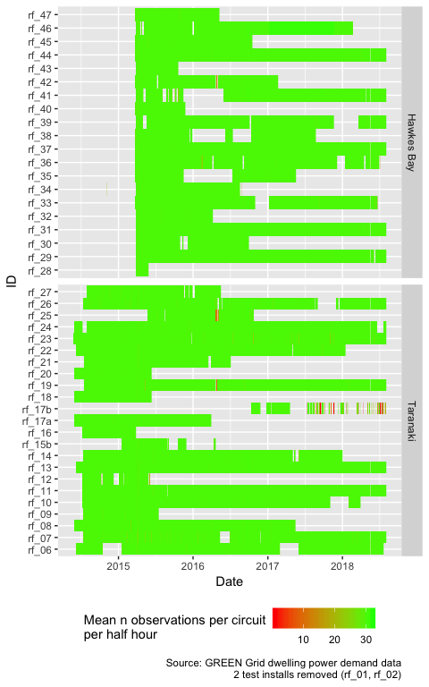

Figure 1: Mean number of observations per circuit per half hour

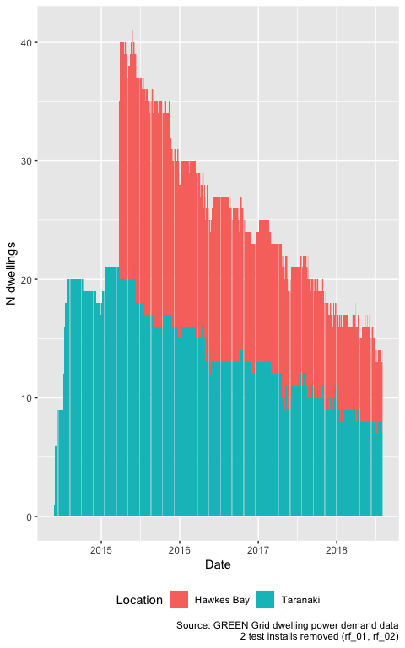

Figure 2: Number of dwellings sending data per day

For clarity, Figure 3 shows the mean daily number of dwellings present in the data in each year and season for each region. It is clear that 2015 provides the highest level of reporting dwellings, however Figure 3 also shows that it is possible to calculate seasonal summaries for several years.

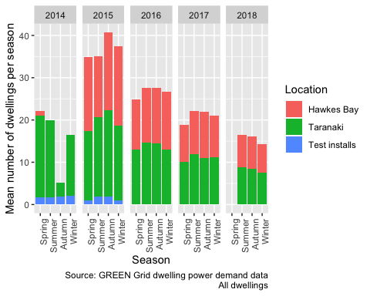

Figure 3: Active dwellings by season

However, it should be noted that:

* not all dwellings contained the appliance circuits of interest;
* two dwellings (rf_01 and rf_02) were test installs in researchers’ homes for whom no survey data exists;
* one dwelling (rf_46) has ambiguous circuit labels and so [should be ignored](https://github.com/CfSOtago/GREENGridData/issues/1);
* a number of dwellings have a very high proportion of -ve power values for some circuits which is probably due to PV installation (e.g. [rf_14,rf_25,rf_26,rf_43](https://cfsotago.github.io/GREENGridData/reportTotalPower_circuitsToSum_v1.1.html#6_implications)) and so should be ignored if total dwelling load is required;
* similarly [some dwellings]((https://cfsotago.github.io/GREENGridData/reportTotalPower_circuitsToSum_v1.1.html#6_implications)) have a small number of -ve power values on non-PV circuits at some times, possibly due to brief incorrect fitting of the monitors.

As a result the *effective* number of dwellings available for any given analysis will always be *lower* than the numbers reported above and should be evaluated on a case by case basis.

# Imputation of ‘total load’ per minute per dwelling

Whilst in theory the calculation of total load in any given minute should be a matter of merely summing all monitored circuits, in practice the task is not quite this simple. There are a number of reasons for this:

* for some dwellings the hot water circuit is separately metered and thus monitored but for others it is part of the overall ‘incomer/mains’ demand;
* photovoltaic panels were installed in several dwellings which produce negative power values and so would reduce apparent demand if naively aggregated;
* several dwellings report either systematic or intermittent negative values yet do not have PV installations.

Our previously work has shown that [with appropriate care](https://cfsotago.github.io/GREENGridData/reportTotalPower_circuitsToSum_v1.1.html) it is possible to derive best effort estimates of total dwelling power load by summing a small number of particular circuits for each dwelling (Anderson 2019). However the issues described above mean that users should:

* exclude dwellings with (link) IDs: rf_14,rf_25,rf_26 and rf_43 due to substantial unexplained negative values;
* exclude other -ve values on a per-value basis. *We recommend setting such values to NA (****not 0****)*;
* include dwellings known to have PV *only if* analysis of demand during non-daylight hours is being undertaken or if net demand is of interest.

Separately, for reasons explained [elsewhere](https://cfsotago.github.io/GREENGridData/gridSpy1mOutliersReport_v1.0.html#45_the_mysterious_case_of_rf_46) we also recommend removing rf_46 from the data prior to analysis.

In all cases we recommend that users check the data carefully before analysis and document any filtering they apply.

We have therefore created a new dataset for each dwelling which comprises the estimated total load per minute for each dwelling for the entire time frame for which we have data (ref Figure 2). For ease of use this data is available as:

* an additional set of observations added to the end of each clean data file with circuit label set to imputedTotalDemand_circuitsToSum_v1.1 indicating that the [aggregation code](https://github.com/CfSOtago/GREENGridData/blob/master/dataProcessing/gridSpy/imputeTotalPower.R) used the [circuitsToSum definition v1.1](https://github.com/CfSOtago/GREENGridData/blob/master/data/circuitsToSum_v1.1.csv);
* a single file containing *only* the estimated total load per minute per dwelling.

Note that we have *not* applied the exclusion rules described above. In order to ensure all data is available if required, these rules should only be applied just prior to analysis. The files are listed in Table 1. Whilst we can make these data files available, potential users should note that they are *larger* than the original data files. The single file containing *only* the estimated total load per minute per dwelling is especially large.

Table 1: Size of clean data files with estimated load

file

Mb (gzipped)

all_1min_data_withImputedTotal_circuitsToSum_v1.1.csv.gz

497.70

rf_01_all_1min_data_withImputedTotal_circuitsToSum_v1.1.csv.gz

35.43

rf_02_all_1min_data_withImputedTotal_circuitsToSum_v1.1.csv.gz

21.24

rf_06_all_1min_data_withImputedTotal_circuitsToSum_v1.1.csv.gz

78.65

rf_07_all_1min_data_withImputedTotal_circuitsToSum_v1.1.csv.gz

83.80

rf_08_all_1min_data_withImputedTotal_circuitsToSum_v1.1.csv.gz

63.28

rf_09_all_1min_data_withImputedTotal_circuitsToSum_v1.1.csv.gz

21.92

rf_10_all_1min_data_withImputedTotal_circuitsToSum_v1.1.csv.gz

69.41

rf_11_all_1min_data_withImputedTotal_circuitsToSum_v1.1.csv.gz

80.80

rf_12_all_1min_data_withImputedTotal_circuitsToSum_v1.1.csv.gz

15.83

rf_13_all_1min_data_withImputedTotal_circuitsToSum_v1.1.csv.gz

98.29

rf_14_all_1min_data_withImputedTotal_circuitsToSum_v1.1.csv.gz

68.16

rf_15b_all_1min_data_withImputedTotal_circuitsToSum_v1.1.csv.gz

16.53

rf_16_all_1min_data_withImputedTotal_circuitsToSum_v1.1.csv.gz

14.47

rf_17a_all_1min_data_withImputedTotal_circuitsToSum_v1.1.csv.gz

38.17

rf_17b_all_1min_data_withImputedTotal_circuitsToSum_v1.1.csv.gz

10.32

rf_18_all_1min_data_withImputedTotal_circuitsToSum_v1.1.csv.gz

23.23

rf_19_all_1min_data_withImputedTotal_circuitsToSum_v1.1.csv.gz

118.11

rf_20_all_1min_data_withImputedTotal_circuitsToSum_v1.1.csv.gz

22.37

rf_21_all_1min_data_withImputedTotal_circuitsToSum_v1.1.csv.gz

38.80

rf_22_all_1min_data_withImputedTotal_circuitsToSum_v1.1.csv.gz

78.65

rf_23_all_1min_data_withImputedTotal_circuitsToSum_v1.1.csv.gz

91.03

rf_24_all_1min_data_withImputedTotal_circuitsToSum_v1.1.csv.gz

86.61

rf_25_all_1min_data_withImputedTotal_circuitsToSum_v1.1.csv.gz

28.56

rf_26_all_1min_data_withImputedTotal_circuitsToSum_v1.1.csv.gz

76.03

rf_27_all_1min_data_withImputedTotal_circuitsToSum_v1.1.csv.gz

36.07

rf_28_all_1min_data_withImputedTotal_circuitsToSum_v1.1.csv.gz

3.49

rf_29_all_1min_data_withImputedTotal_circuitsToSum_v1.1.csv.gz

74.76

rf_30_all_1min_data_withImputedTotal_circuitsToSum_v1.1.csv.gz

29.38

rf_31_all_1min_data_withImputedTotal_circuitsToSum_v1.1.csv.gz

67.48

rf_32_all_1min_data_withImputedTotal_circuitsToSum_v1.1.csv.gz

20.82

rf_33_all_1min_data_withImputedTotal_circuitsToSum_v1.1.csv.gz

66.67

rf_34_all_1min_data_withImputedTotal_circuitsToSum_v1.1.csv.gz

30.87

rf_35_all_1min_data_withImputedTotal_circuitsToSum_v1.1.csv.gz

32.93

rf_36_all_1min_data_withImputedTotal_circuitsToSum_v1.1.csv.gz

57.78

rf_37_all_1min_data_withImputedTotal_circuitsToSum_v1.1.csv.gz

65.21

rf_38_all_1min_data_withImputedTotal_circuitsToSum_v1.1.csv.gz

35.26

rf_39_all_1min_data_withImputedTotal_circuitsToSum_v1.1.csv.gz

56.52

rf_40_all_1min_data_withImputedTotal_circuitsToSum_v1.1.csv.gz

14.53

rf_41_all_1min_data_withImputedTotal_circuitsToSum_v1.1.csv.gz

55.73

rf_42_all_1min_data_withImputedTotal_circuitsToSum_v1.1.csv.gz

38.96

rf_43_all_1min_data_withImputedTotal_circuitsToSum_v1.1.csv.gz

11.20

rf_44_all_1min_data_withImputedTotal_circuitsToSum_v1.1.csv.gz

67.23

rf_45_all_1min_data_withImputedTotal_circuitsToSum_v1.1.csv.gz

32.28

rf_46_all_1min_data_withImputedTotal_circuitsToSum_v1.1.csv.gz

160.69

rf_47_all_1min_data_withImputedTotal_circuitsToSum_v1.1.csv.gz

21.95

Table 2 shows basic statistics for the estimated 1 minute level load for each dwelling and illustrates some of the issues described above.

Table 2: Basic statistics for the estimated 1 minute level load (W) for each dwelling

linkID

PV Inverter

Location

nObs

meanW

minW

maxW

sdW

rf_01

NA

Test installs

851,716

1662.15

0.00

13560.50

1742.03

rf_02

NA

Test installs

581,156

719.25

-330.38

10204.00

998.49

rf_06

Taranaki

1,883,074

941.95

-1436.21

10804.38

1128.38

rf_07

Taranaki

2,010,201

604.47

-263.00

9508.46

656.20

rf_08

Taranaki

1,548,193

1044.98

35.14

11973.94

1144.81

rf_09

Taranaki

527,883

648.63

-16.00

8586.00

757.80

rf_10

Taranaki

1,822,053

596.12

27.68

9860.26

772.91

rf_11

Taranaki

2,127,141

545.92

14.00

11855.49

885.84

rf_12

Taranaki

398,134

779.81

-406.00

10439.03

1217.16

rf_13

Taranaki

2,179,995

1455.69

92.46

11580.60

1188.63

rf_14

Taranaki

1,783,337

612.96

-1758.08

9894.88

739.48

rf_15b

Taranaki

390,846

1255.16

-1062.00

10536.10

1202.39

rf_16

Taranaki

372,306

538.28

-262.00

8691.89

821.54

rf_17a

Taranaki

959,929

526.92

-1084.72

9041.53

788.89

rf_17b

Taranaki

272,150

351.03

32.17

6495.37

481.33

rf_18

Taranaki

540,446

1444.19

-1842.66

13079.07

1901.81

rf_19

yes

Taranaki

2,109,122

-589.54

-12407.52

7363.92

2035.90

rf_20

Taranaki

543,382

813.60

-1273.19

9739.43

1083.75

rf_21

Taranaki

1,010,258

483.36

31.00

7990.10

607.06

rf_22

Taranaki

1,885,333

1291.44

47.92

11535.40

1342.73

rf_23

yes

Taranaki

2,181,070

1078.65

-1871.83

11015.80

1126.36

rf_24

yes

Taranaki

2,107,577

76.59

-7542.61

9929.11

1518.25

rf_25

Taranaki

706,148

859.16

0.00

11814.74

1071.90

rf_26

Taranaki

1,938,549

707.24

-482.36

9366.50

997.70

rf_27

Taranaki

908,658

1118.20

58.00

9569.40

1062.34

rf_28

yes

Hawkes Bay

86,311

-135.48

-3366.52

7960.34

983.91

rf_29

Hawkes Bay

1,749,695

1606.68

76.85

12011.87

1400.14

rf_30

Hawkes Bay

743,770

743.41

30.00

8706.07

751.49

rf_31

Hawkes Bay

1,760,227

642.32

24.00

10547.60

864.45

rf_32

Hawkes Bay

541,109

677.75

0.00

8274.91

850.74

rf_33

Hawkes Bay

1,601,314

814.45

63.47

9654.25

966.47

rf_34

Hawkes Bay

730,613

1159.12

0.00

13043.50

1189.61

rf_35

Hawkes Bay

781,977

1339.89

-622.00

10373.54

1223.08

rf_36

Hawkes Bay

1,605,647

829.98

0.00

14826.00

1301.66

rf_37

Hawkes Bay

1,763,330

583.05

51.00

9365.54

1019.71

rf_38

Hawkes Bay

886,482

1058.81

-179.00

9455.19

1383.36

rf_39

Hawkes Bay

1,537,301

1920.08

-199.00

15593.20

1767.34

rf_40

Hawkes Bay

348,217

1191.50

24.00

12527.77

1326.90

rf_41

Hawkes Bay

1,372,961

1014.34

54.83

12857.00

1053.56

rf_42

Hawkes Bay

975,198

1230.27

33.61

12383.70

1563.55

rf_43

Hawkes Bay

296,190

626.90

0.00

6687.53

719.72

rf_44

Hawkes Bay

1,762,049

1079.67

32.00

12165.12

1573.37

rf_45

Hawkes Bay

819,601

771.95

23.90

10385.13

1237.62

rf_46

Hawkes Bay

1,939,634

1622.95

92.00

12979.28

1399.64

rf_47

Hawkes Bay

588,348

415.53

21.00

11171.30

673.20

# Development of a half-hourly power demand dataset

In response to EECA’s request we have used the per-dwelling files listed in Table 1 and the code available from our [github repo](https://github.com/CfSOtago/GREENGridEECA/blob/master/dataProcessing/makeHalfHourlyData.R) to produce an aggregated half-hourly power demand dataset **for each dwelling**.

These files contain:

* r_dateTimeHalfHour (in UTC) in half hours;
* number of observations, mean, min, max and standard deviation of power (W) for each half hour;
* circuit label with total load labelled as imputedTotalDemand_circuitsToSum_v1.1;
* dwelling linkID (for linkage to survey data).

Table 3 shows the first few rows of one of these files where:

* linkID = dwelling identifier to link to survey data
* circuit = circuit monitored
* r_dateTimeHalfHour = date and time (half hour)
* nObs = number of 1 minute power observations used in the calculations (usually 30)
* meanPowerW = mean of 1 minute power observations (W)
* sdPowerW = standard deviation of 1 minute power observations (W)
* minPowerW = minimum 1 minute power value observed (W)
* maxPowerW = maximum 1 minute power value power observed (W)

Table 3: Half hourly data format with example data

linkID

circuit

r_dateTimeHalfHour

nObs

meanPowerW

sdPowerW

minPowerW

maxPowerW

rf_01

Heating$1633

2014-01-06 16:00:00

2

28.39

0.00

28.39

28.39

rf_01

Heating$1633

2014-03-07 15:30:00

4

28.27

0.24

27.91

28.39

rf_01

Heating$1633

2014-03-07 16:00:00

19

393.55

423.92

27.91

925.09

rf_01

Heating$1633

2014-03-07 16:30:00

30

909.96

7.65

897.09

921.28

rf_01

Heating$1633

2014-03-07 17:00:00

30

896.36

2.77

891.39

903.27

rf_01

Heating$1633

2014-03-07 17:30:00

30

905.08

17.19

885.21

936.97

The resulting files are listed in Table 4.

Table 4: Size of clean half hourly data files

file

Mb (gzipped)

rf_01_allObs_halfHourly.csv.gz

3.67

rf_02_allObs_halfHourly.csv.gz

2.23

rf_06_allObs_halfHourly.csv.gz

7.59

rf_07_allObs_halfHourly.csv.gz

8.54

rf_08_allObs_halfHourly.csv.gz

5.66

rf_09_allObs_halfHourly.csv.gz

2.51

rf_10_allObs_halfHourly.csv.gz

7.13

rf_11_allObs_halfHourly.csv.gz

7.51

rf_12_allObs_halfHourly.csv.gz

1.69

rf_13_allObs_halfHourly.csv.gz

9.86

rf_14_allObs_halfHourly.csv.gz

7.34

rf_15b_allObs_halfHourly.csv.gz

1.57

rf_16_allObs_halfHourly.csv.gz

1.73

rf_17a_allObs_halfHourly.csv.gz

3.68

rf_17b_allObs_halfHourly.csv.gz

1.01

rf_18_allObs_halfHourly.csv.gz

2.19

rf_19_allObs_halfHourly.csv.gz

9.78

rf_20_allObs_halfHourly.csv.gz

2.34

rf_21_allObs_halfHourly.csv.gz

3.84

rf_22_allObs_halfHourly.csv.gz

8.32

rf_23_allObs_halfHourly.csv.gz

8.67

rf_24_allObs_halfHourly.csv.gz

7.70

rf_25_allObs_halfHourly.csv.gz

3.06

rf_26_allObs_halfHourly.csv.gz

7.48

rf_27_allObs_halfHourly.csv.gz

3.07

rf_28_allObs_halfHourly.csv.gz

0.36

rf_29_allObs_halfHourly.csv.gz

6.30

rf_30_allObs_halfHourly.csv.gz

2.80

rf_31_allObs_halfHourly.csv.gz

5.99

rf_32_allObs_halfHourly.csv.gz

1.82

rf_33_allObs_halfHourly.csv.gz

6.02

rf_34_allObs_halfHourly.csv.gz

3.20

rf_35_allObs_halfHourly.csv.gz

3.18

rf_36_allObs_halfHourly.csv.gz

4.93

rf_37_allObs_halfHourly.csv.gz

6.53

rf_38_allObs_halfHourly.csv.gz

3.68

rf_39_allObs_halfHourly.csv.gz

5.62

rf_40_allObs_halfHourly.csv.gz

1.51

rf_41_allObs_halfHourly.csv.gz

5.72

rf_42_allObs_halfHourly.csv.gz

3.97

rf_43_allObs_halfHourly.csv.gz

1.05

rf_44_allObs_halfHourly.csv.gz

6.00

rf_45_allObs_halfHourly.csv.gz

3.06

rf_46_allObs_halfHourly.csv.gz

18.03

rf_47_allObs_halfHourly.csv.gz

2.01

Further, these per-dwelling files have been used to attempt to create single data files containing all observations for the circuits or (partial) circuit labels set out in the following sections. Table 15 in Section 8.1 of the Data Annex shows the unique circuit labels available as a guide to what can be meaningfully extracted. The process of extraction uses partial string matching so, for example, the string Lighting would match to circuits with the following labels:

* "Lighting"
* "Lighting and spa"
* "Lighting and garage"

but not:

* "Outside Lights"

Note that the process may therefore match a number of circuits and in some cases circuits may contain other appliances. Analysis should therefore proceed with caution since some circuits may have been missed that were required and some extracted which were not. For the avoidance of doubt, the [code](https://github.com/CfSOtago/GREENGridEECA/blob/master/reports/partA_dataProcessing/dataProcessingReport.Rmd) used to extract these circuits should be checked against Table 15 in Section 8.1 of the Data Annex.

In each section we extract and save the relevant half-hourly observations and provide two plots:

* a tile plot showing the data avilability and mean power for the extracted circuits over the entire data collection;
* a mean power demand profile plot by time of day and season as a sense-check on the patterns of demand for the extracted circuits.

## Lighting

filter <- "Lighting"  
dt <- halfHourlyPowerDT[circuitLabel %like% filter] # extraction

In this section we extract every record where:

* the string “Lighting” is found in circuit

Table 5 shows summary statistics of the half-hourly mean values for all observations extracted by circuit label.

## # -> 937739 rows of data for 8 unique circuit labels from 23 dwellings covering the period   
## # -> 2014-06-06 16:30:00 to 2018-08-01 23:30:00 (NB: data may not be continuous)

Table 5: Summary statistics for extract

circuitLabel

nObs

nDwellings

meanW

minW

maxW

sdW

Lighting

789233

20

106.147

-127.277

3411.401

236.878

Lighting & 2 Towel Rail

51274

1

278.265

0.000

2101.948

184.507

Lighting (inc heat lamps)

32529

1

361.126

0.000

3528.905

538.110

Lighting 1/2

9153

1

-1.721

-68.609

14.600

5.983

Lighting 2/2

9153

1

7.884

0.000

166.436

19.275

Lighting1

19407

1

440.832

41.400

2187.108

312.316

Lighting2

19407

1

42.556

-127.277

415.553

68.866

Lighting_Imag

7583

1

9.507

-96.211

471.371

68.458

## Gziping /Users/ben/Data/NZ_GREENGrid/safe//gridSpy/halfHour/extracts/halfHourLighting.csv

## Gzipped /Users/ben/Data/NZ_GREENGrid/safe//gridSpy/halfHour/extracts/halfHourLighting.csv

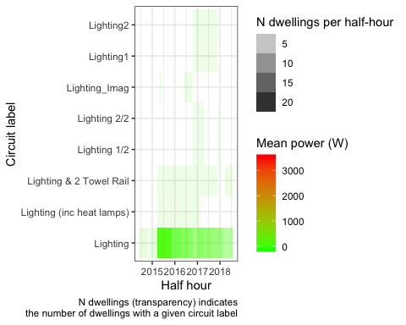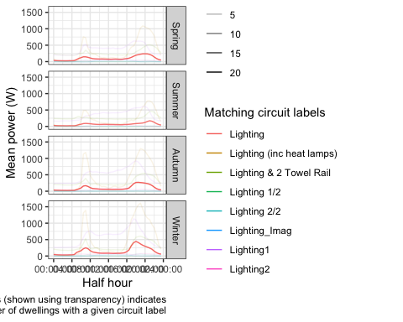

We therefore have *Lighting* data for 27 dwellings.

## Hot water

# more complex (we could de-capitalise first)  
filter1 <- "Hot water" # or  
filter2 <- "Hot Water"  
  
dt <- halfHourlyPowerDT[circuitLabel %like% filter1 |  
 circuitLabel %like% filter2]

In this section we extract every record where:

* the string “Hot water” is found in circuit
* the string “Hot Water” is found in circuit

Table 6 shows the mean power (mean of the half-hourly mean values) for all observations extracted by circuit label.

## # -> 1447845 rows of data for 11 unique circuit labels from 34 dwellings covering the period   
## # -> 2014-01-06 16:00:00 to 2018-08-01 23:30:00 (NB: data may not be continuous)

Table 6: Summary statistics for extract

circuitLabel

nObs

nDwellings

meanW

minW

maxW

sdW

Hot Water

32452

2

305.402

0.000

2215.737

495.432

Hot Water (2 elements)

51274

1

394.893

0.000

3317.472

794.307

Hot Water - Controlled

995591

23

287.919

-525.423

3317.720

637.925

Hot Water - Controlled (HEMS)

72954

1

256.577

0.000

1459.965

430.793

Hot Water - Controlled1

19407

1

264.633

-0.570

2137.988

613.222

Hot Water - Controlled2

19407

1

2.893

-26.632

56.671

6.783

Hot Water - Controlled_Imag

7583

1

1.385

-32.408

89.840

4.947

Hot Water - Uncontrolled

136539

4

308.662

-208.233

3901.050

624.055

Hot Water Cpbd Heater- Cont

70927

1

76.914

0.000

1955.707

156.522

Hot water

28401

1

216.747

0.000

1874.646

470.285

Incomer 1 - Hot Water - Cont

13310

1

431.691

0.000

3057.669

763.904

## Gziping /Users/ben/Data/NZ_GREENGrid/safe//gridSpy/halfHour/extracts/halfHourHotWater.csv

## Gzipped /Users/ben/Data/NZ_GREENGrid/safe//gridSpy/halfHour/extracts/halfHourHotWater.csv

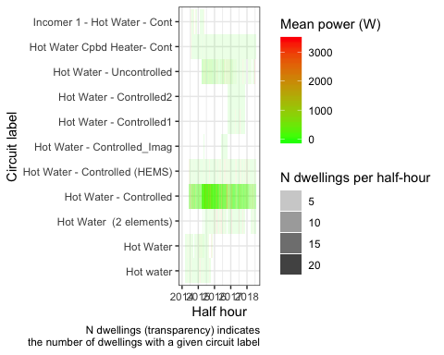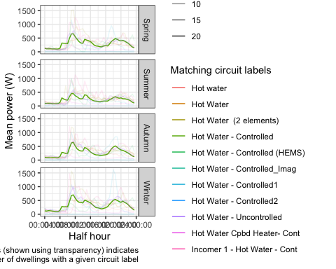

We therefore have *Hot Water* data for 37 dwellings.

## Heat pumps

filter1 <- "Heat Pump"  
  
dt <- halfHourlyPowerDT[circuitLabel %like% filter1]

In this section we extract every record where:

* the string “Heat Pump” is found in circuit

Table 7 shows the mean power (mean of the half-hourly mean values) for all observations extracted by circuit label.

## # -> 1342357 rows of data for 17 unique circuit labels from 29 dwellings covering the period   
## # -> 2014-05-29 10:00:00 to 2018-08-01 23:30:00 (NB: data may not be continuous)

Table 7: Summary statistics for extract

circuitLabel

nObs

nDwellings

meanW

minW

maxW

sdW

Bedroom & Lounge Heat Pumps

70345

1

90.484

0.000

2555.719

194.524

Downstairs (inc 1 Heat Pump)

72683

1

7.251

-2343.788

2967.435

454.010

Heat Pump

644577

18

90.955

-58.367

4982.931

284.471

Heat Pump & 2 x Bathroom Heat

19625

1

119.058

0.000

3559.722

368.699

Heat Pump & Bedroom 2

17605

1

153.405

-26.877

3242.937

320.690

Heat Pump & Kitchen Appliances

58353

1

589.413

20.936

3760.920

482.378

Heat Pump & Lounge

70927

1

221.935

0.000

3314.134

370.098

Heat Pump & Misc

18124

1

176.614

-173.072

1701.146

225.030

Heat Pump & Washing Machine

33684

1

113.523

0.000

3120.887

268.412

Heat Pump (x2) & Lounge Power

11618

1

330.668

0.000

5340.914

710.990

Heat Pumps (2x) & Power

81989

1

116.971

-242.388

2959.364

291.750

Heat Pumps (2x) & Power1

19407

1

235.390

5.915

2959.364

284.451

Heat Pumps (2x) & Power2

19407

1

-66.280

-241.699

249.051

60.350

Heat Pumps (2x) & Power_Imag

7583

1

-105.076

-269.724

250.487

50.018

Kitchen Appliances & Heat Pump

53402

1

274.957

62.990

3180.312

266.882

Theatre Heat Pump

70345

1

3.030

-3.267

999.087

28.796

Upstairs Heat Pumps

72683

1

147.743

-46.290

2762.926

364.076

## Gziping /Users/ben/Data/NZ_GREENGrid/safe//gridSpy/halfHour/extracts/halfHourHeatPump.csv

## Gzipped /Users/ben/Data/NZ_GREENGrid/safe//gridSpy/halfHour/extracts/halfHourHeatPump.csv

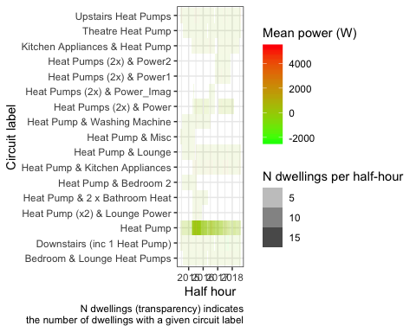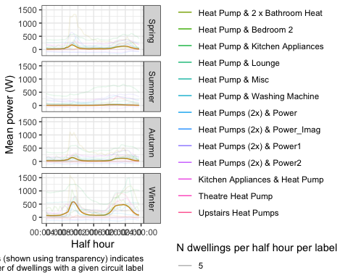

We therefore have *Heat Pump* data for 34 dwellings.

## Kitchen

Noting that this may include other areas of the dwelling…

filter1 <- "Kitchen"  
  
dt <- halfHourlyPowerDT[circuitLabel %like% filter1]

In this section we extract every record where:

* the string “Kitchen” is found in circuit

Table 8 and shows the mean power (mean of the half-hourly mean values) for all observations extracted by circuit label.

## # -> 1854832 rows of data for 23 unique circuit labels from 44 dwellings covering the period   
## # -> 2014-01-06 16:00:00 to 2018-08-01 23:30:00 (NB: data may not be continuous)

Table 8: Summary statistics for extract

circuitLabel

nObs

nDwellings

meanW

minW

maxW

sdW

Heat Pump & Kitchen Appliances

58353

1

589.413

20.936

3760.920

482.378

Hob & Kitchen Appliances

23570

1

349.554

0.000

2379.292

319.873

Kitchen

184740

3

88.059

0.000

2273.916

160.105

Kitchen & Bedrooms

81989

1

111.272

-45.302

2106.422

165.294

Kitchen & Bedrooms1

19407

1

117.717

0.000

1436.520

170.837

Kitchen & Bedrooms2

19407

1

39.627

-37.738

205.681

69.900

Kitchen & Bedrooms_Imag

7583

1

98.201

-41.499

204.522

79.882

Kitchen & Laundry

135563

2

326.218

0.000

4445.761

332.796

Kitchen Appliances

818490

22

117.330

-586.962

3484.788

205.900

Kitchen Appliances & Bedrooms

12416

1

39.718

0.000

2247.657

73.991

Kitchen Appliances & Garage

33684

1

46.272

-2.523

1952.114

178.958

Kitchen Appliances & Heat Pump

53402

1

274.957

62.990

3180.312

266.882

Kitchen Appliances & Laundry

138080

2

169.961

-41.100

3144.275

202.688

Kitchen Appliances & Lounge

13310

1

147.102

-1.686

2063.290

195.101

Kitchen Appliances & Ventilati

18032

1

438.888

-500.265

3044.483

323.134

Kitchen Power & Heat, Lounge

19625

1

142.513

13.810

2670.404

180.314

Kitchen power

28401

1

203.905

0.000

3048.565

296.531

Kitchen, Dining & Office

29556

1

112.220

0.000

2221.450

177.167

Kitchen, Laundry & Beds 1&3

30305

1

344.661

19.907

2555.615

316.372

Kitchen, Laundry & Ventilation

72954

1

240.922

41.791

3810.431

223.795

Laundry & Kitchen

24801

1

15.004

0.000

1073.849

34.050

Laundry & Kitchen Appliances

13040

1

259.593

-564.167

4637.651

401.028

Oven & Kitchen Appliances

18124

1

262.494

39.133

3397.599

278.561

## Gziping /Users/ben/Data/NZ_GREENGrid/safe//gridSpy/halfHour/extracts/halfHourKitchen.csv

## Gzipped /Users/ben/Data/NZ_GREENGrid/safe//gridSpy/halfHour/extracts/halfHourKitchen.csv

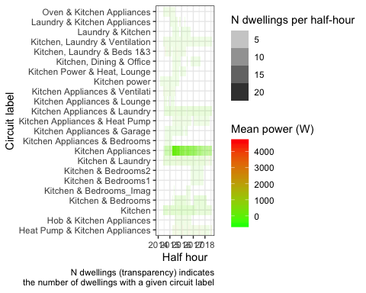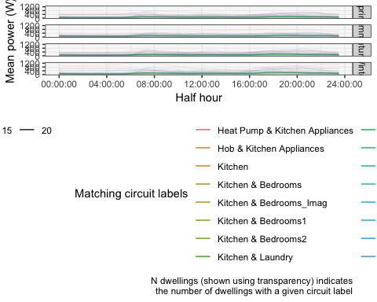

We therefore have *Kitchen* data for 48 dwellings.

## Non-heat pump ‘Heat’

Noting that this circuit label may include other appliances…

# more complex  
filter1 <- "Heat"  
# and not "Heat Pump"   
dt <- halfHourlyPowerDT[circuitLabel %like% filter1 &  
 !circuitLabel %like% "Heat Pump"]

In this section we extract every record where:

* the string “Heat” is found in circuit but excluding ‘Heat Pump’

Table 9 shows the mean power (mean of the half-hourly mean values) for all observations extracted by circuit label.

## # -> 138365 rows of data for 3 unique circuit labels from 4 dwellings covering the period   
## # -> 2014-01-06 16:00:00 to 2018-08-01 23:30:00 (NB: data may not be continuous)

Table 9: Summary statistics for extract

circuitLabel

nObs

nDwellings

meanW

minW

maxW

sdW

Heating

47813

2

635.647

0.00

7084.992

959.578

Hot Water Cpbd Heater- Cont

70927

1

76.914

0.00

1955.707

156.522

Kitchen Power & Heat, Lounge

19625

1

142.513

13.81

2670.404

180.314

## Gziping /Users/ben/Data/NZ_GREENGrid/safe//gridSpy/halfHour/extracts/halfHourNonHP_Heat.csv

## Gzipped /Users/ben/Data/NZ_GREENGrid/safe//gridSpy/halfHour/extracts/halfHourNonHP_Heat.csv

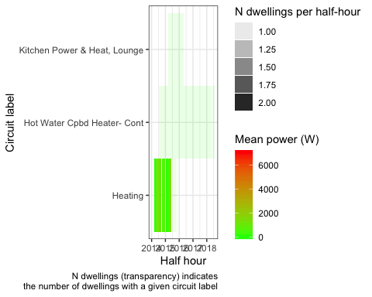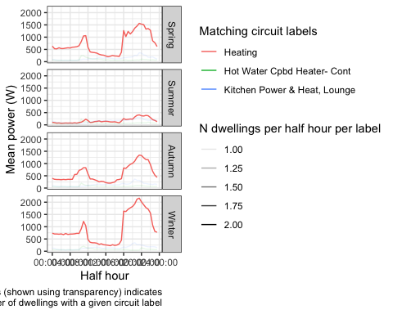

We therefore have non Heat Pump *Heat* data for 4 dwellings.

## Refrigerator/Fridge

Noting that this circuit label may include other appliances…

filter1 <- "Fridge"  
  
dt <- halfHourlyPowerDT[circuitLabel %like% filter1]

In this section we extract every record where:

* the string “Fridge” is found in circuit

Table 10 shows the mean power (mean of the half-hourly mean values) for all observations extracted by circuit label.

## # -> 395576 rows of data for 9 unique circuit labels from 10 dwellings covering the period   
## # -> 2014-03-03 08:00:00 to 2018-08-01 23:30:00 (NB: data may not be continuous)

Table 10: Summary statistics for extract

circuitLabel

nObs

nDwellings

meanW

minW

maxW

sdW

Bed 2, 2nd Fridge

30311

1

80.180

0.000

926.520

159.651

Fridge

53096

2

81.083

0.000

1212.828

104.190

Laundry & 2nd Fridge Freezer

51639

1

146.050

0.000

3843.133

250.991

Laundry & Fridge Freezer

58798

1

55.961

0.000

1136.268

67.101

Laundry & Garage Fridge

27332

1

37.189

0.000

1716.550

82.971

Laundry, Fridge & Freezer

70291

1

97.865

-25.632

1286.748

55.324

Laundry, Fridge & Microwave

13310

1

63.840

-26.408

993.040

52.576

Laundry, Garage Fridge Freezer

26083

1

124.969

25.640

2389.454

92.344

Laundry, Sauna & 2nd Fridge

64716

1

66.285

-7.444

2557.823

75.937

## Gziping /Users/ben/Data/NZ_GREENGrid/safe//gridSpy/halfHour/extracts/halfHourFridge.csv

## Gzipped /Users/ben/Data/NZ_GREENGrid/safe//gridSpy/halfHour/extracts/halfHourFridge.csv

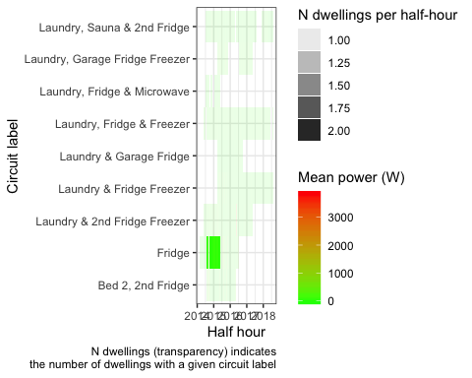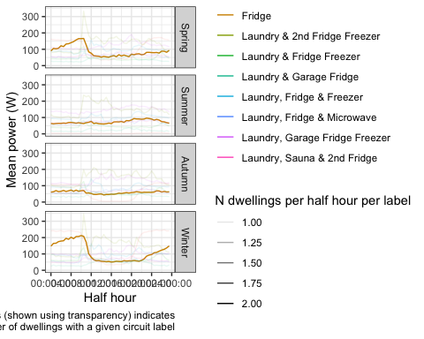

We therefore have *Fridge* data for 10 dwellings.

## Freezer

Noting that this circuit label may include other appliances…

filter1 <- "Freezer"  
  
dt <- halfHourlyPowerDT[circuitLabel %like% filter1]

In this section we extract every record where:

* the string “Freezer” is found in circuit

Table 11 shows the mean power (mean of the half-hourly mean values) for all observations extracted by circuit label.

## # -> 263713 rows of data for 6 unique circuit labels from 6 dwellings covering the period   
## # -> 2014-05-29 10:00:00 to 2018-08-01 23:30:00 (NB: data may not be continuous)

Table 11: Summary statistics for extract

circuitLabel

nObs

nDwellings

meanW

minW

maxW

sdW

Laundry & 2nd Fridge Freezer

51639

1

146.050

0.000

3843.133

250.991

Laundry & Freezer

32529

1

131.294

0.000

1633.096

49.098

Laundry & Fridge Freezer

58798

1

55.961

0.000

1136.268

67.101

Laundry & Garage Freezer

24373

1

104.939

0.000

2209.190

135.381

Laundry, Fridge & Freezer

70291

1

97.865

-25.632

1286.748

55.324

Laundry, Garage Fridge Freezer

26083

1

124.969

25.640

2389.454

92.344

## Gziping /Users/ben/Data/NZ_GREENGrid/safe//gridSpy/halfHour/extracts/halfHourFreezer.csv

## Gzipped /Users/ben/Data/NZ_GREENGrid/safe//gridSpy/halfHour/extracts/halfHourFreezer.csv

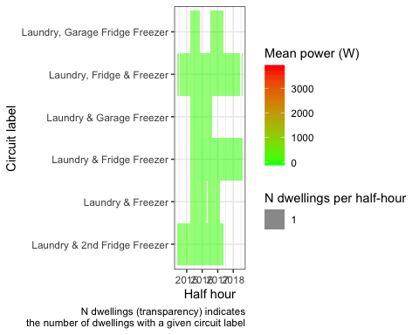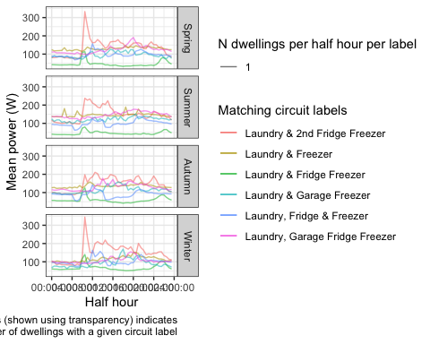

We therefore have *Freezer* data for 6 dwellings.

## Oven

Noting that this circuit label may include other appliances…

filter1 <- "Oven"  
  
dt <- halfHourlyPowerDT[circuitLabel %like% filter1]

In this section we extract every record where:

* the string “Oven” is found in circuit

Table 12 shows the mean power (mean of the half-hourly mean values) for all observations extracted by circuit label.

## # -> 1209258 rows of data for 13 unique circuit labels from 29 dwellings covering the period   
## # -> 2014-05-26 10:30:00 to 2018-08-01 23:30:00 (NB: data may not be continuous)

Table 12: Summary statistics for extract

circuitLabel

nObs

nDwellings

meanW

minW

maxW

sdW

Incomer 1 - Uncont inc Oven

12416

1

61.806

0.000

2251.039

163.328

Incomer 1 - inc Top Oven

9153

1

137.456

0.000

2831.723

242.022

Incomer 2 - Uncont - Inc Oven

17605

1

241.256

-26.040

3920.391

409.398

Incomer 2 - Uncont - inc Oven

32019

1

237.832

-376.067

4797.083

373.024

Incomer 2 - Uncont inc Oven

59477

1

102.715

-1372.399

2974.610

179.291

Incomer 2 - inc Bottom Oven

9153

1

216.215

36.218

2333.497

205.187

Oven

665749

15

37.479

-1067.563

3676.903

195.568

Oven & Hob

257423

4

57.702

-24.645

3919.073

257.646

Oven & Hobb

24801

1

26.524

0.000

2908.371

163.390

Oven & Kitchen Appliances

18124

1

262.494

39.133

3397.599

278.561

Oven & Oven Wall Appliances

30311

1

38.181

0.000

2495.701

225.925

Oven, Hob & Microwave

53402

1

37.418

0.000

3614.151

215.134

Wall Oven

19625

1

26.402

-2.423

2473.255

177.663

## Gziping /Users/ben/Data/NZ_GREENGrid/safe//gridSpy/halfHour/extracts/halfHourOven.csv

## Gzipped /Users/ben/Data/NZ_GREENGrid/safe//gridSpy/halfHour/extracts/halfHourOven.csv

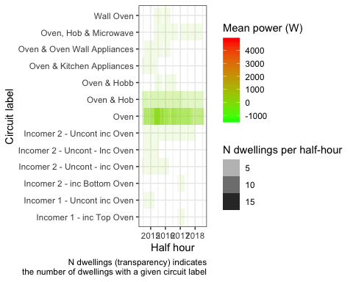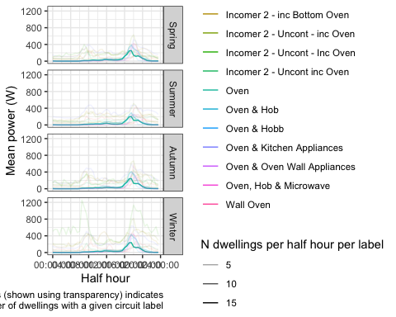

We therefore have *Oven* data for 30 dwellings.

## Photovoltaic panels

Noting that this circuit label may include other appliances…

filter1 <- "PV"  
  
dt <- halfHourlyPowerDT[circuitLabel %like% filter1]

In this section we extract every record where:

* the string “PV” is found in circuit

Table 13 shows the mean power (mean of the half-hourly mean values) for all observations extracted by circuit label.

## # -> 286820 rows of data for 5 unique circuit labels from 4 dwellings covering the period   
## # -> 2014-05-26 10:30:00 to 2018-08-01 23:30:00 (NB: data may not be continuous)

Table 13: Summary statistics for extract

circuitLabel

nObs

nDwellings

meanW

minW

maxW

sdW

PV

70291

1

-799.586

-4549.259

5.767

1235.375

PV & Garage

2885

1

-489.754

-3071.270

93.182

837.672

PV & Storage

72954

1

-93.942

-2044.631

2049.756

410.319

PV 1

70345

1

-594.141

-3966.106

38.187

939.053

PV 2

70345

1

-604.977

-4037.073

27.978

955.060

## Gziping /Users/ben/Data/NZ_GREENGrid/safe//gridSpy/halfHour/extracts/halfHourPV.csv

## Gzipped /Users/ben/Data/NZ_GREENGrid/safe//gridSpy/halfHour/extracts/halfHourPV.csv

## Scale for 'fill' is already present. Adding another scale for 'fill',  
## which will replace the existing scale.

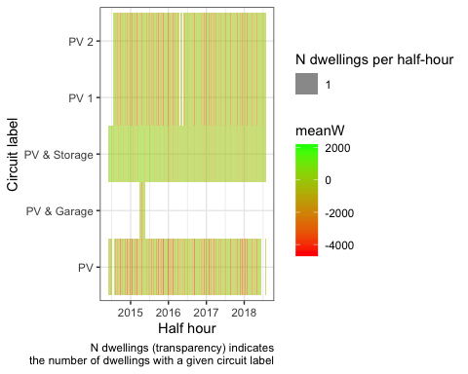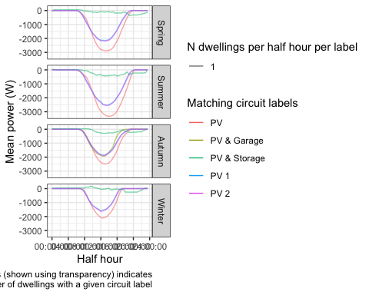

We therefore have *PV* data for 5 dwellings. It is interesting to note that most of the PV output for the dwelling with PV & Storage (rf_23) appears, on average, to be absorbed by its storage.

## Total load

dt <- halfHourlyPowerDT[circuitLabel %like% "imputedTotalDemand"]

In this section we extract every record where:

* the string “imputedTotalDemand” is found in circuit

Table 14 shows the mean power (mean of the half-hourly mean values) for all observations extracted by circuit label.

## # -> 1770614 rows of data for 1 unique circuit labels from 45 dwellings covering the period   
## # -> 2014-01-06 16:00:00 to 2018-08-01 23:30:00 (NB: data may not be continuous)

Table 14: Summary statistics for extract

circuitLabel

nObs

nDwellings

meanW

minW

maxW

sdW

imputedTotalDemand_circuitsToSum_v1.1

1770614

45

863.392

-7627.66

10981.59

1156.803

## Gziping /Users/ben/Data/NZ_GREENGrid/safe//gridSpy/halfHour/extracts/halfHourImputedTotalDemand.csv

## Gzipped /Users/ben/Data/NZ_GREENGrid/safe//gridSpy/halfHour/extracts/halfHourImputedTotalDemand.csv

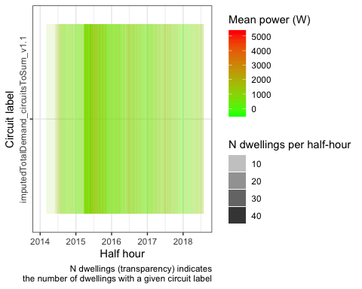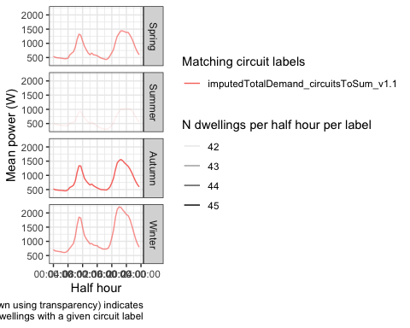

We therefore have *imputedTotalDemand* data for 45 dwellings.

# Summary

This report used the full New Zealand GREEN Grid household electricity demand study research data to:

* test the feasibility of multi-year data analysis beyond the single year made possible by the public available data (Stephenson et al. 2017). **We conclude that multi-year analysis is feasible but potentially limited due to sample attrition over time**;
* impute total dwelling load (W) per minute using the original circuit level data - **completed**;
* produce a smaller mean half-hourly power demand (W) per circuit (and total load) per dwelling dataset for further analysis - **completed**;
* extract half-hourly data for specified circuits - **completed**.

This report described the results of this work and directed the reader to relevant R code where necessary.

All code used to create this report is available from:

* <https://github.com/CfSOtago/GREENGridEECA>

The archived and most recent version of the report is available from:

* <https://cfsotago.github.io/GREENGridEECA/>

The half-hourly mean power demand data together with the circuit level extracts can be made available on request.

# Data Annex

## Circuit labels (all)

Table 15: Summary statistics by circuit label

circuitLabel

nObs

nDwellings

meanW

Bed 2, 2nd Fridge

30311

1

80.179734

Bedroom & Lounge Heat Pumps

70345

1

90.484303

Bedrooms & Lounge

60754

1

130.087294

Cooking Bath tile heat

19412

1

135.770702

Downstairs (inc 1 Heat Pump)

72683

1

7.250718

Fridge

53096

2

81.082776

Hallway & Washing Machine

12416

1

108.155741

Heat Pump

644577

18

90.955170

Heat Pump & 2 x Bathroom Heat

19625

1

119.058261

Heat Pump & Bedroom 2

17605

1

153.405256

Heat Pump & Kitchen Appliances

58353

1

589.412574

Heat Pump & Lounge

70927

1

221.935274

Heat Pump & Misc

18124

1

176.614469

Heat Pump & Washing Machine

33684

1

113.522523

Heat Pump (x2) & Lounge Power

11618

1

330.667698

Heat Pumps (2x) & Power

81989

1

116.970626

Heat Pumps (2x) & Power1

19407

1

235.389913

Heat Pumps (2x) & Power2

19407

1

-66.279776

Heat Pumps (2x) & Power_Imag

7583

1

-105.075756

Heating

47813

2

635.647001

Hob

102091

3

20.518332

Hob & Kitchen Appliances

23570

1

349.553675

Hot Water

32452

2

305.402252

Hot Water (2 elements)

51274

1

394.892831

Hot Water - Controlled

995591

23

287.918961

Hot Water - Controlled (HEMS)

72954

1

256.577056

Hot Water - Controlled1

19407

1

264.633198

Hot Water - Controlled2

19407

1

2.892765

Hot Water - Controlled_Imag

7583

1

1.385089

Hot Water - Uncontrolled

136539

4

308.662463

Hot Water Cpbd Heater- Cont

70927

1

76.914288

Hot water

28401

1

216.747444

Incomer - All

384626

12

764.450124

Incomer - Uncontrolled

892855

17

758.330354

Incomer - Uncontrolled1

19407

1

1602.818895

Incomer - Uncontrolled2

19407

1

308.790044

Incomer - Uncontrolled_Imag

7583

1

164.224745

Incomer -Uncontrolled

58798

1

295.559232

Incomer 1

13040

1

693.701816

Incomer 1 - All

135061

2

-28.090410

Incomer 1 - Hot Water - Cont

13310

1

431.690584

Incomer 1 - Uncont - Inc Hob

17605

1

407.190261

Incomer 1 - Uncont - inc Hob

32019

1

200.584456

Incomer 1 - Uncont inc Oven

12416

1

61.805799

Incomer 1 - Uncont inc Stove

59477

1

280.638399

Incomer 1 - Uncontrolled

103309

3

253.859807

Incomer 1 - Uncontrolled

23570

1

462.200693

Incomer 1 - inc Top Oven

9153

1

137.456088

Incomer 2

13040

1

561.389137

Incomer 2 - All

135061

2

59.875918

Incomer 2 - Uncont - Inc Oven

17605

1

241.256073

Incomer 2 - Uncont - inc Oven

32019

1

237.832149

Incomer 2 - Uncont inc Oven

59477

1

102.715324

Incomer 2 - Uncont inc Stove

12416

1

176.843124

Incomer 2 - Uncontrolled

116619

4

405.569788

Incomer 2 - Uncontrolled

23570

1

397.272814

Incomer 2 - inc Bottom Oven

9153

1

216.215229

Incomer 3 - Uncontrolled

13310

1

93.383268

Incomer Voltage

48543

1

233.044650

Kitchen

184740

3

88.059435

Kitchen & Bedrooms

81989

1

111.271795

Kitchen & Bedrooms1

19407

1

117.717179

Kitchen & Bedrooms2

19407

1

39.627458

Kitchen & Bedrooms_Imag

7583

1

98.201280

Kitchen & Laundry

135563

2

326.218097

Kitchen Appliances

818490

22

117.330190

Kitchen Appliances & Bedrooms

12416

1

39.718440

Kitchen Appliances & Garage

33684

1

46.272475

Kitchen Appliances & Heat Pump

53402

1

274.956827

Kitchen Appliances & Laundry

138080

2

169.960689

Kitchen Appliances & Lounge

13310

1

147.101534

Kitchen Appliances & Ventilati

18032

1

438.888107

Kitchen Power & Heat, Lounge

19625

1

142.513254

Kitchen power

28401

1

203.905063

Kitchen, Dining & Office

29556

1

112.219822

Kitchen, Laundry & Beds 1&3

30305

1

344.660508

Kitchen, Laundry & Ventilation

72954

1

240.921868

Laundry

315368

9

33.598287

Laundry

58753

1

32.965167

Laundry & 2nd Fridge Freezer

51639

1

146.050245

Laundry & Bedrooms

81989

1

167.521191

Laundry & Bedrooms1

19407

1

285.920723

Laundry & Bedrooms2

19407

1

105.456512

Laundry & Bedrooms_Imag

7583

1

4.987965

Laundry & Freezer

32529

1

131.294286

Laundry & Fridge Freezer

58798

1

55.960774

Laundry & Garage

69907

2

205.805607

Laundry & Garage Freezer

24373

1

104.939074

Laundry & Garage Fridge

27332

1

37.188510

Laundry & Hob

18032

1

92.182031

Laundry & Kitchen

24801

1

15.003878

Laundry & Kitchen Appliances

13040

1

259.593196

Laundry & Microwave

59477

1

172.131117

Laundry & Teenagers Bedroom

53402

1

49.287830

Laundry, Downstairs & Lounge

62810

1

237.563145

Laundry, Fridge & Freezer

70291

1

97.864900

Laundry, Fridge & Microwave

13310

1

63.839507

Laundry, Garage & 2 Bedrooms

19625

1

9.693883

Laundry, Garage & Guest Bed

9878

1

11.168184

Laundry, Garage Fridge Freezer

26083

1

124.968893

Laundry, Lounge, Garage, Bed

29556

1

109.408461

Laundry, Sauna & 2nd Fridge

64716

1

66.284595

Lighting

789233

20

106.146513

Lighting & 2 Towel Rail

51274

1

278.264974

Lighting (inc heat lamps)

32529

1

361.125774

Lighting 1/2

9153

1

-1.721405

Lighting 2/2

9153

1

7.883909

Lighting1

19407

1

440.831532

Lighting2

19407

1

42.555726

Lighting_Imag

7583

1

9.506655

Lights

47813

2

79.879469

Lounge, Dining & Bedrooms

17605

1

169.898890

Lower Bedrooms & Bathrooms

33684

1

43.393020

Mains

47813

2

1279.853903

Microwave

67153

1

42.549056

Microwave & Breadmaker

12416

1

59.207837

Oven

665749

15

37.478840

Oven & Hob

257423

4

57.701650

Oven & Hobb

24801

1

26.524159

Oven & Kitchen Appliances

18124

1

262.494127

Oven & Oven Wall Appliances

30311

1

38.180634

Oven, Hob & Microwave

53402

1

37.418284

PV

70291

1

-799.585910

PV & Garage

2885

1

-489.754476

PV & Storage

72954

1

-93.941609

PV 1

70345

1

-594.140589

PV 2

70345

1

-604.976512

Power Outlets

59477

1

37.493547

Range

28401

1

39.211287

Spa

64716

1

405.013320

Spa (HEMS)

72954

1

267.847663

Spa - Uncontrolled

70927

1

29.103788

Theatre Heat Pump

70345

1

3.030213

Upstairs Heat Pumps

72683

1

147.743324

Ventilation & Lounge Power

62880

1

396.925232

Wall Oven

19625

1

26.401845

Washing Machine

53554

1

3.657230

Workshop

67153

1

18.542983

imputedTotalDemand_circuitsToSum_v1.1

1770614

45

863.392151

## Half hourly total load summary

Descriptive statistics for aggregate half hourly power data for all dwellings and all circuits:

## Skim summary statistics  
## n obs: 13075606   
## n variables: 10   
##   
## ── Variable type:character ───────────────────────────────────────────────────────────────────────  
## variable missing complete n min max empty n_unique  
## circuit 0 13075606 13075606 7 37 0 298  
## circuitID 1770614 11304992 13075606 4 4 0 279  
## circuitLabel 0 13075606 13075606 2 37 0 139  
## linkID 0 13075606 13075606 5 6 0 45  
##   
## ── Variable type:integer ─────────────────────────────────────────────────────────────────────────  
## variable missing complete n mean sd p0 p25 p50 p75 p100  
## nObs 0 13075606 13075606 30.01 1.21 1 30 30 30 64  
## hist  
## ▁▁▁▇▁▁▁▁  
##   
## ── Variable type:numeric ─────────────────────────────────────────────────────────────────────────  
## variable missing complete n mean sd p0 p25 p50  
## maxPowerW 0 13075606 13075606 618.38 1162.94 -6970.85 0 140.99  
## meanPowerW 0 13075606 13075606 298.23 711.19 -7627.66 0 76.85  
## minPowerW 0 13075606 13075606 124.16 560.72 -12407.52 0 15.33  
## sdPowerW 705 13074901 13075606 163 322.71 0 0 32.94  
## p75 p100 hist  
## 598.49 30822.4 ▁▇▁▁▁▁▁▁  
## 329.2 10981.59 ▁▁▁▇▁▁▁▁  
## 149.99 9600.58 ▁▁▁▁▇▁▁▁  
## 102.45 5627.37 ▇▁▁▁▁▁▁▁  
##   
## ── Variable type:POSIXct ─────────────────────────────────────────────────────────────────────────  
## variable missing complete n min max  
## r_dateTimeHalfHour 0 13075606 13075606 2014-01-06 2018-08-01  
## median n_unique  
## 2016-03-29 77345

## Per dwelling summaries of half-hourly power data

The following tables show descriptive statistics for the meanPowerW values for each circuit by dwelling.

## #-> Dwelling: rf_01

Table 16: rf_01: Mean of half-hourly mean power (W) by circuit type

circuit

meanPowerW

minPowerW

maxPowerW

nObs

Heating$1633

960.23691

0.000

7084.992

28401

Hot water$1636

216.74744

0.000

1874.646

28401

Kitchen power$1632

203.90506

0.000

3048.565

28401

Lights$1635

118.29809

0.000

1102.658

28401

Mains$1634

1661.72822

90.722

10981.588

28401

Range$1637

39.21129

0.000

3550.979

28401

imputedTotalDemand_circuitsToSum_v1.1

1662.01730

90.722

10981.588

28401

All

694.59204

0.000

10981.588

198807

## #-> Dwelling: rf_02

Table 16: rf_02: Mean of half-hourly mean power (W) by circuit type

circuit

meanPowerW

minPowerW

maxPowerW

nObs

Cooking Bath tile heat$1573

135.77070

0.000

798.9143

19412

Fridge$1572

18.98057

0.000

126.3063

19412

Heating$1576

160.75117

0.000

3360.7323

19412

Hot Water$1574

234.30121

0.000

2215.7370

19412

Lights$1577

23.67056

0.000

559.3363

19412

Mains$1575

721.14730

25.467

7427.8692

19412

imputedTotalDemand_circuitsToSum_v1.1

721.25805

25.467

7427.8692

19412

All

287.98280

0.000

7427.8692

135884

## #-> Dwelling: rf_06

Table 16: rf_06: Mean of half-hourly mean power (W) by circuit type

circuit

meanPowerW

minPowerW

maxPowerW

nObs

Hot Water - Controlled$2248

413.58656

0.00000

2055.397

62810

Incomer - Uncontrolled$2249

528.37421

-1293.19033

5881.824

62810

Kitchen$2246

101.85379

0.00000

1723.618

62810

Laundry, Downstairs & Lounge$2245

237.56314

0.00000

2799.643

62810

Lighting$2244

117.43964

0.00000

2160.544

62810

Oven & Hob$2247

19.62877

-24.64467

3919.073

62810

imputedTotalDemand_circuitsToSum_v1.1

942.01325

-1284.93400

7143.127

62810

All

337.20848

-1293.19033

7143.127

439670

## #-> Dwelling: rf_07

Table 16: rf_07: Mean of half-hourly mean power (W) by circuit type

circuit

meanPowerW

minPowerW

maxPowerW

nObs

Incomer 1 - Uncontrolled$2726

254.97346

-41.633333

2999.776

67153

Incomer 2 - Uncontrolled$2725

349.55311

0.000000

5118.139

67153

Kitchen Appliances & Laundry$2722

201.91405

-41.100000

2440.366

67153

Microwave$2721

42.54906

0.000000

1788.205

67153

Oven$2724

104.30133

0.000000

3399.987

67153

Workshop$2723

18.54298

-7.428571

1759.159

67153

imputedTotalDemand_circuitsToSum_v1.1

604.56831

20.433333

5912.322

67153

All

225.20033

-41.633333

5912.322

470071

## #-> Dwelling: rf_08

Table 16: rf_08: Mean of half-hourly mean power (W) by circuit type

circuit

meanPowerW

minPowerW

maxPowerW

nObs

Heat Pump$2092

67.12562

0.000

2036.822

51639

Hot Water - Controlled$2094

272.31189

0.000

2366.140

51639

Incomer - Uncontrolled$2093

772.53902

244.899

6425.929

51639

Kitchen$2089

136.33455

0.000

2273.916

51639

Laundry & 2nd Fridge Freezer$2090

146.05024

0.000

3843.133

51639

Oven & Hob$2091

48.22041

0.000

3480.848

51639

imputedTotalDemand_circuitsToSum_v1.1

1044.94407

244.899

7882.448

51639

All

355.36083

0.000

7882.448

361473

## #-> Dwelling: rf_09

Table 16: rf_09: Mean of half-hourly mean power (W) by circuit type

circuit

meanPowerW

minPowerW

maxPowerW

nObs

Heat Pump & Bedroom 2$2731

153.40526

-26.87667

3242.937

17605

Incomer 1 - Uncont - Inc Hob$2729

407.19026

38.83267

3396.080

17605

Incomer 2 - Uncont - Inc Oven$2730

241.25607

-26.04000

3920.391

17605

Kitchen Appliances$2727

110.67502

24.50100

1271.055

17605

Laundry$2732

16.05779

0.00000

1479.713

17605

Lounge, Dining & Bedrooms$2728

169.89889

0.00000

3062.734

17605

imputedTotalDemand_circuitsToSum_v1.1

648.58905

13.81733

5490.639

17605

All

249.58176

-26.87667

5490.639

123235

## #-> Dwelling: rf_10

Table 16: rf_10: Mean of half-hourly mean power (W) by circuit type

circuit

meanPowerW

minPowerW

maxPowerW

nObs

Bedrooms & Lounge$2602

130.08729

-358.24333

1319.592

60754

Heat Pump$2598

48.31930

0.00000

2510.320

60754

Incomer - All$2599

596.13591

89.53033

6202.287

60754

Kitchen Appliances$2601

107.85218

0.00000

2090.831

60754

Laundry & Garage$2597

223.85985

21.78100

3457.719

60754

Oven$2600

28.88877

0.00000

2444.982

60754

imputedTotalDemand_circuitsToSum_v1.1

596.16782

89.53033

6202.287

60754

All

247.33016

-358.24333

6202.287

425278

## #-> Dwelling: rf_11

Table 16: rf_11: Mean of half-hourly mean power (W) by circuit type

circuit

meanPowerW

minPowerW

maxPowerW

nObs

Heat Pump & Lounge$2590

221.93527

0.0000000

3314.134

70927

Hob$2589

20.28093

-0.7333333

2354.543

70927

Hot Water Cpbd Heater- Cont$2586

76.91429

0.0000000

1955.707

70927

Incomer - Uncontrolled$2585

439.90404

22.5333333

5982.562

70927

Kitchen Appliances & Laundry$2588

139.70756

0.0000000

3144.275

70927

Spa - Uncontrolled$2587

29.10379

0.0000000

3044.716

70927

imputedTotalDemand_circuitsToSum_v1.1

545.94273

22.5333333

8698.006

70927

All

210.54123

-0.7333333

8698.006

496489

## #-> Dwelling: rf_12

Table 16: rf_12: Mean of half-hourly mean power (W) by circuit type

circuit

meanPowerW

minPowerW

maxPowerW

nObs

Incomer 1 - Hot Water - Cont$2626

431.69058

0.00000

3057.669

13310

Incomer 2 - Uncontrolled$2625

255.26592

16.27286

4005.747

13310

Incomer 3 - Uncontrolled$2627

93.38327

-32.41120

1023.548

13310

Kitchen Appliances & Lounge$2630

147.10153

-1.68640

2063.290

13310

Laundry, Fridge & Microwave$2628

63.83951

-26.40826

993.040

13310

Oven$2629

93.47560

0.00000

3676.903

13310

imputedTotalDemand_circuitsToSum_v1.1

780.43025

48.00048

6001.540

13310

All

266.45524

-32.41120

6001.540

93170

## #-> Dwelling: rf_13

Table 16: rf_13: Mean of half-hourly mean power (W) by circuit type

circuit

meanPowerW

minPowerW

maxPowerW

nObs

Downstairs (inc 1 Heat Pump)$2212

7.250718

-2343.7876667

2967.435

72683

Hot Water - Controlled$2208

198.864226

0.0000000

2311.007

72683

Incomer - Uncontrolled$2209

1455.687777

141.7340000

9575.828

72683

Kitchen & Laundry$2213

436.178197

76.6173333

4445.761

72683

Oven & Hob$2210

107.570635

-0.5226667

3689.630

72683

Upstairs Heat Pumps$2211

147.743324

-46.2900000

2762.926

72683

imputedTotalDemand_circuitsToSum_v1.1

1455.798986

141.7340000

9575.828

72683

All

544.156266

-2343.7876667

9575.828

508781

## #-> Dwelling: rf_14

Table 16: rf_14: Mean of half-hourly mean power (W) by circuit type

circuit

meanPowerW

minPowerW

maxPowerW

nObs

Hot Water - Controlled$2719

229.63362

-525.4233

963.0263

59477

Incomer 1 - Uncont inc Stove$2718

280.63840

0.0000

4072.8347

59477

Incomer 2 - Uncont inc Oven$2717

102.71532

-1372.3987

2974.6097

59477

Kitchen Appliances$2715

75.55101

-586.9623

2694.3280

59477

Laundry & Microwave$2720

172.13112

0.0000

3690.1560

59477

Power Outlets$2716

37.49355

-944.9340

1939.8627

59477

imputedTotalDemand_circuitsToSum_v1.1

613.05153

-1120.3857

6565.6810

59477

All

215.88779

-1372.3987

6565.6810

416339

## #-> Dwelling: rf_15b

Table 16: rf_15b: Mean of half-hourly mean power (W) by circuit type

circuit

meanPowerW

minPowerW

maxPowerW

nObs

Hob$3954

18.63477

-134.600000

1831.218

13040

Hot Water$3952

411.24684

0.000000

1998.152

13040

Incomer 1$3956

693.70182

1.139333

5209.020

13040

Incomer 2$3955

561.38914

-660.500000

5345.709

13040

Laundry & Kitchen Appliances$3951

259.59320

-564.166667

4637.651

13040

Oven$3953

31.02041

0.000000

1648.313

13040

imputedTotalDemand_circuitsToSum_v1.1

1255.17370

-586.433333

7318.499

13040

All

461.53712

-660.500000

7318.499

91280

## #-> Dwelling: rf_16

Table 16: rf_16: Mean of half-hourly mean power (W) by circuit type

circuit

meanPowerW

minPowerW

maxPowerW

nObs

Hallway & Washing Machine$2683

108.15574

-4.552

990.3657

12416

Hot Water - Controlled$2679

299.68561

0.000

2327.8963

12416

Incomer 1 - Uncont inc Oven$2681

61.80580

0.000

2251.0390

12416

Incomer 2 - Uncont inc Stove$2680

176.84312

0.000

2164.4770

12416

Kitchen Appliances & Bedrooms$2684

39.71844

0.000

2247.6567

12416

Microwave & Breadmaker$2682

59.20784

0.000

756.9517

12416

imputedTotalDemand_circuitsToSum_v1.1

538.38054

23.855

4486.0077

12416

All

183.39958

-4.552

4486.0077

86912

## #-> Dwelling: rf_17a

Table 16: rf_17a: Mean of half-hourly mean power (W) by circuit type

circuit

meanPowerW

minPowerW

maxPowerW

nObs

Heat Pump$2148

25.98453

0.0000000

3489.125

32019

Hot Water - Controlled$2150

88.39686

-0.0333333

2056.734

32019

Incomer 1 - Uncont - inc Hob$2152

200.58446

21.2280000

4712.595

32019

Incomer 2 - Uncont - inc Oven$2151

237.83215

-376.0673333

4797.083

32019

Kitchen Appliances$2147

98.30310

-379.2153333

1748.831

32019

Laundry$2149

24.14114

0.0000000

2147.561

32019

imputedTotalDemand_circuitsToSum_v1.1

526.84766

-332.6076667

7611.202

32019

All

171.72713

-379.2153333

7611.202

224133

## #-> Dwelling: rf_17b

Table 16: rf_17b: Mean of half-hourly mean power (W) by circuit type

circuit

meanPowerW

minPowerW

maxPowerW

nObs

Incomer 1 - inc Top Oven$5620

137.456088

0.00000

2831.7230

9153

Incomer 2 - inc Bottom Oven$5621

216.215229

36.21833

2333.4967

9153

Kitchen Appliances$5625

22.879507

0.00000

622.9377

9153

Laundry & Garage$5624

85.968666

0.00000

2039.3000

9153

Lighting 1/2$5623

-1.721405

-68.60867

14.6000

9153

Lighting 2/2$5622

7.883909

0.00000

166.4357

9153

imputedTotalDemand_circuitsToSum_v1.1

353.671318

42.60500

3819.8710

9153

All

117.479045

-68.60867

3819.8710

64071

## #-> Dwelling: rf_18

Table 16: rf_18: Mean of half-hourly mean power (W) by circuit type

circuit

meanPowerW

minPowerW

maxPowerW

nObs

Hot Water - Controlled$2129

348.40618

-74.2000

2107.445

18032

Incomer 1 - Uncontrolled$2128

237.97939

0.0000

3485.951

18032

Incomer 2 - Uncontrolled$2130

857.55685

-890.5782

6400.352

18032

Kitchen Appliances & Ventilati$2131

438.88811

-500.2655

3044.483

18032

Laundry & Hob$2133

92.18203

0.0000

3457.229

18032

Oven$2132

35.22306

-1067.5630

2143.595

18032

imputedTotalDemand_circuitsToSum_v1.1

1444.10304

-373.0617

10051.113

18032

All

493.47695

-1067.5630

10051.113

126224

## #-> Dwelling: rf_19

Table 16: rf_19: Mean of half-hourly mean power (W) by circuit type

circuit

meanPowerW

minPowerW

maxPowerW

nObs

Bedroom & Lounge Heat Pumps$2741

90.484303

0.0000000

2555.71900

70345

Incomer 1 - All$2738

-294.341880

-3698.6333333

2592.05167

70345

Incomer 2 - All$2737

-295.580872

-3929.0263333

4736.61867

70345

Kitchen Appliances$2735

13.511263

-0.0333333

1504.76733

70345

Laundry$2734

19.983934

0.0000000

3288.41833

70345

Oven$2736

0.350688

-107.1110000

1698.06167

70345

PV 1$2739

-594.140589

-3966.1063333

38.18667

70345

PV 2$2733

-604.976512

-4037.0730000

27.97800

70345

Theatre Heat Pump$2740

3.030213

-3.2666667

999.08700

70345

imputedTotalDemand_circuitsToSum_v1.1

-589.892404

-7627.6596667

5541.25500

70345

All

-225.157186

-7627.6596667

5541.25500

703450

## #-> Dwelling: rf_20

Table 16: rf_20: Mean of half-hourly mean power (W) by circuit type

circuit

meanPowerW

minPowerW

maxPowerW

nObs

Heat Pump & Misc$2107

176.61447

-173.07200

1701.146

18124

Hob$2109

22.80259

-1820.11200

2409.673

18124

Hot Water - Controlled$2110

274.15836

0.00000

3163.168

18124

Incomer 1 - Uncontrolled$2112

265.53331

38.48700

3408.817

18124

Incomer 2 - Uncontrolled$2111

273.81090

-319.71800

2726.963

18124

Oven & Kitchen Appliances$2108

262.49413

39.13333

3397.599

18124

imputedTotalDemand_circuitsToSum_v1.1

813.60345

-79.40167

7239.907

18124

All

298.43103

-1820.11200

7239.907

126868

## #-> Dwelling: rf_21

Table 16: rf_21: Mean of half-hourly mean power (W) by circuit type

circuit

meanPowerW

minPowerW

maxPowerW

nObs

Fridge$2752

116.87211

0.000000

1212.828

33684

Heat Pump & Washing Machine$2750

113.52252

0.000000

3120.887

33684

Incomer - All$2748

483.35836

56.122000

5653.114

33684

Kitchen Appliances & Garage$2753

46.27248

-2.523333

1952.114

33684

Lower Bedrooms & Bathrooms$2751

43.39302

-2.128333

1429.159

33684

Oven$2749

26.93497

0.000000

2183.971

33684

imputedTotalDemand_circuitsToSum_v1.1

483.39078

56.122000

5653.114

33684

All

187.67775

-2.523333

5653.114

235788

## #-> Dwelling: rf_22

Table 16: rf_22: Mean of half-hourly mean power (W) by circuit type

circuit

meanPowerW

minPowerW

maxPowerW

nObs

Hot Water - Controlled$2236

355.44151

0.00000

2050.544

62880

Incomer - Uncontrolled$2237

936.13531

49.62267

6899.700

62880

Kitchen & Laundry$2234

199.11520

0.00000

2924.924

62880

Lighting$2232

300.74459

0.00000

3411.401

62880

Oven$2235

31.56112

-431.90800

2339.331

62880

Ventilation & Lounge Power$2233

396.92523

30.17100

4409.606

62880

imputedTotalDemand_circuitsToSum_v1.1

1291.67898

61.51000

8019.169

62880

All

501.65742

-431.90800

8019.169

440160

## #-> Dwelling: rf_23

Table 16: rf_23: Mean of half-hourly mean power (W) by circuit type

circuit

meanPowerW

minPowerW

maxPowerW

nObs

Hot Water - Controlled (HEMS)$2081

256.57706

0.000000

1459.965

72954

Incomer - Uncontrolled$2082

822.73648

-1632.683667

5942.441

72954

Kitchen, Laundry & Ventilation$2084

240.92187

41.791000

3810.431

72954

Oven$2085

38.78318

-1.840667

3301.906

72954

PV & Storage$2083

-93.94161

-2044.630667

2049.756

72954

Spa (HEMS)$2080

267.84766

0.000000

2126.470

72954

imputedTotalDemand_circuitsToSum_v1.1

1079.42044

-1632.683667

6676.896

72954

All

373.19215

-2044.630667

6676.896

510678

## #-> Dwelling: rf_24

Table 16: rf_24: Mean of half-hourly mean power (W) by circuit type

circuit

meanPowerW

minPowerW

maxPowerW

nObs

Hot Water - Controlled$2102

464.29361

-0.1333333

3196.599000

70291

Incomer - Uncontrolled$2101

-387.51502

-4316.0373333

3881.325333

70291

Kitchen$2104

40.26808

0.0000000

1838.259167

70291

Laundry, Fridge & Freezer$2105

97.86490

-25.6320000

1286.747667

70291

Oven & Hob$2103

47.12180

0.0000000

3357.078333

70291

PV$2106

-799.58591

-4549.2590000

5.766667

70291

imputedTotalDemand_circuitsToSum_v1.1

76.80190

-4316.0373333

6319.660667

70291

All

-65.82152

-4549.2590000

6319.660667

492037

## #-> Dwelling: rf_25

Table 16: rf_25: Mean of half-hourly mean power (W) by circuit type

circuit

meanPowerW

minPowerW

maxPowerW

nObs

Heat Pump$2758

88.88346

-0.0333333

1734.691

23570

Hob & Kitchen Appliances$2759

349.55367

0.0000000

2379.292

23570

Hot Water - Controlled$2761

258.40103

0.0000000

2853.940

23570

Incomer 1 - Uncontrolled $2763

462.20069

0.0000000

4566.728

23570

Incomer 2 - Uncontrolled $2762

397.27281

0.0000000

2478.952

23570

Oven$2760

52.59379

0.0000000

1777.121

23570

imputedTotalDemand_circuitsToSum_v1.1

859.53641

19.0990000

5062.934

23570

All

352.63455

-0.0333333

5062.934

164990

## #-> Dwelling: rf_26

Table 16: rf_26: Mean of half-hourly mean power (W) by circuit type

circuit

meanPowerW

minPowerW

maxPowerW

nObs

Incomer 1 - All$2703

261.31962

-65.777778

3598.296

64716

Incomer 2 - All$2704

446.25035

-544.655333

4118.930

64716

Kitchen Appliances$2706

51.22483

-3.982778

2322.703

64716

Laundry, Sauna & 2nd Fridge$2707

66.28460

-7.444444

2557.823

64716

Oven$2705

14.74533

0.000000

2590.046

64716

Spa$2708

405.01332

0.000000

3374.302

64716

imputedTotalDemand_circuitsToSum_v1.1

707.63965

-413.799333

6058.264

64716

All

278.92539

-544.655333

6058.264

453012

## #-> Dwelling: rf_27

Table 16: rf_27: Mean of half-hourly mean power (W) by circuit type

circuit

meanPowerW

minPowerW

maxPowerW

nObs

Bed 2, 2nd Fridge$2828

80.17973

0.00000

926.5203

30311

Heat Pump$2826

138.45418

0.00000

2457.0843

30311

Hot Water - Controlled$2825

278.22393

0.00000

1625.1450

30311

Incomer - Uncontrolled$2824

839.96004

135.34800

6587.1657

30311

Kitchen, Laundry & Beds 1&3$2829

344.66051

19.90727

2555.6150

30305

Oven & Oven Wall Appliances$2827

38.18063

0.00000

2495.7013

30311

imputedTotalDemand_circuitsToSum_v1.1

1118.44838

138.38567

6806.3293

30311

All

405.44563

0.00000

6806.3293

212171

## #-> Dwelling: rf_28

Table 16: rf_28: Mean of half-hourly mean power (W) by circuit type

circuit

meanPowerW

minPowerW

maxPowerW

nObs

Heat Pump$4219

51.89516

0.000000

2463.9630

2885

Incomer - All$4221

-135.60611

-2794.550333

4676.1890

2885

Kitchen Appliances$4216

69.36095

-3.636364

1428.4331

2885

Laundry$4217

27.77702

0.000000

333.0917

2885

Lighting$4218

32.79797

0.000000

226.4063

2885

PV & Garage$4220

-489.75448

-3071.270333

93.1820

2885

imputedTotalDemand_circuitsToSum_v1.1

-135.49572

-2794.550333

4676.1890

2885

All

-82.71789

-3071.270333

4676.1890

20195

## #-> Dwelling: rf_29

Table 16: rf_29: Mean of half-hourly mean power (W) by circuit type

circuit

meanPowerW

minPowerW

maxPowerW

nObs

Heat Pump & Kitchen Appliances$4186

589.412574

20.936333

3760.9203

58353

Hot Water - Controlled$4184

341.670120

0.000000

3242.0953

58353

Incomer - Uncontrolled$4181

1264.919408

136.152000

6046.0460

58353

Laundry$4185

3.608593

-1.773684

184.7330

58353

Lighting$4183

87.796359

0.000000

740.6183

58353

Oven$4182

26.900768

0.000000

3484.1950

58353

imputedTotalDemand_circuitsToSum_v1.1

1606.679050

136.152000

8395.3977

58353

All

560.140982

-1.773684

8395.3977

408471

## #-> Dwelling: rf_30

Table 16: rf_30: Mean of half-hourly mean power (W) by circuit type

circuit

meanPowerW

minPowerW

maxPowerW

nObs

Hot Water - Controlled$4238

190.47906

-1.314333

1473.254

24801

Incomer - All$4239

743.47460

115.755333

5173.553

24801

Kitchen Appliances$4234

286.83927

50.316000

2617.753

24801

Laundry & Kitchen$4235

15.00388

0.000000

1073.849

24801

Lighting$4236

114.88548

-0.367000

1440.129

24801

Oven & Hobb$4237

26.52416

0.000000

2908.371

24801

imputedTotalDemand_circuitsToSum_v1.1

743.53834

115.755333

5173.553

24801

All

302.96354

-1.314333

5173.553

173607

## #-> Dwelling: rf_31

Table 16: rf_31: Mean of half-hourly mean power (W) by circuit type

circuit

meanPowerW

minPowerW

maxPowerW

nObs

Heat Pump$4204

127.50115

0.000

2462.601

58693

Hot Water - Controlled$4200

59.07654

0.000

1917.637

58693

Incomer - All$4199

642.27825

39.786

7101.946

58693

Kitchen Appliances$4201

134.31615

0.000

3227.045

58693

Laundry$4202

17.87071

0.000

2096.166

58693

Lighting$4203

74.20908

0.000

1299.301

58693

imputedTotalDemand_circuitsToSum_v1.1

642.31835

39.786

7101.946

58693

All

242.51003

0.000

7101.946

410851

## #-> Dwelling: rf_32

Table 16: rf_32: Mean of half-hourly mean power (W) by circuit type

circuit

meanPowerW

minPowerW

maxPowerW

nObs

Heat Pump$4196

67.805397

0

2470.511

18044

Hot Water - Controlled$4198

283.857462

0

1480.453

18044

Incomer - All$4193

677.663999

0

7882.022

18044

Kitchen Appliances$4195

113.946538

0

2454.631

18044

Laundry$4194

5.242116

0

1700.831

18044

Lighting$4197

22.238769

0

751.784

18044

imputedTotalDemand_circuitsToSum_v1.1

677.714009

0

7882.022

18044

All

264.066899

0

7882.022

126308

## #-> Dwelling: rf_33

Table 16: rf_33: Mean of half-hourly mean power (W) by circuit type

circuit

meanPowerW

minPowerW

maxPowerW

nObs

Hot Water - Controlled$4144

288.82120

0.0000

2147.5373

53402

Incomer - Uncontrolled$4143

525.68346

143.7633

5115.2227

53402

Kitchen Appliances & Heat Pump$4140

274.95683

62.9900

3180.3123

53402

Laundry & Teenagers Bedroom$4139

49.28783

0.0000

1804.7990

53402

Lighting$4142

24.97706

0.0000

731.3517

53402

Oven, Hob & Microwave$4141

37.41828

0.0000

3614.1510

53402

imputedTotalDemand_circuitsToSum_v1.1

814.59252

143.7633

7016.9233

53402

All

287.96246

0.0000

7016.9233

373814

## #-> Dwelling: rf_34

Table 16: rf_34: Mean of half-hourly mean power (W) by circuit type

circuit

meanPowerW

minPowerW

maxPowerW

nObs

Heat Pump$4223

196.46816

0

4982.931

24373

Hot Water - Uncontrolled$4224

329.87038

0

3901.050

24373

Incomer - All$4225

1159.39702

0

9469.695

24373

Kitchen Appliances$4226

178.94462

0

2362.236

24373

Laundry & Garage Freezer$4227

104.93907

0

2209.190

24373

Lighting$4222

96.63415

0

1078.365

24373

imputedTotalDemand_circuitsToSum_v1.1

1159.42800

0

9469.695

24373

All

460.81163

0

9469.695

170611

## #-> Dwelling: rf_35

Table 16: rf_35: Mean of half-hourly mean power (W) by circuit type

circuit

meanPowerW

minPowerW

maxPowerW

nObs

Heat Pump$4124

58.91764

0.0000

1329.501

26083

Hot Water - Uncontrolled$4125

238.36225

-208.2333

2967.400

26083

Incomer - Uncontrolled$4126

1101.61843

118.8083

5252.648

26083

Kitchen Appliances$4121

91.91850

0.0000

1670.461

26083

Laundry, Garage Fridge Freezer$4122

124.96889

25.6400

2389.454

26083

Lighting$4123

74.64069

0.0000

869.856

26083

imputedTotalDemand_circuitsToSum_v1.1

1340.13736

118.8083

7202.184

26083

All

432.93768

-208.2333

7202.184

182581

## #-> Dwelling: rf_36

Table 16: rf_36: Mean of half-hourly mean power (W) by circuit type

circuit

meanPowerW

minPowerW

maxPowerW

nObs

Heat Pump$4150

104.85081

0.0000000

2566.7637

53554

Hot Water - Uncontrolled$4147

296.36297

-2.2786667

3137.1947

53554

Incomer - All$4148

830.22911

20.0350000

9557.4647

53554

Kitchen Appliances$4145

34.22702

-9.3226667

2367.1767

53554

Lighting$4149

49.72965

-0.7756667

677.3097

53554

Washing Machine$4146

3.65723

-0.7916667

454.5093

53554

imputedTotalDemand_circuitsToSum_v1.1

830.31644

20.0350000

9557.4647

53554

All

307.05332

-9.3226667

9557.4647

374878

## #-> Dwelling: rf_37

Table 16: rf_37: Mean of half-hourly mean power (W) by circuit type

circuit

meanPowerW

minPowerW

maxPowerW

nObs

Heat Pump$4134

49.77442

-58.36700

2224.3923

58798

Hot Water - Controlled$4135

287.49362

0.00000

3152.7550

58798

Incomer -Uncontrolled$4136

295.55923

68.55933

3890.5817

58798

Kitchen Appliances$4137

143.82354

22.11000

1505.9013

58798

Laundry & Fridge Freezer$4138

55.96077

0.00000

1136.2677

58798

Lighting$4133

15.30444

0.00000

520.4113

58798

imputedTotalDemand_circuitsToSum_v1.1

583.08016

68.55933

5955.6347

58798

All

204.42803

-58.36700

5955.6347

411586

## #-> Dwelling: rf_38

Table 16: rf_38: Mean of half-hourly mean power (W) by circuit type

circuit

meanPowerW

minPowerW

maxPowerW

nObs

Heat Pump$4175

247.92379

-7.850667

2451.6447

29556

Hot Water - Controlled$4178

486.39840

-1.962667

3058.4537

29556

Incomer - Uncontrolled$4177

572.46656

53.086000

4309.8773

29556

Kitchen, Dining & Office$4179

112.21982

0.000000

2221.4497

29556

Laundry, Lounge, Garage, Bed$4180

109.40846

0.000000

871.6080

29556

Lighting$4176

53.77341

0.000000

728.8043

29556

imputedTotalDemand_circuitsToSum_v1.1

1058.87731

53.868000

6621.2760

29556

All

377.29539

-7.850667

6621.2760

206892

## #-> Dwelling: rf_39

Table 16: rf_39: Mean of half-hourly mean power (W) by circuit type

circuit

meanPowerW

minPowerW

maxPowerW

nObs

Hot Water (2 elements)$4247

394.89283

0.00000

3317.472

51274

Incomer - Uncontrolled$4248

1525.25154

142.28900

8563.603

51274

Kitchen Appliances$4244

189.19106

-40.22077

2656.270

51274

Lighting & 2 Towel Rail$4245

278.26497

0.00000

2101.948

51274

Oven$4246

51.44574

0.00000

3053.337

51274

imputedTotalDemand_circuitsToSum_v1.1

1920.30385

142.28900

10760.555

51274

All

726.55833

-40.22077

10760.555

307644

## #-> Dwelling: rf_40

Table 16: rf_40: Mean of half-hourly mean power (W) by circuit type

circuit

meanPowerW

minPowerW

maxPowerW

nObs

Heat Pump (x2) & Lounge Power$4166

330.6677

0.0000000

5340.9140

11618

Hot Water - Controlled$4167

336.3902

0.0000000

1991.9203

11618

Incomer - Uncontrolled$4168

855.0246

46.7286364

7003.3600

11618

Kitchen Appliances$4163

137.8220

-13.1000000

1936.0547

11618

Laundry$4164

20.8082

-0.0833333

2218.3740

11618

Lighting$4165

144.2461

0.0000000

792.7483

11618

imputedTotalDemand_circuitsToSum_v1.1

1191.5785

46.7286364

7855.8450

11618

All

430.9339

-13.1000000

7855.8450

81326

## #-> Dwelling: rf_41

Table 16: rf_41: Mean of half-hourly mean power (W) by circuit type

circuit

meanPowerW

minPowerW

maxPowerW

nObs

Heat Pump$4190

51.09836

0.00000

3579.525

45806

Incomer - All$4192

1014.27562

100.08300

7580.263

45806

Kitchen Appliances$4187

292.54651

32.34867

3484.788

45806

Laundry$4188

140.99570

16.19667

3301.477

45806

Lighting$4189

149.18336

0.00000

1783.119

45806

Oven$4191

35.11759

0.00000

2443.117

45806

imputedTotalDemand_circuitsToSum_v1.1

1014.47194

100.08300

7580.263

45806

All

385.38416

0.00000

7580.263

320642

## #-> Dwelling: rf_42

Table 16: rf_42: Mean of half-hourly mean power (W) by circuit type

circuit

meanPowerW

minPowerW

maxPowerW

nObs

Heat Pump$4130

44.57885

0.000

2394.087

32529

Hot Water - Uncontrolled$4131

369.39064

0.000

3082.225

32529

Incomer - All$4132

1230.59328

78.113

9511.441

32529

Kitchen Appliances$4127

161.60835

0.000

2225.846

32529

Laundry & Freezer$4128

131.29429

0.000

1633.096

32529

Lighting (inc heat lamps)$4129

361.12577

0.000

3528.905

32529

imputedTotalDemand_circuitsToSum_v1.1

1230.65249

78.113

9511.441

32529

All

504.17767

0.000

9511.441

227703

## #-> Dwelling: rf_43

Table 16: rf_43: Mean of half-hourly mean power (W) by circuit type

circuit

meanPowerW

minPowerW

maxPowerW

nObs

Heat Pump$4211

195.49477

0.00

1717.945

9878

Incomer - All$4213

626.78328

16.40

4220.100

9878

Kitchen Appliances$4210

134.94147

0.00

2657.540

9878

Laundry, Garage & Guest Bed$4215

11.16818

0.00

343.220

9878

Lighting$4212

101.58944

0.00

1003.771

9878

Oven$4214

15.43599

-4.37

2011.064

9878

imputedTotalDemand_circuitsToSum_v1.1

626.83708

16.40

4220.100

9878

All

244.60717

-4.37

4220.100

69146

## #-> Dwelling: rf_44

Table 16: rf_44: Mean of half-hourly mean power (W) by circuit type

circuit

meanPowerW

minPowerW

maxPowerW

nObs

Heat Pump$4154

97.91995

0.000

2088.850

58753

Hot Water - Controlled$4155

477.59648

0.000

3317.720

58753

Incomer - Uncontrolled$4156

602.17780

77.376

6656.751

58753

Kitchen Appliances$4151

124.22989

0.000

2312.836

58753

Laundry $4152

32.96517

0.000

2336.731

58753

Lighting$4153

94.66398

0.000

1485.102

58753

imputedTotalDemand_circuitsToSum_v1.1

1079.81394

77.376

9833.222

58753

All

358.48103

0.000

9833.222

411271

## #-> Dwelling: rf_45

Table 16: rf_45: Mean of half-hourly mean power (W) by circuit type

circuit

meanPowerW

minPowerW

maxPowerW

nObs

Heat Pump$4160

94.24142

0.000

2654.288

27332

Hot Water - Controlled$4158

316.89667

0.000

3096.385

27332

Incomer - Uncontrolled$4157

455.17969

30.576

4620.431

27332

Kitchen Appliances$4161

92.33676

0.000

1757.619

27332

Laundry & Garage Fridge$4162

37.18851

0.000

1716.550

27332

Lighting$4159

82.99439

0.000

1686.921

27332

imputedTotalDemand_circuitsToSum_v1.1

772.12751

30.576

7298.491

27332

All

264.42357

0.000

7298.491

191324

## #-> Dwelling: rf_46

Table 16: rf_46: Mean of half-hourly mean power (W) by circuit type

circuit

meanPowerW

minPowerW

maxPowerW

nObs

Heat Pumps (2x) & Power$4232

250.567902

5.9150000

2959.36400

45290

Heat Pumps (2x) & Power$4399

-47.900913

-242.3875862

452.67700

36699

Heat Pumps (2x) & Power1$4232

235.389913

5.9150000

2959.36400

19407

Heat Pumps (2x) & Power2$4399

-66.279776

-241.6986667

249.05133

19407

Heat Pumps (2x) & Power_Imag$4399

-105.075756

-269.7236667

250.48667

7583

Hot Water - Controlled$4231

232.173040

-2.4533333

2136.31467

45290

Hot Water - Controlled$4400

2.360899

-31.1823333

52.38333

36699

Hot Water - Controlled1$4231

264.633198

-0.5696667

2137.98800

19407

Hot Water - Controlled2$4400

2.892765

-26.6316667

56.67100

19407

Hot Water - Controlled_Imag$4400

1.385089

-32.4076667

89.83967

7583

Incomer - Uncontrolled$4230

1286.215901

136.3493333

8336.38900

45290

Incomer - Uncontrolled$4401

221.695045

-234.9800000

1400.39000

36699

Incomer - Uncontrolled1$4230

1602.818895

188.3213333

8336.38900

19407

Incomer - Uncontrolled2$4401

308.790044

-171.7506667

1291.09467

19407

Incomer - Uncontrolled_Imag$4401

164.224745

-280.3576667

1306.42600

7583

Incomer Voltage$4405

233.044650

217.7060000

238.86733

48543

Kitchen & Bedrooms$4229

163.253834

0.0000000

2106.42233

45290

Kitchen & Bedrooms$4402

47.121095

-45.3023333

334.21533

36699

Kitchen & Bedrooms1$4229

117.717179

0.0000000

1436.52000

19407

Kitchen & Bedrooms2$4402

39.627458

-37.7376667

205.68133

19407

Kitchen & Bedrooms_Imag$4402

98.201280

-41.4986667

204.52167

7583

Laundry & Bedrooms$4228

228.305912

0.0000000

3784.37833

45290

Laundry & Bedrooms$4403

92.507158

-60.2600000

798.75467

36699

Laundry & Bedrooms1$4228

285.920723

0.0000000

3784.37833

19407

Laundry & Bedrooms2$4403

105.456512

-42.1250000

732.26300

19407

Laundry & Bedrooms_Imag$4403

4.987965

-113.9056667

439.69933

7583

Lighting$4233

331.123502

0.0000000

2187.10800

45290

Lighting$4404

29.693003

-127.2770000

496.45367

36699

Lighting1$4233

440.831532

41.4000000

2187.10800

19407

Lighting2$4404

42.555726

-127.2770000

415.55300

19407

Lighting_Imag$4404

9.506655

-96.2106667

471.37133

7583

imputedTotalDemand_circuitsToSum_v1.1

1504.213795

136.3493333

10156.21067

49551

All

320.458233

-280.3576667

10156.21067

868410

## #-> Dwelling: rf_47

Table 16: rf_47: Mean of half-hourly mean power (W) by circuit type

circuit

meanPowerW

minPowerW

maxPowerW

nObs

Heat Pump & 2 x Bathroom Heat$4171

119.058261

0.000000

3559.722

19625

Incomer - All$4170

415.505533

67.949333

6192.582

19625

Kitchen Power & Heat, Lounge$4174

142.513254

13.809667

2670.404

19625

Laundry, Garage & 2 Bedrooms$4173

9.693883

-1.472000

1773.141

19625

Lighting$4172

22.702200

0.000000

1089.850

19625

Wall Oven$4169

26.401845

-2.422667

2473.255

19625

imputedTotalDemand_circuitsToSum_v1.1

415.526033

67.949333

6192.582

19625

All

164.485858

-2.422667

6192.582

137375

# Runtime

Analysis completed in 319.62 seconds ( 5.33 minutes) using [knitr](https://cran.r-project.org/package=knitr) in [RStudio](http://www.rstudio.com) with R version 3.5.2 (2018-12-20) running on x86_64-apple-darwin15.6.0.

# R environment

## R packages used

* base R (R Core Team 2016)
* bookdown (Xie 2016a)
* data.table (Dowle et al. 2015)
* ggplot2 (Wickham 2009)
* kableExtra (Zhu 2018)
* knitr (Xie 2016b)
* lubridate (Grolemund and Wickham 2011)
* rmarkdown (Allaire et al. 2018)

## Session info

## R version 3.5.2 (2018-12-20)  
## Platform: x86_64-apple-darwin15.6.0 (64-bit)  
## Running under: macOS High Sierra 10.13.6  
##   
## Matrix products: default  
## BLAS: /System/Library/Frameworks/Accelerate.framework/Versions/A/Frameworks/vecLib.framework/Versions/A/libBLAS.dylib  
## LAPACK: /Library/Frameworks/R.framework/Versions/3.5/Resources/lib/libRlapack.dylib  
##   
## locale:  
## [1] en_NZ.UTF-8/en_NZ.UTF-8/en_NZ.UTF-8/C/en_NZ.UTF-8/en_NZ.UTF-8  
##   
## attached base packages:  
## [1] stats graphics grDevices utils datasets methods base   
##   
## other attached packages:  
## [1] kableExtra_1.1.0 ggplot2_3.1.1   
## [3] drake_7.2.0 bookdown_0.10   
## [5] rmarkdown_1.13 GREENGridEECA_0.0.0.9000  
## [7] GREENGridData_1.0 lubridate_1.7.4   
## [9] here_0.1 data.table_1.12.2   
##   
## loaded via a namespace (and not attached):  
## [1] storr_1.2.1 progress_1.2.2 tidyselect_0.2.5   
## [4] xfun_0.7 reshape2_1.4.3 purrr_0.3.2   
## [7] colorspace_1.4-1 viridisLite_0.3.0 htmltools_0.3.6   
## [10] yaml_2.2.0 rlang_0.3.4 R.oo_1.22.0   
## [13] pillar_1.4.1 glue_1.3.1 withr_2.1.2   
## [16] R.utils_2.8.0 readxl_1.3.1 plyr_1.8.4   
## [19] stringr_1.4.0 munsell_0.5.0 gtable_0.3.0   
## [22] cellranger_1.1.0 rvest_0.3.3 R.methodsS3_1.7.1  
## [25] evaluate_0.13 labeling_0.3 knitr_1.23   
## [28] highr_0.8 Rcpp_1.0.1 readr_1.3.1   
## [31] backports_1.1.4 scales_1.0.0 webshot_0.5.1   
## [34] hms_0.4.2 packrat_0.5.0 digest_0.6.19   
## [37] stringi_1.4.3 dplyr_0.8.1 rprojroot_1.3-2   
## [40] grid_3.5.2 cli_1.1.0 tools_3.5.2   
## [43] magrittr_1.5 base64url_1.4 lazyeval_0.2.2   
## [46] tibble_2.1.2 tidyr_0.8.3 crayon_1.3.4   
## [49] pkgconfig_2.0.2 xml2_1.2.0 prettyunits_1.0.2  
## [52] skimr_1.0.5 httr_1.4.0 assertthat_0.2.1   
## [55] rstudioapi_0.10 R6_2.4.0 igraph_1.2.4.1   
## [58] compiler_3.5.2

# References

Allaire, JJ, Yihui Xie, Jonathan McPherson, Javier Luraschi, Kevin Ushey, Aron Atkins, Hadley Wickham, Joe Cheng, and Winston Chang. 2018. *Rmarkdown: Dynamic Documents for R*. <https://CRAN.R-project.org/package=rmarkdown>.

Anderson, Ben. 2019. University of Otago: Centre for Sustainability. <https://cfsotago.github.io/GREENGridData/reportTotalPower_circuitsToSum_v1.1.html>.

Dowle, M, A Srinivasan, T Short, S Lianoglou with contributions from R Saporta, and E Antonyan. 2015. *Data.table: Extension of Data.frame*. <https://CRAN.R-project.org/package=data.table>.

Grolemund, Garrett, and Hadley Wickham. 2011. “Dates and Times Made Easy with lubridate.” *Journal of Statistical Software* 40 (3): 1–25. <http://www.jstatsoft.org/v40/i03/>.

R Core Team. 2016. *R: A Language and Environment for Statistical Computing*. Vienna, Austria: R Foundation for Statistical Computing. <https://www.R-project.org/>.

Stephenson, Janet, Rebecca Ford, Nirmal-Kumar Nair, Neville Watson, Alan Wood, and Allan Miller. 2017. “Smart Grid Research in New Zealand–A Review from the GREEN Grid Research Programme.” *Renewable and Sustainable Energy Reviews* 82 (1): 1636–45. <https://doi.org/10.1016/j.rser.2017.07.010>.

Wickham, Hadley. 2009. *Ggplot2: Elegant Graphics for Data Analysis*. Springer-Verlag New York. <http://ggplot2.org>.

Xie, Yihui. 2016a. *Bookdown: Authoring Books and Technical Documents with R Markdown*. Boca Raton, Florida: Chapman; Hall/CRC. <https://github.com/rstudio/bookdown>.

———. 2016b. *Knitr: A General-Purpose Package for Dynamic Report Generation in R*. <https://CRAN.R-project.org/package=knitr>.

Zhu, Hao. 2018. *KableExtra: Construct Complex Table with ’Kable’ and Pipe Syntax*. <https://CRAN.R-project.org/package=kableExtra>.