**Sprint 3 Plan**

**DAVE**

John Wilde,

Ken “Gondar the Bounty Hunter” High

Cyrus Farsoudi

Alec Reid

Nika Wu

**High-Level Goals:**

Integration of individual pieces

Outputting actual formatted screenplays

Easiness for users

**Team Roles:**

Ken - Product Owner

John - Developer

Nika - Developer

Alec - Scrum Master

Cyrus - Scrum Master

**User Stories:**

**User Story 1 :**As a scriptwriter, I would like a program that can return stories in conventional screenplay format because screenplay format is crucial to readability. (13 pts)

**Task 1:** Write “Director” algorithm using random generators and the generator.py code to generate output. (2 hrs, Ken)

**Task 2:** Continue working on web scraping into .txt files based on genres of screenplays. (2 hrs, Alec)

**User Story 2:** As a user, I want to be able to run the program from a standalone executable file so that I don’t have to deal with the command line. (13 pts)

**Task 1:** Research a method to take Python code and generate a .exe file, and begin implementation of such method. (8+ hrs, Cyrus)

**User Story 3:** As a writer, I would like like to have the option to choose character names myself so that I can develop the characters and be creative. (5 pts)

**Task 1:** Implement a character creation page of the GUI with entry boxes for inputing character names. (5-6 hrs, John, Alec)

**User Story 4:** As person with no time, I want to be able to press a single button to generate a script so that I can be lazy and save time. (2 pts)

**Task 1:** Create functional button on the homepage of the GUI app that when pressed runs the program and generate output. (2 hrs, John)

**User Story 5:** As a user, I want to be able to select specific genres of movies so that I can enjoy a wide range of feels.

**Task 1:** Create buttons for every genre, and set variable flags when to the button are pressed that can be passed to the Director Algorithm. (4 hrs, John)

**User Story 6:** As a writer I would like to read a correctly formatted series of grammatically valid sentences because word jumbles are hard to read.

**Task 1:** Continue refining text generation using n-grams.

(5+ hrs, Nika)

**Scrum Times: MW**: 4:30-5:00pm, BE 316

**F**: 4:30-4:45pm, Santa Cruz Coffee Roasters, Pacific Ave

**Backlog:**

**User Story:** As a user, I want to have a graphical user interface that pleases the eye so that I can fully enjoy my time working with DAVE. (5 pts)

**User Story:** As a user, I want to specify the length of output (preferably by page number) so that things are reasonable and realistic. (3 pts)

**User Story:** As a user, I want to be able to select the amount of primary characters and minor characters so that I have more specific control on the people in the scripts. (3 pts)

**Scrum Board:**

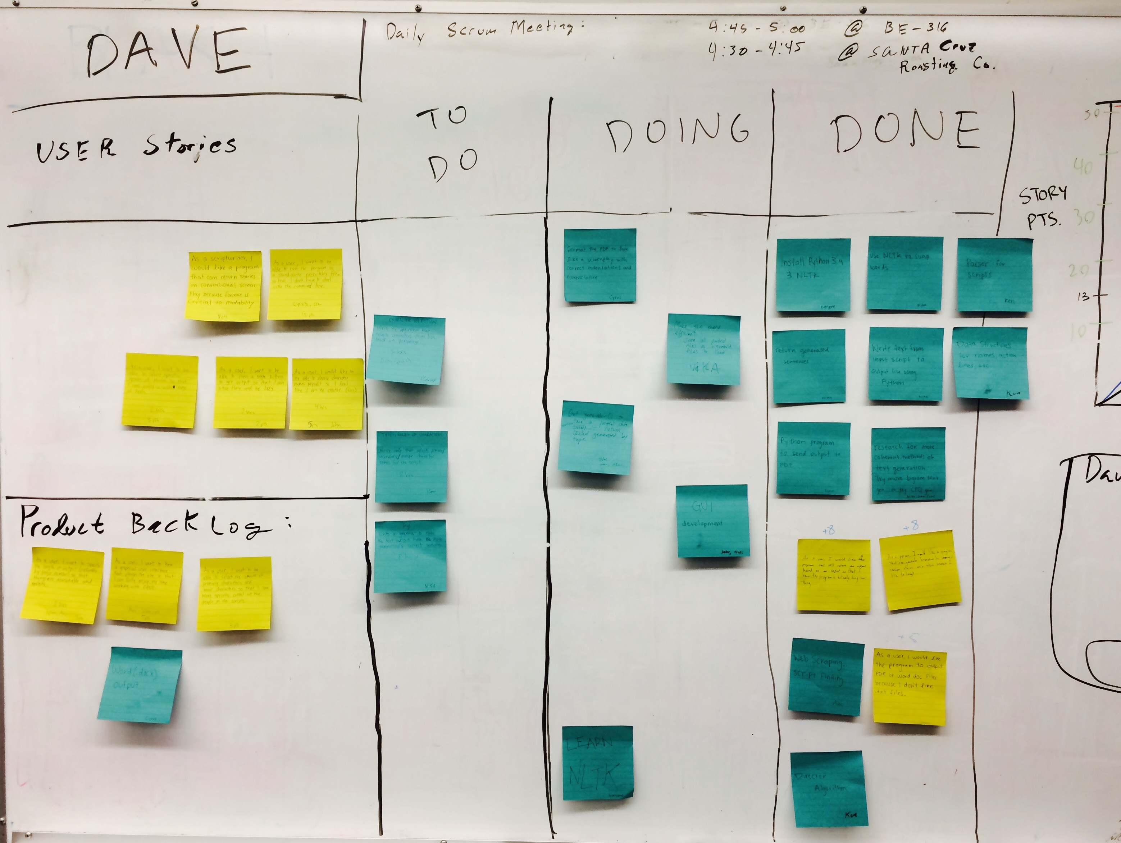**Burnup Chart:**