**Sprint 2 Plan**

**DAVE**

John Wilde,

Ken “Gondar the Bounty Hunter” High

Cyrus Farsoudi

Alec Reid

Nika Wu

**High-Level Goals:**

Formatting the text

Making it more readable

**Team Roles:**

Ken - Product Owner

John - Scrum Master

Nika - Developer

Alec - Developer

Cyrus - Developer

**User Stories:**

**User Story 1 :**As a scriptwriter, I would like a program that can return stories in conventional screenplay format because screenplay format is crucial to readability. (13 pts)

**Task 1:** Revise parser from Python2.7 to Python3.4, and integrate with existing code. (1-2hrs, Ken)

**Task 2:** Write lists for data “pools”. Names, Action Lines, Scene Headings, Dialogue, and Parentheticals. (30 mins, Ken)

**Task 3:** Write “Director” algorithm using random generators and the generator.py code to generate output. (3-4 hrs, Ken)

**Task 4:** Write program so that program can take output and put it into a .docx and .pdf format (5 hrs, Cyrus)

**Task 5:** Continue working on web scraping into .txt files based on genres of screenplays. (8 hrs, Alec)

**Task 6:** Begin GUI development using Python (5 hrs, John)

**User Story 2:** As a person, I would like a program that can generate humorously insane/random stories on a whim because I enjoy laughing. (8 pts)

**Task 1:** Research further methods for Python generation of text, either using bigrams or CFGs. (5 hrs John, 5 hrs Nika )

**Task 2:** Continue refining text generation to be more coherent and follow a story line. (5 hrs John, 5 hrs Nika)

**Scrum Times:** MW: 4:30-5:00pm, BE 316

F: 4:30-4:45pm, Santa Cruz Coffee Roasters, Pacific Ave

**Scrum Board:**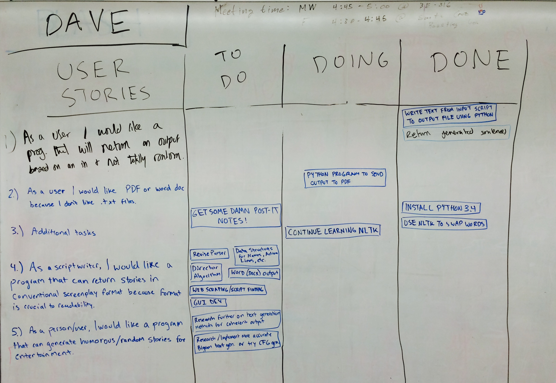

**Burnup Ch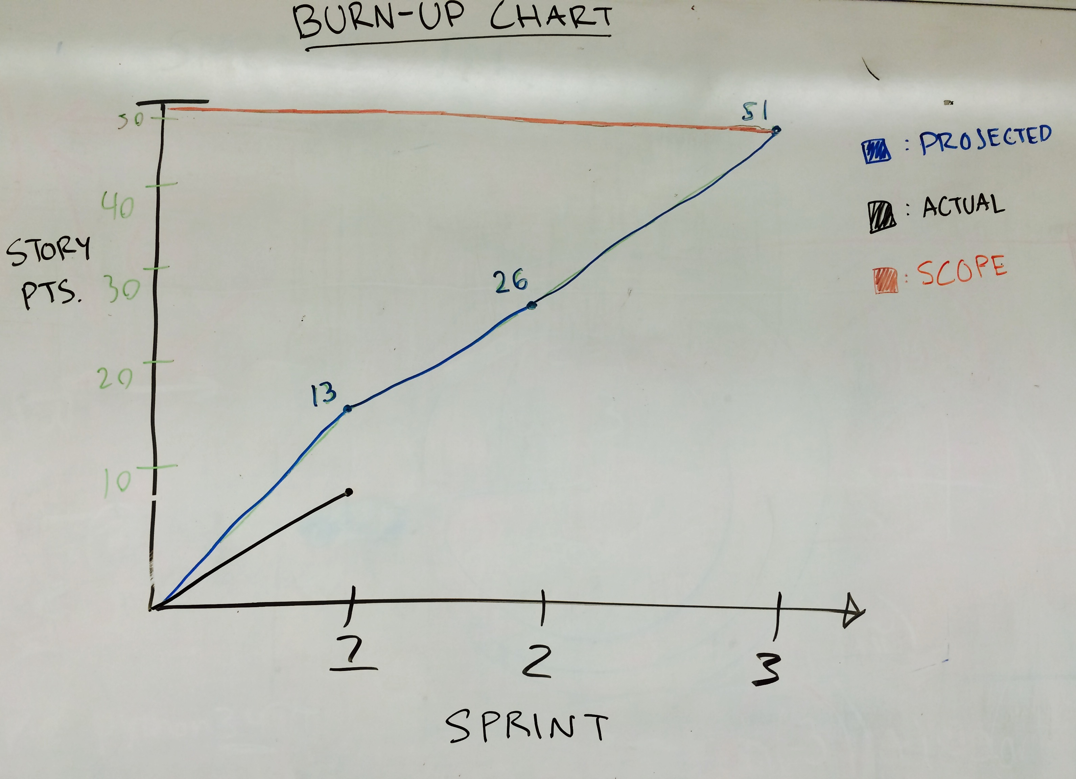art:**