**Backend Design – FoodFast Drone Delivery**

# 1. Subsystems

Hệ thống FoodFast Drone Delivery gồm các subsystem chính:

* **User & Account Management:** quản lý tài khoản, đăng nhập, đăng ký, phân quyền (customer, merchant, admin).
* **Merchant & Store Management:** quản lý merchant, store, menu, categories, giá bán, trạng thái món hàng.
* **Order Management:** quản lý lifecycle đơn hàng từ đặt → xác nhận → thanh toán → gán drone → giao → hoàn tất.
* **Payment Service:** tích hợp VnPay gateway, sinh QR code/mã giao dịch, xử lý callback, cập nhật trạng thái thanh toán.
* **Drone Service:** quản lý fleet drone, drone models, trạm base, gán drone cho order, tracking, unlock code.
* **Tracking & Telemetry:** ghi nhận dữ liệu vị trí drone realtime, lưu checkpoint/route, hiển thị bản đồ cho khách hàng và admin.
* **Monitoring & Logging:** theo dõi sức khỏe drone, lịch sử flight, log event, audit unlock attempts.

# 2. App

* **Client**: mobile app (React Native) cho khách hàng, merchant; web portal cho admin và khách hàng.
* **Backend**: triển khai theo hướng microservice (NestJS / FastAPI).
* **Authentication**: JWT + Refresh token.
* **Realtime communication**:
  + Socket.IO / MQTT cho tracking drone và cập nhật trạng thái order theo thời gian thực.
  + Webhook từ Payment Provider.

# 3. Data

* **Database chính**: PostgreSQL + PostGIS extension để lưu toạ độ (geography(Point,4326)).
* **Realtime cache/stream**: Redis Streams hoặc Kafka để nhận dữ liệu drone 1s/lần.
* **Object storage**: AWS S3/Azure Blob để lưu hình ảnh menu, log file lớn.
* **Message broker**: RabbitMQ/Kafka để đồng bộ event giữa services (order_created, payment_success, drone_assigned…).

# 4. Route (Business Flows)

## 4.1 Order & Payment Flow

1. **User đặt đơn** → tạo orders với status = pending, lưu coordinates vị trí giao hàng.
2. **Store xác nhận** → status = preparing. Khi món sẵn sàng → status = ready_for_payment.
3. **Payment QR sinh ra** → record trong payments với status = pending, gửi QR cho user.
4. **User thanh toán** → Payment Provider callback:
   * Thành công → payments.status = success, orders.status = confirmed.
   * Thất bại → orders.status = cancelled.
5. **Khi success** → backend sinh drone_unlock_code + drone_unlock_ttl, gửi cho user kèm ETA + tracking map.

## 4.2 Drone Flow

1. Dispatcher gán drone → orders.drone_id + drone_flights record.
2. Drone cất cánh → log takeoff.
3. **Tracking realtime**:
   * Drone gửi dữ liệu mỗi 1s → Redis/MQTT (không ghi thẳng DB).
   * Backend snapshot mỗi 1p hoặc mỗi 100m → ghi vào drone_tracking (checkpoint).
   * Kết thúc chuyến bay → route tổng hợp lưu trong drone_flights.flight_path_geo (GeoJSON/polyline).
4. Drone tới nơi → user quét QR drone_unlock_code.
   * Nếu đúng & trong TTL → mở hộp, status = completed.
   * Nếu sai/timeout → log unlock_failed, fail-safe.
5. Drone hạ cánh hoặc quay về → log landing / return, drone về status = available.

# 5. Monitoring

* **Metrics (Prometheus + Grafana)**:
  + Drone uptime, battery %, flights/day, payment success rate.
  + Unlock fail attempts alert.
* **Logs (ELK/EFK)**:
  + Drone event logs (takeoff, landing, emergency).
  + Unlock attempts (thành công/thất bại).
  + Payment callback logs.
* **Alerting**:
  + Battery < 20%.
  + Unlock failed > 3 lần.
  + Payment failures tăng đột biến.

1. **Database – Key Entities**

**Toạ độ**

* Chuẩn hóa: tất cả entity có vị trí (stores, orders, drone_base_stations, drones, drone_tracking) đều lưu dưới dạng **geography(Point,4326)**.

**Drone Tracking Strategy**

* **Realtime (Redis/MQTT)**: 1s/lần → phục vụ map UI.
* **Checkpoint (Postgres)**: mỗi 30s → drone_tracking.
* **Flight summary**: route cuối cùng lưu dạng GeoJSON trong drone_flights.flight_path_geo

1. **ERD**

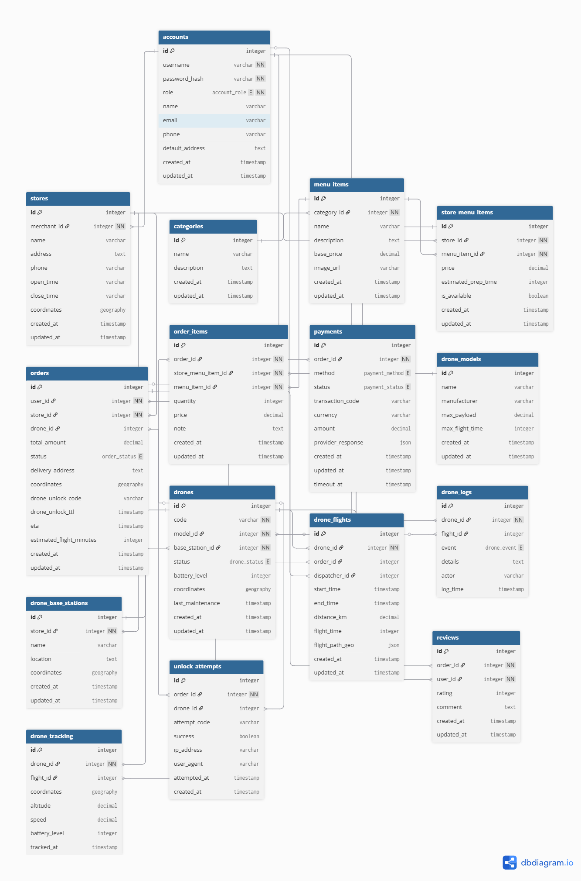

|  |
| --- |
| // ===================== ENUMs =====================  Enum account_role {  customer  admin  merchant  }  Enum order_status {  pending // user vừa tạo đơn  preparing // store xác nhận & đang chuẩn bị  ready_for_payment// store đã chuẩn bị xong, chờ thanh toán  confirmed // payment success, sẵn sàng cho dispatch  delivering // drone đang giao  completed // user đã nhận  cancelled // huỷ  failed_delivery // giao không thành, drone quay về/timeout  }  Enum payment_method {  e_wallet  card  cod  }  Enum payment_status {  processing  pending  success  failed  timeout  }  Enum drone_status {  available  delivering  maintenance  offline  }  Enum drone_event {  takeoff  landing  return  emergency  unlock_attempt  unlock_success  unlock_failed  }  // ===================== TABLES =====================  // ==== Accounts (gộp Users / Admins / Merchants) ====  Table accounts {  id integer [primary key]  username varchar [unique, not null]  password_hash varchar [not null, note: 'hashed password']  role account_role [not null]  name varchar  email varchar  phone varchar  default_address text [note: 'áp dụng cho customer']  created_at timestamp  updated_at timestamp  }  // ==== Stores ====  Table stores {  id integer [primary key]  merchant_id integer [not null, note: 'FK tới accounts.id (role=merchant)']  name varchar  address text  phone varchar  open_time varchar [note: 'HH:MM']  close_time varchar [note: 'HH:MM']  coordinates geography [note: 'POINT(SRID=4326)']  created_at timestamp  updated_at timestamp  }  // ==== Menu categories & items ====  Table categories {  id integer [primary key]  name varchar  description text  created_at timestamp  updated_at timestamp  }  Table menu_items {  id integer [primary key]  category_id integer [not null]  name varchar  description text  base_price decimal  image_url varchar  created_at timestamp  updated_at timestamp  }  Table store_menu_items {  id integer [primary key]  store_id integer [not null]  menu_item_id integer [not null]  price decimal  estimated_prep_time integer [note: 'minutes']  is_available boolean [default: true]  created_at timestamp  updated_at timestamp  }  // ==== Orders & Payments ====  Table orders {  id integer [primary key]  user_id integer [not null, note: 'FK tới accounts.id (role=customer)']  store_id integer [not null]  drone_id integer  total_amount decimal  status order_status  delivery_address text  coordinates geography [note: 'POINT(SRID=4326)']  drone_unlock_code varchar [note: 'QR/OTP mở hộp drone, tạo khi payment success']  drone_unlock_ttl timestamp [note: 'thời hạn hiệu lực mã mở']  eta timestamp  estimated_flight_minutes integer  created_at timestamp  updated_at timestamp  }  Table order_items {  id integer [primary key]  order_id integer [not null]  store_menu_item_id integer [not null]  menu_item_id integer [not null]  quantity integer  price decimal  note text  created_at timestamp  updated_at timestamp  }  Table payments {  id integer [primary key]  order_id integer [not null]  method payment_method  status payment_status  transaction_code varchar [note: 'QR code / mã giao dịch thanh toán từ gateway']  currency varchar [note: 'VND, USD, etc.']  amount decimal  provider_response json [note: 'raw callback payload if needed']  created_at timestamp  updated_at timestamp  timeout_at timestamp  }  // ==== Drone management ====  Table drone_models {  id integer [primary key]  name varchar  manufacturer varchar  max_payload decimal  max_flight_time integer [note: 'minutes']  created_at timestamp  updated_at timestamp  }  Table drone_base_stations {  id integer [primary key]  store_id integer [not null]  name varchar  location text  coordinates geography [note: 'POINT(SRID=4326)']  created_at timestamp  updated_at timestamp  }  Table drones {  id integer [primary key]  code varchar [unique, not null]  model_id integer [not null]  base_station_id integer [not null]  status drone_status  battery_level integer [note: '0-100 percent']  coordinates geography [note: 'POINT(SRID=4326)']  last_maintenance timestamp  created_at timestamp  updated_at timestamp  }  Table drone_flights {  id integer [primary key]  drone_id integer [not null]  order_id integer  dispatcher_id integer [note: 'FK tới accounts.id (role=admin)']  start_time timestamp  end_time timestamp  distance_km decimal  flight_time integer [note: 'minutes']  flight_path_geo json [note: 'optional polyline/geojson snapshot']  created_at timestamp  updated_at timestamp  }  Table drone_logs {  id integer [primary key]  drone_id integer [not null]  flight_id integer  event drone_event  details text  actor varchar [note: 'system/dispatcher/user']  log_time timestamp  }  Table drone_tracking {  id integer [primary key]  drone_id integer [not null]  flight_id integer  coordinates geography [note: 'POINT(SRID=4326)']  altitude decimal [note: 'meters']  speed decimal [note: 'm/s']  battery_level integer  tracked_at timestamp  }  // ==== Security / Audit ====  Table unlock_attempts {  id integer [primary key]  order_id integer [not null]  drone_id integer  attempt_code varchar  success boolean  ip_address varchar  user_agent varchar  attempted_at timestamp  created_at timestamp  }  // ==== Reviews ====  Table reviews {  id integer [primary key]  order_id integer [not null]  user_id integer [not null]  rating integer [note: '1-5']  comment text  created_at timestamp  updated_at timestamp  }  // ===================== RELATIONSHIPS =====================  Ref: stores.merchant_id > accounts.id  Ref: menu_items.category_id > categories.id  Ref: store_menu_items.menu_item_id > menu_items.id  Ref: store_menu_items.store_id > stores.id  Ref: orders.user_id > accounts.id  Ref: orders.store_id > stores.id  Ref: orders.drone_id > drones.id  Ref: order_items.order_id > orders.id  Ref: order_items.store_menu_item_id > store_menu_items.id  Ref: order_items.menu_item_id > menu_items.id  Ref: payments.order_id > orders.id  Ref: drones.model_id > drone_models.id  Ref: drones.base_station_id > drone_base_stations.id  Ref: drone_base_stations.store_id > stores.id  Ref: drone_flights.drone_id > drones.id  Ref: drone_flights.order_id > orders.id  Ref: drone_flights.dispatcher_id > accounts.id  Ref: drone_logs.drone_id > drones.id  Ref: drone_logs.flight_id > drone_flights.id  Ref: drone_tracking.drone_id > drones.id  Ref: drone_tracking.flight_id > drone_flights.id  Ref: unlock_attempts.order_id > orders.id  Ref: unlock_attempts.drone_id > drones.id  Ref: reviews.order_id > orders.id  Ref: reviews.user_id > accounts.id |