SAIGON UNIVERSITY
FACULTY OF INFORMATION TECHNOLOGY



GROUP EXERCISE / LAB 4
ABC PROJECT
Intructor: Dr. Đỗ Như Tài

HO CHI MINH CITY
Team Introduction
 | Full Name | Student Code
1 | Châu Gia Anh | 3122411002
2 | Dương Lê Khánh | 3122411093
3 | Đào Thị Thanh Tâm | 3122411007

REVISION HISTORY
Date | Version | Description | Author
05 Aug 10 | 1.0 | Initial edition | Alexandre Stelmakh

Table of content

Test Plan 6
1. Introduction 6
1.1 Purpose 6
1.2 Background 6
1.3 Scope 6
1.4 Project Identification 6
1.5 References 8
2. Feature to be tested 8
2.1. Functionality 8
2.1.1 Download contact list from server 8
2.1.2 Upload contact list to server 9
2.1.3 Add new contact to contact list 9
2.1.4 Delete contact from contact list 9
2.1.5 Create new message 10
2.1.6 Receive new message 10
2.1.7 Message history 10
2.2 Usability 10
2.2.1 Sessions support 10
2.2.2 Fonts support 11
2.2.3 Graphical emoticons 11
2.2.4 Internet connection management 11
2.2.5 Display support 11
2.3 Design Constraints 11
2.3.1 Maximum message length 11
2.3.2 Test environment 12
2.3.3 Characters 12
2.4 Interfaces 12
2.4.1 User Interfaces 12
3. Feature not to be tested 12
3.1 Setup a user account 12
3.2 Remove user account 13
4. Test Strategy 13
4.1 Testing Types 19
4.1.1 Function and Usability Testing 19
4.1.2 User Interface Testing 20
4.2 Tools 22
5. Resources 22
5.1 Roles 22
6. Project Mileston 24
7. Deliverables 25
7.1 Test Model 26
7.2 Test Logs 26
7.3 Bug Reports 26
7.4 Test Scenarios 26
7.5 Test Case Execution Report 26
7.8 Test Summary 26
Appendix A Project Tasks 27

Test Plan

Introduction

Purpose
This Test Plan document for ABC project supports the following objectives:
- Identify existing project information and software components to be tested.
- List recommended Requirements for Test (high level).
- Recommend and describe testing strategies to be employed.
- Identify required resources and provide a test effort estimate.
- List the test project deliverable elements.

Background
The system developed is an instant messenger for Palm platform. The system should provide a capability to use ICQ instant messaging service. So, the protocol used by this service must be supported by the system.
The system developed is intended for Palm application market and positioned as standalone product.

Scope
This Test Plan describes the system tests that will be conducted within Build 1, Build 2, Build 3, Release candidates and Release versions.
This Test Plan applies to testing all ABC project requirements defined in the Software Requirements Specification [1].

Project Identification
The table below identifies the documentation and availability used for developing the Test Plan:
Document  (and version /date) | Created or Available | Received or Reviewed | Author or  Resource | Notes
Requirements Specification |  Yes  No |  Yes  No
Functional Specification |  Yes  No |  Yes  No
Use-Case Reports |  Yes  No |  Yes  No
Project Plan |  Yes  No |  Yes  No
Design Specifications |  Yes  No |  Yes  No
Prototype |  Yes  No |  Yes  No
User’s Manuals |  Yes  No |  Yes  No
Business Model or Flow |  Yes  No |  Yes  No
Data Model or Flow |  Yes  No |  Yes  No
Business Functions and Rules |  Yes  No |  Yes  No
Project or Business Risk  Assessment |  Yes  No |  Yes  No

References
The following table contains references to external documents.
No. | Document | Description
1 | ABC project Software Requirements Specification, Version 1.0.3.3, Monday, 25/Aug/10 | The SRS fully describes the external behavior of the application or subsystem identified. It also describes non- functional requirements, design constraints, and other factors necessary to provide a complete and comprehensive description of the software requirements.
2 | ABC project Software Development Plan, Version 1.0.5, 05/Sep/10 | The purpose of Software Development Plan is to define tasks of ABC project (hereinafter referred to as IM or the project) to be developed. It focuses on the capabilities sought after by stakeholders, the target users in particular, and the reasons for this search.
3

Feature to be tested
The listing below identifies those items − use cases, functional requirements, and non-functional requirements − that have been identified as targets for testing. This list represents what is to be tested.

2.1. Functionality

Download contact list from server

      - Verify that the system provides the capability to download a contact list from the server. This operation should be performed automatically during connection to ICQ service.
      - Verify that the system provides the capability to disable automatic download of the contact list.
      - Verify that the system provides the capability to download the contact list upon the user request.

Upload contact list to server
- Verify that the system provides the capability to upload the contact list from the device to the server.
- Verify that the system correctly updates existing contact entries on the server.
- Verify that the system allows manual synchronization by user request.
- Verify that conflicts (e.g., different versions of the same contact) are handled properly.

Add new contact to contact list
- Verify that the system allows adding a new contact by ICQ number.
- Verify that the system allows adding a new contact by nickname or email (if supported).
- Verify that the system validates the entered data before saving.
- Verify that the new contact appears correctly in the contact list..

Delete contact from contact list
- Verify that the system provides the capability to delete a contact from the contact list.
- Verify that the deleted contact is removed from both local storage and server (after synchronization).
- Verify that a confirmation prompt is displayed before deletion..

Create new message
- Verify that the system provides the capability to create a new message for a selected contact.
- Verify that the system supports plain text messages.
- Verify that the system supports emoticons and supported character sets.
- Verify that the system prevents sending empty or invalid messages.

Receive new message
- Verify that the system correctly receives new incoming messages in real-time.
- Verify that notifications are displayed to the user upon message receipt.
- Verify that messages are correctly displayed in the conversation window.
- Verify that messages from unknown contacts are handled according to user settings.

Message history
- Verify that the system stores sent and received messages in local message history.
- Verify that the user can view previous conversations with a selected contact.
- Verify that message history persists after restarting the application.
- Verify that the system supports search or navigation within the history (if applicable).

Usability

Sessions support
- Verify that the system allows multiple login sessions (if supported).
- Verify that the system restores user session after temporary disconnection

Fonts support
- Verify that the system supports multiple fonts and sizes for displaying messages.
- Verify that non-Latin character sets (e.g., Cyrillic, Asian languages) are displayed correctly.

Graphical emoticons
- Verify that the system provides graphical emoticons in messages.
- Verify that emoticons are correctly displayed on both sending and receiving ends.

Internet connection management
- Verify that the system automatically reconnects when internet connection is restored.
- Verify that the system provides error messages when connection is lost.
- Verify that the system minimizes data usage while maintaining stable connection.

Display support
- Verify that the system adjusts UI layout to different Palm device screen resolutions.
- Verify that messages are readable in both portrait and landscape modes (if supported).

Design Constraints

Maximum message length
- Verify that the system enforces the maximum message length defined in requirements.
- Verify that the system notifies the user when the maximum message length is exceeded.

Test environment
- Verify that the system operates correctly within the defined Palm OS version and hardware specifications.
- Verify that the system functions in both emulator and physical device environments.

Characters
- Verify that the system supports Unicode characters.
- Verify that unsupported characters are handled gracefully (e.g., replacement with “?” symbol).

Interfaces

User Interfaces
- Verify that the system provides a user-friendly interface for messaging functions.
- Verify that UI elements (buttons, menus, lists) are intuitive and consistent with Palm UI standards.
- Verify that error messages and prompts are clearly displayed to the user.
- Verify that navigation between screens (contacts, chat, settings) is smooth and logical.

Feature not to be tested

Setup a user account
- Verify that the system provides the capability to setup user account for ICQ service.
- Verify that the system provides the capability to setup several user accounts.
- Verify that the system provides the capability to set option “Remember password” for each user account individually.

Remove user account
- Verify that the system provides the capability to remove an existing ICQ user account from the device.
- Verify that after removal, the account no longer appears in the login list.
- Verify that removing an account does not affect message history unless explicitly chosen by the user.
- Verify that the system provides a confirmation prompt before account removal.

Test Strategy
The Test Strategy presents the recommended approach to the testing of the ABC Development Project. The previous section on Test Requirements described what would be tested; this describes how it will be tested.
Test Process Workflow
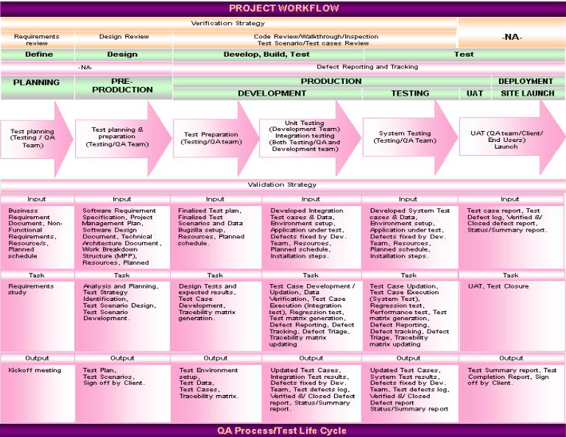
The above diagram explains the complete QA process/Test life Cycle in General. Following are the steps which would explain in detail , the Test Strategy to be followed ABCApplication.

Step1. Test Organize/Review Project Documentation
Step2. Test plan
Step3. Test Design/Development
Step4. Unit Test Execution
Step5. Integration/System Test Execution
Step6. Defect Tracking and Management
Step7. Update Documents and Results
Step8. Test Reports
Step9. UAT and Closure

Test Organize/Review Project Documentation:
Documentation reviews provide a means for testing the accuracy and completeness of the planning, requirements and specifications. Throughout the project, periodic reviews will be held to assure the quality of project documentation. These reviews will:
- Ensure project plans have adequate time allocated for testing activities and determine limitations.
- Ensure that the Business Requirements, Information Site Flow, Use Cases, Business Rules, and Technical Design documents clearly articulate the functionality of the ABC Project

Develop System Test Plan:
This step of the testing process involves creation of the System Test Plan (this document). This will serve as the guidepost for development of test cases and for integration of testing with other project activities.
- This plan describes at a high level the overall testing plan and strategy for the ABC Application.
- Professional Access will follow this plan to develop test scenarios/cases and scripts that will be used for system testing.
- Test scenarios will be described in separate document(s).
- Test Cases will be described in separate document(s)
- Professional Access will obtain test accounts and Ids for Interface testing (see Scope)

Test Design/Development:
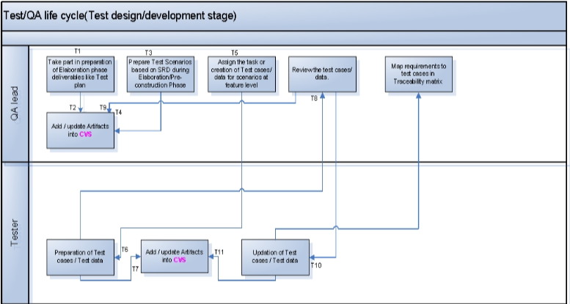
Brief explanation of Test Design/Development workflow with respect to the Process flow diagram displayed above:
Task ID | Description
T1, T2 | Test Lead takes part in preparation of Elaboration phase deliverables like Test Plan and updates the Artifacts in CVS for further reference.
T3, T4 | From Post-elaboration phase to Pre-construction phase, Test Scenarios are designed by the Test Lead for the modules/features available in SRD. Once the final draft version of SRD with all modules/features specifications is received, Test Scenarios are completed and stored in CVS.
T5 | Test Lead assigns the task of test case/test script creation to test team members during the Construction phase.
T6, T7 | For all Test Scenarios created earlier, Test Team members design Test Cases/Test Scripts during Construction Phase. All created Test Cases/Test Scripts are stored in CVS.
T8, T9 | Test Lead reviews all created Test Cases/Test Scripts and updates the review comments in CVS.
T10 | Test Team members check the review comments, update respective Test Cases, and store the updated versions in CVS.
T11 | Test Lead maps the requirements to Test Cases in the Traceability Matrix, showing which Test Case covers which functionality/requirement.

Written test cases and scripts will be used to direct system testing efforts. Professional Access test team will write these in accordance with the System Test Plan.
- Tests will be developed to exercise the required functionality for the website, validate data integrity, and ensure that data is passed or received successfully from external interfaces. Test Cases will be written in a separate document appended to this plan.
- Each test case will document the steps or actions required to exercise a specified area of functionality. The test cases will be reviewed to verify that they properly validate the intended functionality. Actual testing will be performed by executing the steps of the test case. A pass/fail notation will be made for each step.
- Each test case will be executed manually and using automated testing tool(for Performance/Load testing) using the browser versions mentioned in Test environment section. A pass/fail notation will be recorded for each condition tested, noting the severity and reason for each instance of failure. Test scripts to perform Performance/Load testing will be executed automatically during the System testing phase.

Unit Test Execution:
Unit testing verifies each module, component, object, or program developed is functionally correct and conforms to requirements. A unit is defined as a single program function in terms of inputs, processes and outputs. A program unit is small enough that the developer who developed it can test it in great detail.
The developer that wrote the code is responsible for creating, updating and executing the unit tests after each successful build in the development environment. Separate document has been prepared drafting Unit test strategy.
Integration Testing:
The objective of these tests is to ensure that all the components of the system function properly together and that the application interfaces properly with external applications.
Entrance Criteria:
- All functions to be tested have successfully passed unit testing
- All Severity 1 and 2 defects are fixed and have successfully passed unit testing. (See Defect Management portion of this document for severity definitions)
- Software build is properly version controlled
- Build report has been completed and submitted with build
- All hardware and software configurations are in place and ready to test
- All test cases required for integration testing have been prepared
- All required integrated systems are available
Exit Criteria:
- All components delivered and tested function as detailed in the documents in the References portion of
- this document
- Test cases have been updated if and when functionality has changed
- Test results report is developed/updated
- All new defects have been logged into the issues tracking database

System Testing:
The test team will conduct a system test to verify that the software matches the defined requirements. Once the application has executed successfully under integration test, each test suite will be executed against the other supported configurations to ensure defects are not created because the system configuration has changed. A separate test environment must be established for all hardware, software, and browser configurations supported.
Entrance Criteria:
- All functions tested have successfully passed integration testing
- All severity 1 and 2 defects are fixed and have successfully passed regression testing
- Test cases have been updated if and when functionality has changed
- All test cases required for system testing have been prepared
- All hardware and software configurations are in place and ready to test
- All required integrated systems are available
Exit Criteria:
- All Severity 1 and 2 defects are fixed and have successfully passed regression testing
- The risks associated with not correcting any outstanding Severity 3and 4 defects have been identified and signed off by the Project Manager, Technical Lead, QA Lead
- All components delivered and tested function as detailed in the documents in the References portion of this document
- Regression tests have been performed and executed successfully
- Test results report is developed/updated
- All new defects have been logged into the issues tracking database

Testing Types

Function and Usability Testing
Test Objective: | To ensure proper target-of-test functionality, including navigation, data entry, processing, and retrieval.
Technique: | Execute each use case, use-case flow, or function, using valid and invalid data, to verify the following:  - The expected results occur when valid data are used.  - The appropriate error or alert messages are displayed when invalid data are used.
Completion Criteria: | - All planned tests have been executed.  - All identified defects have been fixed.
Special Considerations: | Identify or describe those items or issues (internal or external) that impact the implementation and execution of function test.

User Interface Testing
Test Objective: | Ensure that the system provides a user-friendly, intuitive, and consistent interface that allows users to easily interact with the core application functions. The UI should correctly reflect the business requirements and functionalities, including smooth navigation between different screens.
Technique: | Perform testing by directly observing and interacting with the user interface to verify that:  • UI components (buttons, menus, lists, icons) are displayed in the correct positions, are easy to understand, and consistent with the defined design standards.  • Error messages, warnings, and prompts are displayed clearly and are easily recognizable.  • Navigation between screens (e.g., Contacts, Chat, Settings) is smooth, logical, and consistent.  • The interface supports proper user experience (UX) without causing confusion during use.
Completion Criteria: | • All planned UI test cases have been executed.  • Each screen has been successfully verified against the test version or within acceptable tolerance.
Special Considerations: | • Testing must be performed across multiple screen resolutions and different browsers.  • Not all object properties may be accessible for testing.

Tools
The following tools are employed in this project:
 | Tool | Vendor/In-house | Version
Bug Tracking | Mantis | Open Source | Latest
Project Management | MS project | Microsoft | 2019/365
Automation Testing for web UI | Selenium | Open Source | 15.x
Compatibility Testing | BrowserStack | BrowserStack(Cloud) | Latest

Resources

Roles
This table shows the staff required for the project.
Human Resources
Employee | Minimum Resources Recommended  (number of full-time roles allocated) | Specific Responsibilities/Job Description
Test Developer |  | Identifies, sets priorities for, and implements test cases.  Responsibilities:  • generates test plan  • evaluates effectiveness of test effort
Tester |  | Executes tests.  Responsibilities:  • develops test case specifications  • develops test cases  • executes tests  • logs results  • monitors bug fixing  • requests for documentation to be changes
QA Lead |  | • defines overall test strategy and scope.  • prepares and maintains the master test plan.  • allocates resources and assigns responsibilities.  • tracks progress and ensures milestones are met.  • communicates test status and risks to stakeholders.  • approves final test deliverables and sign-off.
Environment Manager |  | • sets up and maintains the test environments (hardware, OS, simulators, emulators).  • installs necessary software, tools, and patches.  • ensures environment consistency across builds.  • supports testers with environment issues.

Project Mileston

Test activities and milestones are very much dependent upon the development iterations. The Construction Phase is split into 3 builds, release candidate and release version. Each build contains a full test cycle of test planning,design, development, execution, and evaluation.

The following table shows Test Milestones. effort, start date, and end date.
Milestone Task | Effort | Start Date | End Date
Build 1  Plan Test  Design Test  Execute Test  Evaluate Test | 123.7 | 07/Sep/2010 | 07/Sep/2010
Build 2  Plan Test  Design Test  Execute Test  Evaluate Test | 124.0 | 20/Sep/2010 | 20/Sep/2010
Build 3  Plan Test  Design Test  Execute Test  Evaluate Test | 124.6 | 09/Oct/2010 | 09/Oct/2010

Deliverables

7.1 Test Model
Test Model defines all test cases, and references, test procedures and test scripts which are associated with each test case.

7.2 Test Logs
Microsoft Word is used to record and report test results.

7.3 Bug Reports
Mantis bug tracker is used for logging and tracking individual malfunctions.

7.4 Test Scenarios
High-level descriptions of what needs to be tested, grouped by functional area.
They help identify coverage before creating detailed test cases.

7.5 Test Case Execution Report
Summarizes the status of executed test cases, including number of passed, failed, blocked, or deferred cases.

7.8 Test Summary
A final consolidated report of the test cycle, summarizing coverage, defect density, quality risks, and overall readiness for release.

Appendix A Project Tasks
Test-related tasks are given below:
- Test Planning
  - identify requirements for testing
  - assess risks
  - develop test strategy
  - identify test resources
  - create schedule
  - generate Test Plan
- Test Design
  - prepare workload analysis
  - identify and describe test cases
- Test Execution
  - execute test procedures
  - verify results
  - investigate unexpected results
  - log bugs
- Evaluate Test
  - evaluate test-case coverage
  - evaluate code coverage
  - analyze defects
  - determine whether Test Completion Criteria and Success Criteria have been achieved

