答：

|  |  |  |  |  |  |  |  |  |  |  |  |  |  |  |  |  |
| --- | --- | --- | --- | --- | --- | --- | --- | --- | --- | --- | --- | --- | --- | --- | --- | --- |
| 父结点下标 | -1 | 0 | 0 | 0 | 0 | 0 | 0 | 6 | 0 | 0 | 0 | 9 | 0 | 0 | 12 | 0 |
| 结点值 | 0 | 1 | 2 | 3 | 4 | 5 | 6 | 7 | 8 | 9 | 10 | 11 | 12 | 13 | 14 | 15 |
| 结点的下标 | 0 | 1 | 2 | 3 | 4 | 5 | 6 | 7 | 8 | 9 | 10 | 11 | 12 | 13 | 14 | 15 |

2.

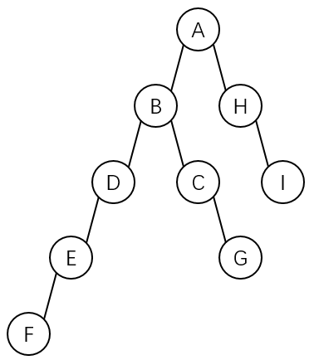答：(1)首先根据带双标记的先根次序表示法求出其所表示的森林所对应的二叉树如下图

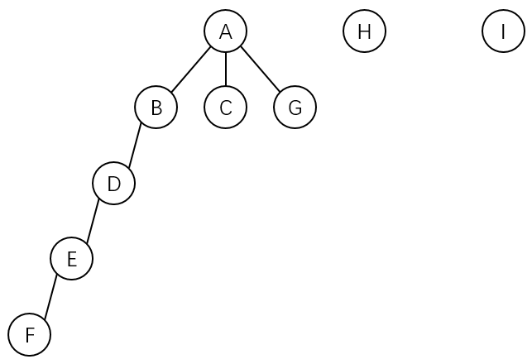其所对应的森林如下图：

(2)带度数的后根次序表示法如下：

|  |  |  |  |  |  |  |  |  |
| --- | --- | --- | --- | --- | --- | --- | --- | --- |
| F | E | D | B | C | G | A | H | I |
| 0 | 1 | 1 | 1 | 0 | 0 | 3 | 0 | 0 |

3.

答：

1)k^l(l为层数，按题意，根结点为0层)

  (2) 结点i(i>1)的前一结点编号为i-1（其最右边子女编号是(i-1)*k+1），故结点 i的第 m个孩子的编号是(i-1)*k+1+m。

(3) 根据以上分析，结点i有右兄弟的条件是，它不是双亲的从右数的第一子女，即 (i-1)%k!=0，其右兄弟编号是i+1