Codebook for R-ladies Demographic Data

Autogenerated data summary from dataMaid

2019-11-08 16:14:32

# Data report overview

The dataset examined has the following dimensions:

|  |  |
| --- | --- |
| Feature | Result |
| Number of observations | 1380 |
| Number of variables | 7 |

# Codebook summary table

|  |  |  |  |  |  |
| --- | --- | --- | --- | --- | --- |
| Label | Variable | Class | # unique values | Missing | Description |
| SchoolName | **School** | character | 4 | 0.00 % |  |
| DistrictName | **District** | character | 1 | 0.00 % |  |
| Student ID | **Student_ID** | numeric | 1380 | 0.00 % |  |
| Student Race | **Race** | factor | 6 | 0.00 % |  |
| Student Gender | **Gender** | factor | 2 | 0.00 % |  |
| Percent Attendance Fall | **Fall_Attendance** | numeric | 45 | 0.00 % |  |
| Percent Attendance Spring | **Spring_Attendance** | numeric | 44 | 0.00 % |  |

# Variable list

## School

*SchoolName*

|  |  |
| --- | --- |
| Feature | Result |
| Variable type | character |
| Number of missing obs. | 0 (0 %) |
| Number of unique values | 4 |
| Mode | “Primary School” |

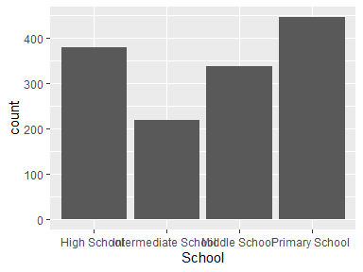

* Observed factor levels: "High School ", "Intermediate School ", "Middle School ", "Primary School ".

## District

*DistrictName*

* The variable only takes one (non-missing) value: " District A". The variable contains 0 % missing observations.

## Student_ID

*Student ID*

|  |  |
| --- | --- |
| Feature | Result |
| Variable type | numeric |
| Number of missing obs. | 0 (0 %) |
| Number of unique values | 1380 |
| Median | 75573484255 |
| 1st and 3rd quartiles | 73197635993; 77931787843 |
| Min. and max. | 71111337335; 79999977913 |

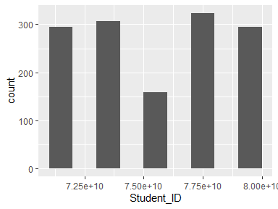

## Race

*Student Race*

|  |  |
| --- | --- |
| Feature | Result |
| Variable type | factor |
| Number of missing obs. | 0 (0 %) |
| Number of unique values | 6 |
| Mode | “White” |
| Reference category | White |

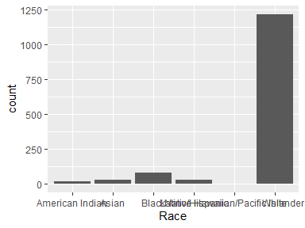

* Observed factor levels: "American Indian", "Asian", "Black", "Latino/Hispanic", "Native Hawaiian/Pacific Islander", "White".

## Gender

*Student Gender*

|  |  |
| --- | --- |
| Feature | Result |
| Variable type | factor |
| Number of missing obs. | 0 (0 %) |
| Number of unique values | 2 |
| Mode | “Male” |
| Reference category | Male |

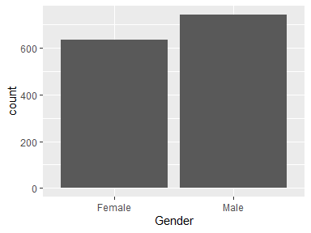

* Observed factor levels: "Female", "Male".

## Fall_Attendance

*Percent Attendance Fall*

|  |  |
| --- | --- |
| Feature | Result |
| Variable type | numeric |
| Number of missing obs. | 0 (0 %) |
| Number of unique values | 45 |
| Median | 96.78 |
| 1st and 3rd quartiles | 94.44; 98.25 |
| Min. and max. | 82.16; 100 |

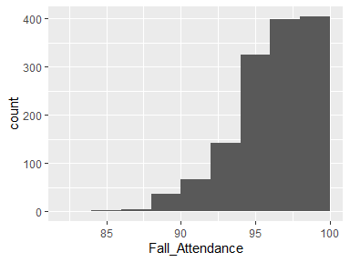

## Spring_Attendance

*Percent Attendance Spring*

|  |  |
| --- | --- |
| Feature | Result |
| Variable type | numeric |
| Number of missing obs. | 0 (0 %) |
| Number of unique values | 44 |
| Median | 96.78 |
| 1st and 3rd quartiles | 94.44; 98.25 |
| Min. and max. | 82.16; 100 |

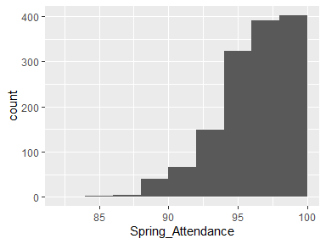

Report generation information:

* Created by Lewis, Crystal G. (username: hamptoncg).
* Report creation time: Fri Nov 08 2019 16:14:54
* Report was run from directory: C:/Users/hamptoncg/Desktop/R-ladies November/R-Ladies-STL-Cleaning-Data-R
* dataMaid v1.3.2 [Pkg: 2019-07-27 from CRAN (R 3.5.3)]
* R version 3.5.1 (2018-07-02).
* Platform: x86_64-w64-mingw32/x64 (64-bit)(Windows 10 x64 (build 18362)).
* Function call: makeDataReport(data = Demo, mode = c("summarize", "visualize", "check"), smartNum = FALSE, file = "codebook_Demo.Rmd", checks = list( character = "showAllFactorLevels", factor = "showAllFactorLevels", labelled = "showAllFactorLevels", haven_labelled = "showAllFactorLevels", numeric = NULL, integer = NULL, logical = NULL, Date = NULL), listChecks = FALSE, maxProbVals = Inf, codebook = TRUE, reportTitle = "Codebook for R-ladies Demographic Data")