Codebook for R-ladies Discipline Data

Autogenerated data summary from dataMaid

2019-11-08 16:28:44

# Data report overview

The dataset examined has the following dimensions:

|  |  |
| --- | --- |
| Feature | Result |
| Number of observations | 132 |
| Number of variables | 3 |

# Codebook summary table

|  |  |  |  |  |  |
| --- | --- | --- | --- | --- | --- |
| Label | Variable | Class | # unique values | Missing | Description |
| Student ID | **Student_ID** | numeric | 132 | 0.00 % |  |
| Fall ISS referrals | **Fall_ISS** | numeric | 8 | 0.00 % |  |
| Spring ISS referrals | **Spring_ISS** | numeric | 9 | 0.00 % |  |

# Variable list

## Student_ID

*Student ID*

|  |  |
| --- | --- |
| Feature | Result |
| Variable type | numeric |
| Number of missing obs. | 0 (0 %) |
| Number of unique values | 132 |
| Median | 75555835314 |
| 1st and 3rd quartiles | 73111167768.5; 77792853127 |
| Min. and max. | 71117331939; 79993755551 |

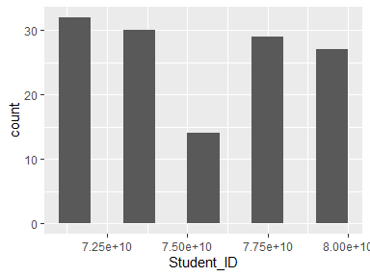

## Fall_ISS

*Fall ISS referrals*

|  |  |
| --- | --- |
| Feature | Result |
| Variable type | numeric |
| Number of missing obs. | 0 (0 %) |
| Number of unique values | 8 |
| Median | 1 |
| 1st and 3rd quartiles | 0; 1 |
| Min. and max. | 0; 8 |

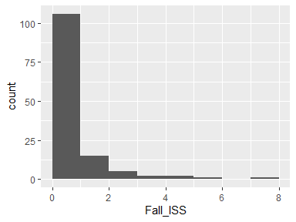

## Spring_ISS

*Spring ISS referrals*

|  |  |
| --- | --- |
| Feature | Result |
| Variable type | numeric |
| Number of missing obs. | 0 (0 %) |
| Number of unique values | 9 |
| Median | 1 |
| 1st and 3rd quartiles | 0; 2 |
| Min. and max. | 0; 8 |

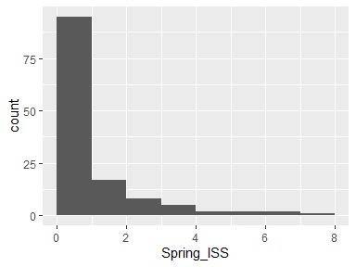

Report generation information:

* Created by Lewis, Crystal G. (username: hamptoncg).
* Report creation time: Fri Nov 08 2019 16:29:03
* Report was run from directory: C:/Users/hamptoncg/Desktop/R-ladies November/R-Ladies-STL-Cleaning-Data-R/R
* dataMaid v1.3.2 [Pkg: 2019-07-27 from CRAN (R 3.5.3)]
* R version 3.5.1 (2018-07-02).
* Platform: x86_64-w64-mingw32/x64 (64-bit)(Windows 10 x64 (build 18362)).
* Function call: makeDataReport(data = ISSJoin, mode = c("summarize", "visualize", "check"), smartNum = FALSE, file = "codebook_ISSJoin.Rmd", checks = list( character = "showAllFactorLevels", factor = "showAllFactorLevels", labelled = "showAllFactorLevels", haven_labelled = "showAllFactorLevels", numeric = NULL, integer = NULL, logical = NULL, Date = NULL), listChecks = FALSE, maxProbVals = Inf, codebook = TRUE, reportTitle = "Codebook for R-ladies Discipline Data")