# Getting started

Before I start making my portfolio i took some ideas from other pages.First think I learned from watching those web pages is that they are simple and easy to read and navigate.The colors must match and should not clash,making the page pleasant to the human eye.I also noticed that the navigation bar is really important as it works as a guide to a web page.I looked some pages but the main inspiration was <https://joel.sh/about>.

# Designs

### Wireframes

#### HomepageC:\Users\user\AppData\Local\Microsoft\Windows\INetCache\Content.Word\home page.png

#### About meabout me.png

#### cvCV.png

#### Contactcontact.png

### Sketches

#### Homepage sketches

I want my homepage to be as simple as can be but also interesting.I will need to add some light colors that will make the page seem friendly towards the user.The colors I decided to put is khaki and brown.I don’t know how to combine them still,but I know that they look simple and the human eye wont get tired of them.I wont use the standard navigation bar for this section of my page instead ill create three boxes that will link to the other sections of my page.In the top of the homepage there will be another box that will write “Home” inside it.And in the end,I will add a footer containing some information like phone number,email,twitter etc.I decided that will pick the brown color for the text and the khaki colour for the padding 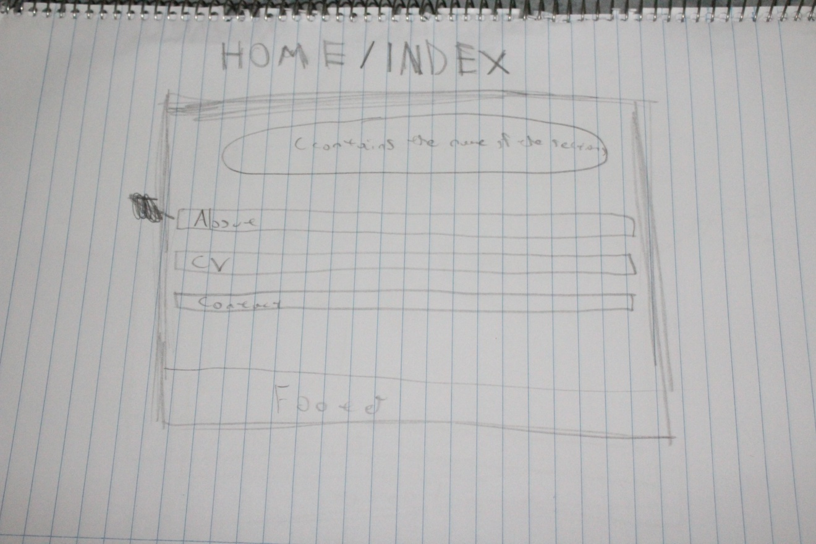

#### About me Sketches

For the about page I will make the standard navigation bar that will be fixed,that means when the user scrolls down the navigation bar will follow.Besides the navigation bar I will add and image,more specifically it will be a picture of me next to the text.Also there will be a footer with some information including phone numbers etc.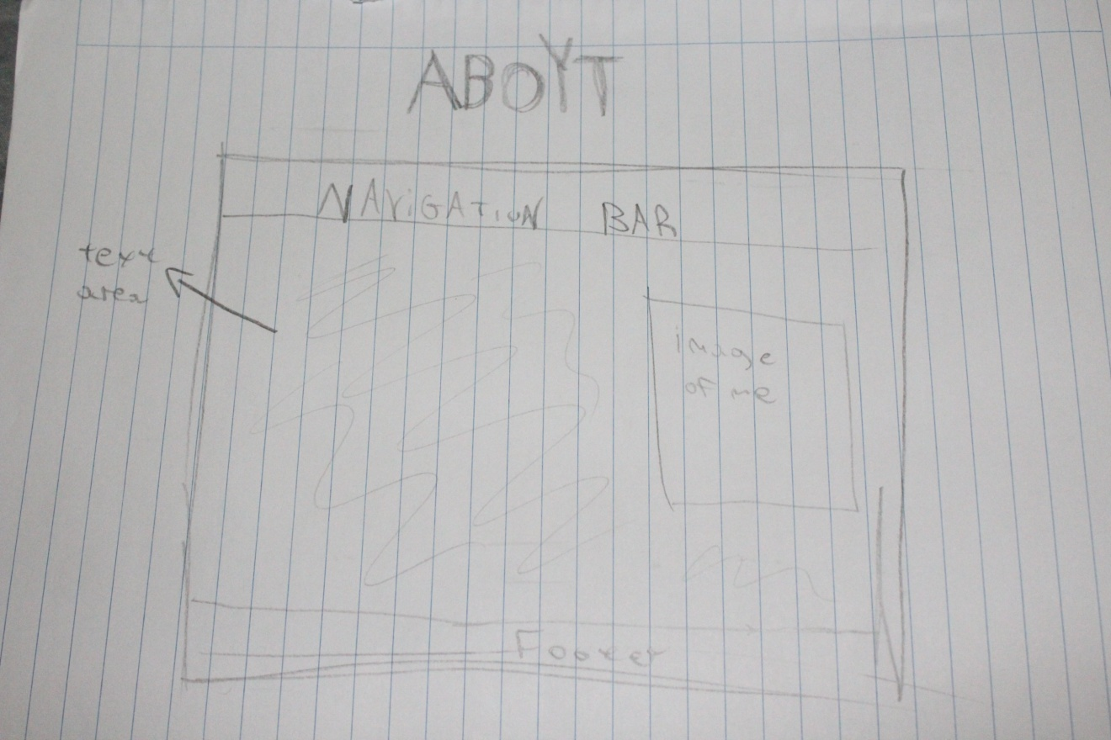

#### CV Sketches

On this section I will make the standard navigation bar and I will make it as simple as it can be.This section will include a random image and some information about my education and skills.Basically,it will be just a text area and a random image.In the end of the section there will be a footer.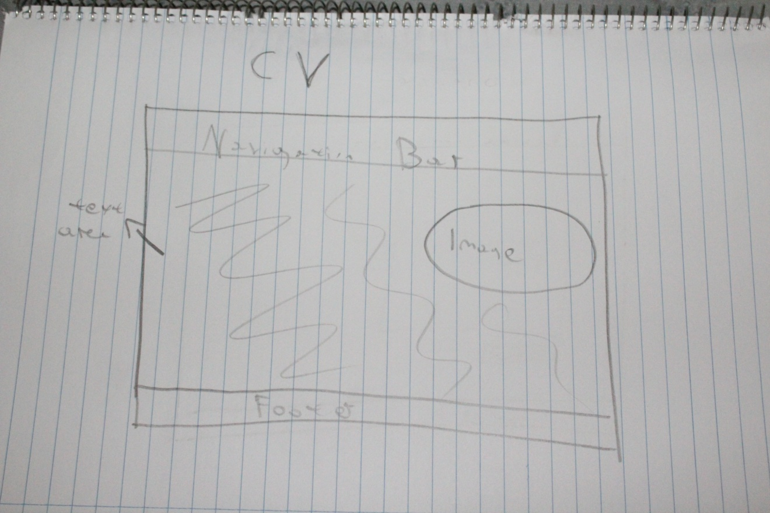

#### Contact Sketches

For my contact page i will just put a contact form.I don’t really want to put too much in this page.In this section there will be no image.In the end there will be a footer.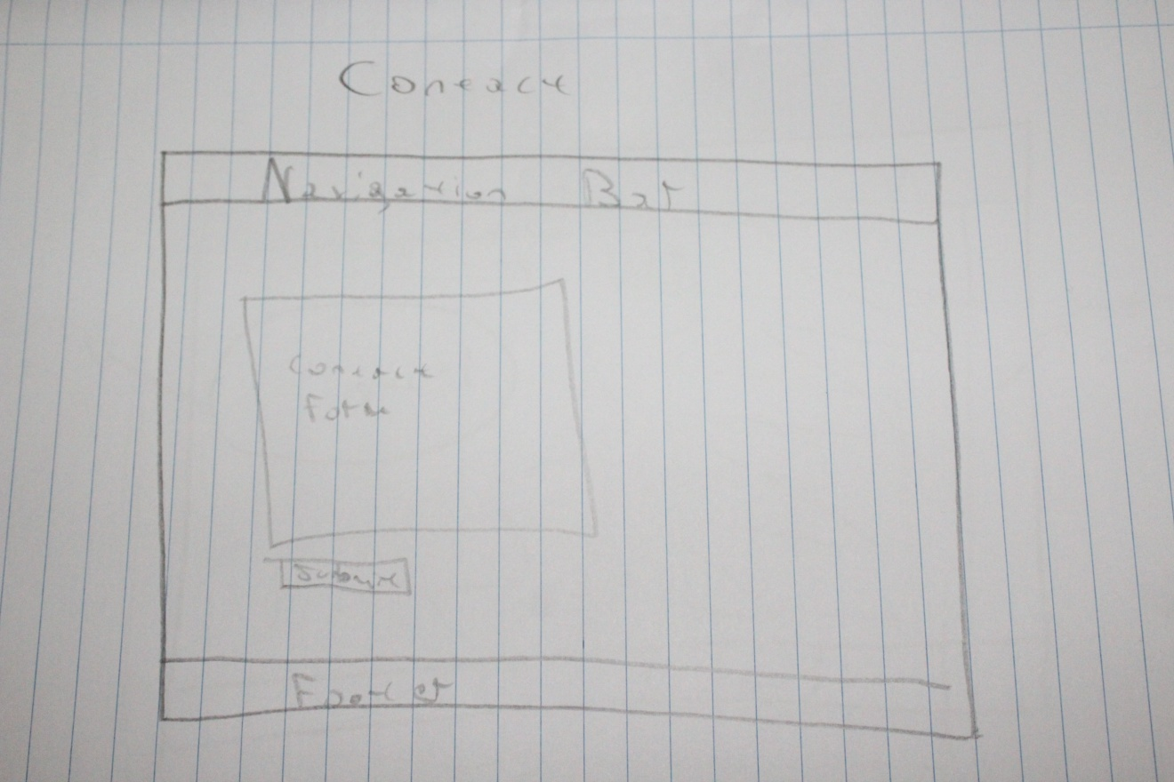

# Visual Appeal

For me it was no secret that visual appeal is a major factor in the creation of a webpage.I tried gathering some ideas by looking at other pages and I realized that simple and organized colors is the key to success.So I thougth some color combinations that would work for my page.I ended up using khaki for the padding and brown for the text.After that I decided to put a backround image that matched perfectly with the other colors.I wanted nothing too crazy but something playful and in my opinion I reached my goal.

# Navigation

I knew I had to pay attention to the navigation.If users cant navigate easily through the page then you done something wrong.I decided to go with the standard navigation bar,nothing too complicated.The user can pick at the top of the page the section that wants to navigate to.Also I made the navigation bar in a fixed position so the user can have an easy access.

# Progression

The amount of time I spent on this page would be about 5 weeks.Right now I will describe the progression of my page in a few words.

#### Week 1

The first week I tried to imagine how my page would look like.I started designing the page in some papers so I could make my work more organized.

#### Week 2

The second week I was done designing my page and I decided to start working on my html files.I already knew what I had to write so that made my work easier.

#### Week 3

The third week I started working on css and I began working on my home page,putting colors and creating the navigation bar.

#### Week 4

after I made my home page everything became easier as I knew how to combine my colors.So since I had the navigation bar ready it was really easy for me to create the cv and about me pages.

#### Week 5

Although it was easy for me to make the other pages I had some troubles creating the contact page.Im not really satisfied about the contact form as I wanted to make it more organized and It turned out too simple and not so friendly towards the user.

# Conclusion

In conclusion,I think I did a good job although I made some mistakes.I think I spend about 5 weeks for this assignment(840 hours more or less).In my opinion I did a pretty good job on the visual appeal and navigation of my page as the colors match together and the navigation bar is understandable but i have done some mistakes.First of all I couldn’t make the page be the same on all resolutions and the backround image in some pages stretches too much because the height is not right.Also the backround image is copyrighted and although I could change I chose not to,because i really liked my page and I didn’t want to mess it up.Also i dint want the contact form to be that simple,I don’t know why but it gave me a hard time and im still working on it.In my opinion I think it went pretty good,thank you for your time and I hope you like my page as well.