Final Project -- Awesamsara.com

Deliverable One

1. Project overview
2. Awesamsara.com
3. Awesamsara.com is a web application that allows users to schedule volunteer service work as part of the travel experience. Whether travel adventures are for family vacation, business, or for volunteering itself, the application will allow a user to book a flight and lodging and create a travel itinerary that includes volunteer work, including the job title and name of an organization located in or near their travel destination. Users will be able to create an account and save multiple trip itineraries.

While the primary goal of the web application is to allow users to schedule volunteer opportunities as part of their travel, there are two more secondary functions of the web application we hope to grow into or to develop if there is time for the final project.

One page of the application will scrape and display web developer volunteer opportunities from Volunteer Match and provide a comment board and a place for developers to work together, sharing Github repositories, to complete web applications for non-profit organizations. This will allow web developers to volunteer their time without having to travel to the volunteer organization location.

Our final goal is to allow users to create Facebook-style profiles to connect with other volunteers, make plans to meet and/or work with other volunteers, and organize resources as needs arise in real-time.

c) The web application will be valuable as it will allow travelers to have a one stop shopping place for finding volunteer opportunities in the communities they visit and booking travel arrangements. The future intent is to find and work with business leaders in the travel industry who will offer rewards or points and thus discounts for airfare and hospitality for doing service work in the local community.

The name Awesamsara is inspired by multiple ideas rooted in both Eastern and Western world philosophies and religions. The word samsāra is a Sanskrit word referenced in the early Upanishads and is loosely translated as "world wandering." It is most commonly associated with Hindu conceptions of karma and rebirth but is also a concept in other Sramanic religions, such as Buddhism and Jainism. Samsāra is a restless wandering, although purposive and necessary in the karmic cycle for growth and eventually liberation.

Sara is also a central figure in Judaism, Christianity, and Islam. Sarai, and then Sara(h), is translated as "noblewoman" or "princess." She is both the wife and half-sister, or niece in Judaism, of Abraham. She was believed to be barren until God blessed her later in life with the birth of Isaac, a patriarch of the Israelites and a prophet in Islam. Sara is therefore a central mother figure in all three major world religions.

Thus, Awesamsara is loosely associated with the awe inspired by charity, a central tenet of all Eastern and Western philosophies, and connecting with others, traveling the world and through the cycle of birth, death, and rebirth however the traveler experiences and understands those ideas.

1. Basic Wireframe

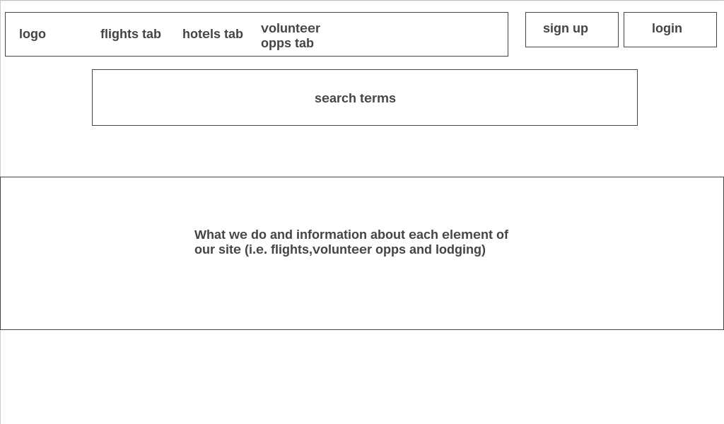

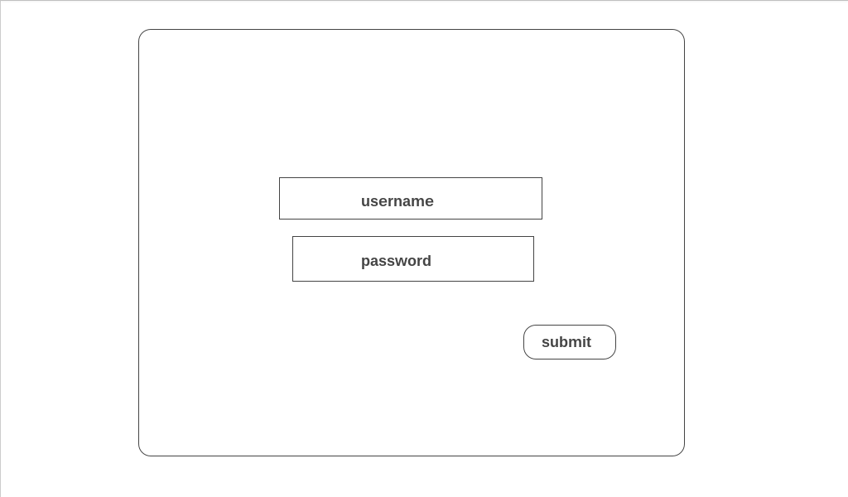

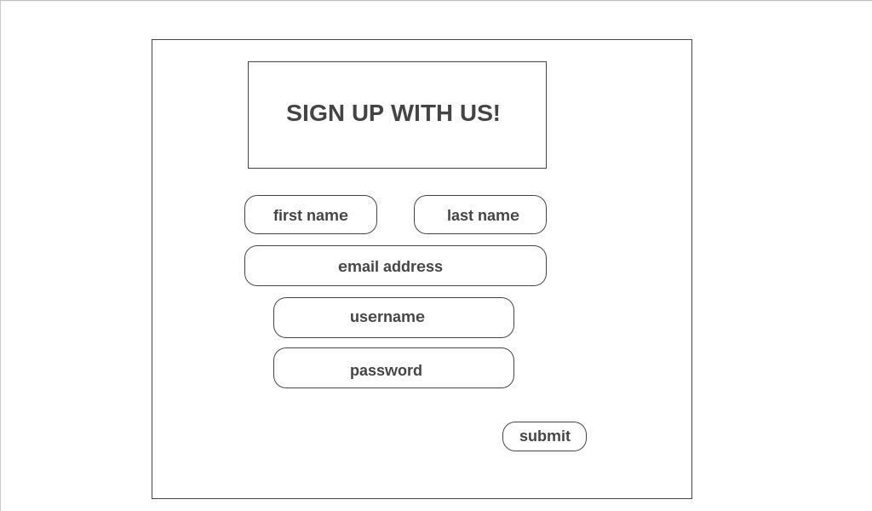

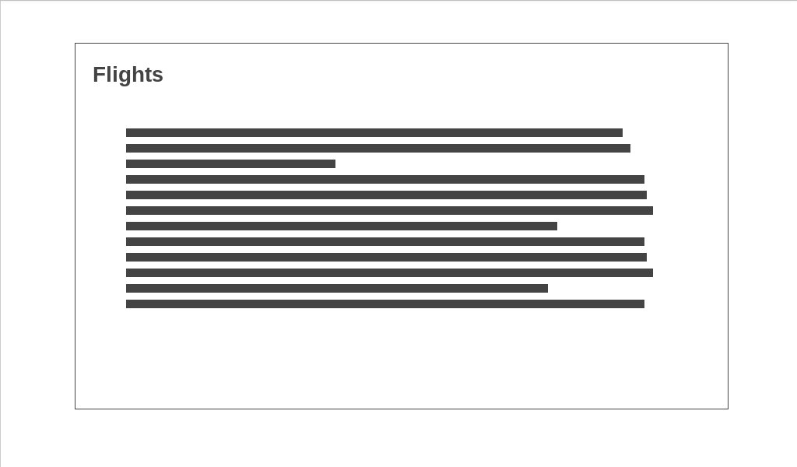

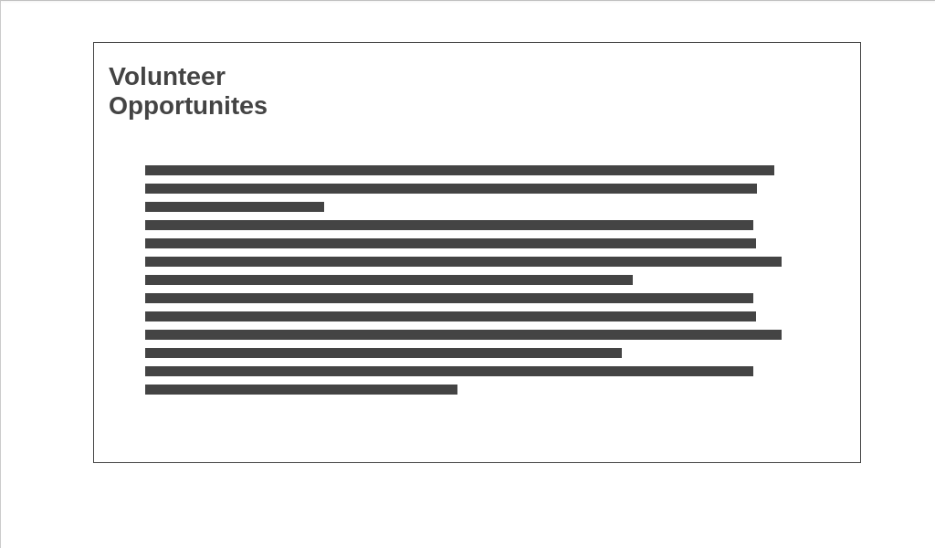

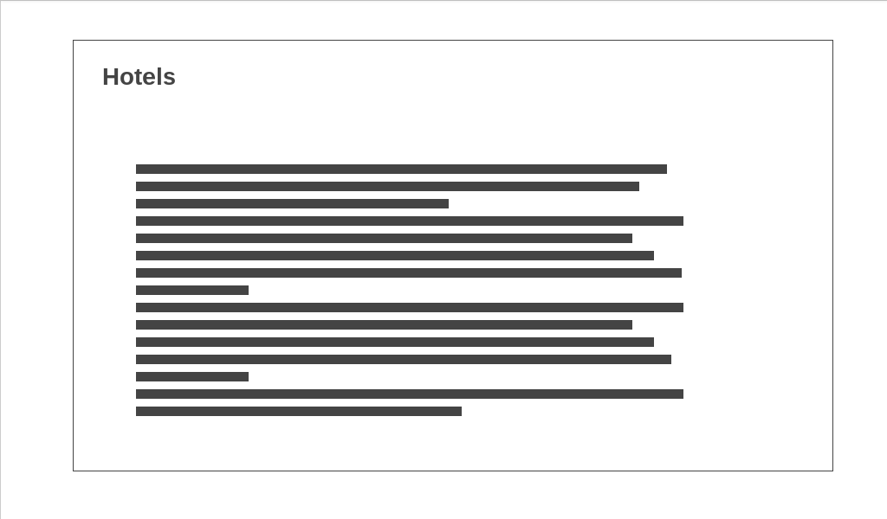

1. A list of tasks to be completed:
2. Make a holding landing page that requires a password to access the site. --Cortney
3. Polish up the front end. -- Cortney
4. Set up MongoDB to handle user accounts and saved trip itineraries and node server. --Jen
5. Contact Priceline to see what is needed to use their API for airline and hotel reservations. Research any other APIs for that use. Research kayak.com and trivago.com more extensively to see how they developed their aggregated data from other booking websites. --Jen/Cortney
6. Start making contacts with others in the travel industry to offer special rates for volunteers. Contact local businesses who may want to advertise on the website or offer special promotions for volunteering in the Orlando area. --Jen/Cortney
7. Make volunteer opportunities clickable to save chosen job as part of the travel itinerary. --Cortney
8. Make flights and hotels bookable. --Cortney/Jen
9. Make or find a logo and favicon. --Cortney
10. If time, make a page that displays web development opportunities and creates a message board for developers to leave comments about the work they have done, what is left to do, github repositories, etc. --Jen
11. Timeline
12. November 26th -- Have a plan for APIs to book flights and hotels; front-end styled near completion; MongoDB database, node, express, and routes for different pages functional; user login, encrypted password, and saving user accounts in the database.
13. December 3rd -- Working app with APIs working to book flights and hotels and users able to save multiple trip itineraries in the database.
14. December 10th -- Have a polished site. If time, make a web development project opportunities page using cheerio to scrape from Volunteer Match so web developers can collaborate to complete projects for non-profits. And, last on the wish list, develop user profiles with the ability to post, Facebook-style, to connect with other users.
15. December 15th -- Final project ready to go without any major bugs, screenshots and mini-presentation ready for the class on December 17th.
16. 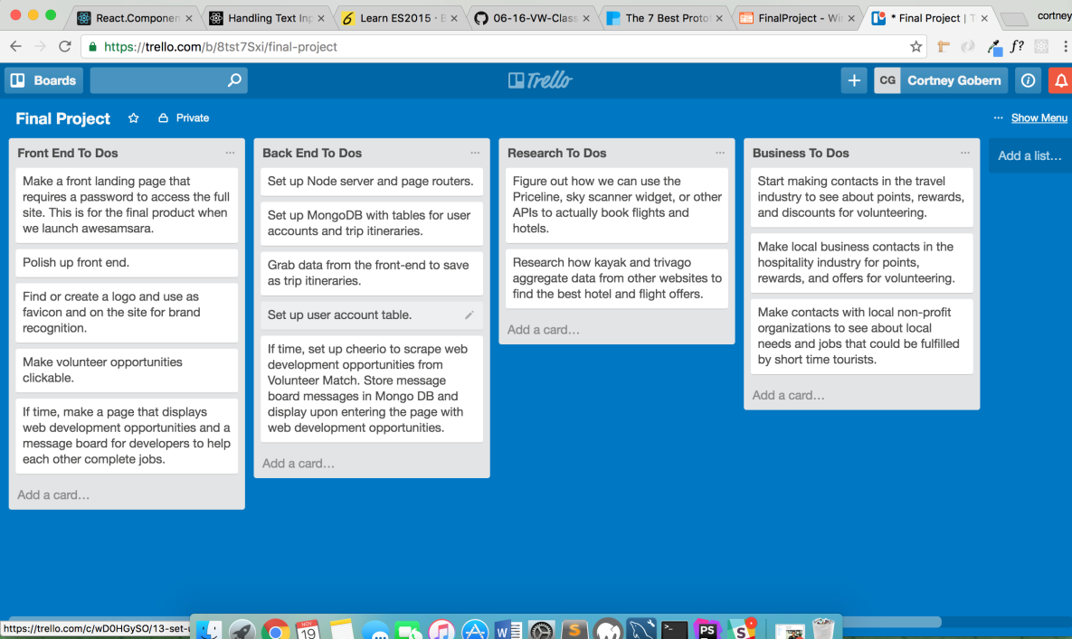
17. https://github.com/Cgobern/FinalProject
18. A markdown of this file can be found on the main page of our github repo.
19. A copy of this file is located on the gitub repo in the documents folder.