**CS602 – Fall 2022**

Homework 2

**Due date: Sunday, February 20, 2022, 11:59pm**

# Instructions:

* For each day of late submission, 10 points will be deducted.
* After two days, no more submission is allowed.
* You must submit through Canvas.
* Keep this file intact, copy your solution codes from your IDE and paste at the bottom of the file under ‘Answer’. Submit this word document with your codes. Do not change the format of the file to pdf or .rar or anything else.

**Reminder:** [**Academic Integrity**](https://www.njit.edu/dos/code-student-conduct-article-11-university-policy-academic-integrity)policy is strictly implemented on all your submissions.

# Learning Objectives:

* Associate the API package for Swing with enhanced implementation
* Convert client applications with Swing components to be interactive.

Design a window interface with a frame that has any light shade as background color (5 points). It should have three text fields (15 points), four radio buttons (20 points), and a label (for the equality sign, 5 points) as follows.

Write a program such that if the user enters two integers on the text fields and clicks on any radio buttons the result of the operation appears in the third text field (15 points). The result of division is usually a non-integer and it should be handled correctly (10 points). Show the use of try-catch block (10 points). You must handle these situations and show a message dialogue box with appropriate message (10 points):

1. Non integer inputs on one or both text fields.
2. No input in one or both text fields.
3. Division by zero.

Note that, there is no command button on this interface.

Name your class as Main.

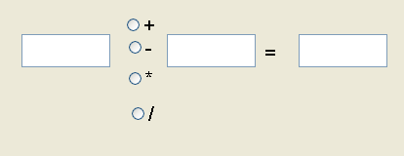

Hint: You need to convert the content of both text fields to integer by using Integer class. It is at the above cases an exception must happen (need try-catch block) and your program must issues an error message by a dialog box.

# Answer:

<paste your codes here>