Skill2: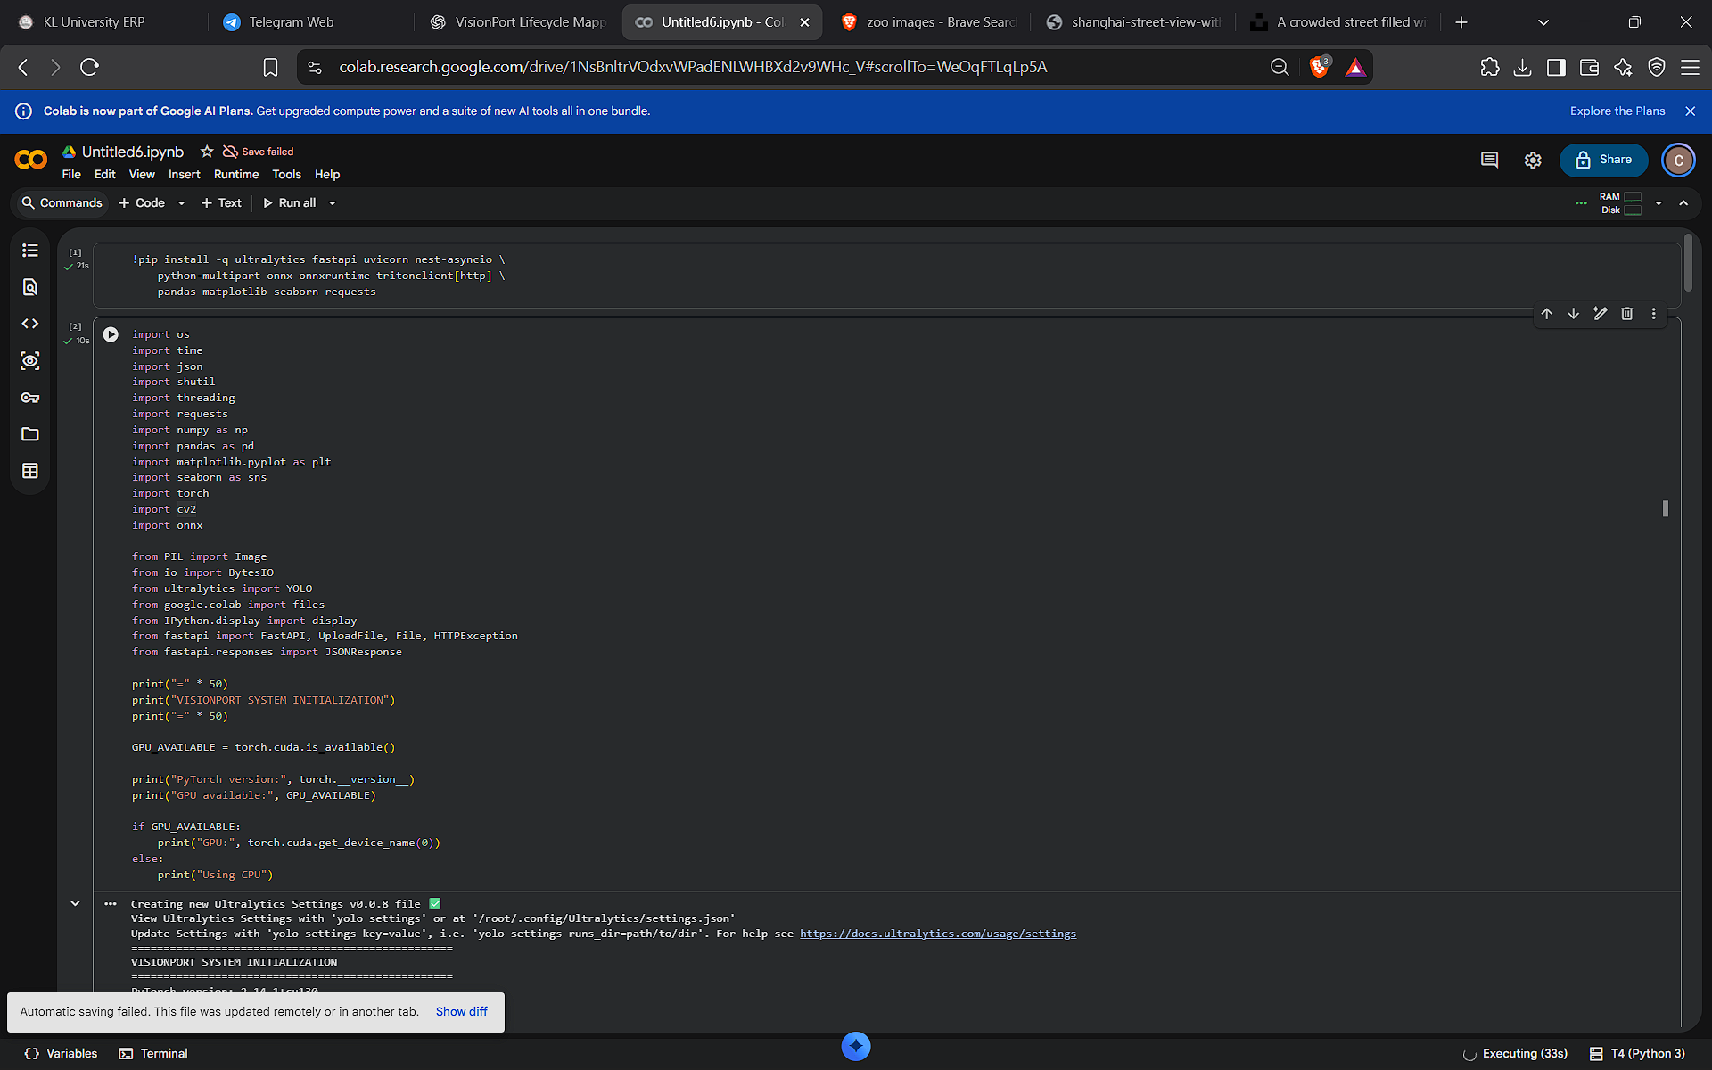

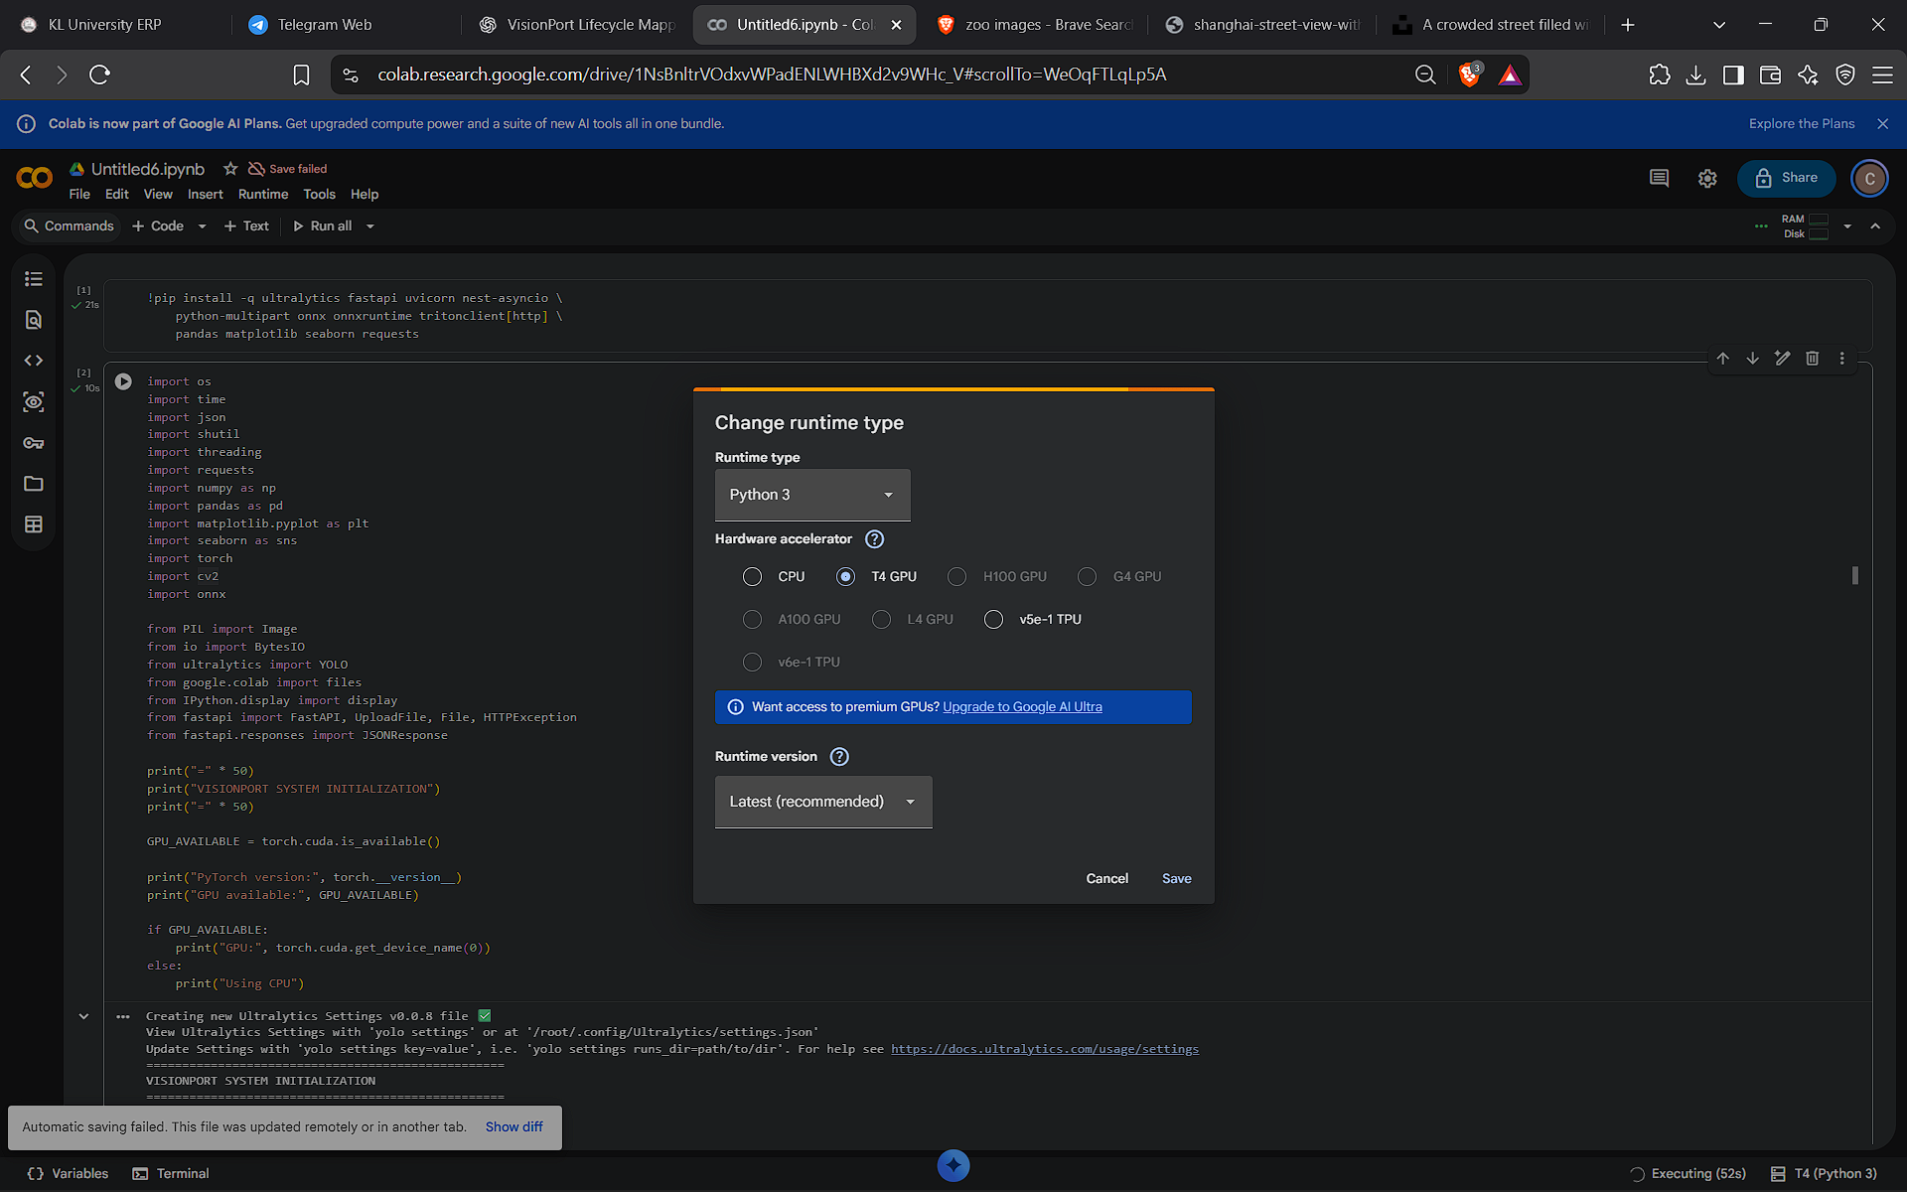
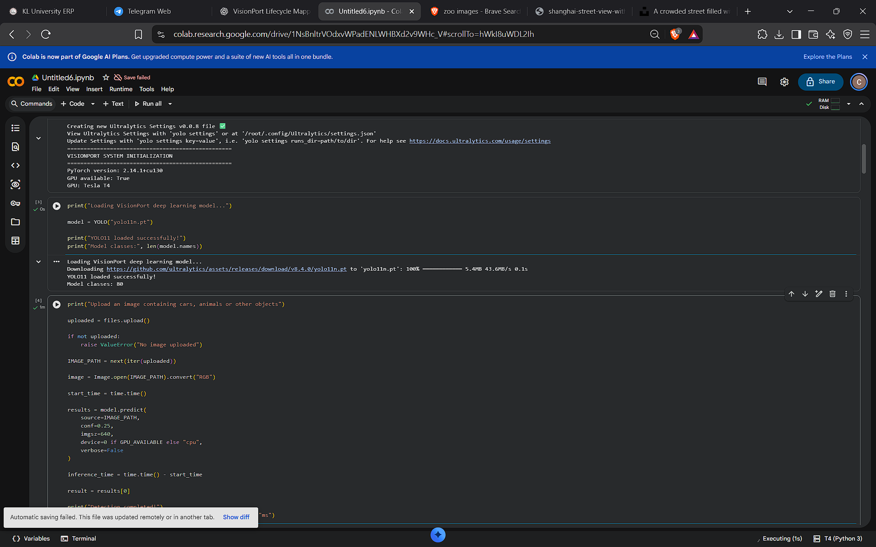
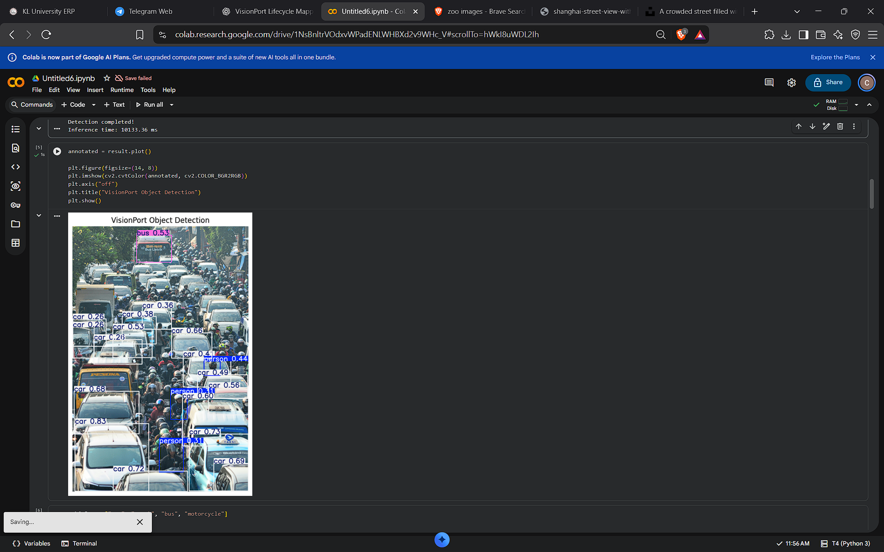
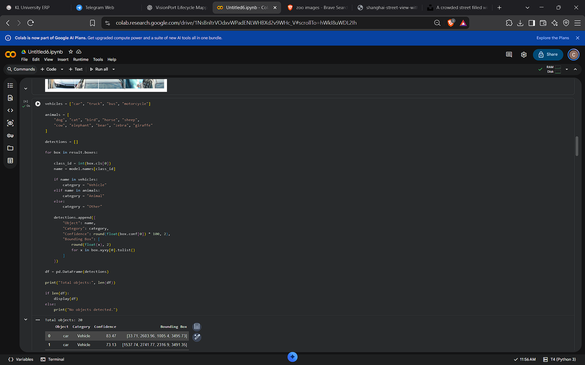
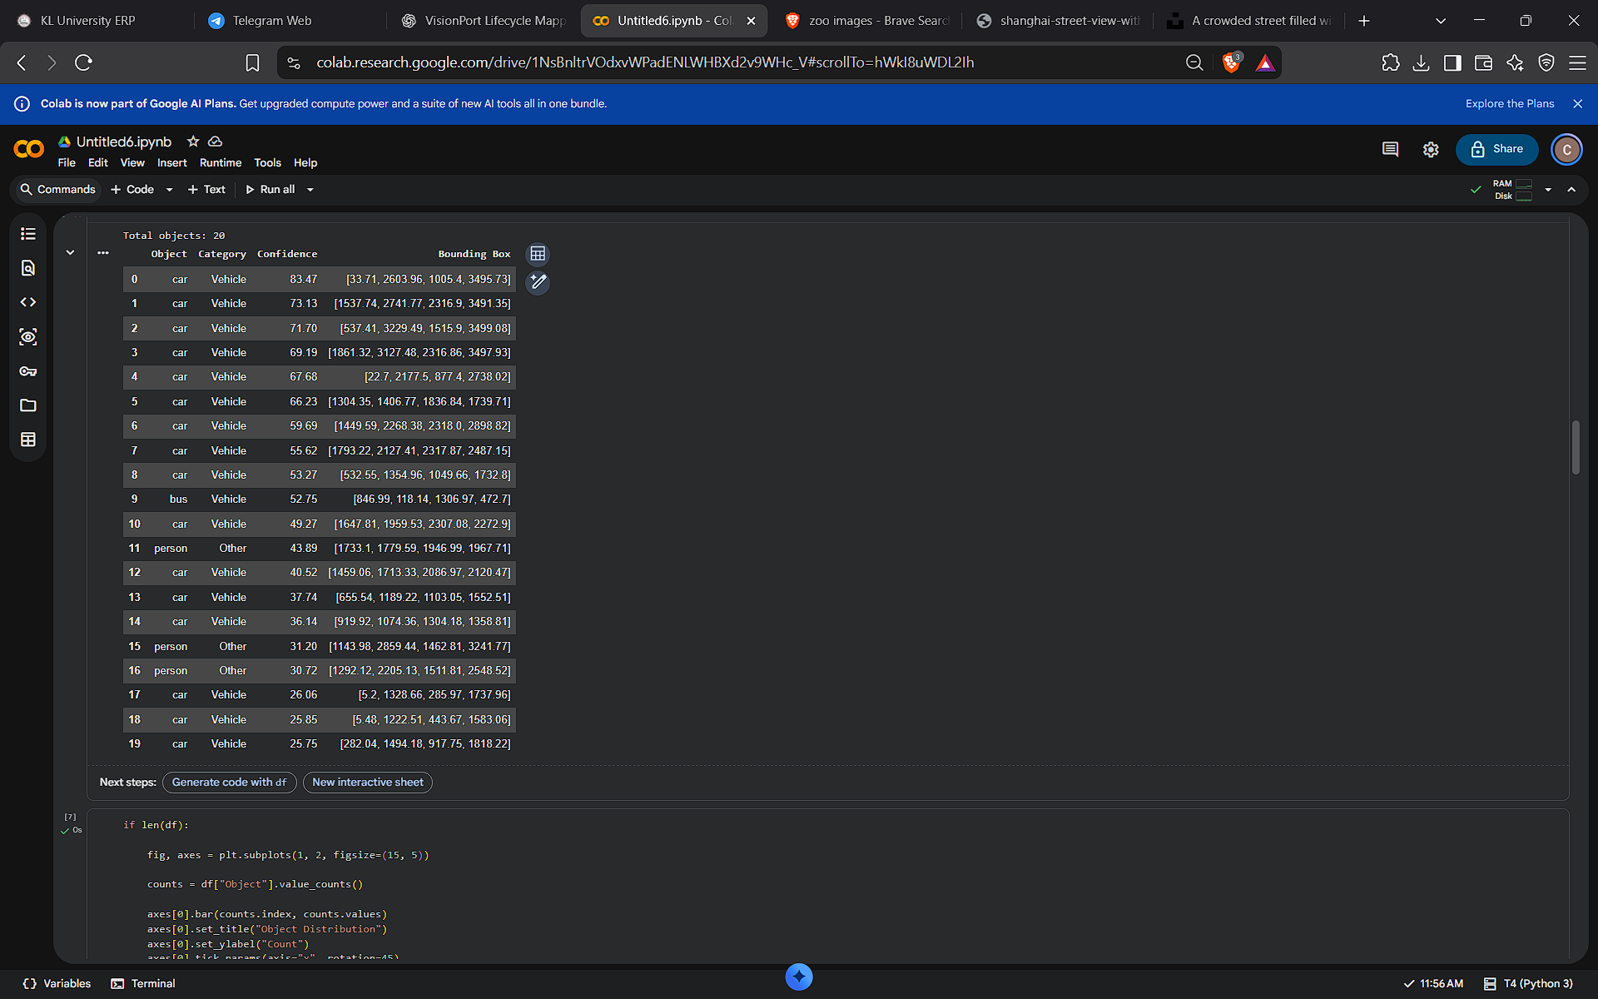
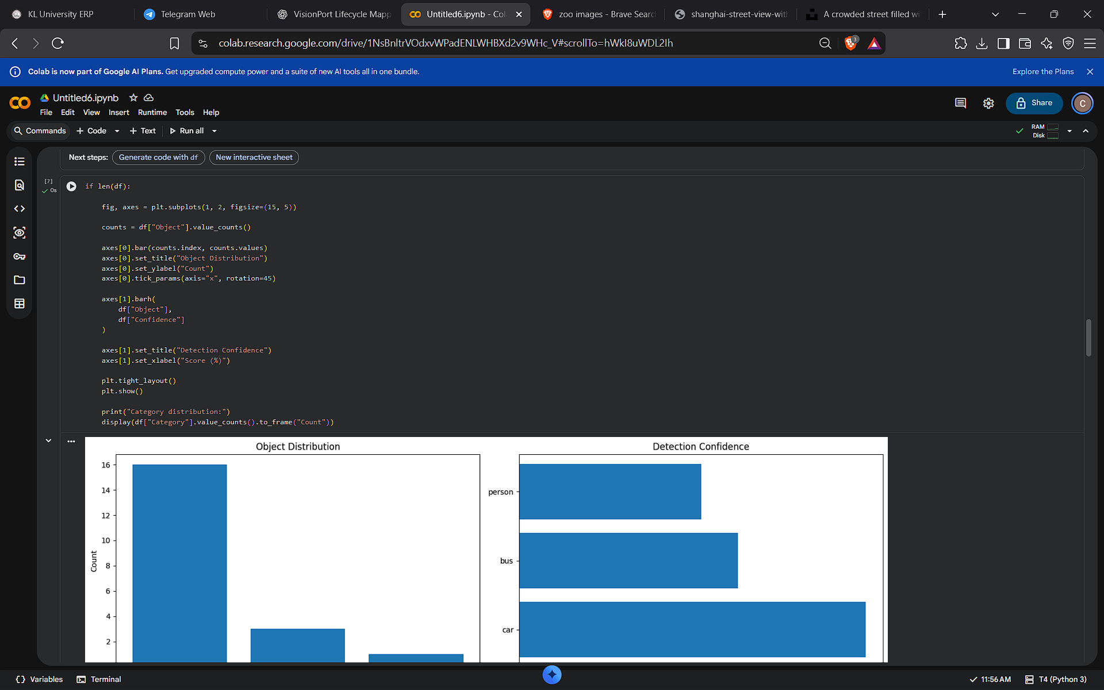

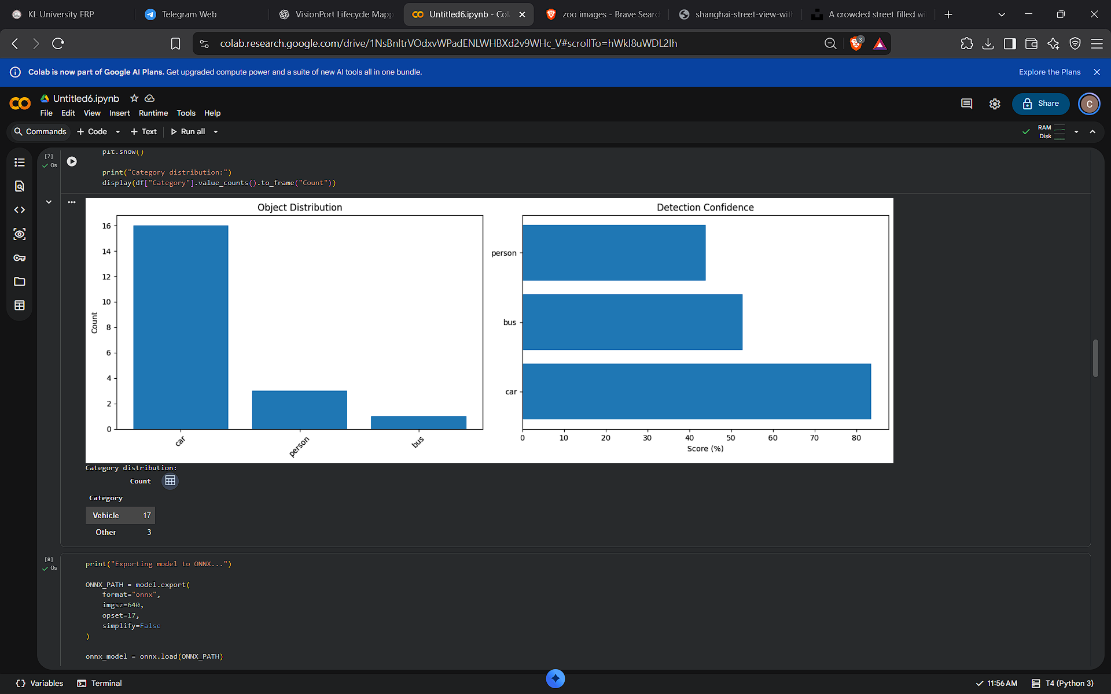

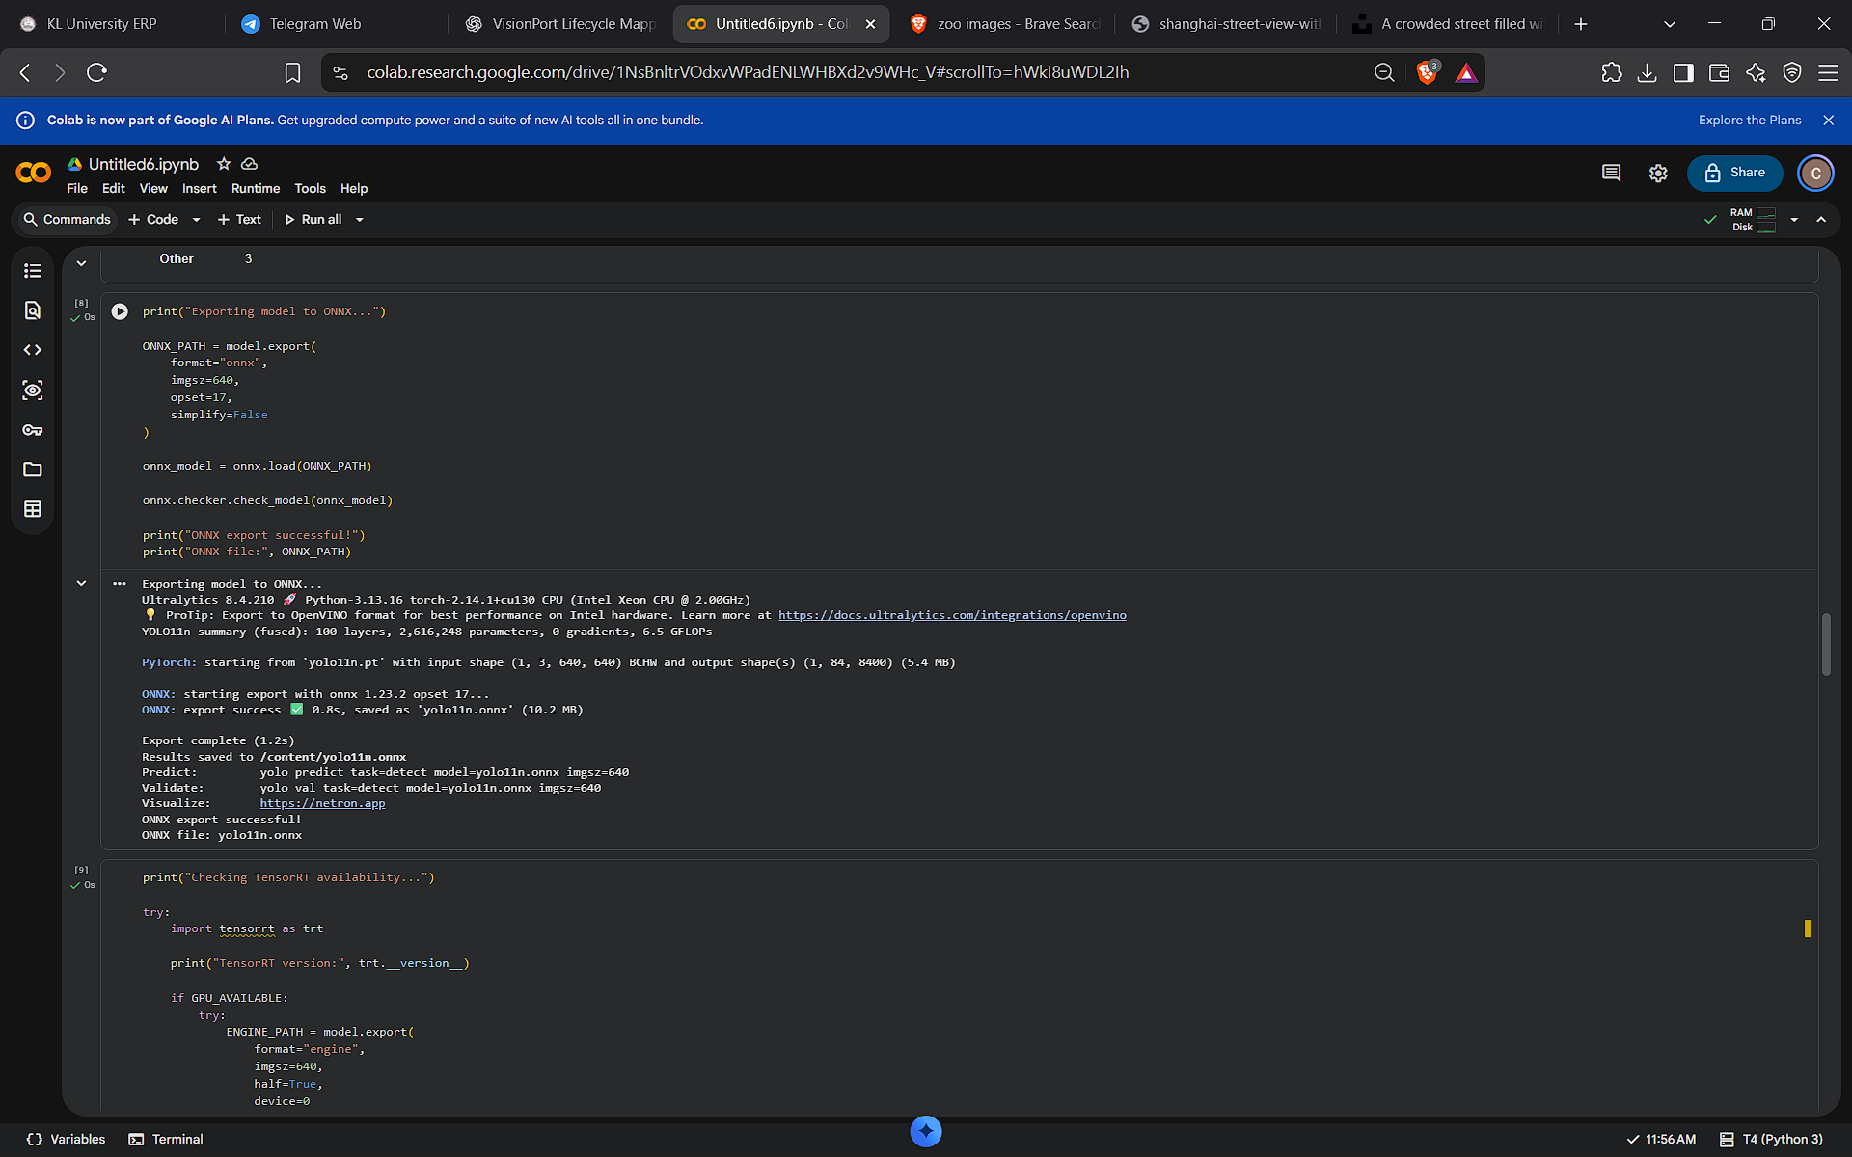

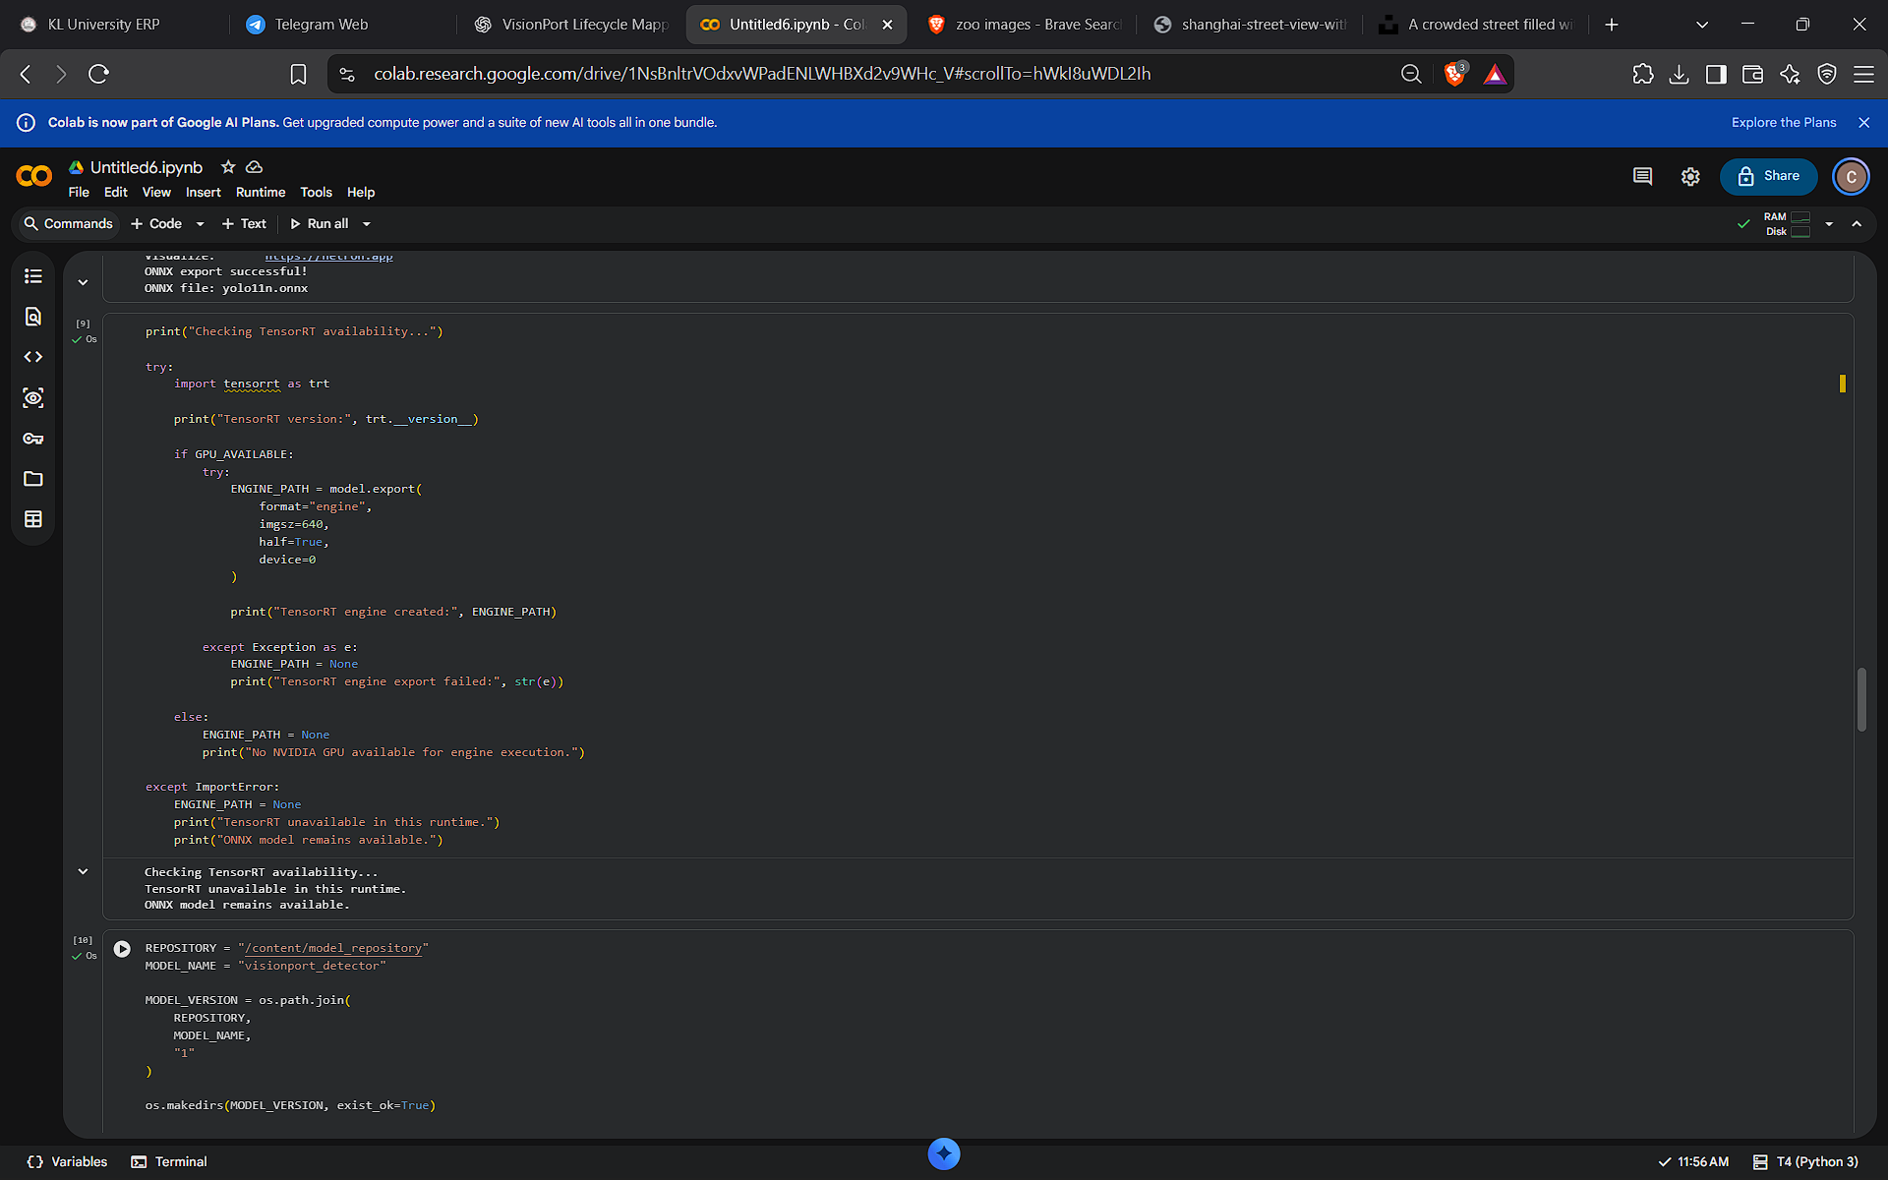

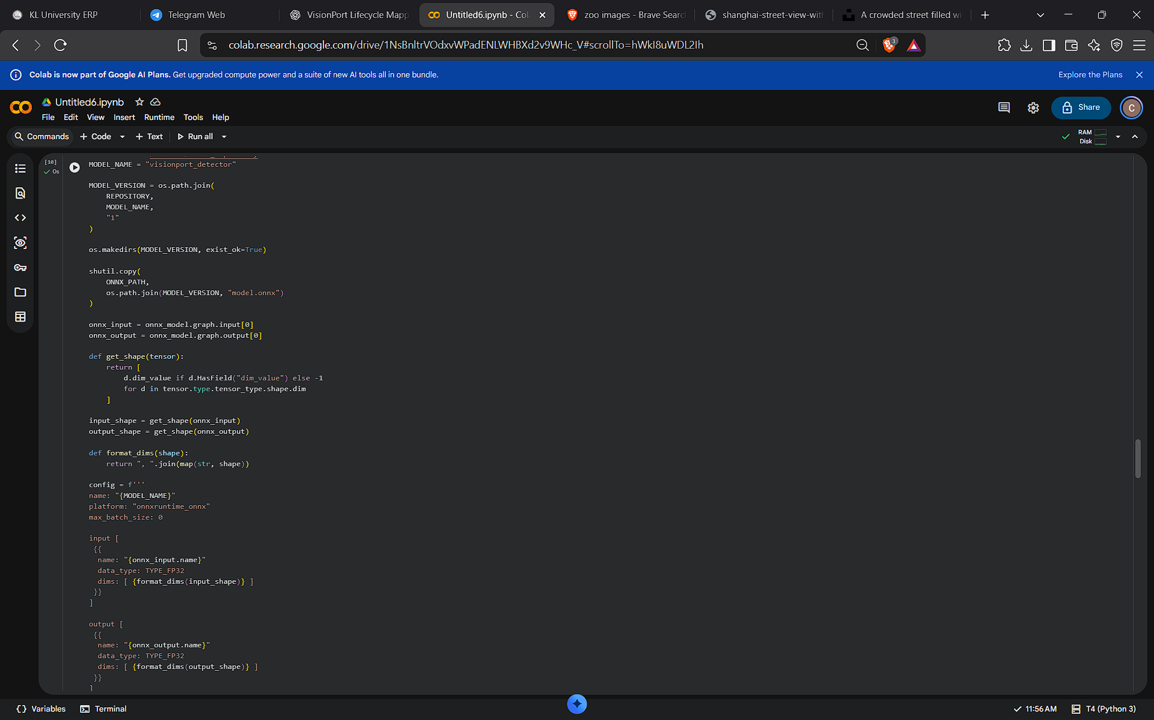

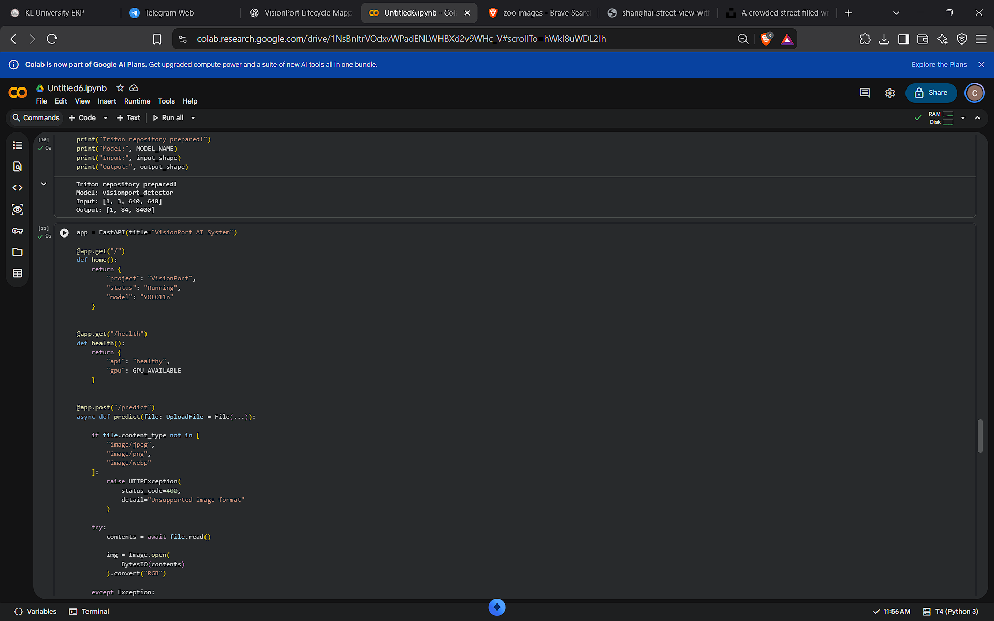

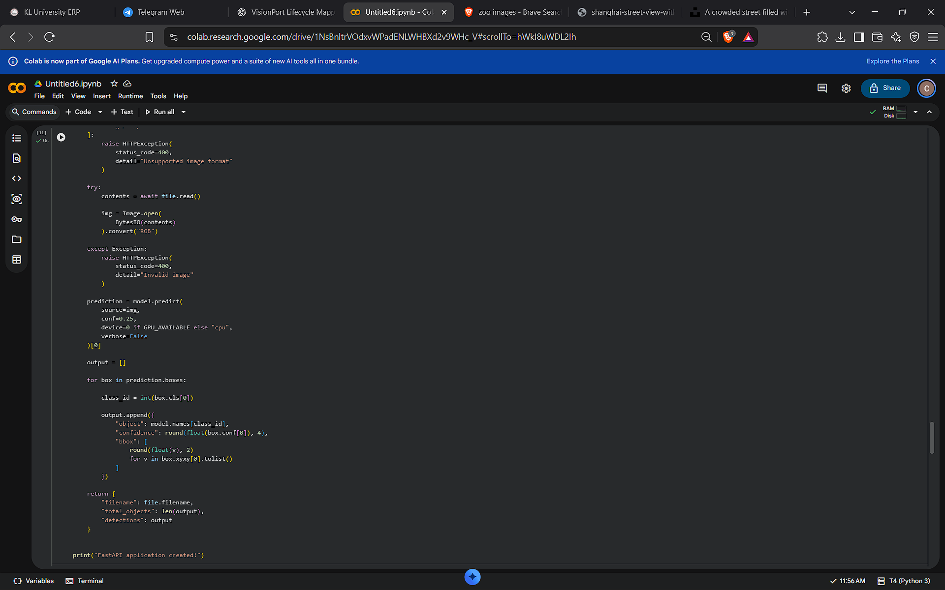

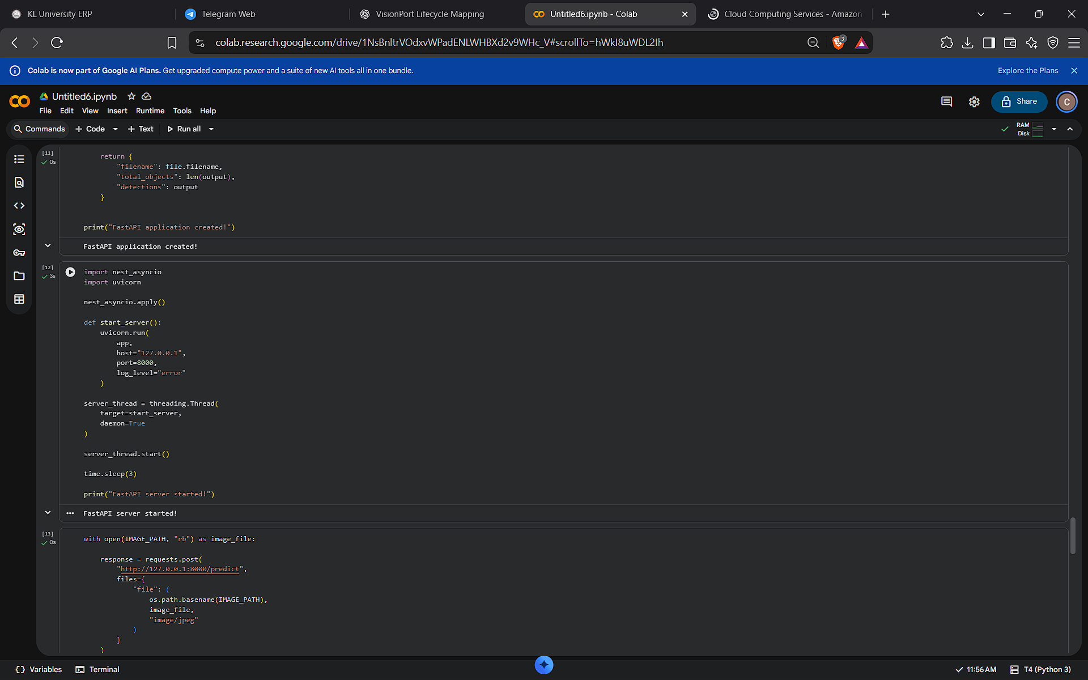

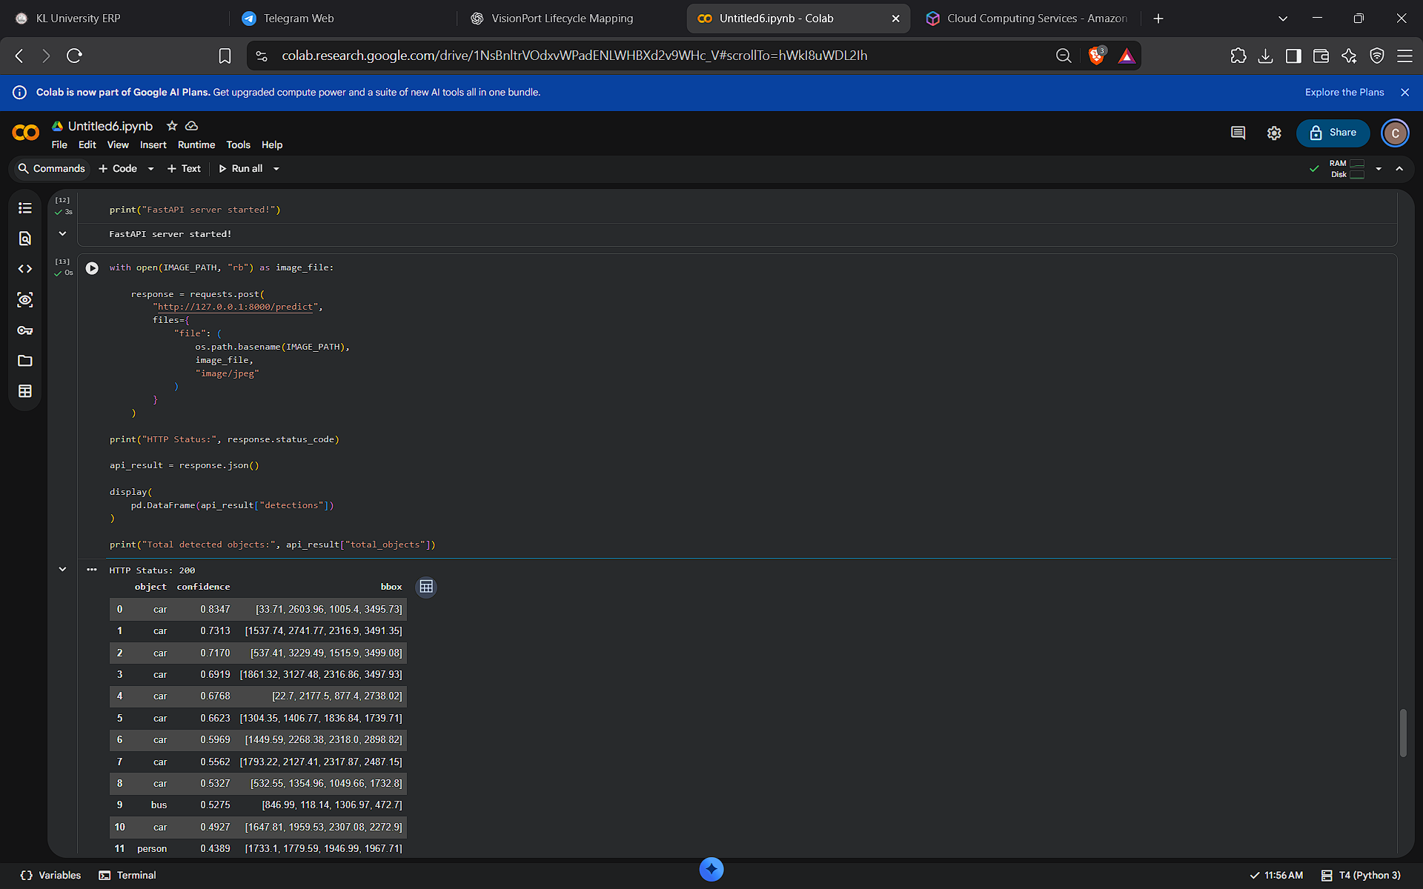

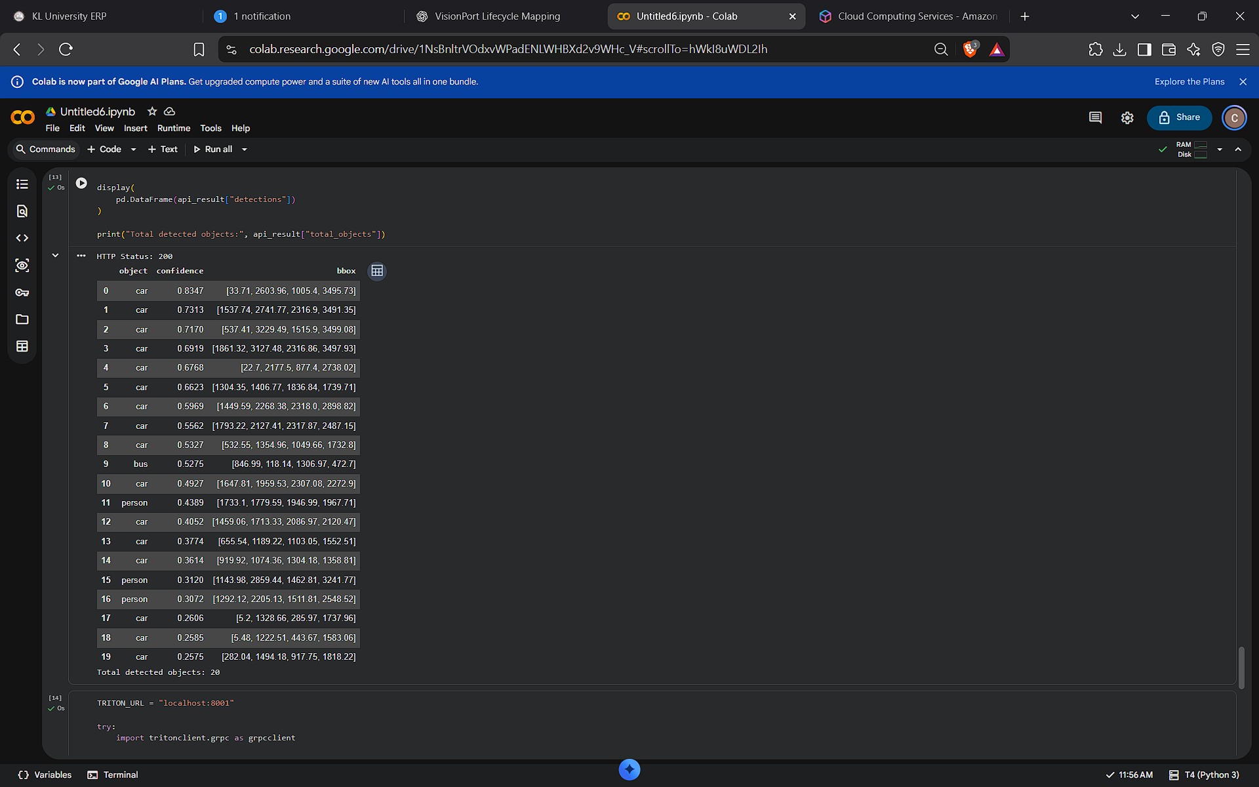

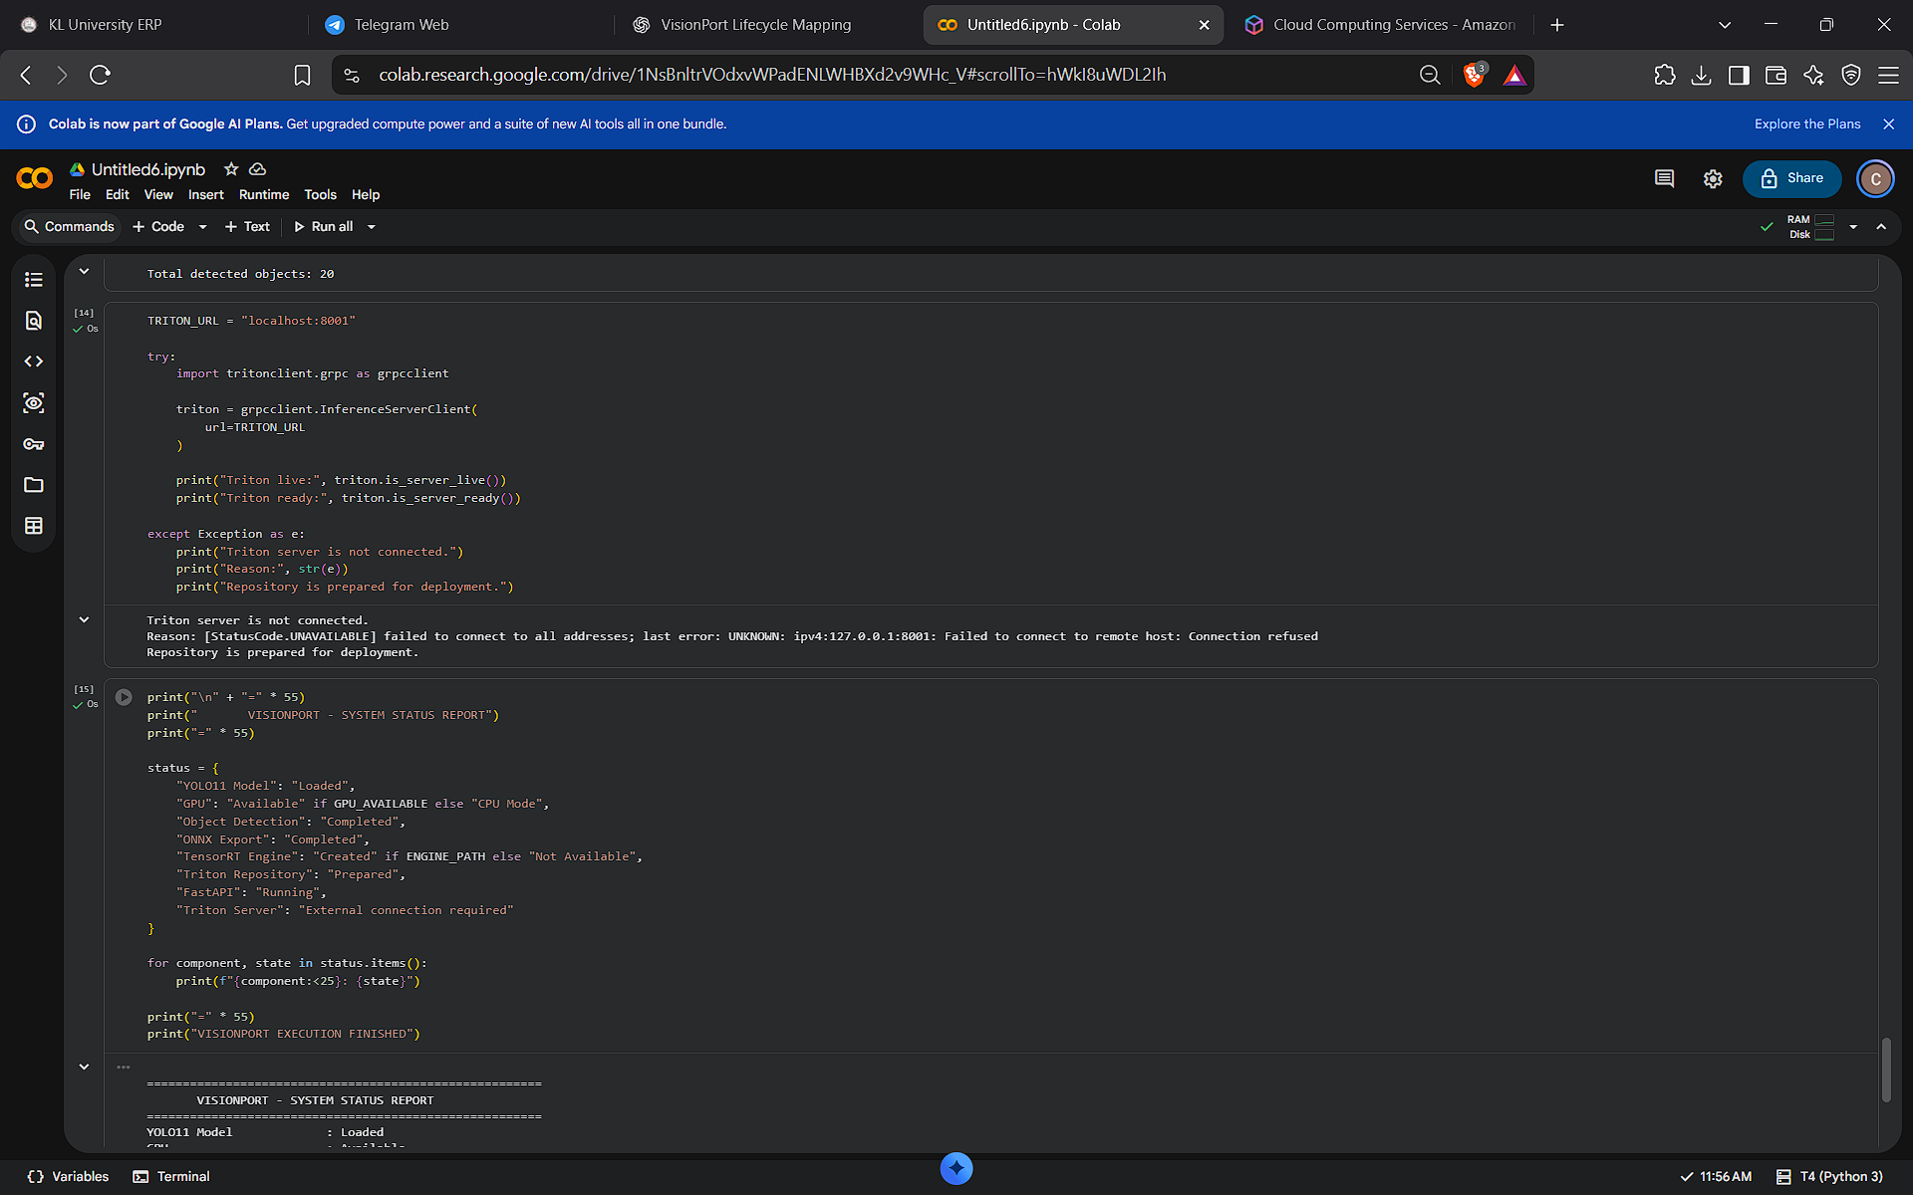

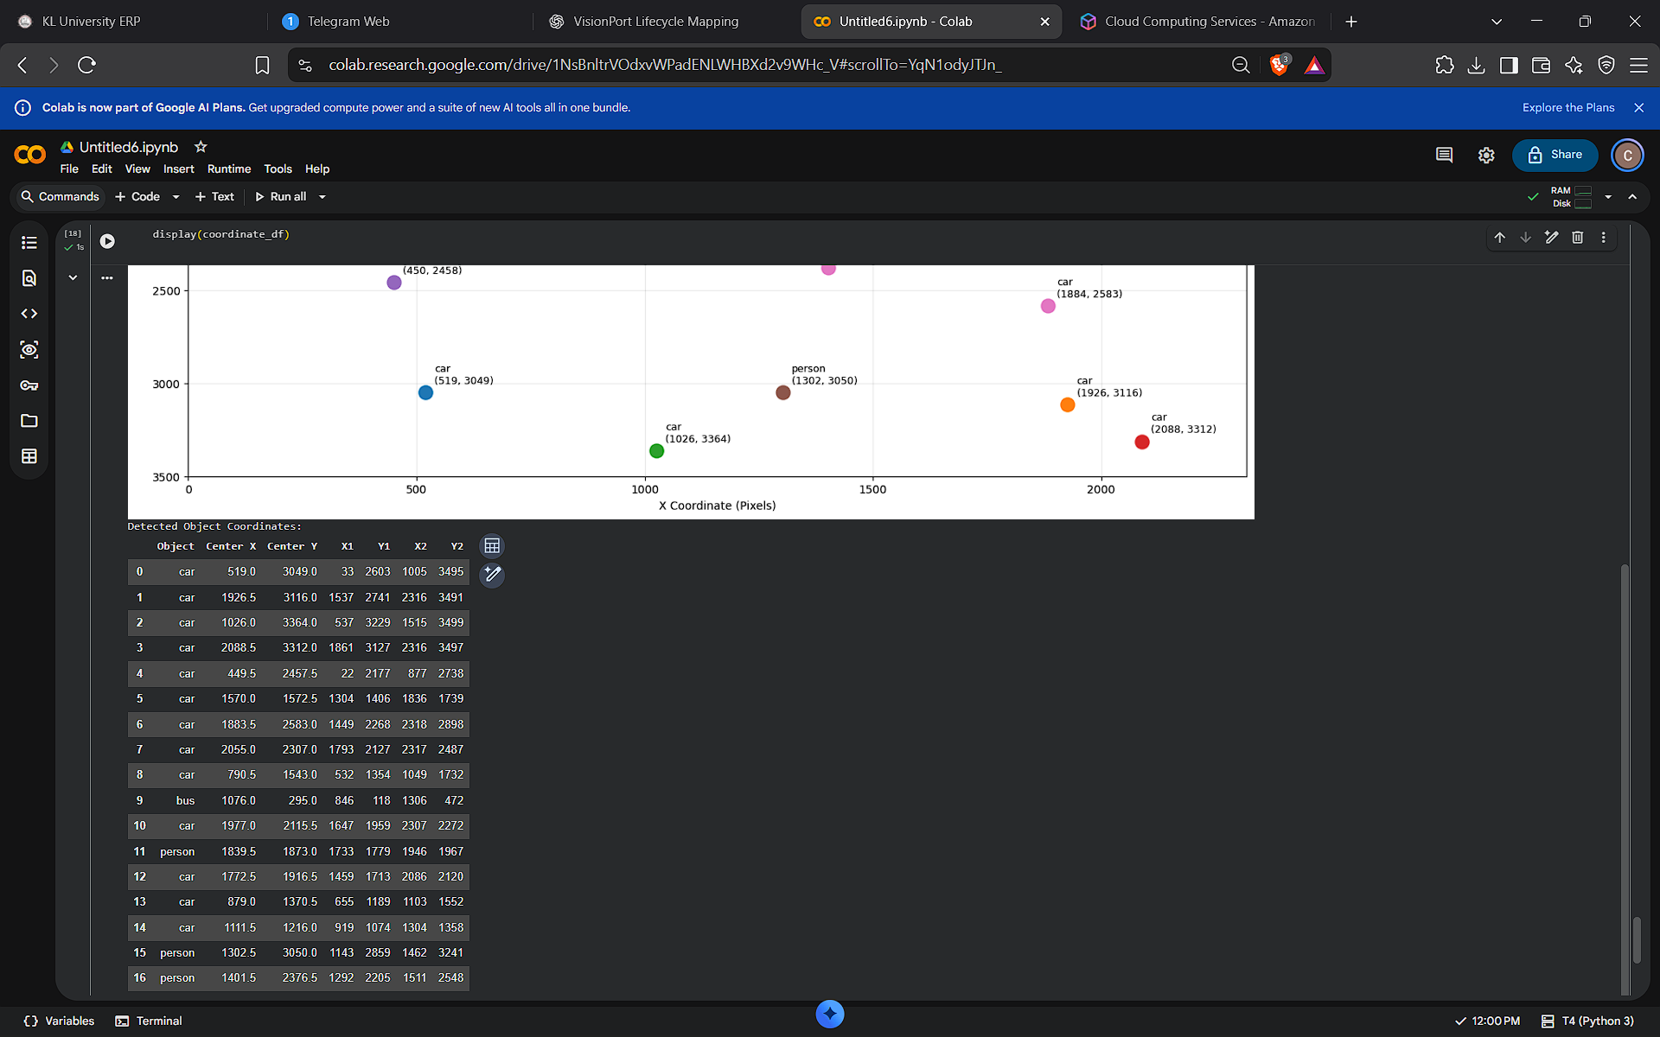

# ============================================================
# VISIONPORT - COMPLETE COMPUTER VISION SYSTEM
# Google Colab | Single Cell Implementation
# ============================================================

!pip install -q ultralytics fastapi uvicorn nest-asyncio \
python-multipart onnx pandas matplotlib requests

import os
import time
import shutil
import threading
import requests
import torch
import cv2
import onnx
import pandas as pd
import numpy as np
import matplotlib.pyplot as plt

from PIL import Image
from io import BytesIO
from ultralytics import YOLO
from google.colab import files
from IPython.display import display
from fastapi import FastAPI, UploadFile, File, HTTPException

# ============================================================
# 1. SYSTEM INITIALIZATION
# ============================================================

print("=" * 65)
print(" VISIONPORT AI SYSTEM")
print("=" * 65)

GPU_AVAILABLE = torch.cuda.is_available()
DEVICE = 0 if GPU_AVAILABLE else "cpu"

print("PyTorch:", torch.__version__)
print("GPU Available:", GPU_AVAILABLE)

if GPU_AVAILABLE:
print("GPU:", torch.cuda.get_device_name(0))
else:
print("Running on CPU")

# ============================================================
# 2. LOAD DEEP LEARNING MODEL
# ============================================================

print("\nLoading YOLO11 model...")

model = YOLO("yolo11n.pt")

print("YOLO11 model loaded successfully!")
print("Available classes:", len(model.names))

# ============================================================
# 3. UPLOAD IMAGE
# ============================================================

print("\nUpload an image containing cars, animals or objects:")

uploaded = files.upload()

if not uploaded:
raise ValueError("No image uploaded!")

IMAGE_PATH = next(iter(uploaded))

image = Image.open(IMAGE_PATH).convert("RGB")

image_width, image_height = image.size

print("Image:", IMAGE_PATH)
print("Dimensions:", image_width, "x", image_height)

# ============================================================
# 4. DEEP LEARNING INFERENCE
# ============================================================

print("\nRunning object detection...")

start_time = time.time()

result = model.predict(
source=image,
conf=0.25,
imgsz=640,
device=DEVICE,
verbose=False
)[0]

inference_time = (time.time() - start_time) * 1000

print("Detection completed!")
print("Inference time:", round(inference_time, 2), "ms")

# ============================================================
# 5. DISPLAY BOUNDING BOX DETECTION
# ============================================================

annotated = result.plot()

plt.figure(figsize=(15, 9))
plt.imshow(cv2.cvtColor(annotated, cv2.COLOR_BGR2RGB))
plt.title("VISIONPORT - OBJECT DETECTION")
plt.axis("off")
plt.show()

# ============================================================
# 6. OBJECT CLASSIFICATION AND COORDINATE EXTRACTION
# ============================================================

vehicles = ["car", "truck", "bus", "motorcycle"]

animals = [
"dog", "cat", "bird", "horse", "sheep",
"cow", "elephant", "bear", "zebra", "giraffe"
]

detections = []

for box in result.boxes:

class_id = int(box.cls[0])
name = model.names[class_id]

confidence = float(box.conf[0])

x1, y1, x2, y2 = map(
int, box.xyxy[0].tolist()
)

center_x = (x1 + x2) / 2
center_y = (y1 + y2) / 2

if name in vehicles:
category = "Vehicle"
elif name in animals:
category = "Animal"
else:
category = "Other"

detections.append({
"Object": name.title(),
"Category": category,
"Confidence (%)": round(confidence * 100, 2),
"X1": x1,
"Y1": y1,
"X2": x2,
"Y2": y2,
"Center X": round(center_x, 2),
"Center Y": round(center_y, 2),
"Width": x2 - x1,
"Height": y2 - y1
})

coordinate_df = pd.DataFrame(detections)

# ============================================================
# 7. DETECTION REPORT
# ============================================================

print("\n" + "=" * 65)
print(" DETECTION REPORT")
print("=" * 65)

print("Total Objects:", len(coordinate_df))

if len(coordinate_df) > 0:

print("Vehicles:", (coordinate_df["Category"] == "Vehicle").sum())
print("Animals:", (coordinate_df["Category"] == "Animal").sum())
print("Other:", (coordinate_df["Category"] == "Other").sum())

display(coordinate_df)

else:
print("No objects detected. Try another image.")

# ============================================================
# 8. OBJECT COORDINATE MAPPING GRAPH
# ============================================================

if len(coordinate_df) > 0:

plt.figure(figsize=(15, 9))

# Show original image as coordinate background
plt.imshow(image)

for _, row in coordinate_df.iterrows():

x = row["Center X"]
y = row["Center Y"]

# Plot object center
plt.scatter(
x, y,
s=180,
marker="o",
edgecolors="black",
linewidths=1.2
)

# Draw bounding box
plt.gca().add_patch(
plt.Rectangle(
(row["X1"], row["Y1"]),
row["Width"],
row["Height"],
fill=False,
linewidth=2
)
)

# Label coordinates
plt.annotate(
f"{row['Object']} ({x:.0f}, {y:.0f})",
(x, y),
xytext=(8, 8),
textcoords="offset points",
fontsize=9,
bbox=dict(alpha=0.7)
)

plt.xlim(0, image_width)
plt.ylim(image_height, 0)

plt.xlabel("X Coordinate (Pixels)")
plt.ylabel("Y Coordinate (Pixels)")

plt.title("VISIONPORT - OBJECT COORDINATE MAPPING")

plt.grid(alpha=0.2)
plt.tight_layout()
plt.show()

# ============================================================
# 9. OBJECT DISTRIBUTION AND CONFIDENCE GRAPHS
# ============================================================

if len(coordinate_df) > 0:

fig, axes = plt.subplots(1, 2, figsize=(16, 6))

counts = coordinate_df["Object"].value_counts()

axes[0].bar(
counts.index,
counts.values
)

axes[0].set_title("Object Distribution")
axes[0].set_xlabel("Detected Objects")
axes[0].set_ylabel("Count")
axes[0].tick_params(axis="x", rotation=45)

axes[1].barh(
coordinate_df["Object"],
coordinate_df["Confidence (%)"]
)

axes[1].set_title("Detection Confidence")
axes[1].set_xlabel("Confidence (%)")
axes[1].set_xlim(0, 100)

plt.tight_layout()
plt.show()

# Category distribution
category_counts = coordinate_df["Category"].value_counts()

plt.figure(figsize=(7, 7))
plt.pie(
category_counts.values,
labels=category_counts.index,
autopct="%1.1f%%",
startangle=90
)

plt.title("Vehicle vs Animal vs Other")
plt.show()

# ============================================================
# 10. EXPORT MODEL TO ONNX
# ============================================================

print("\nExporting model to ONNX...")

ONNX_PATH = None

try:

ONNX_PATH = model.export(
format="onnx",
imgsz=640,
opset=17,
simplify=False
)

onnx_model = onnx.load(ONNX_PATH)
onnx.checker.check_model(onnx_model)

print("ONNX export and validation successful!")

except Exception as e:
print("ONNX export unavailable:", str(e))

# ============================================================
# 11. TENSORRT AVAILABILITY
# ============================================================

ENGINE_PATH = None

print("\nChecking TensorRT...")

try:

import tensorrt as trt

print("TensorRT version:", trt.__version__)

if GPU_AVAILABLE:

try:
ENGINE_PATH = model.export(
format="engine",
imgsz=640,
half=True,
device=0
)

print("TensorRT engine created:", ENGINE_PATH)

except Exception as e:
print("TensorRT engine build failed:", str(e))

else:
print("NVIDIA GPU required for TensorRT engine.")

except ImportError:
print("TensorRT not installed in this runtime.")

# ============================================================
# 12. TRITON MODEL REPOSITORY PREPARATION
# ============================================================

TRITON_REPOSITORY = "/content/model_repository"

MODEL_NAME = "visionport_detector"

MODEL_VERSION = os.path.join(
TRITON_REPOSITORY,
MODEL_NAME,
"1"
)

TRITON_READY = False

if ONNX_PATH:

os.makedirs(MODEL_VERSION, exist_ok=True)

shutil.copy(
ONNX_PATH,
os.path.join(MODEL_VERSION, "model.onnx")
)

model_onnx = onnx.load(ONNX_PATH)

input_tensor = model_onnx.graph.input[0]
output_tensor = model_onnx.graph.output[0]

def get_shape(tensor):
return [
d.dim_value if d.HasField("dim_value") else -1
for d in tensor.type.tensor_type.shape.dim
]

input_shape = get_shape(input_tensor)
output_shape = get_shape(output_tensor)

def fmt(shape):
return ", ".join(map(str, shape))

config = f'''
name: "{MODEL_NAME}"
platform: "onnxruntime_onnx"
max_batch_size: 0

input [
{{
name: "{input_tensor.name}"
data_type: TYPE_FP32
dims: [ {fmt(input_shape)} ]
}}
]

output [
{{
name: "{output_tensor.name}"
data_type: TYPE_FP32
dims: [ {fmt(output_shape)} ]
}}
]
'''

with open(
os.path.join(
TRITON_REPOSITORY,
MODEL_NAME,
"config.pbtxt"
),
"w"
) as f:
f.write(config)

TRITON_READY = True

print("Triton model repository prepared!")

else:
print("ONNX model unavailable; Triton repository not created.")

# ============================================================
# 13. FASTAPI BACKEND
# ============================================================

app = FastAPI(title="VisionPort AI API")

@app.get("/")
def home():

return {
"project": "VisionPort",
"status": "Running",
"model": "YOLO11n"
}

@app.get("/health")
def health():

return {
"api": "healthy",
"gpu_available": GPU_AVAILABLE
}

@app.post("/predict")
async def predict(file: UploadFile = File(...)):

if file.content_type not in [
"image/jpeg",
"image/png",
"image/webp"
]:
raise HTTPException(
status_code=400,
detail="Unsupported image format"
)

try:

contents = await file.read()

img = Image.open(
BytesIO(contents)
).convert("RGB")

except Exception:

raise HTTPException(
status_code=400,
detail="Invalid image"
)

prediction = model.predict(
source=img,
conf=0.25,
device=DEVICE,
verbose=False
)[0]

output = []

for box in prediction.boxes:

class_id = int(box.cls[0])
name = model.names[class_id]

x1, y1, x2, y2 = map(
float,
box.xyxy[0].tolist()
)

output.append({
"object": name,
"confidence": round(float(box.conf[0]), 4),
"coordinates": {
"x1": round(x1, 2),
"y1": round(y1, 2),
"x2": round(x2, 2),
"y2": round(y2, 2)
}
})

return {
"filename": file.filename,
"total_objects": len(output),
"detections": output
}

# ============================================================
# 14. START FASTAPI SERVER
# ============================================================

import nest_asyncio
import uvicorn

nest_asyncio.apply()

def start_api():

uvicorn.run(
app,
host="127.0.0.1",
port=8000,
log_level="error"
)

api_thread = threading.Thread(
target=start_api,
daemon=True
)

api_thread.start()

time.sleep(3)

API_RUNNING = False

try:

api_response = requests.get(
"http://127.0.0.1:8000/health",
timeout=5
)

API_RUNNING = api_response.status_code == 200

print("\nFastAPI health:", api_response.json())

except Exception as e:
print("FastAPI startup issue:", str(e))

# ============================================================
# 15. TEST FASTAPI IMAGE UPLOAD
# ============================================================

if API_RUNNING:

try:

with open(IMAGE_PATH, "rb") as f:

response = requests.post(
"http://127.0.0.1:8000/predict",
files={
"file": (
os.path.basename(IMAGE_PATH),
f,
"image/jpeg"
)
},
timeout=120
)

print("\nAPI response status:", response.status_code)

if response.ok:
api_output = response.json()
print("API detected objects:", api_output["total_objects"])
display(pd.DataFrame(api_output["detections"]))
else:
print(response.text)

except Exception as e:
print("API test failed:", str(e))

# ============================================================
# 16. TRITON SERVER CONNECTION CHECK
# ============================================================

TRITON_CONNECTED = False

print("\nChecking external Triton server...")

try:

import tritonclient.http as httpclient

# Default local Triton HTTP endpoint
client = httpclient.InferenceServerClient(
url="localhost:8000"
)

TRITON_CONNECTED = client.is_server_live()

except Exception:
print("No Triton server detected at localhost:8000.")

print("Triton connected:", TRITON_CONNECTED)

# ============================================================
# 17. EXPORT DETECTION REPORT
# ============================================================

if len(coordinate_df) > 0:

CSV_PATH = "/content/visionport_detection_report.csv"

coordinate_df.to_csv(
CSV_PATH,
index=False
)

print("\nDetection report saved:", CSV_PATH)

# ============================================================
# 18. FINAL SYSTEM STATUS
# ============================================================

print("\n")
print("=" * 65)
print(" VISIONPORT FINAL SYSTEM REPORT")
print("=" * 65)

system_status = {
"YOLO11 Model": "Loaded",
"GPU Inference": "Available" if GPU_AVAILABLE else "CPU Mode",
"Object Detection": "Completed",
"Coordinate Mapping": "Completed",
"Analytics Graphs": "Generated" if len(coordinate_df) else "No detections",
"ONNX Export": "Completed" if ONNX_PATH else "Unavailable",
"TensorRT Engine": "Created" if ENGINE_PATH else "Unavailable",
"Triton Repository": "Prepared" if TRITON_READY else "Unavailable",
"FastAPI": "Running" if API_RUNNING else "Unavailable",
"Triton Server": "Connected" if TRITON_CONNECTED else "Not Connected"
}

for component, status in system_status.items():
print(f"{component:<25}: {status}")

print("=" * 65)
print(" VISIONPORT EXECUTION FINISHED")
print("=" * 65)

print("\nNote: Triton repository preparation does not mean")
print("the Triton inference server is running.")
print("TensorRT requires compatible NVIDIA GPU hardware.")

