SKILL1:

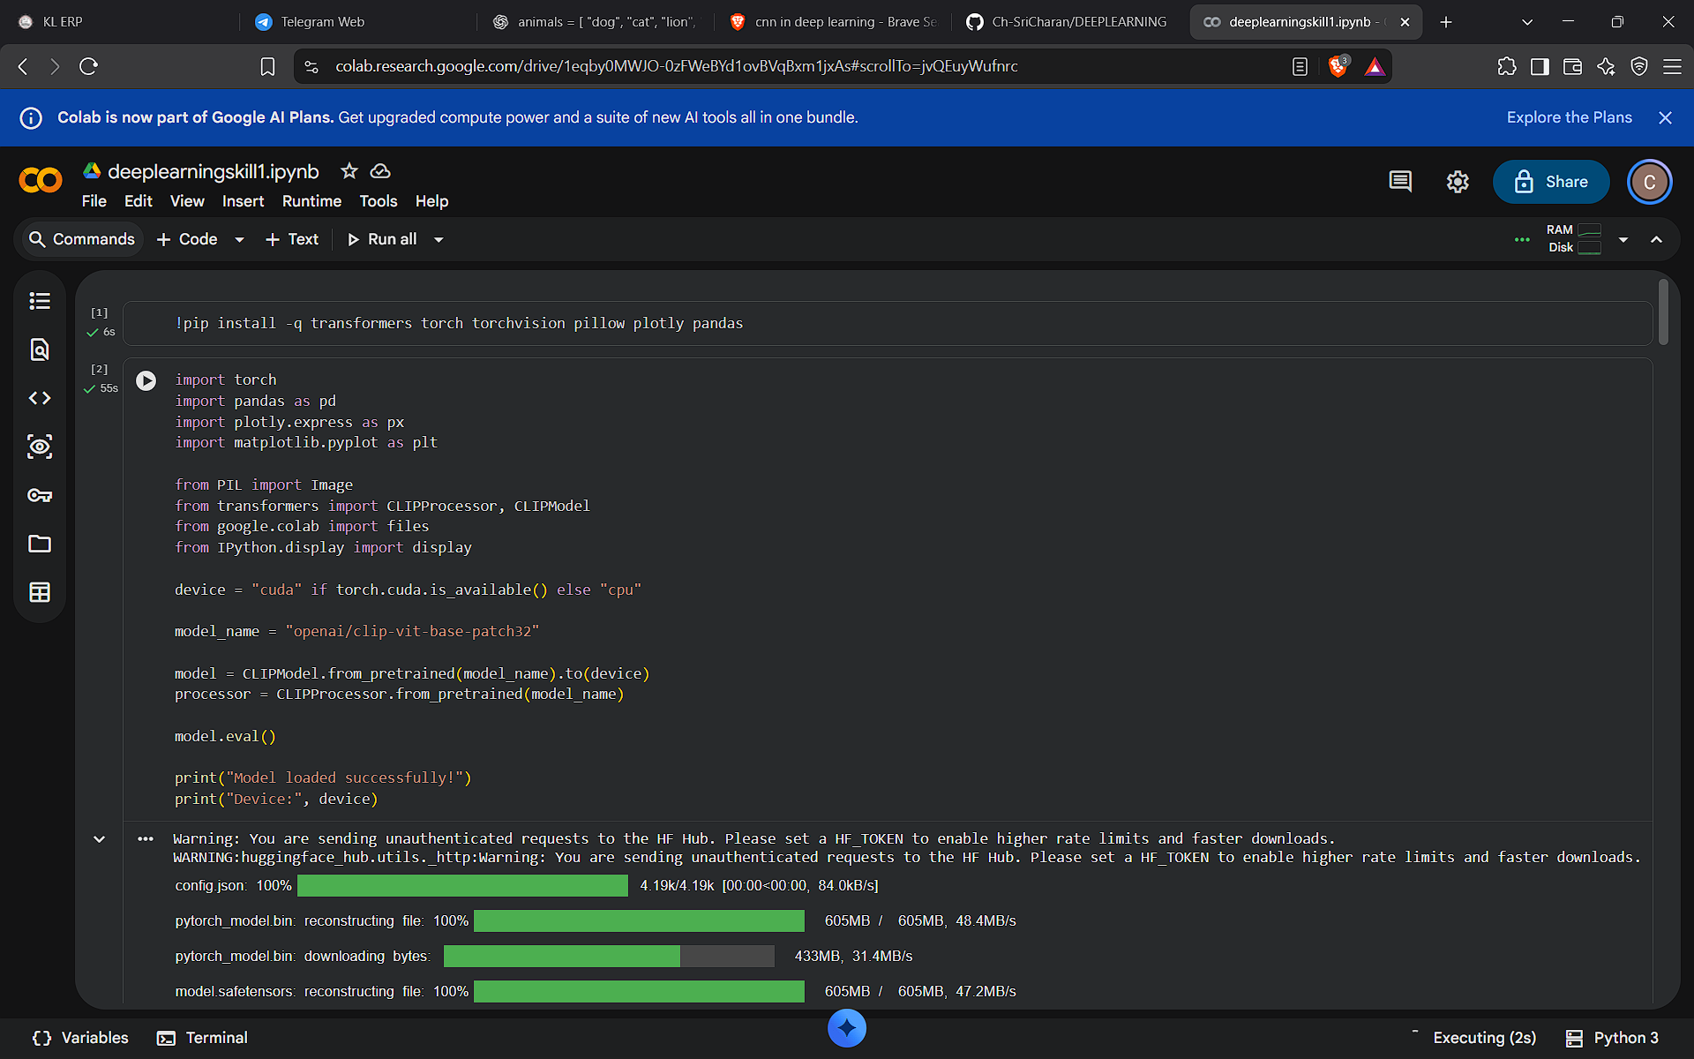

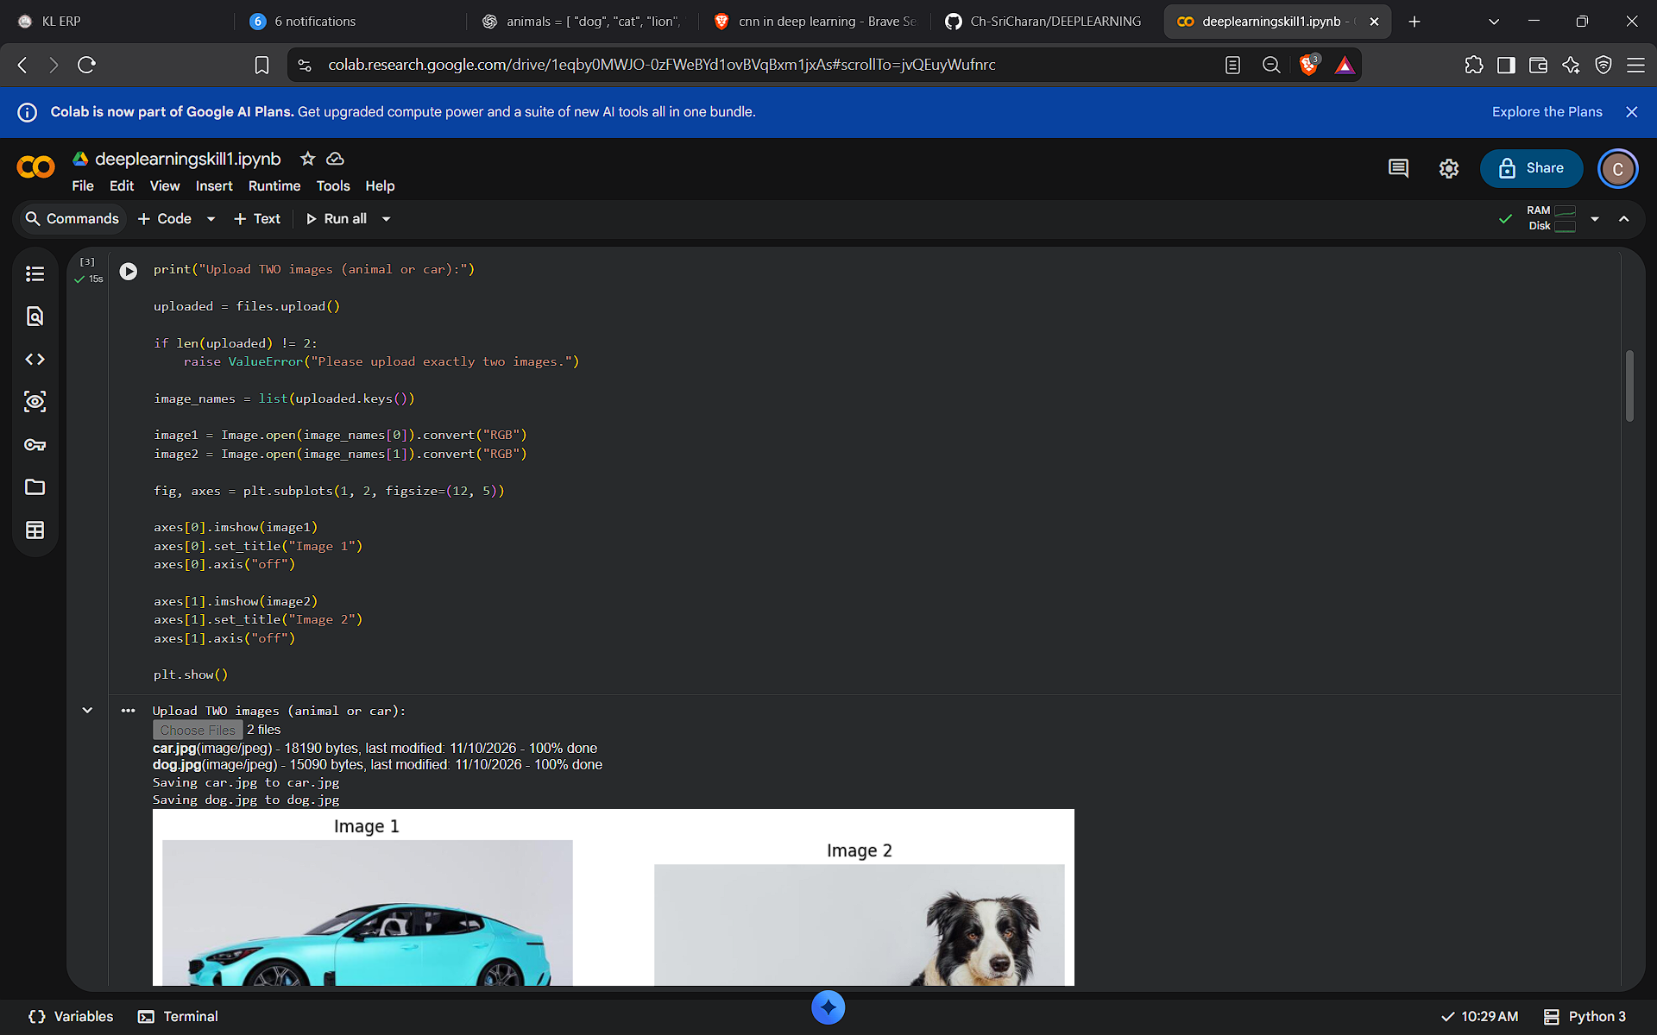

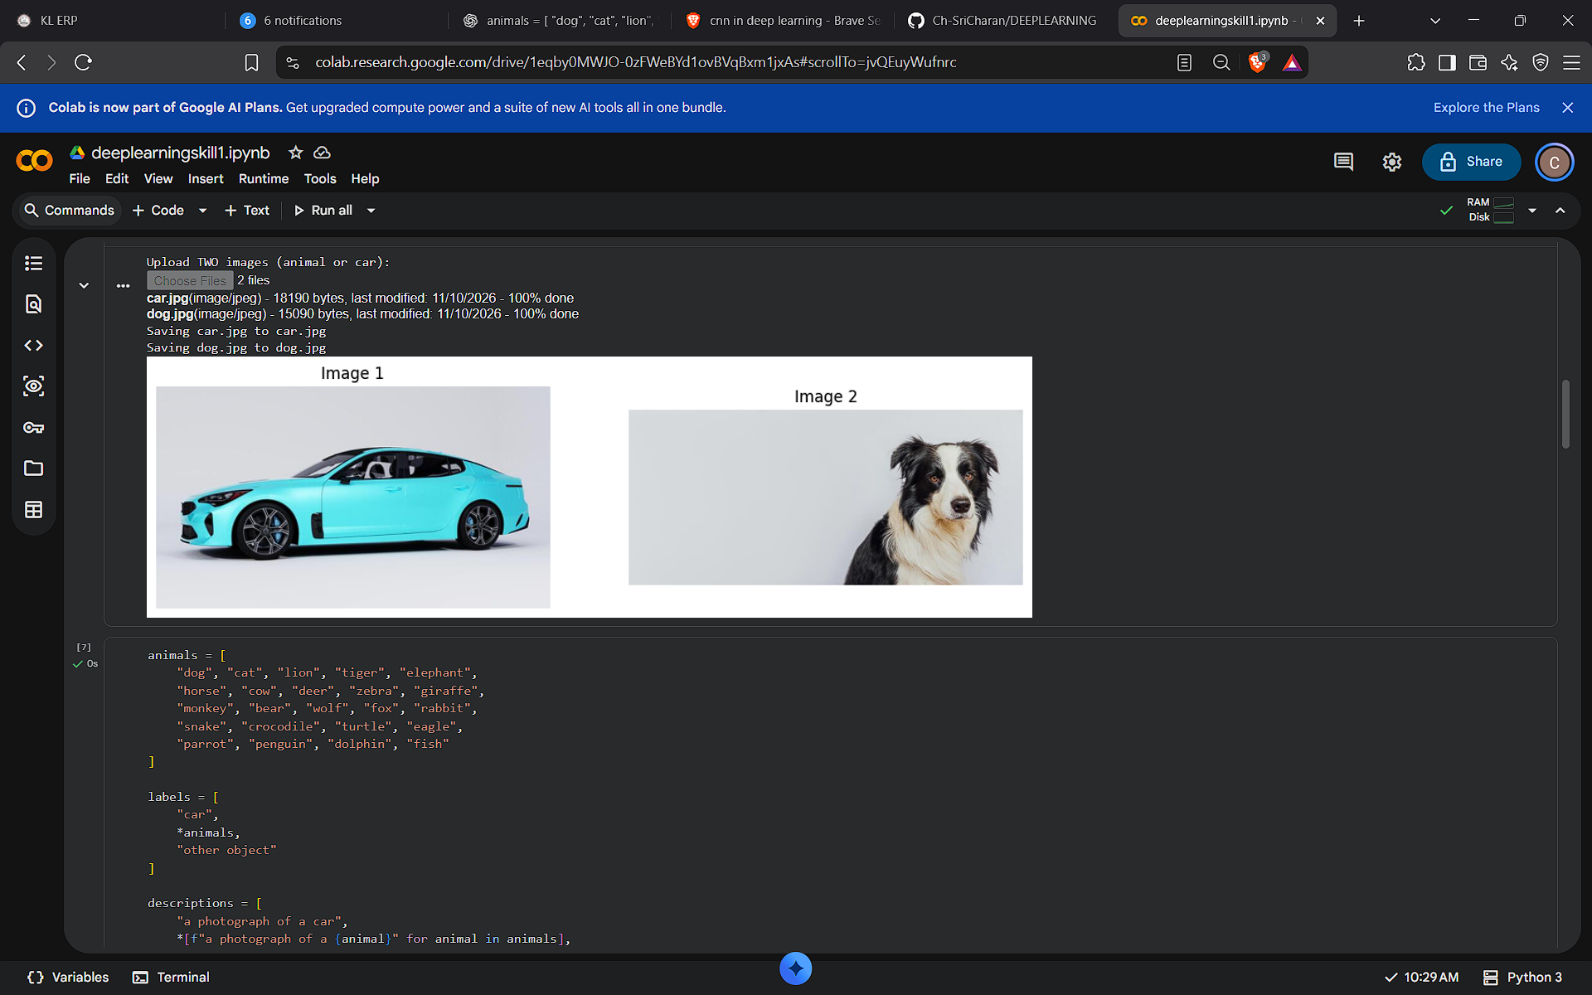

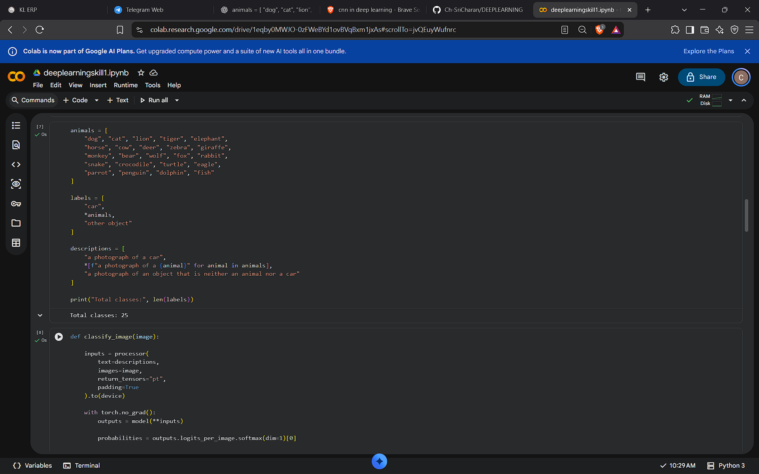

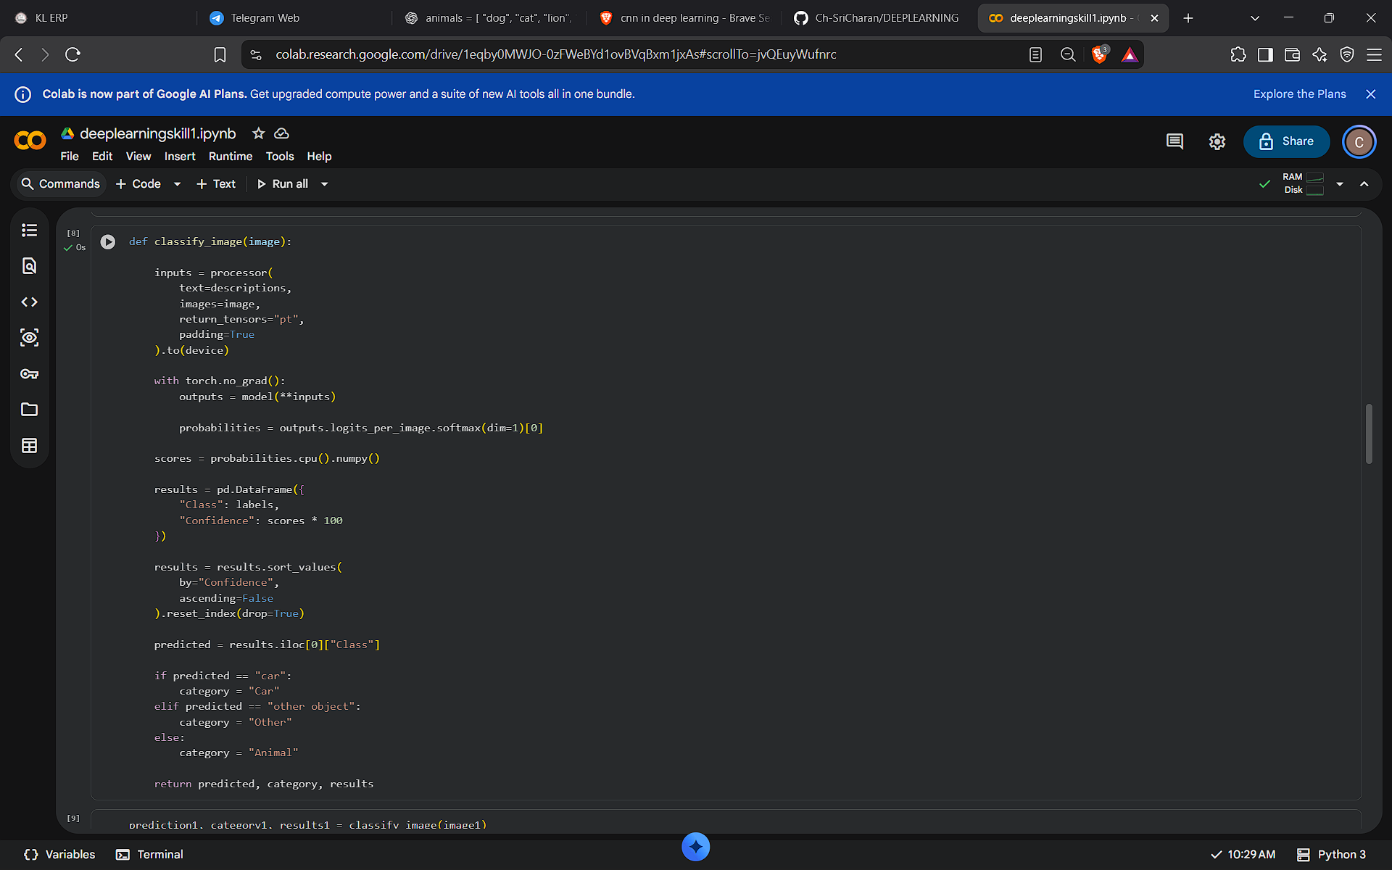




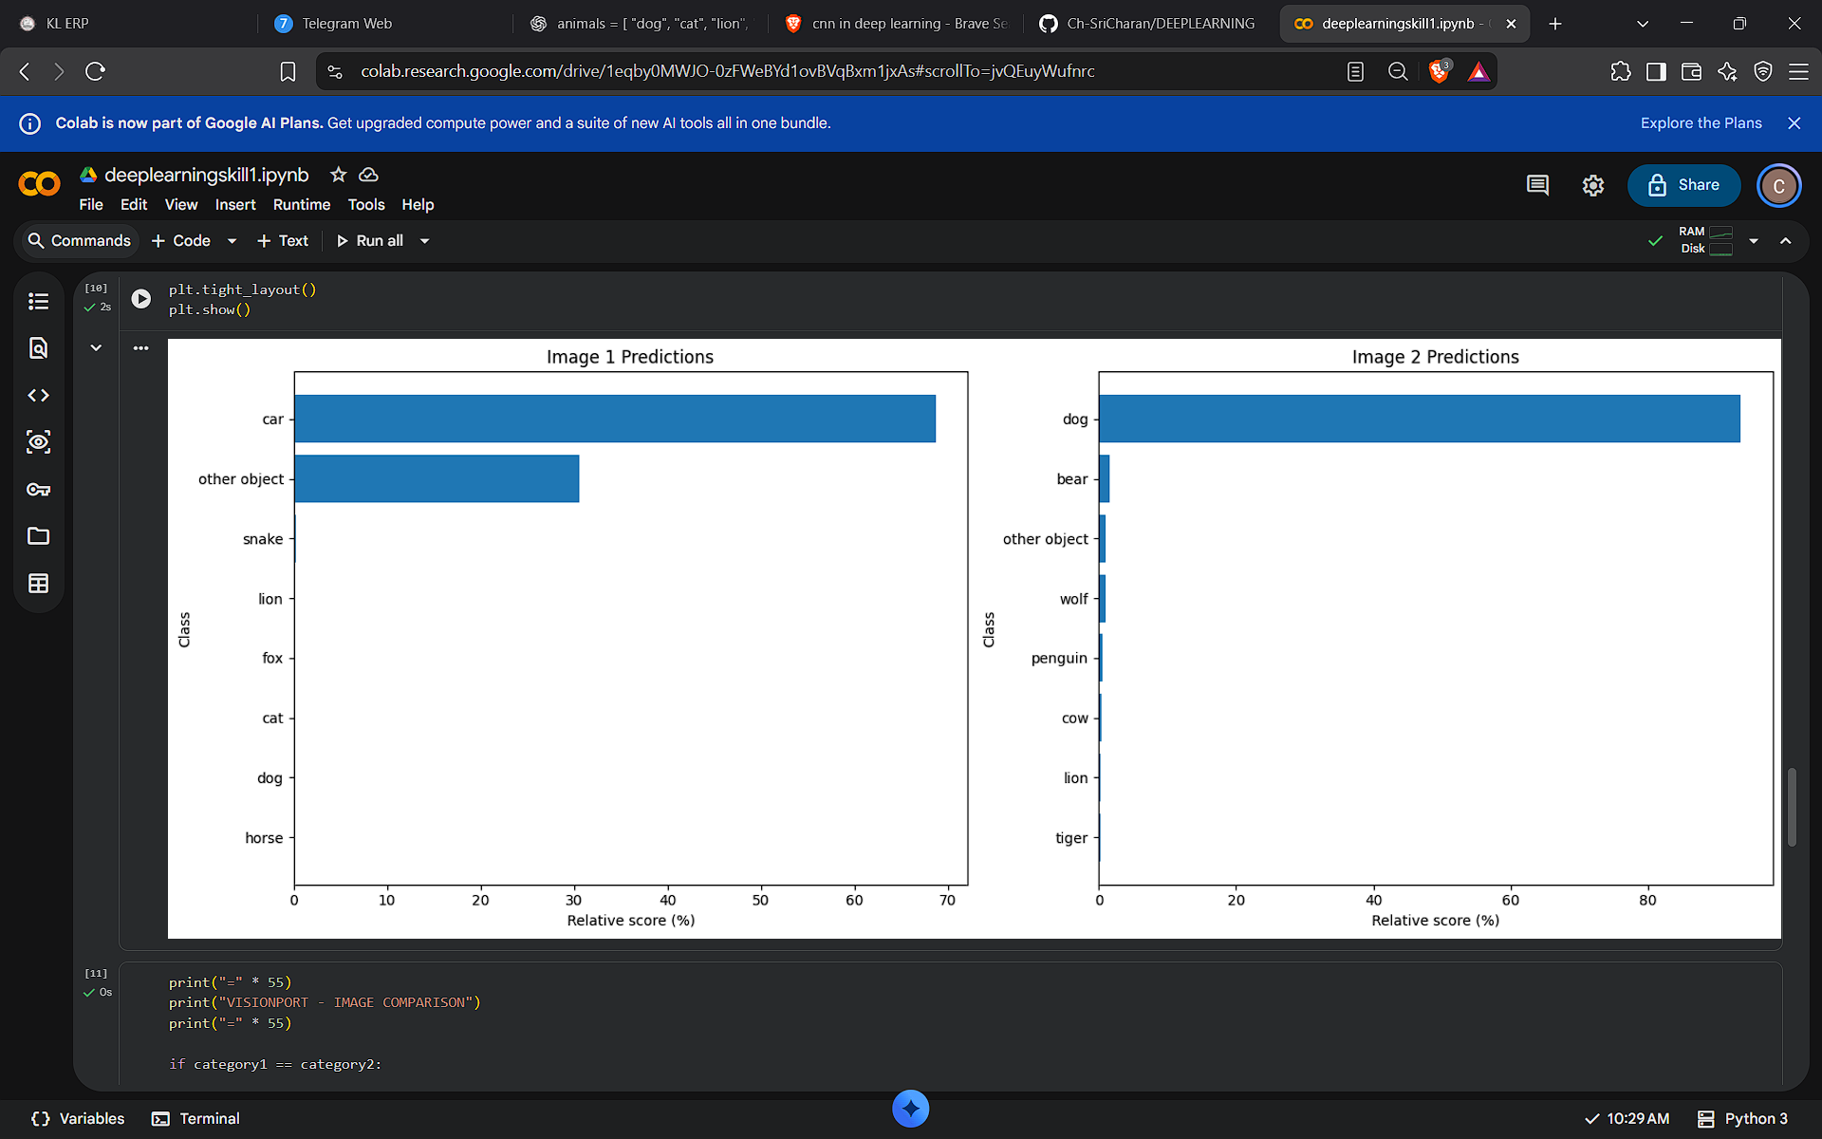




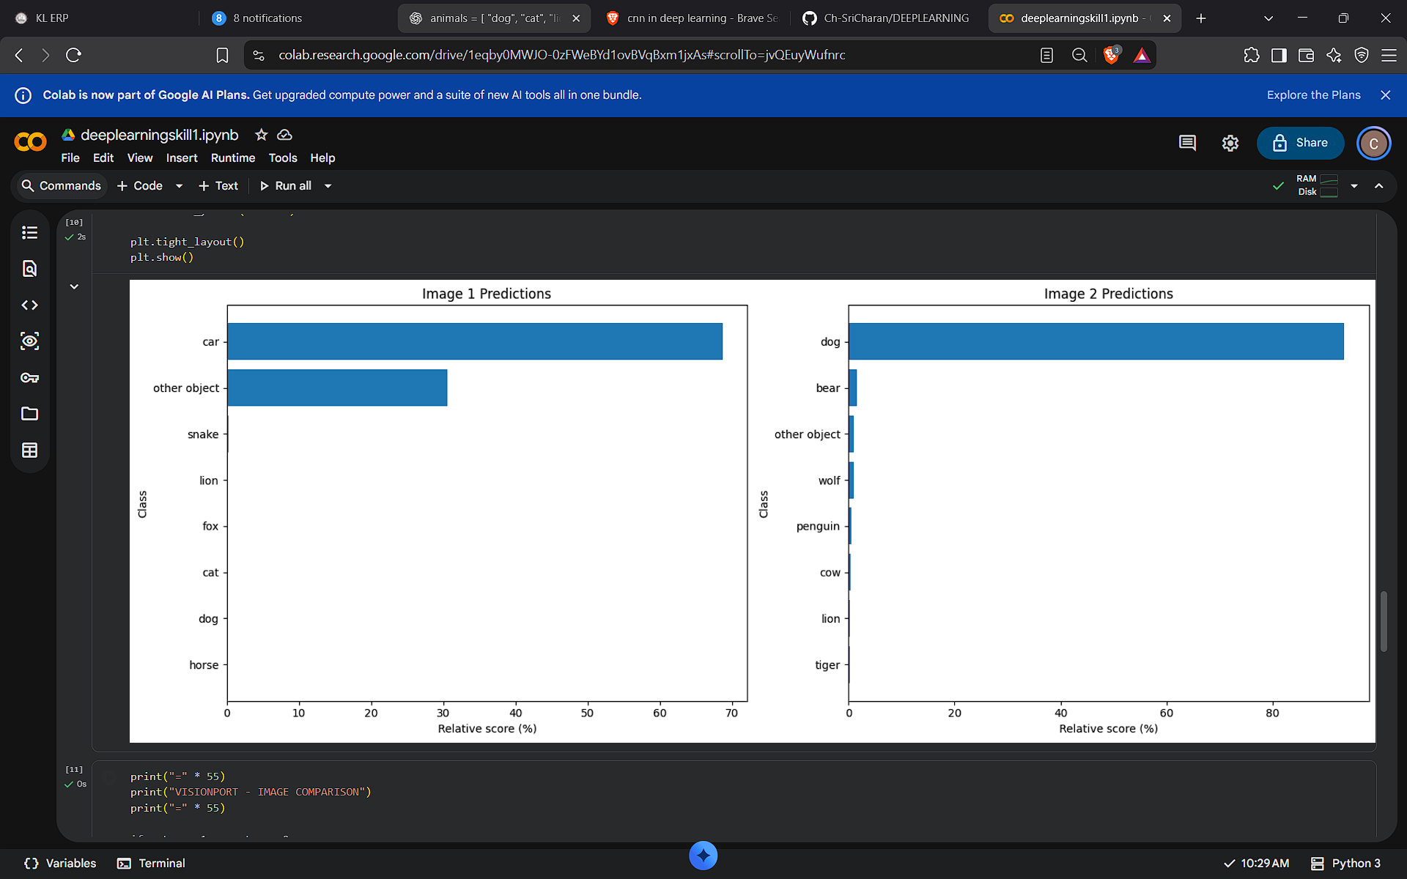



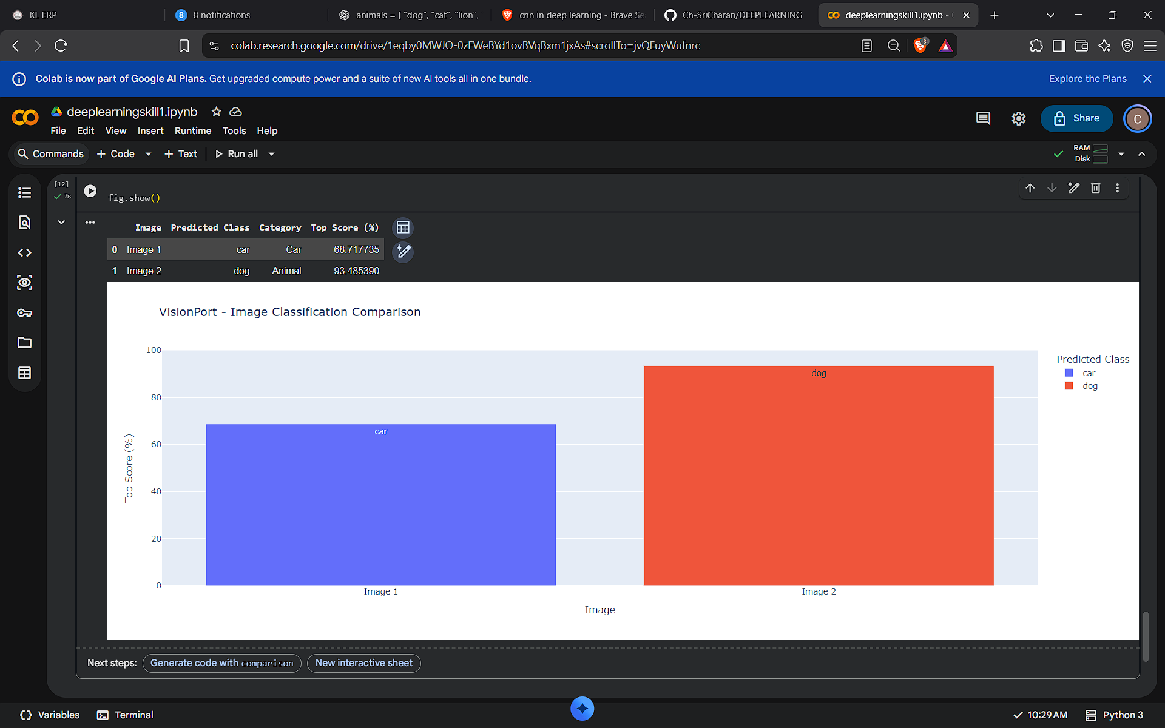

Code

!pip install -q transformers torch torchvision pillow plotly pandas
import torch
import pandas as pd
import plotly.express as px
import matplotlib.pyplot as plt

from PIL import Image
from transformers import CLIPProcessor, CLIPModel
from google.colab import files
from IPython.display import display

device = "cuda" if torch.cuda.is_available() else "cpu"

model_name = "openai/clip-vit-base-patch32"

model = CLIPModel.from_pretrained(model_name).to(device)
processor = CLIPProcessor.from_pretrained(model_name)

model.eval()

print("Model loaded successfully!")
print("Device:", device)
print("Upload TWO images (animal or car):")

uploaded = files.upload()

if len(uploaded) != 2:
raise ValueError("Please upload exactly two images.")

image_names = list(uploaded.keys())

image1 = Image.open(image_names[0]).convert("RGB")
image2 = Image.open(image_names[1]).convert("RGB")

fig, axes = plt.subplots(1, 2, figsize=(12, 5))

axes[0].imshow(image1)
axes[0].set_title("Image 1")
axes[0].axis("off")

axes[1].imshow(image2)
axes[1].set_title("Image 2")
axes[1].axis("off")

plt.show()
animals = [
"dog", "cat", "lion", "tiger", "elephant",
"horse", "cow", "deer", "zebra", "giraffe",
"monkey", "bear", "wolf", "fox", "rabbit",
"snake", "crocodile", "turtle", "eagle",
"parrot", "penguin", "dolphin", "fish"
]

labels = [
"car",
*animals,
"other object"
]

descriptions = [
"a photograph of a car",
*[f"a photograph of a {animal}" for animal in animals],
"a photograph of an object that is neither an animal nor a car"
]

print("Total classes:", len(labels))
def classify_image(image):

inputs = processor(
text=descriptions,
images=image,
return_tensors="pt",
padding=True
).to(device)

with torch.no_grad():
outputs = model(**inputs)

probabilities = outputs.logits_per_image.softmax(dim=1)[0]

scores = probabilities.cpu().numpy()

results = pd.DataFrame({
"Class": labels,
"Confidence": scores * 100
})

results = results.sort_values(
by="Confidence",
ascending=False
).reset_index(drop=True)

predicted = results.iloc[0]["Class"]

if predicted == "car":
category = "Car"
elif predicted == "other object":
category = "Other"
else:
category = "Animal"

return predicted, category, results

prediction1, category1, results1 = classify_image(image1)
prediction2, category2, results2 = classify_image(image2)

print("=" * 50)
print("IMAGE 1 RESULTS")
print("=" * 50)

print("Category:", category1)
print("Detected:", prediction1)

display(results1.head(8))

print("=" * 50)
print("IMAGE 2 RESULTS")
print("=" * 50)

print("Category:", category2)
print("Detected:", prediction2)

display(results2.head(8))
fig, axes = plt.subplots(1, 2, figsize=(16, 6))

for ax, results, title in [
(axes[0], results1, "Image 1 Predictions"),
(axes[1], results2, "Image 2 Predictions")
]:

top = results.head(8).sort_values("Confidence")

ax.barh(top["Class"], top["Confidence"])

ax.set_title(title)
ax.set_xlabel("Relative score (%)")
ax.set_ylabel("Class")

plt.tight_layout()
plt.show()
print("=" * 55)
print("VISIONPORT - IMAGE COMPARISON")
print("=" * 55)

if category1 == category2:

if category1 == "Animal":

if prediction1 == prediction2:
print("RESULT: SAME ANIMAL")
print(f"Both images contain: {prediction1}")

else:
print("RESULT: DIFFERENT ANIMALS")
print(f"Image 1: {prediction1}")
print(f"Image 2: {prediction2}")

elif category1 == "Car":
print("RESULT: BOTH IMAGES CONTAIN CARS")

else:
print("RESULT: BOTH IMAGES CONTAIN OTHER OBJECTS")

else:

print("RESULT: DIFFERENT CATEGORIES")
print(f"Image 1: {category1} ({prediction1})")
print(f"Image 2: {category2} ({prediction2})")
comparison = pd.DataFrame({
"Image": ["Image 1", "Image 2"],
"Predicted Class": [prediction1, prediction2],
"Category": [category1, category2],
"Top Score (%)": [
results1.iloc[0]["Confidence"],
results2.iloc[0]["Confidence"]
]
})

display(comparison)

fig = px.bar(
comparison,
x="Image",
y="Top Score (%)",
color="Predicted Class",
text="Predicted Class",
title="VisionPort - Image Classification Comparison",
range_y=[0, 100]
)

fig.show()

