SKILL3:
2520090019
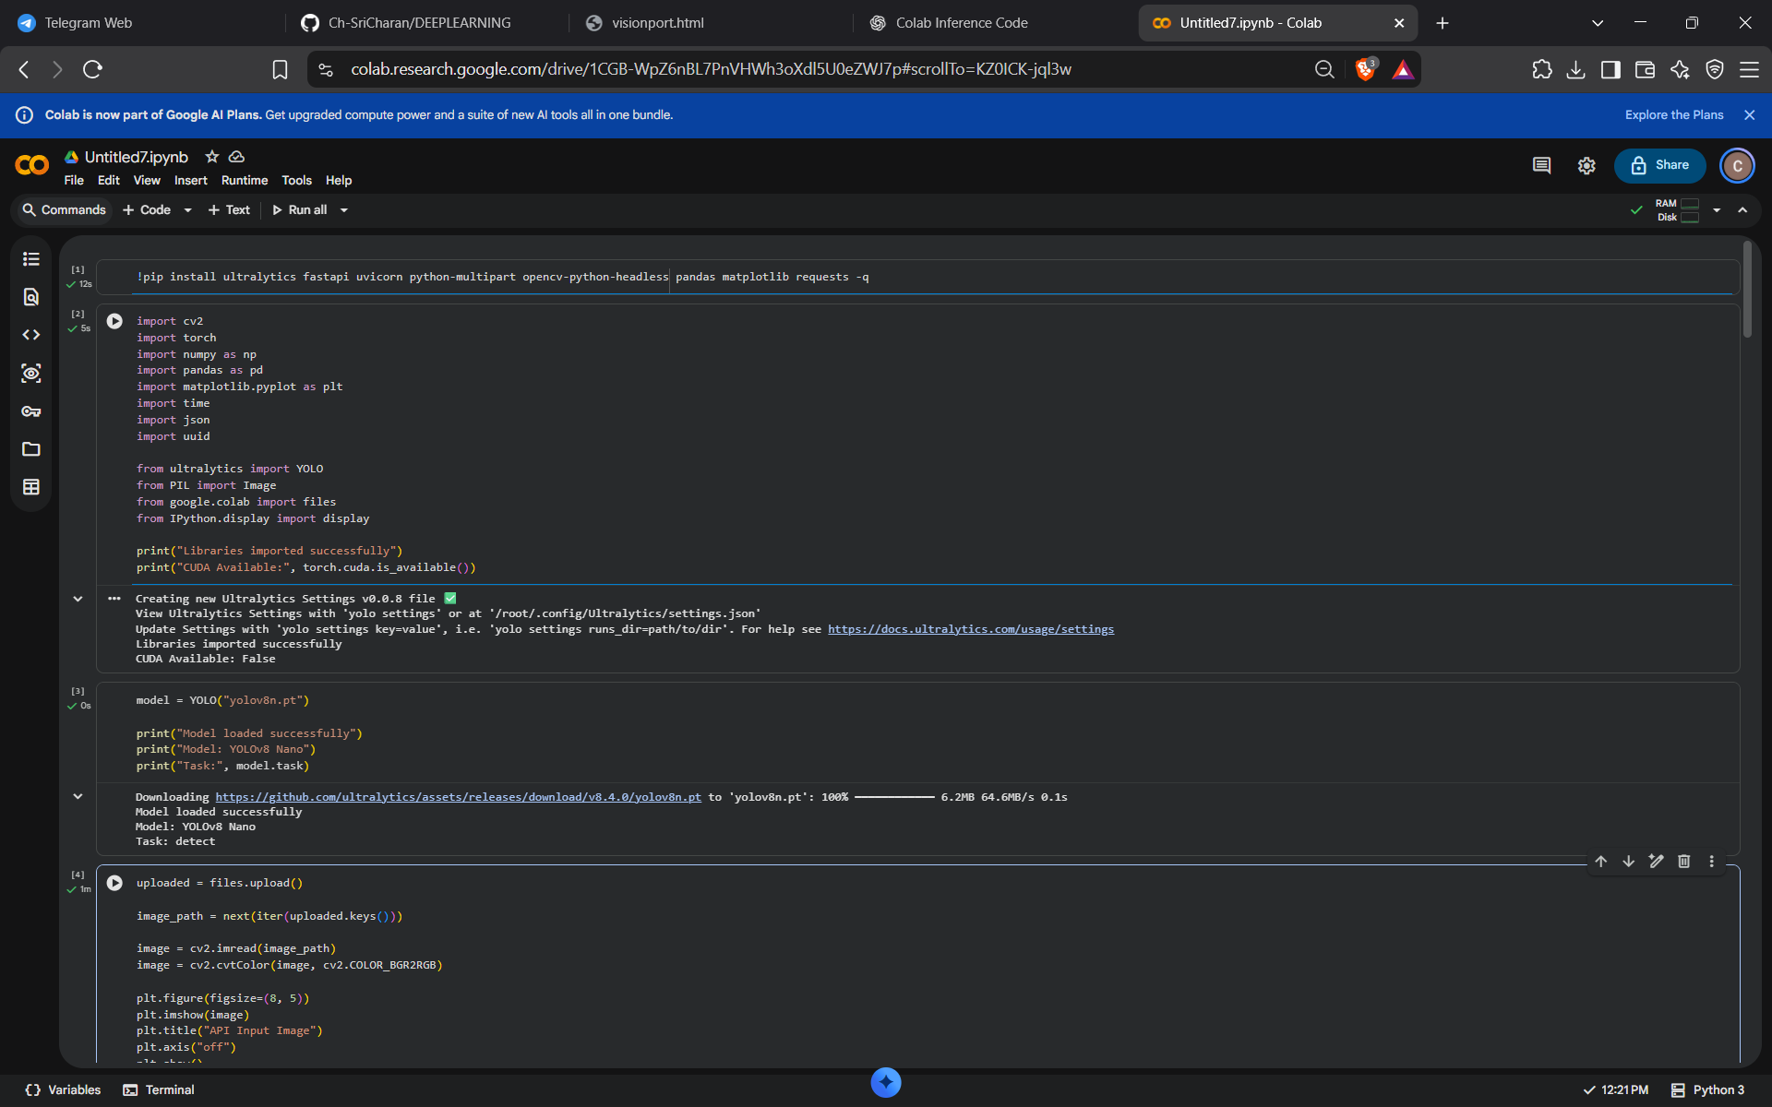

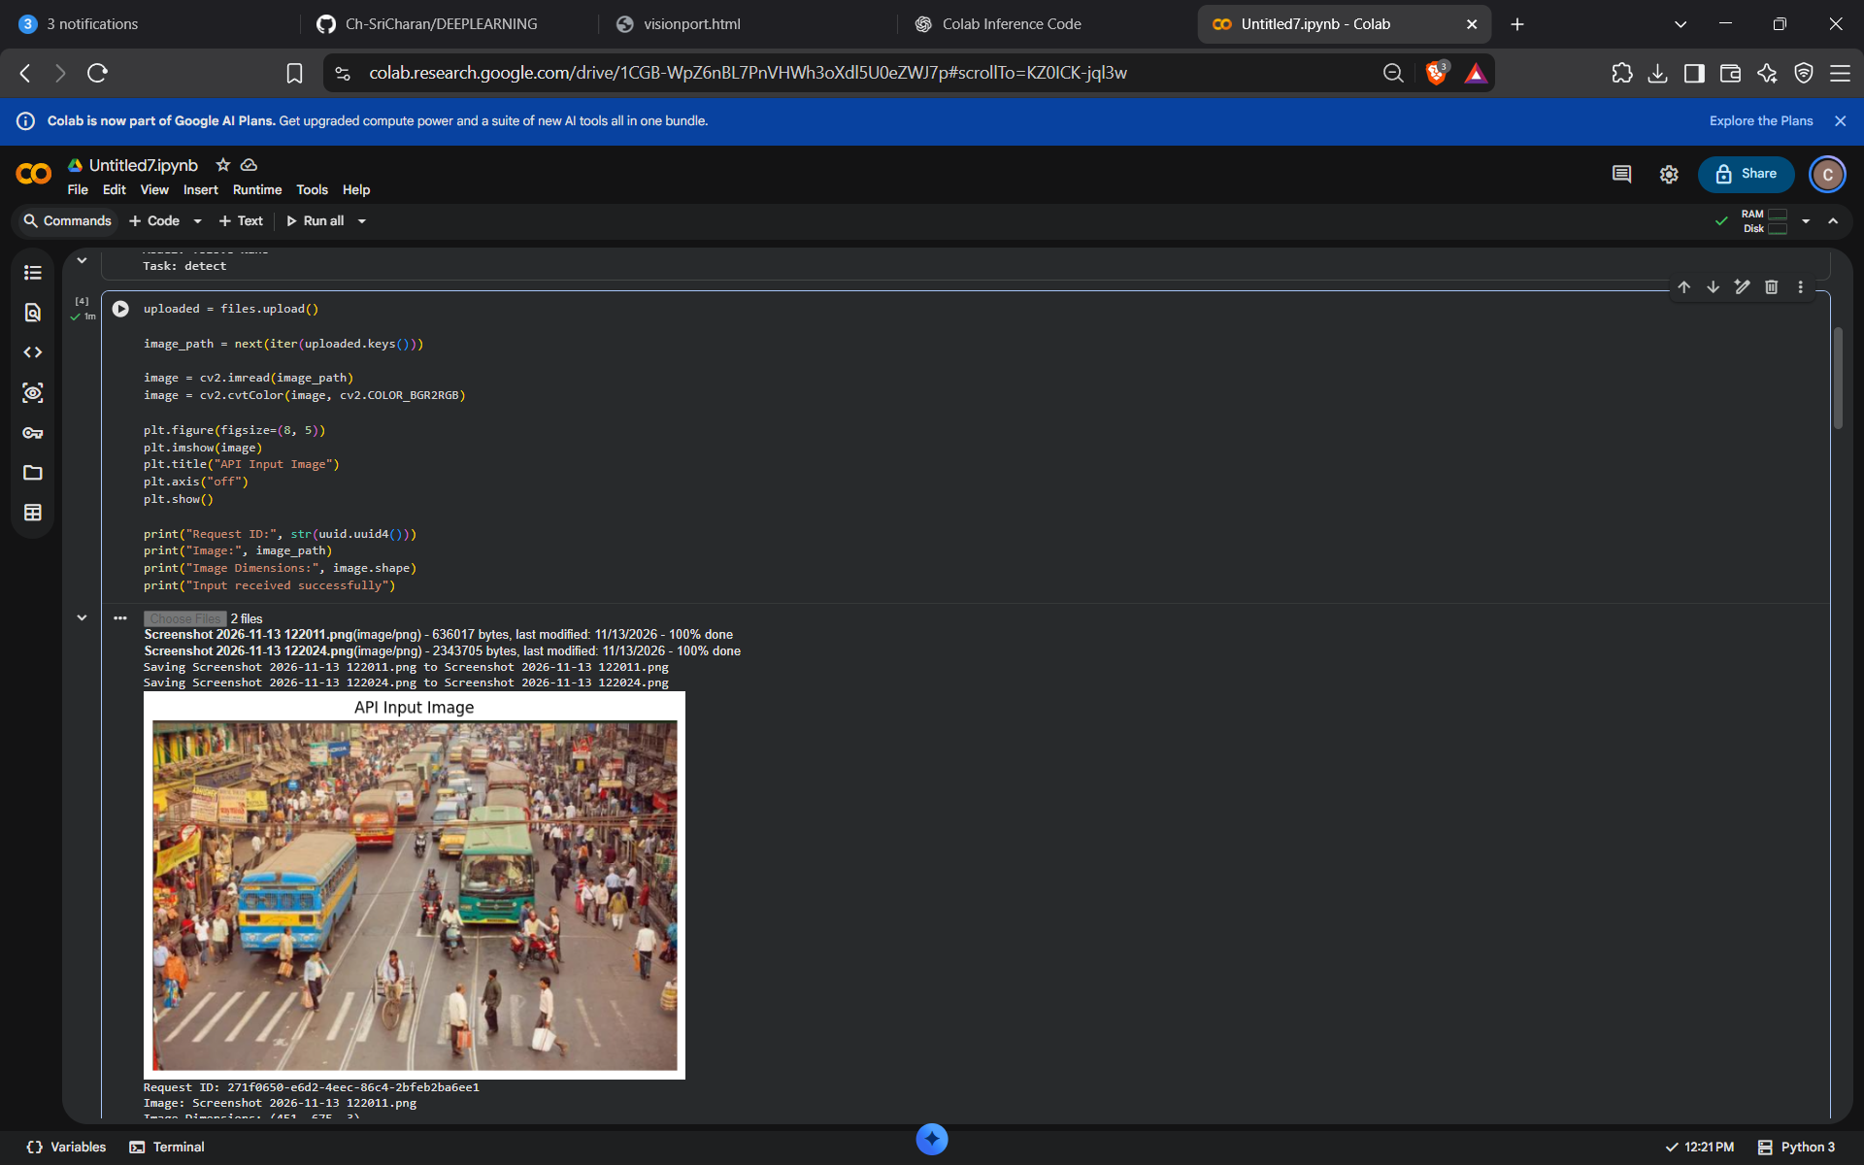

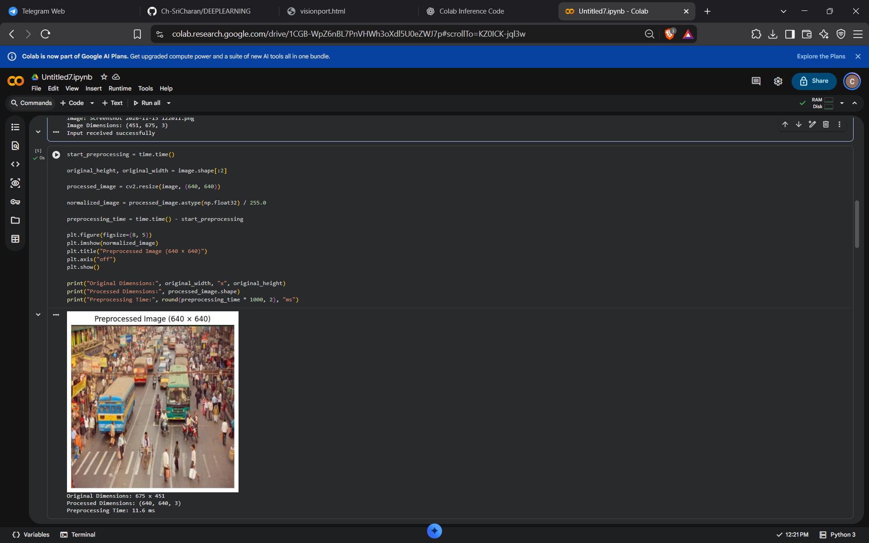

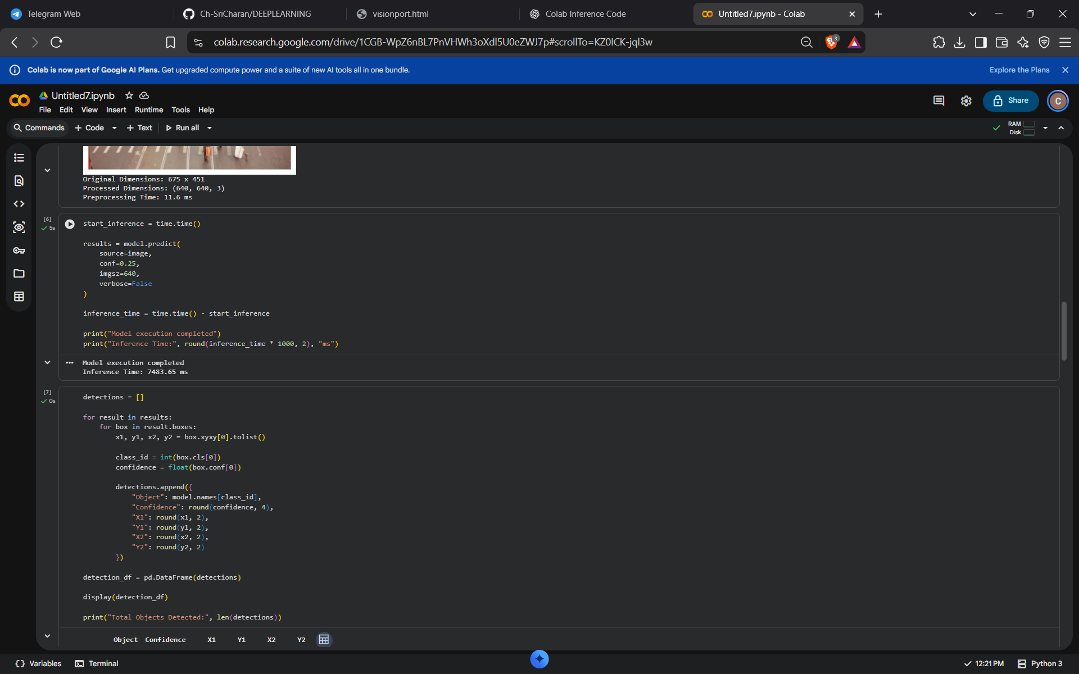

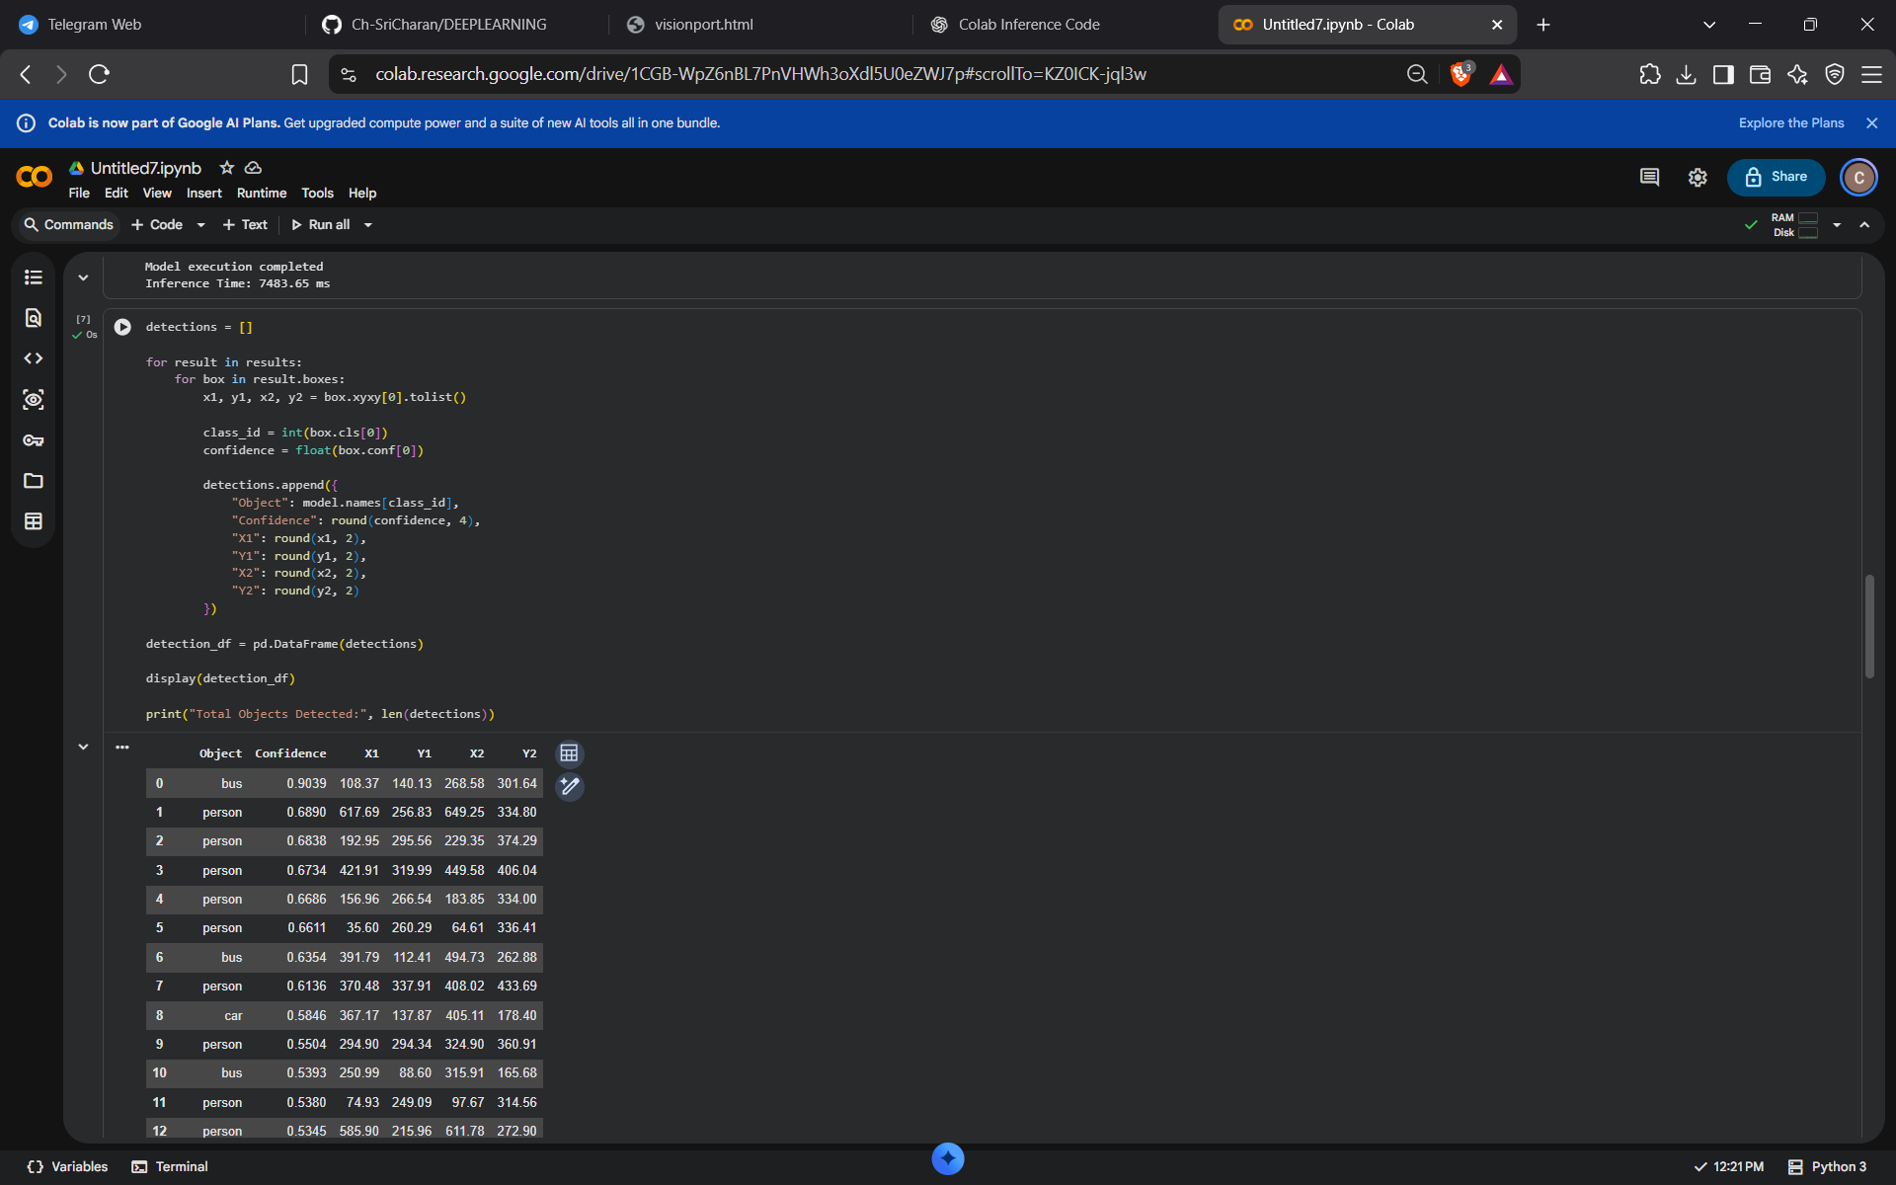

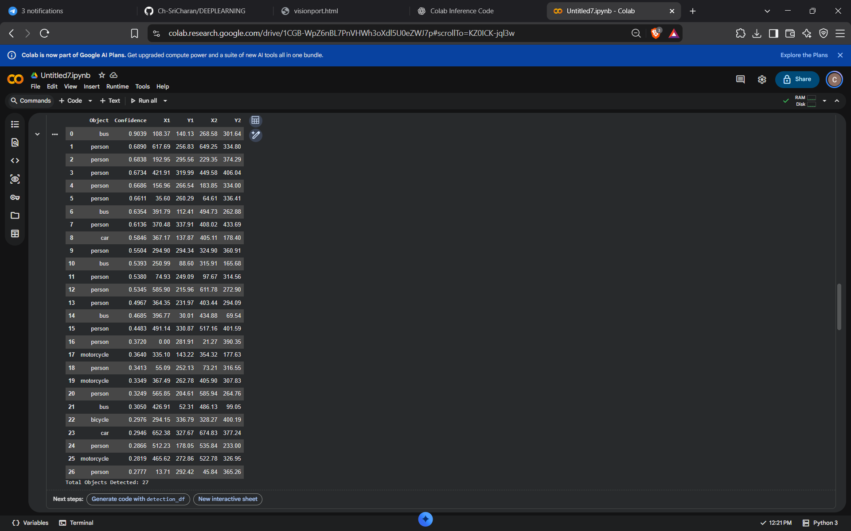

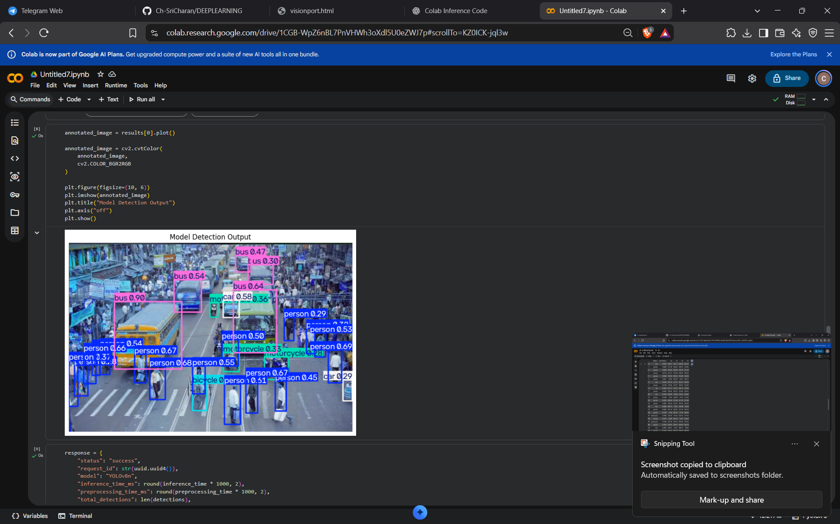

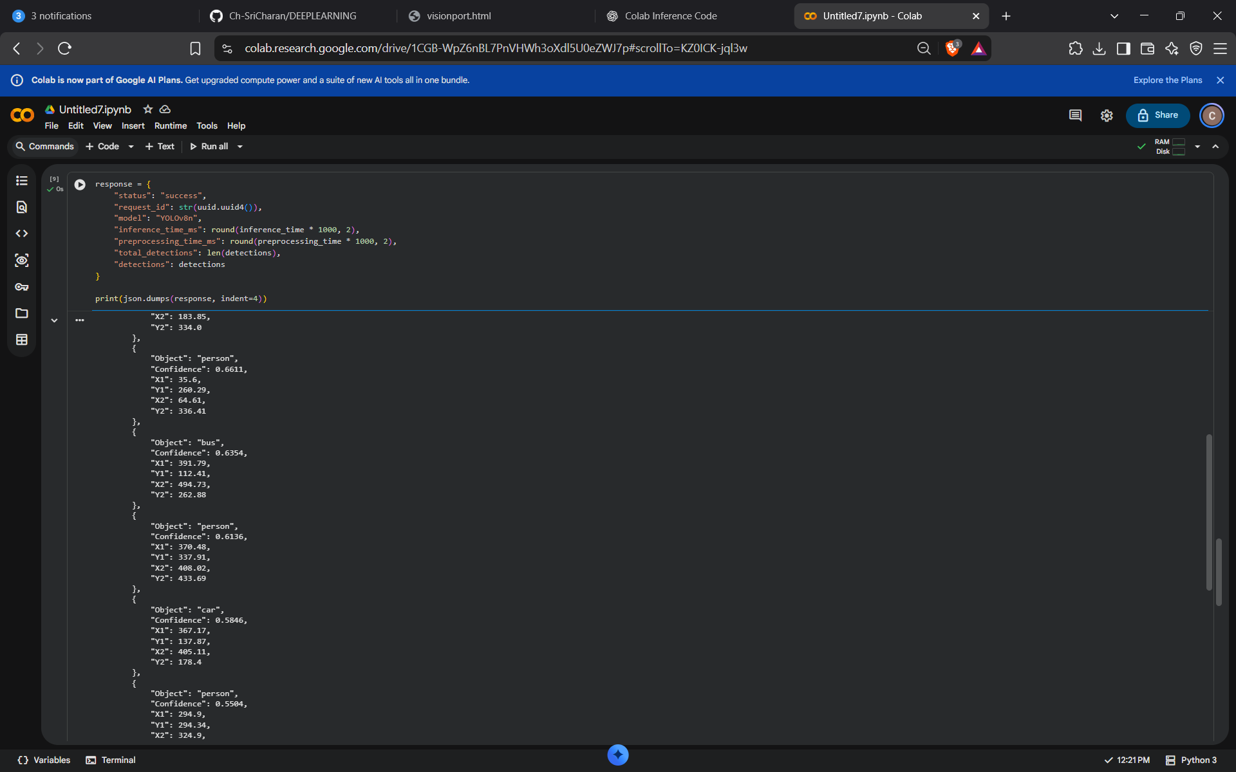

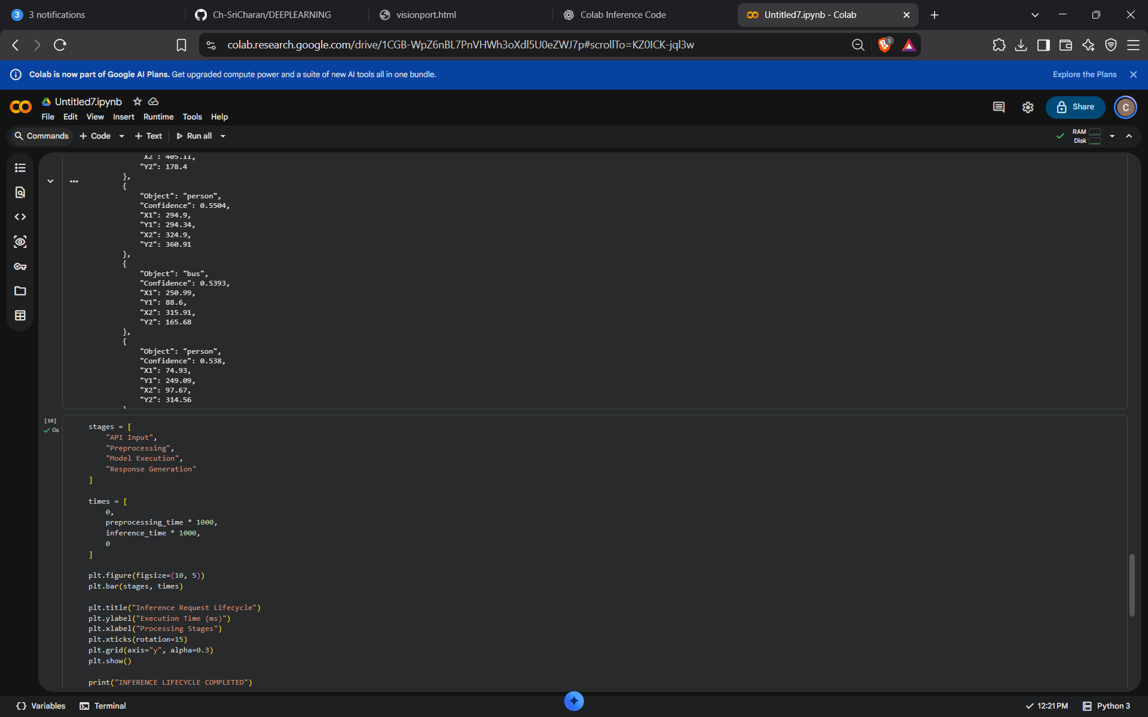

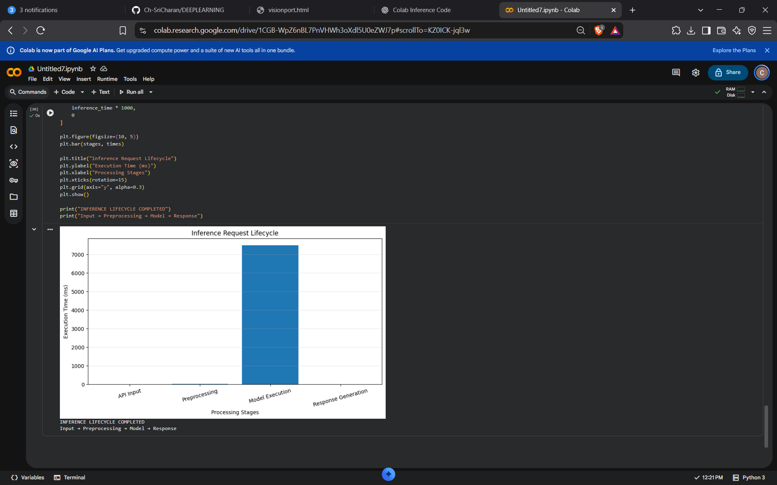

# ============================================================
# VISIONPORT - INFERENCE REQUEST TRACE
# API INPUT -> PREPROCESSING -> MODEL EXECUTION -> RESPONSE
# ============================================================

# 1. INSTALL DEPENDENCIES
!pip install ultralytics opencv-python-headless pandas matplotlib -q

# 2. IMPORT LIBRARIES
import cv2
import torch
import numpy as np
import pandas as pd
import matplotlib.pyplot as plt
import time
import json
import uuid

from ultralytics import YOLO
from google.colab import files
from IPython.display import display

print("\n========== VISIONPORT INFERENCE SYSTEM ==========\n")

# 3. LOAD MODEL
print("[1] Loading YOLO Model...")

model = YOLO("yolov8n.pt")

print("Model loaded successfully!")
print("Model:", "YOLOv8 Nano")
print("Task:", model.task)
print("Device:", "GPU" if torch.cuda.is_available() else "CPU")

# 4. API INPUT
print("\n[2] API INPUT - Upload an image")

uploaded = files.upload()

if not uploaded:
raise ValueError("No image uploaded!")

image_path = next(iter(uploaded.keys()))

image = cv2.imread(image_path)

if image is None:
raise ValueError("Invalid image. Upload a JPG or PNG file.")

image = cv2.cvtColor(image, cv2.COLOR_BGR2RGB)

request_id = str(uuid.uuid4())

print("\nAPI Request Received")
print("Request ID:", request_id)
print("Image:", image_path)
print("Image Dimensions:", image.shape)

plt.figure(figsize=(8, 5))
plt.imshow(image)
plt.title("API Input Image")
plt.axis("off")
plt.show()

# 5. PREPROCESSING
print("\n[3] PREPROCESSING")

start_preprocessing = time.time()

original_height, original_width = image.shape[:2]

# Demonstration of resizing
processed_image = cv2.resize(image, (640, 640))

# Normalize pixel values for demonstration
normalized_image = processed_image.astype(np.float32) / 255.0

preprocessing_time = time.time() - start_preprocessing

print("Original Size:", original_width, "x", original_height)
print("Processed Size:", 640, "x", 640)
print("Normalization: Pixel values scaled between 0 and 1")
print("Preprocessing Time:",
round(preprocessing_time * 1000, 2), "ms")

plt.figure(figsize=(7, 5))
plt.imshow(normalized_image)
plt.title("Preprocessed Image")
plt.axis("off")
plt.show()

# 6. MODEL EXECUTION
print("\n[4] MODEL EXECUTION")

start_inference = time.time()

results = model.predict(
source=image,
conf=0.25,
imgsz=640,
verbose=False
)

inference_time = time.time() - start_inference

print("Model execution completed!")
print("Inference Time:",
round(inference_time * 1000, 2), "ms")

# 7. EXTRACT DETECTIONS
print("\n[5] EXTRACTING DETECTIONS")

detections = []

for result in results:
for box in result.boxes:

x1, y1, x2, y2 = box.xyxy[0].tolist()

class_id = int(box.cls[0])
confidence = float(box.conf[0])

detections.append({
"Object": model.names[class_id],
"Confidence": round(confidence, 4),
"X1": round(x1, 2),
"Y1": round(y1, 2),
"X2": round(x2, 2),
"Y2": round(y2, 2)
})

detection_df = pd.DataFrame(
detections,
columns=["Object", "Confidence", "X1", "Y1", "X2", "Y2"]
)

print("Total Objects Detected:", len(detections))

display(detection_df)

# 8. VISUALIZE DETECTION RESULTS
print("\n[6] DETECTION VISUALIZATION")

annotated_image = results[0].plot()

annotated_image = cv2.cvtColor(
annotated_image,
cv2.COLOR_BGR2RGB
)

plt.figure(figsize=(10, 7))
plt.imshow(annotated_image)
plt.title("VisionPort - Object Detection Output")
plt.axis("off")
plt.show()

# 9. GENERATE API RESPONSE
print("\n[7] GENERATING API RESPONSE")

response = {
"status": "success",
"request_id": request_id,
"model": "YOLOv8n",
"input_image": image_path,
"image_dimensions": {
"width": original_width,
"height": original_height
},
"preprocessing_time_ms": round(
preprocessing_time * 1000, 2
),
"inference_time_ms": round(
inference_time * 1000, 2
),
"total_detections": len(detections),
"detections": detections
}

print(json.dumps(response, indent=4))

# 10. INFERENCE LIFECYCLE SUMMARY
print("\n[8] INFERENCE REQUEST TRACE")

stages = [
"API Input",
"Preprocessing",
"Model Execution",
"Response"
]

stage_times = [
0,
preprocessing_time * 1000,
inference_time * 1000,
0
]

plt.figure(figsize=(10, 5))
plt.bar(stages, stage_times)
plt.title("Inference Request Lifecycle")
plt.xlabel("Processing Stages")
plt.ylabel("Execution Time (ms)")
plt.grid(axis="y", alpha=0.3)
plt.show()

# 11. FINAL SUMMARY
print("\n========== FINAL INFERENCE SUMMARY ==========")

print("Request ID:", request_id)
print("Model: YOLOv8 Nano")
print("Input Image:", image_path)
print("Objects Detected:", len(detections))
print("Preprocessing Time:",
round(preprocessing_time * 1000, 2), "ms")
print("Inference Time:",
round(inference_time * 1000, 2), "ms")

print("\nAPI INPUT")
print(" |")
print(" v")
print("PREPROCESSING")
print(" |")
print(" v")
print("MODEL EXECUTION")
print(" |")
print(" v")
print("API RESPONSE")
print("\nVISIONPORT INFERENCE TRACE COMPLETED SUCCESSFULLY!")

