SKILL3:
Cmdhis.c:
#include <stdio.h>
#include <string.h>

#define MAX_HISTORY 10
#define MAX_COMMAND_LENGTH 100

int main() {
char history[MAX_HISTORY][MAX_COMMAND_LENGTH];
int count = 0;
int current = 0;
char input[MAX_COMMAND_LENGTH];

printf("Command History System\n");
printf("Enter commands.\n");
printf("Type 'p' for Previous, 'n' for Next, 'q' to Quit.\n\n");

while (1) {
printf("Input: ");
fgets(input, sizeof(input), stdin);

input[strcspn(input, "\n")] = '\0';

if (strcmp(input, "q") == 0) {
break;
}

/* Navigate Previous Command */
if (strcmp(input, "p") == 0) {
if (count > 0 && current > 0) {
current--;
printf("\033[1;33mPrevious Command: %s\033[0m\n",
history[current]);
} else {
printf("No previous command available.\n");
}
}

/* Navigate Next Command */
else if (strcmp(input, "n") == 0) {
if (count > 0 && current < count - 1) {
current++;
printf("\033[1;32mNext Command: %s\033[0m\n",
history[current]);
} else {
printf("No next command available.\n");
}
}

/* Store Command History */
else {
if (count < MAX_HISTORY) {
strcpy(history[count], input);
count++;
} else {
/* Shift history when buffer is full */
for (int i = 0; i < MAX_HISTORY - 1; i++) {
strcpy(history[i], history[i + 1]);
}
strcpy(history[MAX_HISTORY - 1], input);
}

current = count;
printf("\033[1;36mCommand Stored Successfully!\033[0m\n");
}
}

printf("\nCommand History:\n");
for (int i = 0; i < count; i++) {
printf("%d. %s\n", i + 1, history[i]);
}

return 0;
}

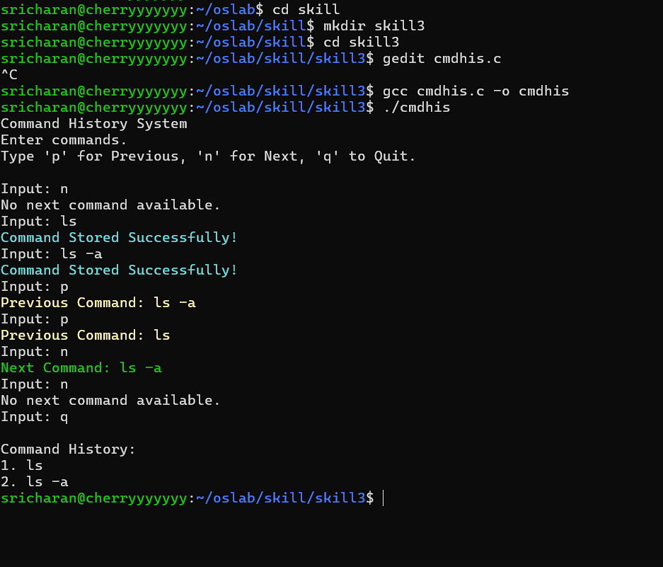

DYNAMICALLOC.c:
#include <stdio.h>
#include <stdlib.h>
#include <string.h>

#define BUFFER_SIZE 100

struct Node {
int data;
struct Node *next;
};

/* Add node to linked list */
struct Node* addNode(struct Node *head, int value) {
struct Node *newNode =
(struct Node *)malloc(sizeof(struct Node));

if (newNode == NULL) {
printf("Memory allocation failed!\n");
return head;
}

newNode->data = value;
newNode->next = head;

return newNode;
}

/* Display linked list */
void displayList(struct Node *head) {
printf("Linked List: ");

while (head != NULL) {
printf("%d -> ", head->data);
head = head->next;
}

printf("NULL\n");
}

/* Free linked list memory */
void freeList(struct Node *head) {
struct Node *temp;

while (head != NULL) {
temp = head;
head = head->next;
free(temp);
}
}

int main() {
int size = 3;
int newSize = 6;

/* Dynamic memory allocation */
int *array = (int *)malloc(size * sizeof(int));

if (array == NULL) {
printf("Memory allocation failed!\n");
return 1;
}

printf("Enter %d integers:\n", size);

for (int i = 0; i < size; i++) {
scanf("%d", &array[i]);
}

/* Resize array dynamically */
int *temp = realloc(array, newSize * sizeof(int));

if (temp == NULL) {
printf("Memory resizing failed!\n");
free(array);
return 1;
}

array = temp;

printf("\nArray resized from %d to %d elements.\n",
size, newSize);

for (int i = size; i < newSize; i++) {
array[i] = 0;
}

printf("Array Elements:\n");
for (int i = 0; i < newSize; i++) {
printf("%d ", array[i]);
}

/* Prevent buffer overflow */
char buffer[BUFFER_SIZE];
getchar();

printf("\n\nEnter a text safely: ");
fgets(buffer, sizeof(buffer), stdin);

buffer[strcspn(buffer, "\n")] = '\0';

printf("You entered: %s\n", buffer);

/* Linked list operations */
struct Node *head = NULL;

head = addNode(head, 30);
head = addNode(head, 20);
head = addNode(head, 10);

displayList(head);

/* Release dynamically allocated memory */
free(array);
freeList(head);

printf("\nMemory released successfully.\n");

return 0;
}
