PRACTICAL 1:
#include <stdio.h>
int main()
{
char cmd[50];

printf("Enter Linux Command: ");
scanf("%s", cmd);

printf("You entered: %s\n", cmd);

return 0;
}
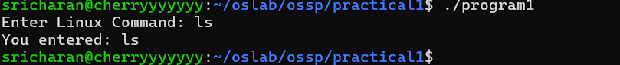

#include <stdio.h>
#include <unistd.h>

int main()
{
fork();

printf("Hello\n");

return 0;
}
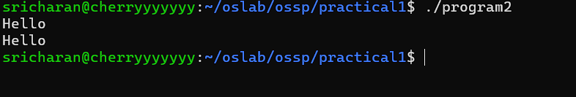

#include <stdio.h>
#include <unistd.h>

int main()
{
pid_t pid = fork();

if (pid == 0)
{
printf("Child executing ls...\n");
execl("/bin/ls", "ls", "-l", NULL);
}
else
{
printf("Parent Process\n");
}

return 0;
}

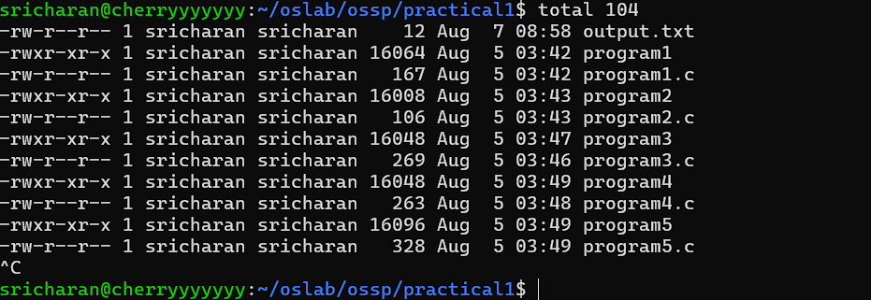
#include <stdio.h>
#include <unistd.h>
#include <sys/wait.h>

int main()
{
pid_t pid = fork();

if (pid == 0)
{
printf("Child Executing\n");
}
else
{
wait(NULL);
printf("Parent Executing\n");
}

return 0;
}
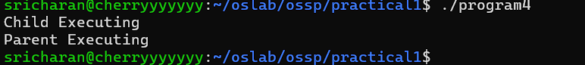

#include <stdio.h>
#include <unistd.h>

int main()
{
pid_t pid = fork();

if (pid == 0)
{
printf("Child PID = %d\n", getpid());
printf("Parent PID = %d\n", getppid());
}
else
{
printf("Parent PID = %d\n", getpid());
printf("Child PID = %d\n", pid);
}

return 0;
}
