PRACTICAL2:
#include <stdio.h>
#include <fcntl.h>
#include <unistd.h>
//0 stinput 1 stoutput 2 sterror 3fileopened
int main()
{
int fd;
fd = open("sample.txt", O_RDONLY);
if (fd == -1)
{
printf("File cannot be opened\n");
return 1;
}

printf("File opened successfully.\n");

close(fd);

return 0;
}
#include <stdio.h>
#include <fcntl.h>
#include <unistd.h>

int main()
{
int fd;
char buffer[100];
int bytes;

fd = open("sample.txt", O_RDONLY);

if (fd == -1)
{
printf("Cannot open file.\n");
return 1;
}

bytes = read(fd, buffer, sizeof(buffer) - 1);

if (bytes > 0)
{
buffer[bytes] = '\0';
printf("%s", buffer);
}

close(fd);

return 0;
}

#include <stdio.h>
#include <fcntl.h>
#include <unistd.h>
#include <string.h>

int main()
{
int fd;
char buffer[100];

fd = open("sample.txt", O_WRONLY | O_CREAT | O_TRUNC, 0644);

if (fd == -1)
{
printf("Cannot open file.\n");
return 1;
}

printf("Enter text: ");
fgets(buffer, sizeof(buffer), stdin);

write(fd, buffer, strlen(buffer));

printf("Data written successfully.\n");

close(fd);

return 0;
}
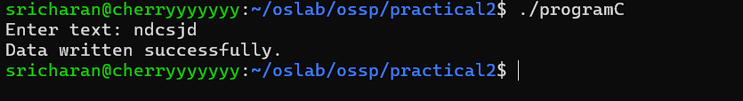
#include <stdio.h>
#include <fcntl.h>
#include <unistd.h>

int main()
{
int fd;

fd = open("sample.txt", O_RDONLY);

if (fd == -1)
{
printf("Cannot open file.\n");
return 1;
}

close(fd);

printf("File closed successfully.\n");

return 0;
}

