PRACTICAL 3:
#include <stdio.h>
#include <unistd.h>

int main()
{
int pid;

pid = fork();

if (pid == 0)
{
printf("Child Process Created\n");
}
else
{
printf("Parent Process Created\n");
}

return 0;
}

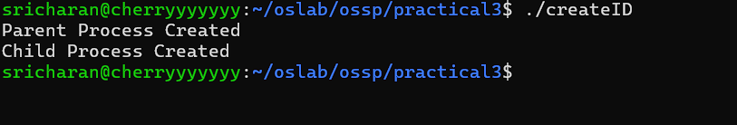

#include <stdio.h>
#include <unistd.h>

int main()
{
int pid;

pid = fork();

if (pid == 0)
{
printf("Child Process\n");
printf("PID = %d\n", getpid());
printf("PPID = %d\n", getppid());
}
else
{
printf("Parent Process\n");
printf("PID = %d\n", getpid());
printf("PPID = %d\n", getppid());
}

return 0;
}

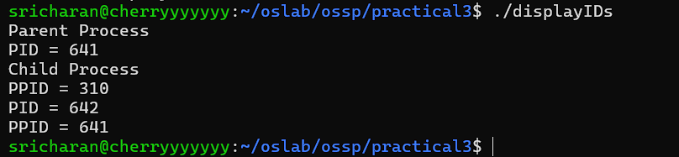

#include <stdio.h>
#include <unistd.h>

int main()
{
int pid;

printf("Before fork: Process is running\n");

pid = fork();

if (pid == 0)
{
printf("Child: Process is running\n");
printf("Child PID = %d\n", getpid());

sleep(20);

printf("Child: Process finished\n");
}
else
{
printf("Parent: Process is running\n");
printf("Parent PID = %d\n", getpid());

sleep(20);

printf("Parent: Process finished\n");
}

return 0;
}

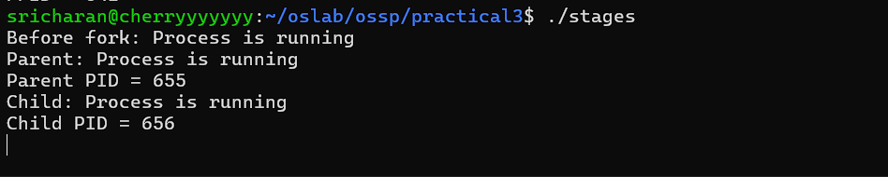

TOP:
