PRACTICAL4:

#include <stdio.h>
#include <stdlib.h>
#include <unistd.h>
#include <sys/wait.h>

int main()
{
int i;
pid_t pid;

for (i = 0; i < 3; i++)
{
pid = fork();

if (pid < 0)
{
perror("fork failed");
exit(1);
}

if (pid == 0)
{
printf("Child %d: PID = %d, Parent PID = %d\n",
i + 1, getpid(), getppid());

sleep(i + 1);
printf("Child %d completed\n", i + 1);
exit(0);
}
}

for (i = 0; i < 3; i++)
{
wait(NULL);
printf("Parent: A child process has completed\n");
}

printf("Parent: All child processes completed\n");

return 0;
}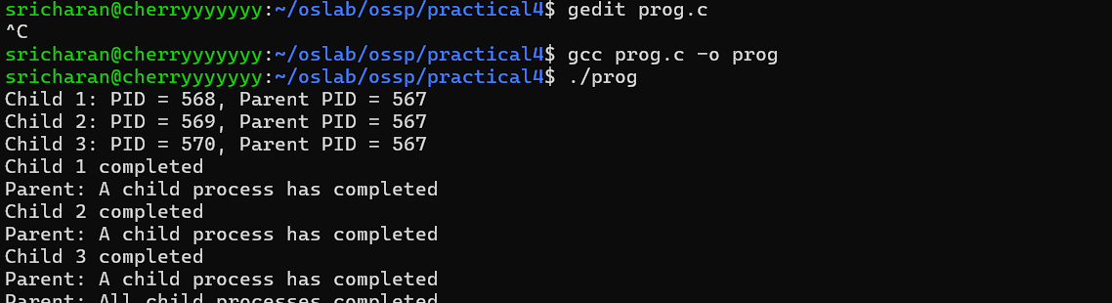

#include <stdio.h>
#include <stdlib.h>
#include <unistd.h>
#include <sys/wait.h>

int main()
{
int i;
pid_t pid;
pid_t child[3];

for (i = 0; i < 3; i++)
{
pid = fork();

if (pid < 0)
{
perror("fork failed");
exit(1);
}

if (pid == 0)
{
printf("Child %d: PID = %d, Parent PID = %d\n",
i + 1, getpid(), getppid());

sleep(3 - i);
printf("Child %d completed\n", i + 1);
exit(0);
}

child[i] = pid;
}

for (i = 0; i < 3; i++)
{
waitpid(child[i], NULL, 0);
printf("Parent: Child %d with PID %d completed\n",
i + 1, child[i]);
}

printf("Parent: All child processes completed\n");

return 0;
}
