TOKENIZATION:
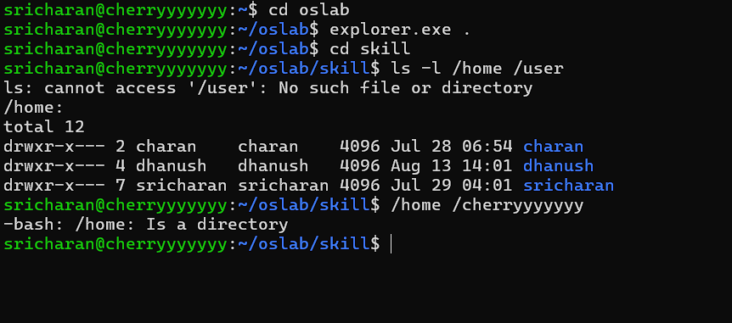
Tokenization means splitting an input command into meaningful pieces called tokens.

IDENTIFY DELIMITERS:
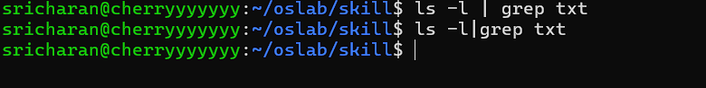
HANDLING WHITESPACES:

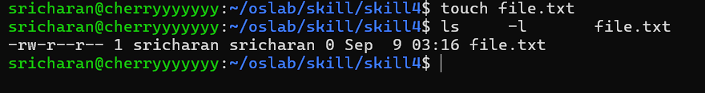

Parser.c
