SIGNALS:
#include <stdio.h>
#include <signal.h>
#include <unistd.h>

void handle_signal(int sig)
{
printf("\nSIGINT received!\n");
}

int main()
{
signal(SIGINT, handle_signal);

while (1)
{
printf("Program is running...\n");
sleep(2);
}

return 0;
}
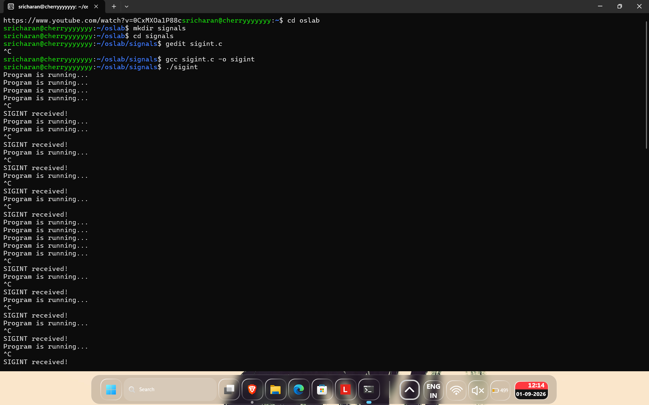

Sighand.c:
#include <stdio.h>
#include <unistd.h>

int main()
{
while (1)
{
printf("Program is running...\n");
sleep(2);
}

return 0;
}
#include <stdio.h>
#include <unistd.h>

int main()
{
while (1)
{
printf("Program is running...\n");
sleep(2);
}

return 0;
}

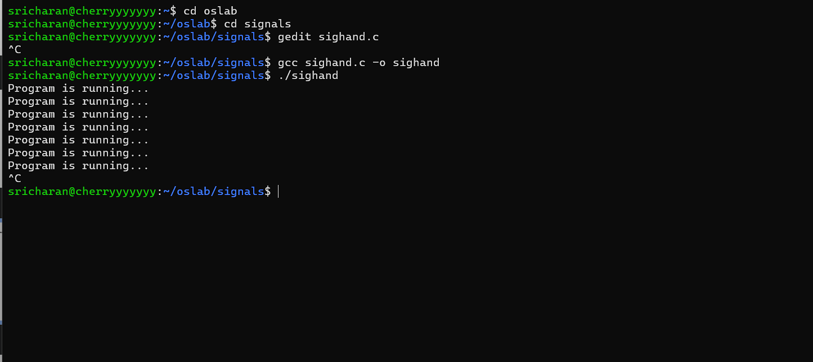

SIGCHILD.c:

#include <stdio.h>
#include <signal.h>
#include <unistd.h>
#include <sys/wait.h>

void handle_sigchld(int sig)
{
printf("SIGCHLD received: Child has terminated.\n");
}

int main()
{
signal(SIGCHLD, handle_sigchld);

pid_t pid = fork();

if (pid == 0)
{
// Child
printf("Child is running...\n");
sleep(3);
printf("Child is terminating...\n");
}
else
{
// Parent
printf("Parent is waiting...\n");
wait(NULL);
printf("Parent finished.\n");
}

return 0;
}

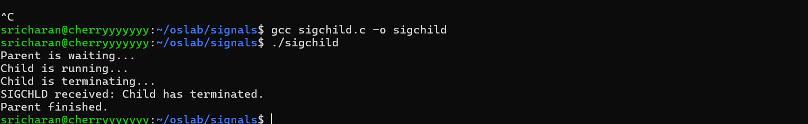
SIGFILE.c:
#include <stdio.h>
#include <unistd.h>

int main()
{
int fd[2];

pipe(fd);

close(fd[0]); // Close read end

printf("Writing to pipe...\n");

write(fd[1], "Hello", 5);

printf("Write completed.\n");

return 0;
}
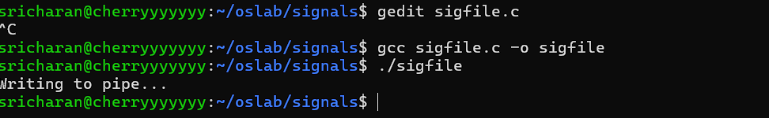
KILL.c:
#include <stdio.h>
#include <signal.h>
#include <unistd.h>
#include <sys/wait.h>

void handler(int sig)
{
printf("Child received SIGUSR1\n");
}

int main()
{
pid_t pid = fork();

if (pid == 0)
{
// Child
signal(SIGUSR1, handler);

printf("Child waiting...\n");

while (1)
{
sleep(1);
}
}
else
{
// Parent
sleep(2);

printf("Parent sending signal...\n");

kill(pid, SIGUSR1);

sleep(2);

kill(pid, SIGTERM);

wait(NULL);
}

return 0;
}
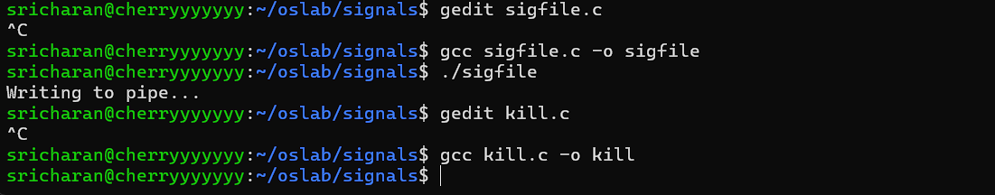

SIGABORT.c:
#include <stdio.h>
#include <stdlib.h>

int main()
{
printf("Program started\n");

abort();

printf("Program ended\n");

return 0;
}
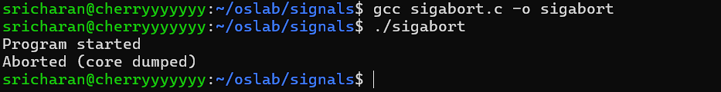

SIGSEV.c:
#include <stdio.h>

int main()
{
int *p = NULL;

printf("Before error\n");

*p = 10;

printf("After error\n");

return 0;
}
