Revenge Odyssey

Report



**Session 2022** - **2026**

**Submitted by:**

Tayyaba Afzal 2022-CS-134

**Submitted To:**

Syed Muhammad Adeel

Department of Computer Science

**University of Engineering and Technology**

**Lahore, Pakistan.**

Table Of Content

Game Idea 3

Genre 3

Art Style 3

Map Design 3

Players 4

Their Mechanics 5

Non-Playable Characters (NPCs) 5

Mission 6

Core Gameplay Loop 6

Level Propagation 7

Flow Diagram 8

User Interface (UI) 9

Cut Scene 11

Third-Person Controller 11

Optimization Techniques 11

# Game Idea

A team of vigilantes works together to seek justice for victims who cannot fight for themselves. The player controls different characters in each level, solving unique cases through teamwork, puzzle-solving, and action sequences. Inspired by the **K-drama "Taxi Driver,"** the game allows players to relive the tragic backstories of the characters and participate in intense missions for justice.

# Genre

The game is a **stealth-based** with elements of **and mystery.** Players must **navigate the school**, collecting evidence while avoiding enemies. Green arrows guide them to easily findable evidence, but enemies pose a constant threat. If an enemy collides with the player, the collected evidence is stolen and hidden in a new location, forcing the player to search again. As levels progress, enemies increase, making stealth and strategy essential. The game challenging players to **outsmart enemies, manage time wisely, and reach the rooftop with all evidence to win.**

# **Art Style**

The art style for our game is heavily inspired by the K-drama **"Taxi Driver"**, maintaining a **realistic** yet stylized look to reflect the gritty nature of the **revenge-driven** storyline. The focus is on immersive, cinematic visuals that blend the harsh reality of each mission with smooth gameplay optimized for mobile platforms.

# Map Design

## School Environment

### Layout

* Two floors: First, and Second.
* Rooftop accessible at the end of the game.
  + Playground backward of building.

### Locations

* + Classrooms.
  + Waiting Room.
  + Computer lab.
  + Teacher’s Office
  + Playground
  + Washrooms and Storeroom
  + Rooftop for final evidence submission.

### Aesthetic

* + Realistic school-themed textures and lighting.
  + Interactive objects like desks, lockers, doors, Benchers, Chairs, Tables, Blackboard, Kitchen appliances.

# Players

## Types

The Agilest (Victims):

* + One players.
  + Mission: Collect evidence, keys, and reach the rooftop.

The Brutes(Bullies):

* + Three players.
  + Mission: Stop Agilest from completing their tasks.

## Roles

* The Agilest: Task-focused, strategic.
* The Brutes: Saboteurs and attackers.

# Their Mechanics

## The Agilest

### Abilities

* + Movement.
  + Pick/ Drop Object
  + Open/Close Drawer
  + Freeze camera rotation

### Interactions

* + Open locked doors using evidence by giving it to a teacher.
  + Progress Tracker: Monitor assigned tasks and completed tasks.
  + Health Bar: Decreases during fights, non-replenishable.

## The Brutes

### Abilities

* + Movement on map on different locations.

### Interactions

* + Push the player to seal evidence and hide on any other location.

### Common Mechanics

### Movement

* + Third-person controller for navigating the school environment.

# Non-Playable Characters (NPCs)

* **School Students:**
  + Various NPCs are present in the school environment.
  + They **move around dynamically**, performing daily activities.
  + Others are walking in hallways, sitting, or playing outside.
* **Behavior & Interactions:**
  + NPCs do **not interfere** with the player’s objectives.
  + They create a **lively and immersive atmosphere** in the school.
  + Some NPCs might react **subtly** if the player moves too close.

# Mission

## The Agilest

* Collect evidence, notes, recordings, and keys.
* Submit all evidence on the rooftop to win.

## The Brutes

* Prevent agilest from completing their mission by:
  + Blocking paths.

# Core Gameplay Loop

* **Game Start:**
  + Player spawns in front of the **school building.**
  + Green arrows highlight **easily findable evidence** to collect.
* **Evidence Collection:**
  + Player moves around collecting **scattered evidence.**
  + **Green arrows** guide the player toward each piece.
* **Enemy Interaction:**
  + If the **enemy collides** with the player:
    - The **collected evidence** is stolen.
    - Enemy **hides** the evidence in a new location.
    - Player must **find and collect it again.**
  + If the player **collides with the enemy three times** in a row, they lose.
* **Winning & Losing Conditions:**
  + **Lose if:**
    - **Three enemy collisions** occur.
    - **Timer runs out.**
  + **Win if:**
    - All evidence is collected.
    - Player reaches the **rooftop.**
    - If even one evidence is missing, the final destination remains locked.

# Level Propagation

1. **Three Levels Designed:** The game consists of **three levels**, each increasing in difficulty.
2. **Dynamic Evidence Placement:**
   * The hiding spots for evidence **change** with each level.
   * Players must search in **new locations** every time.
3. **Increased Enemy Presence:**
   * **More enemies** are introduced as levels progress.
4. **Challenging Gameplay:**
   * Each level demands **quicker reflexes** and **smarter movement.**
5. **Final Goal Remains the Same:**
   * Collect all evidence and **reach the rooftop** to win.

# Flow Diagram

**Fig.1** Complete Flow diagram of game loop

# User Interface (UI)

* **Main Menu UI:**

The game starts with a **main menu** displaying three options:

* + **Play** – Starts the game.
  + **Options** – Opens a settings panel.
  + **Exit** – Closes the game.

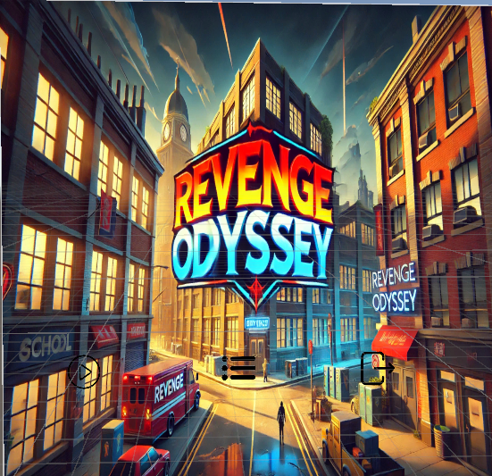

* **Options Panel:**
  + 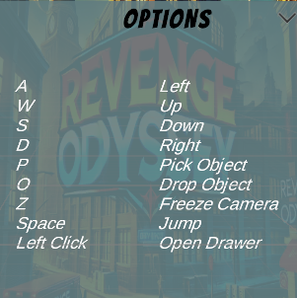Shows all Controls**.**
* **Level Selection UI:**
  + After clicking **Play**, a new screen appears to **select levels.**
  + Displays locked/unlocked levels based on progress.

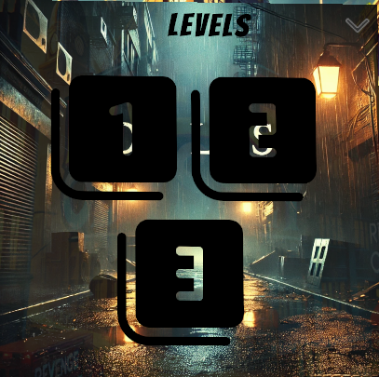

* **In-Game UI:**
  + **Progress Bar** – Tracks task completion within the level.
  + **3-Star System** – Represents available chances/lives.
  + **Timer** – Displays remaining time to complete tasks.

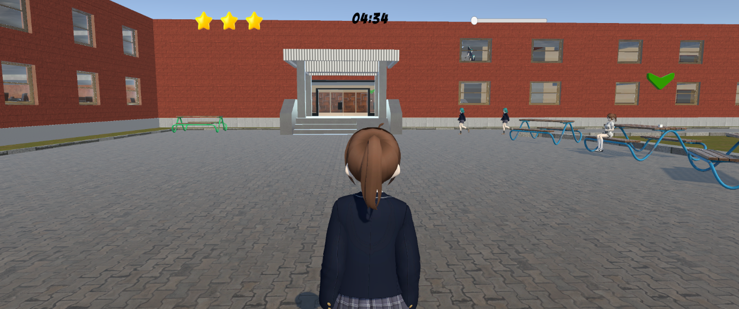

# Cut Scene

## Introduction

* Backstory explaining how Agilest were bullied by Brutes.
* Sets the stage for revenge and the game mission.

# Third-Person Controller

* Players control their characters from a third-person perspective.
* Smooth navigation through the school environment.
* Interaction prompts for tasks like collecting items.

# Optimization Techniques

1. **Use Low-Poly Models & Compressed Textures** – Reduces rendering load for smooth performance.
2. **Implement Object Pooling** – Reuses objects like NPCs and collectibles instead of creating new ones.
3. **Enable Frustum Culling** – Renders only what the player sees, improving efficiency.
4. **Optimize Collisions** – Use simple colliders and limit physics calculations.
5. **Reduce Real-Time Lighting** – Use baked lighting and minimal dynamic shadows to lower GPU usage.