# Report on the fairness of sailing scoring

## Problem

This report will investigate three questions:

1. Is it better to be a consistent or inconsistent sailor?
2. Does this depend on how skilful you are relative to other sailors?
3. How would this change of either no races were discarded or two races were discarded?

## Method

### Scoring

A group of 5 sailors race 6 times. The worst position of each sailor is discarded from the list, leaving a total of 5 scores. These scores are totalled, leaving a series score that is the final score for each sailor. The sailor with the highest series score is the winner of that series.

### Simulation

Results for this study have been generated using a python script. The script simulates a series, being 6 races, a total of 4000 times. The mean performance and standard deviation of each sailor are stored in a separate, editable file. The performance of each sailor during the race is calculated with a random script, working from a normal distribution, and is entirely random. Data is recorded, with the winner of each race scoring 1 point. A pie chart is generated with this data, showing the ratios of who came first the most of the total 4000 series.

## Assumptions

This method assumes that the mean performance and standard deviation is a constant along the 4000 series of the simulation. In reality, 4000 series would take many years and so the skill of each sailor would most probably increase over that period of time.  
This method also assumes the same conditions over each series – water conditions, weather etc.

## Results

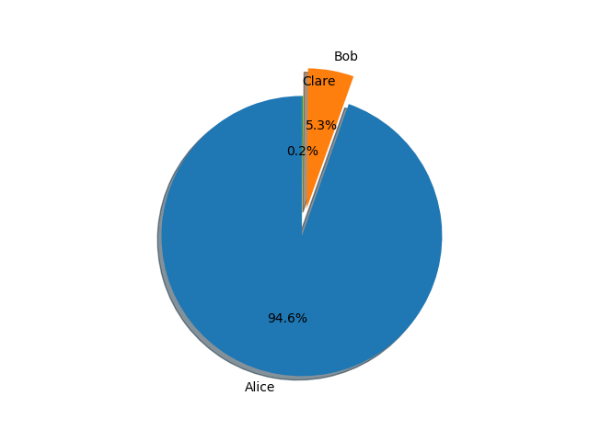Over the 4000 simulations, data was recorded and converted into a pie chart using the matplotlib python plotting library. See Fig. 1 Below:

Figure - A pie chart of the percentages of each series' winner

In this method, Alice can be considered a consistently good sailor, with a standard deviation of 0. Bob has the same mean performance as Alice, however his standard deviation is 5, so he has an equally likely chance of being better than Alice as he does of being worse. Clare also has the same mean performance as Alice and Bob, however her standard deviation is higher than Bob’s, at 10. There are two other competitors, Dennis and Eva, however they both have a mean performance of 10 less than the first 3, and so never win.

From the data, it is clear that it is more beneficial to be a good sailor with a low standard deviation, as Alice takes 94.6% of the wins. Therefore, the answer to the first question is that it is better to be a consistent sailor under this scoring scheme.

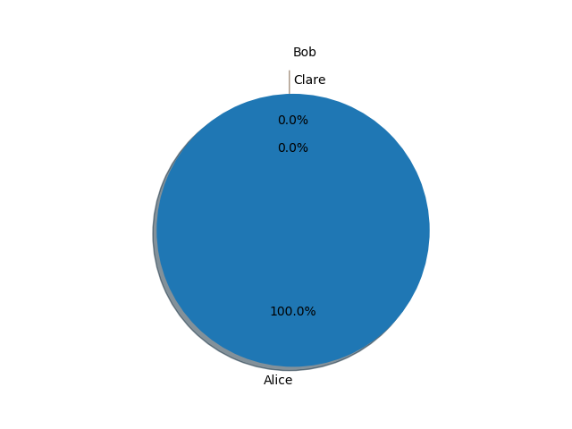To answer the second question, consider a different set of sailors. If one sailor is, on average, drastically more skilful than the other 4, but with a high standard deviation, they are still more likely to come first more often than not. To demonstrate this, I have reset Alice’s statistics to 130 and 20, respectively. The figure below shows the results of this simulation setup:

Figure - Pie chart showing series results when one sailor is drastically more skilled than the others

As you can see, Alice, who is now a lot more skilful than the others, takes 100% of the wins.

Finally, to find an answer for the last question, I modify the scoring system to discard two races, and then discard no races. The figures below show the results of this:

Figures and 4 - Discarding Two or Zero Races

From these two figures, you can infer that discarding two races leads to a greater proportion of wins for higher standard deviation sailors, and discarding 0 races drags those sailors down, leading to a greater proportion of wins for sailors with low standard deviations