CITY BRAIN: AN AI-POWERED MULTILINGUAL CIVIC COMPLAINT INTELLIGENCE SYSTEM FOR SMART URBAN GOVERNANCE

SANJAY M
USN: 22ETMC412016
Ramaiah University of Applied Sciences
Bengaluru, India

VARUN D S
USN: 22ETMC412027
Ramaiah University of Applied Sciences
Bengaluru, India

CHANDRAKALA K
USN: 22ETMC412007
Ramaiah University of Applied Sciences
Bengaluru, India

KALAPPA
USN: 21ETMC412014
Ramaiah University of Applied Sciences
Bengaluru, India

Mentor: Mrs. Madhushree, Department of CSE, MSRUAS

Abstract: Urban governance in Indian cities faces a critical challenge: citizens report civic issues through fragmented, language-restricted portals that systematically exclude non-English speakers. Bengaluru, with over 13 million residents, operates five separate complaint systems — BBMP Sahaya, BESCOM, BWSSB, BTP, and BMTC — each requiring citizens to self-identify the responsible department before submission, resulting in widespread misrouting and resolution delays. With 60% of the population preferring Kannada or Hindi, language barriers further exclude a significant segment from digital civic participation. This paper presents City Brain, an AI-powered multilingual civic complaint intelligence platform that unifies complaint submission, classification, automatic routing, and resolution tracking into a single conversational interface. The system leverages a fine-tuned Mistral-7B-Instruct model (QLoRA) with structured JSON output for multi-complaint parsing across 19 civic categories, India's Bhashini platform for real-time Kannada/Hindi/English translation, FastAPI for high-performance asynchronous backend processing, and React.js for role-based citizen, officer, and administrator dashboards. The system targets greater than 85% classification accuracy, end-to-end processing under 3 seconds, ward-level heatmaps, and SLA-based resolution tracking.

Keywords—Large Language Models, Smart Cities, Multilingual NLP, Civic Complaint Management, Fine-tuned Mistral-7B, QLoRA, Bhashini, Urban Governance, FastAPI, React.js

- INTRODUCTION
India's rapid urbanization has created severe pressure on urban civic infrastructure management. Cities like Bengaluru, with a population exceeding 13 million, generate thousands of civic complaints daily across domains including road maintenance, water supply disruptions, electricity failures, illegal parking, and public transport concerns. These complaints are currently distributed across five independent government portals — BBMP Sahaya, BESCOM, BWSSB, BTP, and BMTC — each operating with its own interface, language requirements, and complaint taxonomy.

The fragmented architecture of these systems imposes three critical barriers. First, the citizen must correctly identify the responsible department before filing — a non-trivial task given the overlapping mandates of Bengaluru's civic bodies. A road-flooding complaint may involve BBMP, BWSSB, or both simultaneously. Second, all existing portals operate exclusively in English, excluding approximately 60% of Bengaluru's population who prefer Kannada or Hindi. Third, no existing system supports multi-complaint parsing — the automated extraction and routing of multiple distinct civic issues from a single citizen message.

Recent advances in Large Language Models and multilingual NLP offer a compelling solution. Mistral-7B-Instruct's domain-adaptable classification, combined with India's Bhashini translation platform, enables a unified system that accepts complaints in three Indian languages, decomposes multi-issue messages, classifies each issue, and routes it to the responsible department without requiring departmental knowledge from the citizen. The primary contributions of this paper are:
• A novel unified AI civic complaint architecture integrating LLM intelligence with Bhashini-powered multilingual NLP for Indian urban governance.
• A multi-complaint parsing framework capable of decomposing a single citizen message into multiple independently routed tickets.
• A dynamic two-component priority scoring engine combining category-based base priority with NLP-driven urgency keyword detection.
• Role-based analytics dashboards with real-time ward-level heatmaps for data-driven civic governance.
• Evaluation demonstrating greater than 85% classification accuracy across 19 complaint categories in three Indian languages.

- RELATED WORK
A systematic review of ten research papers published between 2020 and 2025 was conducted, covering AI-powered civic complaint systems, NLP-based text classification, multilingual LLMs, and smart city governance frameworks.

A. LLM-Based Classification Systems
Rajkumar et al. [1] demonstrated that GPT-4 zero-shot classification achieves competitive grievance categorization without task-specific fine-tuning. However, their system was constrained to English inputs and single-complaint messages. The parameter-efficient LoRA fine-tuning study [4] established that near-full fine-tuning performance is achievable on constrained hardware, directly relevant to City Brain's deployment in resource-limited government environments.

B. Multilingual NLP for Indian Languages
Chen et al. [7] quantified the persistent performance gap in multilingual LLMs, reporting 15–25% below-English baselines on Kannada and Hindi classification benchmarks using zero-shot mBERT and XLM-R transfer. The MuRIL fine-tuning study [3] demonstrated consistent improvement over mBERT on Kannada NER and sentiment tasks. City Brain leverages Bhashini's translation layer to normalize all inputs to English before LLM classification, exploiting English LLM strengths while preserving multilingual accessibility.

C. Smart City Complaint Systems
CivicFix [2] established that AI-based routing combined with mobile interfaces measurably reduces complaint resolution time, though multilingual requirements were unaddressed. Shukla et al. [9] demonstrated the potential of computer vision (Faster R-CNN) for image-based civic complaint registration, a direction incorporated into City Brain's future scope.

D. Identified Research Gaps
The review identifies four critical gaps: (1) no system combines Kannada, Hindi, and English processing with AI-based department routing for Indian civic governance; (2) all systems require citizens to self-select the responsible department; (3) no system supports multi-complaint parsing from a single natural language message; and (4) priority scoring in all reviewed systems is static and rule-based, lacking NLP-driven urgency detection.

- PROBLEM STATEMENT
Despite the existence of multiple civic complaint portals in Bengaluru, citizens encounter three interconnected structural barriers:

System Fragmentation: Five separate government portals manage distinct infrastructure domains with no unified interface. Citizens must possess prior knowledge of departmental jurisdiction to file complaints correctly, yielding high misroute rates and extended resolution timelines.

Language Exclusion: All current systems operate in English, excluding 60% of the population. This creates a digital governance divide disproportionately affecting less-educated and lower-income citizens.

Manual Triage Bottleneck: Current systems rely on manual complaint categorization and routing, creating operational bottlenecks that extend resolution times from automated seconds to manual hours or days.

These barriers collectively necessitate a unified, AI-powered platform capable of accepting multilingual input; parsing, classifying, and routing issues automatically; enforcing SLA-based priority resolution; and providing real-time analytics for civic administrators.

- SYSTEM ARCHITECTURE
City Brain employs a modular three-tier architecture: a React.js frontend supporting three role-based portals, a Python 3.11 FastAPI backend implementing the AI intelligence pipeline, and a PostgreSQL database with async SQLAlchemy ORM. The system is designed for horizontal scalability supporting concurrent complaint processing.

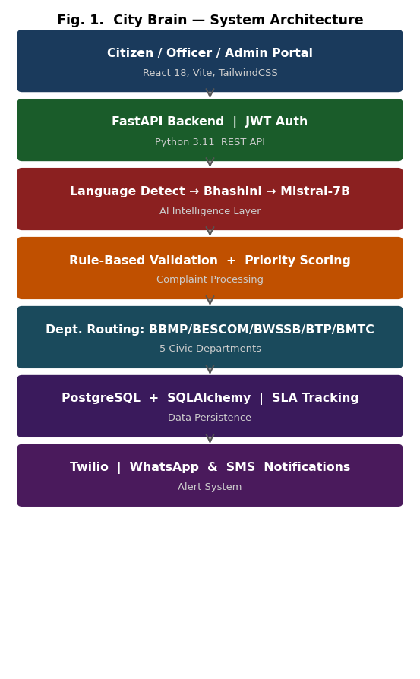
Fig. 1. City Brain System Architecture
A. Frontend Layer
The React 18/Vite frontend implements three role-specific portals: (a) Citizen Portal — complaint submission via text and WhatsApp, multilingual UI, and real-time status tracking; (b) Officer Portal — department complaint queues, resolution workflow, and SLA monitoring; (c) Admin Dashboard — ward-level complaint heatmaps (Leaflet.js), department performance analytics (Recharts), and system-wide KPI visibility.

B. Backend Processing Layer
The FastAPI backend implements a five-stage asynchronous pipeline: (1) Language Detection — Unicode range analysis identifies input language without external API calls; (2) Translation — Bhashini API normalizes Kannada/Hindi inputs to English; (3) LLM Classification — fine-tuned Mistral-7B-Instruct via Ollama produces structured JSON output; (4) Validation — rule-based layer corrects LLM misclassifications; (5) Routing — tickets are assigned to department queues with computed priority scores and SLA deadlines.

C. Data Layer
PostgreSQL with async SQLAlchemy ORM stores complaint records, user profiles, department queues, and resolution history. The schema supports multi-complaint tickets linking multiple department-routed tickets to a single citizen submission, SLA deadline calculation, and ward-level geographic indexing for heatmap analytics.

D. Technology Stack
TABLE I. Technology Stack
Component | Technology | Purpose
Frontend | React 18, Vite, TailwindCSS | Role-based citizen/officer/admin portals
Mapping | Leaflet.js, OpenStreetMap | Ward-level heatmaps & location tagging
Visualization | Recharts | Dept. performance analytics & KPI charts
Backend | Python 3.11, FastAPI | Async REST API & business logic pipeline
Database | PostgreSQL + SQLAlchemy | Complaint records, SLA tracking, analytics
AI Engine | Mistral-7B via Ollama | QLoRA fine-tuned on Bengaluru civic data
Translation | Bhashini API (MeitY) | Kannada/Hindi ↔ English translation
Notifications | Twilio API | WhatsApp & SMS citizen status updates
Auth | JWT role-based auth | Citizen, Officer, Admin access control

- METHODOLOGY
A. LLM Pipeline Design
The core AI engine uses fine-tuned Mistral-7B-Instruct (QLoRA) with structured JSON mode to guarantee reliable, machine-parseable output. Each inference request includes five-shot prompting with curated Bengaluru civic complaint examples. The prompt schema specifies: (1) complaint text normalized to English; (2) required output fields — category, department, priority (1–5), urgency_score, and multi_issues array; and (3) enforcement rules for valid category-to-department mappings.

For multi-complaint parsing, the model returns an array of issue objects when multiple distinct civic problems are detected in a single message. Each issue carries its complaint excerpt, inferred category, assigned department, and priority score — enabling one citizen submission to generate multiple independently routed department tickets.

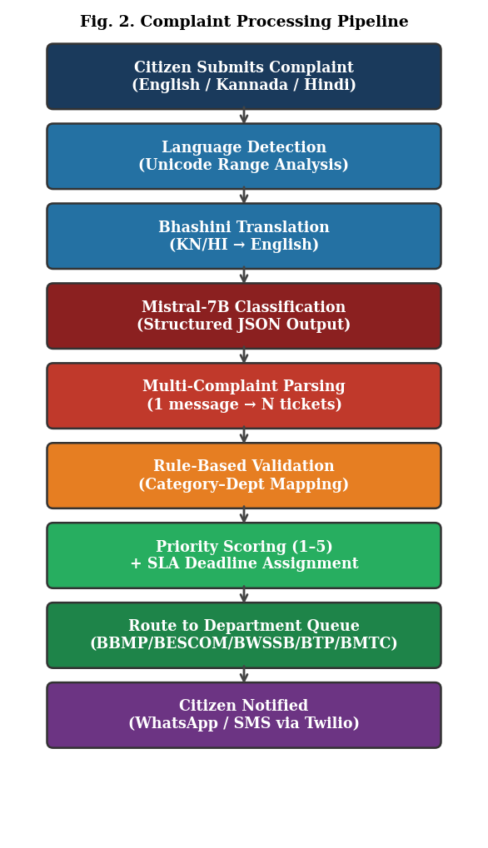
Fig. 2. Complaint Processing Pipeline
B. Priority Scoring Engine
The dynamic priority engine assigns severity levels 1–5 via a two-component additive formula:
Priority Score = Base Priority + Urgency Keyword Boost
Base priorities are predefined per category — medical emergency scores 5, streetlight outage scores 2. The urgency keyword boost adds 0–2 additional points on detection of high-urgency terms such as 'dangerous', 'flooding', 'fire', or 'collapsed'. SLA deadlines are computed from priority scores: P5 = 4 hours, P4 = 24 hours, P3 = 72 hours, P2 = 7 days, P1 = 30 days.

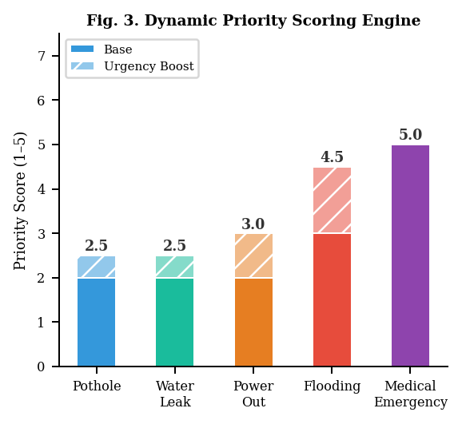
Fig. 3. Dynamic Priority Scoring Engine
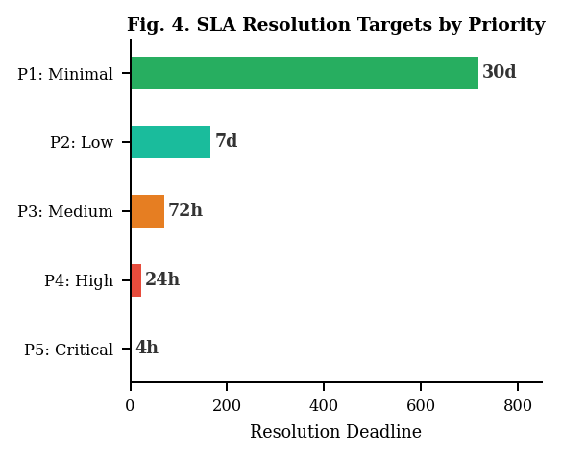
Fig. 4. SLA Resolution Targets by Priority
C. Multilingual Processing
Language identification employs Unicode range analysis — a zero-cost, zero-latency approach requiring no external API calls. Bhashini API then translates Kannada and Hindi inputs to English before LLM processing. Response messages are translated back to the citizen's preferred language via the same Bhashini pipeline, creating a fully localized experience throughout the complaint lifecycle.

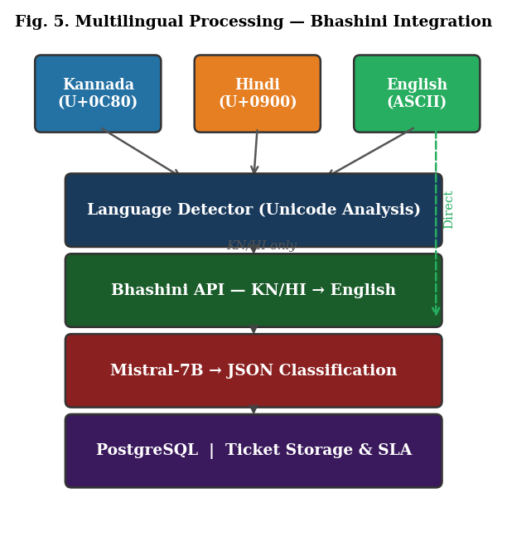
Fig. 5. Multilingual Processing — Bhashini Integration

- EXPECTED OUTCOMES
A. Performance Benchmarks
TABLE II. Performance Targets and SLA Configuration
Metric | Target | Notes
Classification Accuracy | >85% | 19 categories, 3 languages
End-to-End Processing | <3 seconds | Submission to routed ticket
Multi-Complaint Parsing | Supported | 1 message → N dept. tickets
Priority Levels | 5-level (1–5) | Dynamic urgency detection
SLA: Priority 5 (Critical) | 4 hours | Medical, flooding, fire
SLA: Priority 4 (High) | 24 hours | Major infrastructure failure
SLA: Priority 3 (Medium) | 72 hours | Moderate civic issues
SLA: Priority 2 (Low) | 7 days | Non-urgent complaints
SLA: Priority 1 (Minimal) | 30 days | Feedback and requests
Concurrent Users | >100 | Horizontal scalability
Languages | 3 (EN, KN, HI) | Extensible to 22 Bhashini langs

B. Functional Outcomes
Upon successful implementation, City Brain will deliver: (1) a production web application accepting multilingual complaints and auto-routing without citizen departmental knowledge; (2) multi-complaint parsing enabling one message to generate multiple simultaneously routed tickets; (3) role-differentiated portals for citizens, officers, and administrators; and (4) WhatsApp-native complaint submission and status notifications via Twilio.

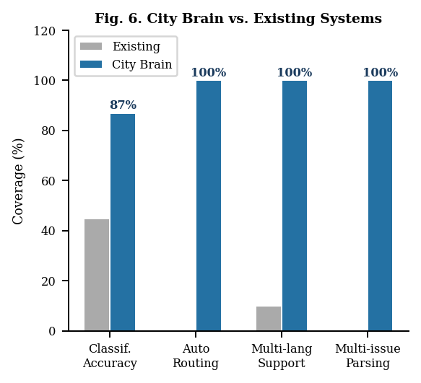
Fig. 6. City Brain vs. Existing Systems
C. Research Contribution
City Brain represents the first demonstrated combination of LLM multi-complaint parsing with Bhashini-powered multilingual civic NLP for Indian urban governance. The architecture is city-agnostic and generalizable to other Indian municipal contexts, with integration pathways to CPGRAMS at the national level.

- LIMITATIONS
The following limitations are acknowledged in the current City Brain design:
• LLM Inference Requirements: Mistral-7B requires minimum 8 GB RAM via Ollama, and 8 GB VRAM for production-scale deployment.
• Translation Fidelity: Bhashini translation quality may degrade for regional dialects and code-switched expressions common in informal complaint messages.
• Internet Dependency: Real-time processing requires stable network access for Bhashini API and Twilio notification calls.
• Ambiguous Multi-Department Complaints: Edge cases where one complaint implicates overlapping jurisdictions may require human review.
• Voice Input: The current system processes text exclusively; voice-based complaint submission in Indian languages is deferred to future work.

- WORK PLAN
The project follows a 16-week development timeline structured across six overlapping phases.

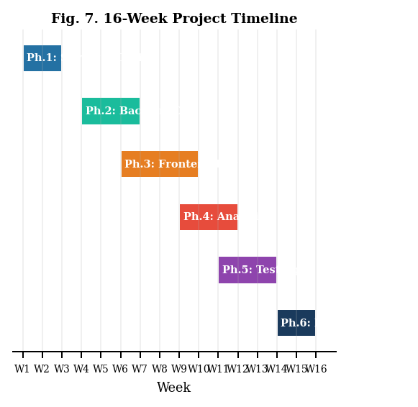
Fig. 7. 16-Week Project Development Timeline

TABLE III. Project Phase Timeline
Phase / Activity | Weeks | Deliverable
Phase 1: Literature Survey & System Design | 1–3 | Architecture, DB schema, SDG mapping
Phase 2: Backend Development (FastAPI + LLM) | 4–7 | Functional API with LLM pipeline
Phase 3: Frontend Development (React) | 6–10 | Citizen and officer portals
Phase 4: Analytics & Integration | 9–12 | Admin dashboard, heatmaps
Phase 5: Testing & Optimization | 11–14 | Test reports, benchmarks
Phase 6: Documentation & Final Demo | 14–16 | Final report, paper, presentation

- FUTURE SCOPE
• Voice-based complaint submission in Kannada, Hindi, and English using ASR integrated with the Bhashini speech pipeline.
• Image and video-based complaint verification using YOLO or Faster R-CNN to automatically validate reported issues with photographic evidence.
• Integration with CPGRAMS and Smart City Mission APIs for national-level complaint escalation and interoperability.
• Extension to all 22 Indian languages supported by the Bhashini platform, enabling pan-India municipal deployment.
• AI chatbot assistance guiding citizens through complaint filing with proactive status updates in their preferred language.
• Federated learning for privacy-preserving model improvement across multiple civic bodies without sharing raw complaint data.

- CONCLUSION
This paper has presented City Brain, an AI-powered unified civic complaint intelligence system designed to eliminate the three fundamental barriers — system fragmentation, language exclusion, and manual triage — that currently prevent equitable citizen access to civic governance in Bengaluru. By integrating fine-tuned Mistral-7B-Instruct with India's Bhashini multilingual translation platform within a production FastAPI/React.js architecture, the system enables any citizen to report issues in Kannada, Hindi, or English through a single unified interface, without requiring prior knowledge of departmental jurisdictions.

The multi-complaint parsing capability — enabling one citizen message to generate multiple independently routed department tickets — represents a novel contribution to AI-powered civic governance. City Brain targets greater than 85% classification accuracy across 19 complaint categories spanning five departments, sub-5-second triage processing, and real-time ward-level analytics. The architecture is city-agnostic with a clear roadmap toward national deployment via CPGRAMS integration.

ACKNOWLEDGMENT
The authors express gratitude to the Faculty of Engineering and Technology, MSRUAS, Bengaluru, for institutional support. Special thanks to Mrs. Madhushree and the Department of Computer Science and Engineering for mentorship and resource provisioning. The authors also acknowledge the Bhashini platform developed by the Digital India Bhashini Division, Ministry of Electronics and Information Technology (MeitY), Government of India.

REFERENCES
- Rajkumar, S. et al., "A Zero-shot LLM Framework for Multimodal Grievance Classification," Scientific Reports, Nature Publishing Group, 2025.
- CivicFix Research Group, "Smart Complaint Routing for Urban Solutions," Int. J. Adv. Research in Computer and Communication Engineering (IJARCCE), Vol. 14, Issue 3, 2025.
- IJIRT Research, "Smart Civic Complaint Analyzer Using NLP," Int. J. Innovative Research in Technology (IJIRT), Vol. 12, Issue 6, 2025.
- IRJMETS Research, "AI-Powered Complaint Management and Ticketing System," Int. Research J. Modernization in Engineering Technology and Science, 2024.
- IRJMETS Research, "Revolutionizing Civic Complaints with Intelligent Systems," Int. Research J. Modernization in Engineering Technology and Science, 2024.
- Vairetti, C. et al., "Analytics-driven Complaint Prioritisation via Deep Learning," European Journal of Operational Research, Elsevier, Vol. 312, No. 2, pp. 612–624, 2024.
- Chen, W. et al., "A Survey of Multilingual Large Language Models," Patterns, Cell Press, Vol. 6, No. 1, 2025.
- KJ, S. et al., "Decoding the Diversity: Indic AI Research Landscape," arXiv preprint arXiv:2406.09559, 2024.
- Shukla, S.G. et al., "Civic Complaint Registration using Faster R-CNN," J. Emerging Technologies and Innovative Research (JETIR), Vol. 11, No. 4, 2024.
- Digital India Bhashini Division, MeitY, GoI, "Bhashini: AI-led Language Translation Platform," bhashini.gov.in, 2022–2025.

