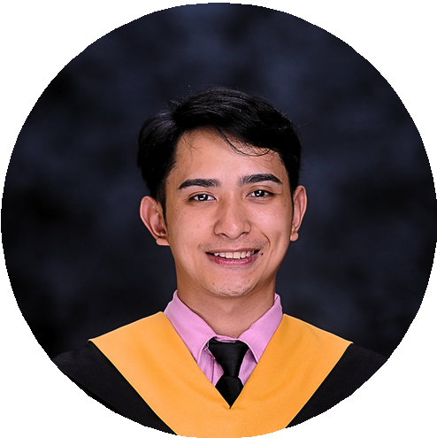
Francis Niño R. Villanueva
IT Support

CONTACT

09953304738
Francisvillanueva25@gmail.com
033 Brgy. Santiago 1, San Pablo City, Laguna

EDUCATION
Laguna State Polytechnic University Bachelor of Information Technology 2022 - 2025
STI San Pablo
Bachelor of Information Technology
2021 - 2022
Liceo De San Pablo
Elementary - Senior High School
General Academic Strand 2011 - 2021

SKILL
Microsoft Office
Photo/Video Editing
Computer Troubleshooting Critical Thinking
Communication Skills Team leader

CERTIFICATION
2021 | Pagcor
Certifiacation of Completion
Teller/Cashier and Supervisor

PROFILE
Computer Skills since 14 years old. 4years of experience working on San Pablo Coco Festival. 1year Experience on Gallotech Ventures Inc. as a Cashier/Teller, Assistant Supervisor and Supervisor. 1year Working on Ichibang Takoyaki as a all around crew and cashier. Happy to learn every step of journey.

WORK EXPERIENCE

Toyota San Pablo (OJT) l IT Support

2025
Toyota is the best of my experience when it comes to IT field, I experience alot of troubleshooting, cabling, resetting, assembling of computers and server configuration.

Laguna State Polytechnic University (OJT) l Documentation / Editing

2024
I was assigned on Dean’s Office for those documents that they need to find and also for the documentation video for the college of computer studies.

Ichibang Takoyaki San Pablo l Cashier / All around crew

2023 – 2024
Experienced how to cook Takoyaki and serving meals to our customers and work under pressure, communicate in English and Tagalog also managed the sales of the business. We serve in big events in schools.

Gallotech Ventures Inc. l Teller / Supervisor

2021 – 2022
I Started as a Teller/Cashier in Online Cockpit Betting Station or Called as Sabong/Online Sabong, After 2 months I was promoted as a Assistant Supervisor Until promoted as a Supervisor in other stations experienced to work under pressure and multitasking skills

Family Business | Cashier / All around crew

2015 – 2025
Since 2015 my family is always present in San Pablo City Coco Festival. We sell foods and drinks and I'm incharge in Cashier and also in the customer's, from 2pm-1am in7days every january 9-15.

Yazaki Torres (OJT) | Programmer / Wiring

2019
I learn how to program a arduino uno, Computer Troubleshooting and Computer wiring management. Experienced cabling and wiring car wire.

REFERENCES

Sept 2024 | Cisco Networking Academy
Certifiacation of Course Completion
Erica Fernandez Nestor Ray Z. Aragon
Gallotech Ventures Inc. / Supervisor Gallotech Ventures Inc. / Supervisor

Ethical Hacker
Phone:
09664184296
Phone:
09564768299

