**Understanding Computer Components Using Linux Shell Commands**

Chioma Chance

Colorado State University Global

CSC507: Ethical Leadership in Software Development

Dr. L

12/15/2024

**Understanding Computer Components Using Linux Shell Commands**

**Introduction**

Modern computing systems are built on four fundamental components: the **processor**, **main memory**, **I/O modules**, and **storage devices**. Each of these components plays a critical role in the performance and functionality of a computer system. Understanding these components through Linux shell commands provides valuable insight into a computer’s specifications. This paper utilizes the Linux operating system and various shell commands to retrieve information about the processor, main memory, I/O modules, and storage devices. Each command will be explained, and its output analyzed. Screenshots will be provided as evidence of the retrieved system details.

**Processor Information**

The **processor**, often referred to as the central processing unit (CPU), is the brain of the computer. To obtain detailed information about the processor, the following shell command is executed:

lscpu

**Command Explanation**  
The lscpu command is used to display the processor's specifications, including the architecture, model, clock speed, and number of cores. This command pulls data from the CPU, providing an overview of its performance capabilities.

**Output Description**  
The output provides the following details:

* **Architecture**: Specifies the CPU's architecture, such as x86_64 (64-bit).
* **Model Name**: Shows the processor’s manufacturer and model (e.g., Intel Core i7-10510U).
* **CPU Frequency**: Displays the processor's clock speed.
* **CPU(s)**: Indicates the total number of processor cores available.

**Interpretation**  
This data reveals the processor's power and performance capacity, which are crucial for system-intensive tasks.

*Screenshot:*

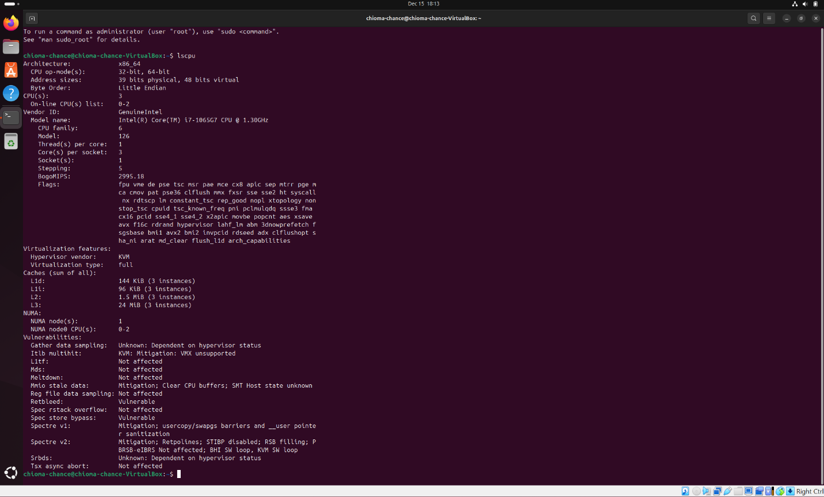

**Main Memory Information**

The **main memory**, or RAM (Random Access Memory), is critical for storing and accessing data quickly. To display RAM details, the following command is executed:

free -h

**Command Explanation**  
The free command provides a summary of memory usage, and the -h flag formats the data in a human-readable form (e.g., GB or MB).

**Output Description**  
The output includes:

* **Total Memory**: The total physical memory available.
* **Used Memory**: The memory currently being utilized.
* **Free Memory**: The unused memory available to the system.

**Interpretation**  
Understanding memory usage is essential for optimizing performance and ensuring the system has sufficient resources for multitasking.

*Screenshot*:



**I/O Modules Information**

I/O modules handle the communication between the system and peripheral devices, such as USB controllers, network cards, and graphic adapters. To gather information about I/O modules, the following command is executed:

lspci

**Command Explanation**  
The lspci command lists all devices connected to the PCI (Peripheral Component Interconnect) bus, which includes essential I/O modules.

**Output Description**  
The output provides:

* **Bus ID**: The address where the device is connected.
* **Device Type**: Identifies devices like Ethernet controllers, USB controllers, and graphics cards.
* **Vendor**: Specifies the manufacturer of the device.

**Interpretation**  
By analyzing the I/O modules, one can identify the hardware components responsible for interfacing with peripherals, ensuring system connectivity and functionality.

*Screenshot*:

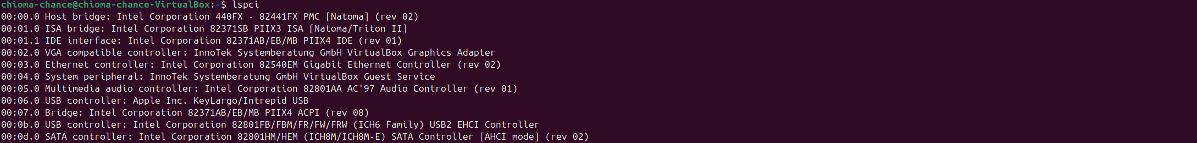

**Storage Devices Information**

Storage devices such as hard drives and solid-state drives (SSDs) are crucial for data storage and retrieval. To view storage details, the following command is executed:

lsblk

**Command Explanation**  
The lsblk command lists all block devices, including storage drives and their partitions.

**Output Description**  
The output includes:

* **NAME**: Device names (e.g., sda for a hard drive).
* **SIZE**: Displays the total capacity of each storage device.
* **MOUNTPOINT**: Shows where the device is mounted in the file system.

**Interpretation**  
This information is vital for managing storage capacity and understanding the partition structure of the system.

*Screenshot*:

**Conclusion**

The Linux shell commands lscpu, free -h,lspci**,** andlsblk provide detailed insights into the processor, memory, I/O modules, and storage devices of a computer system. These commands are essential for system analysis, troubleshooting, and optimization. By understanding the hardware specifications, users can make informed decisions regarding system upgrades, performance monitoring, and hardware compatibility.

**References**

* GNU Core Utilities. (2024). *GNU Core Utilities Manual*. Retrieved from <https://www.gnu.org/software/coreutils>
* Ubuntu Documentation. (2024). *Shell Commands for System Information*. Retrieved from <https://help.ubuntu.com>
* The Linux Documentation Project. (n.d.). *Linux system commands manual*. Retrieved December 15, 2024, from <https://linux.die.net/man/>