



**Module Code & Module Title**

**CS6004NT- Application Development**

**Assessment Weightage & Type**

**Individual Coursework (30%)**

**Year and Semester**

**2024-25 Autumn**

**Student Name:**

**London Met ID:**

**College ID:**

**Assignment Submission Date:**

**Submitted To:**

**GitHub Link:**

*I confirm that I understand my coursework needs to be submitted online via Google Classroom under the relevant module page before the deadline for my assignment to be accepted and marked. I am fully aware that late submissions will be treated as non-submission and a mark of zero will be awarded*

# Introduction

Fynsync is a prototype desktop application developed using the **C#.NET** framework to streamline personal expense management. By combining a user-friendly interface with robust functionality, it empowers users to efficiently monitor, categorize, and analyze financial transactions, including cash inflows, outflows, and debts. Tailored to enhance financial oversight, Fynsync offers features such as customizable transaction tagging, date-range filtering, and a dynamic dashboard for comprehensive financial analysis. By simplifying the complexities of personal finance and ensuring transparency in decision-making, Fynsync serves as an indispensable tool for individuals striving for financial discipline and control.

# Task 1 [Thui ta imahe halday Folder banako ani github ma code akoo!!!]

# User Interface Design

The user interface (UI) is where people interact with a computer, website, or application. A well-designed UI aims to create a simple and intuitive experience, ensuring users can achieve their goals with minimal effort while getting the best possible results.

For User Interface Design I am going to use Figma;  
**Figma**: Figma is a powerful tool for designing and prototyping the user interface of your sentiment analysis project. It allows you to visualize and refine interactive web application designs, such as input areas for text analysis and categorized results. As a browser-based platform, Figma supports real-time collaboration, enabling feedback and iterative improvements. Its interactive prototyping features help simulate user interactions, optimize the design, and enhance the user journey. By customizing text, shapes, colors, and animations, you can create polished UI designs that visually differentiate sentiment outputs. Prototypes can also be shared with stakeholders, bridging the gap between your AI solution and its practical implementation.  
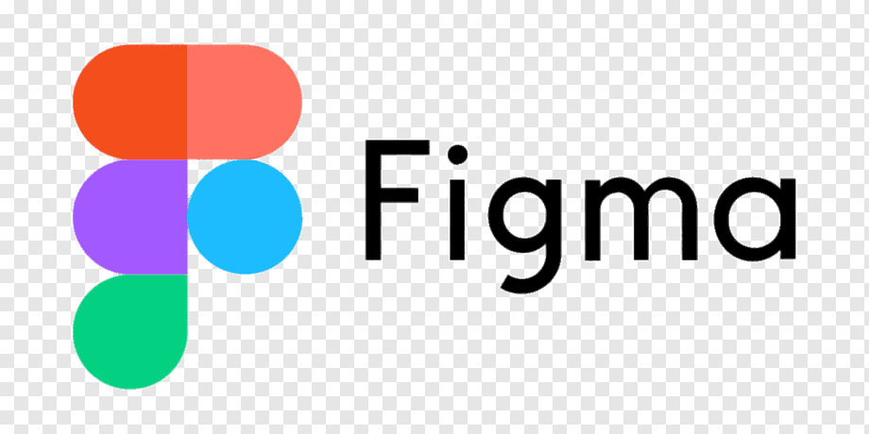

Figure Logo of the user interface design tool figma

* **Register**
* **Login**
* **Dashboard**
* **Cash in flow**
* **Cash out flow**

# Data Entity Modeling

Entities are central to data modeling, acting as the core elements around which data structures and relationships are built. Identifying and defining entities helps create a clear and organized representation of the domain, making it easier to manage and analyze data effectively

## ERD of my project

# Technology Stack

A tech stack refers to the collection of technologies, tools, and frameworks used to create an application. It includes programming languages, databases, front-end and back-end frameworks, APIs, and other essential components. The decisions made when choosing a tech stack can greatly influence the types of features you can implement and the expertise required to develop and maintain the application.

* Technology used to develop the Fynsync are mentoned below:

**Framework:** MAUI Blazor Hybrid.

**External Libraries:** Newtonsoft.Json.

**Persistence Mechanism:** File handling using JSON.