

**Module Code & Module Title**

**CS6PO5NT-Final Year Project**

**Assessment Weightage & Type**

**Final Year Project Proposal (5%)**

**Year and Semester**

**2024**

**Student Name: Anish Puri**

**London Met ID: 22072057**

**College ID: NP05CP4A220016**

**Assignment Submission Date: 11/04/2024**

**Internal Supervisor: Nikesh Regmi**

**External Supervisor: Binit Koirala**

**Title: Niji Salon**

*I confirm that I understand my coursework needs to be submitted online via Google Classroom under the relevant module page before the deadline for my assignment to be accepted and marked. I am fully aware that late submissions will be treated as non-submission and a mark of zero will be awarded*

**Table of Contents**

1 Introduction 1

1.1 Introduction to Topic 1

1.2 Problem Scenario 2

1.3 Project as a solution 3

2 Aims and Objectives 6

2.1 Aims 6

2.2 Project Objective’s 6

3 Expected Outcomes and Deliverables 7

4 Projects risks, Threats and Contingency plans 9

5 Methodology 11

5.1 Considered Methodologies 11

5.2 Selected Methodology 11

5.2.1 SCRUM Methodology 11

6 Resource Requirements 15

6.1 Hardware Requirements 15

6.2 Software Requirements 15

7 Work Breakdown Structure 16

8 Milestones Chart 17

9 Project Gantt Chart 18

10 Conclusion 19

11 Bibliography 20

**Table of Figures**

Figure 1Scrum Methodology 12

Figure 2 WBS of Niji Salon 16

Figure 3 Milestones of my Project Niji Salon 17

Figure 4 Gantt chart 18

**Table of Tables**

Table 1Projects Risks Threats and Contingency Plans 9

Table 2Comparison Niji SAlon with MenSpire 13

# Introduction

## Introduction to Topic

In the dynamic world of beauty and personal care, convenience and innovation are key to enhancing client satisfaction and operational efficiency. Much like other service-based industries, the salon sector thrives on seamless integration of technology to deliver superior experiences. With this in mind, Niji Salon emerges as a transformative platform designed to revolutionize how clients interact with beauty services.

The increasing demand for streamlined services has led to the development of various booking systems across different sectors. Salons, which often face challenges in managing appointments, customer satisfaction, and employee scheduling, can greatly benefit from an efficient digital booking system. This project will focus on creating a salon booking app that allows users to book appointments for haircuts and other services, while salon workers can easily manage their schedules.

The global salon services market, valued at approximately USD 215.65 billion in 2022, is projected to grow to USD 383.88 billion by 2030, with a CAGR of 7.55% during the forecast period. This growth is driven by rising consumer spending on personal grooming and technological innovations in salon management. The salon industry's value chain spans diverse services such as hair care, skin care, and nail care, with increasing demand for quality and personalized experiences. This evolution underscores the potential for substantial future development in salon management and service delivery (Beauty and PErsonal Cares, 2024).

Niji Salon revolutionizes beauty services with features like appointment booking, advance payments, AI-driven recommendations, and a real-time chat system. Clients enjoy personalized experiences with services ranging from haircuts to skincare, while the Admin Portal and notification system streamline salon management. Designed for convenience and growth, Niji Salon bridges modern technology with traditional salon practices, enhancing the beauty industry in Nepal and beyond.

## Problem Scenario

Nepal's salon industry is experiencing rapid growth, but it faces several operational challenges that hinder its efficiency and customer satisfaction. Despite high mobile penetration at 94%, digital adoption in salon management remains low, leaving significant untapped potential for technological solutions. Salons often struggle with inefficient appointment scheduling, leading to double bookings and missed appointments, while the absence of a centralized system to track client preferences affects personalized service. Additionally, inventory management issues, such as stockouts of popular products, disrupt services and sales, causing frustration for both staff and clients (Real Therapy, 2024).

Staff and financial management challenges, such as scheduling conflicts and high turnover, impact service quality and increase costs. Marketing efforts are often ineffective, leading to low customer engagement. Additionally, data security issues pose risks to client information. A robust salon management system can resolve these problems, improving efficiency, customer service, and driving growth in Nepal's salon industry.

* **Limited digital payment adoption:** Despite the growing preference for cashless transactions globally, many salons in Nepal still rely on traditional cash-based payments, creating inconvenience for tech-savvy clients and potential disputes during transactions.

* **Inconsistent appointment management:** Salons often struggle with overbooking, miscommunication, or no-shows due to manual booking methods, leading to inefficiency and customer dissatisfaction.

* **Lack of personalized service recommendations:** Clients often face challenges in finding services tailored to their specific needs, as most salons lack advanced tools to analyze and suggest appropriate offerings based on individual preferences.

* Inventory mismanagement: Salons frequently encounter issues like running out of essential products or overstocking unnecessary items due to the absence of a centralized inventory management system, affecting service quality and profitability.

* **Limited communication channels:** Poor communication between clients and salons—whether for clarifications, rescheduling, or feedback—leads to frustration and missed opportunities to enhance customer satisfaction.

* **Difficulty in accessing notifications and updates**: Clients often miss important updates about their appointments, promotional offers, or service changes due to ineffective notification systems, reducing engagement and retention.

* **Challenges in employee scheduling and task management:** Inefficient systems for managing staff schedules and workloads result in operational bottlenecks, affecting the overall customer experience.

* **Inadequate support for customer engagement:** Salons lack tools for maintaining consistent engagement with clients post-service, such as reminders, personalized promotions, or loyalty programs, which limits client retention and satisfaction.

## Project as a solution

Niji Salon faces several operational challenges that impact its efficiency and customer satisfaction. To address these issues, a robust salon management system is proposed to streamline processes, enhance client experiences, and support business growth through key functionalities are given below:

* **Appointment Scheduling**: For appointment scheduling, an online booking system can simplify the process for clients, minimizing risks of double bookings and missed appointments. Automated reminders sent via SMS or email can further reduce no-shows, ensuring a smooth and organized scheduling experience.
* **Customer Service**: In terms of customer service, maintaining a centralized client database will allow the salon to track preferences, service history, and feedback, enabling a personalized and satisfying experience. Loyalty programs and tailored offers can further enhance customer retention and attract new clients.
* **Inventory Management**: Inventory management can be improved with real-time tracking of product usage to prevent stockouts or overstocking. Automated reordering for popular items will ensure essential products are always available, avoiding disruptions in services.
* **Staff Management**: For staff management, digital scheduling tools can optimize shift planning, reduce conflicts, and maintain adequate staffing during peak hours. Regular training programs will help improve staff skills and reduce turnover, ensuring consistent service quality.
* **Financial Management**: In financial management, automated payroll systems can streamline payments, reduce errors, and eliminate disputes. Additionally, accounting software can efficiently manage finances, track expenses, and generate detailed financial reports.

* **Marketing and Customer Retention:** Marketing and customer retention strategies can benefit from targeted campaigns using insights from the client database to boost engagement. Integrating social media platforms will also help promote services, share updates, and maintain client interactions effectively.
* **Data Security**: data security is critical, requiring secure storage systems with regular backups to prevent data loss. Implementing strong privacy measures will ensure compliance with regulations and safeguard client information, building trust and reliability

.

* **Chat System:** A real-time chat feature will improve communication, allowing clients to make inquiries, request services, and receive updates instantly. This will enhance overall client engagement and satisfaction.
* **Haircut Recommendation:** An AI-driven haircut recommendation system will suggest hairstyles based on client preferences, facial features, and trends, offering a more personalized and enjoyable experience.
* **Admin Portal**: A centralized admin portal will empower salon managers to oversee all operations, including appointment scheduling, inventory tracking, staff management, and financial reports, ensuring efficient business management.

# Aims and Objectives

## Aims

The primary goal of this project is to develop a comprehensive salon management system that simplifies and enhances the operations of Naji Salon. The application aims to provide a seamless, user-friendly interface that facilitates efficient appointment scheduling, inventory management, and customer service. By streamlining these processes, the platform will improve the overall experience for both clients and staff, making salon management more efficient and accessible. The ultimate objective is to create a robust solution that addresses the key challenges faced by Naji Salon, promoting greater customer satisfaction and business growth.

## Project Objective’s

* Gain comprehensive knowledge of web application development by learning tools, techniques, and best practices for creating a salon management system.
* Improve time management skills by prioritizing tasks, meeting deadlines, and efficiently allocating resources throughout the project lifecycle.
* Conduct in-depth research to make informed decisions and apply industry best practices to the project.
* Explore and gain hands-on experience with various libraries and frameworks to select the most suitable tools for developing the application.
* Develop a user-friendly platform that simplifies appointment scheduling and enhances the overall salon experience for clients.
* Learn how to integrate third-party APIs to expand the application's functionality, such as for payment processing, notifications, or AI recommendations.
* Design and implement a robust database system to ensure efficient storage, retrieval, and security of client and business data.
* Streamline salon operations by automating processes like appointment booking, inventory tracking, and client management, reducing manual effort and errors.
* Gain practical experience in creating UML diagrams and other design artifacts to document and communicate the system's architecture effectively.

# Expected Outcomes and Deliverables

The goal of this project is to create a comprehensive salon management system for Naji Salon. Upon completion, the application will deliver the following features and functionalities:

* Online Appointment Booking: The system will enable clients to book appointments online, reducing scheduling conflicts and missed bookings while improving overall efficiency.
* Reminder Notifications: Automated reminders sent via SMS or email will help clients remember their appointments, minimizing no-shows and improving time management
* Client Database: A centralized client database will store preferences, service history, and feedback, allowing for personalized services and enhanced customer satisfaction.
* Inventory Management: Real-time tracking will monitor product usage and prevent shortages or overstocking, ensuring uninterrupted service delivery
* Financial Management: Integrated accounting software will streamline financial management, including expense tracking, payroll, and report generation.
* Social Media Integration: Social media platforms will be integrated to promote salon services, share updates, and engage with customers effectively.
* Data Security: Secure storage and regular backups will safeguard client and business data, reducing the risk of loss or breaches.
* Privacy Compliance: The system will ensure compliance with data privacy regulations, protecting client information and building trust.
* Chat System: A real-time chat feature will enable instant communication, allowing clients to inquire, request services, and receive updates seamlessly.
* Haircut Recommendation: An AI-driven recommendation feature will suggest hairstyles based on client preferences, facial features, and current trends, enhancing personalization.
* Admin Portal: A centralized admin portal will empower managers to oversee all salon operations, including appointment scheduling, inventory management, staff coordination, and financial reporting, ensuring smooth and efficient business management.

**Deliverables:**

This project aims to develop a comprehensive salon management system for Naji Salon, providing a seamless, user-friendly platform to streamline appointment scheduling, inventory management, and customer service. By integrating features such as automated booking, real-time inventory tracking, and targeted marketing campaigns, the system will enhance operational efficiency, improve customer satisfaction, and drive business growth, ultimately creating a more successful and sustainable salon business.

# Projects risks, Threats and Contingency plans

Table 1Projects Risks Threats and Contingency Plans

|  |  |  |  |  |  |
| --- | --- | --- | --- | --- | --- |
| S.N. | Risks and Threats | | Probability | Impact | Contingency Plan |
| 1 | Potential data loss due to system  malfunction | | Low | High | Regularly back up data to secure locations and implement automated backup systems to mitigate significant losses. |
| 2 | Difficulty in  implementing advanced features  (e.g., Live Chat, AI) | | High | High | Seek advice from experts, use online resources, and get regular guidance from supervisors to tackle complex features. |
| 3 | Challenges in maintaining user engagement | | Medium | Medium | Continuously update features based on user feedback and market trends to keep the platform engaging and relevant. |
| 4 | Difficulty in finding appropriate online resources | | Low | Medium | Enhance research efforts by consulting with peers, supervisors, and using credible online resources. |
| 5 | Identifying and fixing bugs during development | | High | High | Conduct thorough testing throughout the development process and seek help from experienced developers if needed. |
| 6 | User Interface (UI) usability issues | | Medium | High | Regularly gather user feedback and iteratively improve the UI based on |
|  |  |  |  |  | usability testing and insights. |
| 7 | Ensuring platform compatibility | cross- | Medium | Medium | Research and adopt frameworks and libraries that support flexible and seamless cross-platform functionality. |

# Methodology

## Considered Methodologies

* Waterfall Methodology: A structured development approach where each phase of development is completed before moving to the next. This was considered but found less flexible for an evolving app.
* Agile Methodology: An iterative and incremental model that allows for flexibility and continuous improvement. It will be ideal for this project as it allows for changes based on user feedback.

## Selected Methodology

### SCRUM Methodology

Scrum is an Agile framework chosen for this project due to its iterative nature, flexibility, and focus on delivering high-quality software in short, incremental cycles. Scrum enables teams to respond to changes quickly and efficiently, which is crucial for an app development project where user feedback and evolving requirements are frequent (Maloney, 2024).

**Key features of Scrum:**

* **Sprints**: The project will be divided into short cycles called sprints, typically lasting 2-4 weeks. Each sprint will focus on delivering a specific set of features or functionality (Rehkopf, 2024).
* **Scrum Roles**:
  + **Product Owner**: The individual responsible for defining the project vision, prioritizing features, and ensuring that the team delivers value to the users.
  + **Scrum Master**: This person ensures the team follows Scrum practices and removes any obstacles hindering progress.
  + **Development Team**: The group responsible for the actual development of the app, including coding, testing, and deployment.
* **Daily Stand-ups**: Short daily meetings where the development team shares progress, challenges, and plans for the day, ensuring transparency and quick problem-solving.
* **Backlog Management**: Features and tasks are placed in a backlog and prioritized based on their value and urgency. The team works on the most important features first.
* **Review & Retrospective**: At the end of each sprint, a review is conducted to assess the work done, and a retrospective allows the team to reflect on the sprint and identify improvements for the next one (What is Scrum?, 2024).

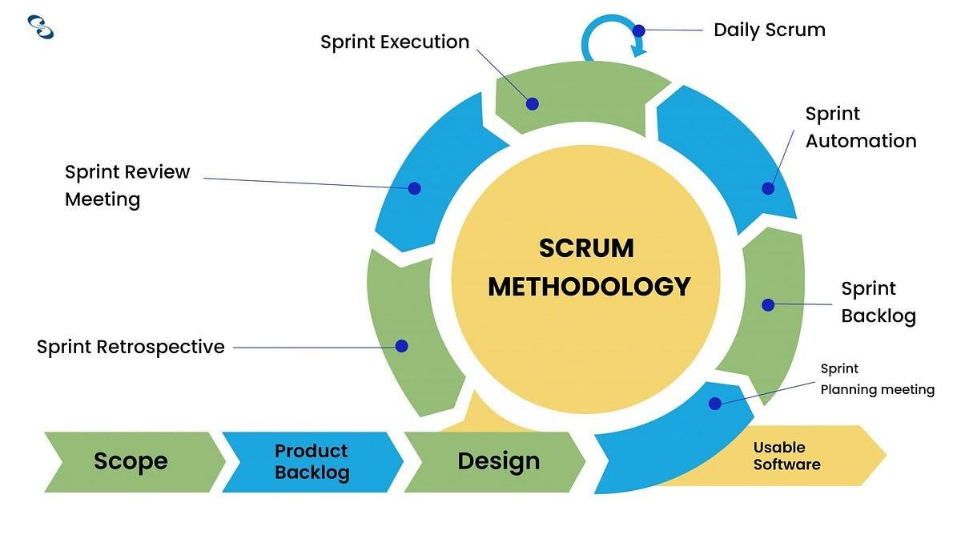

Figure 1Scrum Methodology

**Comparison Niji Salon with MenSpiri**

Table 2Comparison Niji SAlon with MenSpire

|  |  |  |  |  |
| --- | --- | --- | --- | --- |
| Feature | Menspire | Naji Salon | | Advantage |
| Online Booking  System | Yes, allows booking and rescheduling | Yes, automated booking system with reminders | | Naji Salon's system includes automated reminders to  minimize no-shows |
| Grooming  Services | High-quality, awardwinning services | High-quality personalized services |  | Both offer high-  quality services, but Naji Salon focuses on personalized  client preferences |
| Product Line | Exclusive grooming products | Real-time inventory tracking automated reordering | and | Naji Salon ensures continuous availability of popular products with automated  reordering |
| Secure  Transactions | Secure online  transactions | Secure storage privacy compliance | data and | Naji Salon emphasizes data protection and regular backups to prevent data loss |
| Customer  Engagement | Active social media and newsletters | Targeted marketing campaigns and social media  integration | | Naji Salon uses  data-driven  marketing to  increase  engagement and  retention |
| AI for Hair  Suggestions | Not mentioned | Uses AI to  provide personalized hair suggestions based on client preferences and trends | | Naji Salon leverages AI to enhance customer experience with personalized hair suggestions |

# Resource Requirements

## Hardware Requirements

• High-performance Laptop for making the platform.

## Software Requirements

* Backend: Node.js for server-side development.
* Frontend: React for user interface.
* Database: MySQL for data management.
* Communication: WebSocket for real-time chat functionality.
* Vs Code: For Coding
* GitHub: for the Code backup as well as to track the progress by the supervisor.
* Tailwind CSS

# Work Breakdown Structure

The Work Breakdown Structure (WBS) will outline the project’s phases:

* Planning: Defining requirements, timelines, and setting up the development environment.
* Design: Creating wireframes and UI/UX design for both user and worker interfaces.
* Development: Coding the backend and frontend of the app, integrating payment systems, and testing.
* Testing and Deployment: Ensuring the app works correctly, followed by deployment to app stores.
* Feedback & Iteration: Gathering user feedback and making necessary adjustments to improve the app.

Link to My WBS: [https://drive.google.com/file/d/1npr-EBmcv1eBskoXdxIV2r1zuzZuExr/view?usp=sharing](https://drive.google.com/file/d/1npr-EBmcv1-eBskoXdxIV2r1zuzZuExr/view?usp=sharing)

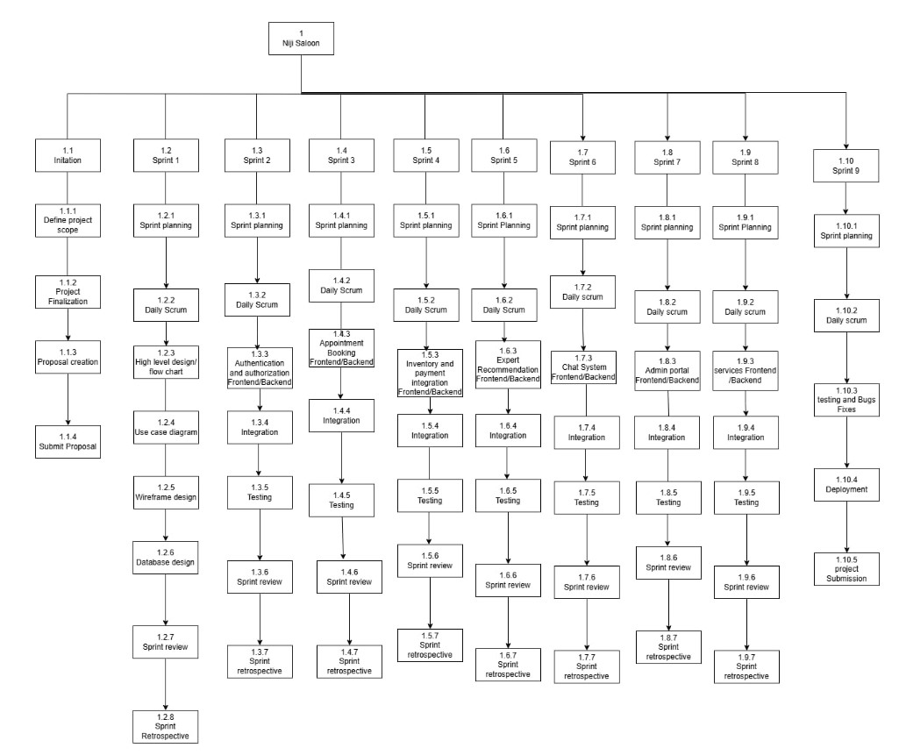

Figure 2 WBS of Niji Salon

# Milestones Chart

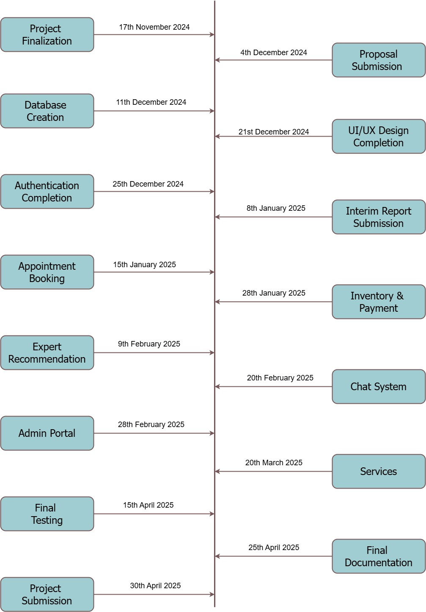

Figure 3 Milestones of my Project Niji Salon

# Project Gantt Chart

Link to Gantt Chart:

[https://drive.google.com/file/d/173zbuYWy_8_aycZHOF4ajx4Xb2x7gxyg/view?usp=shar ing](https://drive.google.com/file/d/173zbuYWy_8_aycZHOF4ajx4Xb2x7gxyg/view?usp=sharing)

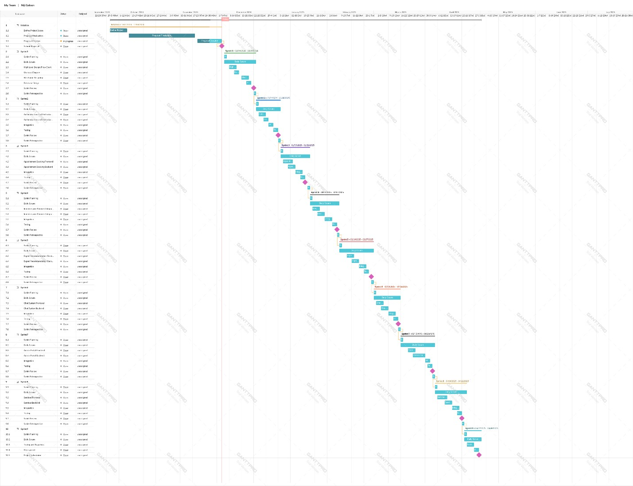

Figure 4 Gantt chart

# Conclusion

This proposal outlines the plan to develop an efficient and user-friendly salon booking app. By automating the booking process and enabling better communication between customers and salon workers, the app aims to improve operational efficiency and customer satisfaction. This project will provide valuable experience in app development and project management, while offering a solution to a common problem faced by salons.

# Bibliography

Beauty and PErsonal Cares. (2024, 11 15). *Salon Services Market Size, Share & COVID-*

*19 Impact Analysis, By Service Type (Hair Care, Nail Care, and Skin Care), By*

*End-user (Women and Men), and Regional Forecast, 2023-2030*. From Fortune Bussiness Insights: https://www.fortunebusinessinsights.com/salon-servicemarket-104608

Korkut, T. (2024, 11 28). *Excelling in Software Development with Scrum Methodology Part 2*. From Medium: https://blog.stackademic.com/excelling-in-softwaredevelopment-with-scrum-methodology-part-2-e2d0b29437ce

Maloney, R. S. (2024, 11 25). *What is scrum?* From Scrum Alliancer:

https://www.scrumalliance.org/about-scrum

Real Therapy. (2024, 05 22). *Challenges & Opportunities for Beauty and Spa Industries in Nepal*. From Challenges For the Spa Industry in Nepal :

https://nepalmassage.com/blog/challenges-opportunities-for-beauty-and-spaindustries-in-nepal

Rehkopf, a. (2024, 11 25). *What are sprints in project management?* From Softwarer Development: https://www.atlassian.com/agile/scrum/sprints

What is Scrum? (2024, 11 28). *What are sprints in project management?* From Software Development: https://www.atlassian.com/agile/scrum/sprints