# Introduction

Artificial Intelligence (AI) is a powerful technology that gives computers the ability to think and learn, much like humans do. It is not just about making machines do tasks automatically it is about creating systems that can understand situations, make decisions, and solve problems. AI allows machines to perform a variety of tasks from recognizing faces and driving cars to diagnosing diseases and managing complex systems. (NASA, 2024)

In simple terms, AI helps create smart machines. These machines use special programs and data to carry out tasks without being directly told what to do instead learning from patterns they observe. As AI develops, it is becoming a crucial tool in many fields changing the way things are done by making processes faster and more accurate. This helps save time on routine jobs and lets people focus on more complex and creative work. This proposal will look at how AI can change healthcare, particularly in detecting and treating diseases early (google cloud, 2024). Artificial Intelligence (AI) can be understood in three main types, each varying in complexity and capability:

* Narrow AI is often called Weak AI is what we commonly see today. It is designed for specific tasks such as recognizing speech, identifying images or running search engines. Narrow AI is limited it operates only within its set tasks and does not mimic human intelligence broadly or make decisions on its own.
* General AI or Strong AI is a type still in development this kind of AI aims to perform any intellectual task that a human can do. It would not only carry out tasks it was specifically programmed for but could also handle new, unfamiliar situations by thinking and learning the way humans do.
* Superintelligent AI which remains theoretical this form of AI would surpass human intelligence in every way, from creativity and emotional insight to problem-solving. The idea of Superintelligent AI brings excitement for its potential but also raises significant ethical and practical concerns, as it could outperform human capabilities by a large margin. (Free learning platform for better future, 2024)

## Explanation of the topic/AI concepts used

Humans have always been curious about replicating intelligence and decision-making in machines. Artificial Intelligence (AI) emerged as a field to create systems that can think learn and make decisions. Over the years, AI has become a transformative technology especially in fields like healthcare where it helps analyze complex data identify patterns and predict outcomes. These capabilities make AI an essential tool for solving critical problems, such as the early detection of diseases. (foresee medical, 2024)

A key area within AI is Machine Learning (ML) which allows computers to learn from data and improve their performance without being explicitly programmed. ML works by training models on data to identify patterns and relationships between input features and desired outcomes. In this project, supervised learning a type of ML is used. Supervised learning involves training models on labeled datasets where the input data such as medical attributes is paired with known outcomes like whether or not a patient has heart disease. (chirag, 2024)

This project utilizes three machine learning algorithms Logistic Regression, Decision Tree and Random Forest. Logistic Regression is a simple and effective algorithm for binary classification predicting whether a patient is at risk of heart disease based on input features like cholesterol levels and blood pressure. Decision Tree breaks data into smaller branches based on key features creating a clear step-by-step model that is easy to interpret. Random forest builds on the Decision tree by combining multiple trees increasing accuracy and reducing errors making it highly reliable for complex datasets. (Logabiraman, 2024)

By applying these machine learning techniques this project aims to develop an accurate and practical heart disease prediction system. The integration of AI in healthcare demonstrates its potential to improve early diagnosis and assist healthcare providers in making informed decisions ultimately enhancing patient outcomes.

## Explanation/introduction of the chosen problem domain/topic

Heart disease is a major global health concern and remains one of the leading causes of death worldwide. According to the World Health Organization (WHO) cardiovascular diseases account for approximately 17.9 million deaths annually, representing nearly 31% of all global deaths. Among these coronary artery disease, heart attacks and heart failure are the most prevalent. Despite advancements in medicine many cases of heart disease go undiagnosed until they progress to severe stages where treatment options become limited, expensive and less effective. The growing prevalence of heart disease is further compounded by lifestyle changes an aging population and increased prevalence of risk factors such as obesity, diabetes and hypertension. (World Heart Federation , 2023)

The primary challenge lies in the early and accurate prediction of heart disease which can significantly improve patient outcomes. Traditional diagnostic approaches involve clinical evaluations such as blood pressure monitoring, cholesterol measurement and physical examinations combined with medical history and lifestyle assessments. While these methods are effective, they are time consuming, resource-intensive and often fail to capture the complex relationships among multiple risk factors. This limitation makes it difficult to identify high-risk individuals early enough to implement preventive measures or interventions. (El-Sofany, 2024)

Historically, the inability to analyze vast amounts of patient data efficiently has hindered early detection efforts. However, with the rise of advanced data analysis techniques and increased availability of electronic health records there is an opportunity to utilize machine learning (ML) to address these challenges. ML algorithms can process large datasets quickly, identify patterns and correlations that may not be obvious through traditional methods and provide predictions with high accuracy. These capabilities make ML a powerful tool for improving heart disease prediction. (Srinivasan, 2023)

The current problem scenario is driven by a growing burden on healthcare systems due to the increasing number of heart disease cases. Late-stage detection often leads to higher treatment costs, more intensive interventions and poorer patient outcomes. Moreover, the lack of efficient data-driven tools in many clinical settings exacerbates this issue leaving healthcare providers reliant on manual evaluations that may not always yield timely results. (Weintraub, 2023)

This project addresses these challenges by leveraging AI and machine learning to develop a predictive model for heart disease. By analyzing patient attributes such as age, gender, blood pressure, cholesterol levels and other risk factors. The system aims to provide an early and accurate assessment of heart disease risk. This approach not only enhances early detection but also supports healthcare providers in making informed decisions ultimately improving patient outcomes and reducing the burden on healthcare systems. (El-Sofany, 2024)

# Background

Heart disease is a major cause of death around the world making it crucial to find ways to catch it early. Traditional methods for predicting heart disease look at risk factors such as age, cholesterol levels, and whether someone smokes. However, these methods might not fully capture how different risk factors interact over time. Heart diseases including coronary artery disease, heart attacks and heart failure are some of the leading causes of death worldwide. According to the World Health Organization (WHO), these diseases cause about 17.9 million deaths every year. This has led to a strong focus on early detection and prevention as key strategies in combating heart disease. (MyCardiologist, 2023)

Machine learning a type of artificial intelligence is proving to be a valuable tool in healthcare. It can sift through large amounts of data and spot patterns that might not be obvious. This is especially helpful for heart disease where early detection and personalized treatment plans can make a big difference. (Coursera, 2024)

Researchers have been using machine learning models like logistic regression and neural networks to analyze health data and predict heart disease. These models have shown promise but there are still challenges to overcome especially, in getting doctors to trust and understand how these models work. (R., 2023)

This project aims to develop a machine learning model that is not only accurate in predicting heart disease but also easy for doctors to use in their everyday work. Improving both the accuracy and usability of the model could significantly impact how we prevent and manage heart disease.

## A paper with text on it Description automatically generatedResearch work done on the chosen topic/problem domain

Figure 1: Search on heart disease prediction using machine learning

The research paper “Heart Disease Prediction Using Machine Learning Techniques”: A Survey explores how machine learning (ML) can help predict and diagnose heart diseases. Cardiovascular diseases like coronary artery disease and heart attacks are among the top causes of death worldwide. According to the World Health Organization (WHO) these diseases lead to millions of deaths every year. Early detection and prevention are essential in addressing this issue and machine learning has proven to be a valuable tool for analyzing large complex medical data to support this effort.

The paper reviews different machine learning methods used for predicting heart diseases summarizing their benefits and limitations:

* Naïve Bayes: A straightforward and fast algorithm that works well for classification but assumes that all features are independent, which might not always be the case.
* Support Vector Machines (SVM): Known for high accuracy, SVMs are used to classify data by finding the best boundaries between categories.
* K-Nearest Neighbors (KNN): A simple method that predicts outcomes based on the closest data points, often used when there is little prior knowledge about how the data is structured.
* Decision Trees: These divide data into smaller groups based on important features, but they can sometimes overfit, meaning they perform well on training data but not on new data.
* Random Forests: A method that uses multiple decision trees together to improve accuracy and avoid overfitting.
* Ensemble Models: These combine different algorithms to deliver better predictions than a single model on its own.

The study also discusses the importance of dimensionality reduction which simplifies data by focusing only on the most important features. This step helps reduce the complexity of calculations and improves the model’s ability to make accurate predictions without overfitting.

The paper concludes that machine learning shows great promise for improving the accuracy and speed of heart disease predictions. However, challenges remain, such as managing large datasets, making complex models easier to understand, and avoiding overfitting. More research is needed to refine these techniques and ensure they work effectively in real-world healthcare settings.

This study highlights the potential of machine learning to transform how we predict and manage heart disease making it easier to catch early signs and provide better care. (Ramalingam, 2018)

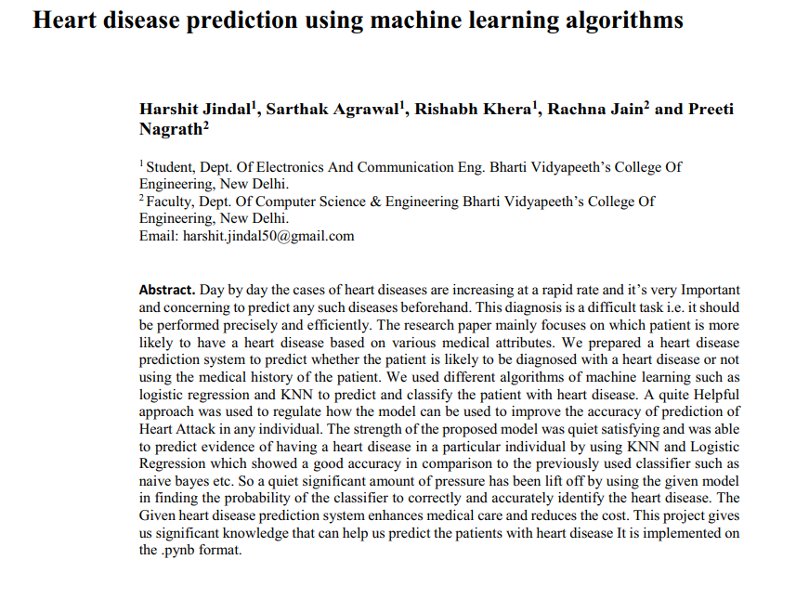

Figure 2:Search on heart disease prediction using machine learning algorithms

The research paper addresses the increasing prevalence of heart diseases globally and the need for effective, accurate, and affordable methods for early prediction. It proposes a heart disease prediction system (HDPS) that leverages machine learning algorithms to analyze patient data and identify individuals at risk. Early detection is crucial for timely treatment which can significantly improve outcomes and reduce healthcare costs.

The study utilized a dataset of 304 patients from the UCI repository, containing medical attributes such as age, gender, chest pain, blood pressure, cholesterol levels, and fasting blood sugar. Three machine learning algorithms—Logistic Regression, K-Nearest Neighbors (KNN), and Random Forest Classifier—were applied to classify patients as being at risk of heart disease or not.

**Key findings include:**

* Logistic Regression: A supervised learning algorithm suitable for binary classification tasks such as determining heart disease risk. It demonstrated strong performance in identifying patterns within the dataset.
* K-Nearest Neighbors (KNN): This algorithm achieved the highest accuracy, 88.52% by classifying patients based on their similarity to existing cases in the dataset.
* Random Forest Classifier: While robust and effective this ensemble method using multiple decision trees showed slightly lower accuracy compared to KNN and Logistic Regression.

The methodology included essential steps such as data preprocessing (handling missing values cleaning and normalization), training the algorithms, and evaluating their performance. The study emphasized that combining multiple machine learning models enhances prediction accuracy and reliability.

In conclusion, the research highlights the potential of machine learning in improving the early detection and diagnosis of heart diseases. Among the three algorithms tested KNN and Logistic Regression demonstrated superior accuracy and efficiency. The developed system offers a cost-effective and practical solution for healthcare aiding both medical professionals and patients by facilitating early diagnosis and personalized care. (nagrath, 2022)

## Review and analysis of existing work.

Many studies and projects have explored how machine learning (ML) can improve the prediction of heart disease. Researchers have used algorithms like Logistic Regression, Decision Tree, Random Forest, Support Vector Machines (SVM) and Neural Networks to create predictive models. These studies have shown that ML can analyze large amounts of data, identify patterns and make accurate predictions, often faster and more effectively than traditional methods. (Rindhe, 2021)

For this project, the Heart Disease Cardiovascular dataset from Hugging Face is used (available at Heart-Disease-Cardiovascular Dataset). This dataset includes important medical information such as age, gender, cholesterol levels, blood pressure and other health indicators. These attributes make it ideal for training machine learning models like Logistic Regression, Decision Tree and Random Forest ensuring the system is accurate and reliable.

Research has highlighted the effectiveness of these algorithms. Logistic Regression is simple and helps establish a clear relationship between features and outcomes making it suitable for binary classification tasks like predicting heart disease risk. Decision Tree organizes data into a structured easy-to-follow format allowing predictions to be explained step by step. Random Forest builds on this by combining multiple decision trees to improve accuracy and reduce errors making it a reliable choice for complex datasets. (Misra, 2023)

Proper preparation of the dataset is key to achieving good results. Preprocessing steps, such as normalizing data and selecting the most relevant features improve model performance and efficiency. Addressing challenges like imbalanced datasets, where there are fewer cases of heart disease compared to non-heart disease is also important to ensure the model predicts accurately for all groups. (Sami, 2021)

In conclusion, the existing research and the Heart Disease Cardiovascular dataset provide a strong foundation for this project. Using these resources and insights this project aims to create an accurate and user-friendly system for predicting heart disease helping healthcare providers detect risks early and make better decisions for patient care.

# Solution

The solution for this project is to develop a heart disease prediction system using machine learning algorithms to analyze patient medical data and predict the likelihood of heart disease. The system uses a dataset containing key medical attributes such as age, cholesterol levels, sex, chest pain type, and fasting blood sugar. The data is cleaned, preprocessed and normalized to ensure accuracy and reliability. Three machine learning algorithms are utilized Logistic Regression for its simplicity and effectiveness in binary classification. Decision tree which provides clear and interpretable decision making and Random Forest which enhances accuracy and reduces overfitting by combining multiple decision trees. The dataset is split into training and testing sets to evaluate the model using metrics like accuracy and precision. The best performing model is implemented into a user-friendly system where healthcare providers can input patient data and receive predictions. This solution aims to assist in the early detection of heart disease, improve treatment outcomes, and provide a cost-effective tool for healthcare professionals.

## Explanation of the proposed solution/approach to solving the Problem.

## Explanation of the AI algorithm/algorithms used.

### Explanation of the Logistic Regression algorithm.

**Logistic Regression:** Logistic Regression is a simple and commonly used machine learning algorithm for solving problems where the outcome has two categories such as predicting if someone is at risk of heart disease or not. It works by analyzing the relationship between input data (like age or blood pressure) and the likelihood of a particular outcome. Logistic Regression uses a mathematical function to estimate probabilities making it effective and easy to understand for prediction tasks. (Ciu, 2022)

### Explanation of the Decision Tree algorithm

**Decision Tree:** A Decision Tree is a machine learning algorithm that helps make decisions by breaking down data into smaller parts based on key features. It creates a structure like a flowchart where each step (or node) represents a decision based on a feature, and the branches lead to different outcomes. Decision Trees are easy to understand and visualize but they can sometimes make overly complex predictions if not managed carefully. Techniques like pruning or combining multiple trees can help improve their performance. (IBM, 2024)

### Explanation of the Random Forest algorithm

**Random Forest:** Random Forest is a more advanced method that uses many decision trees to make better predictions. Each tree in the "forest" looks at a random portion of the data and features and their results are combined to make the final prediction. This approach reduces errors and prevents overfitting (where the model performs well on training data but poorly on new data). Random Forest is reliable, works well with large datasets, and provides more accurate results than using a single decision tree. (Chaudhary, 2021)

## **Pseudocode of the solution**

### **Pseudocode** of the Heart Disease Prediction using the Logistic Regression.

IMPORT NumPy

IMPORT pandas

IMPORT training dataset

PRE-PROCESS dataset

HANDLE missing values

NORMALIZE numerical features

ENCODE categorical features

SELECT relevant features

SPLIT dataset

DIVIDE into training set and testing set

TRAIN model

INITIALIZE Logistic Regression model

FIT the model on the training dataset

FUNCTION predict_risk:

INPUT patient data

APPLY Logistic Regression model

CALCULATE probability of "at risk"

CALCULATE probability of "not at risk"

IF probability("at risk") > probability("not at risk")

RETURN "Patient is at risk of heart disease"

ELSE

RETURN "Patient is not at risk of heart disease"

END IF

EVALUATE model

CALCULATE accuracy

CALCULATE precision

CALCULATE recall

PRINT evaluation metrics

### **Pseudocode** of the Heart Disease Prediction using the Decision Tree.

IMPORT NumPy

IMPORT pandas

IMPORT training dataset

PRE-PROCESS dataset

HANDLE missing values

NORMALIZE numerical features

ENCODE categorical features

SELECT relevant features

SPLIT dataset

DIVIDE into training set and testing set

TRAIN model

INITIALIZE Decision Tree model

FIT the model on the training dataset

FUNCTION predict_risk:

INPUT patient data

APPLY Decision Tree model

CALCULATE prediction based on decision rules

IF prediction == "at risk"

RETURN "Patient is at risk of heart disease"

ELSE

RETURN "Patient is not at risk of heart disease"

END IF

EVALUATE model

CALCULATE accuracy

CALCULATE precision

CALCULATE recall

PRINT evaluation metrics

### **Pseudocode** of the Heart Disease Prediction using the Random Forest.

IMPORT NumPy

IMPORT pandas

IMPORT training dataset

PRE-PROCESS dataset

HANDLE missing values

NORMALIZE numerical features

ENCODE categorical features

SELECT relevant features

SPLIT dataset

DIVIDE into training set and testing set

TRAIN model

INITIALIZE Random Forest model

SET number of decision trees (e.g., n_trees = 100)

FIT the Random Forest model on the training dataset

FUNCTION predict_risk:

INPUT patient data

APPLY Random Forest model

CALCULATE majority vote from all decision trees

IF majority vote == "at risk"

RETURN "Patient is at risk of heart disease"

ELSE

RETURN "Patient is not at risk of heart disease"

END IF

EVALUATE model

CALCULATE accuracy

CALCULATE precision

CALCULATE recall

PRINT evaluation metrics

## Diagrammatical representations of the solution

### Diagrammatical representations of the solution from liner regression algorithm.

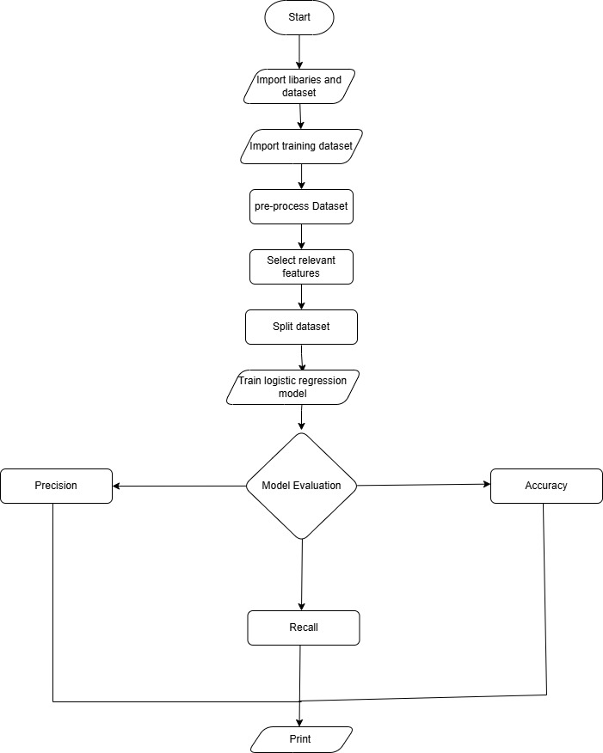

Figure Flowchart for the linear regression algorithm

### Diagrammatical representations of the solution using Decision Tree algorithm.

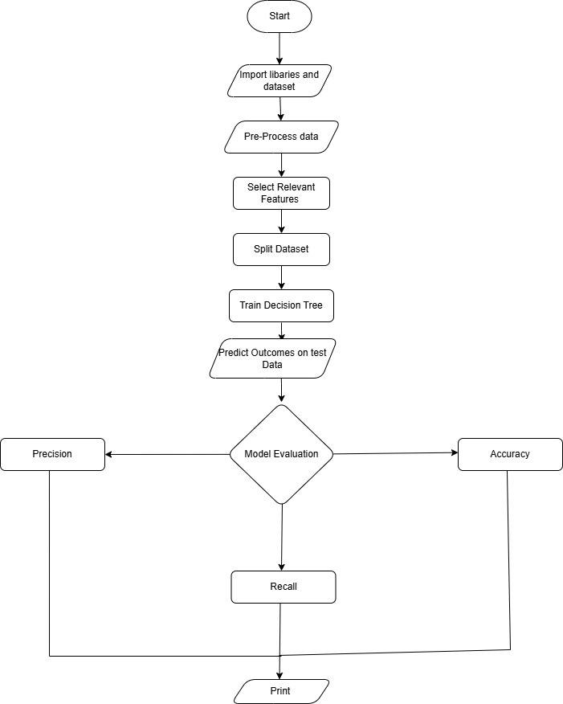

Figure Flowchart for the Decision Tree algorithm

### Diagrammatical representations of the solution using the Random Forest.

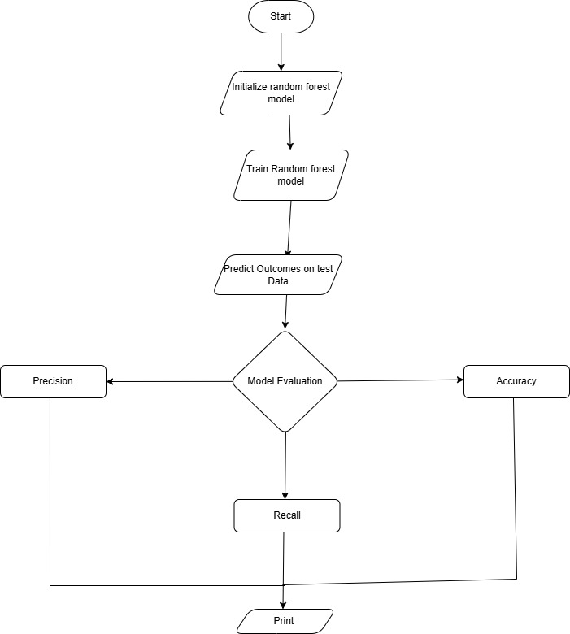

Figure Flowchart of the Random forest algorithm

# Conclusion

This project shows how machine learning can be a powerful tool in predicting heart disease which remains one of the leading causes of death worldwide. By using algorithms like Logistic Regression, Decision Tree and Random Forest the system is able to analyze important medical data and predict the likelihood of heart disease accurately. These predictions can help healthcare professionals detect risks early and take timely action to prevent serious complications.

The use of the Heart Disease Cardiovascular dataset provided valuable and diverse patient information which made it possible to train the system effectively. Preprocessing steps like cleaning the data and selecting the most important features ensured that the model focused on the key factors that contribute to heart disease, improving its accuracy and reliability.

This project highlights how AI and machine learning can transform healthcare by making disease prediction faster, more accurate and more affordable. While the system developed here provides strong results, there is room for further improvement. Expanding the dataset adding more patient features and improving the systems ease of use for medical professionals could make it even more effective.

In summary, this heart disease prediction system demonstrates how machine learning can address real-world healthcare challenges. With further development, tools like this can play an important role in improving early diagnosis, saving lives and reducing the burden on healthcare systems.

## Analysis of the work done

## How the solution addresses real world problems

## Further work