Software Design Specifications

For

A Visualization Tool for Analysing Student Scores
V1.0

Prepared by:

Bollam Siddharth
Backend Developer

Document Information

Title: A Visualization Tool for Analyzing Student Scores
Project Manager: | Document Version No: 1.0
 | Document Version Date: April 8, 2025
Prepared By: Bollam Siddharth | Preparation Date: April 8, 2025

Version History

Ver. No. Ver. Date Revised By Description Filename
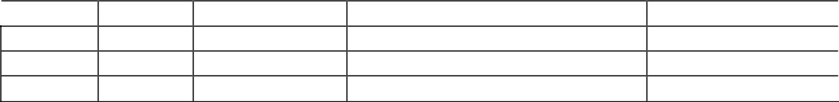

Table of Contents

1 INTRODUCTION ............................................................................................................................................................ |  | 4
1.1 | PURPOSE ...................................................................................................................................................................... | 4
1.2 | SCOPE .......................................................................................................................................................................... | 4
1.3 | DEFINITIONS, ACRONYMS, AND ABBREVIATIONS ........................................................................................................ | 4
1.4 | REFERENCES ................................................................................................................................................................ | 4

2 | USE CASE VIEW ............................................................................................................................................................ |  | 4
 | 2.1 | USE CASE ..................................................................................................................................................................... | 5
3 | DESIGN OVERVIEW ..................................................................................................................................................... |  | 6
 | 3.1 | DESIGN GOALS AND CONSTRAINTS ............................................................................................................................. | 6
 | 3.2 | DESIGN ASSUMPTIONS ................................................................................................................................................. | 6
 | 3.3 | SIGNIFICANT DESIGN PACKAGES ................................................................................................................................. | 6
 | 3.4 | DEPENDENT EXTERNAL INTERFACES ........................................................................................................................... | 6
 | 3.5 | IMPLEMENTED APPLICATION EXTERNAL INTERFACES ................................................................................................. | 6
4 | LOGICAL VIEW ............................................................................................................................................................. |  | 7
 | 4.1 | DESIGN MODEL ............................................................................................................................................................ | 7
 | 4.2 | USE CASE REALIZATION .............................................................................................................................................. | 7
5 | DATA VIEW .................................................................................................................................................................... |  | 8
 | 5.1 | DOMAIN MODEL .......................................................................................................................................................... | 8
 | 5.2 | D ATA MODEL (PERSISTENT DATA VIEW)...................................................................................................................... | 8
 | 5.2.1 Data Dictionary....................................................................................................................................................
6 | EXCEPTION HANDLING ............................................................................................................................................. |  | 8
7 | CONFIGURABLE PARAMETERS .............................................................................................................................. |  | 9
8 | QUALITY OF SERVICE ................................................................................................................................................ |  | 8
 | 8.1 | AVAILABILITY.............................................................................................................................................................. | 9
 | 8.2 | SECURITY AND AUTHORIZATION ................................................................................................................................. | 9
 | 8.3 | LOAD AND PERFORMANCE IMPLICATIONS ................................................................................................................... | 9
9 | 8.4 | MONITORING AND CONTROL ....................................................................................................................................... | 9

1 Introduction

1.1 Purpose

This document outlines the detailed software design for the Student Score Visualizer, a tool developed to help students and teachers analyze academic performance through colorful and interactive visualizations. It is intended for use by developers, project stakeholders, and evaluators.

1.2 Scope

The tool is designed for schools and educational institutions to visualize student performance using a web-based dashboard. It supports login functionality, teacher editing privileges, and student-only viewing mode. Features include heatmaps, GPA auto-calculation, and detailed subject analytics.

1.3 Definitions, Acronyms, and Abbreviations

● GPA: Grade Point Average
● UI: User Interface
● UX: User Experience
● API: Application Programming Interface
● CRUD: Create, Read, Update, Delete

1.4 References

● MongoDB Documentation
● Express.js and Mongoose Docs
● Chart.js / Recharts Visualization Libraries
● React.js Documentation

2 Use Case View

2.1 Use Case Actors

● Student
● Teacher
● Admin/IT Incharge

Use Cases:

● Login/Logout
● View Student Scores
● Add/Edit Student Data (Teacher)
● Visualize Performance via Charts
● View Score Heatmap
● GPA Auto-Calculation
● Export Performance Report
● Filter/Search by Subject or Student

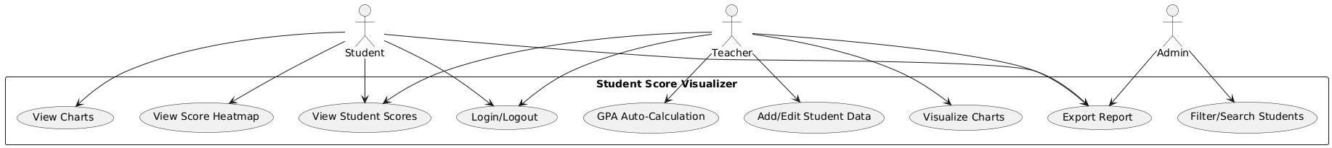

3 Design Overview

3.1 Design Goals and Constraints

● Modern and intuitive UI/UX
● Real-time GPA calculation
● Role-based access (Student: View-only, Teacher: Editable)
● Lightweight backend with Node.js and MongoDB
● Responsive and mobile-friendly design

3.2 Design Assumptions

● MongoDB will be used for data storage
● React.js will be used for frontend
● Teachers and Students have separate login roles

3.3 Significant Design Packages

● Frontend: React.js components (Dashboard, Charts, Login)
● Backend: Express.js API routes, Mongoose models
● Database: MongoDB collections (students, scores, users)

3.4 Dependent External Interfaces

The table below lists the public interfaces this design requires from other modules or applications.

External | Module Using the | Functionality/
Application | Interface | Description
and Interface
Name
MongoDB | Backend Server | Stores user and student score data

3.5 Implemented Application External Interfaces (and SOA web services)

The table below lists the implementation of public interfaces this design makes available for other applications.

Interface | Module | Functionality/
Name | Implementing | Description
 | the Interface
/api/students  /api/auth  /api/scores | Express API routes | Enables frontend to fetch and manipulate data

4 Logical View

4.1 Design Model

● Authentication: Login, Token Storage
● Dashboard: Summary Cards, Graphs
● Visualization: Heatmaps, Bar/Line Charts
● API: Handles requests and database communication

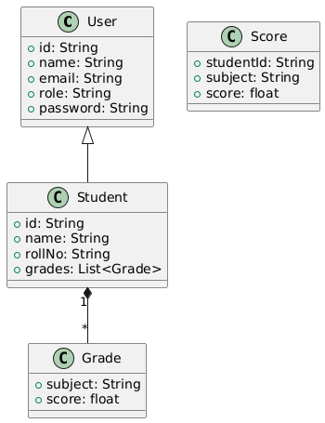

4.2 Use Case Realization

● Login: Calls backend to verify credentials and stores session
● View Scores: Fetches score data from /api/scores
● GPA Calc: Auto-calculated using backend logic during POST/PUT
● Charts: Rendered via Recharts based on fetched data

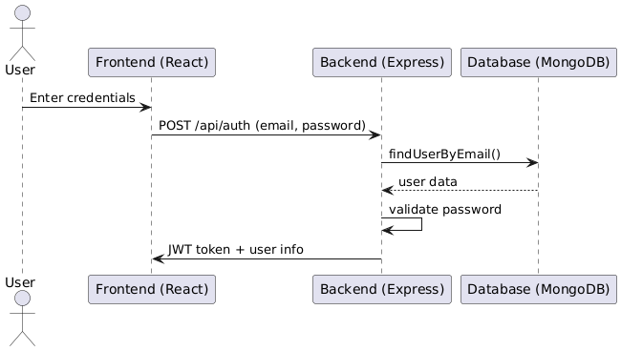

5 Data View

5.1 Domain Model

● User: { id, name, email, role, password }
● Student: { id, name, rollNo, grades: [{ subject, score }] }
● Score: { studentId, subject, score }

5.2 Data Model (persistent data view)
Each score document includes studentId, subject name, and score GPA is calculated dynamically based on available scores

5.2.1 Data Dictionary
● studentId: String – Link to student
● subject: String – Subject name
● score: Number – Score obtained

6 Exception Handling

● Invalid login: Return 401 Unauthorized
● Database errors: Return 500 Internal Server Error
● GPA calculation error: Return fallback GPA = 0.0
● Catch-all error middleware for backen

7 Configurable Parameters

This table describes the simple configurable parameters (name / value pairs).

Configuration Parameter Name | Definition and Usage | Dynamic?
PORT | Backend port number | Yes
MONGO_URI | Mongo DB connection string | No
JWT_SECRET | Secret for login session token | No

8 Quality of Service

8.1 Availability

The app will be hosted locally for development. Uptime depends on deployment server (Heroku, Vercel, etc.).

8.2 Security and Authorization

● JWT-based login authentication
● Role-based access (Student vs Teacher)
● Backend routes protected with middleware

8.3 Load and Performance Implications

● Optimized MongoDB queries
● Frontend loads data asynchronously
● Uses pagination for large datasets

8.4 Monitoring and Control

● Console logs for API monitoring
● MongoDB Compass for DB monitoring
● Optionally, third-party tools like Postman, LogRocket

