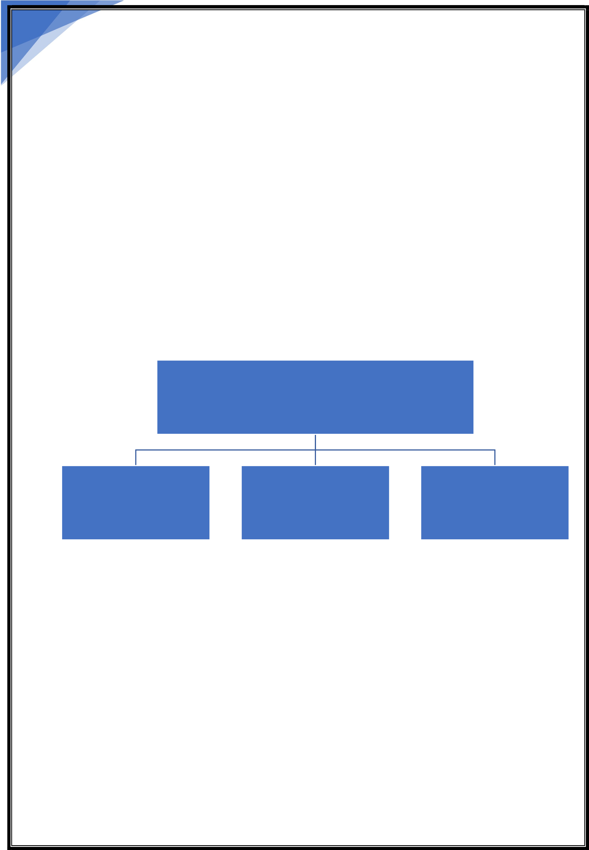

1

leCture – 1

Introduction to programming

**Programming** is a way to instruct the computer to perform various task.

Computers only understands Binary i.e., 0’s and 1’s.

Instructing computers in Binary i.e. 0’s and 1’s are very difficult for humans so, to solve this issue we have programming languages.

**Programming language: -** It is a computer language used by programmers to communicate with computers.

Types of Programming Languages

|  |  |  |
| --- | --- | --- |
| Procedural | Functional | Object- Oriented |

**Procedural**

Specifies a series of well-structured steps and procedures to compose a program.

Contains a systematic order of statements functions and commands to complete a task.

**Functional**

Writing a program only in pure functions i.e., never modify variables but only create new ones as an output.

Used in a situation where we have to perform lots of different operations on the same set of data like ML.

Community Classroom

Kunal Kushwaha

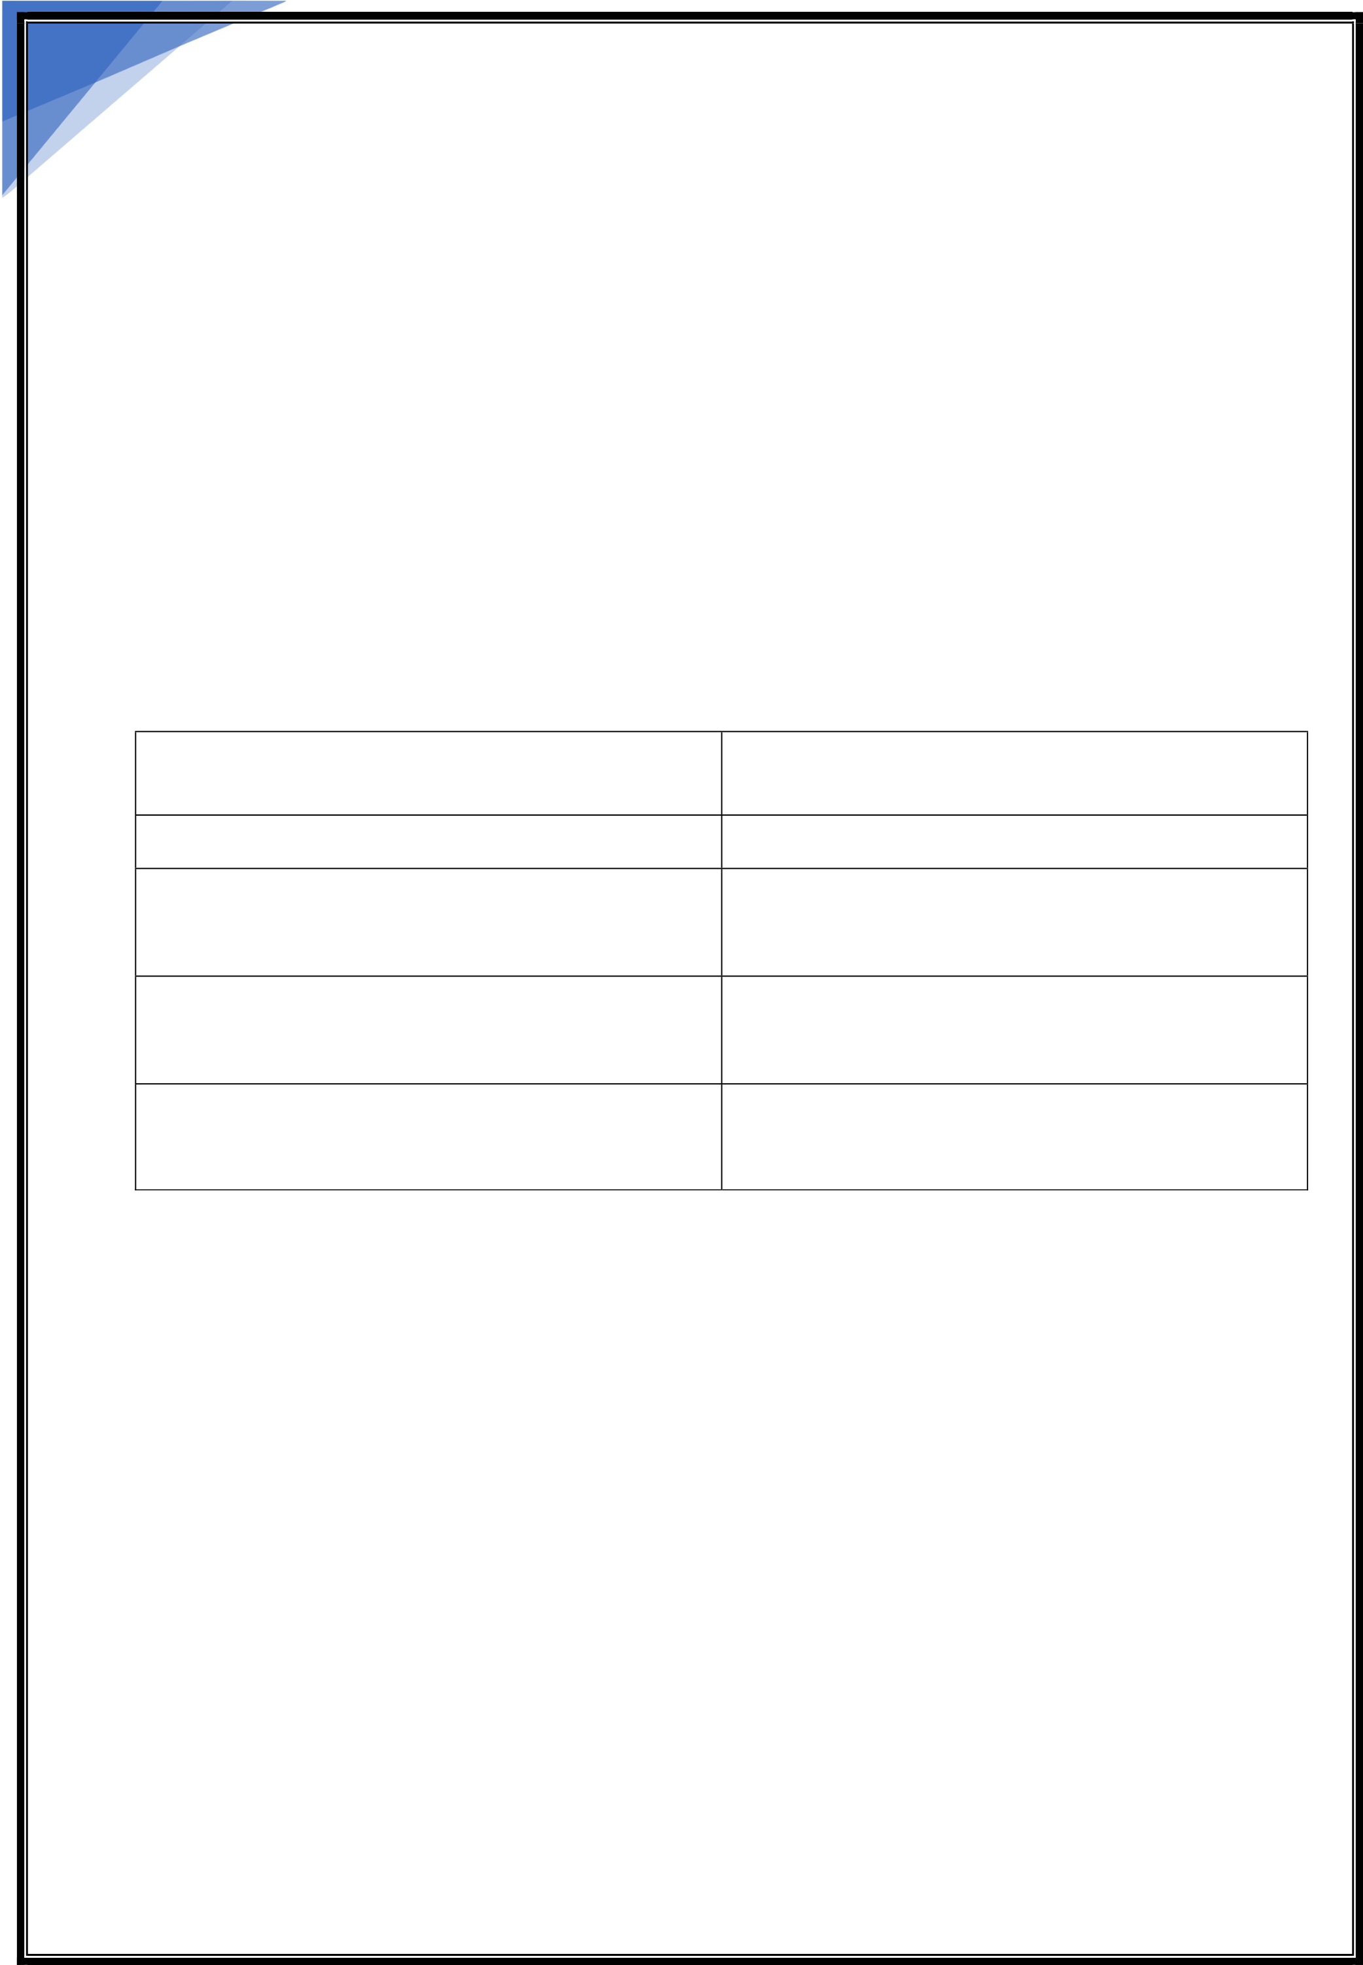

2

**Object Oriented**

Revolves around objects.

Code + Data = objects  
Developed to make it easier to develop, debug, reuse and maintain software.

*“One programming language can be of all 3 types like- Python”*

**Java Follows procedural and object oriented both types**

Static VS Dynamic Languages

Static Dynamic

Perform type checking at compile time

Errors will show at compile time

Declare datatypes before use

More control

Perform type checking at runtime   
Error might not show till programs run

No need to declare datatype of variables

Saves time in writing code but might give error at runtime.

Memory Management

There are 2 types of memory Stack and Heap   
When we declare a variable then the reference variable stored in stack memory points to the object of that variable stored in heap memory.

For ex:- 𝑎= 10   
Here “a” is called reference variable, and “10” is the object of That reference variable   
 Reference variable are stored in stack memory.

Heap memory stores the objects of reference variable.

Community Classroom

Kunal Kushwaha



3

Points to remember:-

➢More than one reference variable can points to the same object. ➢If any changes made to the object of any reference variable that will be reflected to all others variable pointing to same object.

➢If there is an object without reference variable then object will be destroyed by ***“Garbage Collection”***

Community Classroom

Kunal Kushwaha