PROJECT REPORT
Supermarket Sales &
Customer Analytics Dashboard
Interactive Data Analytics and Business Intelligence Application

Student: Ch. Lakshmi Mani Mala
Program: B.Tech - Computer Science / AI & ML
Development Environment: Visual Studio Code
Core Technologies: Python, Pandas, NumPy, Plotly, Streamlit
Project Type: Internship Project

2026

Acknowledgement
I would like to thank everyone who supported me during the development of this internship project. The project gave me an opportunity to apply data analytics concepts in a practical business setting rather than working only with isolated programming exercises. I also appreciate the guidance provided during the internship sessions, particularly the emphasis on selecting useful KPIs, understanding trends, and connecting analysis with business action.
The project was developed independently in Visual Studio Code using Python and a Streamlit-based dashboard. The work covered the complete flow from preparing the dataset to presenting the final analysis in a form that a non-technical business user can understand.

Contents
1. Abstract
2. Introduction
3. Problem Statement
4. Objectives
5. Dataset Description
6. Tools and Technologies
7. Project Methodology
8. Data Preparation
9. Dashboard Design
10. KPI and Business Analysis
11. Results and Findings
12. Business Recommendations
13. Limitations
14. Future Enhancements
15. Conclusion
16. References

1. Abstract
The Supermarket Sales & Customer Analytics Dashboard is an interactive data analytics and business intelligence application developed to turn supermarket transaction records into clear business information. The project works with transaction-level data covering products, quantity, price, revenue, costs, gross income, customer type, gender, payment method, location, date, time, and customer rating. The application first prepares the data for analysis and then presents the results through KPIs, interactive charts, filters, and a summary of insights and recommendations. The dashboard focuses on questions that are useful to a supermarket manager, such as how much revenue is being generated, which product categories contribute most to sales, how different customer groups behave, which payment methods are used more often, and how performance differs across locations. Profitability is also examined so that sales volume is not considered in isolation. The final dashboard combines these views in one interface, allowing the user to filter the data and immediately see the corresponding changes in the metrics and visualizations. The project demonstrates a practical use of Python-based analytics for business intelligence and decision support.

2. Introduction
Supermarket businesses generate a large number of transactions every day. Each transaction contains useful information, but the value of that information depends on how effectively it is analyzed. A raw CSV file can show hundreds of rows, but a manager normally needs a much smaller set of answers: what is selling, where revenue is coming from, which customers contribute more, how profit is performing, and where the business needs attention.
This project was created to address that gap. Instead of presenting the dataset as a static table, the application turns it into an interactive business dashboard. The approach combines data cleaning, exploratory analysis, aggregation, KPI calculation, and visualization. The dashboard was designed around a simple principle: every major visual should help answer a business question.
The project also follows the internship guidance that a good analytics project should move beyond showing data and should connect facts with insights and possible actions. The emphasis is therefore on clarity and usefulness rather than on adding unnecessary technical complexity.

3. Problem Statement
The supermarket transaction data contains enough information to understand sales, customer behavior, product performance, payment preferences, and profitability, but these patterns are not immediately visible in the raw data. Manual analysis can require repeated filtering, grouping, and calculations, which makes it harder to get a quick overall view of the business.
The problem addressed by this project is therefore the lack of a single, interactive view that converts transaction records into business-ready information. The proposed dashboard provides that view by combining KPIs, comparisons, trends, and recommendations in one place.

4. Objectives
- Build an interactive supermarket analytics dashboard using Python and Streamlit.
- Clean and prepare transaction data before analysis.
- Calculate revenue, transaction, quantity, profitability, order-value, and rating KPIs.
- Study sales performance over time and across locations and product categories.
- Understand customer type, gender, and payment behavior.
- Compare revenue and profitability across project display branches and cities.
- Identify strong and weak areas using evidence from the dataset.
- Translate findings into practical business recommendations.
- Provide a simple interface that can be used by non-technical users.

5. Dataset Description
The project uses a supermarket sales dataset containing 1,000 transaction records and 17 fields. The data covers a three-month period in 2019 and includes transaction, product, customer, payment, financial, and rating information. Published inspections of the dataset show 1,000 non-null records across the 17 fields, which makes the dataset suitable for a compact dashboard project while still providing enough dimensions for meaningful comparisons.
Field | Meaning
Invoice ID | Transaction identifier.
Branch | Branch code in the source dataset.
City | Location associated with the branch.
Customer type | Member or Normal customer classification.
Gender | Gender recorded for the transaction.
Product line | Product category purchased.
Unit price | Price of one unit.
Quantity | Number of units purchased.
Tax 5% | Tax value on the transaction.
Total | Final transaction amount.
Date / Time | Transaction date and time.
Payment | Payment method used.
cogs | Cost of goods sold.
gross margin percentage | Gross margin percentage in the source data.
gross income | Gross income generated by the transaction.
Rating | Customer rating on a 1-10 scale.
Source dataset: selva86/datasets supermarket_sales.csv (GitHub mirror of the public supermarket sales dataset).
For the dashboard presentation, the source branch and city labels are displayed using project-specific Indian supermarket names. The underlying numerical transaction values are unchanged.

6. Tools and Technologies
Technology | How it was used
Python | Main language for the dashboard and data-processing logic.
Pandas | CSV loading, cleaning, grouping, filtering, and KPI calculations.
NumPy | Numerical calculations such as profit margin.
Plotly | Interactive charts inside the Streamlit dashboard.
Streamlit | Dashboard interface and interactive controls.
Visual Studio Code | Development, testing, and project organization.
Git / GitHub | Version control and internship submission.

7. Project Methodology
The implementation follows a straightforward analytics pipeline. The dataset is loaded from CSV, cleaned, converted into appropriate data types, enriched with a few derived fields, and then summarized through grouped calculations. The resulting metrics are displayed through interactive visualizations and filters.
Step | Stage | Implementation
1 | Data loading | Read supermarket_sales.csv using Pandas.
2 | Data cleaning | Remove duplicate records and normalize column names.
3 | Type conversion | Convert numerical, date, and time fields to usable formats.
4 | Feature preparation | Create month, day, hour, and profit-margin fields.
5 | KPI calculation | Calculate revenue, transactions, quantity, profit, AOV, rating, and margin.
6 | EDA and comparison | Group results by time, location, product, customer type, gender, and payment.
7 | Visualization | Present trends and comparisons using Plotly charts.
8 | Interpretation | Summarize important patterns and areas for attention.
9 | Recommendation | Connect observed patterns with practical business actions.

8. Data Preparation
The first part of the code is focused on making the source file reliable for analysis. Duplicate rows are removed before aggregation. Numeric fields are explicitly converted to numeric types so that sums and averages behave as expected. The date and time fields are parsed so that monthly and hourly trends can be generated.
A small number of derived fields are also created. The month field is used for the revenue trend, the day and hour fields support time analysis, and profit margin is calculated from gross income and total revenue. These steps keep the analysis reproducible because the dashboard derives the numbers directly from the dataset instead of storing manually entered KPI values.

9. Dashboard Design
The dashboard is organized from high-level performance to detailed analysis. A user first sees the Executive Overview and can then move into sales, branches, products, customers, payments, profitability, time-based activity, and customer satisfaction. This layout was chosen so that a manager can start with the big picture and then investigate the area that needs attention.

9.1 Executive Overview
The Executive Overview contains the main KPIs: Total Revenue, Total Transactions, Total Profit, Average Order Value, Quantity Sold, Average Customer Rating, and Overall Profit Margin. These values are recalculated whenever the sidebar filters change.

9.2 Sales and Product Analysis
The sales section includes monthly revenue, city-level revenue, and category-level revenue. Product analysis continues with quantity sold and profit by category. Together, these visuals show whether a category is important because it sells more units, generates more revenue, or contributes more income.

9.3 Customer and Payment Analysis
Customer analysis compares Member and Normal customers and examines revenue by gender. Payment analysis shows transaction share and revenue across cash, credit card, and e-wallet payments. These views help describe purchasing behavior without requiring a separate database or complex backend.

9.4 Profitability and Satisfaction
The profitability section compares revenue and gross income and calculates category-level profit margins. The customer satisfaction section uses the available rating field to show the distribution of ratings and average ratings by product category.

10. KPI and Business Analysis
The following results are based on the full 1,000-record dataset with no dashboard filters applied. They provide a useful baseline for checking the dashboard output.
KPI | Value | Interpretation
Total Revenue | $322,966.75 | Total recorded transaction value.
Total Transactions | 1,000 | Number of transaction records.
Total Quantity Sold | 5,510 | Total units purchased.
Gross Income | $15,379.37 | Gross income recorded across transactions.
Average Order Value | $322.97 | Average revenue per transaction.
Average Customer Rating | 6.97/10 | Average recorded customer rating.
Gross Income / Revenue | 4.76% | Gross income expressed as a share of total revenue.

11. Results and Findings
The dashboard provides several clear patterns from the dataset. The goal of this section is to describe the results without over-interpreting a small historical sample.

11.1 Overall Sales
The dataset contains 1,000 transactions with total recorded revenue of $322,966.75. Customers purchased 5,510 units, giving an average transaction value of approximately $322.97. Gross income recorded in the dataset is $15,379.37, while the cost of goods sold is $307,587.38. The resulting gross-income-to-revenue ratio is approximately 4.76%.

11.2 Location Performance
The three project display locations contribute fairly similar amounts of revenue, with the Visakhapatnam display location slightly ahead of the other two. The difference is small relative to total revenue, so the result is better interpreted as a relatively balanced location mix rather than a major concentration in one city.
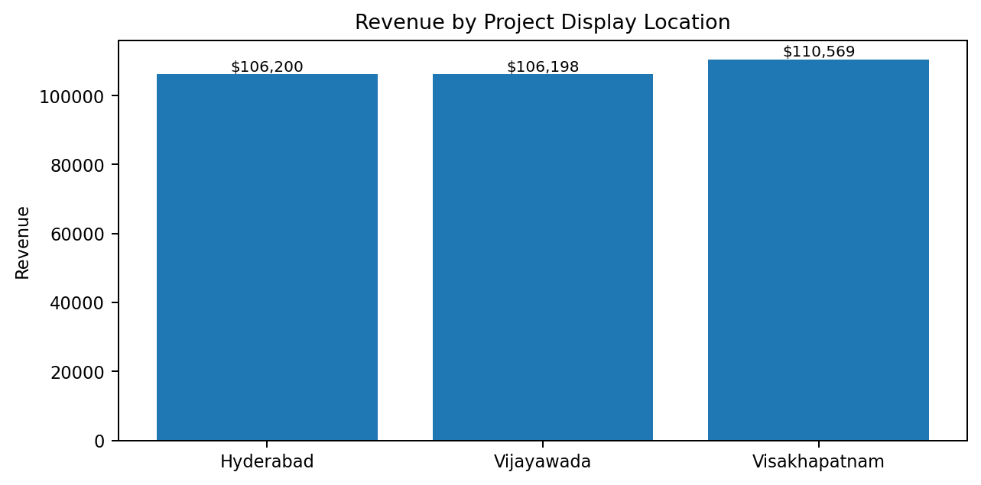
Figure 1. Revenue by project display location, based on the full dataset.
Project display city | Revenue | Transactions
Hyderabad | $106,200.37 | 340
Vijayawada | $106,197.67 | 332
Visakhapatnam | $110,568.71 | 328

11.3 Product Category Performance
Food and Beverages is the highest-revenue product category in the dataset, followed by Sports and Travel and Electronic Accessories. Health and Beauty is the lowest-revenue category among the six product lines. The difference between the categories is not extremely large, but the comparison is useful for identifying where sales volume is concentrated.
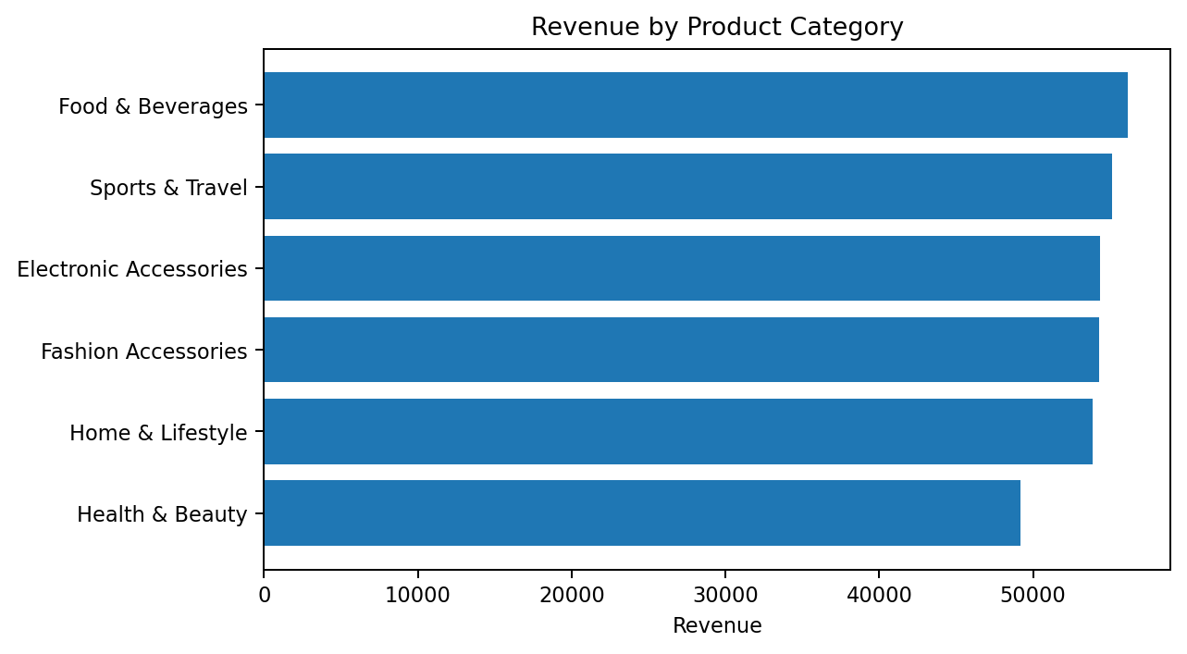
Figure 2. Revenue contribution by product category.
Product category | Revenue
Food & Beverages | $56,144.84
Sports & Travel | $55,122.83
Electronic Accessories | $54,337.53
Fashion Accessories | $54,305.89
Home & Lifestyle | $53,861.91
Health & Beauty | $49,193.74

11.4 Customer Type
Member customers contribute slightly more revenue than Normal customers. The difference is relatively modest, which suggests that the two customer groups are both important to the observed sales mix. The dashboard therefore treats customer type as a segment to monitor rather than assuming that one group is always more valuable.
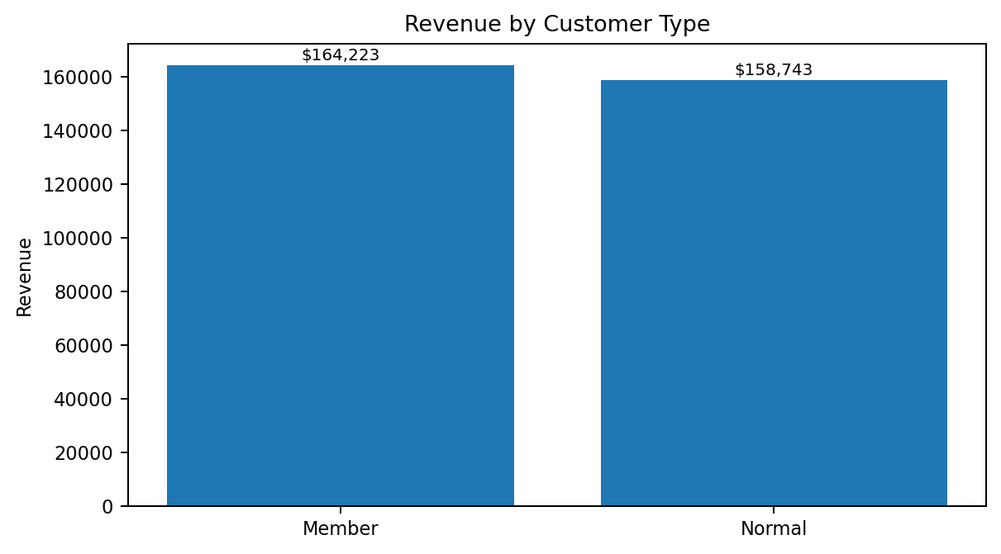
Figure 3. Revenue by customer type.
Customer type | Revenue
Member | $164,223.44
Normal | $158,743.30

11.5 Payment Method
E-wallet is the most frequently used payment method by transaction count, with cash almost equal in usage. Credit card transactions are less frequent than the other two payment methods. This is useful for operational planning because it shows that customers use more than one preferred payment route.
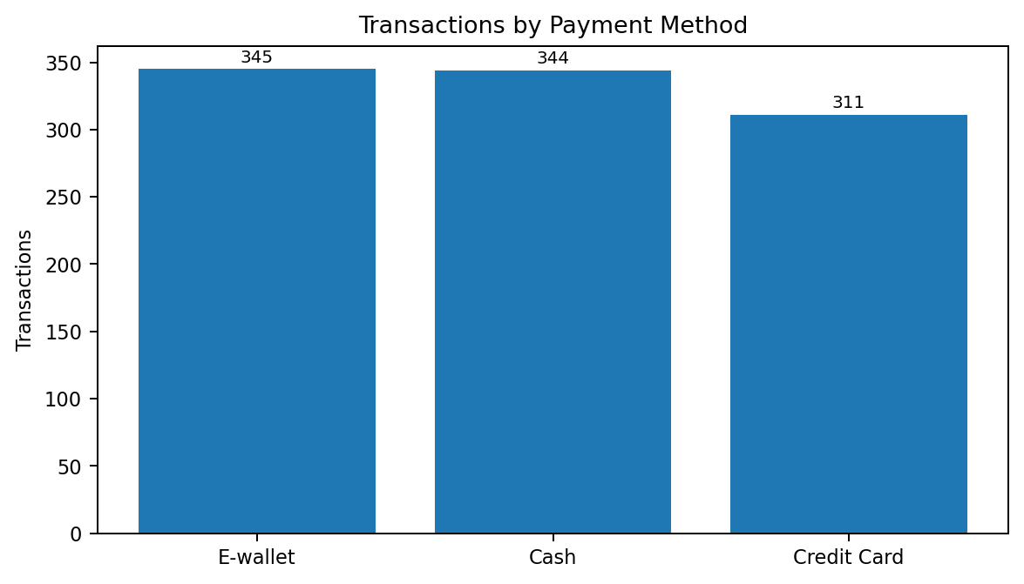
Figure 4. Transaction count by payment method.
Payment method | Transactions | Revenue
E-wallet | 345 | $109,993.11
Cash | 344 | $112,206.57
Credit Card | 311 | $100,767.07

11.6 Customer Gender
Female customers account for a somewhat larger share of revenue than male customers in this dataset. This observation is descriptive and is intended to guide further segmentation analysis rather than to imply that gender alone explains purchase behavior.
Gender | Revenue
Female | $167,882.92
Male | $155,083.82

11.7 Time Pattern
The dataset covers January to March 2019. Published analyses of the same public dataset show that January has the highest monthly sales, followed by a decline in February and a recovery in March. The hourly distribution also suggests stronger activity during later trading hours. These patterns support the inclusion of time-based charts in the dashboard and provide a simple way to think about staffing and promotional timing.

12. Business Recommendations
The recommendations below are intentionally linked to the observed results. They are not intended as guaranteed outcomes; they are practical actions a supermarket manager could consider after reviewing the dashboard.
Maintain availability in strong categories. Food and Beverages leads the revenue ranking. Stock availability and replenishment for high-demand categories should therefore be monitored closely.
Review lower-revenue categories. Health and Beauty records the lowest category revenue in the dataset. Management can examine pricing, assortment, promotion, and customer demand before deciding whether changes are needed.
Use location comparisons for resource planning. Revenue is distributed fairly evenly across the three display locations. This supports continued monitoring of all locations instead of focusing attention on only one branch.
Keep multiple payment options available. E-wallet and cash are both heavily used. Retaining a broad payment mix reduces friction for customers with different preferences.
Treat customer type as a useful segmentation dimension. Member customers contribute slightly higher revenue. Membership behavior can be studied further to understand whether loyalty initiatives are associated with larger or more frequent purchases.
Monitor profit together with revenue. A category or branch can generate strong sales without producing proportionally strong income. Revenue and gross income should therefore be reviewed together.
Use time-based insights operationally. The dataset shows variation across months and hours. Staffing, promotions, and inventory checks can be scheduled with observed busy periods in mind.

13. Limitations
- The dashboard is based on a historical dataset covering three months, so the findings should not be treated as a complete picture of a current supermarket operation.
- The dataset contains transaction-level information but not all operational variables that a real supermarket would use, such as inventory levels, promotions, supplier lead times, or store expenses.
- The project is primarily descriptive and diagnostic. It does not claim to predict future sales or guarantee that a recommendation will improve business results.
- Project display city and branch names are presentation mappings; they do not change the underlying transaction values in the source data.

14. Future Enhancements
- Add sales forecasting for future periods using historical transaction data.
- Build customer segmentation using purchasing frequency, value, and category preference.
- Add inventory and stock-level analysis if inventory data becomes available.
- Introduce anomaly detection for unusual transaction patterns.
- Connect the dashboard to a live database instead of a static CSV file.
- Add role-based access for store managers, marketing teams, and senior management.
- Add automated alerts when important KPIs move outside defined business thresholds.

15. Conclusion
The Supermarket Sales & Customer Analytics Dashboard successfully converts a raw supermarket transaction dataset into a practical business intelligence view. The project covers the complete basic analytics cycle: data loading, cleaning, preparation, KPI calculation, exploratory analysis, visualization, interpretation, and recommendation.
The main value of the dashboard is the way it brings several business questions together in one place. A user can move from overall revenue and transactions to product categories, customer groups, payment methods, locations, profitability, and time patterns without working through the raw data manually. The dashboard also keeps the analysis interactive through filters, so the same metrics can be viewed for a selected city, branch, category, customer type, gender, payment method, or date range.
Overall, the project demonstrates a practical application of Python data analytics and business intelligence for supermarket decision support. It is intentionally focused on clear and useful analysis rather than unnecessary technical complexity.

16. References
Dataset: selva86/datasets - supermarket_sales.csv: https://github.com/selva86/datasets/blob/master/supermarket_sales.csv
Raw dataset file: https://raw.githubusercontent.com/selva86/datasets/master/supermarket_sales.csv
Streamlit documentation: https://docs.streamlit.io/
Pandas documentation: https://pandas.pydata.org/docs/
NumPy documentation: https://numpy.org/doc/
Plotly Python documentation: https://plotly.com/python/
Dataset summary figures in this report were cross-checked against public analyses of the same 1,000-record, 17-column supermarket dataset. The final application itself calculates KPI values directly from the local CSV.

