Activity 05 — CSS Arcade Night
Neon Grid · Retro Tic-Tac-Toe Cabinet
Nirupamarayudu Chitturi · 002931435

Round 1 — Arcade Predictions
Final Team Score: 6 / 6. The screenshot below records the completed prediction round.
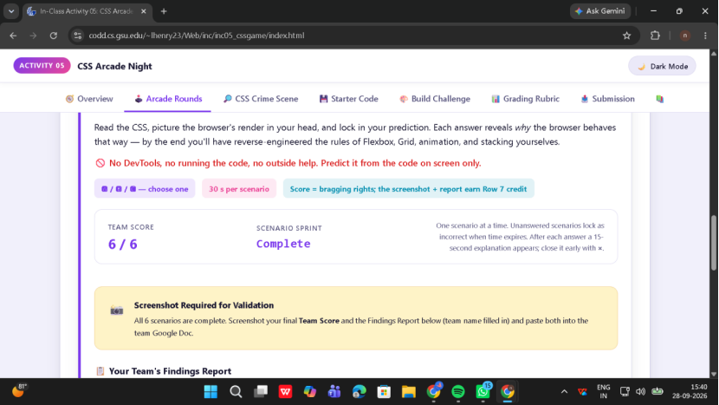
Figure 1. Round 1 final score evidence.
- Cookie Menu Row: Flexbox defaults to a horizontal row, and space-between places the outer cards at the edges with equal space between the items.
- Tic-Tac-Toe Board: Three grid columns place nine cells into a 3 × 3 board.
- Axis Flip: With flex-direction: column, the cross axis is horizontal, so align-items: center centers horizontally.
- Fraction Launch: The 1s value in the animation shorthand is the animation delay.
- Snap-Back: Without a fill mode such as forwards or both, the element returns to its normal style after the animation ends.
- Missing Heart: Without a positioning rule, the heart remains in normal flow and the intended offsets/stacking do not work as expected.

Round 2 — CSS Crime Scene
All four diagnoses were completed. The corrected CSS is included in css_arcade_broken.html.
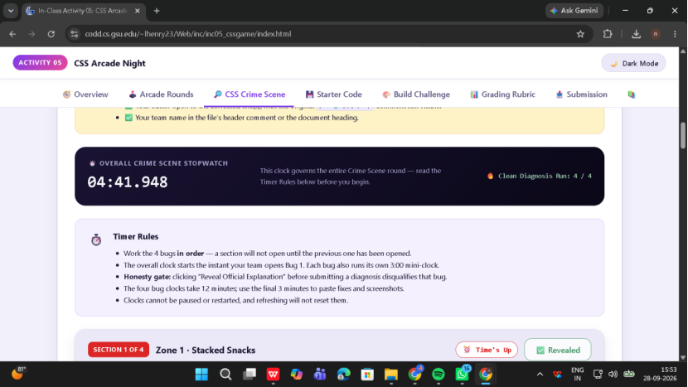
Figure 2. Round 2 completion evidence showing a clean 4 / 4 diagnosis run.

Bug 1 — Flexbox Axis
flex-direction: row;
flex-direction sets the main axis. The broken column value stacked the cards vertically; row restores the intended horizontal layout.

Bug 2 — Grid Tracks
grid-template-columns: repeat(3, 100px);
The broken file defined only two column tracks. Three explicit columns produce the intended 3 × 3 board.

Bug 3 — Animation Fill Mode
animation: moveFraction 3s ease-in-out 1s both;
The both fill mode applies the initial keyframe during the delay and preserves the final keyframe after the animation finishes.

Bug 4 — Positioning & z-index
position: absolute;
The heart must be positioned for top/left offsets and the intended z-index layering to take effect relative to the positioned shirt wrapper.

Round 3 — Build Challenge
Theme: Retro Tic-Tac-Toe Cabinet. The finished page is index.html and contains the required embedded, sectioned stylesheet.
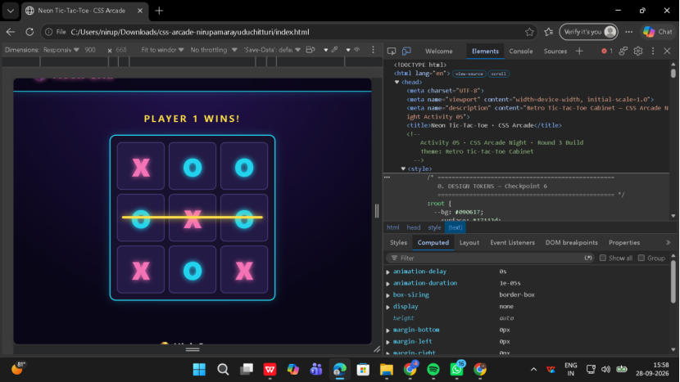
Figure 3. Finished Neon Grid cabinet with DevTools open.

Checkpoint 1 — Flexbox
Selector(s): .cabinet-header and .cabinet-nav
display:flex with justify-content, align-items, and gap.

Checkpoint 2 — CSS Grid
Selector(s): .game-grid
Three tracks defined by repeat(3, minmax(80px, 120px)); nine tiles form a 3 × 3 board.

Checkpoint 3 — Keyframes
Selector(s): .marquee-text and .win-line
0%, 50%, and 100% keyframes use transform, animation delays, and both fill mode.

Checkpoint 4 — Layering
Selector(s): .layer-stack / .layer-back / .layer-mid / .layer-front
Relative parent with z-index:0 and absolutely positioned children using explicit z-index values 1, 2, and 3.

Checkpoint 5 — Interaction
Selector(s): .tile:hover and .tile:focus-visible
Transitions animate transform, box-shadow, and border changes; navigation links also have hover/focus feedback.

Checkpoint 6 — Responsive / Professional
Selector(s): :root and @media (max-width: 768px)
Uses custom properties, semantic structure, no inline styles, responsive layout change, and reduced-motion handling.

Live Defense — 3 Required Questions
Which element is your flex container, and how do you flip its main axis?
.cabinet-header is the main flex container. Add/change flex-direction: column to flip the main axis from horizontal to vertical.
How many grid tracks did you define and how?
.game-grid defines three column tracks using grid-template-columns: repeat(3, minmax(80px, 120px));. Enable the DevTools Grid overlay on .game-grid.
Which element owns the stacking context, and why does the top layer win?
.layer-stack uses position: relative and z-index: 0, so it establishes the local stacking context. The absolute children use z-index 1, 2, and 3; .layer-front wins with z-index: 3.

Repository / Live URLs
GitHub repository: https://github.com/ChNirupam/css-arcade-neon-grid
Expected GitHub Pages URL: https://chnirupam.github.io/css-arcade-neon-grid/
Shared Google Doc URL: paste after uploading/converting this evidence document to Google Docs.

Submission Note
This evidence document intentionally does not include the 15–30 second demo recording or official W3C validator screenshots. Those two items were excluded from the requested package and must be added separately before final submission if required by the instructor.

