**International recognition of European Union ‘actorness’:   
Language-based evidence from United Nations General Debate speeches 1970-2020**

Christian Rauh  
christian.rauh@wzb.eu  
www.christian-rauh.eu

Version: 20.06.2025  
Word count: 9,846  
(excl. title & appendices)

**Abstract:** The European Union is often portrayed as a global actor that is said to wield ‘economic’ or even ‘normative’ power. Such perspectives presume that states in the international system recognize EU ‘actorness’ along the modestly growing foreign policy capabilities of the Union over time. Does this hold true? In which contexts does this happen? And which third states have an incentive to do so? This article explores the explicit recognition of EU actorness on the international stage by applying novel natural language processing algorithms to 8,481 speeches in the United Nations General Debate 1970-2020. Dependency parsers help to identify all sentences in which the EU is presented to act while word embedding models uncover in which contexts this takes place. Along these measures the recognition of international EU actorness has indeed increased to comparatively high levels over time. But this is primarily driven by EU member states themselves and happens much more in economic than in normative contexts. Non-EU states recognize actorness when they are geographically close or economically dependent on the EU, while illiberal regimes and great powers systematically avoid presenting the EU in its capability to act on the international stage. The recognition of EU actorness is thus hardly a global phenomenon and rather mirrors power and value-based conflicts in the international system.

**Keywords:** European Union, agency, actorness, United Nations General Assembly, text analysis

**Acknowledgements**: I am grateful for feedback on prior versions of this paper at the ECPR General Conference 2023 (Charles University, Prague), the DVPW IR section meeting 2023 (Zeppelin University, Friedrichshafen), the WZB Global Governance colloquium, and the Chair for European and Multilevel Politics (Sven-Oliver Proksch) at the University of Cologne. Furthermore, three anonymous reviewers of International Interactions have provided very constructive comments. Finally, I appreciate the contribution of Magdalena Kennel, Severin Kieper, and Anna Weißer who coded numerous sample statements used in the validation of the text analysis methods presented here. A fully documented replication package is available in the II dataverse at https://dvn.iq.harvard.edu/dvn/dv/internationalinteractions.

# **1. Introduction**

The European Union’s role in the global international system is notoriously ambiguous. On the one hand, there is no lack of ambition. The Union’s founding treaty (Art. 2, para. 5, TEU) defines ‘relations with the wider world’ – amongst other things in the name of ‘free and fair trade’, ‘protection of human rights’, or ‘peace’ and ‘security’ – as key purposes of political integration. In this vein, allusions to the EU’s global importance abound in virtually any grand speech of European politicians. During her first inauguration as president of the European Commission, for example, Ursula Von der Leyen announced a ‘geopolitical’ Commission to shape a ‘better world order’.[[1]](#footnote-1)

On the other hand, the EU faces numerous internal and external obstacles in living up to these ambitions. Internally, a lack of foreign policy cohesion of EU member states is often lamented and there has been only slow progress in pooling or delegating foreign policy competences to supranational institutions. Externally, the peculiar nature of the EU as a multi-level governance system with only partially integrated foreign policy competences appears alien to an international system that is still often structured along states. The interest of foreign states, furthermore, often stand in sharp contrast to the common trade interests or declared values of the EU. As demonstrated by the lead-up to the Russian aggression against Ukraine, China’s Belt and Road Initiative involving countries like Hungary and Greece, and the talks following the aggressive tariff policies of the second Trump administration, major international powers often seem to prefer engaging with individual European member states rather than with the EU as a whole.

In this field of tension, a vibrant literature on EU’s global ‘actorness’ has developed (a.o. Bretherton and Vogler 2006; Niemann and Bretherton 2013; Sjöstedt 1977). This multi-facetted literature deals with capabilities, cohesion, or autonomy of EU institutions in specific foreign policy areas. But it also agrees that *recognition by others* is a highly relevant indicator, if not a necessary condition for establishing EU actorness on the global stage (esp. Gehring, Oberthür, and Mühleck 2013; Jupille and Caporaso 1998; Kratochvíl, Cibulková, and Beník 2011). In this view, EU actorness resides, or is at least observable in the extent to which other relevant actors in the international system – most notably foreign states – view and present the EU as an entity that is capable of acting on its own. It is this international recognition of EU actorness that the present study focusses on.

I aim to make two contributions. The first one is empirical. I propose and validate a generic method of extracting actorness recognitions from foreign policy discourse by combining dictionary-based entity recognition with linguistic dependency parsing. While extant work on EU actorness has often focussed on specific fora, institutions, or policy areas, this method allows me to explore a broader, comparative, and long-term perspective on the explicit international recognition of EU actorness. I analyse 8,481 speeches of nation states in the United Nations General Debate between 1970 and 2020, the broadest and most regular forum for publicly visible international exchange on a myriad of foreign policy topics and extract all instances in which any of the speeches ascribes an action to the EU. Then I employ word vector models to study in which semantic contexts such recognition of EU actorness occurs. This uncovers temporal and semantic patterns of EU recognition which are benchmarked against other regional organizations, international institutions, and even states.

My second contribution is more substantive. I want to complement the extant capability-based explanations of EU actorness recognition by emphasizing the varying incentives of third countries more strongly. In this view international recognition of EU actorness should vary with the degree to which third states depend on and actually interact with the EU. Furthermore, external recognition contains an element of strategic choice: foreign states might have different preferences on whether the EU should be seen as a global actor in the first place. Specifically, I expect that great power states as well as authoritarian regimes have incentives to downplay the EU’s actorness on the global stage, as their national interests can clash with the EU’s ambitions rather fundamentally.

Exploring these arguments in an integrative manner, the original data presented here initially show that the explicit recognition of EU actorness has notably increased after the end of the Cold War and with the enhanced institutionalization of EU foreign policy competences in the Maastricht Treaty. After 1992, the likelihood that EU actorness is recognized in UNGD speeches exceeds that of most other major regional organizations (except for the African Union), key international institutions, and even most states. But afterwards this notable level of EU recognition seems to stagnate and also does not increase further with the additional integration of foreign policy competences in the 2009 Lisbon treaty.

Moreover, I show that this international recognition of EU actorness in the UNGD is very Eurocentric: it is primarily driven by EU member states themselves while explicit recognition from countries outside of Europe is, in fact, a very rare event. External recognition furthermore varies across countries: while geographical proximity to and trade dependence on the EU tend to increase the likelihood of actorness recognition, large external trading powers such as the U.S. and China as well as especially autocratic regimes tend to withhold it.

The international recognition of EU actorness, and the corresponding self-perception that European politicians often propagate, should thus not be seen as a globally accepted or as flowing quasi-automatically from the EU’s formal and informal foreign policy capabilities. Rather, whether and by whom the EU’s actorness is deliberatively recognized is as much driven by power and value-based conflicts in the contemporary international system.

# **2. Recognition of EU ‘actorness’: relevance and expectations**

From its beginnings the political integration of Europe stirred questions about its wider international significance. A customs union, an internal market, and the harmonization of corresponding industrial and later also social policies among a set of countries that account for large shares of the world’s economy unquestionably matter in the international system. Yet, observers were also quick to note that the international significance of the emerging block does not automatically equate international influence. As early as 1977, Sjöstedt therefore proposed the concept of ‘*actorness*’, which he defined as the European Community’s ‘capacity to behave actively and deliberately in relation to other actors in the international system’ (Sjöstedt 1977, 16).[[2]](#footnote-2)

To capture this actorness, he argued, one needs to study whether the EU (then still the EC) can be delineated from other international actors, whether it has autonomy in taking foreign policy decisions, and whether it controls state-like diplomatic resources. This emphasis on competences and capacities figures in all subsequent conceptualizations of EU actorness. In a highly cited contribution, Jupille and Caporaso (1998) likewise stress ‘authority’, here meaning legal competence, as well as ‘autonomy’, defined as distinctiveness of the EU in negotiations and discretionary goal formation and decision-making, as important elements of actorness. In another highly cited contribution, Bretherton and Vogler (2006) combine these points into a ‘capability’ perspective on EU actorness.

It is thus uncontroversial that the EU needs to develop capabilities from within to become an international actor in its own right. But it is also uncontroversial that the EU is an emerging polity: its actorness must be analyzed as a matter of degree. The internal capabilities underpinning the EU’s international actorness have developed only slowly and selectively over time. Along the EC’s initial impetus as a customs union and a jointly regulated market, formal capabilities are most pronounced in the area of trade and the so-called ‘common commercial policy’. As early as 1957, the six founding members delegated their power to negotiate international trade agreements to the High Authority, the predecessor of the European Commission. Common commercial policy is also an exclusive competence of the Union, so that member states can no longer act unilaterally in this area. This has some limits for agreements on investment or intellectual property, but generally DG Trade of the European Commission has remarkable formal competences, backed by highly skilled and experienced staff that is commonly seen as highly effective on the international stage (Meunier and Nicolaïdis 2017).

In other areas of foreign policy, in particular regarding security interests, however, the EU member states have been much more reluctant to pool or delegate their competences in or to joint institutions (Moravcsik 1993). Yet and still, capability has developed beyond external trade. In 1970, for example, EU member states established the European Political Co-operation, an informal consultation process meant to develop common foreign policy in areas of shared EC interests.

In more formal terms, EU capabilities in foreign policy developed especially through reforms of the Union’s founding treaties. Most notably, the 1992 Maastricht Treaty integrated the ‘Common Foreign and Security Policy’ as one of three pillars of the newly established European Union – not the least against insufficient coordination of member states during the Yugoslav wars. In contrast to the strong integration of regulatory internal market powers, however, this domain was kept strictly intergovernmental. Later on, the 1997 Amsterdam treaty established the High Representative for the Common Foreign and Security Policy in an attempt to structure and strengthen intergovernmental coordination. Institutionally, this was especially consolidated in the 2009 Lisbon Treaty, which made the High Representative a member and vice-president of the European Commission and also established a joint diplomatic corps, the so-called European External Action Service (EEAS). Along these own diplomatic resources, the EU has even become an observer member with enhanced status in the United Nations in 2011.

From a capability perspective, thus, EU actorness should be especially strong in the area of trade and should have increased over time especially along the key treaty revisions covering foreign policy more generally. Yet, even with greater pooling EU foreign policy remains constrained by veto powers of individual member states. Some scholars thus include ‘cohesion’ of national foreign policy interests into the concept of EU actorness (Jupille and Caporaso 1998), stimulating a rich research agenda on whether European governments speak with a ‘single voice’ on the international stage (Conceição-Heldt and Meunier 2016).

For the narrower question of whether the EU as a joint and distinct entity exhibits autonomous actorness, however, extant work stresses that there is more than formal foreign policy competence. The seminal conceptualization of EU actorness by Bretherton and Vogler (2006), for example, subsumes ‘presence’ and ‘opportunity’ into the concept. ‘Presence’ refers to the idea that the EU exerts influence beyond its borders ‘by virtue of its existence’ (24). For example, by setting standards of market access or by using its competition policy powers, the European Commission creates adaptive pressures for outside actors. Relatedly, ‘opportunity’ refers to the match between whatever is salient in the international context and the EU’s ability to contribute by virtue of its internal competences. One may think of the rising international salience of climate change as an example, where the share of global production residing in Europe in conjunction with internal regulatory power might render the European Commission a relevant international interlocutor. Beyond formal foreign policy competences, thus, the initially internal competences of supranational EU institutions affect their international or even global environment – either inadvertently (Gehring, Urbanski, and Oberthür 2017) or by proactive attempts of ‘external governance’ (Lavenex and Schimmelfennig 2009).

Thus, the EU may be externally recognized as a relevant actor on the international stage even beyond its formal foreign policy competences. And since the formal policy competences are internally constrained, such external perceptions should matter for the influence that the EU as a joint but still unfinished entity can muster on the international stage. Given that the Union’s foreign policy capabilities remain stuck somewhere in between a loose intergovernmental agreement and an autonomous trade power, *the degree to which external parties recognize it as a relevant actor* should matter for its international clout.

In fact, virtually all conceptions of EU actorness point to such external recognition. In Sjöderstedt’s original account, state-like resources such as a foreign policy service are a means to get recognized by other actors on the international stage. The ‘opportunity’ element in Bretherton and Vogler’s (2006) conception of actorness also explicitly involves external perceptions (cf. Niemann and Bretherton 2013, 265). And also in constructivist accounts, the EU develops actorness by seeing itself ‘through the eyes of others’ (Klose 2018, 1147; see also Wendt 1992).

This importance of external recognition has also been explicitly conceptualized. Especially the seminal analysis of EU global actor capacity by Jupille and Caporaso (1998: 214 pp.) ranks recognition – defined as acceptance of the entity by third parties – first among the other elements of actorness such as authority, autonomy, and cohesion. Such recognition can be *de jure* or *de facto*. The former refers to diplomatic accreditation and is quasi automatically granted to nations as a ‘definitional component of sovereign statehood’. But it does not automatically apply to the EU as a multi-level entity which is thus much more dependent on de facto recognition. Externalities of its internal powers can provide a motive for such recognition, but the criterion is only satisfied if these third parties actually treat the Union as a corporate entity, ‘rather than, or in addition to, going to one or more EU member state(s)’ separately (ibid: 216).

Kratochvil *et al.* (2011, 394) also argue that the external recognition by influential international actors is as important as the ‘domestic constitution’ of the EU’s foreign policy capabilities, since ‘recognition from outside may increase the Union’s authority and room for manoeuvre’ on the international stage. Gehring et al. (2013) agree on the independent importance of this recognition, which, as they argue and show empirically, can even trump the lack of formal membership and accreditation of the EU in other international institutions or negotiations. But they insist that the EU’s capabilities and its external recognition are related: third parties should recognize the EU where its formal competences and/or its internal governance resources are most pronounced. While there are different views on how it is produced, all these conceptions agree that *the external recognition of the EU by third parties is an important observable implication of its international actorness*.

What, then, explains whether external parties – most notably states as the ‘natural’ inhabitants of the international system – recognize the EU as an actor in its own right? My theoretical model initially sides with those arguing that formal capabilities of the EU are an important driver of international recognition (Gehring, Oberthür, and Mühleck 2013). It is indeed plausible that the EU’s internally developing capacities to coordinate or to act more autonomously on the international stage increase the likelihood that it is taken serious by the rest of the world. The slowly increasing coordination and integration of EU foreign policy competences – especially in treaties of Maastricht and Lisbon as discussed above – should accordingly be reflected in variation of its international recognition over time:

H1: *The recognition of EU actorness by third countries increased especially with the 1992 Maastricht Treaty (CSFP) and the 2009 Lisbon Treaty (High Rep. and EEAS).*

This capability perspective furthermore predicts variation by issue area, as the EU’s formal and informal capabilities vary along those as well. It should be greatest in the area of trade and economic policy more generally. Here, the EU controls exclusive competences in negotiating agreements while the huge externalities of its internal market regulation powers grant informal international relevance that should enhance recognition by third parties. In contrast, the hesitancy of EU member states in pooling their foreign and defense policies beyond trade, the resulting absence of EU military capabilities, and its corresponding nature of a ‘civilian power’ (Bull 1982) suggest that third parties will recognize EU actorness much less in the domain of international security.

But there is also room in between. While the EU’s economic capability does not readily translate into military or security-related influence more generally, it could also be exploited to achieve non-economic goals. The EU’s self-portrayals and various scholarly accounts suggest that the EU uses its economic power also as a means of projecting is regulatory and societal model onto its environment, rendering it not only a power *of* but also a power *through* trade (Damro 2015; Meunier and Nicolaïdis 2006). In exercising this power, it pursues decidedly normative ambitions in promoting its regulatory model based on democracy, the rule of law and, as prescribed in Art. 3 TEU, in striving for the protection of human rights in its relations with the wider world. This has led some observers to see the EU as a benign ‘normative power’ (Manners 2002) or, less benign, as a ‘normative empire’ (Del Sarto 2016) that pushes for liberal democracy internationally. Against these arguments, I expect:

H2: *Recognition of EU actorness varies along the broad issue areas of international politics   
(trade &economy > lib. democracy > security).*

Note that such variation across issue areas also implies variation over time along the ebbs and flows of issues that dominate the international political agenda, very much in line with the ‘opportunity’ argument in Bretherton and Vogler’s (2006) conception of EU actorness: The more trade and economy questions and probably also rule of law and human rights discussions figure on the international agenda, the more we should see the EU externally recognized. The more security concerns become salient, in contrast, the less EU recognition we expect to see.

These capability-based arguments should go a long way in explaining whether, why, and when third countries recognize EU actorness. However, they also appear rather Eurocentric and quite deterministic: Essentially, they assume that the EU just needs to internally get its act together to become externally recognized as a relevant actor in the international system.

But given the EU’s unfinished nature as an only partially integrated polity, it seems somewhat far stretched to assume that the recognition of its actorness would flow linearly from its internal capability or that the recognition of such capabilities would be automatically global. Instead, recognition of this emerging polity by third parties contains an element of choice and there are good reasons to believe that the corresponding incentives vary systematically across the globe.

Initially, the sociological theory on the emergence of actorness of collective entities (for an excellent overview: Knight 2022) or the literature on state sovereignty in the international system (see e.g. Krasner 1999) suggest that recognition is not only a function of static relevance but is often produced through actual interaction. For the purpose here this means that not all states around the globe might be equally affected by the EU’s foreign policy ambitions and/or the externalities of its internal competences. Recognition should rather vary with the degree to which they depend on the EU. Such dependence should initially be related to geographical distance. On the one hand, the EU might have a greater incentive to act in the name of controlling its immediate neighborhood (Lavenex and Schimmelfennig 2009). On the other hand, actors from contingent or surrounding states more often (have to) interact with the EU’s competences and rules. Beyond such immediate distance, however, the EU and its internal market are also very important in *global* supply chains – a potential source of power. In this light, an interactional logic also suggests that those states should recognize EU actorness more whose domestic economy depends more strongly on direct trade with the European internal market.

H3a: *Recognition of EU actorness decreases with geographical distance of third countries.*

H3b: *Recognition of EU actorness increases with third countries’ trade dependence on the EU’s internal market.*

This dependence argument also points to another blind spot in the extant conceptions of EU actorness. This literature has mostly focussed on the emergence of actorness against internal resistance but has rarely discussed external resistance. Recognizing EU actorness on the international stages, however, may come at a cost on part of third countries as well. Gehring et al. (2013, 851) initially emphasize transaction costs: admitting the EU to the international negotiation table increases complexity and does not sit easily with a key ordering principle of the still rather state-centered international system.

In addition, I want to stress that the active recognition of EU actorness has strategic implications in international politics. Accepting the EU as a block potentially enhances the joint bargaining power of European states and thus increases Europe’s influence within international institutions (Emerson et al. 2011; Smaghi 2004). Depending on what position a third country holds in the extant international system, this might not be particularly welcome. In some instances, it may even fundamentally clash with the interests of specific third countries.

I consider three dimensions relevant in this regard. Firstly, a country’s position in the contemporary hierarchy of the international system should matter for the choice of whether to pro-actively recognize the EU as an international actor. Admitting a multi-level polity onto the international stage can especially go against the structural interests of those states that occupy a particularly powerful position in the international system. Particularly, the P5 states with their veto powers over direct interventions with international legitimation could see themselves and their position challenged by the EU. For them, an internationally recognized joint block of coordinated or even integrated states might constrain their informal influence. And an emerging multi-level polity with international recognition also challenges their legitimacy as unilateral veto powers while setting a precedent for such block-building in other parts of the world (cf. Gehring 1994, 124–128).

H4a: *Recognition of EU actorness is lower for third countries holding a permanent seat in the United Nations Security Council.*

Secondly, a logic of economic competition seems highly plausible. In 2020, the combined economies of the EU member states accounted for roughly 18% of the worldwide gross domestic product. As a unilateral power, China was on par and about to overtake the EU, while the U.S. economy accounted for roughly 25% of worldwide GDP (Appendix A1). If there is a national interest in maintaining or expanding such international market shares, these two unilateral economic powers, and also other powerful economies for example among the BRICS states, should prefer to deal with European economies separately rather than exhibiting a strong urge to recognize their joint actorness on the international stage:

H4b: *Recognition of EU actorness decreases with the worldwide GDP share of third countries.*

Third and finally, I expect regime type to matter. The EU itself is, or at least aspires to be, a living example that liberal democracy and the rule of law can be transferred to levels beyond the nation state. And as discussed above it also intends and tries to project this ambition to its external environment. This is hardly in line with the interests of states, or, more specifically, the governments of states, whose political system deviates notably from liberal democracy. These governments have no incentive to enhance the international recognition of a powerful, decidedly liberal actor and should accordingly avoid contributing to its recognition:

H4c: *Recognition of EU actorness decreases for third countries with less liberal or even autocratic political systems.*

These interactional and strategic arguments are not meant to reject the capability-based perspective. Even an economically powerful, autocratic country holding an UNSC seat might not be able to fully avoid the foreign policy capabilities that the EU can wield. But the interactional and strategic logics should complement and potentially qualify the capability-based perspective particularly with a view to cross-national variation in explicit recognition. External actors with diverging interests should downplay the international actorness of the EU’s emerging polity wherever they can, thus providing us with information on the boundaries of the capability perspective and the resulting room of manoeuvre that the EU could gain from its *de facto* recognition on the international stage. Whether this holds true is, of course, an empirical question that calls for a broad, comparative perspective on the international recognition of EU actorness.

# **3. Assessing EU ‘actorness’ in a comparative manner: a text analysis approach**

Extant empirical work has produced highly valuable insights by studying the EU’s distinct role in specific international negotiations, for example, on climate change (Bretherton and Vogler 2000), by analyzing *de facto* against *de jure* EU recognition in comparative case studies across international institutions (Gehring, Oberthür, and Mühleck 2013), or by studying EU perceptions in public and elite opinion in selected countries at specific points in time (Lucarelli and Fioramonti 2009). However, these approaches do not provide the variation over time, over issue areas, and over the full set of third countries that an integrative test of the above specified hypotheses requires.

Comparative data, furthermore, insure against the *sui generis* trap (cf. Niemann and Bretherton 2013). The EU is an emerging polity wielding much more authority than many other international institutions, but it is hardly the only authoritative institution beyond the nation state that could aspire international actorness (Zürn, Tokhi, and Binder 2021). A realistic sense of recognized EU actorness can only be gained by benchmarking it against other non-state institutions in the international system. And on the other end of this spectrum, a realistic sense also requires benchmarking it against recognition of states as the ‘natural’ actors in the international system. Only a comparative perspective allows to determine how much or how little actorness the EU possesses in the eyes of third countries.

To generate such comparative data, I propose to study actorness recognition of the EU and other entities comparatively in the high-level foreign policy discourse of third-party states over time. While it is hard to empirically assess whether elites in third states privately acknowledge the EU’s relevance, analyzing whether and how they present the Union in their outward and often strategic communication offers an empirical window into whether they want to explicitly recognize the EU’s actorness on the international stage.

Specifically, I resort to the *United Nations General Debate (UNGD)* during the annual assembly of this truly global institution. Over and above specific, nitty-gritty policy negotiations, the General Debate is the most visible and most regular forum in which key representatives of virtually all national governments communicate their foreign policy stances and priorities to the wider domestic and international audiences (Smith 2006). While the annual debates are to some extent informed by the international challenges of the day, states’ representatives (most often government leaders or foreign ministers) are rather free in terms of topics or actors they want to emphasize. Typically, government representatives therefore use this stage to present their worldviews in an attempt to influence the international perception of their own state and that of other actors in the international system (Hecht 2016, 10). The UNGD is thus ideal to study whether and how much the almost complete international community of states wants to recognize EU actorness from one year to the next.[[3]](#footnote-3)

To *measure the explicit actorness recognition of the EU and other entities* I thus resort to the machine-readable full texts in version 6 of the UNGD corpus (Baturo, Dasandi, and Mikhaylov 2017), which provides all 8,481 speeches between 1970 and 2020.[[4]](#footnote-4) Building on an established dictionary of EU references (Rauh and De Wilde 2018), I mark all sentences in which the European Union (or the European Community for earlier periods) was explicitly mentioned. While mere mentions of the EU in UNGD speeches signal that the speaker acknowledges its existence, they cannot be directly equated with the recognition of actorness, however. As Sjörstedt’s (1977) original conception, the literature on state sovereignty (Krasner 1999), but also linguistic and sociological approaches to measuring ‘agency’ in textual data (Franzosi, De Fazio, and Vicari 2012; Knight 2022) remind us, the entity must be also be explicitly presented *in its capability to act*. We do not only want to know whether the EU is mentioned in a given country’s annual UNGD speech, we rather want to know whether actors signal that the EU does, can, or should *act* on its own.

The key measurement idea that I pursue along this line is that an UNGDspeaker recognizes EU actorness only if and when he or she explicitly links the EU to some kind of action. In natural language such entity-action links can be articulated in many ways, but virtually all of them are encoded in the syntactic relations that make up the grammar of a statement. EU action is clearly implied if the EU appears as the active or passive subject of a verb in a sentence, for example. In implementing this measurement idea, I build in particular on the pathbreaking work by Oscar Stuhler (2022) who showed how grammatical dependency parsers can be used to extract semantic motifs from text data. Specifically, I resort to the industry-leading parsers of the SpaCy NLP python library (Honnibal and Montani 2020) as wrapped in the spacyr package (Benoit and Matsuo 2020), and then use the *rsyntax* tools (Welbers and Van Atteveldt 2022) to extract relevant grammatical patterns in UNGD sentences along which the EU (or other entities) are clearly linked to some kind of action. Appendix A4 develops the approach in greater detail, compares it to other automated coding methods (including mere EU mentions), and validates its performance against a random, human-coded sample of 750 sentences from UNGD speeches. Ultimately, my text-as-data measure codes *an* *explicit recognition of EU actorness if a UNGD speaker syntactically links the EU to an action as represented in a verb, a nominalized verb, or an adverbial noun phrase*.

The theoretical arguments furthermore require inferring the broad issue context in which such actorness recognitions take place. Rather than inductively extracting distinct issue themes with fixed and literal word distributions as typically extracted by topic models, I approach this as a question of semantic similarity captured by word embedding algorithms and the resulting word vector models (Pennington, Socher, and Manning 2014; Spirling and Rodríguez 2022). These models encapsulate the key idea of distributional semantics according to which ‘you shall know a word by the company it keeps’ (Firth 1957). They reduce the dimensionality of word-to-word co-occurrence matrices from very large and representative corpora to quantitively represent the idea that words with similar neighbors also receive similar vector values. Expressed differently, words that often share certain contexts live closer together on the dimensions of the vector space. We can exploit this here by first measuring how semantically similar each word spoken in the UNGD is to the terms circumscribing the concepts of interest – trade and economy; liberal democracy; security – to then aggregate the resulting word weights to each sentence and/or speech. Appendix A5 justifies the approach in greater detail and successfully validates it against a human-coded sample of almost 1,000 sentences from UNGD speeches. Table 1 illustrates the resulting text-based measures along real exemplary UNGD sentences.

|  |  |  |  |
| --- | --- | --- | --- |
|  | **Sentences  without EU reference** | **EU reference without actorness recognition** | **Explicit EU  actorness recognition** |
| **Particularly strong  ‘economy & trade’ semantics** | All of us will benefit from the expanded trade and investment that comes from a vibrant, growing world economy. (USA, 1992) | It should take into account economic interrelations that were formed in the CIS, opportunities for foreign investment in our economy, and a step-by-step integration of the Ukrainian economy into that of the European Community and the world. (UKR, 1993) | However, even more serious for our sugar industry is the continuance of subsidy policies practiced by the European Economic Community (EEC) for the benefit of its producers which substantially depress prices on the international market. (DOM, 1985) |
| **Particularly strong  ‘liberal democracy’ semantics** | These are protests for democracy and freedom, respect for human rights and social justice.  (SMR, 2011) | Romania, now a member of the European Union, evolved under the political idea that democracy, human rights and the rule of law are essential for the development of our societies. (ROU, 2007) | The European Union will actively pursue its work on consolidating human rights and fundamental freedoms, with particular insistence on the universal, indivisible and interdependent nature of all human rights. (BEL, 2001) |
| **Particularly strong  *‘security’*  semantics** | Security is more than the absence of war; it is the presence of peace. (CAN, 1990) | We believe that acceptance by the parties to the conflict of the principles already enunciated by the member states of the European Community, namely, the right to security and existence of all states in the region, including Israel, and justice for all its peoples, is essential if progress is to be made towards a peace settlement. (IRL, 1981) | I welcome the commitment made by the European Union and our bilateral partners to supporting the training and bolstering of our defence and security forces and to supporting the implementation of the national defence plan and the deployment of the Central African Armed Forces, with a view to setting up a garrison army and establishing control throughout the national territory. (CAF, 2018) |

**Table 1:** Example classifications/ratings of real sentences from UNGD speeches

Finally, the hypotheses require independent variables on the level of the year and the country a speaker represents. Data for a country’s geographical distance to the EU – measured as the distance between the capital and Brussels – are extracted from the GeoDist database (Mayer and Zignago 2011). Trade dependence on the EU was derived from the International Monetary Fund Direction of Trade Statistics (DOTS), accessed via Gandrud’s imfr package.[[5]](#footnote-5) It is calculated as the sum of annual imports from and exports to the EU as a share of a country’s GDP in the year of the respective speech. GDP data (measured in current USD) come from the World Development indicators accessed via the Niehaus Dataverse (Graham and Tucker 2019). To measure the degree to which a country’s political system approximates a liberal democracy or not, I resort to the seminal V-Dem liberal democracy index (Lührmann, Lindberg, and Tannenberg 2017). Merging these diverse data sets with the speech-level data was tremendously facilitated by the countrycode package (Arel-Bundock, Enevoldsen, and Yetman 2018).

# **4. Descriptive patterns: To what extent is EU actorness recognized in UNGD speeches?**

To start with, we can initially note that 1,012 of the 8,481 speeches in the United Nations General Debate between 1970 and 2020 indicate some kind of EU action at least once. In other words, the likelihood that a given state representative in a given year recognizes EU actorness in this central forum of international foreign policy exchange amounts to 11.9%.[[6]](#footnote-6) Figure 1 plots variation in this share of UNGD speeches over time, separating the three major phases of treaty-based institutionalization of the EU’s foreign policy competences in order to shed light on the capability hypothesis (H1).

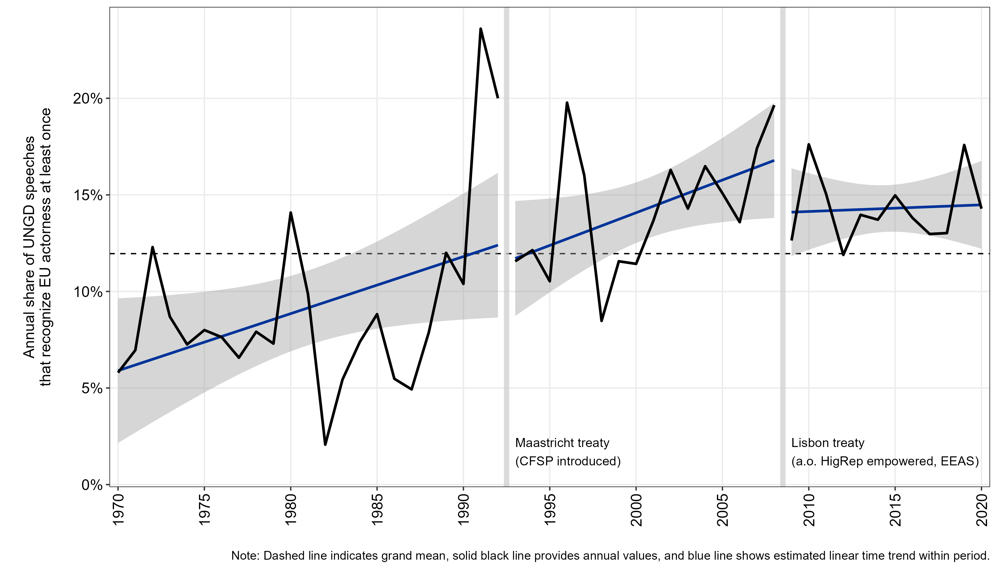

**Figure 1:** Annual share of UNGD speeches recognizing EU actorness

Initially one notes quite substantial variation from one year to the next – the observed annual standard deviation amounts to about five percentage points. Following Bretherton and Vogler’s opportunity argument, this might reflect the ebbs and flows of issue salience in UNGD debates and the degree to which the issues on the agenda fit the EU’s internal capabilities – an argument we test along the issue context measures below.

On average, however, the estimated linear time trends show that the recognition of EU actorness has indeed been growing – at least from the 70ies to the mid-2000s. Recognition of EU actorness in UNGD speeches increased most drastically with collapse of the Soviet Union and the Yugoslav wars in the early 1990ies, that is with drastic geopolitical events in the close neighborhood of the EU. EU actorness recognition peaks with about 24% of speeches in 1991, when the EU member states happened to be in the final stages of negotiating the Maastricht treaty. The entry into force of this treaty, which made the Common Foreign and Security Policy the ‘third pillar’ of European integration, however, is not associated with the clear jump in EU actorness recognition that the capability perspective would imply for this treaty revision. But we note that the statistically significant upward trend continues in the subsequent decade.

However, this trend breaks after the Lisbon treaty entered into force. In 2009 we observe a drop and a slightly decreasing tendency afterwards (even more visible in a count-based perspective, appendix A6). Given that the Lisbon treaty established the European External Action Service led by the High Representative of the Union for Foreign Affairs and Security Policy, rendering the post also a vice president of the European Commission, the observed pattern is not immediately consistent with the capability perspective.[[7]](#footnote-7) However, this descriptive pattern cannot rule out that it is just the topical focus in the debates that diverts from the EU’s ‘pet issues’.

To see whether such ‘pet issues’ – areas in which the EU has strong capability and/or ambition – are indeed reflected in the international recognition of its actorness as suggested by H2, Figure 2 picks out all 1,012 sentences in which EU actorness was explicitly recognized. For these sentences it averages their semantic similarity to the three broad target concepts in the joint word vector space described above. The resulting cosine similarities have been z-standardized for this exposition, so that they can interpreted as deviations of sentences with EU actorness recognition from the grand means across all almost one million sentences in UNGD speeches.

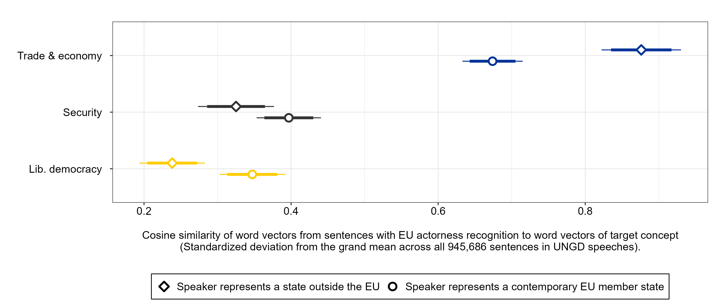

**Figure 2:** Semantic similarity of EU actorness recognition to three target concepts

We see that statements recognizing EU actorness are much more similar to concepts circumscribing economy and trade issues when compared to random sentences. This bodes well with the capability perspective and the ‘EU as a trade power’ arguments. EU actorness is particularly recognized in more economic contexts. Notably, this is even more pronounced for UN speeches given by states outside of the European Union.

In contrast to H2, however, the recognition of EU actorness appears not very strongly driven by a ‘normative power Europe’ logic: Sentences recognizing EU actorness are slightly closer to concepts of ‘democracy’, ‘rights’, or ‘law’ than the average sentence in UNGD speeches, but this descriptive effect is comparatively weak. It amounts to only .24 standard deviations for foreign states, and around .35 standard deviations for EU member states only. Member states are apparently somewhat more eager to present EU actorness in the context of liberal democracy themes than third states. Somewhat surprisingly – at least in the light of H2 above – we also see a positive deviation from the average pattern when it comes to security themes. At least sometimes, EU actorness is recognized in contexts that are semantically closer to respective seed terms such as ‘security’, ‘war’, ‘peace’, ‘terrorism’ or ‘military’.

The temporal and contextual variation uncovered thus far, however, does not yet really help us assessing whether this is really much or rather little recognition of actorness that the EU really enjoys in this leading international forum of state-based foreign policy exchange. To accordingly benchmark this better, Figure 3 initially compares recognition of EU actorness (in blue) to that of other regional organizations (light blue), or to international institutions in the economic or trade (pink) and security policy domain (grey).

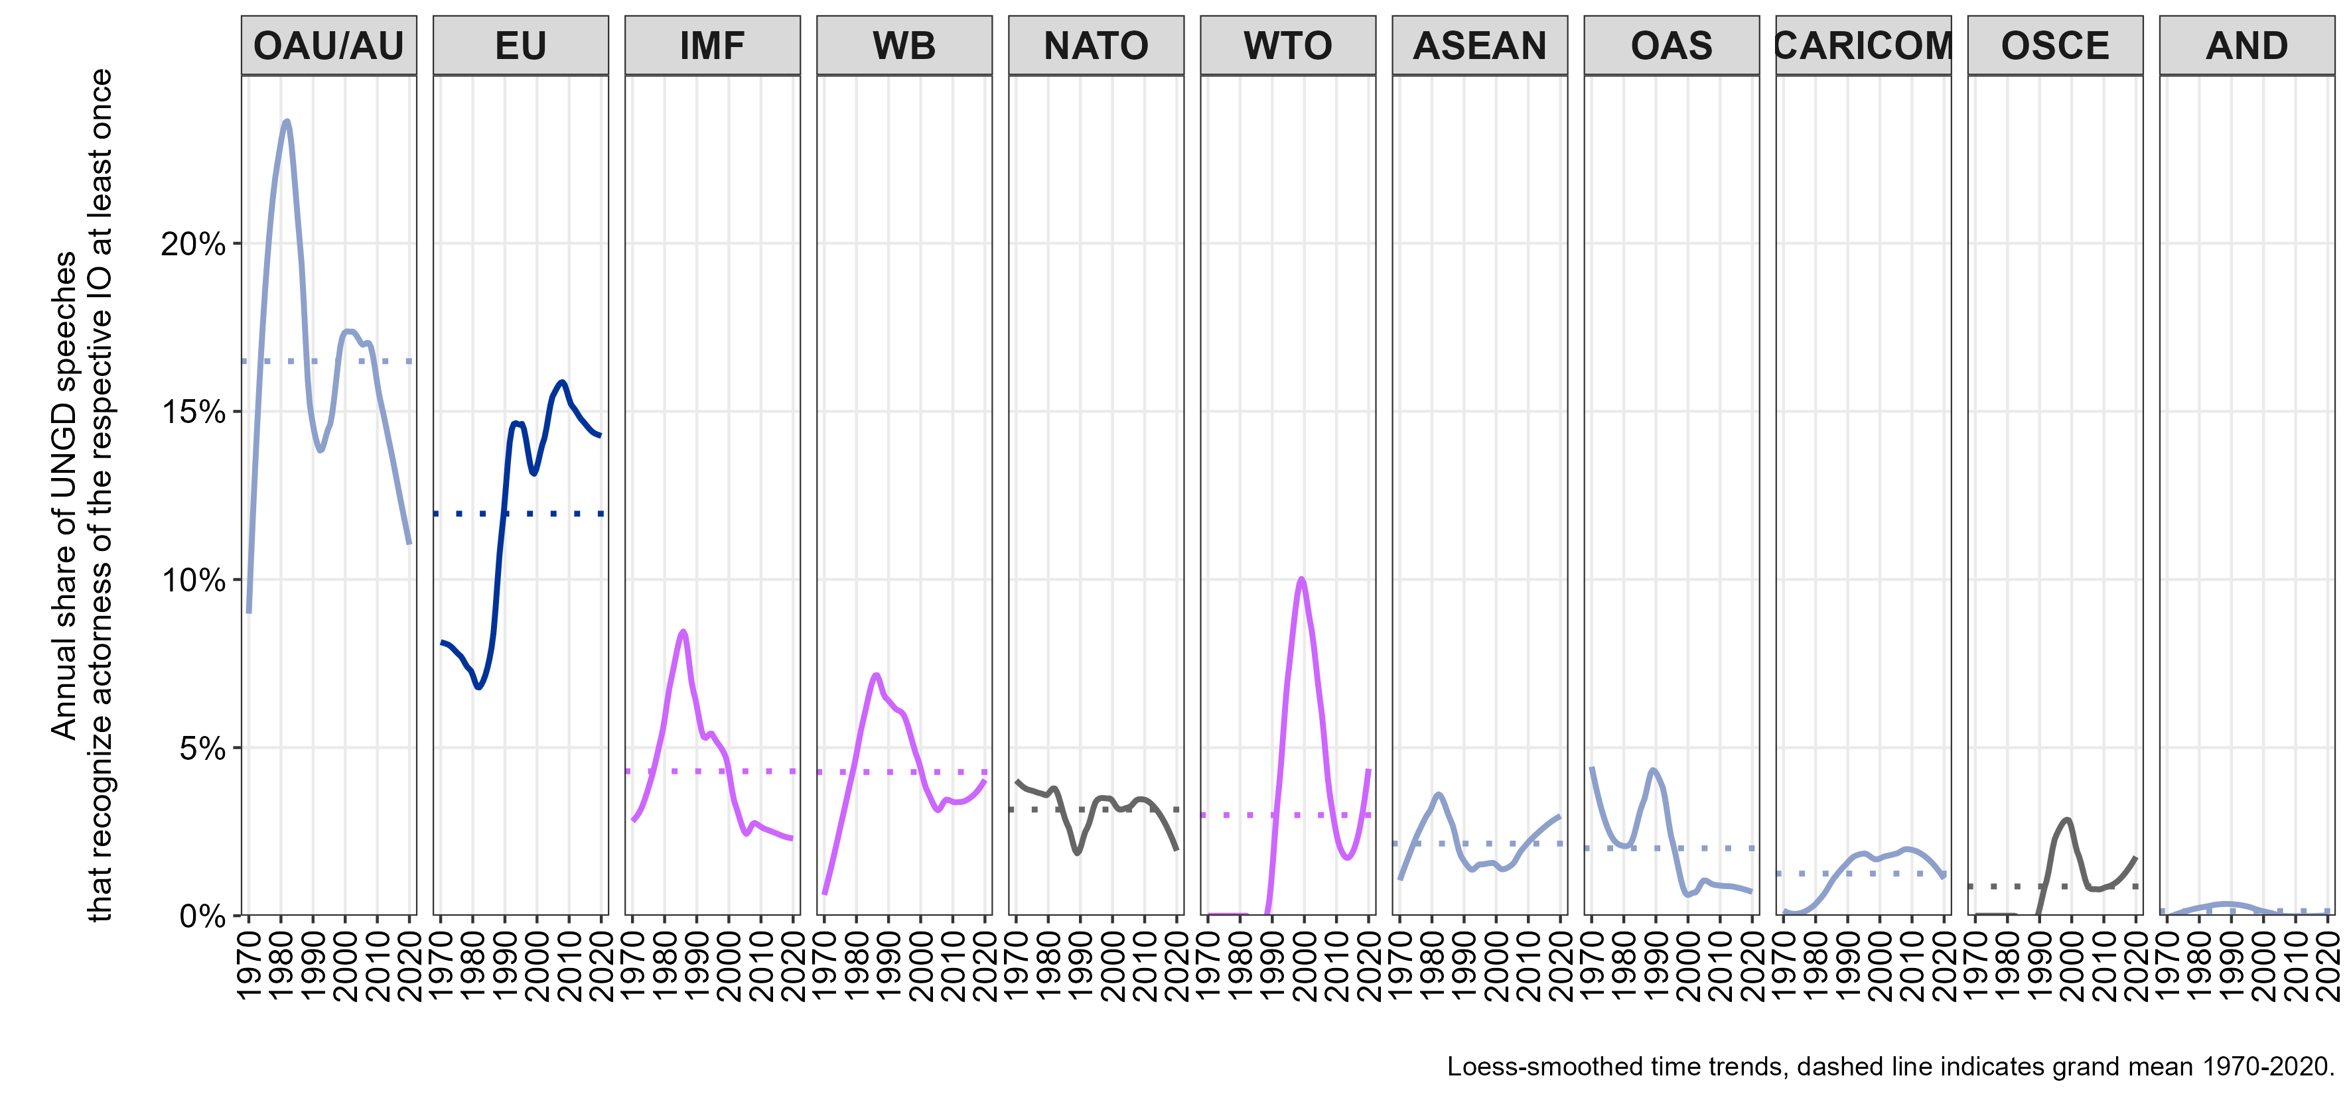

**Figure 3:** Annual share of UNGD speeches recognizing actorness of different ROs and IOs

In this comparative perspective, actorness recognition of the EU is only trumped by that of the African Union (and its predecessor, the Organization of African Unity) – an organization with a much larger state membership that is also crucial for UN coordination of African states on questions of decolonialization and regional peace (Murithi 2017). But with this exception, the EU is indeed a strong positive outlier in terms of internationally recognized actorness amongst comparatively authoritative organizations and institutions beyond the nation state. UNGD speakers recognize action capabilities of some international institutions at specific points in time – e.g. the World Trade Organization in the early 2000s – but the grand average of EU actorness recognition in UNGD speeches more than doubles that of key IOs such as the IMF, the World Bank or NATO, or that of other regional organizations such as ASEAN, which all figure as actors in only less than 5% of UNGD speeches on average.

We can then also compare the recognition of EU actorness to that of states as the ‘natural’ inhabitants of the international system (Figure **4**). Looking at the top-25 lists of states pre- and post-Maastricht initially provides some hints on whose actorness is recognized in global discourse. We see, for example, that great power status matters, with the United States ranking particularly high in both periods. All other P5 states (values for Russia include the USSR for earlier periods) and other leading trade powers also make it to the top-25 lists of recognized state actors in UNGD speeches. But one also sees that security concerns and contested statehood seem to matter for actorness recognition in these debates. Many states in the top-25 list are countries involved in armed conflicts with either international externalities or international involvement. Prime examples are Israel and the Palestinian Territories throughout both periods, but also states like Afghanistan, Iraq, Iran, Libya, Syria, or Vietnam. Moreover, we note that the distribution is flatter after 1992, supporting the perspective of a more multipolar world order after the end of the Cold War. This highlights that actorness recognition in UNGD debates appears as state- and security-driven. Future research could thus exploit the measures proposed here to study the discursive construction of state sovereignty (cf. Krasner 1999)

But for the present purposes we note that the EU fares remarkably well in that comparison. Even before 1992, the EU would have made it to the top-25 list of recognized ‘state’ actors. In the post-Maastricht period, the EU even achieves the fifth spot in this average ranking, coming close to France, one of its largest member states that also has a P5 status.

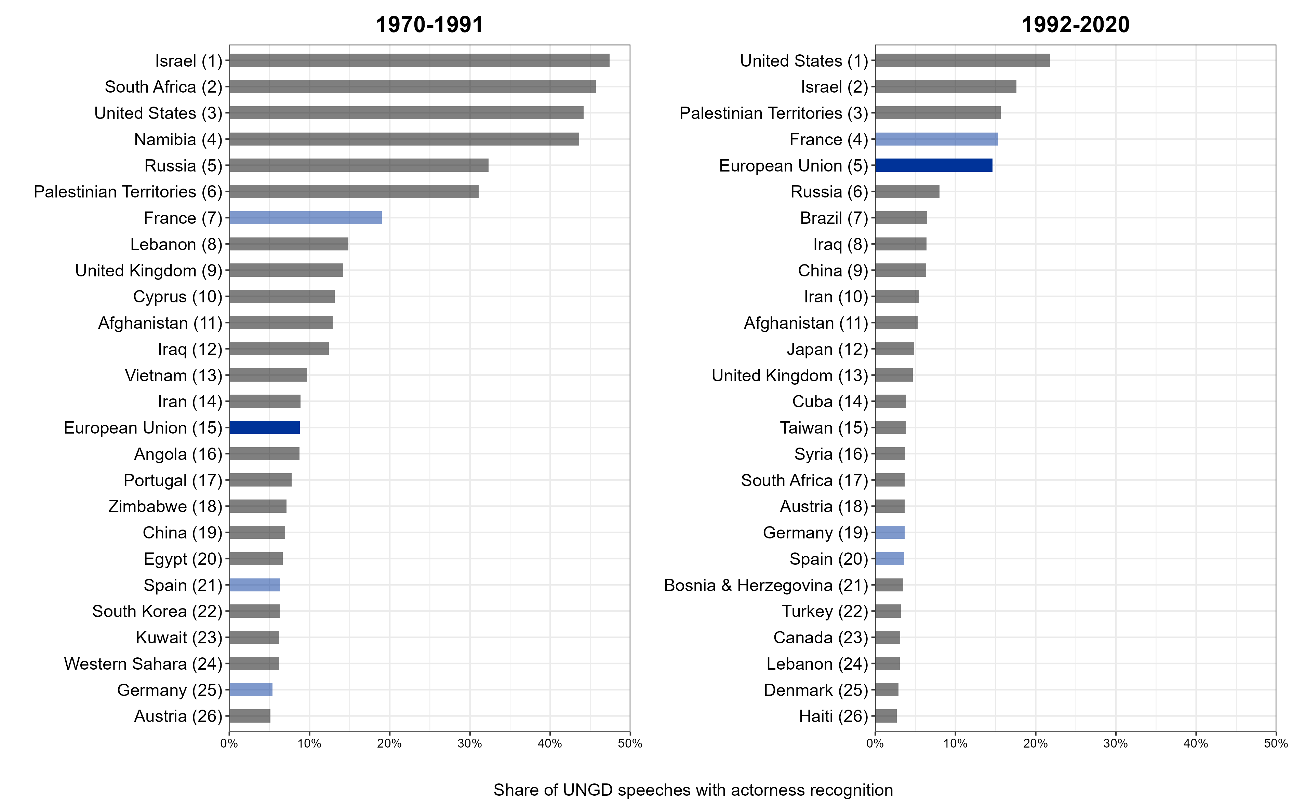

**Figure 4:** Benchmarking the recognition of EU actorness to that of the top-25 states with recognized actorness in UNGD speeches

In descriptive terms, we can thus conclude that the recognition of EU actorness in this major forum for intergovernmental exchange has increased over the 50 years observed here, it happens primarily in economic but partially also in security contexts, it trumps the recognized actorness of most other key institutions beyond the nation state, and it can even partially keep up with the actorness ascribed to individual states in the international system.

Yet and still, caution is warranted: the observed average of 14% of speeches recognizing EU actorness in the post-Maastricht period inversely implies that 86% of national representatives do not explicitly recognize EU actorness when giving their probably most important international foreign policy speech in a given year. In other words, there is significant cross-national variation.

# **5. Which states recognize EU actorness in their UNGD speeches?**

To get a descriptive sense of such cross-national variation, Figure 5 maps the share of speeches that recognize EU actorness along the country that UNGD speakers represent – focusing on the more meaningful post-Maastricht period from now on.

This geographical distribution sends a very strong visual message: recognizing EU actorness on the international stage is a primarily a European thing. While there is some internal variation, states located in or immediately around the Union ascribe EU actorness in a much larger share of UNGD speeches than countries from the rest of the world. Initially it is not overly surprising that members of a bloc emphasize actorness of that bloc more strongly than the outside world – along the data generated here, similar patterns can be retrieved for the African Union or ASEAN, for example.

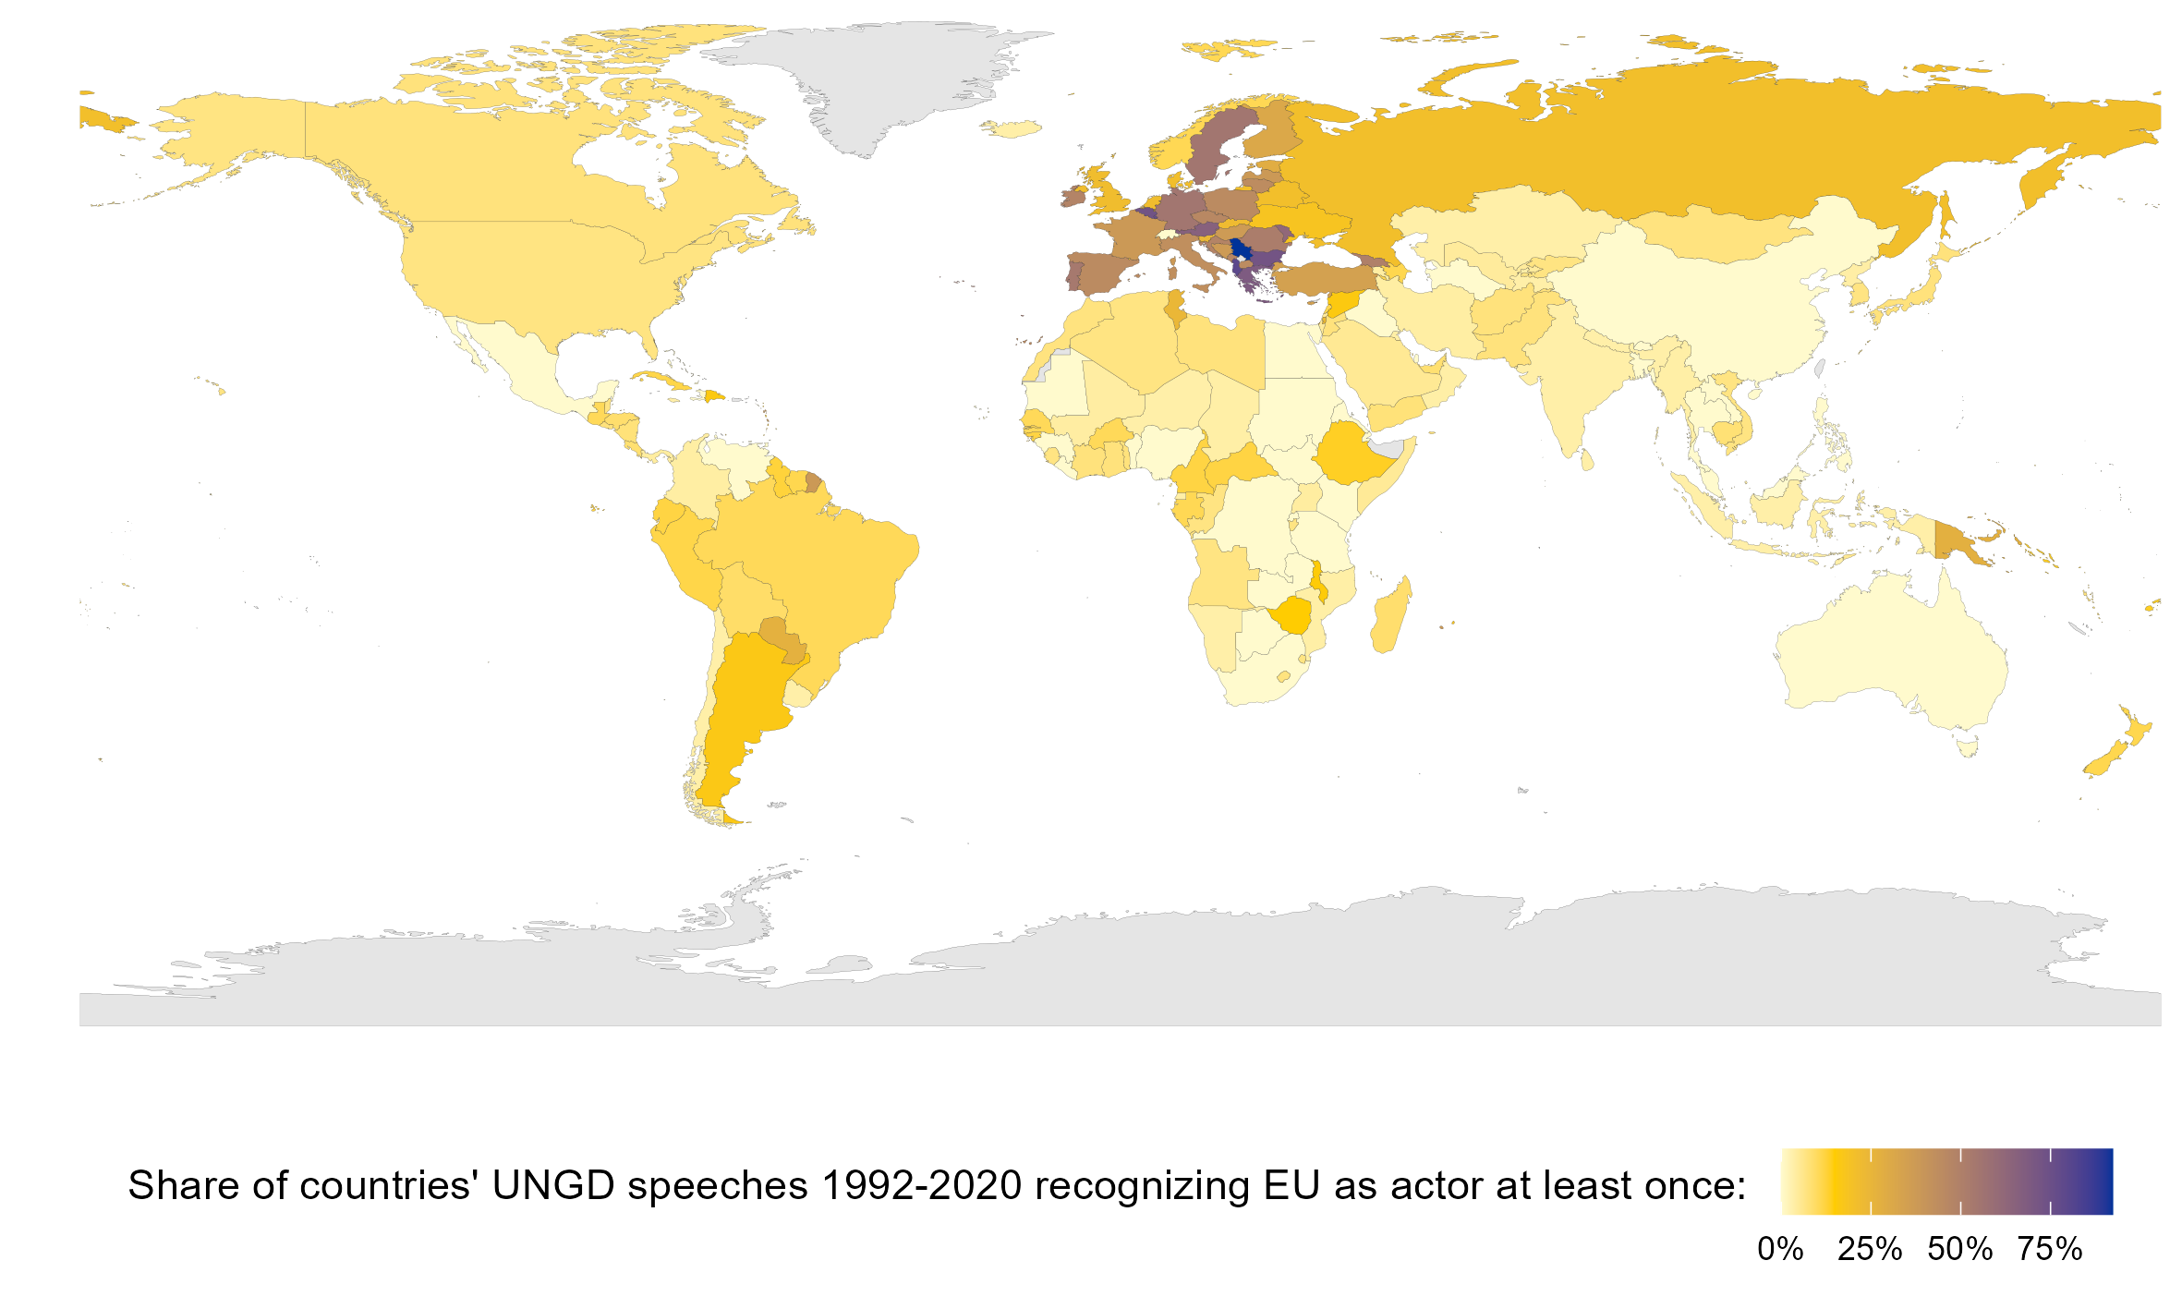

**Figure 5:** Recognition of EU actorness by speakers’ country in the 1992-2020 period

But against the EU’s repeatedly formulated ambition to be recognized as a global actor, the differences between portrayals from within and external recognition are quite sobering. In the 1992-2020 period, the likelihood that speakers link the EU to some kind of action in their annual UNGD speech is around 47% when they represent a contemporary EU member state, that is this occurs in roughly every second speech. These chances drop to 30% for representatives of other states located on the European continent, that is every third speech. Yet, for speakers representing states that are not located in Europe, EU actorness is recognized in only 7% of speeches, on average. Explicit recognition of EU actorness from outside of Europe is, in fact, a rare event in this central forum of global politics. Even after the Maastricht treaty has institutionalized the CSFP-pillar, the recognition of the EU’s international actorness thus still reflects largely an *ambition from within Europe* rather than a high amount of decidedly *external recognition*.

Yet and still, there is notable variation among states outside of Europe. Representatives from Turkey (34%), Papua New Guinea (28%), Paraguay (27%), but also Tunisia (24%), Russia (21%), or Saint Lucia (21%), for example, recognize EU actorness in their speeches at least somewhat frequently. Others, in contrast, recognize EU actorness in the 28 years of UNGD speeches observed here only once, among them Chile, Uruguay, India, and – strikingly – the United States.[[8]](#footnote-8) Finally, a notable number of 43 countries never associate the EU with some kind of direct action during the three decades we observe here – among them decidedly authoritarian regimes such as Iran, Uzbekistan, or Venezuela, but also major trade powers such as South Africa and, particularly noteworthy, China (which, in fact, never mentions the EU at all). Again, these patterns are sobering for the EU’s global actor ambitions and they point to the above theorized arguments according to which the recognition of EU actorness might be driven by distance, trade dependence, but also by regime type and strategic competition more broadly.

To test whether this theorized co-variation is systematic, let us move down to the level of individual annual speeches by representatives from non-EU countries. In the 1992-2020 period, we have relevant country/year data to test the above specified hypotheses on contextual and cross-national variation for a total of 3,638 of such speeches (descriptives in appendix A7). Figure 6 summarizes a linear model of the probability that EU actorness is recognized in these speeches.

The upper panel initially shows that the semantic content of a statement – here measured on the level of the full speech – matters for whether EU actorness is recognized therein. In line with the capability perspective on EU actorness, an increase in the emphasis of economy- and trade-related terms by one standard deviation is associated with a roughly two percentage points higher chance that EU action is recognized in that speech. Surprisingly, also this multivariate, speech-level analysis suggests a positive link between EU actorness recognition by foreign actors when their speeches revolve around security terms that are semantically close to ‘war’, ‘peace’, ‘terrorism’ or ‘security’ itself. But we also see that this link is not fully robust in statistical terms. But even more strongly contrasting hypothesis 2, a speech using around one standard deviation more words associated with key terms circumscribing liberal democracy – ‘democracy’ itself, but also ‘law’, ‘rights’ or ‘freedom’ – comes with a two percentage points lower probability that EU actorness is recognized therein. In fact, this is the strongest negative effect in the estimated model, which is hardly consistent with the ‘normative power Europe’ arguments or ambitions – at least in their UNGD speeches, third countries do not recognize it as such.[[9]](#footnote-9)

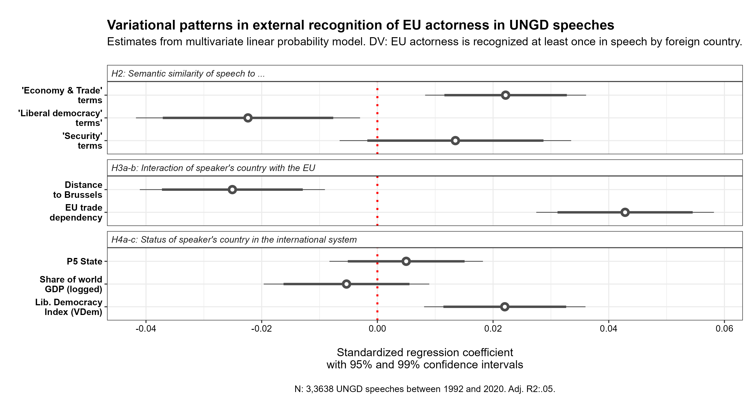

**Figure 6:** Regression model of external EU actorness recognition 1992-2020

The middle panel of Figure 6 focusses on the interactional logics of EU actorness recognition. In line with hypotheses 3a and b, we see that a larger geographical distance to the EU decreases the likelihood that a speaker recognizes EU actorness, while countries whose GDP is more dependent on trade with EU clearly recognize its actorness more often. In fact, trade dependency is the strongest positive predictor identified in this setting. It is thus not just EU capability that explains external recognition, it is the likelihood that third states experience these capabilities in more direct interaction.

Finally, the lower panel focuses on the potential strategic (dis-)incentives that third countries might have for recognizing the EU as an international actor in its own right. We initially see that the expectation for P5 states does not bear out – this state characteristic shows a weak positive tendency, which is not robust in statistical terms at all. A plausible reason is that the four non-EU states among the P5 are better explained by other interactional or strategic factors in the model. Russia and, since 2017, the UK are, for example, located comparatively closely to the EU and might thus recognize it more often along the interactional logics.

China and the U.S. are not only P5 states but also the leading trade powers on the globe which might mean that the theorized economic competition logic captures these cases better. With regard to this hypothesis, the model shows that a higher share of a county’s economy in the worldwide gross product is indeed associated with a lower likelihood that EU actorness is recognized. Yet, this expected effect does not reach conventional levels of statistical significance in this particular model specification.

In sum, this multivariate perspective indicates that the contextual and especially the variation across countries matters for the external recognition of EU actorness over and beyond the slow development of its foreign policy capabilities from within. To illustrate this in more substantive terms, a one-standard-deviation decrease in a capital’s distance to Brussels – around 3,500 kms, which approximates the distance between the EU capital and Cairo (Egypt) or Yerevan (Armenia) – decreases the likelihood that a speaker from a respective country recognizes the EU as an actor already by more than two percentage points. This is quite remarkable if we recall that the average likelihood for external recognition is 7% overall only. And, again, this neighborhood effect is hardly in line with the EU’s ambition to be a truly global actor.

Yet, some statistical caution is warranted. Most importantly, the reader should recall that external recognition of EU actorness is a very rare event overall. This is first and foremost important as an empirical fact in itself, but also creates statistical challenges. The linear model might be off at the fringes of the probability distribution, but also logit models underestimate event likelihoods in such instances and suffer from small sample and separation problems (King and Zeng 2001). Appendix A8 thus re-estimates the model by a logit and then a penalized maximum likelihood logit specification that accounts for the rare event nature of the data. Moreover, given that we observe panel data – a largely stable number of countries over 28 years – we might overestimate the statistical robustness of the effects if the estimation residuals are not identically and independently distributed. Since a fixed-effects specification does not help here – we would absorb the substantially interesting variation of the slowly changing variables on the country level – appendix A8 applies consecutively stricter error correction methods that consider heteroskedastic error distributions as well as potential error clustering on either the year or the country level.

Yet and still, these robustness checks lead to the same inferences. The theorized effect of GDP world-share even finds more robust support in some of the 11 tested model specifications. Given these minor fluctuations and the myriads of idiosyncratic logics that might drive EU actorness recognition in any given year – among them crowding out effects by other issues of the day – these models are hardly exhaustive explanations for whether and when the EU is recognized as an international actor. But the covariation of external EU actorness recognition on the one hand and the speech and country-level characteristics on the other is systematic and remains largely robust even against such high levels of unexplained variability.

# **6. Conclusions**

Are the EU’s global ambitions and its direct and indirect foreign policy capabilities explicitly and increasingly recognized by other states in the international system? The original data that this article has generated from the annual United Nations General Debates – the most regular, most visible and broadest governmental foreign policy exchange among virtually all states – offer a mixed picture.

On the one hand, explicit recognitions of the EU’s capability to act as a joint entity have increased over time in UNGD speeches. They do exceed those of most other regional and international organizations and, notably, those of many other states, particularly in economic but partially also in security contexts. The EU is an unusually powerful institution beyond the nation state but given that it is still an emerging polity with incomplete foreign policy competences, this high level of actorness recognition is quite remarkable.

On the other hand, we have also seen that this rather reflects the ambitions of EU member states themselves rather than decidedly external recognition by third states – external recognition is almost seven times lower than recognition from within. Even after the Maastricht treaty has established the Common Foreign and Security Policy and the Lisbon treaty has backed this with a formal office and an agency, explicit actorness recognition by third states and especially by other major powers in the world is indeed a very rare event in UN debates. This challenges the capability-perspective that often dominates the actorness literature: The patterns found here suggest that the EU will not just be recognized as an actor when it’s treaty-based powers or the externalities of its internal regulatory competences increase over time.

In contrast, incentives of outside actors should be taken more seriously: Those few external actors that explicitly recognize EU actorness in their UNGD speeches are primarily those that depend economically on the EU, that are located close to its borders, or that are liberal democracies themselves. In contrast, states that compete with the EU either on international market shares or on regime type are even less likely to explicitly recognize its actorness in the global foreign policy discourse. This appears somewhat sobering for the optimistic view in the extant actorness literature according to which lacking *de jure* recognition could be compensated for high levels of *de facto* recognition of the EU on the international stage.

Of course, we observe ‘only’ rhetorical action here. The uncovered patterns cannot and should not serve to infer that autocratic trade powers, such as China for example, do not recognize potential action capabilities of the European Union *privately*. But the patterns do indeed demonstrate that such actors have not much of an appetite to *publicly* embrace joint EU actorness in the broader foreign policy discourse, thereby revealing that their lacking interests in welcoming the supranational entity to the international stage contrasts strongly with the EU’s own ambitions.

More generally, the results on variation across states and international organizations above suggest that the tools proposed here are helpful to study questions of discursively constructed actorness in contemporary international relations by treating it not as an immutable, uniform status, but rather as a relational property negotiated in multilateral fora (cf. Krasner 1999; Ruggie 1993). The study of contested EU actorness here thus offers an example for examining how the authority and legitimacy of political entities are recognized, contested, or denied in global politics.

But focusing on the EU in more pragmatic terms, what can the Union do in the light of the patterns highlighted here? Caution is warranted when deriving policy implications from expressed preferences in highly aggregated speech data, but at least two strategic pointers emerge from what we have learned about who recognizes EU actorness internationally and why.

First, that actorness recognition happens in economic contexts and that it is influenced strongly by foreign countries’ dependence on EU trade suggests that the EU’s push for continued international trade liberalization, even in the currently adverse climate, is an advisable strategy also for upholding its international political clout in the long run. The recent EU-MERCOSUR trade partnership, which now needs to be ratified, is likely to improve its actorness recognition internationally along the patterns shown here. Inversely, the growing risk of trade wars emanating especially from the United States and China is not only an economic but also a political danger for an EU that wants to be recognized as a decisive player in international affairs.

Second, the findings on geographical distance underline that the EU’s international clout runs primarily through its neighborhood. Particularly the countries in the EU’s closer vicinity seem to recognize EU actorness the most – sometimes also in security contexts. When it comes to prioritizing the manifold challenges in world politics, thus, the EU could focus on an even more active neighborhood policy as one of the most promising strategies for slowly building influence on the international stage.

That is not to say that EU should abandon its ambition to be a truly global actor. But a realistic assessment of who actually wants and who does not want to recognize the international actorness of the supranational entity should help to avoid overstating the EU’s clout in the international system and building more realistic strategies in striving for that goal.

# **7. References**

Arel-Bundock, Vincent, Nils Enevoldsen, and C. J. Yetman. 2018. “Countrycode: An R Package to Convert Country Names and Country Codes.” *JOSS - The Journal of Open Source Software* 3 (28): 848.

Baturo, Alexander, Niheer Dasandi, and Slava J. Mikhaylov. 2017. “Understanding State Preferences with Text as Data: Introducing the UN General Debate Corpus.” *Research & Politics* 4 (2): 2053168017712821. doi:10.1177/2053168017712821.

Benoit, Kenneth, and Akitaka Matsuo. 2020. “Spacyr: Wrapper to the ‘spaCy’ ‘NLP’ Library. R Package Version 1.2.1.” https://cran.r-project.org/package=spacyr.

Benoit, Kenneth, Kohei Watanabe, Haiyan Wang, Paul Nulty, Adam Obeng, Stefan Müller, and Akitaka Matsuo. 2018. “Quanteda: An R Package for the Quantitative Analysis of Textual Data.” *JOSS - The Journal of Open Source Software* 3 (30): 774. doi:10.21105/joss.00774.

Biber, Douglas, Susan Conrad, and Randi Reppen. 1998. *Corpus Linguistics: Investigating Language Structure and Use*. Cambridge ; New York: Cambridge University Press.

Bretherton, Charlotte, and John Vogler. 2000. “The European Union as Trade Actor and Environmental Activist: Contradictory Roles?” *Journal of Economic Integration* 15 (2). Center for Economic Integration, Sejong University: 163–194.

Bretherton, Charlotte, and John Vogler. 2006. *The European Union as a Global Actor*. London: Routledge.

Bull, Hedley. 1982. “Civilian Power Europe: A Contradiction in Terms?” *JCMS: Journal of Common Market Studies* 21 (2): 149–170. doi:10.1111/j.1468-5965.1982.tb00866.x.

Coleman, James S. 1982. *The Asymmetric Society*. Syracuse, NY: Syracuse University Press.

Conceição-Heldt, Eugénia da, and Sophie Meunier, eds. 2016. *Speaking With a Single Voice: The EU as an Effective Actor in Global Governance?* London: Routledge. doi:10.4324/9781315717197.

Damro, Chad. 2015. “Market Power Europe: Exploring a Dynamic Conceptual Framework.” *Journal of European Public Policy* 22 (9). Routledge: 1336–1354. doi:10.1080/13501763.2015.1046903.

Del Sarto, Raffaella A. 2016. “Normative Empire Europe: The European Union, Its Borderlands, and the ‘Arab Spring.’” *JCMS: Journal of Common Market Studies* 54 (2): 215–232. doi:10.1111/jcms.12282.

Emerson, Michael, Rosa Balfour, Sven Biscop, Piotr Maciej Kaczynski, and Thomas Renard. 2011. *Upgrading the EU’s Role as Global Actor: Institutions, Law and the Restructuring of European Diplomacy*. Brussels: Centre for European Policy Studies.

Firth, J. R. 1957. “A Synopsis of Linguistic Theory 1930-55.” *Studies in Linguistic Analysis* 1952–59. Oxford: The Philological Society: 1–32.

Franzosi, Roberto, Gianluca De Fazio, and Stefania Vicari. 2012. “Ways of Measuring Agency: An Application of Quantitative Narrative Analysis to Lynchings in Georgia (1875–1930).” *Sociological Methodology* 42 (1). SAGE Publications Inc: 1–42. doi:10.1177/0081175012462370.

Gehring, Thomas. 1994. *Dynamic International Regimes: Institutions for International Environmental Governance*. Frankfurt am Main ; New York: Peter Lang GmbH, Internationaler Verlag der Wissenschaften.

Gehring, Thomas, Sebastian Oberthür, and Marc Mühleck. 2013. “European Union Actorness in International Institutions: Why the EU Is Recognized as an Actor in Some International Institutions, but Not in Others.” *JCMS: Journal of Common Market Studies* 51 (5): 849–865. doi:10.1111/jcms.12030.

Gehring, Thomas, Kevin Urbanski, and Sebastian Oberthür. 2017. “The European Union as an Inadvertent Great Power: EU Actorness and the Ukraine Crisis.” *JCMS: Journal of Common Market Studies* 55 (4): 727–743. doi:10.1111/jcms.12530.

Graham, Benjamin A. T., and Jacob R. Tucker. 2019. “The International Political Economy Data Resource.” *The Review of International Organizations* 14 (1): 149–161. doi:10.1007/s11558-017-9285-0.

Hecht, Catherine. 2016. “The Shifting Salience of Democratic Governance: Evidence from the United Nations General Assembly General Debates.” *Review of International Studies* 42 (5). Cambridge University Press: 915–938. doi:10.1017/S0260210516000073.

Honnibal, Matthew, and Ines Montani. 2020. “spaCy: Industrial-Strength Natural Language Processing.” https://spacy.io/.

Jupille, Joseph, and James A. Caporaso. 1998. “States, Agency, and Rules: The European Union in Global Environmental Politics.” In *The European Union in the World Community*, edited by Carolyn Rhodes, 157–182. Boulder, CO: Lynne Rienner Publishers.

King, Gary, and Langche Zeng. 2001. “Logistic Regression in Rare Events Data.” *Political Analysis* 9 (2). Cambridge University Press: 137–163. doi:10.1093/oxfordjournals.pan.a004868.

Klose, Stephan. 2018. “Theorizing the EU’s Actorness: Towards an Interactionist Role Theory Framework.” *JCMS: Journal of Common Market Studies* 56 (5): 1144–1160. doi:10.1111/jcms.12725.

Knight, Carly. 2022. “When Corporations Are People: Agent Talk and the Development of Organizational Actorhood, 1890–1934.” *Sociological Methods & Research* 51 (4): 1634–1680.

Krasner, Stephen D. 1999. *Sovereignty: Organized Hypocrisy*. Princeton, NJ: Princeton University Press. https://www.jstor.org/stable/j.ctt7s9d5.

Kratochvíl, Petr, Petra Cibulková, and Michal Beník. 2011. “The EU as a ‘Framing Actor’: Reflections on Media Debates about EU Foreign Policy\*.” *JCMS: Journal of Common Market Studies* 49 (2): 391–412. doi:10.1111/j.1468-5965.2010.02122.x.

Lavenex, Sandra, and Frank Schimmelfennig. 2009. “EU Rules beyond EU Borders: Theorizing External Governance in European Politics.” *Journal of European Public Policy* 16 (6): 791–812. doi:10.1080/13501760903087696.

Lucarelli, Sonia, and Lorenzo Fioramonti. 2009. *External Perceptions of the European Union as a Global Actor*. Reprint Edition. London: Routledge.

Lührmann, Anna, Staffan I. Lindberg, and Marcus Tannenberg. 2017. *Regimes in the World (RIW): A Robust Regime Type Measure Based on V-Dem*. SSRN Scholarly Paper ID 2971869. Rochester, NY: Social Science Research Network. doi:10.2139/ssrn.2971869.

Manners, Ian. 2002. “Normative Power Europe: A Contradiction in Terms?” *JCMS: Journal of Common Market Studies* 40 (2): 235–258. doi:10.1111/1468-5965.00353.

Mayer, Thierry, and Soledad Zignago. 2011. *Notes on CEPII’s Distances Measures: The GeoDist Database*. Working Papers 2011–25. CEPII. http://www.cepii.fr/CEPII/en/publications/wp/abstract.asp?NoDoc=3877.

Meunier, Sophie, and Kalypso Nicolaïdis. 2006. “The European Union as a Conflicted Trade Power.” *Journal of European Public Policy* 13 (6). Routledge: 906–925. doi:10.1080/13501760600838623.

Meunier, Sophie, and Kalypso Nicolaïdis. 2017. “The European Union as a Trade Power.” In *International Relations and the European Union*, edited by Christopher Hill, Michael Smith, and Sophie Vanhoonacker, 209–234. Oxford, UK: Oxford University Press.

Moravcsik, Andrew. 1993. “Preferences and Power in the European Community: A Liberal Intergovernmentalist Approach.” *JCMS: Journal of Common Market Studies* 31 (4): 473–524. doi:10.1111/j.1468-5965.1993.tb00477.x.

Murithi, Timothy. 2017. *The African Union: Pan-Africanism, Peacebuilding and Development*. London: Routledge.

Niemann, Arne, and Charlotte Bretherton. 2013. “EU External Policy at the Crossroads: The Challenge of Actorness and Effectiveness.” *International Relations* 27 (3). SAGE Publications Ltd: 261–275. doi:10.1177/0047117813497306.

Pennington, Jeffrey, Richard Socher, and Christopher D. Manning. 2014. “GloVe: Global Vectors for Word Representation.” In *Empirical Methods in Natural Language Processing (EMNLP)*, 1532–1543. http://www.aclweb.org/anthology/D14-1162.

Rauh, Christian, and Pieter De Wilde. 2018. “The Opposition Deficit in EU Accountability: Evidence from over 20 Years of Plenary Debate in Four Member States.” *European Journal of Political Research* 57 (1): 194–216.

Ruggie, John Gerard. 1993. “Territoriality and beyond: Problematizing Modernity in International Relations.” *International Organization* 47 (1): 139–174. doi:10.1017/S0020818300004732.

Silge, Julia, and David Robinson. 2016. “Tidytext: Text Mining and Analysis Using Tidy Data Principles in R.” *JOSS - The Journal of Open Source Software* 1 (3). doi:10.21105/joss.00037.

Sjöstedt, Gunnar. 1977. *The External Role of the European Community*. Swedish Studies in International Relations. Farnborough, Hampshire: Saxon House.

Smaghi, Lorenzo Bini. 2004. “A Single EU Seat in the IMF?” *JCMS: Journal of Common Market Studies* 42 (2): 229–248. doi:10.1111/j.1468-5965.2004.00486.x.

Smith, Courtney B. 2006. *Politics and Process at the United Nations: The Global Dance*. *Politics and Process at the United Nations*. Boulder, CO: Lynne Rienner Publishers. doi:10.1515/9781685853556.

Spirling, Arthur, and Pedro L. Rodríguez. 2022. “Word Embeddings What Works, What Doesn’t, and How to Tell the Difference for Applied Research.” *Journal of Politics* 84 (1): 101–115.

Stephen, Matthew D. 2015. “‘Can You Pass the Salt?’ The Legitimacy of International Institutions and Indirect Speech.” *European Journal of International Relations* 21 (4). SAGE Publications Ltd: 768–792. doi:10.1177/1354066114563417.

Stuhler, Oscar. 2022. “Who Does What to Whom? Making Text Parsers Work for Sociological Inquiry.” *Sociological Methods & Research* 51 (4). SAGE Publications Inc: 1580–1633. doi:10.1177/00491241221099551.

Welbers, Kasper, and Wouter Van Atteveldt. 2022. “Rsyntax: Extract Semantic Relations from Text by Querying and Reshaping Syntax.” https://cran.r-project.org/package=rsyntax.

Wendt, Alexander. 1992. “Anarchy Is What States Make of It: The Social Construction of Power Politics.” *International Organization* 46 (2): 391–425. doi:10.2307/2706858.

Wickham, Hadley. 2015. “Stringr: Simple, Consistent Wrappers for Common String Operations. R Package Version 1.0.0.” https://cran.r-project.org/package=stringr.

Zürn, Michael, Alexandros Tokhi, and Martin Binder. 2021. “The International Authority Database.” *Global Policy* 12 (4): 430–442. doi:10.1111/1758-5899.12971.

1. <https://ec.europa.eu/commission/presscorner/detail/en/speech_19_6408> (last accessed: 15.02.2023) [↑](#footnote-ref-1)
2. This conceptualization is consistent with the idea of ‘agency’ in the sociological or linguistic study of collective or corporate actors (Biber, Conrad, and Reppen 1998; Coleman 1982). However, as ‘agency’ has a specific conceptual meaning in political science studies of delegation processes and as ‘actorness’ is an established term in the literature on EU foreign policy, I stick with Sjöstedt’s wording in this article. [↑](#footnote-ref-2)
3. One may object that the UN focusses primarily on security issues, thus being biased against EU actorness as implied by the discussion of issue contexts above. But if present, this bias should be by and large constant over time and countries, allowing for valid relative conclusions on EU actorness recognition. [↑](#footnote-ref-3)
4. The raw corpus is available at [https://doi.org/10.7910/DVN/0TJX8Y](https://doi.org/10.7910/DVN/0TJX8Y" \t "_blank) (Version 6, last accessed: 16.02.2023). For all text-processing steps, I build on the quanteda (Benoit et al. 2018), tidytext (Silge and Robinson 2016), and stringr (Wickham 2015) R packages. Data and scripts reproducing the following extraction and analysis steps are fully documented in the replication archive available in the II Dataverse: <https://dvn.iq.harvard.edu/dvn/dv/internationalinteractions>. Please contact the author in case of questions. [↑](#footnote-ref-4)
5. <https://github.com/christophergandrud/imfr> (last accessed: 16.02.2023). [↑](#footnote-ref-5)
6. There are 978 further speeches mentioning the EU in passing, but without ascribing any specific action to this entity. To give a random example (further ones can be inspected in the replication package): ‘Several Western and European ties of solidarity already bind us, and you know how happy we should be if the accession of Norway to the European Communities were to bring us even closer together.’ (Belgium, 1970, sentence 208). [↑](#footnote-ref-6)
7. Note that the EU also became an observer member of the UN with speaking rights in the General Debate in 2011 (where virtually all of EU speeches unsurprisingly recognize EU actorness). As proposed by an anonymous reviewer, this could have decreased EU members’ incentives to emphasize EU actorness themselves. Indeed, the share of German speeches recognizing EU actorness drops from 74% before to only 20% after 2011. Yet and still, this decline and then stagnation in overall recognition appears inconsistent with a perspective claiming that the EU’s formal (i.e. treaty-based) capabilities drive international recognition of its actorness. [↑](#footnote-ref-7)
8. The U.S. does mention the EU five times during the 1992-2020 period but links it only once to an explicit action (the multilateral negotiations over Iran’s nuclear program in 2013). In other U.S. speeches the EU is merely listed among other multilateral institutions while the 2019 U.S. speech (Trump I administration) mentions the EU only in the context of supporting the U.K.’s exit from it. [↑](#footnote-ref-8)
9. Note that democracy-related talk in international exchanges often appears to serve as indirect speech to couch specific positions or demands in cloudy legitimacy language (Stephen 2015), which may partially explain the pattern observed here. [↑](#footnote-ref-9)