**Assignment 1**

Assignment 1: Please setup C++ Development environment ready.

Assignment 2: Create a program to declare different types of variables and use them :

* Integer
* Boolean
* Char
* Double
* String

Note: Separate program is required for each variables.

**Code**:

#include <iostream>

#include <string>

using namespace std;

int main() {

int a=12;

double b=90.5;

bool Light=true;

char word='a';

string ba="hello";

cout <<a<<endl;

cout <<b<<endl;

cout <<Light<<endl;

cout <<word<<endl;

cout <<ba<<endl;

}

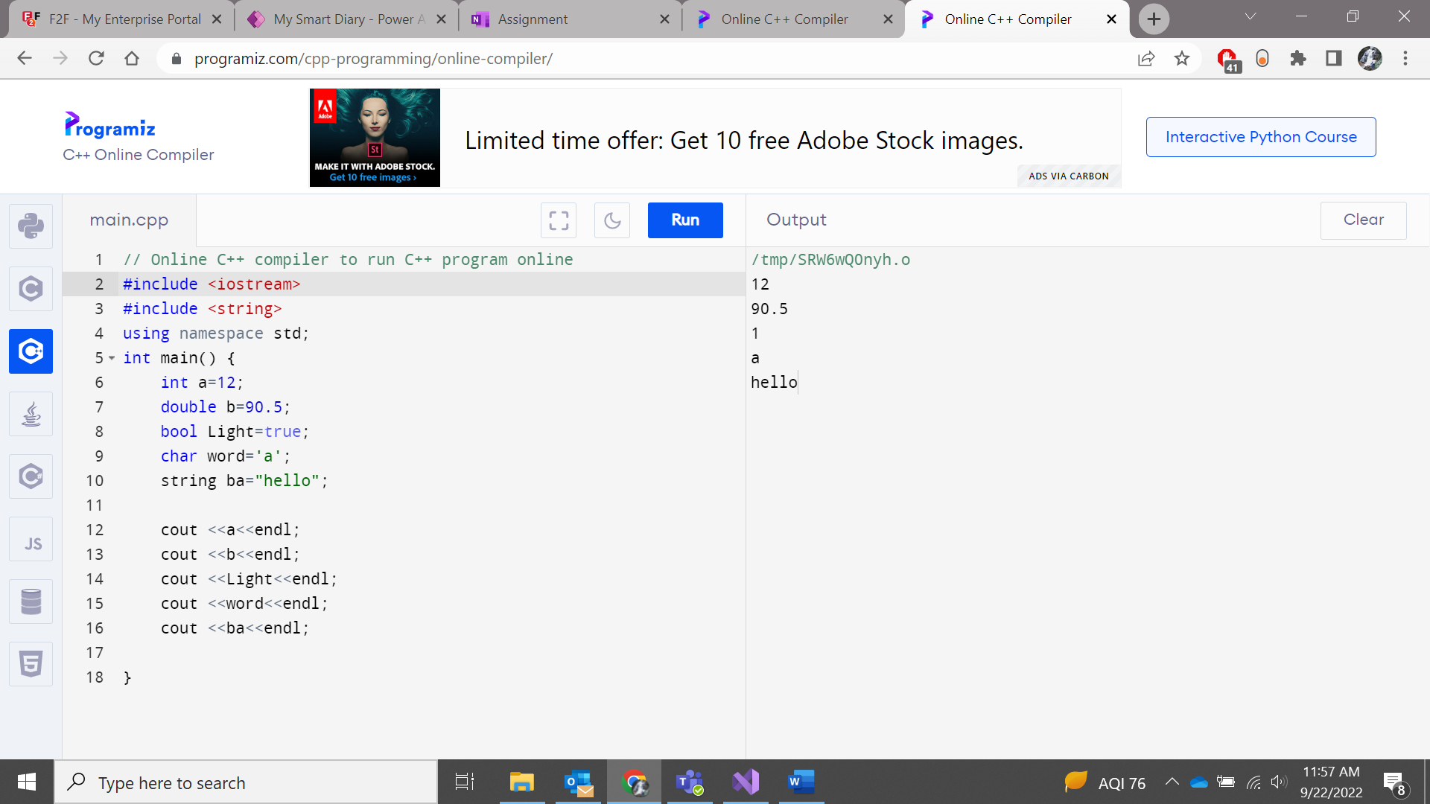

Assignment 3: Create a program with one error. Explain the reason behind the error.

Only single ‘=’ operator used in the if condition instead of ‘==’ to compare to operands.

**Code:**

**#include <iostream>**

**using namespace std;**

**int main() {**

**int a;**

**cout << "Enter the value of a num: " << endl;**

**cin >> a;**

**if(a%2=0){**

**cout << "It is an even number" <<endl;**

**}**

**else**

**cout << "It is a odd number" << endl;**

**return 0;**

**}**

