**Assignment 11**

1. Write C++ Program to find area and volume using multiple inheritance

**Code:**

#include <iostream>

using namespace std;

class Area

{

    Pu blic:

        int getArea(int l, int b)

        {

            return l * b;

        }

};

class Volume

{

    public:

        int getVolume(int l, int b,int h)

        {

            return l*b*h;

        }

};

class Rectangle : public Area, public Volume

{

    int length;

    int breadth;

    int height;

    public:

        Rectangle()

        {

            length = 70;

            breadth = 30;

            height = 15;

        }

        int area()

        {

            return Area::getArea(length, breadth);

        }

        int Volume()

        {

            return Volume::getVolume(length, breadth,height);

        }

};

int main()

{

    Rectangle rt;

    cout << "Area : " << rt.area() << endl;

    cout << "Volume : " << rt.Volume() << endl;

    return 0;

}

**Output:**

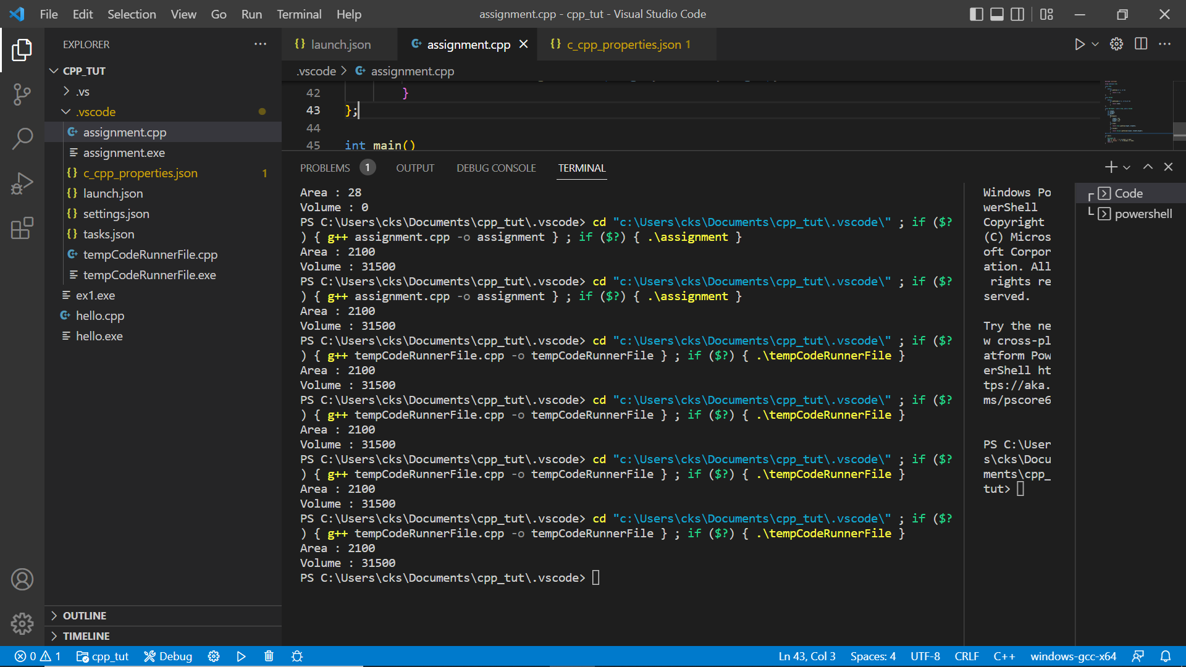

1. Write C++ Program to demonstrate an Example of Hybrid Inheritance.

Code:

#include <iostream>

using namespace std;

class Footballer // indicates class A

{

public:

Footballer()

    {

cout<< "He is a footballer.\n";

    }

};

class Forward: public Footballer // indicates class B derived from class A

{

public:

Forward()

    {

cout<< "He likes scoring goals and getting the W for the team.\n";

    }

};

class Midfielder: public Footballer  // indicates class C derived from class B

{

public:

Midfielder()

    {

cout<< "Totally unselfish and backbone of the team.(Assists++)\n";

    }

};

class Defender: public Footballer // indicates class D derived from class C

{

public:

Defender()

    {

cout<< "Attacks help win matches but defense helps win the championship.\n" <<endl;

    }

};

int main() {

    Footballer f1;

    Forward a1;

    Midfielder obj;

    Defender d1;

    return 0;

}

**

1. What is the default value of static variables?
2. 0
3. 1
4. Garbage value
5. None of the above

Ans: Option a. is the correct one.

1. Write C++ Program to Swap Two Numbers Without Using third variable.

Code:

#include <iostream>

using namespace std;

int main()

{

int a=500, b=100;

cout<<"Before swap a= "<<a<<" b= "<<b<<endl;

a=a*b;

b=a/b;

a=a/b;

cout<<"After swap a= "<<a<<" b= "<<b<<endl;

return 0;

}

Output:

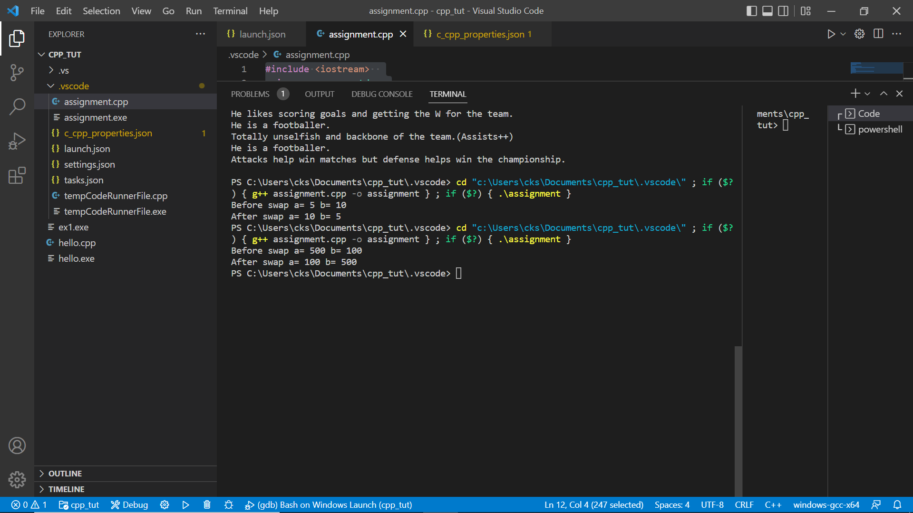

1. Write a C++ Program to Reverse a Number using while loop.

**Code:**

#include <iostream>

using namespace std;

int main()

{

int n, r=0, rem;

cout<<"Enter a number: ";

cin>>n;

  while(n!=0)

  {

     rem=n%10;

     r=r*10+rem;

     n/=10;

  }

 cout<<"Reversed Number: "<<r<<endl;

return 0;

}

**Output:**

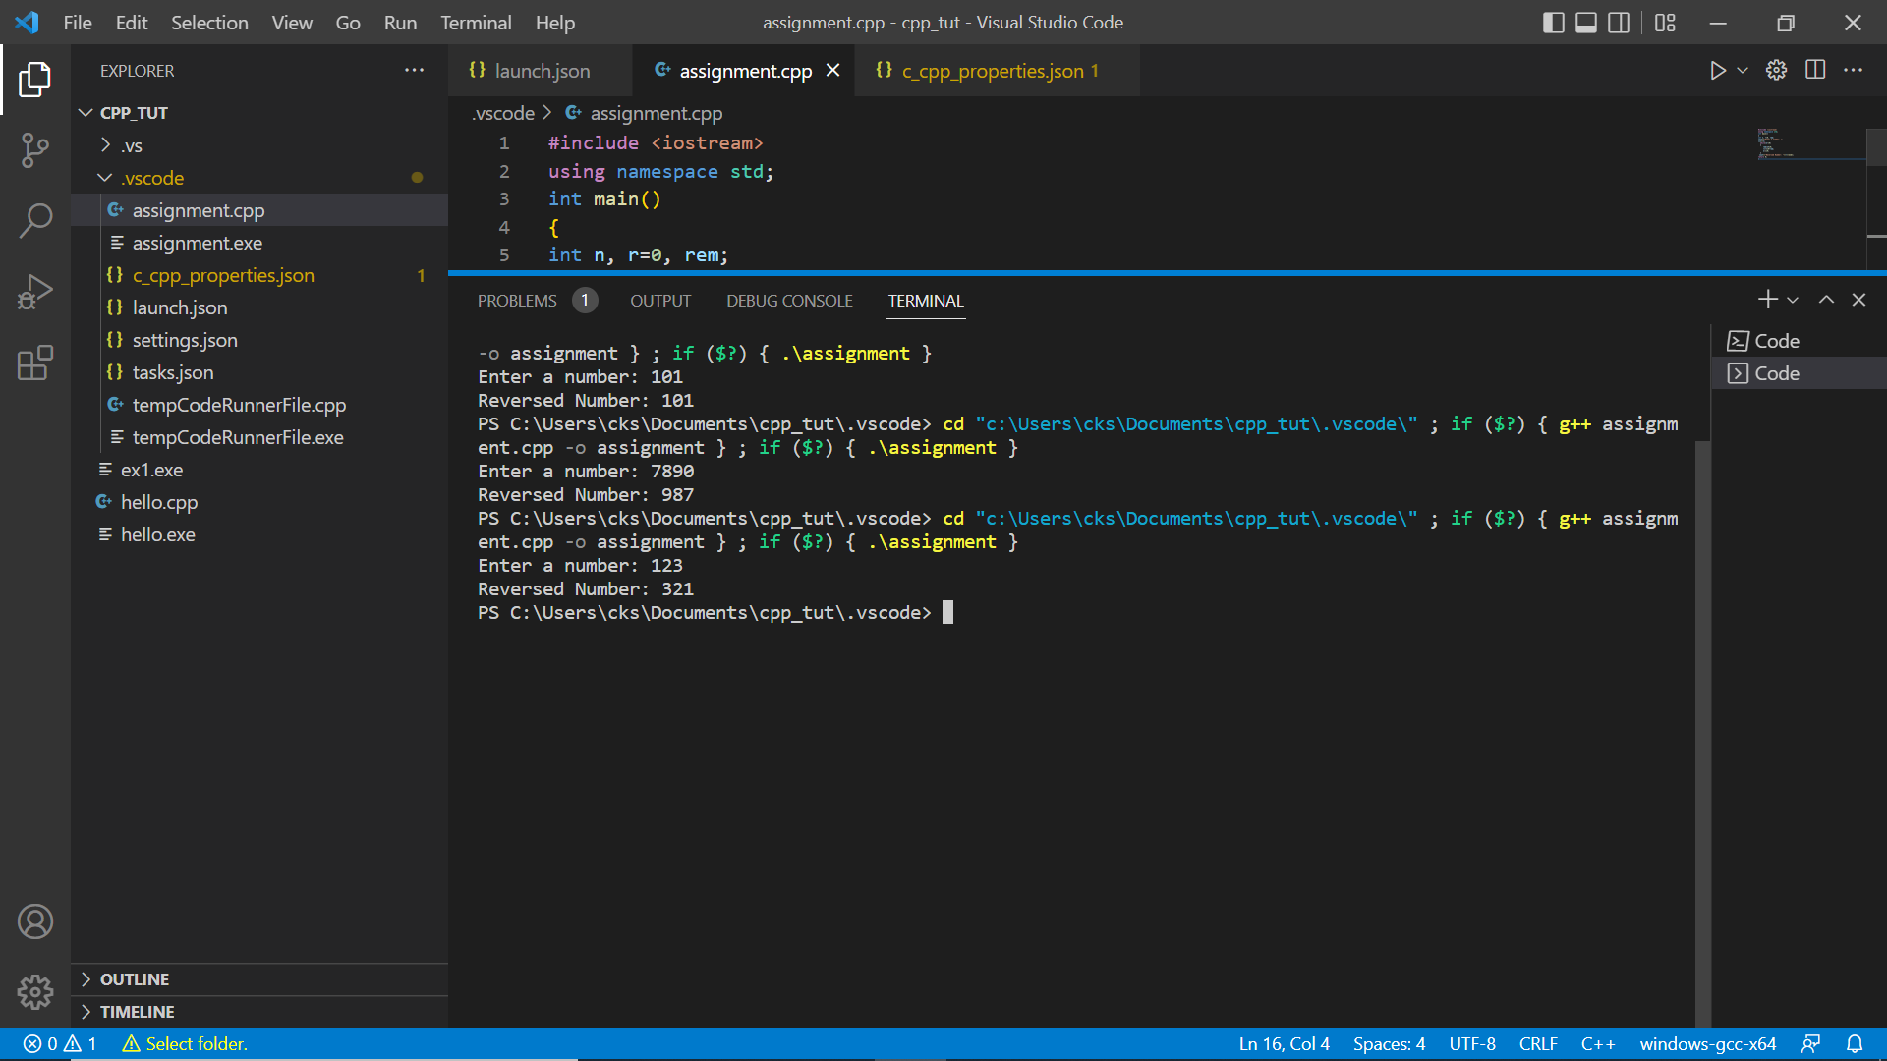

1. Write C++ Program to illustrate an example of Pure Virtual function

Code:

#include <iostream>

using namespace std;

class Shape {

   protected:

    float dimension;

   public:

    void getDimension() {

        cin >> dimension;

    }

    // pure virtual Function

    virtual float calculateArea() = 0;

};

// Derived class

class Square : public Shape {

   public:

    float calculateArea() {

        return dimension * dimension;

    }

};

class Circle : public Shape {

   public:

    float calculateArea() {

        return 3.14 * dimension * dimension;

    }

};

int main() {

    Square square;

    Circle circle;

    cout << "Enter the length of the square: ";

    square.getDimension();

    cout << "Area of square: " << square.calculateArea() << endl;

    cout << "\nEnter radius of the circle: ";

    circle.getDimension();

    cout << "Area of circle: " << circle.calculateArea() << endl;

    return 0;

}

Output:

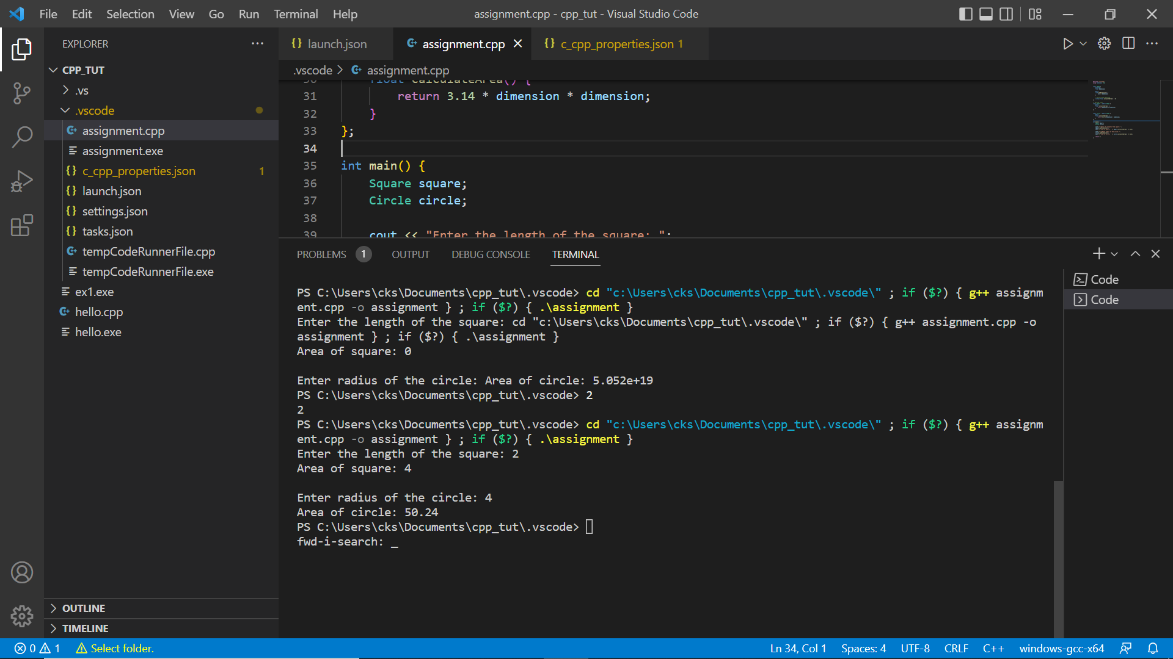

1. Which operator has highest precedence in * / % ?

(A) *

(B) /

(C) %

(D) all have same precedence

Ans: D all of them follow the same precedence from Left to Right.

1. What is the error in following code:

Class t {virtual void print();}

A. No error

B. Function print() should be declared as static

C. Function print() should be defined

D. Class t should contain data members

Ans: A. No error.

1. Write C++ Program to illustrates the use of Constructors in multilevel inheritance.

Code:

#include<iostream>

using namespace std;

class A

{

    public:

        A()

        {

            cout << "Base class A constructor \n";

        }

};

class B: public A

{

    public:

        B()

        {

            cout << "Class B constructor \n";

        }

};

class C: public B

{

    public:

        C()

        {

            cout << "Class C constructor \n";

        }

};

int main()

{

    C obj;

    return 0;

}

Output:

