**Assignment 2**

**Assignment 1**: Create a simple calculator program contains 5 operations.

**#include<iostream>**

**using namespace std;**

**int main(){**

**int choice;**

**cout <<"Simple Calculator" <<endl;**

**cout <<"1. Addition\n2. Subtraction\n3.Multiplication\n4.Division\n5. Modulus\n" << endl;**

**cin>>choice;**

**int var1, var2;**

**double add,sub,mul,divd,mod;**

**switch(choice) {**

**case 1:**

**cout<<"Enter the two variables for addition: " <<endl;**

**cin>>var1>>var2;**

**add=var1+var2;**

**cout << "The sum is: " << add << endl;**

**break;**

**case 2:**

**cout<<"Enter the two variables for subtraction: " <<endl;**

**cin>>var1>>var2;**

**sub=var1-var2;**

**cout << "The difference is: " << sub << endl;**

**break;**

**case 3:**

**cout<<"Enter the two variables for multiplication: " <<endl;**

**cin>>var1>>var2;**

**mul=var1*var2;**

**cout << "The product is: " << mul << endl;**

**break;**

**case 4:**

**cout<<"Enter the two variables for division: " <<endl;**

**cin>>var1>>var2;**

**divd=var1/var2;**

**cout << "The quotient is: " << divd << endl;**

**break;**

**case 5:**

**cout<<"Enter the two variables for modulus: " <<endl;**

**cin>>var1>>var2;**

**mod=var1%var2;**

**cout << "The remainder is: " << mod << endl;**

**break;**

**default:**

**cout << "Error" << endl;**

**break;**

**}**

**}**

**Output:**

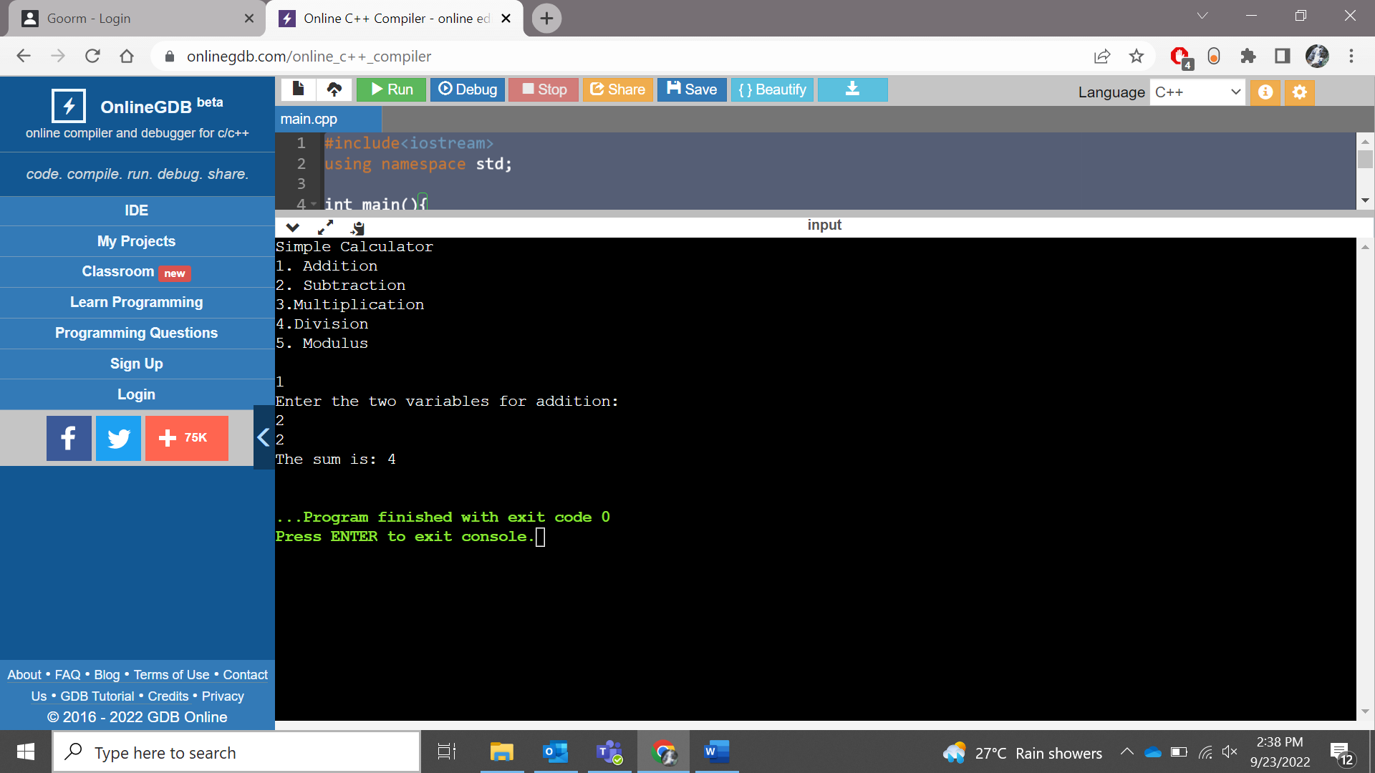

**Assignment 2:** Create a program to all assignment operators :

**Code:**

**#include<iostream>**

**using namespace std;**

**int main(){**

**int num;**

**cout << "Enter a number: " << endl;**

**cin>>num;**

**cout<<"Addition: "<<(num+=10)<<endl;**

**cout<<"Subtraction: "<<(num+=10)<<endl;**

**cout<<"Multiplication: "<<(num+=10)<<endl;**

**cout<<"Division: "<<(num=10)<<endl;**

**cout<<"Modulus: "<<(num%=10)<<endl;**

**cout<< "Bitwise And: "<<(num&=0)<<endl;**

**cout<< "Bitwise Or: "<<(num|=1)<<endl;**

**}**

**Output:**

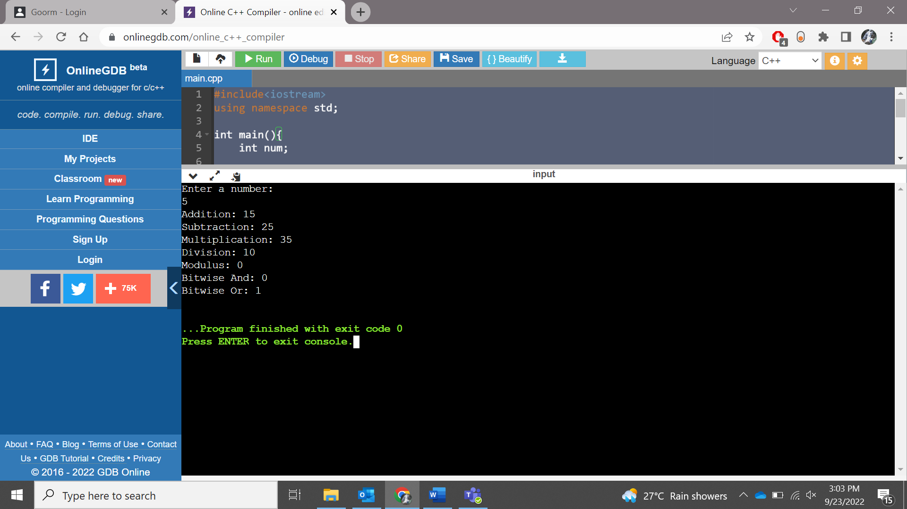

**Assignment 3**: Create a program to access local variable and global variable.

**#include<iostream>**

**using namespace std;**

**int x = 0;**

**int main()**

**{**

**int x = 10;**

**cout << "Value of global x is " <<::x;**

**cout<< "\nValue of local x is " << x;**

**return 0;**

**}**

**Output:**

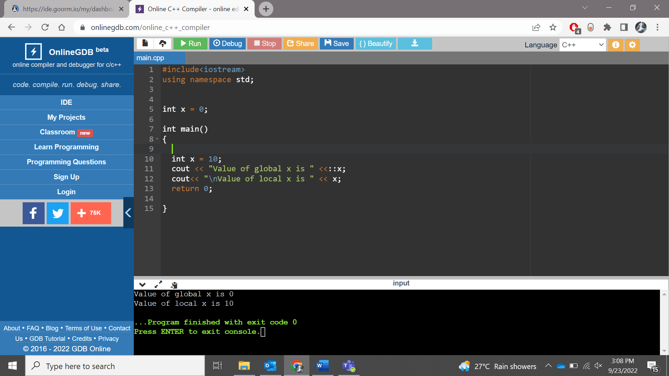

**Assignment 4**: Create a program to check manipulators.

**Code:**

**#include <iostream>**

**#include <iomanip>**

**using namespace std;**

**main()**

**{**

**int number = 100;**

**cout << "Hex Value =" << " " << hex << number << endl;**

**cout << "Octal Value=" << " " << oct << number << endl;**

**cout << "Setbase Value=" << " " << setbase(8) << number << endl;**

**cout << "Setbase Value=" << " " << setbase(16) << number << endl;**

**return 0;**

**}**

**Output:**

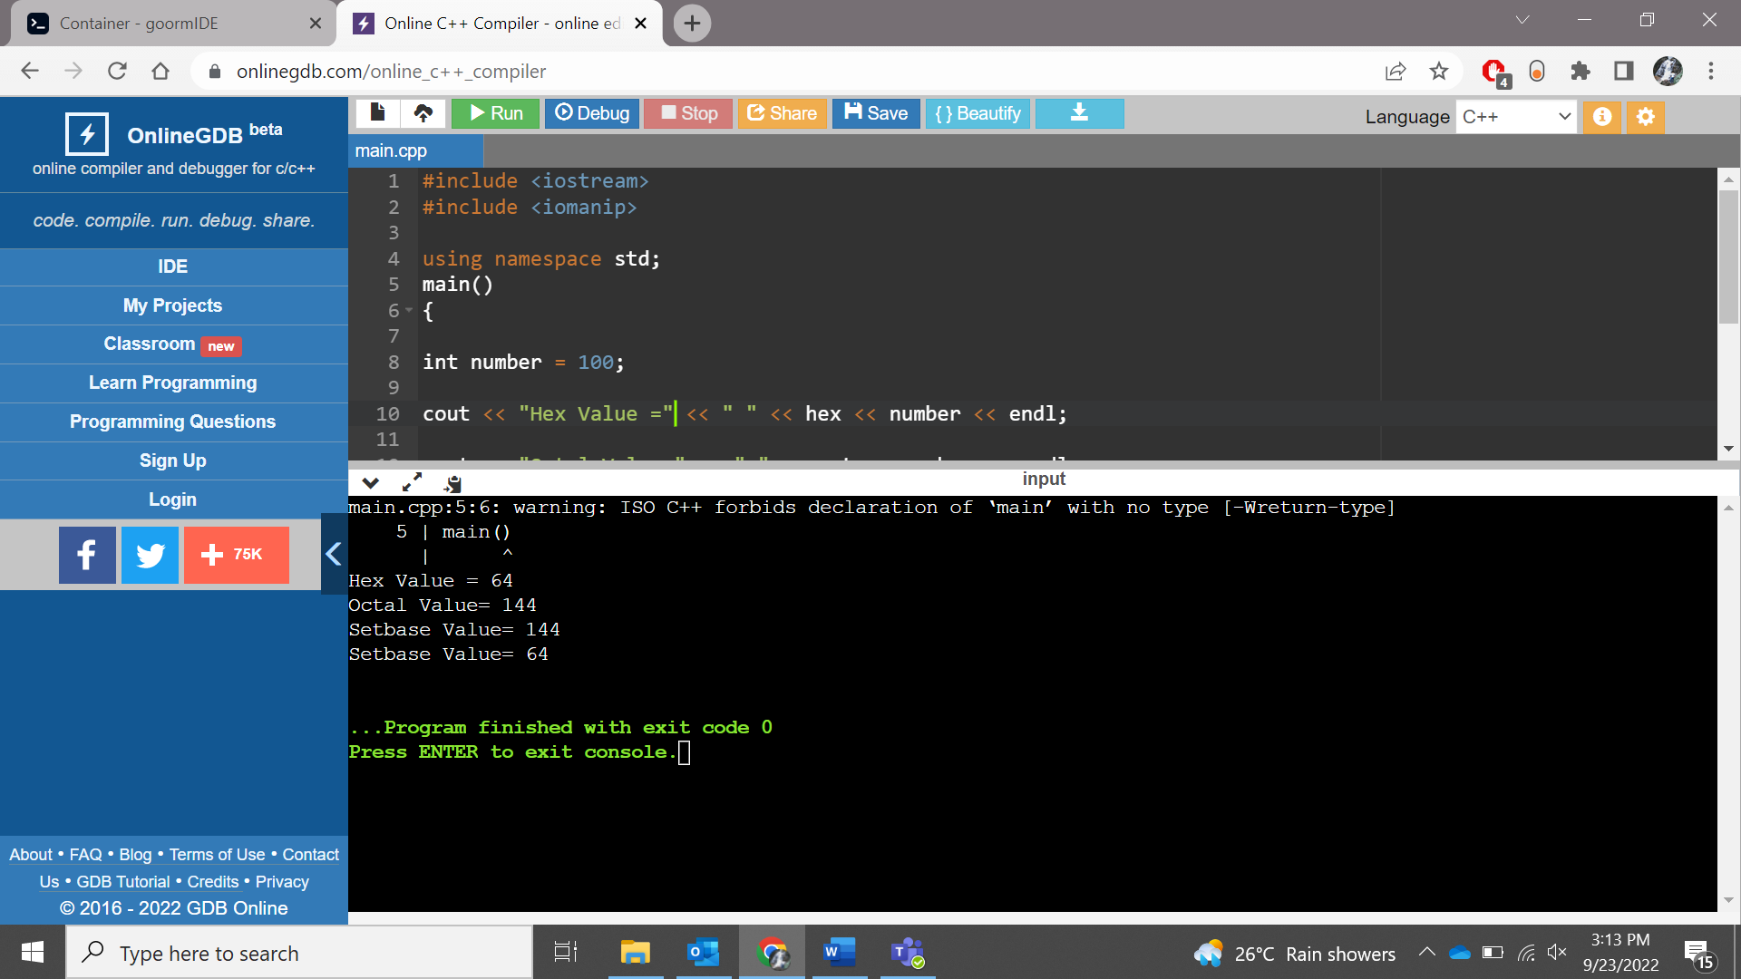

**Assignment 5** : Practice every "**Try**" in the W3schools

1. Print the ASCII value of the character 'h'. --> 72

Code:

**#include <iostream>**

**using namespace std;**

**main()**

**{**

**char c;**

**cout << "Enter a character : ";**

**cin >> c;**

**cout << "ASCII value of " << c <<" is : " << (int)c;**

**}**

**Output:**

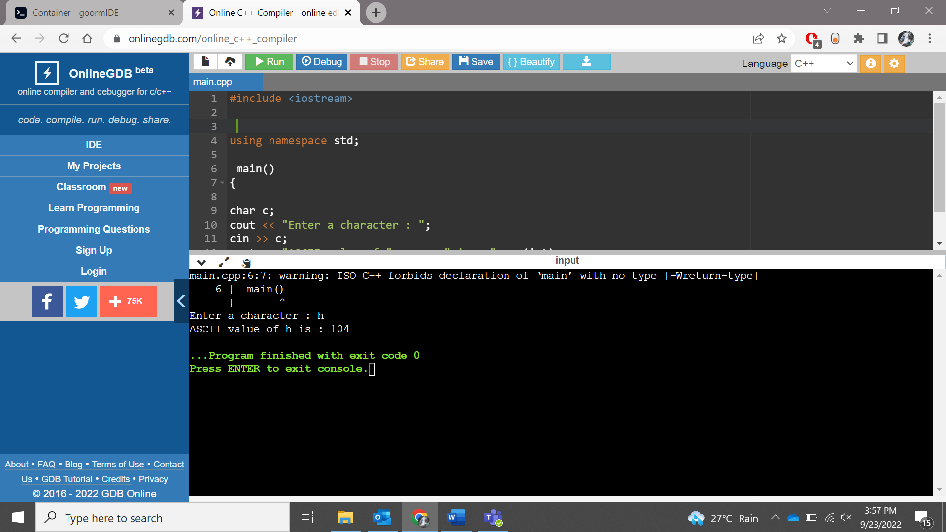

1. Write a program to find the square of the number 3.9.

**Code:**

**#include <iostream>**

**using namespace std;**

**int main()**

**{**

**int num=3.9;**

**cout << "Square of 3.9: " <<(num*num)<< endl;**

**}**

**Output:**

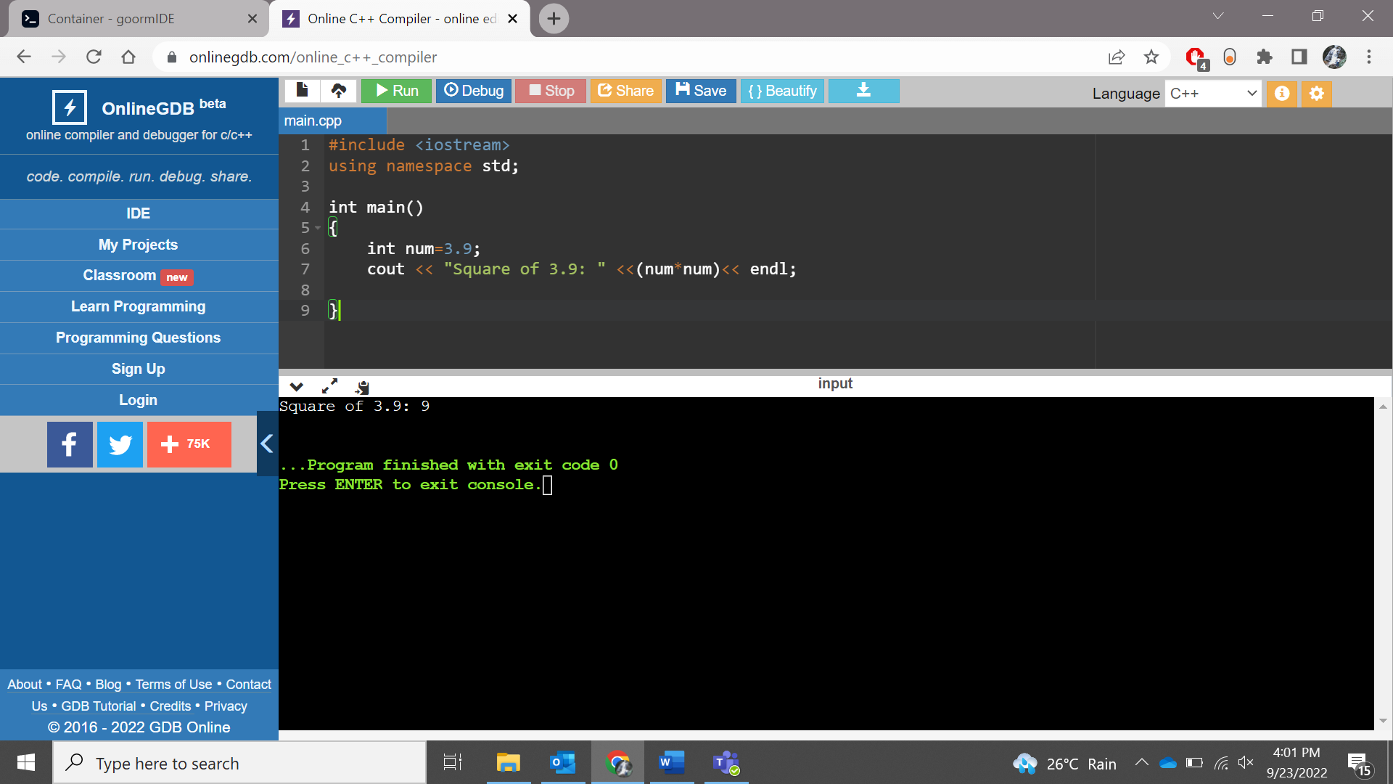

3. What would be the output of following code snippet:

int global = 5;

void display()

{ cout<<global<<endl;}

int main()

{

display();

global = 10;

display();

}

**Code:**

**#include <iostream>**

**using namespace std;**

**int global = 5;**

**void display()**

**{ cout<<global<<endl;}**

**int main()**

**{**

**display();**

**global = 10;**

**display();**

**}**

**Output:**

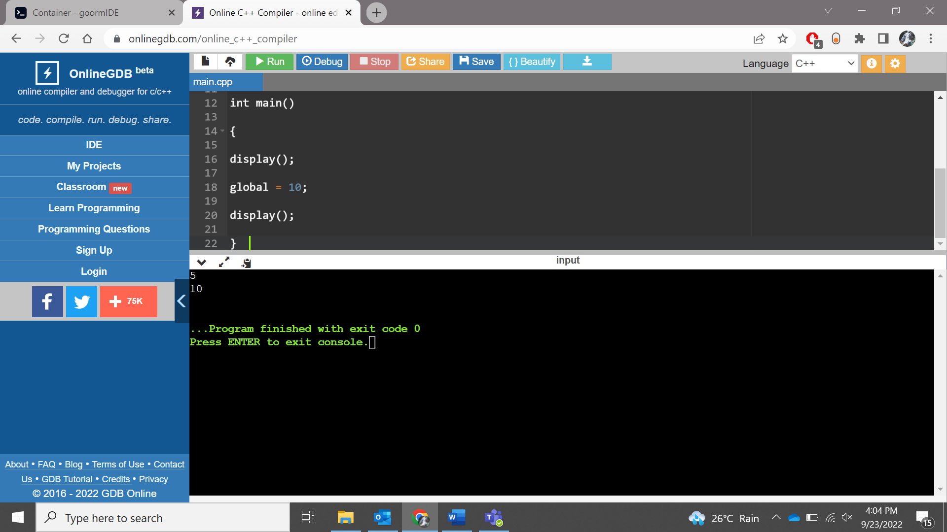

4. What could be the output of following code snippet:

int main()

{

const int x;

x = 10;

printf("%d", x);

return 0;

}

**Output: Compile time error**

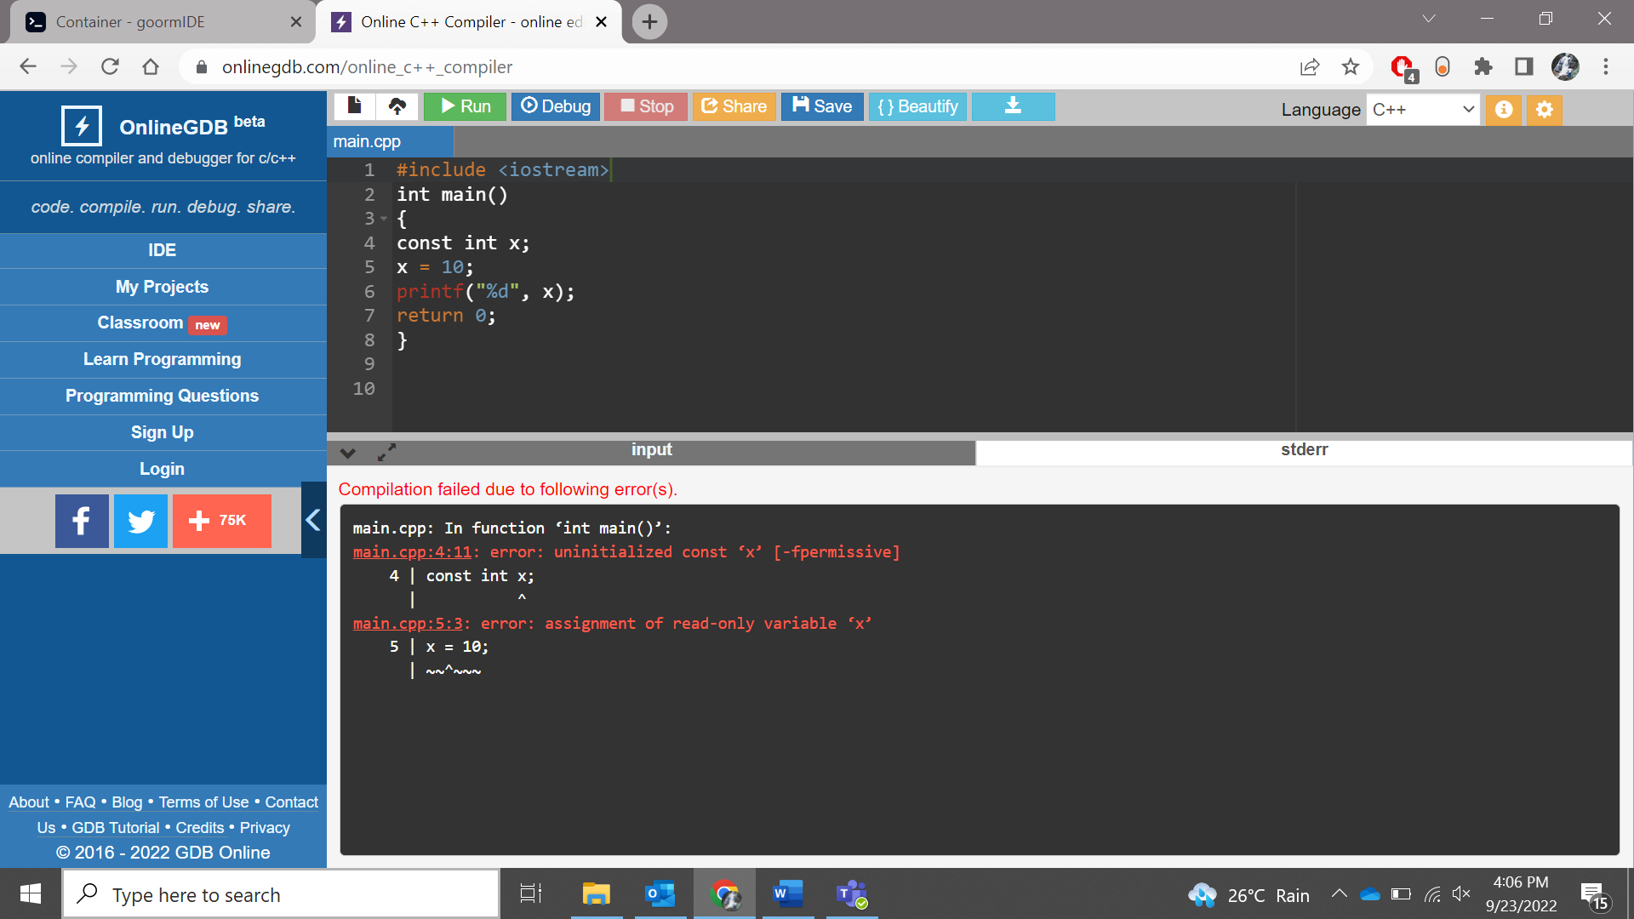

5. Write a program to concatenate [or combine] two strings in one resultant string.

Code:

**#include <iostream>**

**#include <string>**

**using namespace std;**

**int main()**

**{**

**string fName = "Cristiano";**

**string whiteSpace=" ";**

**string LName = "Ronaldo";**

**string fullName=fName+whiteSpace+LName;**

**cout << "Full Name: " << fullName <<endl;**

**return 0;**

**}**

**Output:**

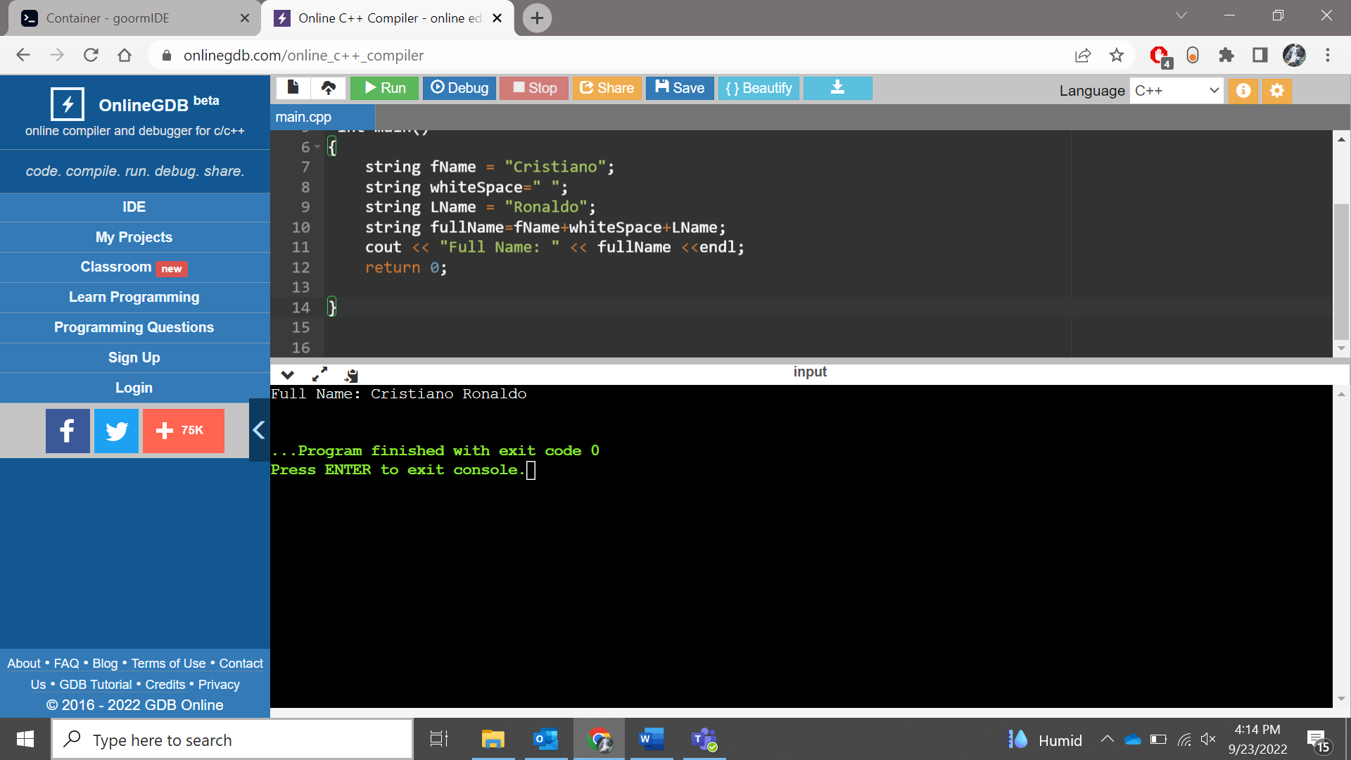

6. Write a program to display hexadecimal and octal value of 100

**Code:**

**#include<iostream>**

**using namespace std;**

**int main() {**

**int x = 100;**

**cout << "Hexadecimal Value is " << hex << x << endl;**

**cout << "Octal Value is " << oct << x << endl;**

**}**

**Output:**

