**ASSIGNMENT 2**

**Assignment 1**: Create a simple program to print all months in a year using switch statement

**Code:**

**#include <iostream>**

**using namespace std;**

**int main() {**

**int month;**

**cout << "Enter the number of the month: "<< endl;**

**cin>>month;**

**switch(month){**

**case 1: cout << "January" <<endl;**

**break;**

**case 2: cout << "February" <<endl;**

**break;**

**case 3: cout << "March" <<endl;**

**break;**

**case 4: cout << "April" <<endl;**

**break;**

**case 5: cout << "May" <<endl;**

**break;**

**case 6: cout << "June" <<endl;**

**break;**

**case 7: cout << "July" <<endl;**

**break;**

**case 8: cout << "August" <<endl;**

**break;**

**case 9: cout << "September" <<endl;**

**break;**

**case 10: cout << "October" <<endl;**

**break;**

**case 11: cout << "November" <<endl;**

**break;**

**case 12: cout << "December" <<endl;**

**break;**

**default: cout<<"Enter a valid input!!"<<endl;**

**}**

}

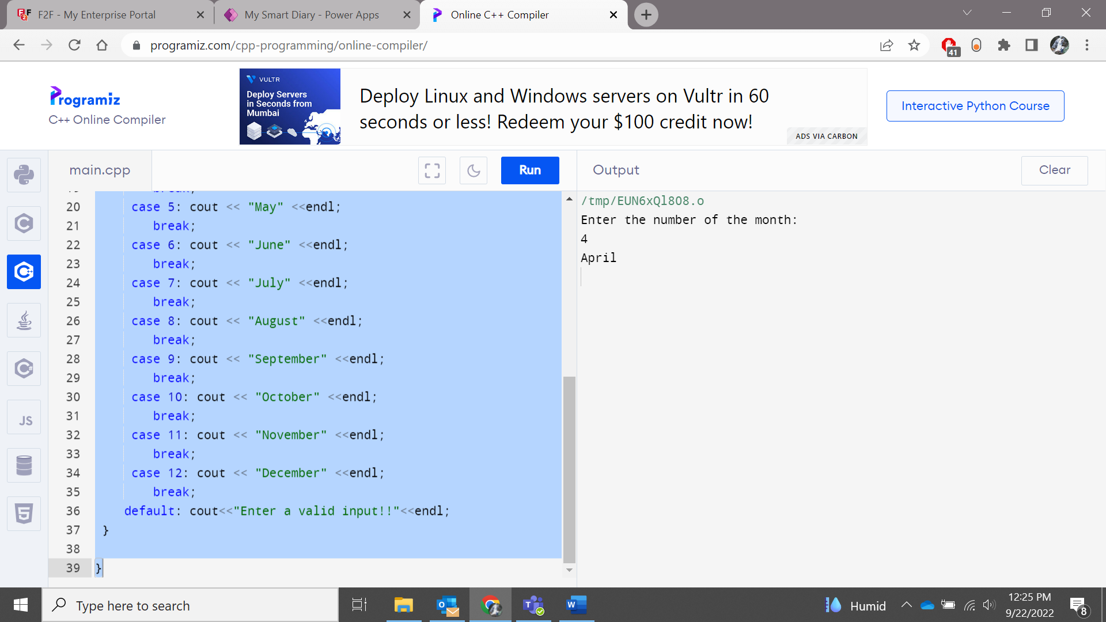

**Assignment 2:** Create a program to find the smallest number among the 3 numbers using if, else statements

**Code:**

#include <iostream>

using namespace std;

int main() {

int a,b,c;

cout << "Enter the values of a,b,c: "<< endl;

cin>>a>>b>>c;

if(a<b&&a<c){

cout << "A is the smallest number!"<<endl;

}

else if(b<c)

cout << "B is the smallest number!"<<endl;

else

cout<< "C is the smallest number!"<<endl;

}

**Assignment 3**: Create a program to display multiplication table up to 10 (For Eg: Table of 5) using for loop.

**Code:**

**#include <iostream>**

**using namespace std;**

**int main() {**

**cout <<"Multiplication table of 5: "<<endl;**

**for(int i=1;i<=10;i++){**

**cout <<"5*" <<i<<"="<<5*i<<endl;**

**}**

**}**

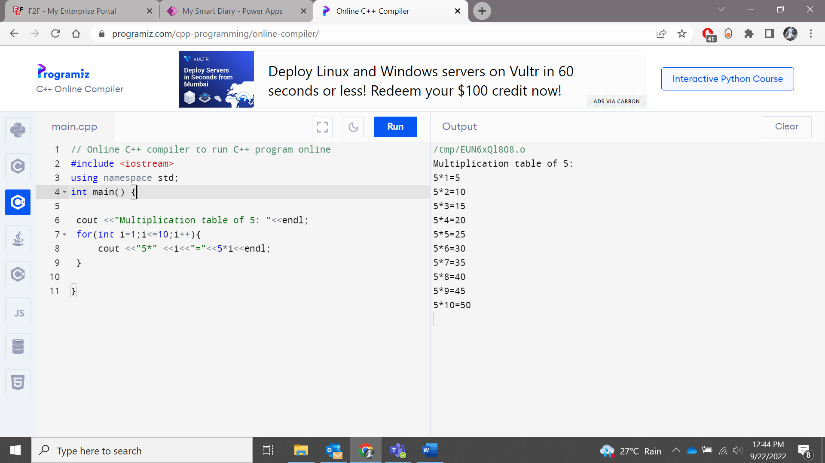

**Assignment 4**: Create a program to display numbers from 1 to 20 using while loop.

**Code:**

**#include <iostream>**

**using namespace std;**

**int main() {**

**cout <<"Numbers from 1 to 20 "<<endl;**

**int i=1;**

**while(i<=20){**

**cout<<i<<endl;**

**i++;**

**}**

**}**

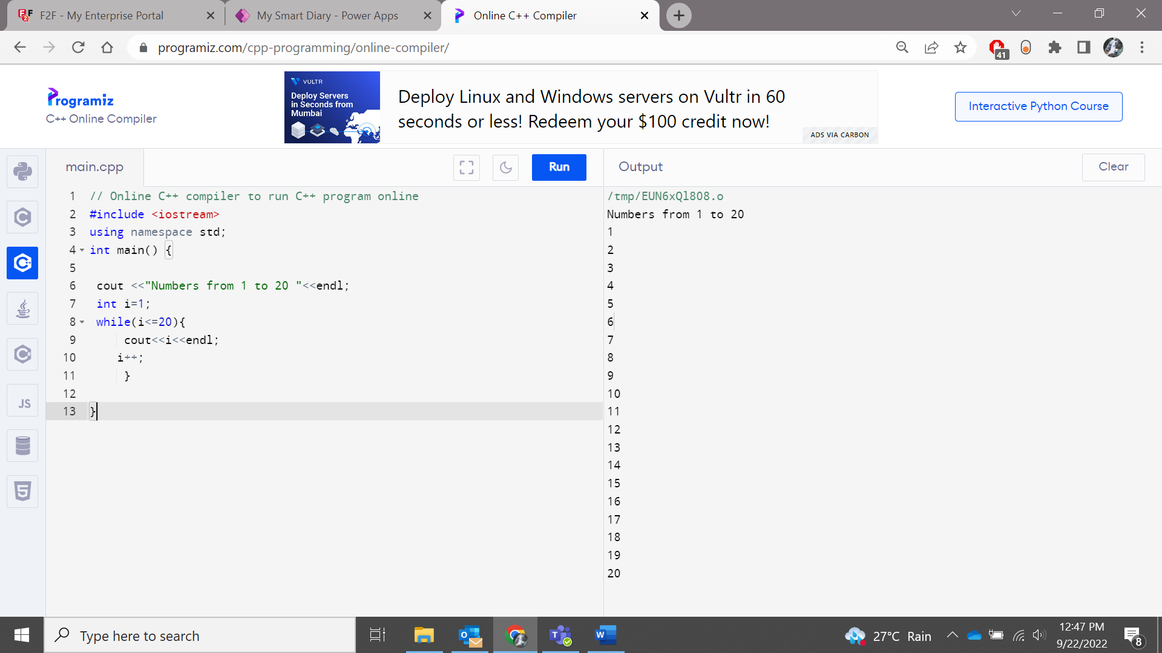

**Assignment 5** : Write a program to find the sum of positive numbers, if the user enters a negative number, the loop ends but the negative entered is not added to the sum  use do while loop.

**Code:**

**#include <iostream>**

**using namespace std;**

**#include <iostream>**

**using namespace std;**

**int main() {**

**int number = 0;**

**int sum = 0;**

**do {**

**sum += number;**

**cout << "Enter a number: ";**

**cin >> number;**

**}**

**while (number >= 0);**

**cout << "The sum is " << sum << endl;**

**return 0;**

**}**

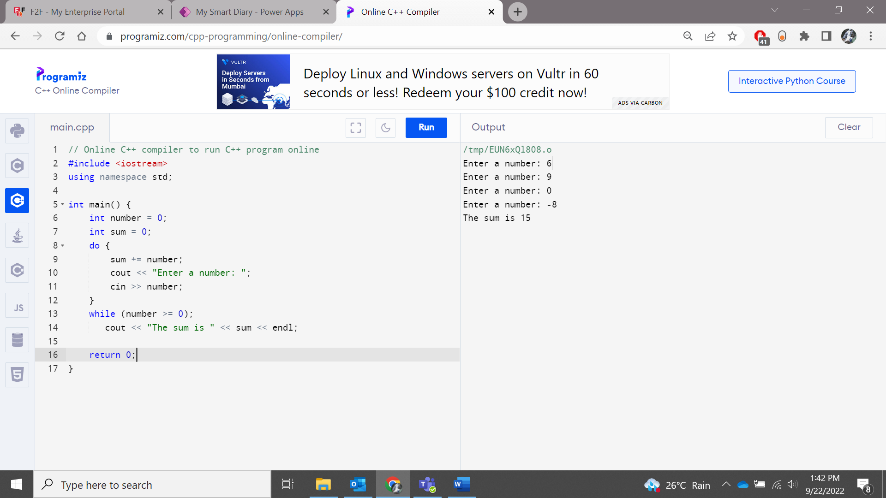

**Assignment 6**: Write a program to decrement number from 20 to 1 using for loop.

**Code:**

**#include <iostream>**

**using namespace std;**

**int main() {**

**for(int i=20;i>0;i--)**

**cout <<i<<endl;**

**return 0;**

**}**

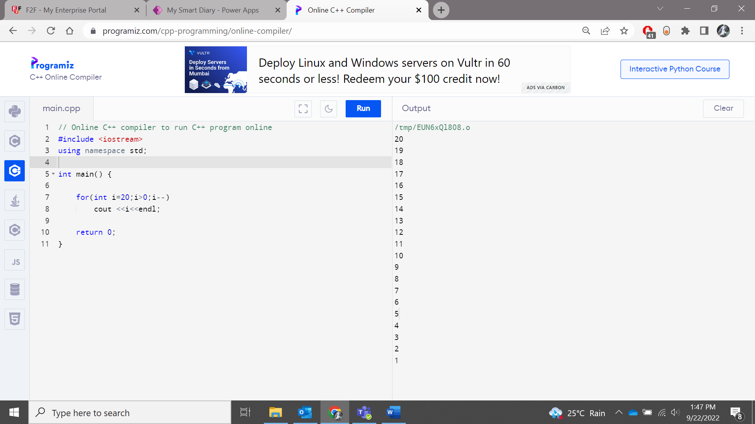

**Assignment 7:** Input a number and Check if the number is palindrome.

**Code:**

**#include <iostream>**

**using namespace std;**

**int main() {**

**int n,rev=0,rem,org;**

**cout << "Enter a number: " <<endl;**

**cin>>n;**

**org=n;**

**while(n!=0){**

**rem=n%10;**

**rev=rev*10+rem;**

**n/=10;**

**}**

**if(org==rev)**

**cout << "The number is a palindrome" << endl;**

**else**

**cout << "The number is not a palindrome" << endl;**

**}**

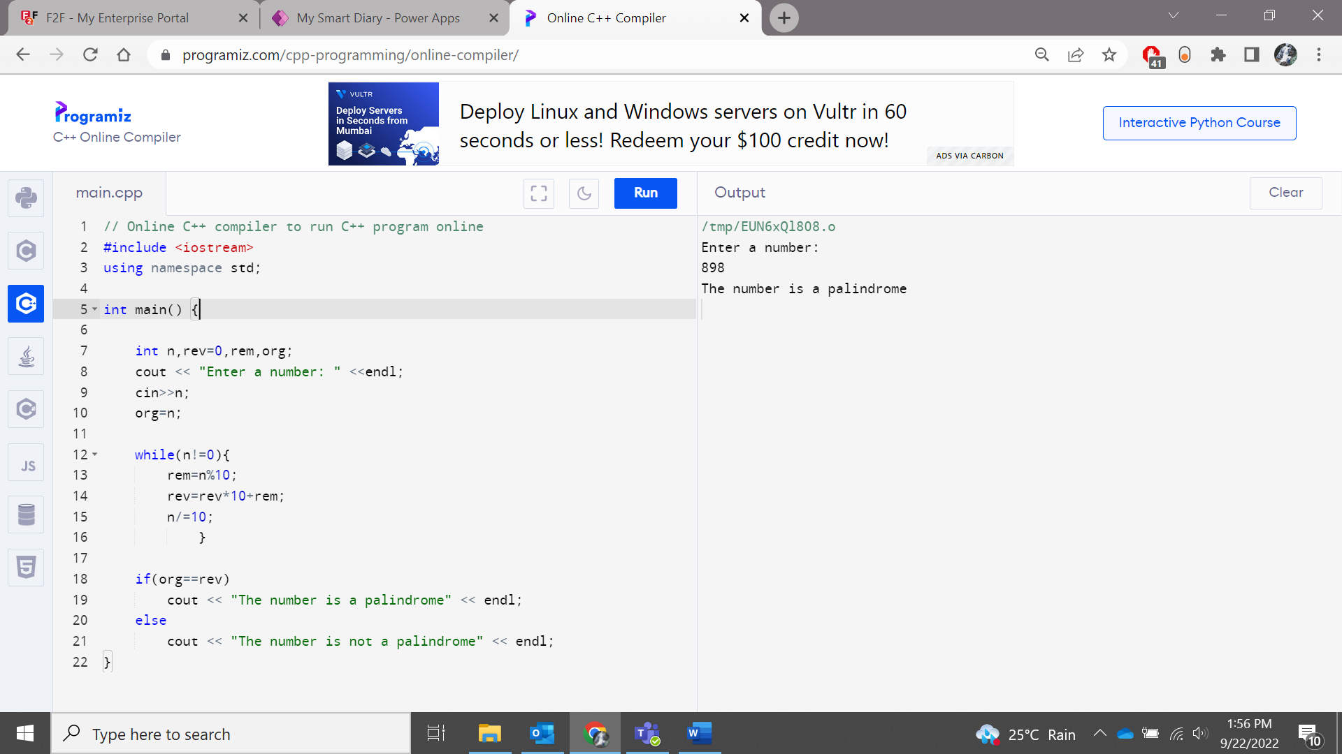

**Assignment 8:**Check if the number is Armstrong number(check for prime)

**Code:**

**#include <iostream>**

**#include <math.h>**

**using namespace std;**

**int temp,sum=0,r,num,flag=0;**

**int arm(int n){**

**for(temp=num;num!=0;num=num/10){**

**r=num % 10;**

**sum=sum+(r*r*r);**

**}**

**if(sum==temp)**

**cout << "It is an armstrong number!" << endl;**

**else**

**cout << "It is not an armstrong number!" << endl;**

**};**

**bool isPrime(int n)**

**{**

**if (n <= 1)**

**return false;**

**for (int i = 2; i <= sqrt(n); i++)**

**if (n % i == 0)**

**return false;**

**return true;**

**}**

**int main() {**

**cout<< "Enter a number: " << endl;**

**cin>>num;**

**arm(num);**

**if(isPrime)**

**cout << " It is a prime number " << endl;**

**else**

**cout << " It is not a prime number " << endl;**

**}**

**Assignment 9**:  Input two number . Swap those number without using the third variable.

**Code:**

#include <iostream>

using namespace std;

int main()

{

int x = 10, y = 5;

cout << "Before Swapping: x =" <<x << ", y=" << y<<endl;

x = x + y;

y = x - y;

x = x - y;

cout << "After Swapping: x =" << x << ", y=" << y;

}

