**ASSIGNMENT 4**

Write a program to perform binary search in an array.

Code:

**#include <iostream>**

**using namespace std;**

**int binaryS(int arr[], int l, int r, int x)**

**{**

**if (r >= l) {**

**int mid = l + (r - l) / 2;**

**if (arr[mid] == x)**

**return mid;**

**if (arr[mid] > x)**

**return binaryS(arr, l, mid - 1, x);**

**return binaryS(arr, mid + 1, r, x);**

**}**

**return -1;**

**}**

**int main(void)**

**{**

**int arr[] = { 2, 3, 4, 10, 40 };**

**int x = 10;**

**int n = sizeof(arr) / sizeof(arr[0]);**

**int result = binaryS(arr, 0, n - 1, x);**

**if (result == -1)**

**cout << "Element is not present in array";**

**else**

**cout << "Element is present at index " << result;**

**return 0;**

**}**

Write a program to perform bubble sort in an unsorted array.

Code:

**#include <iostream>**

**using namespace std;**

**void bubbleSort(int array[], int n) {**

**for (int i = 0; i < n; ++i) {**

**for (int j = 0; j < n - i; ++j) {**

**if (array[i] > array[j + 1]) {**

**int temp = array[j];**

**array[j] = array[j + 1];**

**array[j + 1] = temp;**

**}**

**}**

**}**

**}**

**void display(int array[], int n) {**

**for (int i = 0; i < n; ++i) {**

**cout << " " << array[i];**

**}**

**cout << "\n";**

**}**

**int main() {**

**int data[] = {-2, 45, 0, 11, -9};**

**int n = sizeof(data) / sizeof(data[0]);**

**bubbleSort(data, n);**

**cout << "Sorted Array in Ascending Order:\n";**

**display(data, n);**

**}**

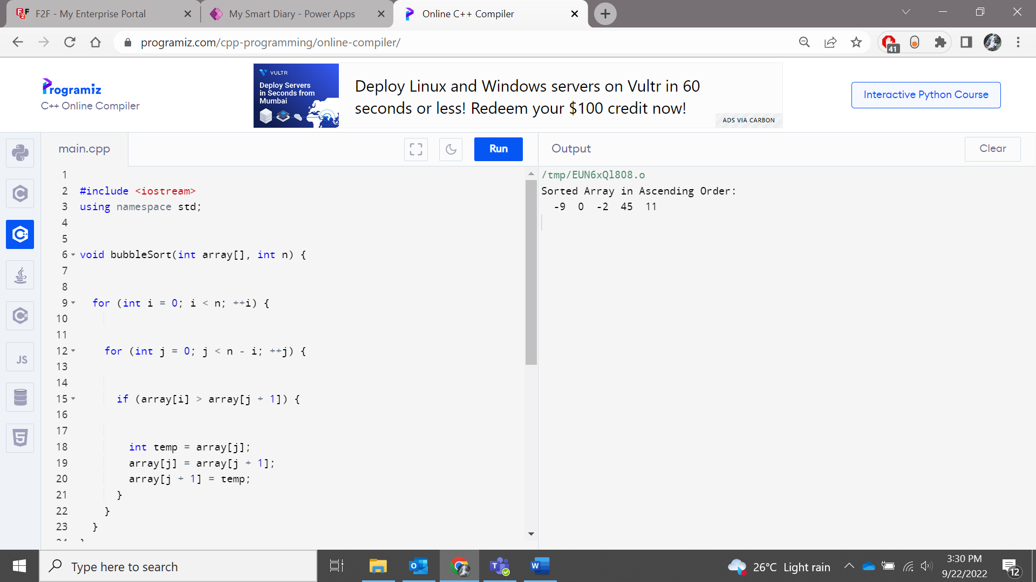

Write a program to determine occurrences of substring in a string.

Code:

**#include<iostream>**

**using namespace std;**

**int count(string &sub, string &txt)**

**{**

**int M = sub.length();**

**int N = txt.length();**

**int res = 0;**

**for (int i = 0; i <= N - M; i++)**

**{**

**int j;**

**for (j = 0; j < M; j++)**

**if (txt[i+j] != sub[j])**

**break;**

**if (j == M)**

**{**

**res++;**

**}**

**}**

**return res;**

**}**

**int main()**

**{**

**string txt,sub;**

**cout << "Enter a string " <<endl;**

**cin>>txt;**

**cout << "Enter a substring " <<endl;**

**cin>>sub;**

**cout << count(sub, txt);**

**return 0;**

**}**

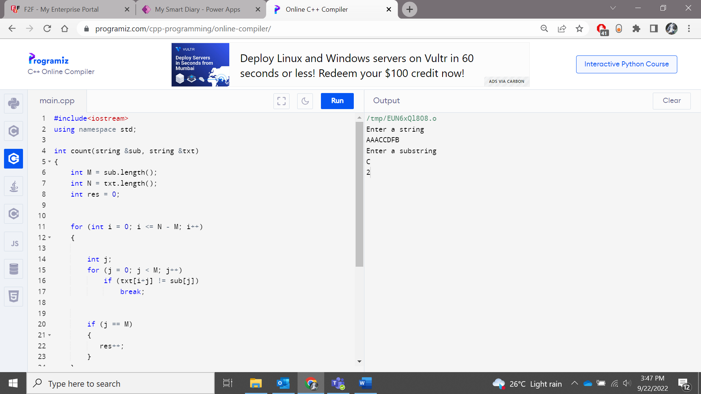

Write a program to demonstrate return and Goto statements.

Code:

**#include <iostream>**

**using namespace std;**

**int main()**

**{**

**int n;**

**cout << "Enter a number: " <<endl;**

**cin>>n;**

**if (n % 2 == 0)**

**goto l1;**

**else**

**goto l2;**

**l1:**

**cout << "Even" << endl;**

**return 0;**

**l2:**

**cout << "Odd" << endl;**

**}**

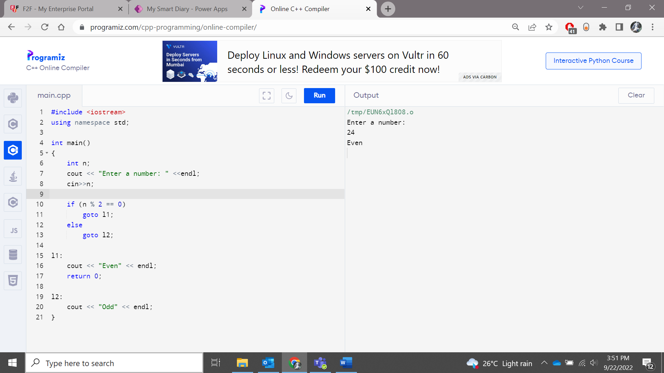

Write a program to demonstrate every functions in string.

**Code:**

**#include <iostream>**

**#include <cstring>**

**using namespace std;**

**int main()**

**{**

**char firstStr[50] = "This is Sopra Steria";**

**char secStr[50] = "A French MNC";**

**int len = strlen(firstStr);**

**cout<<"Length of firstStr : "<<len;**

**strcpy(secStr,"in Bangalore");**

**cout<<"\nResultant string (secStr):"<<secStr;**

**cout<<"\nComparing firstStr and secStr :"<<strcmp(firstStr,secStr);**

**strcat(secStr," India");**

**cout<<"\nConcatenated secStr: "<<secStr;**

**return 0;**

**}**

