Assignment 5

A1. Given two integer arrays nums1 and nums2, return *the maximum length of a subarray that appears in* ***both*** *arrays*.

**Example 1:**

**Input:** nums1 = [1,2,3,2,1], nums2 = [3,2,1,4,7]   
Output: 3   
Explanation: The repeated subarray with maximum length is [3,2,1].

**Example 2:**

**Input:** nums1 = [0,0,0,0,0], nums2 = [0,0,0,0,0]   
Output: 5 

Code:

**#include <iostream>**

**using namespace std;**

**int maxSubArray(int A[], int B[], int e, int f)**

**{**

**int c[e + 1][f + 1];**

**for (int i = 0; i <= e; i++)**

**for (int j = 0; j <= f; j++)**

**c[i][j] = 0;**

**for (int i = e - 1; i >= 0; i--) {**

**for (int j = f - 1; j >= 0; j--) {**

**if (A[i] == B[j])**

**c[i][j] = c[i + 1][j + 1] + 1;**

**}**

**}**

**int maxl = 0;**

**for (int i = 0; i < e; i++) {**

**for (int j = 0; j < f; j++) {**

**maxl = max(maxl, c[i][j]);**

**}**

**}**

**return maxl;**

**}**

**int main()**

**{**

**int A[100],B[100],e,f;**

**cout<<"Enter the size of the first array : " <<endl;**

**cin>>e;**

**cout<<"Enter the elements of the first array : "<<endl;**

**for(int i=0;i<e;i++){**

**cin>>A[i];**

**}**

**cout<<"Enter the size of the second array : "<<endl;**

**cin>>f;**

**cout<<"Enter the elements of the subarray : "<<endl;**

**for(int i=0;i<f;i++){**

**cin>>B[i];**

**}**

**cout << "Maximum Length of the equal subarray: " << (maxSubArray(A, B, e, f));**

**}**

Output:

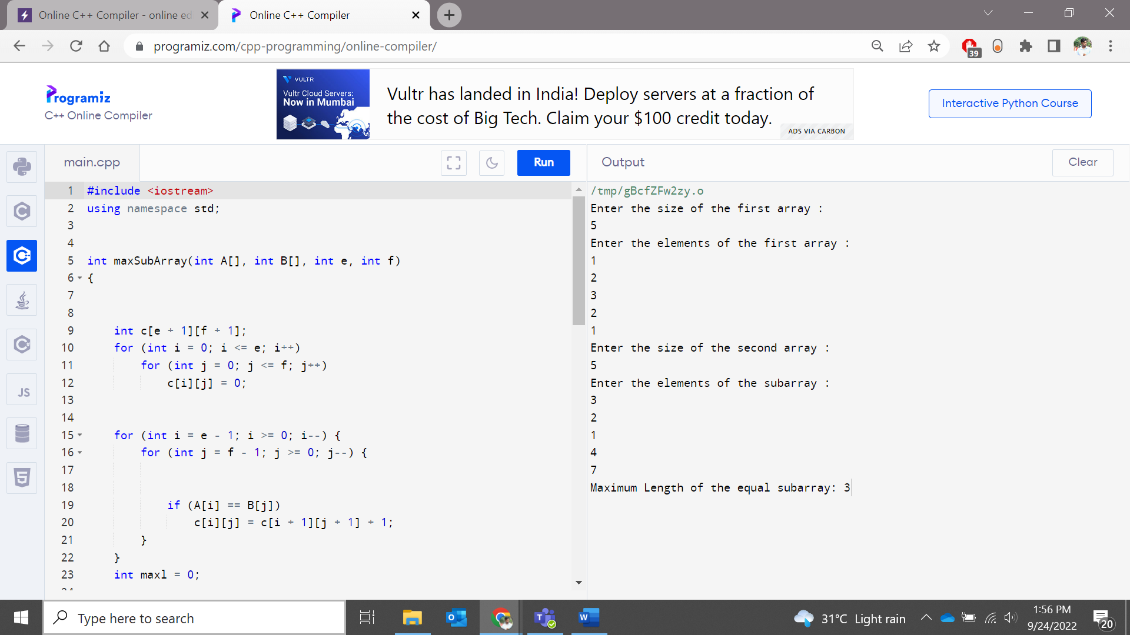

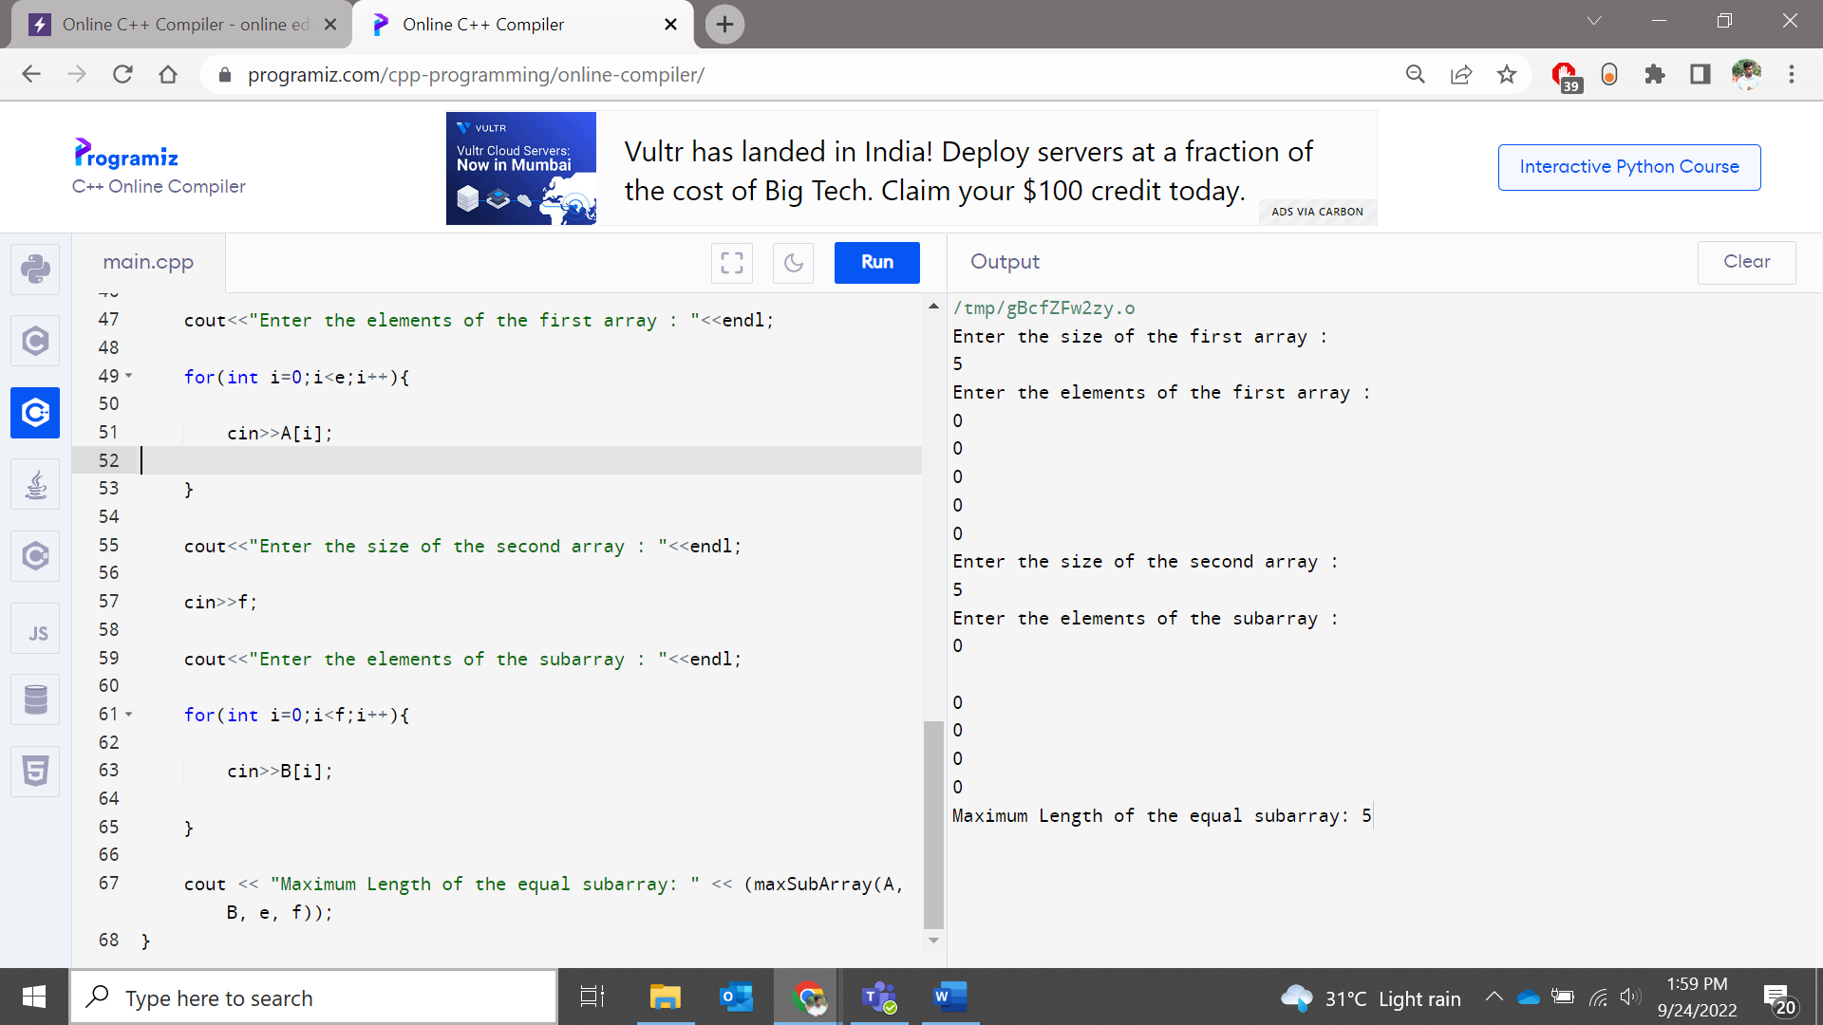

A2. Given an integer array nums sorted in **non-decreasing order**, remove the duplicates [**in-place**](https://en.wikipedia.org/wiki/In-place_algorithm) such that each unique element appears only **once**. The **relative order** of the elements should be kept the **same**.

Since it is impossible to change the length of the array in some languages, you must instead have the result be placed in the **first part** of the array nums. More formally, if there are k elements after removing the duplicates, then the first k elements of nums should hold the final result. It does not matter what you leave beyond the first k elements.

Return k *after placing the final result in the first* k *slots of* nums.

Do **not** allocate extra space for another array. You must do this by **modifying the input array** [**in-place**](https://en.wikipedia.org/wiki/In-place_algorithm) with O(1) extra memory.

**Custom Judge:**

The judge will test your solution with the following code:

int[] nums = [...]; // Input array   
int[] expectedNums = [...]; // The expected answer with correct length   
   
int k = removeDuplicates(nums); // Calls your implementation   
   
assert k == expectedNums.length;   
for (int i = 0; i < k; i++) {   
    assert nums[i] == expectedNums[i];   
} 

If all assertions pass, then your solution will be **accepted**.

**Example 1:**

**Input:** nums = [1,1,2]   
Output: 2, nums = [1,2,_]   
Explanation: Your function should return k = 2, with the first two elements of nums being 1 and 2 respectively.   
It does not matter what you leave beyond the returned k (hence they are underscores). 

**Example 2:**

**Input:** nums = [0,0,1,1,1,2,2,3,3,4]   
Output: 5, num = [0,1,2,3,4,_,_,_,_,_]   
Explanation: Your function should return k = 5, with the first five elements of nums being 0, 1, 2, 3, and 4 respectively.   
It does not matter what you leave beyond the returned k (hence they are underscores). 

**Constraints:**

* 1 <= nums.length <= 3 * 104
* -100 <= nums[i] <= 100
* nums is sorted in **non-decreasing** order.

**Code :**

**#include<iostream>**

**using namespace std;**

**int removeDup(int arr[], int n)**

**{**

**if (n==0 || n==1)**

**return n;**

**int j = 0;**

**for (int i=0; i < n-1; i++)**

**if (arr[i] != arr[i+1])**

**arr[j++] = arr[i];**

**arr[j++] = arr[n-1];**

**return j;**

**}**

**int main()**

**{**

**int n;**

**cout << "Enter the size of the array: " << endl;**

**cin >> n;**

**int arr[n];**

**cout << "Enter the elements of the array: " << endl;**

**for (int i=0;i<n;i++){**

**cin >> arr[i];**

**}**

**n = removeDup(arr, n);**

**for (int i=0; i<n; i++)**

**cout << arr[i] << " ";**

**return 0;**

**}**

**Output:**

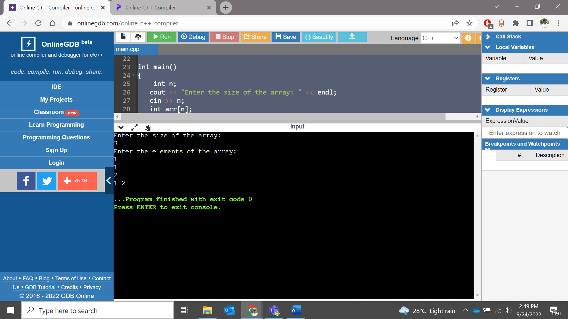

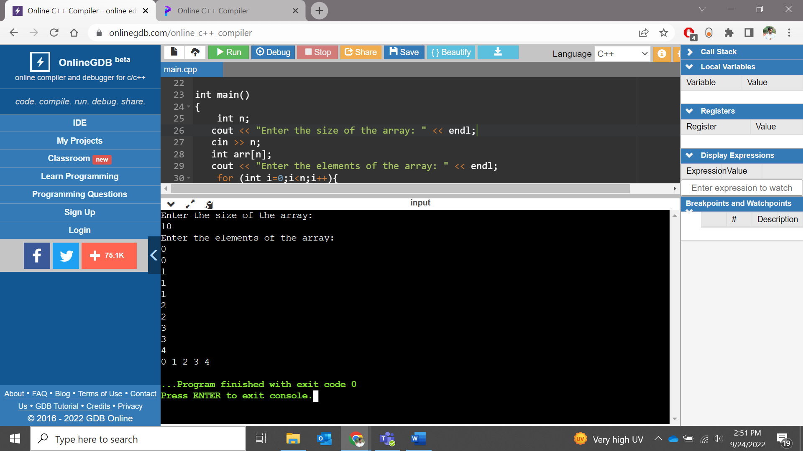

**A3**. Given a string s and a character c that occurs in s, return *an array of integers* answer *where* answer.length == s.length *and* answer[i] *is the* ***distance*** *from index* i *to the* ***closest*** *occurrence of character* c *in* s.

The **distance** between two indices i and j is abs(i - j), where abs is the absolute value function.

**Example 1:**

**Input:** s = "loveleetcode", c = "e"   
Output: [3,2,1,0,1,0,0,1,2,2,1,0]   
Explanation: The character 'e' appears at indices 3, 5, 6, and 11 (0-indexed).   
The closest occurrence of 'e' for index 0 is at index 3, so the distance is abs(0 - 3) = 3.   
The closest occurrence of 'e' for index 1 is at index 3, so the distance is abs(1 - 3) = 2.   
For index 4, there is a tie between the 'e' at index 3 and the 'e' at index 5, but the distance is still the same: abs(4 - 3) == abs(4 - 5) = 1.   
The closest occurrence of 'e' for index 8 is at index 6, so the distance is abs(8 - 6) = 2. 

**Example 2:**

**Input:** s = "aaab", c = "b"   
Output: [3,2,1,0] 

**Constraints:**

* 1 <= s.length <= 104
* s[i] and c are lowercase English letters.
* It is guaranteed that c occurs at least once in s.

**Code:**

**#include <string>**

**#include <iostream>**

**#include <bits/stdc++.h>**

**using namespace std;**

**void shortestD(string S, char C)**

**{**

**int prev = INT_MAX;**

**vector<int> ans;**

**for (int i = 0; i < S.length(); i++)**

**{**

**if (S[i] == C)**

**prev = i;**

**if (prev == INT_MAX)**

**ans.push_back(INT_MAX);**

**else**

**ans.push_back(i - prev);**

**}**

**prev = INT_MAX;**

**for (int i = S.length() - 1; i >= 0; i--)**

**{**

**if (S[i] == C)**

**prev = i;**

**if (prev != INT_MAX)**

**ans[i] = min(ans[i], prev - i);**

**}**

**for (auto val: ans)**

**cout << val << ' ';**

**}**

**int main()**

**{**

**string S = "loveleetcode";**

**char C = 'e';**

**shortestD(S, C);**

**return 0;**

**}**

**Output:**

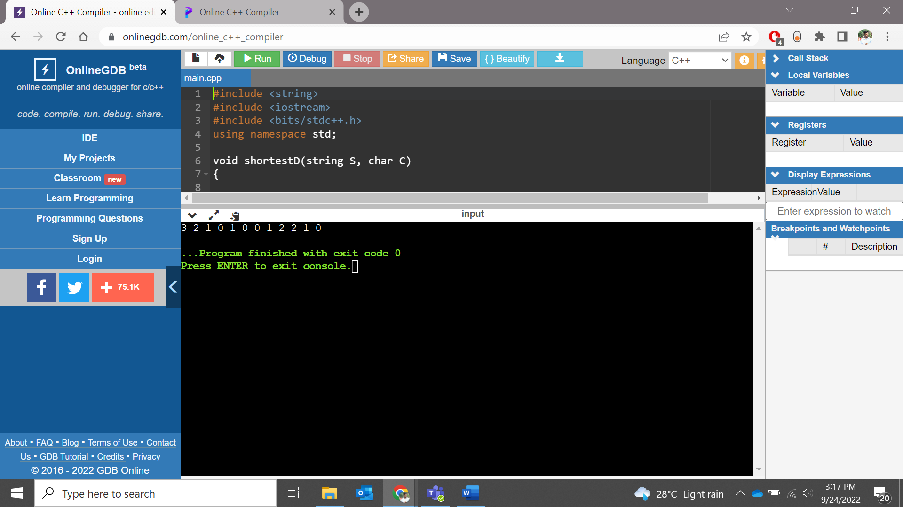

A4. Calculate total payment of employees using structure and function (10 employees, employee details like id,name,and salary in the structure and function for adding the salary)

**Code:**

**#include <iostream>**

**using namespace std;**

**struct Employee {**

**char name[50];**

**int salary;**

**int employeeCode;**

**char dept[5];**

**}e[10];**

**int add(struct Employee *e,int n){**

**int total_salary=0;**

**for(int i=0; i<n;i++)**

**{**

**total_salary+=e[i].salary;**

**}**

**return total_salary;**

**}**

**int main() {**

**int n;**

**cout << "Enter the number of employees: " << endl;**

**cin >> n;**

**for(int i=0;i<n;i++){**

**cout << "Enter name of employee : ";**

**cin >> e[i].name;**

**cout << "Enter department : ";**

**cin >> e[i].dept;**

**cout << "Enter salary of employee : ";**

**cin >> e[i].salary;**

**cout << "Enter employee code : ";**

**cin >> e[i].employeeCode;**

**cout <<" " <<endl;**

**}**

**cout << "\n*** Employee Details ***" << endl;**

**for(int i=0;i<n;i++){**

**cout << "Name : " << e[i].name << endl << "Salary : " << e[i].salary << endl;**

**cout << "Employee Code : " << e[i].employeeCode << endl << "Department : " << e[i].dept << endl;**

**}**

**int sum=add(e,n);**

**cout << "Total Salary: " << sum <<endl;**

**return 0;**

**}**

**Output:**

